“Synthesize a solution to a potential real-life scenario” - Component 1
Author: Geminiano (Gio) Aguilar
Module: Networks and Cyber Security Essentials ACCA4024
School of Applied Computing
Wales Institute of Science and Art
Date and Time of submission: on or before 8th January 2021 (Friday) by 18:00 Hrs

Table of Contents
Contents:
- Introduction

- Flaws in Che-Si’s policy/infrastructure – Vulnerabilities, Threats and Possible attacks that could take place

- Recommended techniques/guidelines to help with mitigation

- Demonstration of Mitigation – Steps (with screenshots), Evaluation

- Importance of digital signatures - What are digital signatures, why are they important?

- Strategy to mitigate flaws

- Conclusion

- Reference list

Abstract
I discovered the different flaws associated with Che-Si’s company. I have implemented methods that the company can use to help mitigate the existing flaws. I also included a “demonstration attack” that could be used towards their system. I recommended mitigation techniques to prevent these attacks from happening in the future.

Introduction
Network security Is important for all organizations to have. Security provides safety for the companies, employees as well as their clients. Strong security in a network can keep sensitive data safe and prevent it from being accessed to unauthorized users such as hackers. Without security, a network will be left with many vulnerabilities that can be exploited by threats. This could make it easy for a hacker to intrude a network system and attack it.

Flaws in Che-Si’s policy/infrastructure
There are several vulnerabilities, threats, and attacks that could happen in Che-Si’s system. The use of different personal devices at any location increases the chance of a cyber-attack to become successful. For example, an employee connecting a device to free Wi-Fi in a location (coffee shop, bus station, restaurant etc) to complete/do work for the company, can lead to many risks to their self as well as Che-Si’s company. This is because the connection between the device and the internet is not secure.
Vulnerabilities
There are vulnerabilities associated with the use of personal devices at different locations. These vulnerabilities include the personal devices – they can be infected with viruses, malicious software/code, and the use of devices in an unsecure location. Ensuring security in a network is important as it will help prevent sensitive information being viewed or accessed. Network security’s main function is to ensure that data has not been lost or stolen by unauthorized individuals [1].
Threats
These vulnerabilities in the network can be exploited by threats. There are multiple threats involved with the use of personal devices at different locations. These threats include threats to the company – their sales, business plans, trades etc. Using devices in unsecure locations could reveal sensitive information to the Che-Si company. Plus, connecting devices in an unsecure network poses threats to the employees as well as the clients that the company provides its service to. This is because sensitive information that belongs to them could also be revealed. This sensitive data includes bank details, medical records, social security, ethnic origin etc. The leak of sensitive data poses a massive threat to the company’s reputation. Clients will lose trust in the company leaving them with no customers to provide their service to. This will then lead to a loss in profit which will eventually lead to an end to the business.
Possible attacks that could take place
There are numerous possible attacks that a hacker can do to gain access or prevent a system from performing its normal functions. A hacker in the same Wi-Fi network can use packet forgery to disrupt Che-Si’s network system. A hacker can do this by sending a packet that appears to be part of the Che-Si network system to the employee. This packet could contain malicious software. The employee could then pass it onto the Che-Si system without knowing it is malicious. This packet will cause the entire Che-Si system to be infected with malicious software. The hacker has access to the whole entire system as the malicious software they have created is now inside the system. The hacker can use other methods such as Denial of Service (DOS). This type of attack is when a hacker overwhelms a computer network by sending of meaningless and useless packets into the system which will eventually cause it to dysfunction. A Denial-of-Service attacks prevents authorized users in the system to access it [2].
Another attacking method that attackers can use to compromise data in Che-Si’s network is by packet sniffing. Once the device is connected to the free Wi-Fi, hackers in the same location can monitor the packets that are flowing in the network using tools like packet sniffers. The packets flowing in the network can reveal sensitive data. This sensitive data could belong to the employee, the company, and clients. Hackers can view all text that the employee is inputting into the network and can now gather information that is useful to them such as passwords and login credentials. By collecting useful and meaningful information together, the hacker could possibly login to the system using an employee’s credentials.
Hackers can shoulder-surfing or tailgate users to intrude a system. Hackers can be physically close to an employee and can spy on the device that the employee is using. By spying and paying close attention the hacker could see login credentials, information related to the business and sensitive information without interfering with the employee. This hacker could then gather useful information together to launch an attack to the network.

Recommended techniques/guidelines to help with mitigation
There are several methods and techniques to prevent these types of attacks, make the network less vulnerable and lower the risk of a threat from happening. To help mitigate these factors from happening without impacting employee’s productivity and performance, the employee should use encryption methods such as a Virtual Private Network (VPN). Using a VPN when connected to public Wi-Fi offers data protection. The function of a VPN is to allow users to access different networks across the internet securely. Hackers are unable to see data flowing across the network in plain text making it harder for them to perform an attack. This is because data is encrypted when a VPN is used. The VPN acts as a gateway between the client and the server. The “gateway” encrypts data in an unreadable format so hackers cannot see data they are trying to retrieve [3]. VPN’s ensure confidentiality in a network. This means that data flowing in the network is kept private and hard for hackers to retrieve.
A firewall is used in a networking system to ensure safety in the network. The function of the firewall is to block out any packets that are not intended for the network. Firewalls can prevent unwanted, useless, and forged packets that may be sent by hackers. Firewalls can prevent the risk of malicious software from entering the network as packets that may contain malicious software will be filtered out. Filtering out packets could help mitigate a DoS attack as packets are being blocked from coming into the network.
Installing antivirus software helps keep track and notifies a user if there is a virus in the system. Every file stored in the computer system is scanned to check for a virus. If the antivirus software detects any type of virus that resides in the network, it will remove it [4]. Installing anti-virus software is crucial for devices that are used in unsecure locations as these devices are prone to malicious software. It ensures that the virus will not affect the data stored meaning that the Che-Si’s network system is somewhat resistant to virus’.
An employee can use strong and complex passwords making it difficult for the hacker to see if the hacker is shoulder surfing or tailgating. Typing in passwords in a hidden text format can increase the risk of the hacker finding out what the password is.
Regularly updating the OS can strengthen security. These new updates fix broken patches in the system that are a target for hackers to install malicious software. OS updates can lower the chance of a hacker to break into the system as old patches and vulnerabilities have been restored and updated.

Demonstration of Mitigation
I will be using a packet sniffer and the command prompt to demonstrate a possible attack. I used an FTP Server called ‘mcafee’ to show how a packet sniffer can capture login credentials.
First step
I opened and run both applications to get started. I split them between the screen so that I can access them easier.
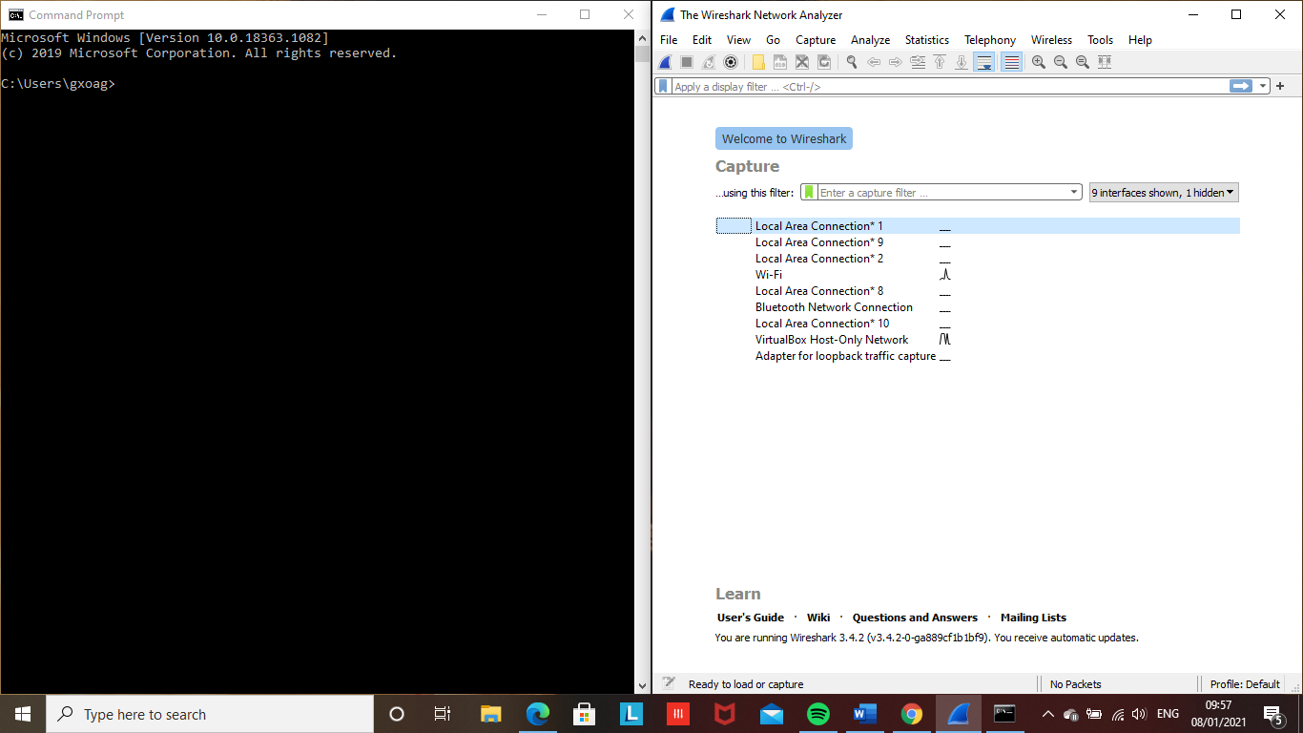

Second step
I selected the Wi-Fi interface on the packet sniffer menu to observe all packets flowing in the Wi-Fi connection.
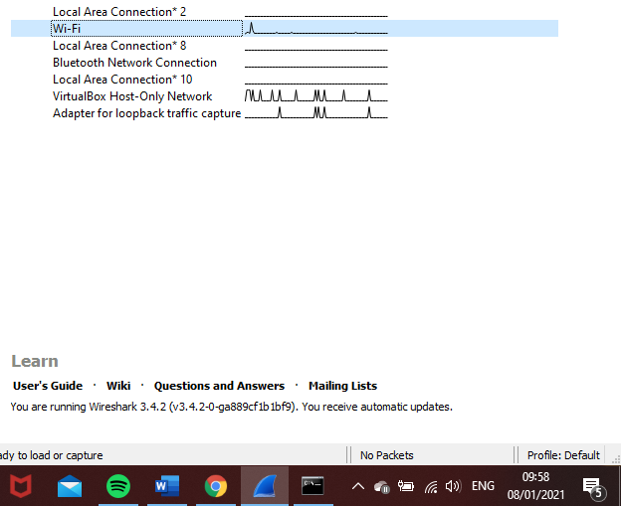

Third step
I decided to use an unsecure FTP server and give login credentials to mitigate this attack. In the command prompt, I established a connection with an FTP server called “mcafee”. I executed the command “ftp ftp.mcafee.com” to enter their server. I then went back on to the packet sniffer application and selected the correct interface. I filtered the packets to the FTP (File Transfer Protocol) so that I can view all the FTP files. Filtering makes it easier to view and find the packets I want to retrieve as it filters out the unneeded packets. as you can see on the diagram below, there are three FTP packets. The packet sniffer has tracked the FTP related commands that were used in the command prompt and it displays information on the packet list pane, packet details pane and the packet bytes pane.
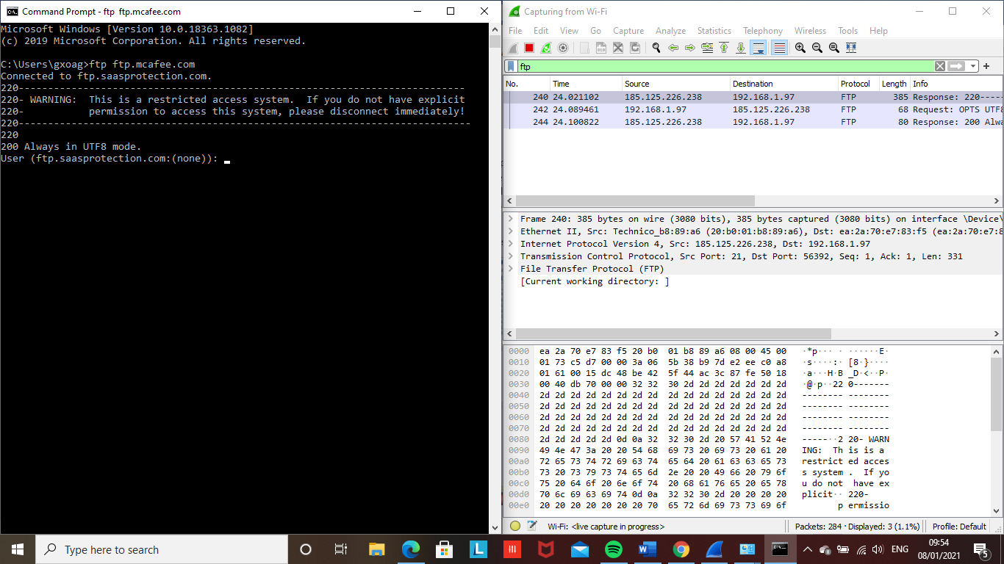

Fourth Step
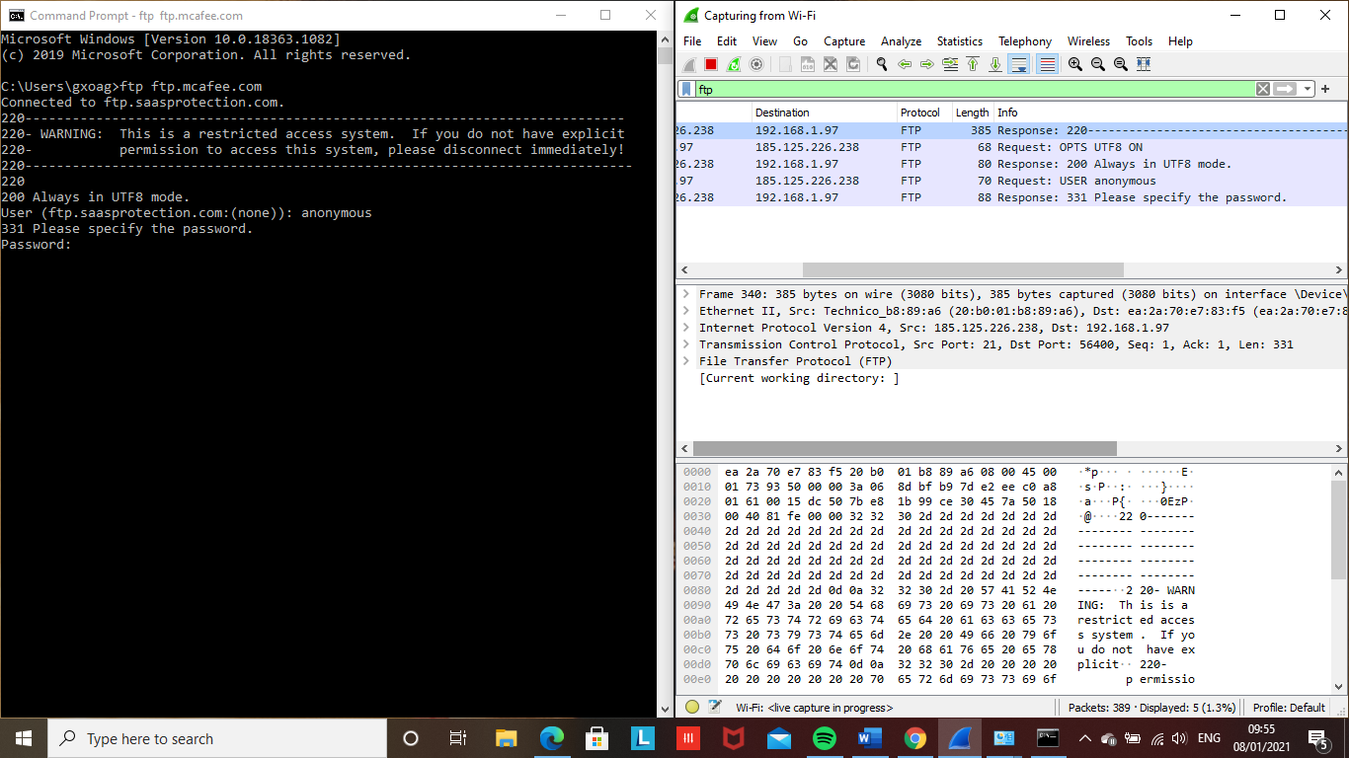
Afterwards, I switched back to the command prompt and gave login credentials. “Anonymous” is the default username used to login to this server. I entered anonymous for the user and pressed enter. On the packet sniffer, it has captured more FTP packets and you can see it has captured the username used to login. The username has now been revealed.

Last step
Lastly, in the command prompt, after giving the username it asks for the password. I typed in the made-up password and entered it. As you can see in the packet list pane, it displays the password that was given in the command prompt (PASS). The password is written in plain text giving hackers an opportunity to login to a network as an authorized user to steal information from the company.
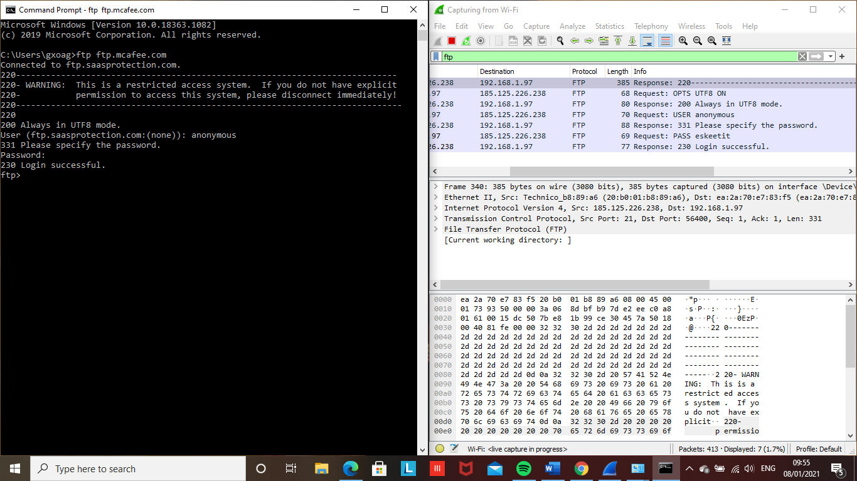

Evaluation of the demonstration
Tools and methods used in this demonstration can be used by a hacker to compromise Che-Si’s company. By using a packet sniffer tool, a hacker can monitor all packets in the entire network. It is important for employees to have a secure connection with a network and encrypt sensitive data to prevent it from leaking out. An employee can do this by using encryption protocols such as SSH (Secure Shell) and HTTPS (Secure Hyper Text Transfer Protocol) when browsing the internet and sending files. Using these protocols will make it more difficult for a hacker to retrieve sensitive data as it is encrypted.

Importance of digital signatures
What are digital signatures?
Digital signatures are an electric form of a signature. They are used to provide authenticity of a message on the internet [5]. They ensure and prove that a message has not been modified or tampered. It does this by performing a mathematical hash function and encryption. Both intended users have a public and private key to access the message. ‘The private key encrypts the data and is only available to the signer. The public key decrypts the data pertaining to the digital document and is given to the receiver’ [6]. This strengthens the confidentiality of the message as it will be hard for hackers to access.
Why are they important?
They prevent data or information from being modified from its original format meaning they provide data integrity. Companies such as Che-Si should consider implementing digital signatures in their network to prevent sensitive information stolen from cyber criminals. Only the intended users can have access to the message as both users use a public and private key to access the message.
Strategy to mitigate flaws
Having regular security training sessions with employees in the company will help them be more aware of the dangers associated with using devices in an unsecure location. Teaching employee’s security measures such as using a VPN, encryption methods (HTTPS, SSH) etc. will lower the chance of an attack on the system to take place. The employees will absorb the information discussed in the training sessions and apply it when working. Security training sessions will help ensure data confidentiality as data will be more private and harder for unauthorized individuals to access.

Conclusion
In conclusion, Che-Si’s company should consider implementing data protection methods to ensure good confidentiality of their data. The demonstration shows how easy it is to capture data packets that are in an unsecure location and to capture unencrypted packets. Regular training with employees and discussing methods about protecting sensitive data can lower the risk of hackers intruding the system.

Reference list
[1] L. Crider, “ Why is Network Security Important?”, algol it solutions, Dec. 12, 2018. [Online]. Available: https://www.algolitsolutions.com/blog/why-is-network-security-important/. [Accessed Jan. 8, 2021].
[2] J. Frankenfield, “Denial-of-Service (DoS) Attack”, Investopedia, Nov. 27, 2020. [Online]. Available: https://www.investopedia.com/terms/d/denial-service-attack-dos.asp. [Accessed Jan. 8, 2021].
[3] A. Baig, “5 Tips for Staying Safe on Public Wi-Fi Networks”, GlobalSign, Oct. 19, 2018. [Online]. Available: https://www.globalsign.com/en/blog/staying-safe-using-public-wifi. [Accessed Jan. 8, 2020]
[4] H. Gupta, “What are the Advantages of Using Antivirus Software?”, Geekflare, Jan. 21, 2020. [Online]. Available: https://geekflare.com/advantages-using-antivirus/ [Accessed Jan. 8, 2020]
[5], [6] E. Paul, “What is Digital Signature- How it works, Benefits, Objectives, Concept”, EMPTrustHR, Sep. 12, 2017. [Online]. Available: https://www.emptrust.com/blog/benefits-of-using-digital-signatures. [Accessed Jan. 8, 2020]

