Pneumatics Assignment

by Cameron Davey

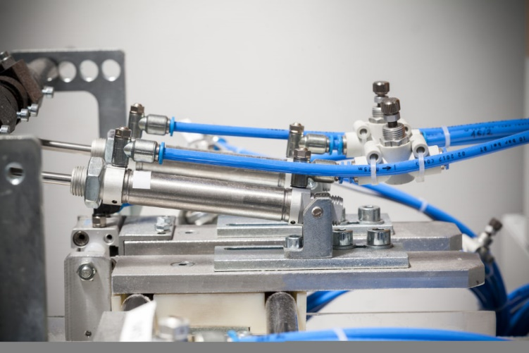

Table of Contents
Introduction Page 3
Pneumatic circuit Page 3
Flowchart Page 3
Circuit diagrams for pneumatic Page 4
Costings for pneumatic Page 6
Electro-pneumatic circuit Page 7
Circuit diagrams for electro-pneumatic Page 7
Costings for electro-pneumatic Page 8
Summary Page 9
Bibliography Page 9

Introduction
In this assignment, I have been given a task to design and implement a pneumatic circuit which will perform a certain set of functions. The pneumatic circuit will be used in a polymer processing plant that will be welding thermoplastic sheets together. The welding process requires a heating element and double acting cylinders to move it. As these will be pressing the sheets for welding for around 12 seconds, the sheets will become hot and dangerous. To prevent any injury, there is a requirement for a guard to lower before the heating element is lowered and to then rise after the heating element has retracted.
Pneumatics are used in many applications nowadays such as automatic doors and in heavy machinery. Pneumatic systems are ideal for automation within industrial environments as they allow for movement of heavy or heated elements. Pneumatic systems can be simplified further using electronic components such as relays reducing the amount of components needed in the system. Within this assignment, I will design, implement and test a pneumatic system which will then be altered into an electro-pneumatic system. The system may need fault finding if there are issues when functioning.
Pneumatic Circuit
Pneumatic circuits use compressed air from a reservoir produced using a compressor. This pressure of the air used can be low or high. As the pressure gets higher, the more dangerous this becomes as compressed air when released can cause serious injury. The pressure of the circuit that I build only requires three Bar or 43.5 psi. This circuit will conform to health and safety legislation from the HSE such as the Pressure Systems Safety Regulations 2000 (PSSR) and Pressure Equipment Regulations 1999 (SI 1999/2001) (PER). According to the HSE, ‘The Regulations apply to design, manufacture and conformity assessment of pressure equipment and assemblies of pressure equipment with a maximum allowable pressure >0.5 bar’ (HSE, Pressure Systems, The Law, 2002). When testing the circuit, I will also be wearing the relevant PPE such as safety glasses to protect me from dangerous compressed air.
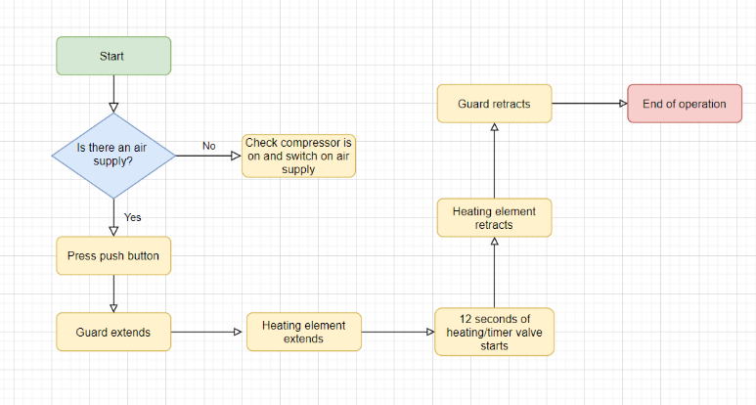
Flow Chart

Above is a flowchart showing the key process that the circuit I have built will carry out and what operation happens at each stage.
The circuit will be made up of many components varying in type. When designing the circuit, I used OFT2 to start this process. Firstly, I gathered all the components that I thought I would need. These included (assuming all these are pressure activated);
- Double acting cylinder
- Three way, double acting, directional control valve
- Air supply (compressor)
- Air manifold
- Exhausts
- Feeler directional control valve
- Three way, double acting, push button, directional control valve
- Timed directional control valve
Once I had the components I needed, I started to place them in the arrangement that fit suitably and connected the components up. This then started a trial and error process to fault find the circuit. I had to ensure all the connections were correct by testing the circuit on this software first. I found some components were not behaving as they should be, this would then highlight that I had made the wrong connection. For example, a fault would be the double acting cylinder starting in the extended position resulting in the connection from the two-way control valve being incorrect.
The cylinders are required to lower simultaneously after the guard has lowered. These will then stay extended for twelve seconds as they are the heating element. This is carried out using a timing control valve. This will slowly let pressure into the component to reach a max pressure before it lets air flow out to another component such as the control valve to retract the guard. On these components there are dials that can be rotated to a certain time that the component will wait for before operating. I will set this to twelve seconds. On the software I had to decide how much pressure it will take before operating so I had to time the circuit. This was trial and error in the fault finding process.
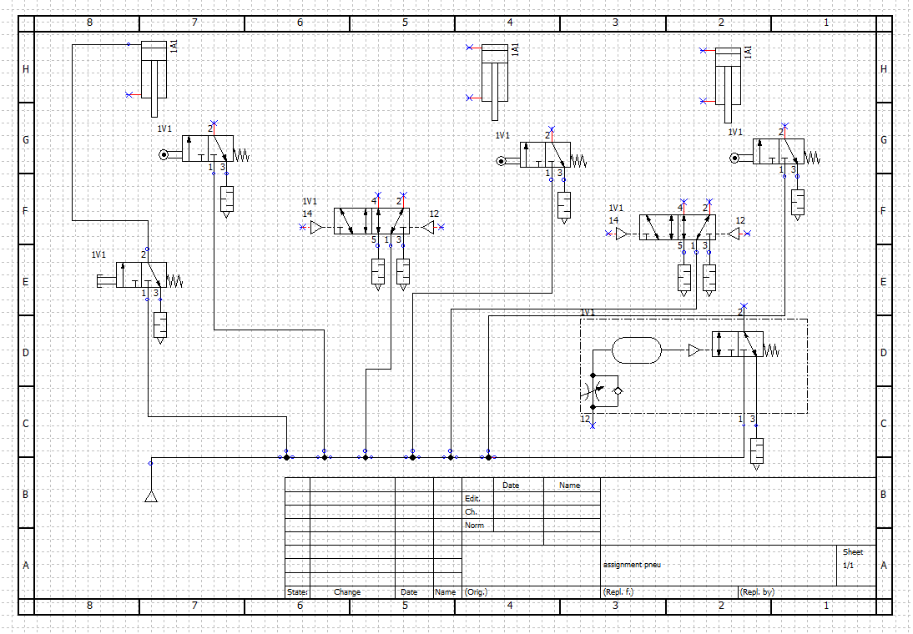

The image above represents the first pneumatic circuit that I created using the OFT2 software. This is the first draft of the circuit using most of the components required for a fully operational circuit. Here I have tested the use of T pieces to distribute the compressed air throughout the components. I found this circuit did not operate how I wanted it to with the timing aspect being hard to tune and the circuit not behaving as I wanted it to.

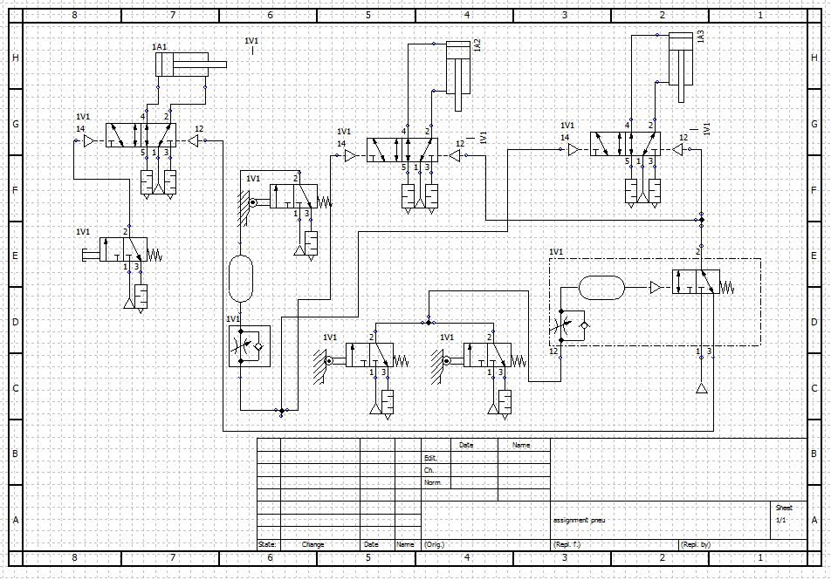

From the first draft design of the pneumatic circuit, I decided to redesign it. This was by changing connections and using two timing components. I moved the circuit around for it to fit together and changed the required pressures on each component. This then operated to the standard I wanted.

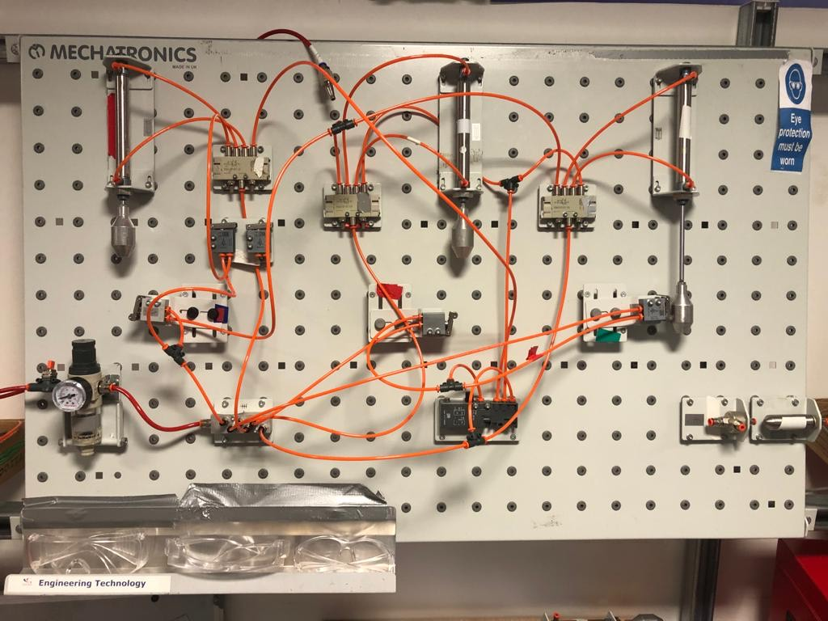

The image above is the circuit I built from the pneumatic circuit diagram I created previously. After testing, this circuit functioned and completed the task that it was required to carry out. The guard came down when it was supposed to (double acting cylinder on the left) and after this, the two double acting cylinders lower for twelve seconds providing heat. These will then retract and the process is complete. The circuit is activated by the push button control valve and continues to function using the feeler control valves. Some of the components were slightly different so I found there were faults along the way. These faults were discovered using the half split technique. This is where I would test the circuit at the halfway point. This will indicate whether the fault is in the first or second half of the circuit. From this the half of the circuit where the fault lies will be halved again or split into different parts for testing and so on until the fault is found. This is how I found that the use of a throttle valve and compressed air tank does not allow for twelve second delays or does not retract the cylinders. This resulted in the use of a timed directional control valve instead to perform this operation. The dial on this component was adjusted to find the correct time.
When building this circuit and the electro-pneumatic circuit, I wore all the relevant PPE needed when working with pressure systems such as safety glasses and protective gloves. I conformed to the Personal Protective Equipment Regulations 2002. The HSE states that, ‘Only use PPE as a last resort. You must choose the equipment carefully (see selection details below) and ensure employees are trained to use it properly, and know how to detect and report any faults’ (HSE, Risk at Work - Personal protective equipment (PPE), 2002). I was shown what to wear when working with this equipment and to always check the equipment was in good condition.
Costings
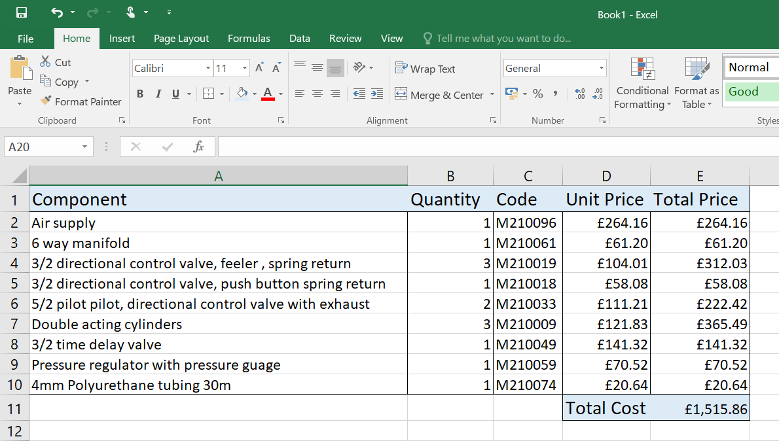

Electro-Pneumatic circuit
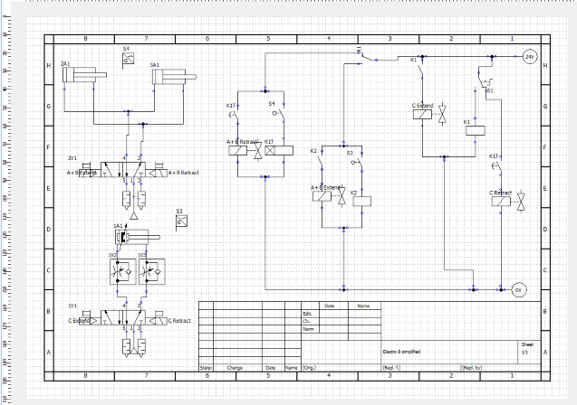

As you can see, the image above is the circuit diagram for the electro-pneumatic circuit. This circuit is built from the previous pneumatic circuit by looking at what internal operations can be replaced with electronic relays and solenoids. These kind of circuits use low, direct current, voltage to power the relays yet this is a very effective system. This circuit functions by a switch being pressed and powering relays and contacts. These components will then power solenoid directional control valves will which will allow air to flow to the double acting cylinders. The guard will extend first with the heating element cylinders following. After twelve seconds, they will retract. The timing is operated by timing relay. This is where a contact is energised and there is a delay before the relay signal is sent for the solenoid directional control valve to then send the air supply the opposite way for retraction.
The aim of using this type of circuit is to reduce the amount of components being purchased and used as electro-pneumatic circuits will reduce the number of components being used.
- The electro- pneumatic components I used are;
- Power supply
- Compressed air supply
- Electrical manifold
- Pneumatic manifold
- Electrical push button
- Electrical relay, three ways, double acting, directional control valve
- Feeler, electrical directional control valve
- Electrical relay
- Electrical timer relay
- Double acting cylinder

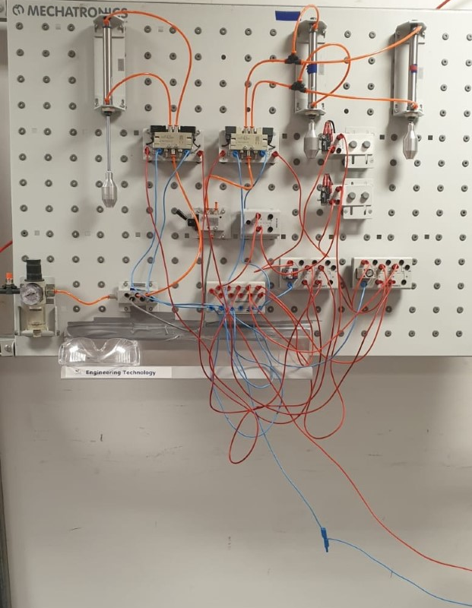

The above image is the electro-pneumatic circuit I built using the circuit diagram I designed using OFT2. As you can see, it uses more electrical components than pneumatic making the overall process simpler. The circuit uses a 24-volt DC supply. The red cables are the positive/live cables and the blue cables are the neutral/ground (0 volt) cables. I have used an electrical manifold or junction box which is powered using the electrical supply and allows the components to be powered from here. There is also a pneumatic manifold to supply air to the directional control valves and double acting cylinders.
Costings

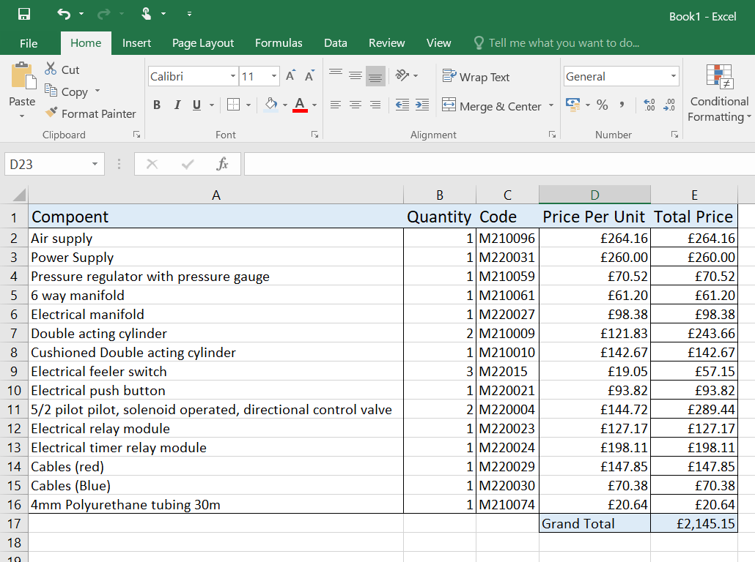

Summary
In summary, I have designed two types of circuits to accommodate the task that was required. The task was to control a heating element in a production engineering environment. A guard was required to extend protecting the heating element from people and then extending the element for 12 seconds. After this, they will retract and this process can be repeated repeatedly. I designed a pneumatic circuit to operate this criteria using valves and cylinders. Along with this, I designed a diagram, flow chart and produced a costing sheet for the components required. I then built an electro-pneumatic circuit that will carry out the same task but use electrical components instead. These components included electrical relays, timer relays and solenoid valves. This type of circuit is easier to build and requires less bulky components compared to the pneumatic circuit. There were faults along way that I found using relevant techniques to rectify. Overall, the circuits completed the required task and worked efficiently.

Bibliography
HSE. (2002, May 30th). Pressure Systems, The Law. Retrieved from HSE (Health and Safety Executive): https://www.hse.gov.uk/pressure-systems/law.htm
HSE. (2002). Risk at Work - Personal protective equipment (PPE). Retrieved from HSE - How to control risk at work: https://www.hse.gov.uk/toolbox/ppe.htm

