Marketing plan written for: BEST WESTERN UK

Student Name: MARINA MIRABELA MOCANU

Student ID number: 2215561

Marketing Essentials BMIH4005

Lecturer: LUCIANA SUARDI

Introduction
According to Davcik and Sharma (2016), a marketing plan describes a competitive position as well as describes resources that are essential for attaining a competitive edge. The hotel that is selected for this report is Best Western UK. Best Western UK is a known hotel. The business focus on improving its marketing strategies for attracting guests (Best Western, 2022a). This report will highlight the marketing plan of Best Western UK as well as describe its micro and macro environment. The purpose of a marketing plan is to ensure that activities of marketing are relevant and aid in attaining hotel objectives. Various frameworks will be highlighted in this report, like SWOT, STP, Porter's five forces and many others.

Situation Analysis

Company: SWOT analysis
Strengths  -Best Western UK have a strong brand reputation (Best Western, 2017).  -The business utilises effective marketing strategies  -Provide quality services | Weaknesses  -The preferences of guests are always changing.  -New technology implementation require huge cost, which causes financial disruption
Opportunities  -By effectively interacting with the guest through social media platforms, the hotel can attract guests.  -The business can see growth in the hospitality sector by improving its marketing strategies.  -Digital marketing can provide effective opportunities for Best Western UK. | Threats  -There are many known hotels in the UK due to which competition is a major threat to Best Western  -Various legislation and laws related to the health and safety of guests and employees are also a threat to the hotel.

Customers: Segmentation and Targeting/ Customer profiles
Todorova (2015) described that STP aids businesses in assessing their consumer segment and developing marketing communication and products for targeting consumers. Best Western UK target consumer who wants to attain a relaxed and comfortable environment either for a business trip or a personal trip. The target consumer for Best Western UK is middle to upper-class people. The hotel also provides comfort services to business travellers.
Geographic | -International and domestic people
Demographic | Age: 18 – 65  Both Males and Females
Behavioural | -Tourist  -Business People
Psychographic | -Middle to upper class  -Aspirer, Explorer and Traveller

Competitors: Porter's five forces
Buyer’s Bargaining Power | -High  - The buyer power in the hospitality sector is high due to enhance understanding of the sector and its services.
Supplier’s Bargaining Power | -Low  -The power is low as there are many suppliers present in the hospitality market.
Substitute Threat | -High  -Substitute threat is high as it is easy to imitate the services ad products that a hotel offers.
Entrants Threat | -Moderate  -There are known competitors due to which entrants' threat is medium.
Competition | -High  -Premier Inn, Marriott, and Holiday Inn are some known competitors in this industry.

Perceptual positioning maps
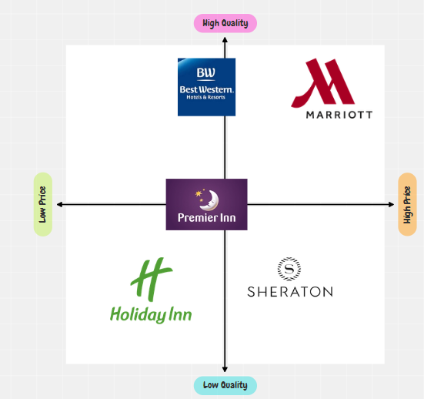

Collaborators.
- Best Western UK manage good relationship with its partners and the B2B businesses through proper communication channels and continuous cooperation (Ryrberg et al., 2017)

Climate: PESTLE
Political | - The regulations to do business in the Uk are flexible  - Government policies are supportive of the Hospitality industry (cooper, 2022)
Economical | - The GDP of the UK is stable, i.e., 3.187 trillion USD (2021)
Social | - Consumers prefer experience and luxury
Technological | - The adoption of technology is supported by the Uk government (Gupta et al., 2019).
Legal | - Laws related to employability, minimum wages
Environmental | - Strict laws for environmental issues

Objectives
According to Bjerke and Renger (2017), SMART objectives aid in providing direction and organising and attaining the goals. The SMART objectives for Best Western UK's marketing plan are:
- To attract guests and increase the share of the market by 15% by the mid of 2023
- To increase engagement of guests by 20% by utilising social media marketing by the end of 2023.
- To attract potential investors towards hotel operations and increase sales by 10% in a year.

Strategy
Best Western's current value proposition circulates around their customers' engagement with digital platforms. Further, through customers' active presence on such digital platforms, Best Western ensures that they learn about their services and book their rooms with ease (Best Western, 2020). Given that, the hotel works efficiently to evolve its customer-facing applications, for which they cater with excellence and promote the message of diversity and cleanliness. On the other hand, the hotel would propose several strategies which could strengthen its value proposition. First, Best Western is seeking to evolve its 34 core businesses application, where each of them caters to their customer's guide respectively (Best Western, 2022). They further seek to unify the application for easy accessibility. The hotel wills undergo service evolution which could enable them to deliver value faster and better. Best Western would also partner up with businesses in terms of medical resources, sports and entertainment. Such would enable the hotel to attain an audience from their partner companies' domains.

Tactics

Marketing mix:
Product: Best Western hotels offer more than 4000 hotels on an international basis, providing room services, dining facilities, resorts, spas, gymnasiums and other entertaining services. For being one of the most preferred hotel chains in the UK and other nations, Best Western values product safety and relevancy (Odeh, 2021). At the same time, the hotel requires modification and seeks to highlight health and safety policies, especially after COVID's demise. Since the customers are more vigilant in terms of sanitisation and cleanliness, Best Western would look forward to including sterilised services, often changing bed sheets and cleaning dining utensils.
Place: Best Western casters its services internationally, including the UK. The hotel chain currently possesses two distribution channels, where one includes its digital presence, and the other concerns its retailers in physical form. Best Western's available for booking services and rooms on their official website and webpages such as Booking.com. Their connected retailers also aid their clients in booking rooms (Odeh, 2021). However, during recent times after COVID, Best Western adapted to the usage of social media presence and would offer room or resort booking services through platforms such as Facebook, Twitter and Instagram.
Pricing: Presently, Best Western’s pricing tactic involves the cost of the product determined by its construction process and demand criteria. The hotel also based its pricing strategy in regards to the product’s trendiness and relevance among the customers (Sánchez-Pérez et al., 2019). Further, given the aftereffects of COVID on the hotel industry, Best Western seeks to price their general products low while pricing their sanitary and health products high. Customers would approach their sanitary products more, leading to the generation of healthy income.
Promotion: At the moment, the Best Western hotel promotes its brand image through digital or physical approaches. The hotel's digital approaches include marketing through TV, social media applications, official websites and ads on numerous web pages (Leung et al., 2017). Next, its physical presence counts its constant marketing through events, occasions and international expos. The hotel also markets itself by selling its product and encouraging its customers to spread word of mouth. Henceforth, after the era of pandemic, Best Western intends to focus its promotion through social media and, as a result, attract a younger audience.

Action
As it has been identified that there is competition in the industry and the aim of best western UK is to increase the consumer base and approach the consumers effectively. So, social media marketing would be used to acquire a new base of consumers.
The first activity would be the survey in the market to evaluate the consumers and the platforms on which our targeted consumers are available. Further, the next activity is to gather and evaluate the data which will be gathered through a survey.
Likewise, after evaluating the platforms, the teams will make social media campaigns to keep the consumers engaged and informed about the hotel services and promotional discounts. The social media channels have been selected because it is considered as most effective marketing channels (Kaur, 2016). The majority of the targeted consumers are present on these platforms. Further, the effectiveness and success of this strategy will be evaluated through the sales and the conversion rate from the social platforms.
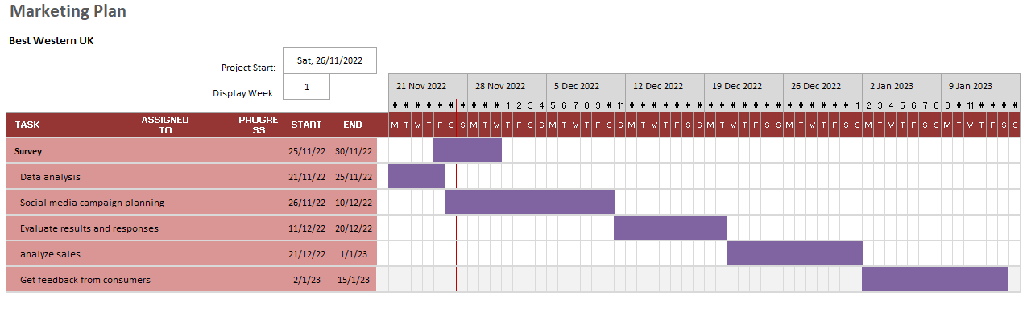
Figure 1: Gantt Chart
Sources: (Self-developed)

Control
The USP for best western Uk is the quality of the services that the Hotel offers because best western offers more engaging and efficient services and facilities for the visitors in the hotel. The major focus of best western UK is to deliver luxury and memorable experiences to their visitors because Best western is targeting the consumers who spend to get greater experiences. The targeted consumers can get a luxurious and more engaging experience during their vacations (Wijayanto et al., 2019). Along with that, they can also indulge in other activities like shopping, entertainment and spa. In order to evaluate the effective system and ensure that the company has achieved its goals. The overall sales and consumer feedback would be used.in addition to that, the positive attitude of the consumers towards the Hotel can also help to identify the success of the campaign. The acquisition of a new consumer base and its rate would also help in evaluating its success.

Conclusion
Best Western Uk is a well-reputed hotel in the industry, but the increasing competition in the industry and increased use of technology are potential threats to the hotel, and it has been identified that investing in promotional activities can help to manage the business to acquire a new consumer base. Further, it has been concluded that the best western Uk overcome the challenges through continuous analysis of the business promotional activities.

References
Best Western (2020) Best Western International® Timeline and Story. Available at: https://www.bestwestern.com/en_US/about/press-media/best-western-timeline-and-story.html (Accessed: November 26, 2022).
Best Western (2022) About best western: About us: Best western hotels. Available at: https://www.bestwestern.co.uk/company/about-us (Accessed: November 26, 2022).
Best Western 2017. Best Western® Hotels & Resorts Achieves Record-Breaking Level of Guest Satisfaction. [Online] Available at https://www.bestwestern.co.uk/company/about-us [Accessed on 26 November 2022]
Bjerke, M.B. and Renger, R., 2017. Being smart about writing SMART objectives. Evaluation and program planning, 61, pp.125-127.
Cooper, R.J., 2020. Pestle and mortal: the demise of community pharmacy in the UK. International Journal of Pharmacy Practice, 28(3), pp.205-206.
Davcik, N.S. and Sharma, P., 2016. Marketing resources, performance, and competitive advantage: A review and future research directions. Journal of Business Research, 69(12), pp.5547-5552.
Gupta, A., Gupta, N. and Gupta, M., 2019. British Airways-A SWOT and PESTLE Analysis-The impact of Europe 2020 policy. NOLEGEIN-Journal of Corporate & Business Laws, 1(1), pp.1-11.
Kaur, S., 2016. Social media marketing. Asian Journal of Multidimensional Research (AJMR), 5(4), pp.6-12.
Leung, X.Y., Bai, B. and Erdem, M., 2017. Hotel social media marketing: a study on message strategy and its effectiveness. Journal of Hospitality and Tourism Technology.
Odeh, G., 2021. Implementing Mckinsey 7S Model of Organizational Diagnosis and Planned Change, Best Western Italy Case Analysis. Journal of International Business and Management, 11(4), pp.01-08.
Ryrberg, C.M.H., Akbar, S.N. and Vej, J., 2017. Measuring the Effects of Airbnb’s Growth on Consumer Brand Perception in the Hotel Industry: A Case Study of Best Western Hotels & Resorts. Copenhagen Business School.
Sánchez-Pérez, M., Illescas-Manzano, M.D. and Martínez-Puertas, S., 2019. Modelling hotel room pricing: A multi-country analysis. International Journal of Hospitality Management, 79, pp.89-99.
Todorova, G., 2015. Marketing communication mix. Trakia Journal of sciences, 13(1), pp.368-374.
Wijayanto, H., Purnomo, B. and Ermawati, K.C., 2019. Pengaruh Kinerja Room Service Waiter Terhadap Kualitas Pelayanan Di Hotel Best Western Premier Solo Baru. Jurnal Pariwisata Indonesia, 15(1), pp.29-39.

Appendix



