PROCUREMENT PROCESS SEMSESTER 2 ASSIGNMENT
-LLOYD MITCHELL

- Given my focus on delivering the project within budget, my advice on the best procurement route to choose would be to analyse each route and apply their suitability to this project.

Traditional Procurement
Traditional procurement is a method where the client appoints a design team to fully complete the building design before selecting a contractor. Once drawings and specifications are finished, contractors tender competitively, and one is chosen to carry out the construction. This route gives the client strong control over design quality and ensures all contractors price the same information, improving cost reliability at tender stage. Standard contracts, such as those from the Joint Contracts Tribunal, are often used. However, it can be slower due to its sequential process and offers limited contractor input during design, which may affect efficiency.
A pro to this method is that between both parties a strong cost certainty can be agreed upon before construction. The cost will be affected by the quality required for the job which in this traditional procurement the client will have great access in design control as well as quality oversight. This route having a deep level of detail creates clear separation between design and construction roles which allows for clarity of responsibility between pre-construction and construction teams. As the contractors present their plan for the project before a contractor is selected, pressure is raised to present a low price while containing enough profit to make the project justifiable to take on. While not quoting a far greater price than the other companies also attempting to land the job.
However, as there is a large design process required before contractor selection this will be very time consuming all before tender. The agreed upon pricing of the project will most likely not be the final costing of the project. As construction takes place there will be many variations which will cause extra work to be completed. These extra completions of work will have to be justified to the client through PMI (Project Managers Instruction) documents. Having the clients design team for the project although beneficial, can also cause discrepancies between them and the contractor with adjustments may taking place which will need input from both parties.
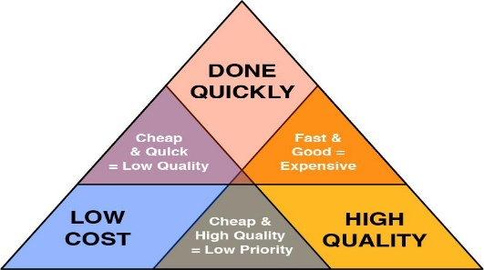
With every procurement route both the contractor and the client will use the ‘Iron Triangle’ as reference when deciding how to approach every project. The triangle refers to time, quality and cost of project. It is almost impossible to have the shortest time to complete a project without either the cost being exceedingly high or the quality taking a considerable decrease. This makes contractors consider which concern takes the clients priority

Design and Build
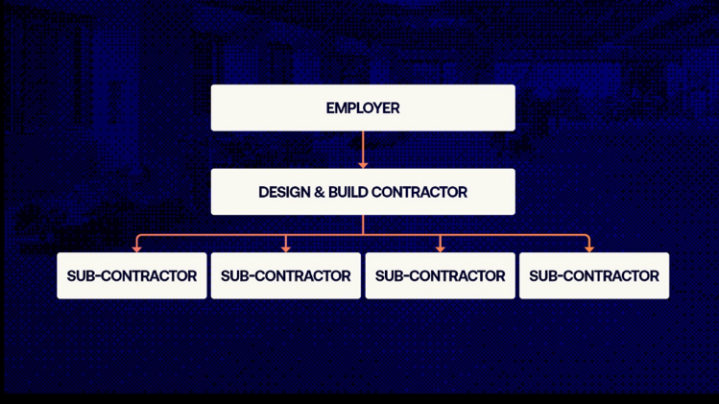
Design and build are another procurement method which the basis is that the main contractor takes responsibility for both the design and build on a project. The Contractor will have to present their estimated pricing and agree on a price with allowance of gain-share (usually around depending on the scale of the project 5%).
Instead of fully designing everything yourself first, you provide a clear brief (called Employer’s Requirements) that explains what you want the building to do, how it should perform, and the level of quality you expect. The contractor then takes that brief and develops the design before building it.
A big advantage of this approach is that there is one point of responsibility. if something goes wrong, you deal with the contractor, not separate designers and builders. It can also give you a clearer idea of the final cost earlier on, which helps with budgeting. Because design and construction can overlap, the project can usually be delivered faster than more traditional routes.
The downside is that you have less direct control over the detailed design as a client, since the contractor is managing it. There’s also a risk they may try to cut costs in ways that affect quality, especially if your brief isn’t detailed enough. That’s why it’s important to be clear about what you want from the start, otherwise you might not get exactly what you expected.
In simple terms, Design & Build works well if you want a simpler process, better cost control, and less risk on your side, but you need to be clear about your requirements and keep an eye on quality as the project develops.

Construction Management
With Construction management, you don’t hire one contractor to complete everything. Instead, you can appoint a construction manager to organise and oversee the project, while the actual building work is to be split into many smaller packages like groundworks and M&E which will each be carried out by different trade contractors. What the main difference is compared to the other methods is who holds the risk. Usually, the client directly holds the contracts between all the trade contractors, and the manager oversees them for a fee. But in construction management, the manager holds the contracts instead but overall, this route involves having multiple packages rather than a single main contractor.

Perhaps the biggest advantage of this route is speed as you can start construction before the design is fully completed. Once one of the packages designs is completed it may not have to wait for another to be designed, creating a healthy workflow with space to work on site. The flexibility this allows gives the ability to adjust designs as the project develops with unexpected challenges being interpreted into designs that may have not been completed. This will save the client both time and money.

However, the efficiency of this route comes with a price. This route gives a significantly less cost certainty as you will not have a fixed price at the start. As you gain progress on the project the final costing will become clearer. This means that you take on more risk especially at the beginning of the project. If multiple packages end up costing more than expected this will cause panic with the budget as the final price is still yet to be known. This rout will require a strong, organised and experienced team to carry out which although is good for quality of work but will also rise the staff costs.

Conclusive decision

Given the focus of delivering the project within the budget, Design & Build id what route I would advise the client to take. As stated previously, the single point of responsibility allows for easier access and conversation to be had when overseeing how the project is progressing.

Further Reasons
- Unlike Construction Management the contractor has designed the entire project preconstruction giving a cost certainty far earlier.

- It will be important to stay on top of the progress of the project to ensure that quality is kept to a high standard.

- The flexibility of D&B plays a part in my reasoning choosing it over traditional. With the contractor designing and building the entire project it allows the contractor to have further understanding of implementing the designs. I believe this will also cause less friction between both the client and the contractor.

- Along with this method, yourself as the client will have to retain a strong advisory team including roles such as Quantity Surveyors to manage cost and quality throughout the duration of the project.

2) Considering the above, provide advice on the type of tendering process that should be used with justification?
Given how much information has been given in the brief along with the consideration of what tendering would best suit Design and Build, I have decided to advise on using two-stage tendering for this project.
Two-stage tendering is used to allow a contractor to be selected early on, before all the required information is gathered. In the first stage the contractor is selected based off their reputation, team and initial pricing approach. Once selected, client and contractor will work together during preconstruction to develop a design and a rough idea of costing for the project.
The second stage once the design is near completion a final contract sum can be agreed upon which will later move into the construction phase.
The 2 stages help prevent both higher initial prices and claims and variations later in the project because the price had been agreed during development of the design when there was more information to base prices of.
The collaboration of both parties and their teams will help identify gaps and mistakes within the design and are able to correct it prior to a final agreed price is issued.
However, as always there are risks that are involved in this tendering method. At the beginning of the design price certainty will be very limited as there is little to no design information to base the pricing. But this can be monitored by setting a clear price cap and sticking to it.
Choosing one contractor to help throughout the process may put too much reliability than the client would like on the contractor. But this is why the 2 stages are both crucial, in the first stage clear agreements along with clear exit provisions can and should be made to prevent binding contracts causing the fall of this project.

References
Two stage tender-Two-stage tender - Designing Buildings- https://www.designingbuildings.co.uk/wiki/Two-stage_tender

D&B- Design and build procurement route - Designing Buildings-https://www.designingbuildings.co.uk/Design_and_build_procurement_route

Traditional- Traditional contract for construction - Designing Buildings- https://www.designingbuildings.co.uk/wiki/Traditional_contract_for_construction

Construction Management-Engineering Procurement and Construction Management Contract - Designing Buildings- https://www.designingbuildings.co.uk/wiki/Engineering_Procurement_and_Construction_Management_Contract

