Use and Integration of Sustainable Practices

Student Name: Gabriel Ivanof
Student ID: 2119317
The assignment title: Planning and Delivering an International Meeting/Event.
The module title: International Meetings Management BMIH6007
Name of the Lecturer: Philippa Fitzgerald

Introduction:
This report aims to analyze the strategic planning and delivery for supervision to manage and create an event that is based on sustainable practices for the MICE industry inside the hospitality industry. MICE tourism is constructed as meetings, incentives, conferences, and exhibitions altogether. Hence, the event that is being planned will be taken forward based on the sustainability practices that will be further used by businesses to perform business operations in the sector. Thus, the primary aim of the report will be to focus on the evaluation of the event cycle to understand the concept of the event in a detailed way. Considering this, the report will be analyzing the estimations and costs considering industry trends and their impact on the businesses by focusing on the cultural and situational considerations at 41 Portland Place in the United Kingdom. Since the event is focusing on the use and integration of sustainable practices, the report will cover the sustainability practices that will contribute to the business towards achieving the business goals (Ahmad et al., 2021).

Figure 1: Sustainable practices
(Source: environmentalscience.org, 2024)
The Event Cycle:
The event cycle is a framework to lead the business towards achieving sustainability. Thus, in the event cycle conceptual framework, there are a total of 5 stages that lead the business to achieve sustainable development and accomplish business goals. Hence, these stages involve planning, organizing, measuring, analyzing, and sharing. Therefore, to plan and run the business or any event successfully, it is very essential to have a good plan that reflects on the plan of action and set of activities to maximize the engagement of people in the event or enhance the business profit through the event. In addition to this, the event cycles deal with these 5 stages on a primary level to gain success and focus on encouraging actions taken to perform a successful event and to reach the goals of the event that are set in the early stages of the event in more depth (mdpi.com, 2023).

Figure 2: The Event Cycle
(Source: created by learner, 2024)

Plan:
The very first stage of the event cycle is planning. Since every event is developed based on the event cycle; the planning is based on the event plan of the previous event.
Therefore, in this stage, the outcomes and primary findings from the earlier event cycle are analyzed and the new goals are set to justify the new event cycle with the help of designing the coping mechanism based on new targets and objectives as well. Thus, the planning stage involves resetting the target and identification of a perfectly suitable audience for an event considering realistic estimations or budget and costing. For this event of using and integrating sustainable practices, the planning stage also helps in deciding the location for an event, which is, 41 Portland Place in the United Kingdom.

Organize:
The stage of organizing involves the organization of the event on either online or offline platforms. In this stage, the event is taken on the onsite location or online landscapes, and pre-event, as well as post-event steps related to the marketing of an event, are taken during this stage so that the right audience group will be attracted.

Measure:
In this stage of the event cycle, the event will be assigned the Experience Value Score (EVS) so that the event can calculate the value it perceives. Hence, this measurement for the event value also helps the event to receive feedback from the realistic participants of an event and eventually leads the event to evaluate the Key Performance Indicators (KPI) of an event.

Analyze:
The analysis stage helps to analyze the event based on the designed aim and outcomes if they justify the set event objectives or not. Hence, in the analysis stage, the Experience Value Score and participant’s feedback are analyzed.
Share:
During the sharing stage, the key discussions and important findings are analyzed to work on understanding the plan of action and expect the event planners to alter how they are running the events if necessary.
Therefore, to design and plan the utilization and integration of the sustainability practices for the event to achieve sustainability; it is very essential to plan this event that revolves around these stages in the event cycle and justifies the sustainability sphere as well. Since, the sphere of sustainability has three aspects that include economic, environmental, and social factors; every event needs to satisfy the needs of is three aspects of the sustainability sphere. Thus, the event will primarily focus on achieving environmental sustainability as it is the most expected plan of action for the success of an event activity to run smoothly which might get help from innovation policies (AlTaweel and Al-Hawary, 2021). In addition to this, the gaps in these three spheres of sustainability require understanding the integration of social-environmental, environmental-economic, and economic-social aspects between the spheres of sustainability. Since strategic planning and delivery play very integral and viable part in shaping the use and integration of sustainability practices for an event; the operations and event concept are also important to perform detailed retrospection on the event theme and idea behind the implementation of the event by considering event cycle (researchgate.net, 2015).
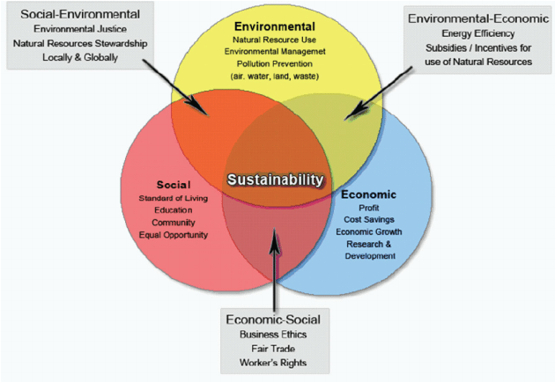
Figure 3: Three Spheres of Sustainability (Source: reserachgate.net, 2015)
The Event Concept :
The concept of the event reflects on using and integrating sustainable practices in the business event to achieve sustainability and enhance the overall business performance. The concept of an event deals with defining the goals and objectives of the event and measuring the percentages of the growth and success rate for the event.
The event concept helps in attracting the target audience and creating a very productive and creative environment for participants as well so that they can get a very memorable and good experience (forbes.com, 2023). Hence, it is very essential to develop and design a strategic sustainable plan and deliver it to participants to make it easy for them to coordinate with event experts as well. Furthermore, the concept of an event primarily helps in determining the mission and vision of the event so that it will be easy in the future to decide the event objectives and formulate the strategy while dealing with attracting the targeted audience. Taking the hospitality sector into consideration, it is very necessary to understand the concept of an event so that it would be beneficial to focus on the participants that will be the primary support for an event to be successful. In addition, designing a detailed strategic plan is necessary to manage and create an event around sustainable practices and utilize sustainability practices in the event by implementing and integrating a sustainable environment is practiced in this event concept.
In addition to this, it is very important to understand the event concept as it is the major factor in attracting the right group of participants to contribute to an event. The primary aim of the event concept is to understand the aims and observe by measuring the Success sectors for instance, the event concept focuses on the MICE industry inside the hospitality sector. Therefore, this event must understand the importance and significance of incentives, meetings, exhibitions, and conferences. Since the event aims at improving business performance through accomplishing sustainability it is very necessary to focus on business operations with an improved and enhanced approach towards obtaining a sustainable balance between internal activities at the event (researchgate.net, 2015). Henceforth, the evaluation of operational as well as financial factors that include retail market analysis is also performed to manage this event for the MICE industry at 41 Portland Place, London in the United Kingdom. Thereafter, from many marketplaces to convey the event concept across the United Kingdom for determining the percentage of success that will be gained, it becomes essential to focus on various factors like supplier demand, competitiveness, and target market which may affect the concept of the event on crucial levels (Sołoducho-Pelc and Sulich, 2020).
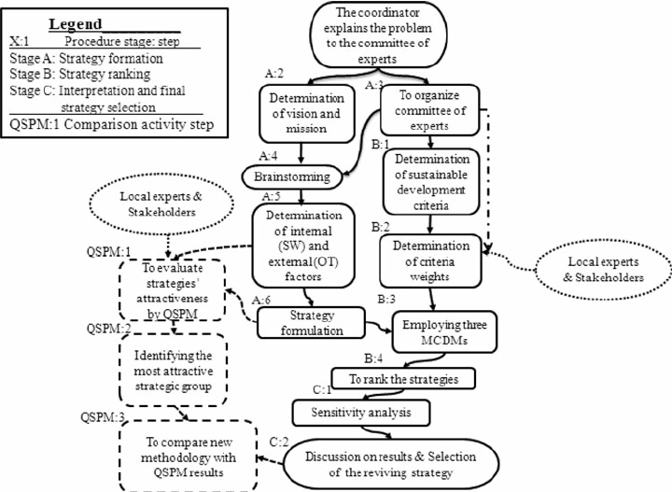
Figure 4: Strategic Sustainable Plan Framework
(Source: researchgate.net, 2015)
Hence, to perform the event, strategic planning and delivery are necessary to gain sustainability. The primary benefits of use and integration of sustainable practices for an event rephrase their enhancement of already obtained benefits as well. In addition to this, the integration and utilization of sustainable practices in an event concept drives an entire event towards more optimization and the process becomes very prompt to pore over the internal activity of events by helping the project managers as well. Furthermore, streamlined operations are easily performed with the use and integration of sustainable practices and tend to reduce the amount of waste from an event by providing efficient resources to achieve less cost consumption and decrement in the environmental effect by achieving sustainability through the event.

Aim and Objectives of the Event
Aim of the event:
To achieve sustainability through the use and integration of Sustainable Practices by planning, organizing, and hosting the event at 41 Portland Place, London, UK with the help of a strategic plan and successful delivery.
Objectives of the event:
- To understand the target market and participants for an event
- To utilize sustainable practices to conduct the event successfully
- To analyze the significance of strategic plan and delivery
- To study the importance of sustainable practices through their integration into an event

Event Operations:
Event operations are necessary to manage the internal activities inside core departmental levels. The primary responsibility of the event operations is to coordinate and integrate the internal operations by giving justification to the event and the selected location. In event operations, the managers of the event operation take the responsibility to assist the event planning and perform the event organization by hosting the cities across the UK, for instance, for an event using and integrating sustainable practices, the selection of venue is 41 Portland Place, London. Therefore, to deal with assigning the planning and delivery-related tasks. Henceforth, in the event operations, the managers of the event and every other individual included have common goals like accomplishing the success of the event, achieving decided objectives and the event aims as well as acquiring the expertise in the event by the strategic implementation of the process to conduct the event successfully (environmentalscience.org, 2023).
In addition to this, an event operation requires exploring the capacity of an event and performing the power management procedures to achieve sustainability in the event. The mainstreaming of the operations is performed through event management if the necessary actions are promptly taken and internal activities are performed with detailed focus. Furthermore, the implementation of event operations in a successive manner is possible with a detailed strategic plan and delivery of that plan to practice and achieve sustainable practices during an event. Hence, it is very necessary in event planning to practice certain steps to gain sustainability which mainly includes the cost-cutting of an event budget and estimation that is accomplished through the detailed strategic approach and plan and delivery of the event requirements. While ensuring the smooth operations of the event various skills can be necessary. These skills can also be crucial while ensuring that top quality of experience is provided to the guests of the event. One of the most important skill which can be required while managing this event can be inter-personal skills (Baker et al., 2021). With the help of interpersonal skills effective communication with the guests can be ensured. Effective communication can ensure that no issues or challenges arise during the event due to miscommunication.
Furthermore, other skills which can be essential for this event can be management, leadership, and many more.

Event budget:
A total of $100,000 can be required while planning this event. Out of the $100,000, $95,000 would be fixed expense while the $5000 can be placed as a fluctuating or emergency expense. While raising the required amount of funds for this event the use of crowdfunding will heavily done. Other sources of fundraising which could be used can be donations from individuals, organizations or governing bodies. All these fundraising techniques can prove to be beneficial while raising the required amount of capital for the event.

Industry trends:
The topic of sustainability and the integration of sustainable practices is currently trending in the MICE industry due to the rise in the amount of environmentally conscious individuals around the world (Ramely et al., 2022). This event can be used as a vital introduction for conducting more events based on the same topic of sustainability and how these practices can be used by businesses across all industries. This event can also be further linked to trending environmental topics such climate change and global warming. Overall, the event can have a wide range of positive future implications.

Cultural and situational considerations:
Various cultural and situational considerations have to be contemplated while planning this event. As the event will host individuals belonging to different cultures and races, special attention has to be paid to ensure that no discriminatory activities take place during the event. This cultural consideration can be important while planning the event. During the event, ensuring that no individuals get hurt or offended by the perspectives of others. This consideration can largely boost the experience of customers. To effectively implement these considerations, formulating a proper code of conduct can be key.

Conclusion:
In the conclusion part of the report, the focus of the report is on using and integrating sustainability to plan, organize, and conduct the event successfully. Thus, through this report, the importance and significance of sustainability is addressed. In addition to this, the report has also analyzed the strategic planning and delivery through sustainable practices along with the evaluation of the event cycle to understand the concept of events through in-depth investigation of event operations as well.
Furthermore, the budget and overall event costing that is required to organize and successfully conduct this event are examined by focusing on the cultural and situational considerations investigated in this report.

References:

Ahmad, N., Mahmood, A., Ariza-Montes, A., Han, H., Hernández-Perlines, F., Araya-
Castillo, L. and Scholz, M., (2021). Sustainable businesses speak to the heart of
consumers: Looking at sustainability with a marketing lens to reap banking consumers’
loyalty. Sustainability, 13(7), p.3828.

AlTaweel, I.R. and Al-Hawary, S.I., (2021). The mediating role of innovation capability
on the relationship between strategic agility and organizational
performance. Sustainability, 13(14), p.7564.

Baker, F.R., Baker, K.L. and Burrell, J., (2021). Introducing the skills‐based model of
personal resilience: Drawing on content and process factors to build resilience in the
workplace. Journal of Occupational and Organizational Psychology, 94(2), pp.458-481.
environmentalscience.org, (2023)
[Online] Available at: https://www.environmentalscience.org/sustainability
[Accessed on 01st Feb 2024]
forbes.com, (2023) [Online] Available at:
https://www.forbes.com/sites/forbestechcouncil/2023/08/03/20-sustainable-practices-to-
help-businesses-and-tech-teams-go-green/ [Accessed on 01st Feb 2024]
mdpi.com, (2023) [Online] Available at:
https://www.mdpi.com/journal/sustainability
[Accessed on 01st Feb 2024]

Ramely, A., Talib, M.F.A., Radha, J.Z.R.R.R. and Mokhtar, M.F., (2022). Green event
practices: Understanding the adaptation of event organisers through a systematic
review. Malaysian Journal of Sustainable Environment, 9(1), pp.119-140.
researchgate.net, (2015) [Online] Available at:
https://www.researchgate.net/figure/Strategic-Sustainable-Planning-Framework-SSPF-
flowchart-stages-and-steps-solid_fig2_273257488 [Accessed on 01st Feb 2024]
researchgate.net, (2015) [Online] Available at:
https://www.researchgate.net/figure/The-
three-spheres-of-sustainability_fig3_274025882 [Accessed on 01st Feb 2024]

Sołoducho-Pelc, L. and Sulich, A., (2020). Between sustainable and temporary
competitive advantages in the unstable business environment. Sustainability, 12(21),
p.8832.

