ASSESSMENT 2
ENTREPRENEURSHIP

Stefan Gheorghe-2024473

Entrepreneurship – LCBB 5001
Lecturer Dr.John-Paul Okeoma Okeke
University of Wales Trinity Saint David
30.08.2022

BUSINESS PLAN – GO VEG PARADISE

BUSINESS DESCRIPTION / MARKET OPPORTUNITY
Our mission at “Go Veg Paradise” is to establish a restaurant business that makes available a wide range of healthy meals at affordable prices to the residents of Basildon and the surrounding areas, and to other cities of United Kingdom where we intend to open a chain of vegetarian and vegan restaurants. Our vision is to become the leading vegan restaurant in major cities of UK and bring health and smiles to our customers. The tagline presented in our store, and future stores, is “Eat healthy, live long and prosper!”. This is aimed at leaving customers with a lasting positive impression of the brand imagine we want to create. We intend to protect our intellectual property by obtaining a trademark for the custom-made recipes and tagline words and logo. We also intend to copyright the description of how the restaurant looks and how it operates.
The business will start as a Private Limited Company (LTD) and after the first year in operation will seek partnership from other investors that see value in the business idea.

INDUSTRY ANALYSIS
The restaurant will operate in the food service industry, which has seen a period of steady growth in revenue between 2008 and 2020, prior to the COVID-19 outbreak (Fig.1). The turnover generated in 2020 was in amount of 33.7 billion British pounds, which reflects a decrease from 2019, when the turnover was 42.1 billion pounds (Lock, S.- Statista, 2022). The uncertainty of Brexit and the pandemic, along with rising costs and an over-saturated market has caused a decline in revenues and saw a rise in churn of businesses. By differentiating our products and service offered and by targeting a niche market, we can create a competitive advantage over our rivals that can provide financial sustainability and prospective growth.
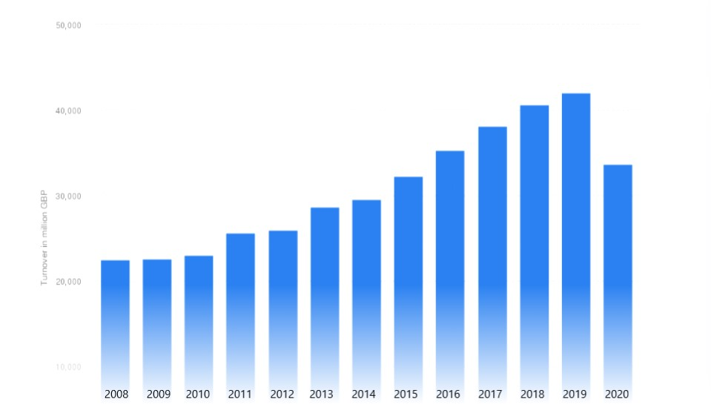
Fig.1: Source: (Statista, 2022)

Threat of new entrants – Any entrants to an industry add capacity that will reduce the profitability of that industry. Since we are the only vegan restaurant in Basildon, we have a first mover competitive advantage, that can increase brand awareness faster and gain consumer loyalty. The long-term benefit of being a first mover is that it can create high barriers for potential new entrants. Another factor to consider can be the moderate level of investment, making it easy to enter the industry. New entrants must regard the high fixed costs and operating costs involved, and make sure that they can achieve a cost advantage (Hill & Jones, 2014), either by buying in bulk or obtaining discounted prices from suppliers. From all the above points we can say that the threat of new entrants is moderate.
Threat of substitutes – Force is very high as our products are meat-free and can easily be substituted by the well know and established meat products offered by our competitors. Considering that switching costs are low, we can reduce the risk from substitutes by employing consumer loyalty programs and aggressively expanding our marketing strategy. We can create an operational plan that offers consumer experiences that are in accordance with their expectations.
Bargaining power of customers – Customers hold the power to influence our company pricing decisions, so the industry is affected by choices and switching behaviour of our buyers (Adhikari & Rao, 2013). We need to offer our services at a competitive price that will create value for our customers and protect our profit margin. The customers choices and expectations increase their bargaining power until it becomes a threat to our business.
Bargaining power of suppliers – The size of the restaurant is a determining factor when establishing the power of suppliers. Our restaurant scale can afford to order in bulk and negotiate better prices. But not all suppliers have equal measure of bargaining power, as common ingredients can be purchased from various suppliers, meaning low power in bargaining, while more specific ingredients needed for daily operations may have a limited number of suppliers, meaning power is high. Overall, the bargaining power of suppliers is high and presents a threat on profitability.
Competitive Rivalry: According to a 2022 survey (Fig.2) of restaurant brands in the United Kingdom, Greggs had the highest rating among the British public, with 74 percent having a positive opinion of the brand. Pizza Express, KFC, Pizza Hut, and Costa Coffee were also rated among the top five brands (Lock, S.- Statista, 2022). The competitor list cannot be limited to just this statistic, it must be expanded to include all direct competitors and indirect competitors, some of which have a well-established brand image.
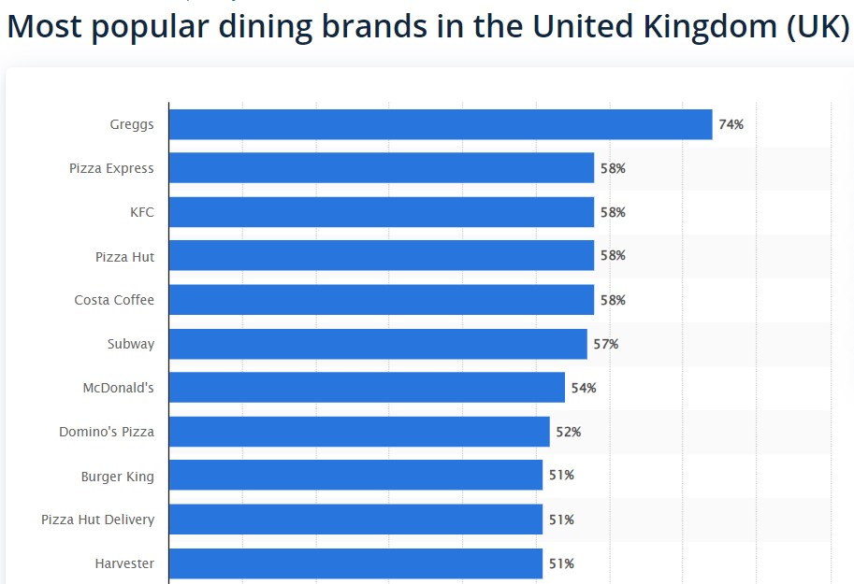
Fig.2 Source: (Statista, 2022)

Name of competitor | Differentiation
Greggs PLC | Healthier products that address a specific target group. Table service offered at higher standards.
McDonald’s  and K.F.C. | Lower prices than competitors’ meat-based products; Higher service quality offered at table.
Deniz-Turkish restaurant | Lower prices than competitor, healthier products, and higher target market.

OPERATIONS AND MANAGEMENT TEAM OPERATIONS
The basis of differentiation from our competitors is that we can offer healthier food at convenient prices and offer high quality customer service. This is the main reason why we believe that consumers will choose our venue to either dine-in or place delivery orders. Based on research made regarding trends in consumption of how often people eat-out (Fig.3), we can target Generation Z and Millennials as our target market, since these are more inclined of following a meat-free diet or trying new experiences.
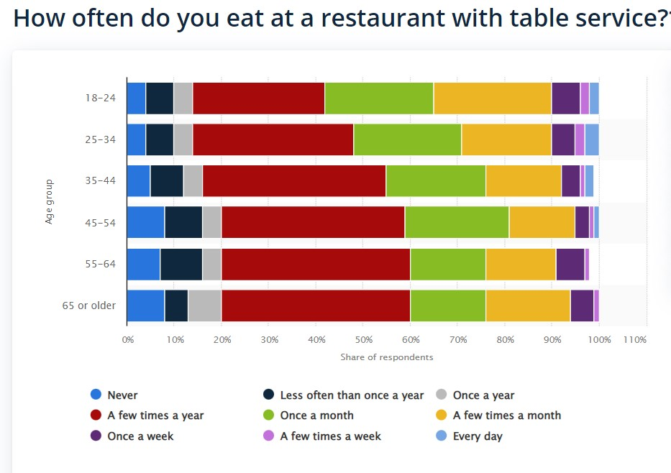Fig.3 Source: (Statista, 2022)
We believe that the type of restaurant that will suit our target market will be a contemporary casual restaurant type, which is characterised by the modern flair, energetic vibe and innovative dishes and drinks that it brings to customers. A specific and unique interior design that promotes a balance between nature and human activity is what the restaurant will promote. The interior will be made from sustainable, environmentally friendly materials with a combination of self-sustained plants that will create a pleasant atmosphere.
To achieve the proposed objectives the company will need several strategic key partners, resources and activities. The most important key partners will be the suppliers of meat-free groceries and vegetables, drinks, and the financial partners. We can buy vegetables from local farmers, with which we have bargaining power, but the meat-substitutes can only be bought from a few companies that provide them at convenient prices and who have bargaining power over us. There are several local farms like Barleylands Farm, Foxes Farm and The Green Barn Farm that can supply us with fresh vegetables at competitive prices. The meat substitutes can be bought from Vegan Wholesaler, based in London, or from VeganStore Wholesale, which is the largest independent distributor of vegan products. We don’t have much bargaining power, but we can negotiate better deals for larger volumes of orders.
The key resources are the assets of the company that will support in creating value for our customers. We have the physical resources that include the rental location of the restaurant, which is close to a new cinema venue, the interior designing products as well as the equipment used. Another key resource is represented by staff, which will be comprised of 2 chefs, 4 kitchen helpers, 4 waiters, all of them with experience in vegan or vegetarian diets, 2 bartenders and 2 cleaners. The management team is also another key resource for the company which will bring invaluable expertise and knowledge of the operations and marketing strategies to follow.
The key activities of the business resumes to the food and service provided. The products of our restaurant will be quality fresh vegetarian or vegan dishes. Our menu will focus on providing a wide range of products from various recipes. We will be serving lunch and dinner food and our customers will have to select foods from the menu and order them with one of the waiters. To make the ordering process easier we installed on all our tables a small device that can be used by customers to gain attention when needed. All our food comes with an attached barcode that can be scanned with the CronoMeter App and display the nutritional values of the food ordered. We also encourage customers to install this app and monitor the calories and macronutrients consumed each day. As payment for the service customers have the option of paying by mobile devices, QR code, or P.O.S. A wi-fi network will also be provided to all customers. For the home delivery system, we will partner with several well-known providers, where customers may place their orders. We will be also offering a special service by which we sent the customer the ingredients and simplified recipe for them to cook at home. This service addresses those that want to eat healthy food but don’t have the time to visit a restaurant, or they prefer to cook with family.
The revenue stream will be mainly composed by the in-restaurant sales and by the delivery service sales, which we can improve by offering incentives to customers, either in the form of discounts, loyalty programs or meal kits. We could also sell our data to statistics companies for a fee, offer to cater some exclusive events that apply to our specific business, and organise some indoor events to attract more customers. The revenue stream is based on a fixed pricing mechanism as all prices are set in menus for consumers to pay. Considering that our location has 10 tables of 4 and 5 tables of 2, which results in a total number of 50 seats, and that we are opened Monday to Thursday from 14:00 to 22:00 and Friday to Sunday from 09:00 to 22:00 (Appendix 1), we can make some forecasts of the expected gross revenue. On average we expect to gain a revenue of £25 per seat occupied, £18 from foods and £7 from drinks. We aim at a gross profit margin of 70% and a net profit margin of 5%. We forecast that the labour costs will be 30%-35% of total revenue and that the cost of goods sold will be at 30% of gross revenue, with another 30% of gross profit going on overhead expenses. The figure below shows some calculations of costs of labour force, as well as forecasts of gross revenue expected.
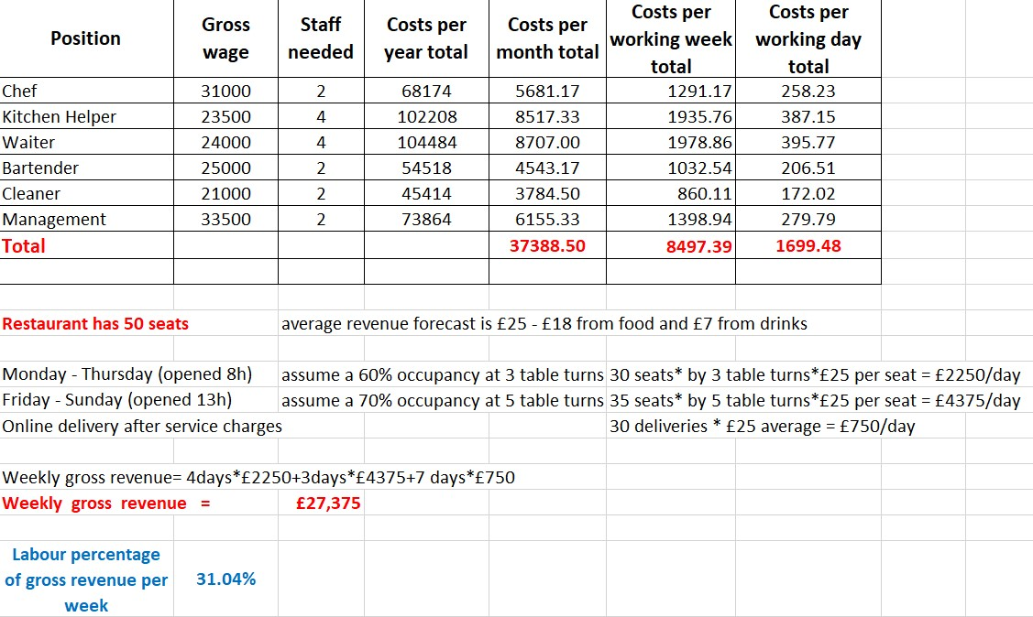
All wage costs include PAYE tax and N.I. company contribution
MANAGEMENT TEAM

Name | Skills | What do they bring to the firm
Stefan Gheorghe | - Leadership  - Communication  - Positive attitude  - Problem-solving  - Attention to detail  - Flexibility | - The ability to foster a team orientated environment which can help reduce one of the biggest problems restaurants faces: high staff turnover.  - Good communication skills that are useful in a fast paced and stressful environment, also good problem-solving skills will play a major role in day-to-day operations  - Always having a positive attitude can inspire others to be more supportive and create a happy atmosphere.  - Flexibility is always important in managing budgets, inventories or staff members.
Colin McRae | - Marketing  - Financial  - Decision making  - Visionary  - Numerical Skills | - As administrator of the restaurant, Mr. McRae will be in close contact with the accountant and the bank accounts of the company  - He will also take charge in the recruitment process, payroll, daily earnings and marketing strategies.

MARKETING:
Product: Our products will be represented in the form of a menu. The products will be described containing as much detail as possible, without leading to over information. Each of our menu item will have a detailed managerial sheet in which we add all the required ingredient to produce it. This way we know what items we need to order and in what quantities, leading to a better cost management and reduced waste.
Price: Our pricing strategy is based on a fixed priced mechanism. Knowing our costs for the ingredients required we can calculate a cost of goods sold and add that to the specific gross profit margin we want to achieve, in our case being 70%. More explicit, if our costs of producing an item on the menu, referring only to the ingredients, is £3 then our sale price will be £10. Maintaining a low cost on factors of production should be a priority as this way we would be able to offer competitive prices for our customers.
Promotional Mix: The primary aim of this is to increase awareness about the products and services our company offers. We can do this prior to the opening of the restaurant by offering samples of our products in places where the target market congregate. Also, a web site with a restaurant reservation tool is essential in our marketing strategy. This can be build using third-party help and we can spread the costs by paying a low monthly fee of £10. We can use social media presence on Instagram, Twitter and Facebook, as well as the in-trend TikTok. Having an active account in which we post information about our restaurant and representative pictures each day can increase the awareness and presence of our business. We could also seek the assistance of local influencers that can help us promote ourselves. To increase the presence of customers on slower days like Mondays and Tuesdays, we could organise some live entertainment that would appeal our target market and other demographic groups. Overall, we should have a specific budget each month for using promotional strategies, like £2.000 revised at every 6 months.
Place (Distribution strategy): We can use a third-party delivery service like: Just Eat, Deliveroo or Uber Eats, to distribute our products to the customers that cannot or are not willing to visit our physical location. The restaurant will be located in the premises of a new cinema venue called “Empire Cinema”, which we believe will provide a perfect location for targeting our customers.
FINANCIALS
Sources of funds: The start-up costs for the restaurant are estimated at £150.000, and the sources of funding will be represented by a personal investment of £50.000 and an unsecured business bank loan of £100.000 from Barclays Plc., secured at an interest rate of 4.5% for a term of 60 months. We have also obtained a six-month repayment holiday at the start of the loan, with the interest rate being accrued and included in the repayments. The monthly repayment will be £1.860 per month and the total amount repayable will be £111.612.
The funds acquired will be spent on premises costs, which will include the property charges of the estate agent and the surveyor hired to compile the energy efficiency report for the property. We will also need to pay a deposit of £10.000 for the property, and the first month rent of £3.000 in advance. We need to think about the legal charges, licences and permits to operate the restaurant. A solicitor can be hired to make the process easier, but this will cost us an average of £100 per hour of consultation. The renovation and decor will be outsourced and will cost us an estimated £20.000, as the materials used for this are all recyclable. The cost of the kitchen equipment is estimated at £30.000, as only the most important equipment is going to be purchased as new, the rest will be purchased at second-hand value, thus reducing our costs on the short run. Before opening we will need insurance for the restaurant premises but also for public, contents, stock and employee liability insurance. The estimated costs for all the insurances are between £1.100 and £1.200.
Technology plays an important role in the management of a restaurant and a point of sale (POS) is necessary. The hardware cost is estimated at £800 per unit, and we need 2 of them, while the monthly maintenance fee is about £100. We will also need mobile payment terminals with costs varying around £50 and a transaction fee of 1.5%.
The marketing expenses are fixed for the period at £2.000, that includes the website creation and maintenance, social media presence and the organisation of special events. This expense is believed to provide a long-term competitive advantage and increase brand awareness.

Use of funds

 | Month 1- June | Month 2- July | Month 3-August | Month 4-September | Month 5 - October | Month 6 - November
Revenue | £109.500 | £ 114.450 | £ 112.800 | £ 115.655 | £ 114.850 | 115.760
Fixed Costs  Property charges  Deposit  Rent –every 3 months  Building insurance  Licences and permits fees  Insurance coverage  Renovations and decor  Kitchen equipment  Waste management  Technology costs  Marketing expenses  Business rates  Loan repayment | £ 2.000  £ 10.000  £ 3.000  £ 1.000  £ 2.000  £ 120  £ 20.000  £ 30.000  £ 100  £ 2.000  £ 2.000  £ 1.000  - | -  -  £ 3.000  £ 1.000  -  £ 120  -  £ 1.000  £ 100  £ 800  £ 2.000  £ 1.000  - | -  -  £ 3.000  £ 1.000  -  £ 120  -  £ 1.000  £ 100  £ 800  £ 2.000  £ 1.000  - | -  -  £ 3.000  £ 1.000  -  £ 120  -  £ 1.000  £ 100  £ 800  £ 2.000  £ 1.000  - | -  -  £ 3.000  £ 1.000  -  £ 120  -  £ 1.000  £ 100  £ 800  £ 2.000  £ 1.000  - | -  -  £ 3.000  £ 1.000  -  £ 120  -  £ 1.000  £ 100  £ 800  £ 2.000  £ 1.000  -
Variable Costs  Staff wages  Cost of goods sold  Utility bills  Waste  VAT 20% | £ 37.388  £ 33.112  £ 750  £ 500  - | £ 39.588  £ 34.335  £ 770  £ 400  £ 21.900 | £ 39.588  £ 33.832  £ 765  £ 350  £ 22.890 | £ 39.588  £ 34.702  £ 755  £ 400  £ 22.560 | £ 37.388  £ 35.768  £ 1.150  £ 350  £ 23.131 | £ 39.588  £ 34.582  £ 1.250  £ 300  £ 22.970
Profit before tax | £ -35.470 | £ 8.437 | £ 6.685 | £ 8.630 | £ 8.043 | £ 8.050
Corporation tax 19% | - | £ 1.603 | £ 1.270 | £ 1.640 | £ 1.528 | £ 1.530
Net profit | £ -35.470 | £ 6.834 | £ 5.415 | £ 6.990 | £ 6.515 | £ 6.520

Appendix

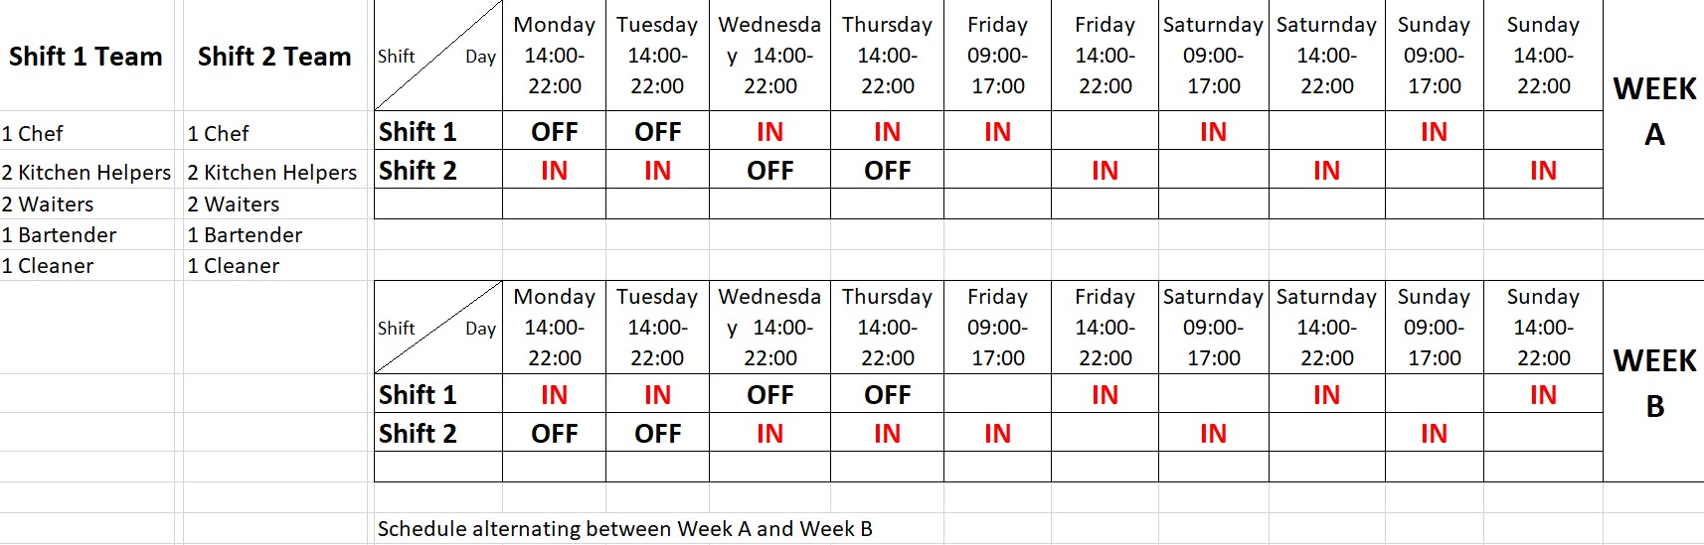

References
Adhikari, A. & Rao, A. K., 2013. Individual Preference and Bargaining Behavior in Families Buying Decisions of Restaurant Service. Cornell Hospitality Quarterly, 54(3)(doi: 10.1177/1938965512459801), pp. 248-261.
Hill, C. W. & Jones, G. R., 2014. Strategic Management Theory: an Integrated Approach. South Western: Cengage Learning.
Lock, S.- Statista, 2022. Statista. [Online]
Available at: https://www.statista.com/statistics/558137/restaurant-and-mobile-food-services-business-turnover-uk/
[Accessed 21 08 2022].
Statista, 2022. Statista. [Online]
Available at: https://www.statista.com/statistics/558137/restaurant-and-mobile-food-services-business-turnover-uk/
[Accessed 21 08 2022].

