Appendix
Appendix 1- Consent form and Letter
Appendix 2- Interview Questions
Appendix 3- Interview Responses
Appendix 4- Blank Observation Sheet
Appendix 5- Completed Observation Sheet
Appendix 6- Questionnaire Questions
Appendix 7- Questionnaire Responses
Appendix 8- Ethics form

Appendix 1
Research Information Sheet
What are the pupils and staff perceptions on Assessment for Learning?

Dear Parent/Guardian,

My name is Kelsey and I am studying BA Primary Education with QTS at Yr Athrofa University of Wales Trinity Saint David. I have previously been a student teacher at your child’s school between 4th November 2019 and 7th February 2020, and I have had the opportunity to teach in your child’s class.
I would like to invite your child to participate in my research project. The title of the project is What are the pupils and staff perceptions on Assessment for Learning? and I aim to observe and complete interviews and questionnaires. Through your child’s participation, I hope to ascertain data and research to aid in writing an assignment.
I plan to observe the class during their lessons to identify how questioning is used to aid learning and how the children respond to these questions. I will ask the children to complete a questionnaire and participate in interviews with myself to gather relevant information for my research project.
All names will be kept strictly confidential and will only be known by myself. Your child’s participation in this study is completely voluntary so you or your child can withdraw from the study at any stage. Your child will also be asked to give their assent before the beginning of the study.
After careful and precise analysis of the data obtained from the lesson observation and group interview, I would be happy to provide you with a copy of the findings at your request. The results of the research will be discussed in a university assignment that will contribute to my Primary Education course. The results of this study will be stored on one drive and all raw data will be destroyed once the assessment has been marked.
I thank you in advance for your time. If any questions do arise, feel free to contact me at your convenience.
Yours sincerely,
Kelsey Tucker

Consent form (Parents)
What are the pupils and staff perceptions on Assessment for Learning?

Name of Researcher: Kelsey Tucker
Please initial box
- I confirm that I have read and understand the information sheet dated 03/03/2020 for the above study.
- I understand that my child’s participation is voluntary and that I am free to withdraw my child from the study at any time, without giving any reason.
- I understand that my child can choose to withdraw at any time, without giving any reason.

- I understand that the information given by my child will be used in a university assignment.

- I understand that my child’s name will not appear at any time.

- I agree for my child to take part in the above study.

Child’s name Parent Signature Date
_________________________ _____________________________ _______________

When completed, please return in the envelope provided to Kelsey Tucker by the 2nd of March (02/03/2020)

Thank you.

Appendix 2

Over-arching question: What are the pupils and staff perceptions of Assessment for Learning?
Research question: How is questioning being used in the classroom?
Interview Questions (Teacher)

- How often would you say you use the questioning AFL strategy in a lesson?
- What types of questions would you ask the pupils during a Maths lesson?
- How do you think the pupils benefit from your questioning?
- Do you have to alter your questioning to suit certain pupils needs?
Interview Questions (Pupils)

- Do you like when your teacher asks you questions? If yes, why?
- Can you give an example of what question your teacher might ask you in a maths lesson?
- Do you feel confident answering questions in front of the class? Why?
- How much time would you say your teacher gives you to answer a question?
- Do you think being asked questions is important to your learning? Why?

Appendix 3
Interview with pupils
 | Do you like when your teacher asks you questions? Why?
A | Yes, because it can help me with my work.
B | Yes, because it helps me with my work.
C | Yes, because questions can help me with my work and the activity I am doing.
D | Yes, because it helps me figure out if I am stuck on anything. It helps with my learning and if the teacher didn’t ask me questions then I wouldn’t know as much as I know.
E | Yes, because it helps me with what I am doing and the task.
F | Yes, because I can say I am stuck on something and the teacher can help me.

 | Can you give an example of what question your teacher might ask you in a maths lesson?
A | The teacher asks if we understand.
B | The teacher asks us if we can solve a problem.
C | The teacher asks us maths problems.
D | She asks if we need help. She also asks maths problems.
E | She asks us maths sums and to show how we work them out.
F | The teacher asks us to solve maths problems and sometimes we show our workings out on the board.

 | Do you feel confident answering questions in front of the class? Why?
A | I feel confident if the questions are simple but if they are hard then sometimes, I stutter, and I feel embarrassed.
B | I don’t mind as I know they help me learn.
C | Not every question. I struggle on hard questions because I get embarrassed if I get something wrong.
D | I don’t mind if it’s hard or easy because I know the teacher is trying to challenge me.
E | I don’t normally like answering hard questions in front of the class as I feel under pressure.
F | Sometimes I feel confident if it’s a simpler question but if it’s a harder question I start to worry a bit more.

 | How much time would you say your teacher gives you to answer a question?
A | It depends on what question it really is. If it was easy it would be about 1 or 2 minutes, if it was hard it would be about 5 minutes.
B | It depends on the question. If it’s an easy question then 1 minute, but if it’s a hard question then 5 minutes.
C | If it’s an easy question, then 20-30 seconds and the hard questions about 1 or 2 minutes.
D | I agree with A and B. Sometimes we think, pair, share our answers so we have more time.
E | If it was harder the teacher would give us more time because it is difficult but if it was an easy one, they’d give us less time.
F | Agree with A, B and D. If it was a hard question, the teachers will say they’ll help as well as give us the time to answer.

 | Do you think being asked questions is important to your learning? Why?
A | You can learn from your mistakes when you get asked questions. Being asked questions gives you an understanding of what you’re learning.
B | It is important because I feel like if you get asked questions it helps you learn what you haven’t learnt already.
C | It puts you under pressure and when you have answered questions enough you start to not feel under pressure and you feel like you can answer more questions. If you struggle with the question, the teacher asks you similar questions to make it easier for you and then they go back up to the level you should be on.
D | It helps with your work and if you are stuck on something you can ask, and the teacher will help you. Even though they put you under pressure, the teacher is just trying to help you improve. If you didn’t understand then the teacher would help you know the different things you need to know.
E | It is important because you need to know how to do work and it helps you to do it.
F | I think it’s important because you have got to learn to be under pressure.

Teacher’s Interview
How often would you say you use the questioning AfL strategy in a lesson?
I use it continuously throughout all of my lessons.

What types of questions would you ask the pupils during a maths lesson?
I use a range of open-ended and closed questions. I use open-ended to get the children to explain their understanding. I use closed questions to get instant feedback. It allows me to see whether I need to go over something again or if they understand.

How do you think the pupils benefit from your questioning?
It gives them the opportunity to express their thoughts. It also gives the opportunity for children to contribute to discussions in the class.

Do you have to alter your questioning to suit certain pupils needs?
I use more open-ended questions which allows me to meet all children’s abilities. I tend to question the lower end more to try and get the answer I want from them. I ask more questions to the top end pupils to try to get them to have a deeper understanding and to give me higher level answers.

Appendix 4
Observation
Name of observer: Date:
Class: Lesson/Subject Area:
Number of children:
Comments:
 | Questions asked by teacher | Feedback | Questions asked by pupils | Feedback
1.
2.
3.
4.
5.
6.
7.
8.

Appendix 5
Observation
Name of observer: Kelsey Tucker Date: 03/03/2020
Class: Year 6 Lesson/Subject Area: Reading
Number of children: 23 P.E.E of text
Comments:
Pupils given a P.E.E example to look at and discuss.
The teacher stopped the class by saying ‘snapback’ to get the pupils to then feedback their responses. The teacher used ‘pitstops’ to stop the class and share discussions. The teacher used a variety of open-ended questions.
The teacher used a very limited amount of closed questions. The teacher used more open-ended questions to get the pupils to think and to promote discussions.
 | Questions asked by teacher | Feedback | Questions asked by pupils | Feedback
1. | What have we been doing recently? | Pupil explained.  Open-ended  P.E.E
2. | What do we need to do when getting evidence? | Pupil explained.  Open-ended
3. | What do you notice about the text? | Open-ended.  Variety of responses from class.
4. | What is similar and different? What do you mean? | Chose one pupil to ask.  Think, pair, share
5. | Can you think of something else?  I will come back to you. | Pupil struggling to answer. Time for pupil to think.
6. | Do you think that the paragraph is effective? | Closed question. Response was ‘no.’
7. | How do you know? | Promoting pupils to think.
8. | What has this person used? | Open-ended. Range of responses.

Appendix 6
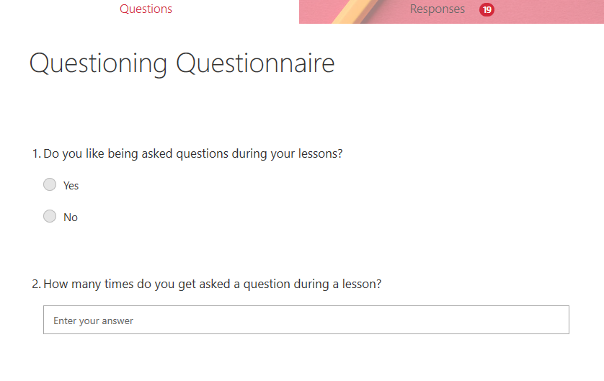

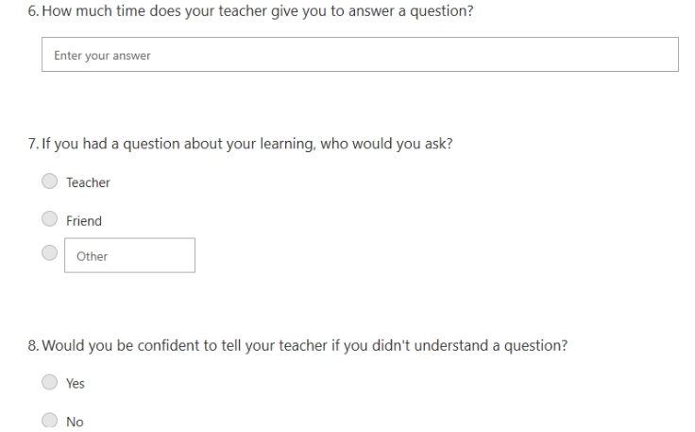

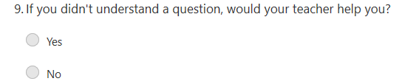

Appendix 7
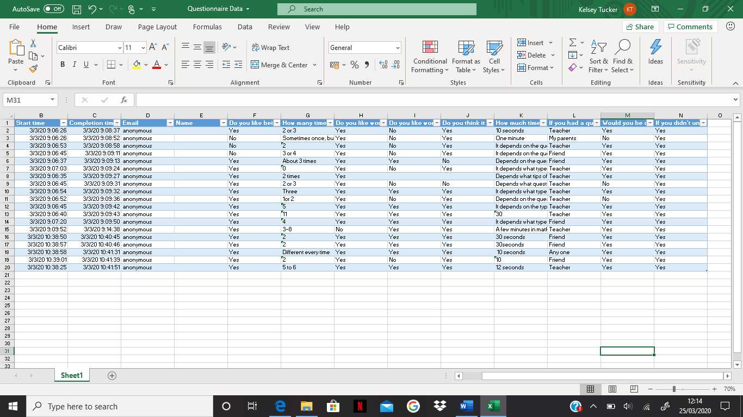

Appendix 8
APPLICATION FOR ETHICAL APPROVAL

In order for research to result in benefit and minimise risk of harm, it must be conducted ethically. A researcher may not be covered by the University’s insurance if ethical approval has not been obtained prior to commencement.

The University follows the OECD Frascati manual definition of research activity: “creative work undertaken on a systematic basis in order to increase the stock of knowledge, including knowledge of man, culture and society, and the use of this stock of knowledge to devise new applications”. As such this covers activities undertaken by members of staff, postgraduate research students, and both taught postgraduate and undergraduate students working on dissertations/projects.

The individual undertaking the research activity is known as the “principal researcher”.

Ethical approval is not required for routine audits, performance reviews, quality assurance studies, testing within normal educational requirements, and literary or artistic criticism.

Please read the notes for guidance before completing ALL sections of the form.

This form must be completed and approved prior to undertaking any research activity. Please see Checklist for details of process for different categories of application.

Delete the Guidance Notes at the end of the form BEFORE submitting your application

SECTION A: About You (Principal Researcher)
Full Name: |  | Kelsey Tucker
Tick all boxes which apply: |  | Member of staff: | ☐ | Honorary research fellow: | ☐
Undergraduate Student | ☒ | Taught Postgraduate Student | ☐ | Postgraduate Research Student | ☐

Faculty/School/Centre: | Initial Teacher Education, Yr Athrofa
Campus: | Carmarthen
E-mail address: | 1800913@student.uwtsd.ac.uk
Contact Telephone Number: | 07790388768
For students:
Student Number: | 1800913
Programme of Study: | BA Primary Education with QTS
Director of Studies/Supervisor: | Dr. Sioned V. Hughes

SECTION B: Approval for Research Activity
Has the research activity received approval in principle?  (please check the Guidance Notes as to the appropriate approval process for different levels of research by different categories of individual) |  | YES | ☒ | NO | ☐
 |  |  |  | Date
If Yes, please indicate source of approval (and date where known): Approval in principle must be obtained from the relevant source prior to seeking ethical approval | Research Degrees Committee |  | ☐
 | Faculty Research Committee |  | ☐
 | Other (write in) ECAD5010 Module Lead |  | ☒ | 27.02.20

SECTION C: Internal and External Ethical Guidance Materials
Please list the core ethical guidance documents that have been referred to during the completion of this form (including any discipline-specific codes of research ethics, and also any specific ethical guidance relating to the proposed methodology). Please tick to confirm that your research proposal adheres to these codes and guidelines.
UWTSD Research Ethics & Integrity Code of Practice | ☐
UWTSD Research Data Management Policy | ☐
British Educational Research Guidelines (BERA, 2018)  https://www.bera.ac.uk/researchers-resources/publications/ethical-guidelines-foreducational-research-2018 | ☐
 | ☐

SECTION D: External Collaborative Research Activity
Does the research activity involve collaborators outside of the University? |  | YES | ☐ | NO | ☒
If Yes, please provide the name of the external organisation and name and contact details for the main contact person and confirmation this person has consented to their personal data being shared.as part of this collaboration.
Institution
Contact person name
Contact person e-mail address

Has this individual consented to sharing their details on this form? |  | YES | ☐ | NO |  |  | ☐
Are you in receipt of a KESS scholarship? |  | YES | ☐ | NO |  |  | ☐
Is your research externally funded |  | YES | ☐ | NO |  |  | ☐
Are you specifically employed to undertake this research in either a paid or voluntary capacity? | Voluntary | YES | ☐ | NO |  | ☐
 | Employed | YES | ☐ | NO |  | ☐
Is the research being undertaken within an existing UWTSD Athrofa Professional Learning Partnership (APLP) | If YES then the permission question below does not need to be answered. | YES | ☒ | NO |  |  | ☐
Permission to undertake the research has been provided by the partner organisation | (If YES attach copy)  If NO the application cannot continue | YES | ☐ | NO |  |  | ☐

Where research activity is carried out in collaboration with an external organisation
Does this organisation have its own ethics approval system? | YES | ☐ | NO | ☒
If Yes, please attach a copy of any final approval (or interim approval) from the organisation

SECTION E: Details of Research Activity
Indicative title: | How is questioning being used in the classroom?
Proposed start date: | 02.03.20 | Proposed end date: | 01.04.20
Introduction to the Research (maximum 300 words)
Ensure that you write for a Non-Specialist Audience when outlining your response to the three points below:
- Purpose of Research Activity
- Proposed Research Question
- Aims of Research Activity
- Objectives of Research Activity
Demonstrate, briefly, how Existing Research has informed the proposed activity and explain
- What the research activity will add to the body of knowledge
- How it addresses an area of importance.
Purpose of Research Activity
- To explore how AFL strategy questioning is used in the classroom
- To trial different research tools in practice

Research Question

How is questioning being used in the classroom?

Aims of Research Activity

- To explore staff and learner’s perceptions of the AFL strategy of questioning
- To critically evaluate the different research tools used- observation, interview and questionnaire
- To further develop personal knowledge and understanding of AFL (questioning) to improve professional practice

Objectives of Research Activity

- To explore the AFL questioning strategies and approaches used by staff to support and develop pupils’ learning using a questionnaire
- To interview 10-11 year-old learners to capture their views about questioning
- To observe questioning
- To critically reflect on the process of using different research tools to collect data
Proposed methods (maximum 600 words)
Provide a brief summary of all the methods that may be used in the research activity, making it clear what specific techniques may be used. If methods other than those listed in this section are deemed appropriate later, additional ethical approval for those methods will be needed.
Interviews- Small group of children from the Year 6 class will be involved in a structured interview where they will be invited to respond to key questions. For example, do you like answering questions? If yes, why? This interview will be conducted in an informal setting in the classroom and I will make notes of and audio record their responses. The children will not be forced to participate. They will be made aware that they do not have to answer any questions and that they can stop at any time. All children will be asked if they wish to be involved. Children will use their ‘smiley face’ cards to show that they are happy to continue. I will check on the children’s feelings regularly. I will ensure that there is an additional adult present during my interview. No names will be recorded.
I will also interview the class teacher. The class teacher will be asked for their consent and they will be informed that they have the right to withdraw from the interview at any point.

Questionnaire- The whole of the Year 6 class will be involved in completing a structured questionnaire where they will be invited to respond to key questions. For example, do you like working on your own to answer a question? This questionnaire will be conducted in an informal setting in the classroom. I will gather the data after the research day has been conducted. The children will not be forced to participate. They will be made aware that they do not have to answer any questions and that they can stop at any time. All children will be asked if they wish to be involved. Children will user their ‘smiley face’ cards to show that they are happy to continue. I will check on the children’s feelings regularly. I will ensure that there is an additional adult present during the questionnaire. No names will be recorded.

Observations- I will observe the whole of the Year 6 class during a lesson. I will be looking for how many times the teacher asks questions and the responses for the children. As well as this, I will observe how many times the children ask questions and record the responses from the teacher. The children will be made aware of on-going consent and if at any point they do not want to continue to participate, they can withdraw. I will ensure that there is an additional adult present during my observation. No names will be recorded.

Location of research activity
Identify all locations where research activity will take place.
The research activity will take place in a large school in a coastal town. The school has 2 classes for every year group. Some year groups are small, for example 48 pupils and some year groups are large, for example, 60 pupils. I will complete my research with a Year 6 class of 23 pupil’s.

Research activity outside of the UK
If research activity will take place overseas, you are responsible for ensuring that local ethical considerations are complied with and that the relevant permissions are sought. Specify any local guidelines (e.g. from local professional associations/learned societies/universities) that exist and whether these involve any ethical stipulations beyond those usual in the UK (provide details of any licenses or permissions required). Also specify whether there are any specific ethical issues raised by the local context in which the research activity is taking place, for example, particular cultural and/or legal sensitivities or vulnerabilities of participants.
N/A

(this box should expand as you type)
Use of documentation not in the public domain: Are any documents NOT publicly available? | NO | ☒
 | YES | ☐
If Yes, please provide details here of how you will gain access to specific documentation that is not in the public domain and that this is in accordance with prevailing data protection law of the country in question and England and Wales.

(this box should expand as you type)

SECTION F: Scope of Research Activity
Will the research activity include: | YES | NO
Use of a questionnaire or similar research instrument? | ☒ | ☐
Use of interviews? | ☒ | ☐
Use of diaries? | ☐ | ☒
Participant observation with their knowledge? | ☒ | ☐
Participant observation without their knowledge? | ☐ | ☒
Use of video or audio recording? | ☒ | ☐
Access to personal or confidential information without the participants’ specific consent? | ☐ | ☒
Administration of any questions, test stimuli, presentation that may be experienced as physically, mentally or emotionally harmful / offensive? | ☐ | ☒
Performance of any acts which may cause embarrassment or affect self-esteem? | ☐ | ☒
Investigation of participants involved in illegal activities? | ☐ | ☒
Use of procedures that involve deception? | ☐ | ☒
Administration of any substance, agent or placebo? | ☐ | ☒
Working with live vertebrate animals? | ☐ | ☒
Other primary data collection methods, please explain in this box  For example, ‘focus groups’. Please indicate the type of data collection method(s) in this box and tick the accompany box. | ☐ | ☒
Details of any other primary data collection method:  (this box should expand as you type) | ☐ | ☒
If NO to every question, then the research activity is (ethically) low risk and may be exempt from some of the following sections (please refer to Guidance Notes).

If YES to any question, then no research activity should be undertaken until full ethical approval has been obtained.

SECTION G: Intended Participants
Who are the intended participants: | YES | NO
Students or staff at the University? | ☐ | ☐
Adults (over the age of 18 and competent to give consent)? | ☒ | ☐
Vulnerable adults? | ☐ | ☐
Children and Young People under the age of 8? (Consent from Parent, Carer or Guardian will be required) | ☒ | ☐
Prisoners? | ☐ | ☐
Young offenders? | ☐ | ☐
Those who could be considered to have a particularly dependent relationship with the investigator or a gatekeeper? | ☐ | ☐
People engaged in illegal activities? | ☐ | ☐
Others (please identify specifically any group who may be unable to give consent) please indicate here and tick the appropriate box. | ☐ | ☐
Other – please indicate here:  (this box should expand as you type) | ☐ | ☐

Participant numbers and source
How will you identify participants and how will they be recruited?
How many participants are expected? | 24 participants
Who will the participants be? | 1 teacher, 23 pupils (Year 6, age 10-11)
How will you identify the participants? | From PTE2 experience, I am returning to the Year 6 class that I taught, and I am aware of the abilities of all children.

Information for participants: | YES | NO | N/A
Will you describe the main research procedures to participants in advance, so that they are informed about what to expect? | ☒ | ☐ | ☐
Will you tell participants that their participation is voluntary? | ☒ | ☐ | ☐
Will you obtain written consent for participation? | ☐ | ☐ | ☒
Will you explain to participants that refusal to participate in the research will not affect their treatment or education (if relevant)? | ☒ | ☐ | ☐
If the research is observational, will you ask participants for their consent to being observed? | ☒ | ☐ | ☐
Will you tell participants that they may withdraw from the research at any time and for any reason? | ☒ | ☐ | ☐
With questionnaires, will you give participants the option of omitting questions they do not want to answer? | ☒ | ☐ | ☐
Will you tell participants that their data will be treated with full confidentiality and that, if published, it will not be identifiable as theirs? | ☒ | ☐ | ☐
Will you debrief participants at the end of their participation, in a way appropriate to the type of research undertaken? | ☐ | ☐ | ☒
If NO to any of above questions, please give an explanation
(this box should expand as you type)

Information for participants: | YES | NO | N/A
Will participants be paid? | ☐ | ☒ | ☐
Is specialist electrical or other equipment to be used with participants? | ☐ | ☒ | ☐
Are there any financial or other interests to the investigator or University arising from this study? | ☐ | ☒ | ☐
Will the research activity involve deliberately misleading participants in any way, or the partial or full concealment of the specific study aims? | ☐ | ☒ | ☐
If YES to any question, please provide full details
(this box should expand as you type)

SECTION H: Anticipated Risks

Outline any anticipated risks that may adversely affect any of the participants, the researchers and/or the University, and the steps that will be taken to address them.

If you have completed a full risk assessment (for example as required by a laboratory, or external research collaborator) you may append that to this form.
Full risk assessment completed and appended? |  | Yes | ☐
 |  | No | ☒
Risks to participants
For example: emotional distress, financial disclosure, physical harm, transfer of personal data, sensitive organisational information
Risk to Participant:  The pupils may feel under pressure to give the correct answer to questions.  The pupils may experience emotional distress from feeling under pressure.  The pupils may give answers they think I want and not be honest.  The pupils may encounter physical harm.  Transfer of physical data and sensitive organisational information. | How will you mitigate the Risk to Participant  Pupils will be told that they are no consequences for anything they say. I will make it clear that I want open and honest answers. I will make it clear that the answers they give will affect their education in no way and there will be no repercussions for their actions and answers regarding the research.  I will always be in the company of an adult throughout my research. I will follow the BERA Guidelines to ensure that I am acting appropriately during my research.  I will conduct myself in a professional manner to ensure that all pupils are safe, keeping their well-being in mind.  I will keep all names of pupils confidential and no personal information will be taken. The information of the school will not be used and all reference to the school and children in the research will be anonymised.
If research activity may include sensitive, embarrassing or upsetting topics (e.g. sexual activity, drug use) or issues likely to disclose information requiring further action (e.g. criminal activity), give details of the procedures to deal with these issues, including any support/advice (e.g. helpline numbers) to be offered to participants. Note that where applicable, consent procedures should make it clear that if something potentially or actually illegal is discovered in the course of a project, it may need to be disclosed to the proper authorities
N/A

Risks to investigator
For example: personal safety, physical harm, emotional distress, risk of accusation of harm/impropriety, conflict of interest
Risk to Investigator:  Allegations from pupils in the classroom while completing the research.  Physical harm and emotional distress to the investigator. | How will you mitigate the Risk to Investigator:  Most of the research will be during a normal activity in the classroom. The class teacher will be present whilst all research activities are taking place.  Ensure that there is always another adult present during the research process.
University/institutional risks
For example: adverse publicity, financial loss, data protection
Risk to University:  Behaving in a way that could impact the relationship between school and university.  Data protection of information. | How will you mitigate the Risk to University:  I will always behave in a professional manner.  I will ensure that all data collected is anonymous and does not contain any personal information which means that the school and/or participants can be identified.

Disclosure and Barring Service
If the research activity involves children or vulnerable adults, a Disclosure and Barring Service (DBS) certificate must be obtained before any contact with such participants. | YES | NO | N/A
Does your research require you to hold a current DBS Certificate? | ☒ | ☐ | ☐

SECTION I: Feedback, Consent and Confidentiality
Feedback
What de-briefing and feedback will be provided to participants, how will this be done and when?
N/A

(this box should expand as you type)
Informed consent
Describe the arrangements to inform potential participants, before providing consent, of what is involved in participating. Describe the arrangements for participants to provide full consent before data collection begins. If gaining consent in this way is inappropriate, explain how consent will be obtained and recorded in accordance with prevailing data protection legislation.
I will converse with my class teacher and senior mentor prior to the research day to inform them of the research I will be undertaking, providing reason and rationale behind the research. However, I will verbally ask children identified to participate whether they wish to participate, e.g. using smiley yes/no cards. If they show a smiley face, then they are happy to participate/answer the question, if not then I will know they are not happy to participate. This will be an individual exercise so that the children are encouraged to respond honestly with their interest and well-being in mind. Children will also be informed they can approach me at any time to ask questions and discuss their contribution to the project.
Confidentiality / Anonymity
Set out how anonymity of participants and confidentiality will be ensured in any outputs. If anonymity is not being offered, explain why this is the case.
I will ensure that no names will be recorded. I will not disclose names. I will ensure that no individual data (raw scores, individual identifiable performance outcomes) are made available to schools/parents etc.

SECTION J: Data Protection and Storage
In completing this section refer to the University’s Research Data Management Policy and the extensive resources on the University’s Research Data Management web pages (http://uwtsd.ac.uk/library/research-data-management/).
Does the research activity involve personal data (as defined by the General Data Protection Regulation 2016 “GDPR” and the Data Protection Act 2018 “DPA”)? | YES | NO
“Personal data” means any information relating to an identified or identifiable natural person (‘data subject’). An identifiable natural person is one who can be identified, directly or indirectly, in particular by reference to an identifier such as a name, an identification number, location data, an online identifier or to one or more factors specific to the physical, physiological, genetic, mental, economic, cultural or social identity of that natural person. | ☐ | ☐X
If YES, provide a description of the data and explain why this data needs to be collected:
(this box should expand as you type)
Does it involve special category data (as defined by the GDPR)? | YES | NO
“Special category data” means sensitive personal data consisting of information as to the data subjects’ –  (a) racial or ethnic origin,  (b) political opinions,  (c ) religious beliefs or other beliefs of a similar nature,  (d) membership of a trade union (within the meaning of the Trade Union and Labour Relations (Consolidation) Act 1992),  (e) physical or mental health or condition,  (f) sexual life,  (g) genetics,  (h) biometric data (as used for ID purposes), | ☐ | ☐X
If YES, provide a description of the special category data and explain why this data needs to be collected:
(this box should expand as you type)
Will the research activity involve storing personal data and/or special category data on one of the following: | YES | NO
Manual files (i.e. in paper form)? | ☐ | ☒
University computers? | ☐ | ☒
Private company computers? | ☐ | ☒
Home or other personal computers? | ☐ | ☒
Laptop computers/ CDs/ Portable disk-drives/ memory sticks? | ☐ | ☒
“Cloud” storage or websites? | ☐ | ☒
Other – specify: | ☐ | ☒
For all stored data, explain the measures in place to ensure the security of the data collected, data confidentiality, including details of password protection, encryption, anonymisation and pseudonymisation:
(this box should expand as you type)
All Data Storage
Will the research activity involve any of the following activities: | YES | NO
Electronic transfer of data in any form? | ☐ | ☒
Sharing of data with others at the University? | ☐ | ☒
Sharing of data with other organisations? | ☐ | ☒
Export of data outside the European Union or importing of data from outside the UK? | ☐ | ☒
Use of personal addresses, postcodes, faxes, emails or telephone numbers? | ☐ | ☒
Publication of data that might allow identification of individuals? | ☐ | ☒
Use of data management system? | ☐ | ☒
Data archiving? | ☐ | ☒
If YES to any question, please provide full details, explaining how this will be conducted in accordance with the GDPR and DPA (and/or any international equivalent):
(this box should expand as you type)
List all who will have access to the data generated by the research activity:
Data generated can be shared with teachers/parents on request. However, no personal information, or names, will be used in the data or research.
List who will have control of, and act as custodian(s) for, data generated by the research activity:
N/A

Give details of data storage arrangements, including security measures in place to protect the data, where data will be stored, how long for, and in what form. Will data be archived – if so how and if not why not.
Data might be stored on one drive.

Please indicate if your data will be stored in the UWTSD Research Data Repository (see https://researchdata.uwtsd.ac.uk/ ). If so please explain. (Most relevant to academic staff)
The data will not be stored in the UWTSD Research Data Repository.

Confirm that you have read the UWTSD guidance on data management (see https://www.uwtsd.ac.uk/library/research-data-management/) | YES | ☒
 | NO | ☐
Confirm that you are aware that you need to keep all data until after your research has completed or the end of your funding | YES | ☒
 | NO | ☐

SECTION K: Declaration
The information which I have provided is correct and complete to the best of my knowledge. I have attempted to identify any risks and issues related to the research activity and acknowledge my obligations and the rights of the participants.

In submitting this application I hereby confirm that I undertake to ensure that the above named research activity will meet the University’s Research Ethics and Integrity Code of Practice
Signature of applicant: | KATucker | Date:  27.02.20

For STUDENT Submissions:
Director of Studies/Supervisor: | Dr. Sioned V. Hughes | Date:  28.02.20
Signature: |  | Date:  28.02.20

For STAFF Submissions:
Head of School/Assistant Dean: |  | Date:
Signature: |  | Date:

Checklist: Please complete the checklist below to ensure that you have completed the form according to the guidelines and attached any required documentation:
☐ | I have read the guidance notes supplied before completing the form.
☐ | I have completed ALL RELEVANT sections of the form in full.
☐ | I confirm that the research activity has received approval in principle
☐ | I have attached a copy of final/interim approval from external organisation (where appropriate)
☐ | I have attached a full risk assessment (and have NOT completed Section H of this form) (where appropriate) ONLY TICK IF YOU HAVE ATTACHED A FULL RISK ASSESSMENT
☐ | I understand that it is my responsibility to ensure that the above named research activity will meet the University’s Research Ethics and Integrity Code of Practice.
☐ | I understand that before commencing data collection all documents aimed at respondents (including information sheets, consent forms, questionnaires, interview schedules etc.) must be confirmed by the DoS/Supervisor, module tutor or Head of School.
☐ | I have deleted the guidance notes before submitting the PG2 for consideration

