Drive Cycle Requirements Specifications
JIAN SONG
Introduction
In the search for sustainable mobility solutions, the integration of alternative energy sources in vehicle technology represents a key shift in vehicle design and functionality. This report provides a comprehensive analysis of a simulated retrofit of the Tesla Model 3, in which half of the battery capacity is replaced by a hydrogen fuel cell. The primary objective of this modification is to assess potential improvements in vehicle performance, particularly in terms of range and energy efficiency under the Worldwide Harmonised Light Vehicle Test Procedure (WLTP). Electric vehicles (EVs) have traditionally relied exclusively on battery technology, which is effective but has limitations in terms of energy density and charging times. Fuel cell technology, which converts hydrogen into electricity, is a promising complementary alternative due to its high energy density and fast recharging time. By combining a battery with a fuel cell, the retrofit vehicle aims to take advantage of the benefits of both energy systems: the high energy efficiency and zero-emission capability of the battery, and the long range and fast charging time of the fuel cell. The WLTP is the global standard for determining a vehicle's range and fuel consumption, providing a rigorous testing framework that simulates real-world driving under controlled laboratory conditions. In this simulation, the Tesla Model 3 will be subjected to WLTP testing to assess how effectively a hybrid powertrain can meet these real-world challenges compared to a traditional battery-only setup. This analysis not only explores the technical outcomes of such a retrofit, such as changes in energy consumption and driving range, but also delves into the broader implications for refuelling logistics, operating costs and peak performance characteristics. Understanding these dynamics is critical for automakers, policymakers and consumers as the automotive industry moves towards more diverse and sustainable energy solutions. This report aims to shed light on the practical and theoretical implications of integrating fuel cell technology into existing electric vehicle frameworks, providing insights into future eco-friendly vehicle innovations.

Eestablish the driving cycle
A MATLAB driving cycle model was created to validate the WLTP driving cycle, which is known for rigorously evaluating vehicle performance characteristics in terms of fuel consumption and emissions. Model inputs included vehicle dynamics parameters for the Tesla Model 3, such as mass, drag coefficient, frontal area, and rolling resistance coefficient, to ensure an accurate representation of the vehicle's physical characteristics.
The simulation results show a total energy consumption of 3.30 kWh over the WLTP cycle, the vehicle has an estimated range of 528.85 km with a fully charged 75 kWh battery, and a calculated energy consumption of 141.82 Wh/km per 100km, the overall simulation results show that the driving cycle model that I have created not only meets, but slightly exceeds the typical WLTP standards. Modifications to the vehicle.
I have analysed the MATLAB simulation results of a modification to the Tesla Model 3 to replace 50% of its battery capacity with a fuel cell. The goal is to maintain similar performance in terms of WLTP range. The initial setup consisted of simulating a standard Tesla Model 3 with a 75 kWh battery, using the WLTP driving cycle to establish energy consumption and range baselines. Subsequent simulations integrated a fuel cell that replaced half of the battery capacity, keeping the total energy at 75 kWh. Vehicle parameters were adjusted to accommodate the increased weight and different energy dynamics of the fuel cell.
Summary of results:
Initial model (battery only): Energy consumption: 141.82 Wh/km Range: 528.85 km.
Improved model (battery + fuel cell): Energy consumption: 109.80 Wh/km Range: 528.85 km Range 722.71 km.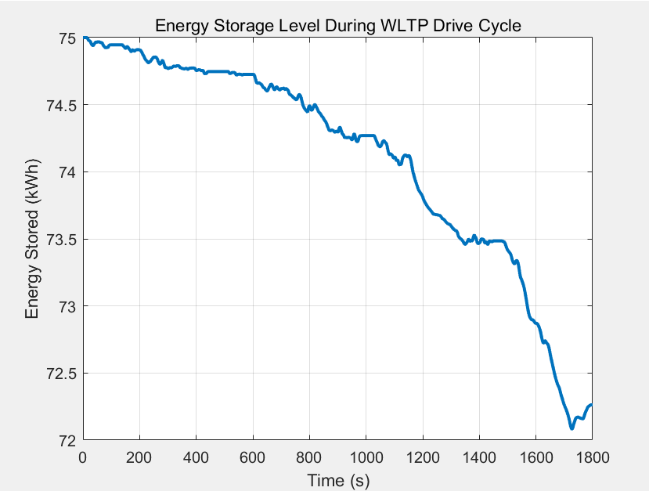
Fig. 1 Purely electric energy storage level chart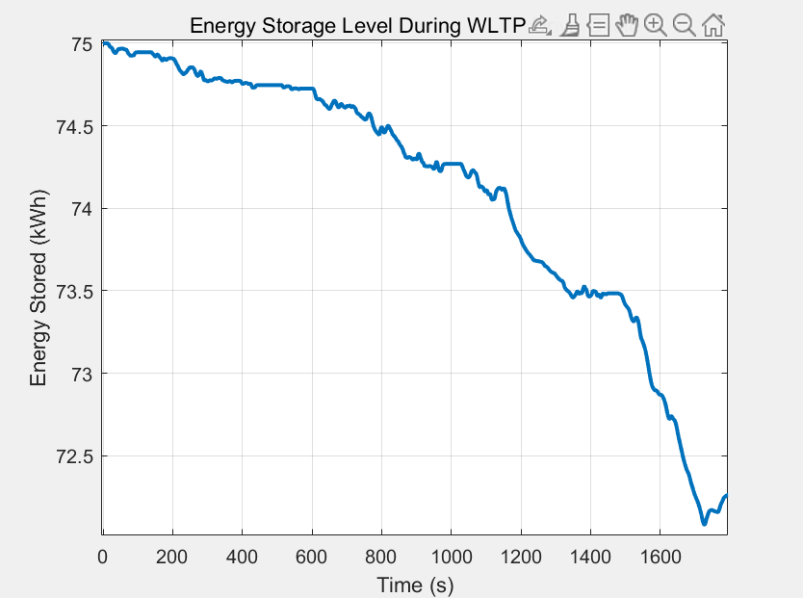
Fig. 2 Fuel cell + battery energy storage level map

Analysis of results
Energy consumption and range: The improved model shows a reduction in energy consumption per kilometre from 141.82 Wh/km to 109.80 Wh/km, indicating improved efficiency. The range increased significantly from 528.85 km to 722.71 km. This improvement shows that the integration of the fuel cell not only compensates for the reduced battery size, but also improves the overall energy efficiency of the vehicle. Refuelling time: the refuelling time of the battery remains the same; however, after adding the fuel cell, we need to add hydrogen, as this time a hydrogen production unit is used and the energy source is methane, so we need to add methane, which may be quicker than charging, but adding methane is not as common as electric charging stations.
Cost per kilometre: The initial cost of installing a fuel cell may increase the upfront cost of the vehicle. However, if methane fuel is competitively priced, the reduction in energy consumption per kilometre may reduce operating costs. Limitations of the model: simplification of energy management: This time the model assumes a direct distribution of energy contributions between the battery and the fuel cell, without complex management systems that would normally optimise power output based on real-time driving demands and conditions.
Real-world driving conditions: The WLTP loop attempts to approximate real-world driving conditions, but still lacks some of the dynamics of everyday driving, such as changes in traffic, road conditions, and more aggressive acceleration and deceleration behaviour.
of the current fuel cell infrastructure, which may affect the practicality and ease of operation of fuel cell vehicles.

Fuel Cell Electric Vehicle Design Solution
The comprehensive design strategy comes next. Fuel cell electric vehicles are a type of on-board hydrogen generation vehicle. They generate hydrogen using the autothermal reforming method, which combines partial oxidative and methanol vapour reforming to achieve an instantaneous supply of hydrogen; they drive the vehicle using a hybrid system that combines fuel cells and Li-ion batteries; additionally, the Li-ion batteries' regenerative braking system recycles braking and coasting energies. In contrast to the hydrogen storage fuel cell vehicle, it does away with the high-pressure hydrogen storage device and uses the fuel cell as its primary power source to power the motor, with the lithium battery acting as an auxiliary power source to power energy recovery and acceleration.
This is an investigation of the structural design and part selection for fuel cell electric vehicles. The project's fuel cell electric vehicle's structure is combined with an analysis of its principal components, which include the electric drive system, on-board hydrogen production system, fuel cell system, auxiliary power supply, and management system, in that order.
1 The basic structure of on-board hydrogen generation fuel cell electric vehicles
The main components of the on-board hydrogen generation fuel cell electric vehicles under investigation in this project are the fuel cell system, the motor drive system, the DC/DC converter (electric coupling device), the auxiliary battery (the power battery pack is conceptually included in the peak power supply scope in this paper, as is the inner battery), and the management system. and its administration framework, etc.
2 Vehicle hydrogen system selection and basic structure
The major parts of a vehicle's oxygen system include purifiers, methanol storage tanks, burners, and reformers, among other parts. It understands the role that filtration and oxygen generation play.
The primary source of hydrogen generation at the moment is hydrocarbon fuel reforming. The process of reforming involves a chemical reaction that releases oxygen from hydrocarbons. Hydrogen is produced during this process from the C-H bonding energy of hydrocarbons. For on-board hydrogen generation, a range of feedstocks can be utilized, including hydrocarbons like gasoline, diesel, methane, natural gas, and liquefied petroleum gas (LPG) and alcohols like methanol, ethanol, and dimethyl ether.
Methanol can be produced, stored, transported, charged, and refueled without the need for additional equipment since it is liquid at normal temperature and pressure, has a low toxicity, good safety, and a high energy density. It is also not prone to spontaneous combustion or explosions. It is feasible to make use of the current fuel storage and transportation infrastructure with some adjustments. Methanol is easy to add, doesn't require any additional safety precautions, and can enhance driving range provided the fuel tank is large enough. Considering everything, methanol is now the best feedstock for producing oxygen on board.
3 The structure, working principle and performance analysis of the proton exchange membrane fuel cell .
Proton Exchange Membrane Fuel Cells have a potential energy conversion efficiency of 70%–80%, while their present practical use is 50%–60% ^{[1]}. Electrolyte with conductive proton polymer membrane that allows for H + ion function selective transfer. With a mass specific power of up to 200W/kg, the actual use of methanol hydrogen production, a voltage of 350 ~ 400V, and a power of 30 ~ 200KW, this device can operate continuously and fulfill the needs of flexibility, mobility, and a long driving range at both part-load and full-load conditions.
One of PEM fuel cells' greatest advantages for widespread usage is its low operating temperature. It can function normally at room temperature, but its ideal operating temperature is between 80 and 90 degrees Celsius. Fig. illustrates the principle of operation. The process by which the battery functions involves the diffusion of reactive gas in the diffusion layer, electrocatalytic reaction in the catalytic layer, transfer of protons from the anode reaction to the opposite side via the exchange membrane, and arrival of electrons at the cathode through the external circuit, where they react with oxygen to produce water.
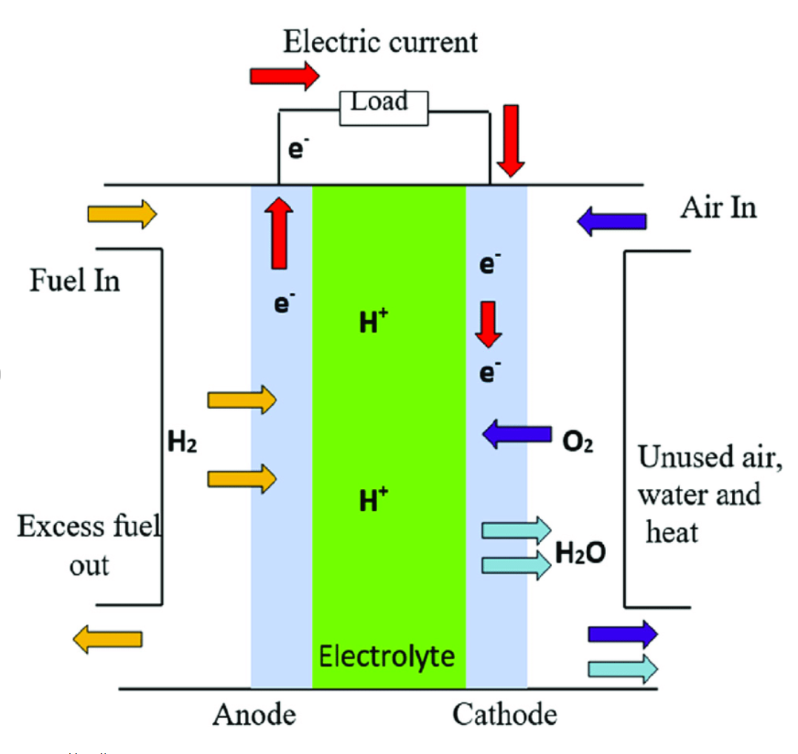
Fig. 3 Schematic diagram of the operating principle of PEMFC
Since proton exchange membrane fuel cells run at low temperatures, a catalyst is essential. A catalyst is required because of the proton exchange membrane fuel cell's low operating temperature and the electrolyte's acidic composition. Thus far, the electrode catalyst material is typically drilled for the particular working parameters of the fuel cell, and the dose is very considerable, which significantly raises its cost. Technology advancements have resulted in a reduction of the bearing load from the initial 28 mg/cm2 to 0.2 mg/cm2, as well as a smaller particle size distribution range, more uniform sentence distribution, the use of binary or even more distant alloy catalysts, and anti-monoxide breakage.
Fuel cell monomer typically operates at 0.7V, which is insufficient for practical application and necessitates using it in series. Furthermore, wire connections, such as those used in dry cell series connections, cannot be used with the series connection method, which will result in a decrease in both output voltage and current. A useful method for creating a series connection is the bipolar plate connection. The bipolar plates transfer hydrogen to the anode and oxidant (air or oxygen) to the cathode of the two adjacent fuel cells by coming into contact with them on both sides.
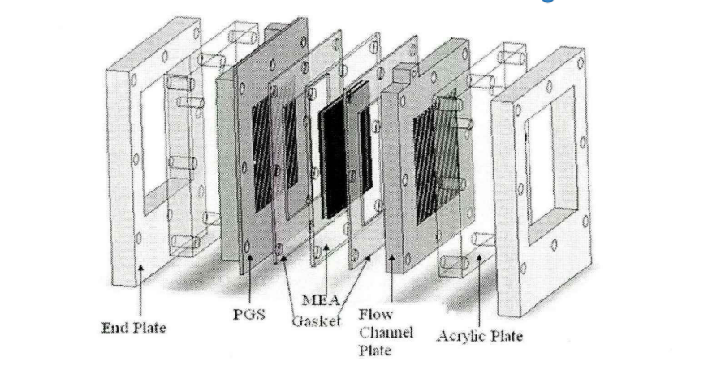
Fig. 4 Bipolar plate structure of proton exchange membrane fuel cell
Conductivity, a tight seal, little resistance to gas flow, ease of surface moisture evaporation, ease of cooling, and compact size are all necessary for bipolar plates.
The water management system of the current membrane is even more complicated due to its needs for high humidity and low temperature. A thermal management system must also be installed in the low-temperature working environment. Maintaining the water balance on both sides of the proton exchange membrane and controlling gas humidification are the primary responsibilities of the water management system. The primary functions of the thermal management system are to regulate the fuel cell's water cooling and heating as well as the temperature and cooling medium for the auxiliary devices (compressor-expander, feeder, power pack, power converter, drive motor, etc.).
4 DC/DC power converter analysis and selection
In general, the fuel cell's output voltage is lower than the power bus', and as output current grows, so does the voltage drop ^{[2]}. The fuel cell electric vehicle must be equipped with a DC/DC power converter in order to balance the fuel cell's output voltage with the power bus voltage and regulate the fuel cell system's energy output. This converter can deliver the fuel cell's DC/DC power output to the drive motor through boost conversion and to the power battery pack for storage through buck conversion. It also serves to stabilize the bus voltage and regulate the voltage overall. Moreover, it controls the energy distribution across the entire vehicle and stabilizes the bus voltage.
A bidirectional step-up/down DC/DC power converter is the converter we select, in accordance with the electric vehicle's operating principle.
The converter acts as a booster when the motor is jointly powered by the fuel cell and the battery pack. In situations where the fuel cell has excess power or recovered energy to charge the battery pack, the DC/DC converter functions as a step-down converter. The power source and the power bus are connected to a bi-directional DC/DC converter, which controls and regulates the input and output currents in both directions. There are three distinct operating modes for it: fuel cell, battery pack charging, and hybrid operating mode for battery pack discharge.
These days, a power converter may essentially fulfill the aforementioned characteristics since it is tiny, light, has a high specific power, high efficiency, strong dynamic performance, and can be utilized in a number of control modes.
5 Drive motor and its control system
In this instance, a permanent magnet brushless DC motor is employed ^{[3]}. The accelerator and brake pedals are used by the driver to regulate the motor's output torque when operating an electric car. The gating signal is generated and fed to the three inverters, or power converters, to generate the desired phase currents of the motor. The output torque is controlled by the accelerator or brake pedal, the torque controller provides the desired current, the information received by the current controller and commutation sequence generator from the position detector, or the current feedback information through the current detector.
When operating a car, speed control is also included (e.g. cruise control). Following receipt of the provided speed information and the speed sensor's speed information, the speed controller transfers the torque data to the torque controller, whereupon the procedure is analogous to torque control.
6 Auxiliary battery and its management system
To guarantee the efficiency of fuel cell electric cars, particularly during acceleration, ascents, and regenerative braking, the peak power supply (auxiliary battery) must be equipped in addition to the fuel cell system to guarantee adequate power output and energy recovery ^{[4]}.
Good management of silver batteries based on their properties is required to guarantee driving safety, maintain battery performance, extend service life, and enhance efficiency. Data collection, status estimate, real-time communication, energy management, temperature management, safety management, and problem diagnostics are among the primary duties of the battery management system.
The primary purpose of the data collecting function is to gather battery pack temperature, voltage, and current. To calculate the driving range and battery life, the state estimation function primarily evaluates the battery's state of health (SOH) and remaining charge (SOC). Data exchanged between the battery management system and devices like the vehicle management system and motor control system is referred to as "real-time communication." The primary goal of energy management is to regulate the battery's charging and discharging cycles. The primary goal of thermal management is to regulate the battery so that it operates within the ideal temperature range. When safety issues arise, timely alerts and emergency care are the primary components of safety management. When a system has a malfunction, fault diagnostics is the process of quickly identifying the problematic components. The microcontroller is often responsible for completing data processing, which is the fundamental function of the battery management system.

Conclusion
This study highlights the essential parts of a fuel cell electric car that produces hydrogen on board and looks at its basic design. It examines the design and workings of the proton exchange membrane fuel cell, concentrates on the on-board hydrogen generation technology utilizing methanol autothermal reforming, and chooses a bidirectional lift-voltage DC/DC converter for electric energy conversion. The vehicle's primary power source is a lithium-ion battery pack, and it is propelled by a permanent magnet brushless DC motor. Comprehensive assessments are also performed on the lithium battery pack management system controller, the electric energy converter, and the electric drive system controller.

[1] Jung-Ho Wee, Applications of proton exchange membrane fuel cell systems, Renewable and Sustainable Energy Reviews, Volume 11, Issue 8,2007,1720-1738.
[2] Abdelfatah Kolli, Arnaud Gaillard, Alexandre De Bernardinis, Olivier Bethoux, Daniel Hissel, Zoubir Khatir, A review on DC/DC converter architectures for power fuel cell applications, Energy Conversion and Management, 2015, 716-730.
[3] Z. Q. Zhu and D. Howe, "Electrical Machines and Drives for Electric, Hybrid, and Fuel Cell Vehicles," in Proceedings of the IEEE, vol. 95, no. 4, pp. 746-765, April 2007
[4] C.P. Lawrence, R. ElShatshat, M.M.A. Salama, R.A. Fraser, An efficient auxiliary system controller for Fuel Cell Electric Vehicle (FCEV), Energy, 2016, 417-428.

