EFFECTIVE TEAM WORKING AND COMMUNICATION BMSW4002

Ralph Azagoh-Kouadio (2133598)

ASSIGNMENT

Write a report of 2000 words, demonstrating your understanding of:
1/ The three models of communication thaught in class
2/ The communication skills discussed
3/ The disadvantage of Technology on Communication (Mobile phones / The Internet)

Refer to any case study done (e.g Maria and Pedro)to show how these helped your understanding and give example of poor communication in your own or your friend’s workplace and suggest how it could be improved by using your findings from published literature (i.e. refer to theory)

STRUCTURE OF THE REPORT

Introduction

1/ Models of communication
2-1 Shannon and Weaver (1948)
2-2 Schramm (1954)
2-3 Berlo (1960)

2/ The communication skills

3/ The disadvantages of Modern Technology

Introduction

Communication is the process of exchanging information and ideas, both verbally and non-verbally between two persons, or between a person and group of people, or within a group of people.
Communication can be done in different forms, including verbal exchanges, mails, videoconferencing, text messages, notes and telephone calls.
According to Vartika Kashyap, (2021) Effective Communication in the Workplace: How and Why?, “Communication is one of the major concerns in the workplace”.
So, what is workplace communication? Why is workplace communication so important?
Vartika Kashyap, (2021) carries on to say that “Creating and maintaining a positive work environment is what means effective workplace communication”.

So, workplace communication is the process of exchanging information and ideas within an organisation. However, effective communication in the workplace occurs when a message is sent and received accurately. In every aspect of life (both professional and personal), effective communication is important as it is central to achieve business goals and generate happiness.

Effective workplace communication is critical in building trust and breaking all cultural barriers in order to strengthen employees cooperation for good productivity.

There are many types of communication, the models of which have been used by different organisations according to their needs. But for the purpose of this course, we will concentrate our efforts on three specific models of communication.

The three models of communication we will discuss are the Shannon–Weaver model, the Schramm model and the Berlo model, covering the transmission, the interaction, and the transaction modes of communication. And although these models of communication differ, they contain some common elements.

Models of communication

The Shannon and Weaver Model of Communication (1948)

The Shannon–Weaver model is one of the first and most influential models of communication. It was initially published in the 1948 paper ‘A Mathematical Theory of Communication’ and explains communication in terms of five basic components: a source, a transmitter, a channel, a receiver, and a destination, as sketched in the below image.
This model was first published in 1948, and it has been adapted, modified, and developed in many ways since. Claude Shannon was a mathematician and Warren Weaver was a scientist. They were primarily interested in “machine translation”, and how early computers, radios and televisions transmit information.

Sender - Encoder - Channel - Decoder - Receiver
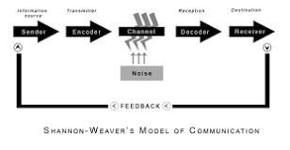

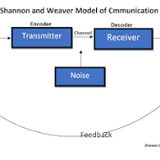
So, the Shannon weaver model is a model consisting of basic elements such as a source, encoder, medium, decoder, receiver, and noise. This model describes the way in which information flows from a sender to a receiver; thereby contrasting with a transaction model of communication which describes both the sender and the receiver engaging simultaneously.

Here is a typical example of the Shannon-Weaver model of communication: Thomson making a call to his assistant: “come here, I want to see you”.

During the call, some noise occurs as a transmission error, and the assistant can only receive: “I want”. The assistant then asked Thomson, as a feedback: “what do you want”.

Because of the transmission error due to noise, the assistant could not properly understand Thomson’s message. So, the noise clearly affected the communication flow between both parties.
The Shannon-weaver model clearly deals with external noises affecting messages or signals from external sources. For example, network problems occur can badly in network affect a mobile phone communication.

This model is specially designed to develop the effective communication between the sender and the receiver. At first, the model was developed to improve technical communication; and was later widely applied in the broad field of communication.
Unfortunately, in this model, the “noise factor” can badly affect the communication process.

Disadvantages
The Shannon-Weaver model of communication is one of the simplest model and which is generally applied into various communication theories. This model attracts both Academics of Human Communication and Information Theorist to leads their research in communication.
The Shannon-Weaver model is more effective in a person-to-person basis communication rather than a group or mass audience; as it is based on a a “Sender and Receiver” mode, whereby the sender plays the primary role and receiver plays the secondary and passive role.
A good and effective communication should not be a one way process, as it happens between two parties and should be interactive in order to avoid losing its strength. As a matter of facts, when an audience (or the receiver) listens to he radio, reads a book or watches television, there is no interaction, therefore no feedback.
The Schramm Model of Communication (1954)

The Schramm's model of communication perceives communication as a process between an encoder and a decoder, as per the below sketch . Most importantly, this model accounts for how people interpret the message they receive. Wilber Schramm who proposed his model of communication in 1954, argued that a person's background, experience, and knowledge are factors that impact their interpretation.

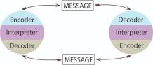

The Schramm communication model identifies five components that help explain the communication process. These components include the sender, the receiver, the message, the feedback, and the semantic noise. Information is of no use unless and until it is carefully put into words and conveyed to others. Encoding plays a very important role because it initiates the process of communication by converting the thought into content. When Wilber Schramm believed that when the information reaches the recipient, their responsibility is to understand what the speaker or the sender intends to convey. Unless and until the second party or the receiver is able to understand or decode the information, in terms of what the sender wants to communicate, then the message is of no use.

The following example, depicting a communication between two individuals, (Ralph and Ivo), will help us understand a bit more of the Schramm communication model.
Ralph to Ivo: “Will you accompany me for a walk in the park?”
Ivo did not respond to Ralph’s suggestion and so, kept Ralph waiting for a reply. Hence, the communication between Ralph and Ivo was not complete. If Ivo had no interest in going for a walk in the park, he should have responded back to Ralph or given Ralph a feedback about his non-interest.

According to Schramm’s model, whenever the information reaches the recipient, it ultimately becomes the receiver’s responsibility to give a feedback and let the communication initiator know whether the message was received and dealt with in the way the sender expected it to be handled. Should the receiver not understand the message, or have any doubts, they must ask the sender to be clearer or more specific. Thus when the speaker conveys any message to the listener, the listener, decodes the message and then sends a message back to the speaker after understanding it, hence completing the full circle.

Schramm believed that an individual’s knowledge, experience and cultural background also play an important part in communication. Individuals from diverse cultures, religion or background tend to interpret messages in different ways.
Another example to help understand the Schramm communication model, is that of this aristocratic man who was so full of himself, he would not great, nor would he speak to the common people of the village he lived in.
One day, his beautiful mansion was on fire and rapidly burning down. He went out there desperately calling for help, using a level of language the villagers could not understand. So, no-one came to his rescue and his house burnt to the ground.
The villagers were not on the common grounds with their aristocrat neighbour, so they could not understand or interprate the message sent to them by him. It was neither the aristocrat’s nor the villagers’ fault, but actually the differences in both their backgrounds which was to blame.

Disadvantages / Weaknesses

The Schramm communication model does not recognise that communication can be unequal. However, there are many circumstances where communication may involve one authority figure talking while one (or many) listeners are trying to interpret the message being passed on to them.

The Berlo Model of Communication (1960)
The Berlo model of communication consists of six stages:
The communications source, the encoding of the message, the message, the delivery method of the message, the decoding of the message, and the message receiver.
The Berlo's communication model stipulates that for an effective communication to take place, the source and the receiver need to be on the same level. Only then communication will occur.
David Berlo's model of communication known as SMCR is said to represents the process of communication in its simplest form, and based on four components. The acronym SMCR stands for Sender, Message, Channel and Receiver.
Each of the component and their various sub-factors must be closely aligned between the sender and the receiver for an effective communication.
In other words, Berlo’s SMCR model argues that the sender and the receiver must be synchronised for the communication to be effective.
Synchronisation occurs when a clear and concise message is transmitted by the sender which is then actively heard and interpreted by the receiver.
In this way, Berlo saw communication as a linear process made more successful when the skills of the receiver complemented or matched those of the sender

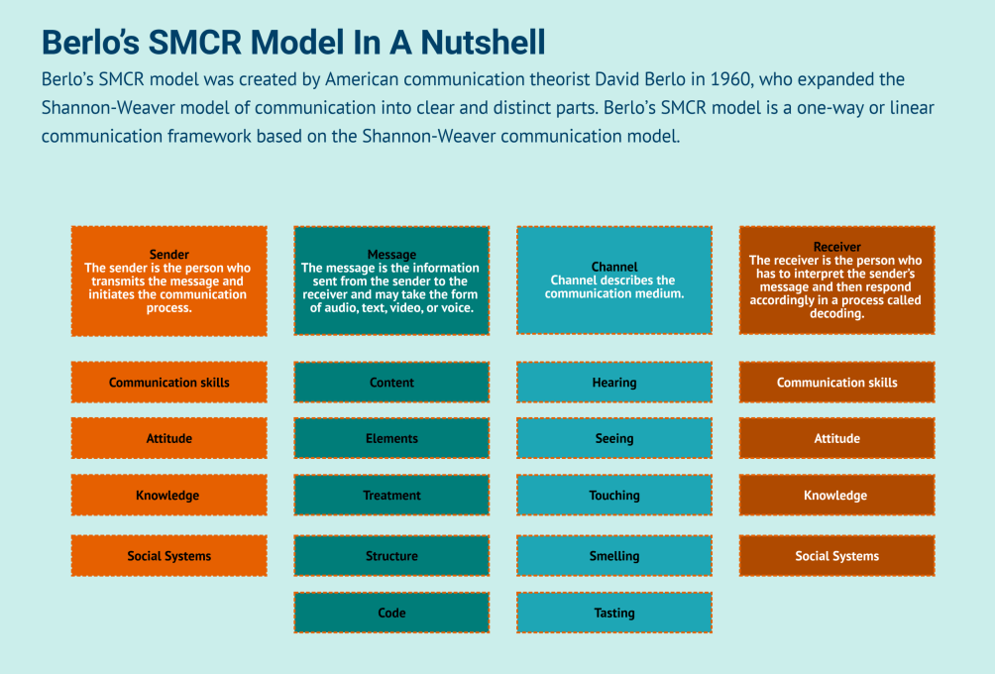

The sender is the person who initiates the communication process by transmitting the message, which is is the information sent from the sender to the receiver and may take the form of audio, text, video, or voice.

The following lines describe the five factors identified by Berlo in relation to the sender:

The communication skills, or the ability to utilise speaking, writing, listening, reading. This also include nonverbal cues such as body language, facial expression, intonation, and gestures are also used to increase communication effectiveness.

The attitude of the sender toward themselves, the audience, or the subject. Attitude, according to Berlo, influences the meaning and effect of the message sent.

Knowledge, or the level of subject familiarity the sender possesses when sending the message to the receiver.

Social systems, or any values, beliefs, laws, rules, or religions that impact the way the sender communicates.

Culture, as a difference in cultural background between the sender and the receiver can influence the way messages are interpreted.

The key factors affecting the message include:

The Content (or the information contained in the message from start to finish).

The Elements, (any non-verbal factors that accompanies the content, such as gestures and body language).

The Treatment, (which is how the message is passed on or delivered).

The Structure, (the way the message has been structured to increase its effectiveness

The Code, (this describes how the message is sent, and in what form).

On the other end of the sent message, the receiver is also characterised by the same five factors as the sender.

In theory, these factors should match or at least closely align for the message to be interpreted successfully.

Advantages of Berlo’s model of communication

Since it’s a linear communication model, it helps simplify how a communication strategy is structured.

Thus helping formulate a simple execution plan for a company’s communication strategy.

In fact, as often happens in the corporate world, many of these models are not supposed to be used to represent the real world.

So this is the advantage of Berlo’s model of communication; it’s simple.

Disadvantages

Berlo’s communication model does not consider noise’s impact on communication effectiveness.

This is a major drawback, as noise affects how a potential audience perceives the speaker’s message.

Noise can potentially reframe the message and make it perceived to the final audience in the opposite direction of what it was meant for.

And usually, noise can be of two types: external (or physical noise) and internal (or mental noise).

Understanding all the facets of noise within an environment is critical.

This understanding helps structure a proper message and understand how thorough this message needs to be delivered!

The lack of consideration for the impact of noise on communication is one of the major drawbacks of using Berlo’s communication model.

The communication skills

The communication skills used in the three of communication we studied, could be verbal, spoken or written.

The communication skills used could also be non-verbal - as in body language (gesture, facial expressions, posture, tone and pitch of voice, signals and signs)

The communication skills used could also be in a form of listening, which includes Active listening (paying attention and not doing other thing else), Emphatic listening (listening and trying to put yourself in the speaker’s place).

The disadvantages of Modern Technology

Today’s world is very technologically oriented. Technology is used everywhere (in schools, universities, hospitals, police and other emergency departments), and positively impact people’s lives. There is no such field in the world in which technology is not involved; the main purpose of technology being to make our work easier and help us carry out our work or other activities easily.

However, modern technology also has its disadvantages. Modern technology actually has lots of bad effects on human life. We do use technology happily, without realising or paying attention to its bad effects on our lives. The bad impact or disadvantages of modern technology on humans include things such as the dependency of people (young and old) on Technology, the wastage of money due to technology, which also causes serious health issues. Modern technology also caused a big surge in a lack of Interest in studying, as youngsters get more and more addicted to it. Technology also causes Environmental problems as well as social Isolation of the People.

Conclusion

Due to some unforeseen life circumstances, it could happen that we do not talk to some friends for a long while, and one of these days, we decide to give them a call her. We are happy to talk to each other and we take turns to update each other on things that happened to us since we stopped seeing each other, we update on what we planned for the weekend, summer or so, and how members of our respective families are doing. Then before we eventually hang up, we promise to chat again soon. Without realising it, we had engaged in a two-way system of communication; actually popularised as the Osgood-Schramm model, which is a two way street communication and which stands out the most, as it allows the two parties to be effectively engaged.

Non interactive communication can be ineffective and can lead to communication gaps, which causes confusion, waste of time, and reduces productivity. People in all walks of life should be able to interact clearly and effectively with each other through verbal communication and non-verbal communication to achieve specific goals; whether they are business or social goals.
Another important aspect of effective communication, and this time, in the workplace, is taking into consideration the different cultural backgrounds of employees or work colleagues.
While diversity enriches the environment, it can also cause communication barriers.

Reference

Kashyap, V, (2021) Effective Communication in the Workplace: How and Why?

Osgood-Schramm Model of Communication: Definition & Application

Schramm, W, The Process and Effects of Communication

Shannon, C and Weaver, W (1948) “Bell System Technical Journal” / “A Mathematical Theory of Communication” / “Shannon-Weaver model of communication”.
https://www.communicationtheory.org/shannon-and-weaver-model-of-communication/

Berlo, D, (2019)'s SMCR Model of Communication
https://www.communicationtheory.org-berlos-smcr

