BMSK4004
Mohammed Nazmul Ahmed (1805954)
Problem Solving and Decision Making
Tesco

Table of Contents
Executive Summary 2
1.0 Terms of Reference 3
2.0 Findings 4
2.1 Problem 1 5
2.2 Problem 2 5
2.3 Problem 3 6
2.4 Nature 6
2.5 Scope 7
2.6 Impact 7
2.7 SWOT Analysis 8
2.8 PESTLE Analysis 9
2.9 Stakeholder Analysis 10
3.0 Conclusion 11
4.0 Recommendations 12
5.0 Appendices 13
6.0 Acknowledgments 14
7.0 References / Bibliography 15

Executive Summary
This report considers the problems currently being faced by Tesco and how they can be tackled by using different theories such as the SWOT analysis, PESTLE analysis as well as the fishbone analysis also known as Ishikawa theory (1969). PESTLE stands for political, economic, social, technology, legal and environment. The report offers a detailed look into the issues Tesco faced in the past and problems they may face in the future. The theories will be analysed to consider the best possible outcomes Tesco can take to make sure there are no problems in the future and solve any problems more effectively and efficiently without suffering any losses. The report will look at the nature, scope and impact of problems Tesco has previously faced and the steps that could have been taken to solve the issues before escalating.

1.0 Terms of Reference
This report was requested by Laura James from the University of Wales Trinity Saint David. The report requested on 15th February 2019 for submission on 29th March 2019. This report was compiled by Mohammed Nazmul Ahmed, a student at the University of Wales Trinity Saint David attending Skills for the Workplace Diploma. The report was created to discuss the problems being faced by Tesco and what tools could be used to help Tesco to solve the problem. The different analysis was used to determine how the problems occurred and solved.

2.0 Findings

Research was carried out on Tesco’s problems and how they can solve the problems they currently face by using different theories. SWOT analysis, PESTLE analysis, the nature, scope, impact and the stakeholder analysis will be used to analyse and evaluate to solve the issues Tesco face and may face in the future. Tesco was formed in 1929 by Jack Cohen and business partner T E Stockwell. In 1929 their first shop was opened in Burnt Oak Edware. Following their success, Mr Cohen bought more land the following year to expand their new venture Tesco which was named using T E S from Mr Cohen’s partners and C O from Mr Cohen’s surname. As Tesco became popular, they decided to open the first self-service stores and supermarkets in the 1940’s and 1950’s which allowed them to offer a wide range of products. As the 1960’s approached, Tesco started facing some competition therefore, they decided to offer household products at lower prices than their competitors. This also prompted Tesco to think out of the box to make sure they are one step ahead of their competitors and this bought along green shield stamps. The stamps were given for every £1 spent and could be traded in for products of their choice. This was a strategy used to keep customers coming back and loyal to the company. By 1990’s Tesco had opened petrol garages, entered the electric goods market through Tesco Extra also announced a major expansion strategy into Europe, Ireland, Malaysia and India. In order to bring in new customers, Tesco came up with a ground-breaking loyalty scheme called Clubcard. This became a huge success as it saw five million new customers in the first year of launch. This success was apparent as Tesco overtook Sainsburys in market share. The 2000’s saw Tesco enter financial services, launching their ‘finest’ range also entering online market by allowing customers to shop online. By 2018, Tesco decided to merge with wholesaler Booker group to launch their new product named ‘Jacks’ with the message to bring tasting food at the lowest possible prices.

2.1 Problem 1
In 2013, Tesco faced a serious allegation of using horse meat within some of their ready-made meals. This impacted on Tesco hugely as there were many concerns in shoppers, can they trust the products sold by Tesco also this wiped £300 million off of Tesco’s market share as reported by Fletcher (2013) in the Guardian. This caused an uproar within the supermarket industry, many consumers felt cheated that Tesco were selling meals that contained horse meat. Consumers became on high alert and doubted other supermarkets such as Sainsburys, ASDA and Morrisons that they may also be selling products that contained horse meat. This scandal alerted FSA (Foods Standard Agency) and the Environmental Agency which caused Tesco to change suppliers as backed by Hodge (2013) which in turn drove the price up of the product in question and immediately remove all of these products from their shelves. They were in constant communication with the FSA to make sure that this issue never occurs again also monitored the new suppliers to meet their standards.

2.2 Problem 2
Another issue Tesco faced was an offer to triple your Clubcard points to have money off on train tickets was scrapped two months early which angered many shoppers as announced by Schraer (2018) and Blake (2018). This offer was very popular amongst many shoppers which in turn caused a lot of headlines in newspapers. This affected Tesco many ways such as customers looking at alternative supermarkets that give similar offers which resulted in loss of customers. However, Tesco decided to pull the plug on the offer early in order to bring forward their new plans for the Clubcard scheme. Due to the demand and the complaints Tesco received, Tesco decided to action by updating their Clubcard website by stating that they are working with their partner to bring back the offer in the coming days. Tesco realised they made a mistake by shutting down the offer early so they took the decision to bring back the offer.

2.3 Problem 3
Another problem Tesco has faced is the uncertainty of the quality of network provided to their mobile customers. This will have major impact on the existing customers as well as potential new customers. In December 2018, an article created by Snelling (2018) and reported in the Sun, Tesco’s mobile customers faced the daunting problem of not having any network on their mobile devices. In the 21st century, mobile devices have become an essential part of one’s life from keeping in touch with loved ones to surfing the net for the latest news and gossip. Without access to the net, a lot of people cannot carry out their day to day chores also there are people whose work revolve around using the internet therefore no internet means no work. Tesco use O2 as their network provider who had some technical issues which caused a lot of Tesco mobile customers to be without network. O2 issued a statement apologising for the outage however, this could have been catastrophic for Tesco as their customers may have been angered by the outage which resulted in them considering changing providers even though it was a problem caused by O2. Tesco could have considered changing network providers in a bid to make sure that they do not suffer from the same issue in the future also this issue could have been used as a good bargaining tool to get a better deal from O2.

2.4 Nature
The nature of the problems Tesco faces in the future will be discussed, as well as the problems currently being faced. As Sergi (2017) illustrates in his journal. On 23rd June 2016, a referendum took place for the UK to leave Europe widely known as Brexit. The referendum resulted in the UK to leave the EU by midnight on the 29th March 2019. This decision left many businesses stunned as to what would happen to businesses in the UK and businesses that operate throughout Europe. Tesco was one of many businesses that operate in the UK and in Europe. This is a problem being faced by majority of businesses as there is no indication as to what the outcome will be for businesses once Brexit takes place. There are many implications such as employment issues (immigration), cost of buying goods from European countries may increase, investors hesitating to invest into the UK market due to the uncertainty of Brexit, possible increase of taxes and changes to the legislations and laws. Brexit will have a massive impact on the way Tesco run their business. They will need to consider many factors from their product range all the way to number of stores currently operating in order to make a good profit. There are competitors that provide products same as Tesco at cheaper prices which means if Tesco cannot compete then they’ll lose a lot of revenue. Due to the unclear intentions of Brexit, Tesco have taken the decision to close down the deli and fish departments in their stores as well as cutting down on as much as 19,000 employees.

2.5 Scope
The scope of the problem will be analysed as to who is affected and how wide the problem reaches. First and foremost, the shareholders will be affected hugely due to the loss of sales which in turn affects the amount of profit made for them. Also, the employees will suffer as there would be a lot of redundancies due to the cost cutting strategy Tesco implement to save money and increase profits. Others that will be affected include, suppliers, investors, government, sponsors/partners and consumers. Brexit has had a huge impact on Tesco’s future plan as the uncertainty will affect many people linked to Tesco.

2.6 Impact
The impact looks at how the above have been impacted by the problem faced by Tesco. The impact shareholders will face from Brexit are the amount of profit they receive and also will deter other shareholders or investors from investing in to the company to move the company forward. This will stagnate the business and competitors will overtake to make more money. Investors will be very wary of investing money into Tesco because the question will arise, is Tesco making enough profit and what’s Tesco’s future profit/revenue projection. On the other hand, suppliers to Tesco will feel a huge blow to their revenues as Tesco is a multi-million-pound company that buys many millions of pounds worth of products from their suppliers which will need reducing because of closures of departments such as the deli counter and the fish counter as well as closure of stores throughout the UK. Consumers will feel the effects of Brexit when shopping at Tesco’s because the prices of fresh produce and most of the other products will see a rise in price directly affecting consumers. Therefore, consumers will look at alternative supermarkets such as ASDA, Sainsburys, Morrisons or even Aldi/Lidl who offer the same products or better at more affordable prices. This will have a huge knock on Tesco’s revenue and profits.

2.7 SWOT Analysis
A SWOT analysis was conducted to analyse Tesco’s strengths, weaknesses, opportunities and threats. “The SWOT analysis is used as a decision-making tool and to facilitate the development of a strategic plan” (Seth, 2015). It was identified, one of Tesco’s strengths in the supermarket was, they provided a wide range of services from retailing to online shopping, providing bank services to selling insurance. Tesco had the knowledge and shares in different markets. This was a major strength to Tesco as these were many ways Tesco were making money and if the retail side of their business was not doing well but their financial side was doing well then therefore, they would be able to balance their books. This also enabled Tesco to capture/enter markets which may have better profit margins also this allows them to increase their customer base as there may be customers who do not use Tesco stores but buy Tesco’s insurance. On the contrary, this can be a major weakness to Tesco because they are entering a market that is not well known to them also, they would need to hire experts which know the industry well, costing them a lot in salaries. A way Tesco can turn this weakness into an opportunity is by possibly looking at what other competitors are doing in terms of expanding and consider going into the market before their competitor in order to get the edge on them. This opportunity can give the upper hand to Tesco to expand their portfolio over their competitors and start making more profits for their shareholders. However, Tesco will face some threats when trying to expand on their current portfolio. These include competitors also expanding to keep up with Tesco, the expansion may fail and possibly investors may withdraw their investment as they believe Tesco are setting goals out of their reach. These threats can be avoided, Tesco would need to put together a lucrative business plan to make sure investors are on board and carefully plan which market they intend to enter.

2.8 PESTLE Analysis
Another analysis used to analyse Tesco’s problems was the PESTLE analysis. PESTLE is an acronym for political, economic, social, technology, legal and environment. This analysis looks at the ways an organisation is affected politically e.g. Brexit, economic eg. Banks/investors, social e.g. Demo graph of customers, technology eg. New technology, legal e.g. New legislations and environment eg. Environmentalists. Del Marmol (2015) believes “allow the manager to better anticipate the strategic decisions needed to ensure the proper development and sustainability of the business”. An in depth look at three of the areas were undertaken. These were political, technology and legal. Due to the uncertainty of Brexit, this has impacted the supermarket industry hugely. Prices of products and fresh produce from European countries are likely to see a price increase as published on market-inspector.co.uk (2019), which will affect consumers who will pay a lot more for their shopping and therefore, customers will look at alternative supermarkets for their shopping. Also with Brexit, it is unclear whether European residents will be allowed to work in the UK without a visa, therefore, Tesco will have to adhere to the new rules that come in place and probably make a lot of redundancies to those who are not allowed to work in the UK causing Tesco to close many stores due to the shortage of employees backed by McLeod (2017), however, it is argued by cipd.co.uk (2019) that since the vote for Brexit, employers are looking to increase staff and not reduce them. As technology advances day by day, this creates a problem for Tesco. Keeping up with technology advancements has become a challenge for Tesco as it can be costly also, there are many threats of software’s being vulnerable to cyber-crime causing all sorts of issues from customers personal data being stolen to viruses installed on to the software. As the UK leave the European Union, UK will have the power to change any legislations they do not agree with. This could impact Tesco as new laws would need to be complied with otherwise breaking the law can land Tesco a hefty fine as well as tarnish the brand name if the media get hold of the news. The laws include trading with European countries, laws testing products bought in from other countries and product specifications.

2.9 Stakeholder Analysis
As part of the report, a stakeholder analysis was carried out on Tesco’s. This identified who affects or is affected by the achievement of Tesco’s objectives backed by Freeman (1984). For example, employees are stakeholders of Tesco’s because without any employees Tesco would not be able to operate and expand their business. Stakeholders are broken down into four groups which are primary, secondary, internal and external. Primary stakeholders have a direct, official or contractual relationship with the organisation. A secondary stakeholder is everyone else such as customers. Internal stakeholders are the people within the organisation who help the organisation to run such as employees, shareholders and managers. External stakeholders are everyone outside the business but have a great impact on the business such as customers, suppliers and banks. As Lewis and Williams (2008) explains, in 1991, Mendelow created a power/interest matrix which identified how important in terms of power and interest a stakeholder has in an organisation. For example, a shareholder would have a strong interest and possess a lot of power in an organisation whereas the community may not have much interest or power in the organisation’s affairs. The matrix helps companies like Tesco’s identify which stakeholders have huge and little impact on the running of their business and help get closer to stakeholders who may not have much interest to boost their revenue, see appendix 1, however Grundy (2001) believes stakeholder analysis’s can be developed further. Using a power/interest matrix, Tesco will be able to narrow down stakeholders who might be a strength, weakness, a threat or create opportunities for the organisation as appendix 2 displays.

3.0 Conclusion
This report looked at the problems Tesco are facing and faced previously. After conducting a thorough analysis using the different models available such as PESTLE, SWOT, Nature, Scope and Impact, it was agreed that Tesco could have solved these issues effectively and efficiently if the models were considered. The models help organisations such as Tesco to locate and solve any issues that have risen and ways you could prevent them by looking at PESTLE. PESTLE analyses different areas that problems could occur from such as political and economic. Using SWOT can help Tesco discover where their strengths are, weaknesses lie in, threats may arise and any opportunities to come their way. Looking at the nature, scope and impact will help Tesco’s from stumbling upon any more problems that may appear or have the right strategy in place to counter the problem. Another analysis undertaken was the stakeholder analysis. This analysis helps identify all stakeholders related to Tesco’s also the matrix created by Mendelow (1991) helps Tesco’s to establish who has interest and power in the organisation. To conclude the report, it is believed that Tesco would have profited if they had taken the models into consideration when faced with these problems by being able to pinpoint exactly where the problem originated.

4.0 Recommendations
For Tesco to have better decision making for future problems, they could possibly look at other models such as the Ishikawa theory which is also known as the fishbone theory. This allows organisations to get to the root of the cause before the problem escalates any further. Here’s an example Tesco can use to help them with their problem. 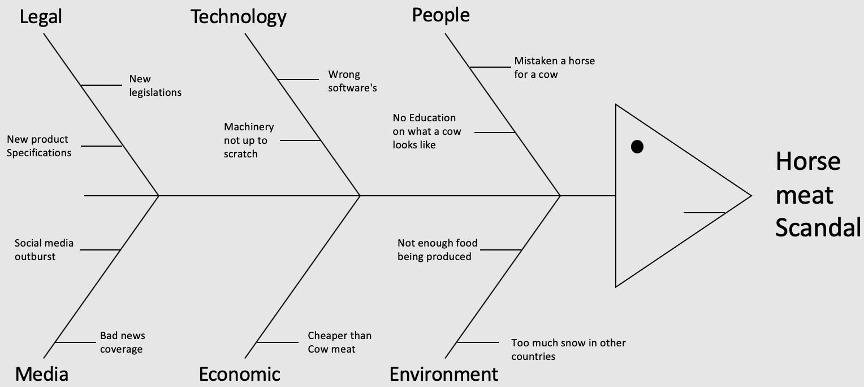
Another option Tesco’s decision makers can use to avoid any future problems and resolve the issues would be to use the five why’s theory to distinguish the problem. This theory can give several outcomes which is a positive as you can see the different outcomes and see which one has the most effect on the business and come up with a solution to solve the rising problem.
Five Whys? 

5.0 Appendices

Power/Interest Matrix
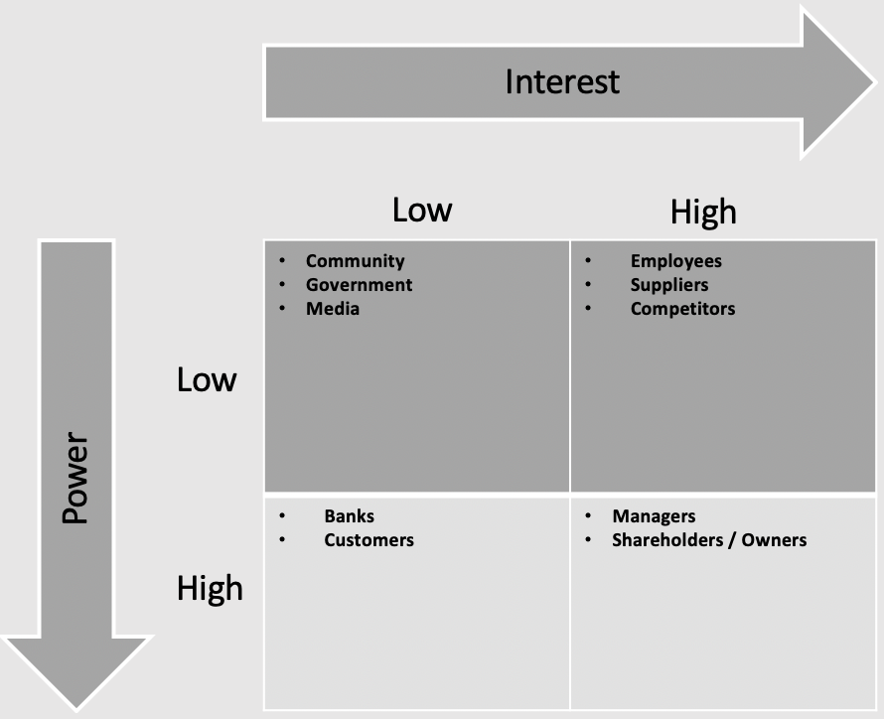
Appendix 1 - Power/Interest Matrix
SWOT analysis on stakeholders
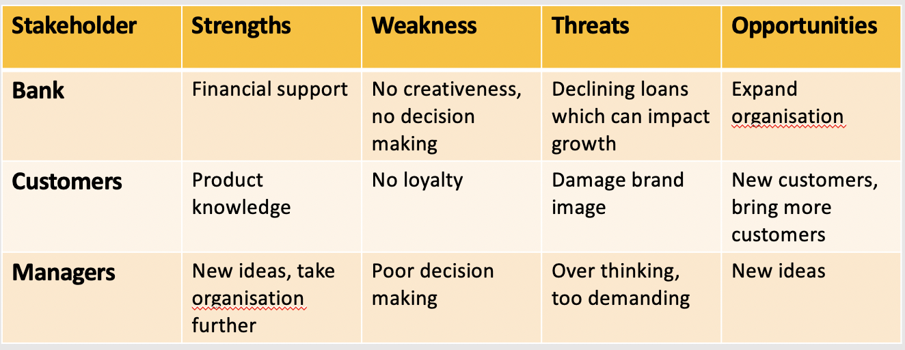
Appendix 2 - SWOT analysis

6.0 Acknowledgments
In creating this report, a lot of help and resources have been provided by Laura James a leading lecturer at the University of Wales Trinity Saint David as well as support provided by Beth Downing a study support lecturer. Also, a big thank you to the internet for providing many resources of information to help complete this report on problems faced by Tesco’s.

7.0 References / Bibliography

Blake, I. (2018). LOYALTY CULL Anger as Tesco pulls RedSpottedHanky Clubcard offer TWO MONTHS before planned axe. The Sun. [online] Available at: https://www.thesun.co.uk/money/7837038/tesco-pulls-redspottedhanky-clubcard-offer/ [Accessed 25 Mar. 2019].
CIPD. (2019). Workforce trends: the impact of Brexit | CIPD. [online] Available at: https://www.cipd.co.uk/news-views/brexit-hub/workforce-trends [Accessed 27 Mar. 2019].
Fletcher, N. (2013). Horse meat scandal wipes £300m off Tesco's market value. The Guardian. [online] Available at: https://www.theguardian.com/business/marketforceslive/2013/jan/16/horse-meat-tesco-market-value-shares [Accessed 24 Mar. 2019].
Freeman, R. E. (1984). Strategic Management: A Stakeholder Approach. Boston, Pitman.
Grundy, T. (2001) Competitive strategy and strategic agendas. Strategic Change, 10(5), p.247.
Hodge, K. (2013). Horsemeat scandal: Tesco drops burger meat supplier after 'breach of trust'. Independent. [online] Available at: https://www.independent.co.uk/news/uk/home-news/horsemeat-scandal-tesco-drops-burger-meat-supplier-after-breach-of-trust-8472183.html [Accessed 24 Mar. 2019].
Ishikawa. K. (1985). What is Total Quality Control?, Prentice-Hall Inc., Englewood Cliffs, NJ.
Market-inspector.co.uk. (2019). Impact of Brexit on Businesses in the UK | Market-Inspector. [online] Available at: https://www.market-inspector.co.uk/blog/2016/10/impact-of-brexit-on-businesses-in-the-uk [Accessed 27 Mar. 2019].
Marmol, D, T. and Feys, B. (2015) PESTLE Analysis: Understand and Plan for Your Business Environment. Namur: Lemaitre Publishing.
McLeod, A. (2017). We are going to face a massive employment crisis after Brexit. [online] The Independent. Available at: https://www.independent.co.uk/voices/brexit-employment-eu-workers-small-businesses-recruitment-crisis-a7838711.html [Accessed 27 Mar. 2019].
Mendelow, A. (1991). Stakeholder mapping. Proceedings of the 2nd International Conference on Information Systems, Cambridge, MA.
Qerimi, Q., & Sergi, B. S. (2017). The nature and the scope of the global economic crisis’ impact on employment trends and policies in South East Europe. Journal of International Studies.
Schraer, N. (2018). Anger as Tesco unexpectedly pulls top Clubcard offer. MSE News. [online] Available at: https://www.moneysavingexpert.com/news/2018/11/confusion-as-tesco-clubcard-suspends-top-offer/ [Accessed 24 Mar. 2019].
Seth, C. (2015). The SWOT Analysis: A Key Tool for Developing Your Business Strategy Lemaitre.
Snelling, D. (2018). Tesco Mobile DOWN - 4G network NOT WORKING as customers face issues getting online. The Sun. [online] Available at: https://www.express.co.uk/life-style/science-technology/1055087/Tesco-Mobile-4G-down-not-working-data-connection-issues-outage [Accessed 24 Mar. 2019].
Williams, Wil & Lewis, Duncan. (2008). Strategic management tools and public sector management. Public Management Review.

