Dylan Hocking (2312757)
2312757@student.uwtsd.ac.uk
Software Engineering Design and Testing
Software Engineering Principles and Testing (ACCB5030)

Table of Contents
1. Introduction 2
2. Evaluation of Design 2
3. CRC cards 3
4. Software Testing Evaluation 5
4.1. Black and White Box Testing 5
4.2. Black Box Tests 6
4.3. White Box Tests 6
5. Application for Unit Testing 6
6. Conclusion 7
References 7

1. Introduction
The task the author had was to work in a group to design a game of Battleships with two extra rules. The first rule is that once per game each player can use a drop bomb which will destroy a ship if it hits one. The second rule is once per game each player can use a counter manoeuvre to move a ship into one space in any direction to doge an attack from the opponent. This will count as a near miss which the player needs to inform their opponent about. The author will discuss and evaluate the design that the author’s group has created, this will include their User Stories and their Class Responsibility Collaboration (CRC) cards. The author will discuss types of testing like black and white box testing and unit testing. They will also describe the black and white box tests that they would do on this Battleship game.

2. Evaluation of Design
The design of the game of Battleships the author’s group was tasked with creating was created using User Stories. How the author’s team approached the User Story mapping was using an inbuild template which made the structure of the map tidy. The user's activities are short and clear on what the main flow the user is going to take through the game. The user tasks that the group created outline the main tasks the user will be doing throughout the game. While creating the map for the User Stories, there was not enough commutation in the group, so each group member had their own thoughts on what the user's activities and tasks should be. Which caused some confusion with other members when creating User Stories. The overall design of the user stories is clear with what each story wants to do and why. There are also User Stories which describe the same feature but are worded differently which is unnecessary.
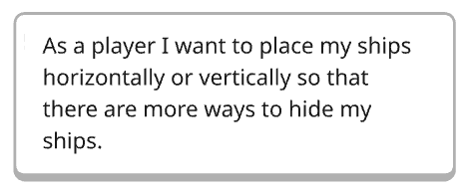
The User Story above is beneficial because it will let players place their ship in a lot of different coordinates and rotations. This also will make ships harder to find for the other player. This is important because it will make the players more interested in the game so they will play the game more.
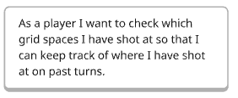
This User Story is important because it will allow the players to check where they have shot their past turns and if the shot missed or hit a ship. This allows them to concentrate more on the game instead of trying to remember where they have shot before. In the design of the User Stories, there is no user story about seeing where the opponent has shot at. The User Story the author would add is: As a player, I want to check which grid spaces my opponent has shot at so that I can know how close my opponent is to sinking my ships.
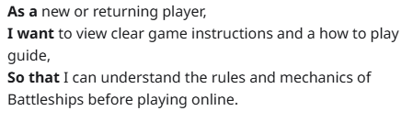
The benefits of the above User Story are that players new to Battleships can learn the rules of the game. This version of Battleships does have new rules added to the game as well, so instruction of how those new rules work is helpful for players who have played the original game before as well.

3. CRC cards
The author’s group found classes that the game needed by looking through the User Stories that they created. The group came up with eight classes to make the game work they are Player, Board_Grid, Ship, Game, Coordinates, TurnManager, SpecialAction and ScoreManager. The overall design of CRC cards that the author’s group created using the classes that they came up with the design is clear on what each class’s responsibilities are and what class they need to collaborate with. One weakness of the design is that the names of the classes do not follow just one naming convention, this could cause confusion.
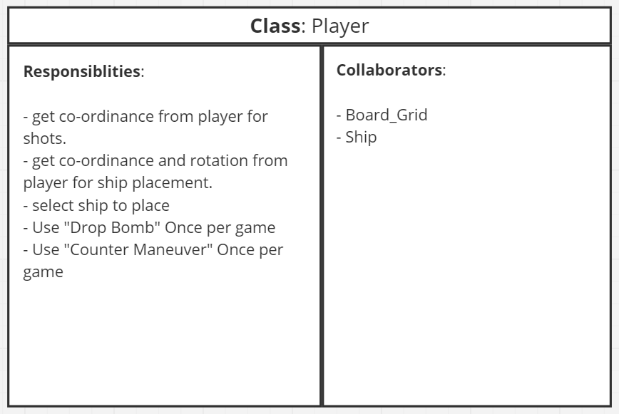
The CRC card for the Player class does describe the main responsibilities that the player will do when playing the game. Each of the responsibilities that the card describes can be turned into a method for the class. The Player class needs to collaborate with the Board_Grid class so the player can look at the grids to know where they have hit in the past and to check where their opponent has hit as well. This class also needs to have access to the ship class to selects ships to place them. The Player class is missing collaborator to the SpecialAction class which could cause the problem that the player cannot use their special actions.
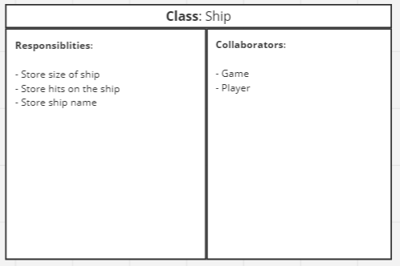
The Ship CRC card describes what the Ship class will need to store this is because this class will not need to do anything its only responsibility is to store information of the ship. For example, the size of the ship, where the ship is located and how many hits have landed on that ship. The ship should collaborate with the Player class is to let the ship know which player owns that ship. The ship also needs to let the Game class know if that ship has sunk so the Game class can keep score.

4. Software Testing Evaluation
Software testing is very important as you are making sure that the program is working as expected and no bugs are appearing. Testing is a step that should be considered throughout the entire process of making a program. So programmers can use test driven programming which is about writing tests and then coding software to pass those tests. The term testable code mean code that is how easy is the code to test which can involve lessening code being tightly coupled together as this makes it hard to unit test which is about testing smaller parts of code. Testable code will also help with keeping the code maintained and easy to modify when necessarily. But developers should not let making code testable be the main factor when writing code as this can lead to a decrease in quality in the code. To keep testable code, you must observe the code to check the change that happen. Testable code is making tasks that are repetitive into smaller functions and making the setup for the test simply like if the code needs a database or any variables have a function to create a test database or variable [1].

4.1. Black and White Box Testing
Black box testing means when testing a program, the testers do not know what the code is doing or how the code it does things. This type of testing can find bugs in the program fast but not what is causing the bugs as the testers do not know what is happening in the code to make the program work. This testing method will also test the usability of the program, and if the program has a graphical user interface, black box testing will test that as well [2, pp. 80-81]. A upside of black box testing is that the testers do not need to know how to program. Downside of black box testing is that it's difficult to know how much of the code will be covered in the testing [3]. An example of black box testing is beta testing for games as the people who play the game do not know the code behind the game.
White box testing is when conducting this type of test, the tester should know how the code works this will allow the testers to test parts of the program that they know need to be tested. Testing like this will help understand what the bugs are and what are causing them. While white box testing testers need to keep in mind to test the behaviours of the program and be less worried about how the program does the behaviour. Testers also would know boundary inputs for the decision in the program [2, p. 81]. There are different ways to white box testing, example ways are path coverage, loop, integration, unit and mutation testing. The benefits of white box testing are that it can make sure all the code will be tested and will allow developers more understanding of the code which they then can use to improve the code. Some of the disadvantages of white box testing are that it needs the testers to have knowledge of how the code works this also increases the complexness of the testing as testers need to look in depth into the code [4].

4.2. Black Box Tests
To black box test this Battleship game the author would at least have two testers who have player the original Battleship game and at least two testers who have not played the original game before or have only played the original game a small number of times. The testers who have played should have a game against each other, then the testers can compare this new version of Battleship with the original game. The testers who have not played will go against each other to test how friendly is this Battleships for new players.

4.3. White Box Tests
To white box test this program testers who understand the code of the game will be needed. A test that is needed is to test the ship placement stage which they need to test if ships can be placed horizontally and vertically. They also need to test if the ship is not in a valid place like out of bounds or the ships are overlapping. So to test this place one to the ships in horizontally in bounds and one ship vertically touching the edge of the grid as a perfect case for ship placements. But to test the invalid placements try to place one ship slightly outside of the grid, next try to place one ship on a grid space which already has a ship placed on it, these tests should not allow the player to place the ships and let them try to place them in a different space.
Another white box tests that they should have is to test the special actions like the drop bomb and counter manoeuvre. With the drop bomb they need to test that it hit as ship and destroys it, the drop bomb missing by landing on an empty space and then test to try to use the drop bomb a second time which should fail. To test the counter manoeuvre, they need to test that when using the special action, the ship should move out of the way of the shot and then a message saying it was a near miss. They also need to test when moving using the counter manoeuvre the ship cannot move outside of the grid and the ship cannot move on to a space which already has a ship on it.

5. Application for Unit Testing
Unit Testing is a means to test smaller parts of code called units these can be a function, class or method. As developers will test each unit separately it makes sure that each unit works how it is supposed to. Unit testing also are normally written before developing any code this is done so developers can use the tests to guide them through the coding process, which can help the developers write testable code. Writing tests before can also help finding bugs early in the development process this allows developers to fix the bugs quickly, so the bugs do not affect different parts of the code which makes the bugs more complex to fix. Unit testing is also useful as it can be used for documentation for how the program is expected to behave [5, p. 271].
Unit testing can be used to test the methods in the class for the special actions this then can be tested faster as testers do not have to play through the game and then restart the game to test other outcomes of the tests. They could also unit test a single player turn by testing the Player class to check the player can do everything that they need to be able to do. Another place unit testing can be used is in the ship placement stage which they then can just reset that stage do to test more outcomes for placements.

6. Conclusion
In conclusion the author has worked in a group to design a version of Battleships by using User Stories and CRC cards. They have mentioned why software testing is so important and what the term testable code means as well. The author has also written about black and white box testing and what test they would perform on the game. They have also written about unit testing and how they would use it with the white box tests that they came up with for this program.

References
[1] K. C. Dodds. "Good Code, Testable Code." Accessed: May 5 2026. [Online]. Available: https://www.epicweb.dev/good-code-testable-code
[2] Nataliіa Golіan, Vira Golіan and I. Afanasieva, "BLACK AND WHITE-BOX UNIT TESTING FOR WEB APPLICATIONS," no. 1, pp.79–83, 2022, doi: 10.20998/2079-0023.2022.01.13.
[3] "What is Black Box Testing." imperva. Accessed: May 4 2026. [Online]. Available: https://www.imperva.com/learn/application-security/black-box-testing/
[4] C. Staff. "What Is White Box Testing?" Accessed: May 4 2026. [Online]. Available: https://www.coursera.org/articles/white-box-testing
[5] D. Danilov, REFACTORING WITH C++ : explore modern ways of developing maintainable and efficient applications, 1st Ed. Birmingham, UK: Packt Publishing Ltd, 2024.

