Jessica Dando
UWTSD – Undergraduate


Assignment Two

Critical Examination Report

Airbnb & The Sharing

Economy
Table of Contents
1.0 Introduction 2
1.1. The platform 3
2.0. Airbnb and the sharing Economy 5
3.0. Airbnb Business Model 5
3.1. Airbnb Business Model Canvas 7
4.0. Strategic Formulation Framework and the Grand Strategy Matrix for Airbnb 7
4.1. Strategic Formulation Framework - GSM 9
4.2. Disadvantages of the SFF and GSM 12
5.0. Conclusion 13
Bibiliography

 and The Sharing Economy

Introduction

Airbnb is an online community marketplace that connects owners of residential properties with travelers, who are interested in short-term rentals. Their story started in 2008, when founders Joe Gebbia and Brian Chesky (later joined by Nathan Biecharczyk) set out to solve the problem of affordability for rental properties in San Francisco, California - where properties are notoriously expensive to rent. They started by setting up a simple website, with a map and rented out three mattresses and offered breakfast. At first, three people arrived, and they realized they had stumbled on something that had potential. After that initial rental, they improved their website, took high quality photographs and began their journey towards the creation of Airbnb, which is now the world’s biggest online travel company. (Dolcinar, 2018)

Since filing for IPO, their estimated valuation, according to Carville et al (2020) is a massive $100 billion. Despite some setbacks and losses relating to the Coronavirus pandemic, their valuation and worth remains high. (Ali, 2021)

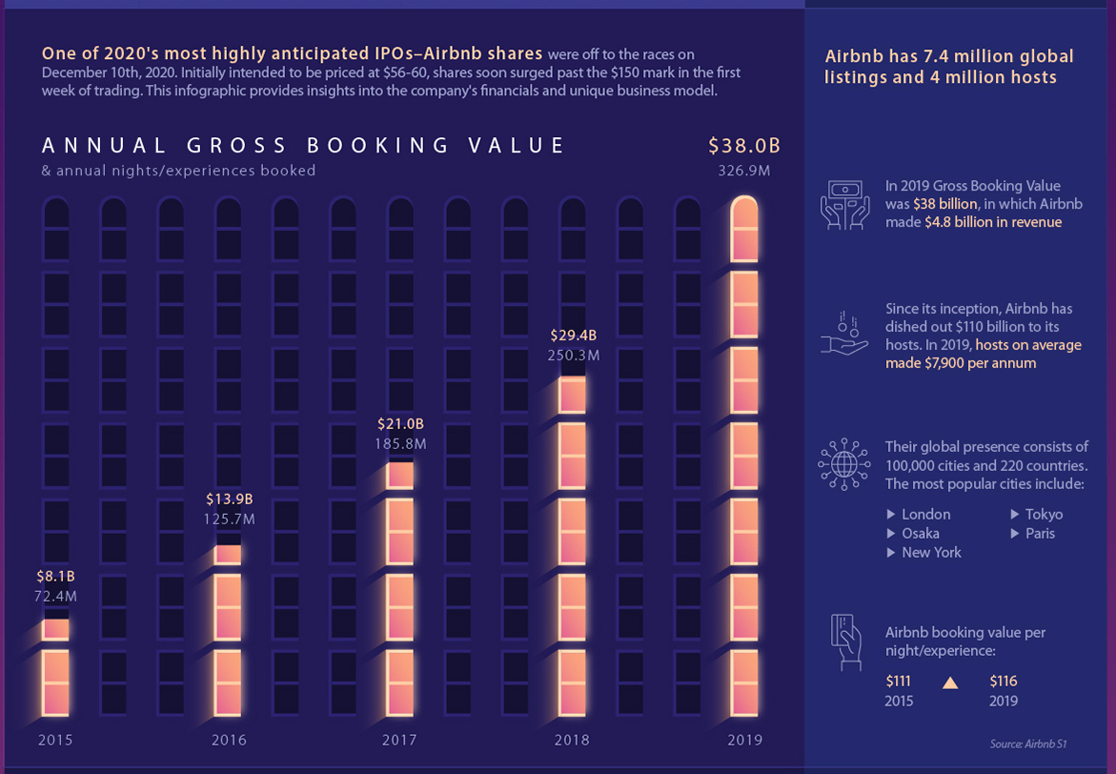
Fig 1 Taken from Ali (2021)

The platform

The C2C platform from Airbnb enables hosts to collect rent money, when a traveler selects their listing. The site offers consumers a variety of different lodgings in different locations and price ranges. Airbnb and their organization has grown so rapidly, that theorists have named their business model a ‘phenomenal disruptive innovation’ (Mabu, 2019)

According to Tabari (2019) The emergence of peer-to-peer based business models have recently led to the creation of larger numbers of ‘micro-entrepreneurs’ enabling them to utilize their unused properties as avenue to make an income and utilize their spare time. But this new wave of entrepreneurialism, and the rapid growth of Airbnb’s platform, is said to be a threat to the hotel industry (ibid)

Technology is the key driver for the development of Airbnb because it enables their operation, which relies on online transactions (Daugherty, 2016) For instance, Airbnb communicates with its guests mainly through online channels, such as social media, websites and apps (Oskan et al, 2016) Theories regarding the success of Airbnb’s business model suggest that the economic crisis and advances in technology have been the catalyst for their growth and success (Scholand & Straaten, 2015)

According to Kaplan and Haenlein (2010) The development of information technologies, as well as the growth of Web 2.0 has led to the development of online platforms that promote content generated by the user, as well as the collaboration and sharing that shapes the modern marketplace. Airbnb is at the forefront of what is termed the ‘Sharing economy’ where people view assets more as resources, that can be shared as opposed to personal belongings (Jasper, 2015)

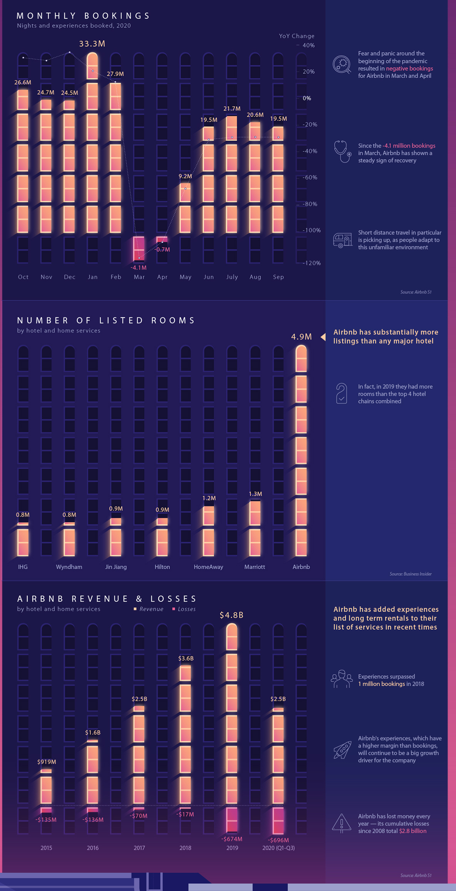
Fig 2. Ali (2021)

Airbnb and the sharing Economy

Kathan et al (2016) suggests that the innovation in digital technology makes the sharing and accessing of products convenient and transparent, on a much larger scale than before (Cohen & Kietzmann, 2014) There has also been a shift in what people value as important, the sharing economy and the new digital environment has become less about physical products and more about ‘virtual’ attributes such as knowledge (Garcis, 2013)

Digital technologies play a very important part in the sharing economy, and reduce the cost of transactions, it also opens up possibilities to overcome distance, between multinational enterprises and markets (Nachtum & Zaheer, 2005)

Online collaborative commerce is based on peer-to-peer interactive platforms and are defined as a form of balanced trade, that utilizes Web 2.0 and supports social interactions and user contributions to engage in buying and selling products and services (Wang & Zhang, 2012)

Some argue that the sharing economy is not actually based on sharing, but on the use of information technology to take advantage of the inefficiencies in the marketplace and compete on price. Eckhardt & Bardhi (2016) suggest that the sharing economy is nothing more than a more efficient pricing system.

Airbnb Business Model

The emergence of the concept of the business model is still quite new, and is related to the diversification of traditional resources and processes used by organizations like Airbnb to provide value propositions for customers in valuable conditions (Barbu & Bratu, 2018)

The sharing economy enhances competition in traditional markets and integrates access to products and services. The success of the sharing economy and Airbnb demonstrates the viability of these peer-to-peer business models. Since many of the sharing economy initiatives are associated with innovation, Airbnb itself is a particularly strong example of that ‘disruptive innovation’ (Martin, 2016; Shor, 2014)

By allowing free membership and free access to list properties, Airbnb quickly overcame the initial mobilization hurdle and attracted a dedicated following of hosts and guests (Wu et al, 2013) they capitalized on their first-mover advantage by focusing on customer service, satisfaction and solidifying their reputation.

To establish this ecosystem, Airbnb used revenue from transaction fees to implement systems such as customer verification, million-dollar theft/damage insurance and authentic guest reviews and social interactions. All of these factors enabled Airbnb to create a sustainable and scalable business model, that has resulted in a rapidly growing and successful business. (Wu et al, 2013)

Airbnb’s model is referred to as a multi-sided platform, matching the guests with the hosts and vice versa, it creates value for both sides of the platform

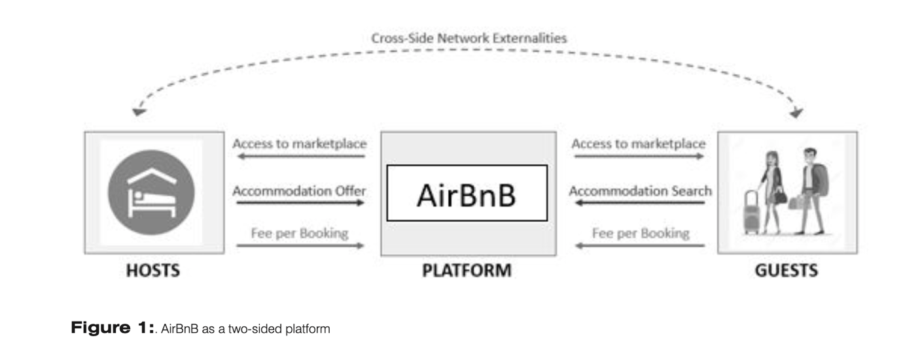

Airbnb’s platform can be seen as an online marketplace, the users interact directly with one another to complete the transaction and the platform provides regulatory and institutional framework for the transactions to take place. (Wu et al, 2013)

An important aspect of Airbnb’s business model is the fact that they can easily scale and adapt to different contexts. With Airbnb we can see that this makes it easier for them to scale considerably quicker than the more traditional models (Dreyer et al, 2017)

The disadvantages of a digital business model are that the activities of the organization in the sharing economy takes place on platforms, which makes it more difficult to gain trust from guests and hosts and for them to feel secure. In light of several incidents that have occurred in Airbnb properties, including a shooting and the damage of property, murder and may more incidents, organizations like Airbnb have to work much harder to gain legitimacy and then keep it, than other companies and economic models (Wu et al, 2013)

Airbnb Business Model Canvas

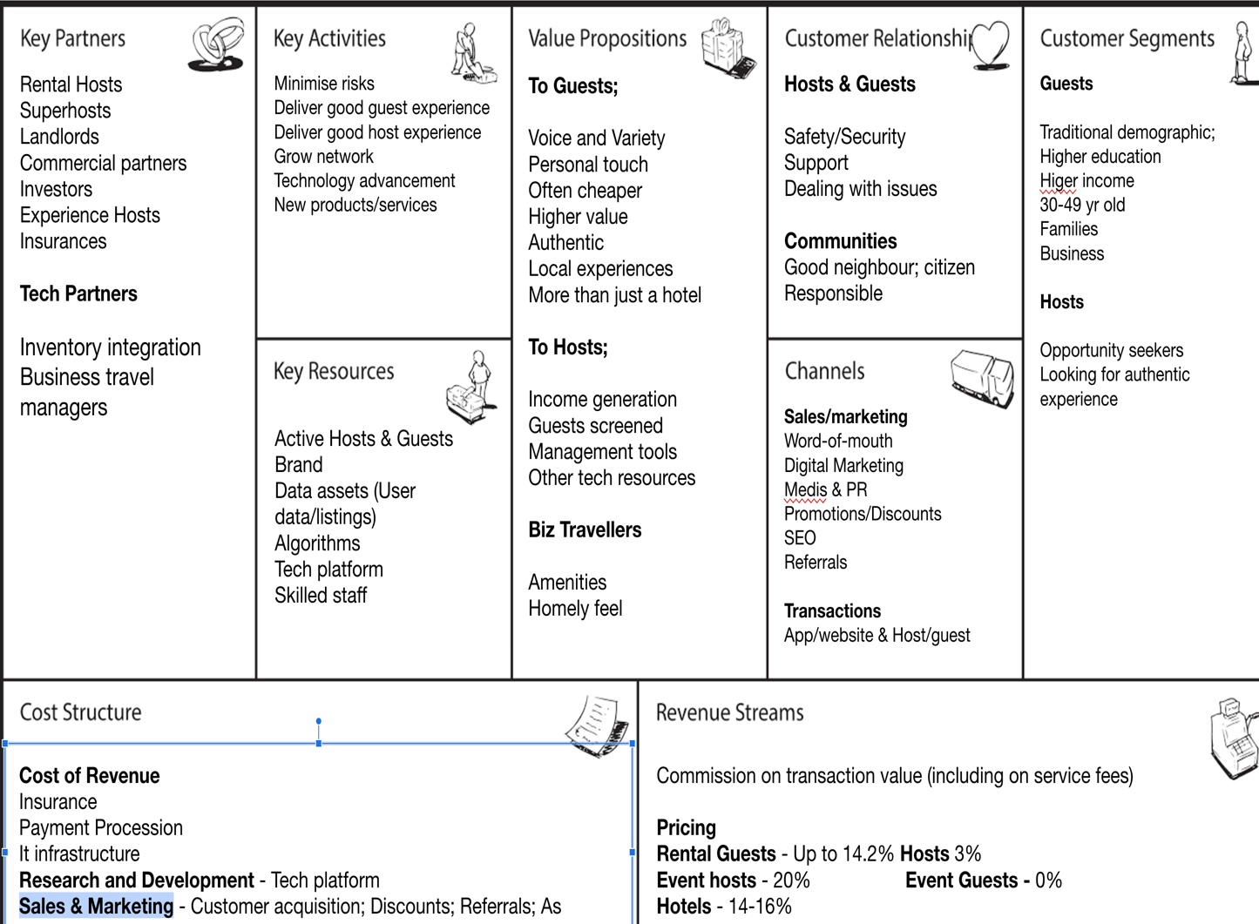

Strategic Formulation Framework and the Grand Strategy Matrix for Airbnb

With the opportunities that have that have been presented by the advances in technology, e-commerce has advanced immensely, enabling Airbnb to launch as a platform the operates entirely online up until when the guest arrives at the rental property (Zervas et al, 2017 p.87) Additionally, there is an increasing demand for mobile applications as well as the evolution of the mobile customer base. Both the popularity of e-commerce, and the development of smart devices has attributed to Airbnb’s rapid growth (MarketLine, 2018, p.14)

Airbnb predominantly operates three of Porter’s generic strategies which are: Differentiation, cost leadership and focus (Porter, 1980)

Airbnb also implements focus strategy in communities, setting up community centers that can connect hosts (Community center, 2018) They primarily use a planned strategy which they implement in the global market and also shift between planned and emergent. When they encountered safety issues and property damage which concerned hosts, they responded with the launch of host protection insurance (Airbnb, 2018)

The emergent strategy demonstrates how they dealt with the COVID-19 pandemic, which began in April 2020 and led to travel restrictions, which posed serious threats to their business (Mauguin, 2020)

By the end of 2020, data from the United nations World Tourism organization showed that 100 per cent of destinations now had travel restrictions in place.

Airbnb estimates, that because of the pandemic, its revenue for the year 2020 is likely to be less than half of the previous year. According to AirDNA, (2020) an outside tracker of Airbnb listings, hosts saw $1.5 billion in bookings dissolve for the month of March 2020 in the US alone, and they had to cut one fourth of their workforce, (around 1900 people)

The pandemic represents a huge challenge to the travel industry, According to Mauguin, (2020) Airbnb responded quickly to the crisis by highlighting the risks of travel on their platform, they then subsequently revamped their website in a matter of days. In order to keep their business going at this time, they decided to take their service online - through an online experience feature, Airbnb users could enjoy a range of activities that would normally be offered as part of a trip, from their homes. A simple and effective solution to some of the lockdown measures. (ibid)

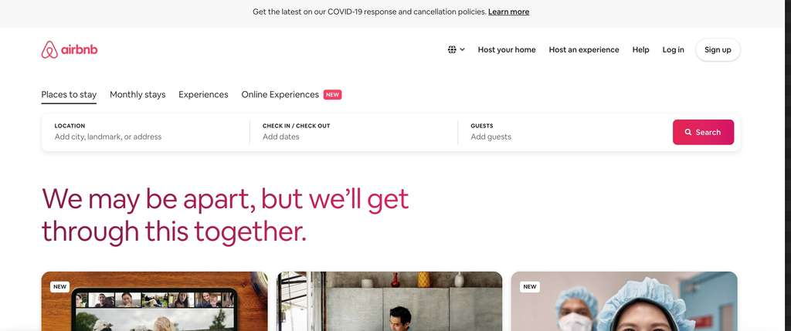

Above – Airbnb’s website in April 2020 (Maugin, 2020)

When reviewing digital strategy options, there will be a range of possible options and alternatives to be evaluated. Airbnb manages to integrate and utilize the following systems to enable their platform offers the most value for hosts and guests on the network (Chaffey, 2019)

eCRM system – lead generation (huge database of hosts and guests with verifications/reviews/contact details and more)
eCRM system – Customer Service management (Contact and communication for any problems/queries)
eCRM system – personalization of content for users (e.g., only showing specific suitable properties to guests and filtering for hosts too)
Partner relationship management for distributors, agents and social networks
(ibid)

Strategic Formulation Framework - GSM

The planning of strategy begins with the business defining their values and the mission of their organization, assessing both the internal and external environment and the strategic issues they face (Torlak & Sanal, 2007)

Strategy formulation techniques can be integrated into a model which has three stages, this helps strategists to identify and evaluate the correct strategies (ibid)

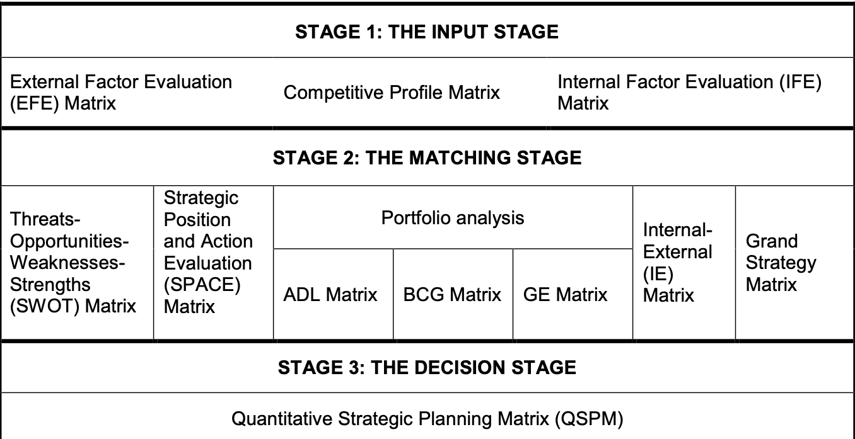

Fig 4 Above David (2007)

For the purposes of the report and the strategic analysis of Airbnb, the matching stage and Grand Strategy Matrix will be used.

The Grand Strategy matrix has become a popular tool for businesses for formulating suitable strategies, although some feel it is now outdated in a highly digital environment, many MNE’s still use it to help formulate and identify suitable strategies. Appropriate strategies for an organization to consider are listed in order of attractiveness in each quadrant of the matrix (David, 2007) Fig 5. Below

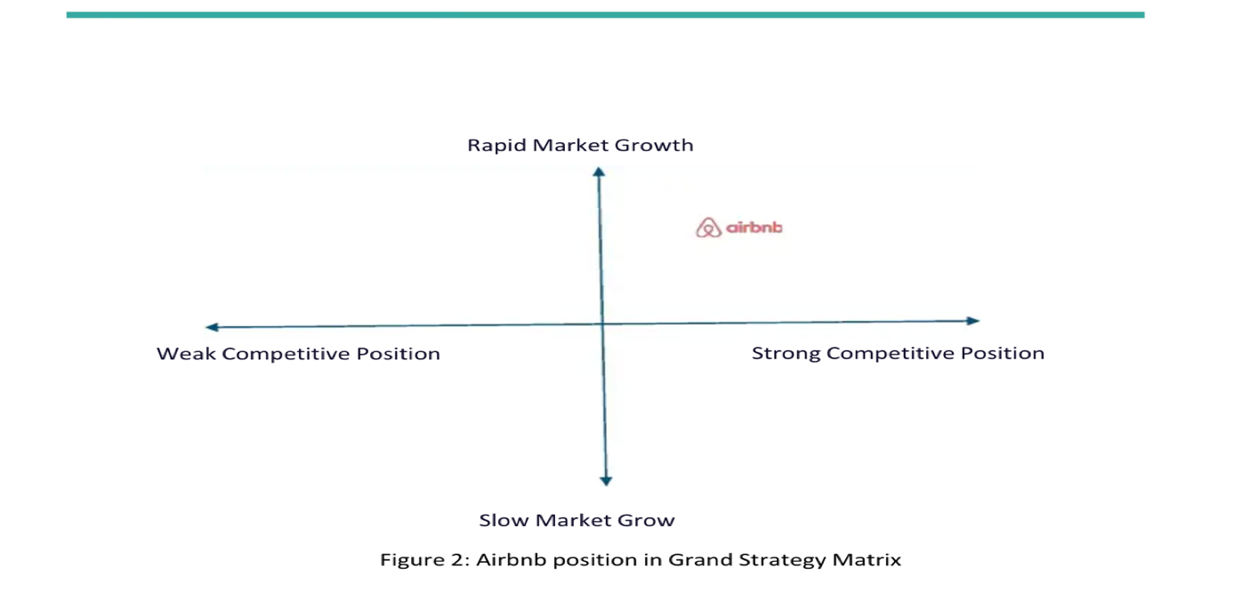

Fig 4 shows the positioning of Airbnb in Quadrant I of the matrix, although this would have to be adjusted for issues related to the pandemic, the strategy recommendations remain the same.

The following strategies are suggested using the matrix, as appropriate for Airbnb.

Forward integration
Airbnb owns no property, does not have control over hosts or guests. Gaining ownership or increased control over suppliers would strengthen their position.

Backward integration
Seeking ownership or increased control over business suppliers – Airbnb could place more emphasis on providing short-term rentals for business owners and by seeking ownership would enhance their position in this market.

Horizontal integration
Seeking ownership and control over competitors, such as hotels and Bed and breakfasts, would strengthen their position in the market, perhaps purchasing other online booking platforms would do this also.

Market Penetration
Seeking increased market share for present service and markets through greater marketing efforts

Marketing Development
Introducing products and services into new geographic areas, this could include China, where their market share is small and there are opportunities for advancement.

Product development
Seeking increased sales by improving services and products and developing new ones
(Their response to the COVID crisis, and introducing new online experience is a good example of this) they could also consider offering more exotic, high quality properties with additional security which would increase their market share within that sector.

Related diversification
Adding new related products and services - very much like product development, but to do with related products, such as the insurance for hosts.

Based on Airbnb’s position in the Grand Strategy Matrix, we can conclude that Airbnb, despite recent setbacks still have a strong position in a rapid-growth industry. Despite the industry suffering currently, Airbnb’s position has held steadily, and they have managed to use their innovative thinking to come up with temporary solutions to the problems. (Mauguin, 2020)

The COVID-19 pandemic has highlighted the fragility of many industries including the travel industry, and it will be interesting to observe the reactions from large travel operators and other digital businesses such as Booking.com, Kayak, Expedia and many more. If Airbnb continue their emergent strategies and diversify and enhance their products and services, they will continue to disrupt and innovate the industry (ibid)

The issues that Airbnb tend to face, aside from the pandemic, are issues that relate to safety, trust and regulations. Hosts and guests still perceive an element of risk involved in using Airbnb, and although insurances worth $1 million have addressed that, they still need to continue to work on building that trust and making hosts and guests feel safe.

Another issue they face is that or regulatory risk, there is a global economy, and with each country they operate in bringing in tighter regulation on short-term rentals, it is increasingly important for them to maintain their relationships with cities and regulatory authorities as well as adapt culturally to the diversity in the countries they operate in. (Zuckerman, 2020)

Disadvantages of the SFF and GSM

The disadvantages of the Strategy Formulation Framework and in particular the Grand Strategy Matrix being used for strategic analysis of Airbnb are numerous.

David (1986) points out, results of the GSM can only be as good at the information and matching analysis upon which it is based.

The strategic options available to Airbnb at any given point don’t always align with to the options available to the organization in adjacent quadrants of the matrix. (O’Reagan, 2012)

The GSM really does need to be utilized alongside other tools, as it is incredibly simplistic and it is often the case that an organization may operate in different quadrants with different products. It is not really detailed enough in relation to Airbnb, and doesn’t take into account different time periods, including past and future. For example, the quadrant Airbnb fit into during the pandemic, may well be different to the quadrant they were in prior to it, and again after, which makes the GSM an incomplete solution, applied to situations and environments that demand a more complex analysis (Lucidity, 2020)

Conclusion

Airbnb is certainly not a stranger to innovation; it has responded to world events with an emergent and adaptive strategy that reflects the innovation it is so famous for. From adapting quickly to the COVID pandemic, through to providing free accommodation during hurricanes, as well as launching campaigns that seek to tackle segregation, Airbnb knows how to adapt to the changing marketplace. (Mauguin,2020; Zuckerman, 2020)

In order to keep its strong position in the GSM and the business afloat during periods of uncertainty, Airbnb has to adapt and has done that by beginning to offer long-term stays as well as taking more of its services online. As well as rethinking its services to respond to emerging trends, Airbnb continues to use opportunities for growth and survival. They have set up global resource hubs that are dedicated to helping hosts secure bookings in a new environment.

One of their strengths is their ability to collect data, which they turn into personalization and insights. By focusing on local travel, longer stays and flexibility, Airbnb will continue to remain in Quadrant I of the matrix and retain their reputation as a disruptive innovator in an industry that has seen many hurdles over the last year especially. (Davis, 2019)

It is clear that Airbnb is not directly competing with hotels despite hoteliers perceiving them as such. The safety, cleanliness, and additional services offered by hotels are recognized as an advantage, so Airbnb needs to focus on those factors if they want to continue to compete.

The COVID-19 era may be a difficult time for Airbnb and an opportunity for the hotel industry, Airbnb must build loyalty programs and position themselves to be a safer and more rational choice for travelers. As safety risks as a concern, future travelers will be willing to spend more, and therefore price may not be the dominant factor it once was (Jun,2020)

The sharing economy and home exchange is a particularly new business model. Identifying incentives for tourists to choose Airbnb as opposed to traditional hotels and accommodations and the missing elements in both hotels and Airbnb could be useful post-covid for Airbnb enabling them to identify and formulate strategy which will allow them to retain their strong position in the marketplace.(ibid)

Bibiliography

68 Airbnb Statistics: 2020/2021 Market Share Analysis & Industry Growth | CompareCamp.com. (2021). https://comparecamp.com/airbnb-statistics/

Abrosimova, K., & Osadchiy, V. (2020). The Technology Stack Behind Airbnb. https://yalantis.com/blog/the_technology_stack_behind_airbnb/

Airbnb . 2019. Airbnb Hosts Share More Than Six Million Listings Around the World. https://press.airbnb.com/airbnb-hosts-share-more-than-six-million-listings-around-the-world[accessed online 3rd March 2021]. Available at: [Google Scholar]

Airbnb Inc. Report 2019 - Research-Methodology. (2019). https://research-methodology.net/airbnb-inc-report-2019/

AirBnB’s Environmental Impact: Should A Sustainable Traveler Stay with AirBnB?. (2020). https://www.getawaygirl.us/airbnb-environmental-impact/

Ali, A. (2021). Infographic: The Business of Airbnb, by the Numbers. https://www.visualcapitalist.com/the-business-of-airbnb-by-the-numbers/
Available at: https://digitalcommons.fairfield.edu/nealsb/vol37/iss1/1

Barbu, C., & Bratu, R. (2018). Business Models of the Sharing Economy (19th ed.). Review of International Comparative Management

Bardhi, F and M.Eckhardt, G, 2012. Access Based Consumption: The case of Car Sharing Journal of Consumer Research, 39, pp. 881-898

Barken, Marlene; Seaquist, Gwen; and Bramhandkar, Alka (2018) "AirBNB: A Digital Platform For Sharing Or Excluding?," North East Journal of Legal Studies: Vol. 37 , Article 1.

Chaffey, D. (2019). Digital Business and e-Commerce Management, Seventh Edition. Pearson UK.

Chang H-H, Sokol DD. How incumbents respond to competition from innovative disruptors in the sharing economy – The impact of Airbnb on hotel performance. Strategic Management Journal. 2020;1-22. http://doi.org/10.1002/smj.3201

Chen, J., Zhang, C., and Xu, Y. 2009. “The Role of Mutual Trust in Building Members’ Loyalty to a C2C Platform Provider,” International Journal of Electronic Commerce (14:1), pp. 147–171.

Chen, W., Wei, X., & Zhu, K. X. (2018). Engaging voluntary contributions in online communities: A hidden Markov model. Management Information Systems Quarterly, 42(1), 83–100.

Cheng M., Foley C. The sharing economy and digital discrimination: the case of Airbnb. Int. J. Hosp. Manag. 2018;70:95–98. [Google Scholar]

CHESKY, B 2013 Who we are and what we stand for. [online] Available at: http://blog.airbnb.com/who-we-are/
[Accessed 3rd March 2021]

COHEN, B and KEITZMANN, J 2014. Ride On! Mobility Business Models for the Sharing Economy. Organization & Environment, 27, pp 279-296.

Coldwell, W. (2014). Airbnb’s legal troubles: what are the issues? | Travel | The Guardian. https://www.theguardian.com/travel/2014/jul/08/airbnb-legal-troubles-what-are-the-issues

Cuafano, G. (2020). Business Strategy: Examples, Case Studies, And Tools - FourWeekMBA. https://fourweekmba.com/business-strategy/

Daniel Guttentag, (2019) "Progress on Airbnb: a literature review", Journal of Hospitality and Tourism Technology, https://doi.org/10.1108/JHTT-08-2018-0075

David, F. (1986) The Strategic Planning matrix – a quantitative approach. Long range planning, 19-95-195

Davies, P. (2015). Hotel firms invest in rivals to Airbnb. Travel Weekly. Retrieved from http://www.travelweekly.co.uk/articles/54735/hotel-firms-invest-in-rivals-to-airbnb.

Dolnicar, S. (2017). Peer to Peer Accommodation Networks. Goodfellow Publishers Ltd.

Douw, S. (2016). Business to Business Value Creation Through Airbnb’s Own Community Centre – Customer Engagement Management in Tourism. https://customerengagementmanagementintourism.wordpress.com/2016/10/09/business-to-business-value-creation-through-airbnbs-own-community-centre/

Edward Koh & Brian King (2017) Accommodating the sharing revolution: a qualitative evaluation of the impact of Airbnb on Singapore’s budget hotels, Tourism Recreation Research, 42:4, 409-421, DOI: 10.1080/02508281.2017.1314413

Eisape, D. (2020). Platform Business Models in Sharing Economy: Using A Balanced Scorecard Approach to Compare Airbnb, Marriott and Uber Business Model Canvases. Nordic Journal of Media Management, 1(3), 401- 432.
DOI : 10.5278/njmm.2597-0445.5824

Frandkin, A. (2017). THE CRITICAL ROLE OF DIGITAL MARKETPLACE DESIGN: EVIDENCE FROM AIRBNB (7th ed.). MIT Initiative on the Digital Economy

Goodheart, J. (2018). Airbnb: Can it be effectively regulated?. https://www.fastcompany.com/90318427/how-to-rein-in-airbnb

Guttentag D.A., Smith S.L. Assessing Airbnb as a disruptive innovation relative to hotels: substitution and comparative performance expectations. Int. J. Hosp. Manag. 2017;64:1–10. [Google Scholar]

Hagiu, A. (2009). Two-sided platforms: Product variety and pricing structures. Journal of Economics and Management

Harrison-Walker, L. J. (2001). The measurement of word-of-mouth communication and an investigation of service quality and customer commitment as potential antecedents. Journal of Service Research, 4(1), 60-75

Hein, A., Schreieck, M., Riasanow, T., Setske, D., Wiesche, M., Bohm, M., & Krcmar, H. (2019). Digital Platform Ecosystems (30th ed.). Electronic Markets
Hickey, S., & Cookney, F. (2016). Airbnb faces worldwide opposition. It plans a movement to rise up in its defence | Airbnb | The Guardian. https://www.theguardian.com/technology/2016/oct/29/airbnb-backlash-customers-fight-back-london

How Airbnb mixes politics and brand values | WARC. (2018). https://www.warc.com/newsandopinion/news/how-airbnb-mixes-politics-and-brand-values/40647

How Airbnb’s Exponential Business Model Works - Business Models Inc. (2020). https://www.businessmodelsinc.com/exponential-business-model/airbnb/
https://doi.org/10.1108/JHTT-08-2018-0075

Hung, W., Shang, J., & Wang, F. (2010). Pricing determinants in the hotel industry: Quantile regression analysis.
https://doi.org/10.33015/dominican.edu/2015.bus.01

In Airbnb We Trust - Digital Innovation and Transformation. (2017). https://digital.hbs.edu/platform-digit/submission/in-airbnb-we-trust/
Information Systems CAIS (Pre‐ publication version as of 2012.02.13), p. 23.

International Journal of Hospitality Management, 29(3), 378–384
Introduction to the Grand Strategy Matrix | Resources | Get Lucidity. (2020). https://getlucidity.com/strategy-resources/introduction-to-the-grand-strategy-matrix/

Kaplan, A. M., & Haenlein, M. (2010, 01). Users of the world, unite! The challenges and opportunities of Social Media. Business Horizons, 53(1), 59-68. doi:10.1016/j.bushor.2009.09.003

Karimah, F. (2016). Business Model Innovation for Airbnb.

Kelly, H. (2015). Airbnb wants to turn hosts into ’grassroots’ activists. https://money.cnn.com/2015/11/04/technology/airbnb-after-prop-f/

Kessler, S. (2020). How Airbnb Turned Its Hosts Into Political Foot Soldiers. https://www.fastcompany.com/3059975/how-airbnb-turned-its-hosts-into-political-foot-soldiers/

Kumar, Vanktesh & Lahiri, Avishek & Dogan, Orhan. (2017). A strategic framework for a profitable business model in the sharing economy. Industrial Marketing Management. 69. 10.1016/j.indmarman.2017.08.021.

Lehr, Dean D., "An Analysis of the Changing Competitive Landscape in the Hotel Industry Regarding Airbnb" (2015). Graduate Master's Theses, Capstones, and Culminating Projects. 188.

Martineau, P. (2019). Inside Airbnb ;Guerrilla War; Against Local Governments | WIRED. https://www.wired.com/story/inside-airbnbs-guerrilla-war-against-local-governments/

Mauguin, M. (2020). What hotels can learn from Airbnb’s response to the COVID-19 crisis | By Matthieu Mauguin – Hospitality Net. https://www.hospitalitynet.org/opinion/4100678.html

MBA SWOT : AccorHotels’ Digital Transformation: A Response to Hospitality Disruptor Airbnb SWOT Analysis & Matrix. (2019). https://embapro.com/frontpage/swotcase/20225-digital-accorhotels

Mody, M., & Gomez, M. Airbnb and the Hotel Industry: The Past, Present, and Future of Sales, Marketing, Branding, and Revenue Management | Boston Hospitality Review. https://www.bu.edu/bhr/2018/10/31/airbnb-and-the-hotel-industry-the-past-present-and-future-of-sales-marketing-branding-and-revenue-management/

Mohammed, S. (2020). Airbnb, Sustainable Competitive Advantage — Business Strategy and The Key Success Factors. https://shahmm.medium.com/airbnb-sustainable-competitive-advantage-business-strategy-and-the-key-success-factors-fe17eb9359d1

Moreno, H. (2015). Holacracy Against the Conformist Management Styles. [online] MonsterPost. Available at: https://www.templatemonster.com/blog/holacracy-againstconformist-management-styles/

Oskam, J., & Boswijk, A. (2016). Airbnb: the future of networked hospitality businesses. Journal of tourism futures.

Osterwalder, A. & Pigneur, Y. (2010). Business Model Generation: A Handbook for Visionaries, Game Changers, and Challengers. John Wiley & Sons.

Patel, N. (2019). How Airbnb Uses Data Science to Improve Their Product and Marketing. https://neilpatel.com/blog/how-airbnb-uses-data-science/

Penn, J., & Wihbey, J. (2016). Uber, Airbnb and consequences of the sharing economy: Research roundup - The Journalist's Resource. https://journalistsresource.org/economics/airbnb-lyft-uber-bike-share-sharing-economy-research-roundup/

PORTER M. E, 2001. Strategy and the Internet. Harvard Business Review, 79(3), pp.62-78

Porter, M. E. (1985). Competitive advantage: Creating and sustaining superior performance ; with a new introduction. Free Press.

Project, W. O. W. The Strategic Management Framework: A Simple Look - The World of Work Project. https://worldofwork.io/2019/03/strategic-management-framework/

Saad, T. A. (2019). Airbnb’s Growth Strategy: How they attract and retain 150 million users | Growth Manifesto. https://www.growthmanifesto.com/airbnb-growth-strategy

Samuely, A. (2017). Airbnb upgrades digital platforms to place bigger focus on hosts | Retail Dive. https://www.retaildive.com/ex/mobilecommercedaily/airbnb-upgrades-digital-platforms-to-place-bigger-focus-on-hosts

Sawar, H. (2020). Airbnb Launches New Sustainability Program To Reduce Its Carbon Footprint. https://therising.co/2020/02/02/airbnb-sustainability-program-reduce-carbon-footprint/

Schatford, S. The AIRBNB Expert’s Playbook. Rentingyourplace.com.

Schmidt, G. M., & Druehl, C. T. (2008). When is a disruptive innovation disruptive?. Journal of Product Innovation Management, 25(4), 347-369.

Shaughnessy, H. (2017). The Airbnb Ecosystem, Lessons In Platform and Ecosystem Strategy. https://www.linkedin.com/pulse/airbnb-ecosystem-lessons-platform-strategy-haydn-shaughnessy/

Singla, S. (2019). How Airbnb Works | Insights into Business & Revenue Model - Juggernaut. https://jungleworks.com/airbnb-business-model-revenue-insights/

Sisson, P. (2020). Airbnb’s Data ‘Portal’ Promises a Better Relationship With Cities. https://www.bloomberg.com/news/articles/2020-09-23/why-airbnb-launched-a-data-sharing-tool-for-cities

STRATEGY-FORMULATION FRAMEWORK*Strategic Management| Lessons Free Online Read Lessons. http://www.zainbooks.com/books/management/strategic-management_23_strategy-formulation-framework.html

Sundararajan A. 2014. Peer-to-peer Businesses and the Sharing (collaborative) Economy: Overview, Economic Effects and Regulatory Issues. Written Testimony for the Hearing Titled the Power of Connection: Peer to Peer Businesses. [Google Scholar]

Tellis, G. J. (2006). Disruptive technology or visionary leadership?. Journal of Product Innovation Management, 23(1), 34-38.

Torlak, N., & Sanal, M. (2007). DAVID’S STRATEGY FORMULATION FRAMEWORK IN ACTION: THE EXAMPLE OF TURKISH AIRLINES ON DOMESTIC AIR TRANSPORTATON (6th ed.). Fatih University Management Department

Wachsmuth, David & Weisler, Alexander. (2018). Airbnb and the Rent Gap: Gentrification Through the Sharing Economy. Environment and Planning A: Economy and Space. 50. 10.1177/0308518X18778038.

Walsh, C., Saxena, D., & Muzellec, L. (2020). Airbnb: Management trust and safety on a platform business (10th ed.). Irish Journal of Management

Walsh, C., Saxena, D., & Muzellec, L. (2020). Airbnb: Managing trust and safety on a platform business, The Irish Journal of Management (published online ahead of print 2020), 000010247820200004. doi: https://doi.org/10.2478/ijm-2020-0004

Wang, C., and Zhang, P. 2012. “The Evolution of Social Commerce : The People , Management ,

Wang, Y., Wie, L., Chen, W., Leiblein, M., Lieberman, M., Markman, G. (2017). Challenges and Opportunities in the sharing economy. Special Issue Call for Papers. Journal of Management Studies.

Warren, K (2002) Competitive strategy dynamics. New York: Wiley

Watts, S. (2020). Digital Platforms: A Brief Introduction; BMC Software | Blogs. https://www.bmc.com/blogs/digital-platforms/

Werner K.: Toolboxes are out; thinking is in, from Mastering Management, Financial times, 1997, p. 640

Wu, S., Lee, F., & Reynard, J. (2012). Airbnb. UCLA Economics

Xu, Y. H., KIM, J. W., & Pennington-Gray, L. (2017). Explore the spatial relationship between Airbnb rental and crime.

Yoffie, D. B., Gawer, A., & Cusumano, M. A. (2019). A study of more than 250 platforms a reveal why most fail. Harvard Business Review.

Zervas, G., Proserpio, D., & Byers, J. (2015b). The rise of the sharing economy: Estimating the impact of Airbnb on the hotel industry. Boston University School of Management Research Paper Series, No. 2013-16.

ZERVAS, G., PROSPERIO, D and BYERS, J 2015. The Rise of the Sharing Economy: Estimating the Impact of Airbnb on the Hotel Industry. Boston University. School of Management Research, Paper No. 2013-16 [online] available at SSRN http://ssrn.com/abstract=2366898[accessed 3rd March 2021]

Zhang T., Bufquin D., Lu C. A qualitative investigation of microentrepreneurship in the sharing economy. Int. J. Hosp. Manag. 2019;79:148–157. [Google Scholar]

