ACCA4025 CertHE Computing Skills for the Workplace
Learning in the Digital Era (ACCA4025)
Assignment 1: E-Portfolio Report
Student Information
Student Name: Md Saleh Akram
Student ID: 2228288
University of Wales Trinity Saint David

E-Portfolio Link: https://salehmarin.wixsite.com/eportfolio
Contents
Introduction 2
Task 1: Essential Academic and Employment Skills for Computing Careers 2
Task 2: Collaborative Teamwork and Professional Academic Poster 3
Task 3: Virtual Collaboration and RefWorks 6
Task 4: E-Portfolio Creation and Review 9
Conclusion 10
References 11

Introduction
The way pupils learn, work collaboratively and are prepared for their future careers has been impacted by digital technology. Learning in the Digital Era module focuses on the learning of digital skills and academic practices/ workplace competencies for the 21st Century. This e-portfolio will be used to demonstrate progression and development of a range of academic and work skills, teamwork qualities and knowledge of virtual work and the use of digital tools. This report aims to share evidence of learning for four assessment tasks.

Task 1: Essential Academic and Employment Skills for Computing Careers
Task 1(a) Written Summary
There is a need for technical expertise, academic skills and professional abilities if one is to pursue a successful career in computing. The digital industries are developing rapidly, and graduates need to be digitally competent and able to learn throughout their lives. Technical skills, such as digital literacy, programming, cyber security awareness and problem-solving skills, are vital for computing professionals [10].
Academic skills are also relevant, as computing students will be required to look for information, evaluate information sources and communicate technical information in an effective manner. Critical thinking assists professionals to analyse a problem and make effective solutions rather than making assumptions. Good academic writing and referencing skills are also important as computing professionals are often tasked to produce reports, documentation and solutions based on research.
Other employment skills come into play as well; communication, teamwork, adaptability and time management are of equal importance. Multidisciplinary teams are often used to complete computing projects, and team members need to work cooperatively with their colleagues, clients and stakeholders [1].Ability to impart technical data to technical and non-technical people.
Improving these skills will help me be a better problem-solver, work cooperatively and become more proficient in new technologies in the workplace in the future. PMI report indicates that some of the key areas that affect the success of a project include communication and teamwork. Similarly, digital competence is considered to be an important key competence for employment in technological areas. I will therefore also have further developed transferable and technical skills that will increase my confidence, employability and effectiveness in contributing to the computing industry.
Task 1(b): Similarity Report Reflection
The similarity score of this task is 9% (on Turnitin). The main reasons were the use of correct academic and technical words and their proper referencing in the text. In the future, I would work on using more of my own words, develop my paraphrasing skills, and make sure to convey the meaning of all ideas from the sources rather than the close meaning. I would award myself a 9% using the General Assessment Criteria as there is some evidence of research in the work and some evidence of understanding of computing skills and computational use of academic referencing. Improvements need to be made in the areas of deepening the evaluation and broadening independent research.

Task 2: Collaborative Teamwork and Professional Academic Poster
2.1 Collaborative Mind Map: Key Considerations of Effective Teamwork
Effective Teamwork in Academic and Professional Computing Environments
Working with others is an essential skill for computing students and professionals: most technology projects involve working with someone else who possesses different skills or knowledge. Communication, collaboration, trust, leadership and the effective use of digital technologies are vital to successful teamworking [5].
Communication
Communication is an important aspect of good teamwork. The members of the team need to communicate and exchange ideas clearly, provide constructive feedback and report on the progress of the project often. In the world of computing, communication clarity helps ensure proper comprehension of technical needs and also minimises mistakes in the project development process. Because professionals are expected to communicate by means of meetings, emails, reports, and digital platforms, verbal and written communication skills are important [6].
Clearly define roles and responsibilities.
Each member of the team must understand his/her role and responsibility in the team. Assigning tasks based on a team member's abilities allows a team to be more efficient and productive when meeting goals. For instance, in software development projects, various team members could be assigned to programming, testing, managing databases, ensuring cybersecurity, or coordinating the project.
Collaboration and Trust
Relationships among team members foster a healthy environment where team members are comfortable in sharing ideas and seeking assistance. Teams can pool their different viewpoints and create innovative solutions in a collaborative approach. Tuckman's sequence of team development stages (forming, storming, norming, performing) predicts the stages that a team should go through before becoming an effective team.
Problem Solving and Conflict Management.
It's not uncommon for teams to disagree. Groups should be able to resolve conflicts maturely, hearing different views and reaching a resolution. A healthy discussion can help to make decisions and result in a better outcome [3].
Digital Collaboration Tools
The use of digital collaboration technologies is growing more and more for today's teams. Communication, document sharing and project management are provided by tools like Microsoft Teams, Zoom, Google Workspace and Trello. These technologies enable teams to work together effectively, regardless of their location.
Leadership and Motivation
Effective leadership ensures a team's cohesion and concentration on the team's shared objectives. A good leader facilitates participation, encourages team members and makes sure deadlines are met. Successful teamwork, however, also demands that each team member be responsible and take an active part in the team.
Good teamwork is important because it has benefits such as:
Effective teamwork allows students to achieve well in their studies and to be prepared for work. Develops transferable skills like communication, leadership, adaptability and problem-solving [7]. The skills apply to computing professions as numerous organisations depend on teamwork in the design, development and maintenance of computing solutions.
2.2 Individual Academic Poster Content
Effective Teamwork: A Key Skill for Academic and Career Success in Computing
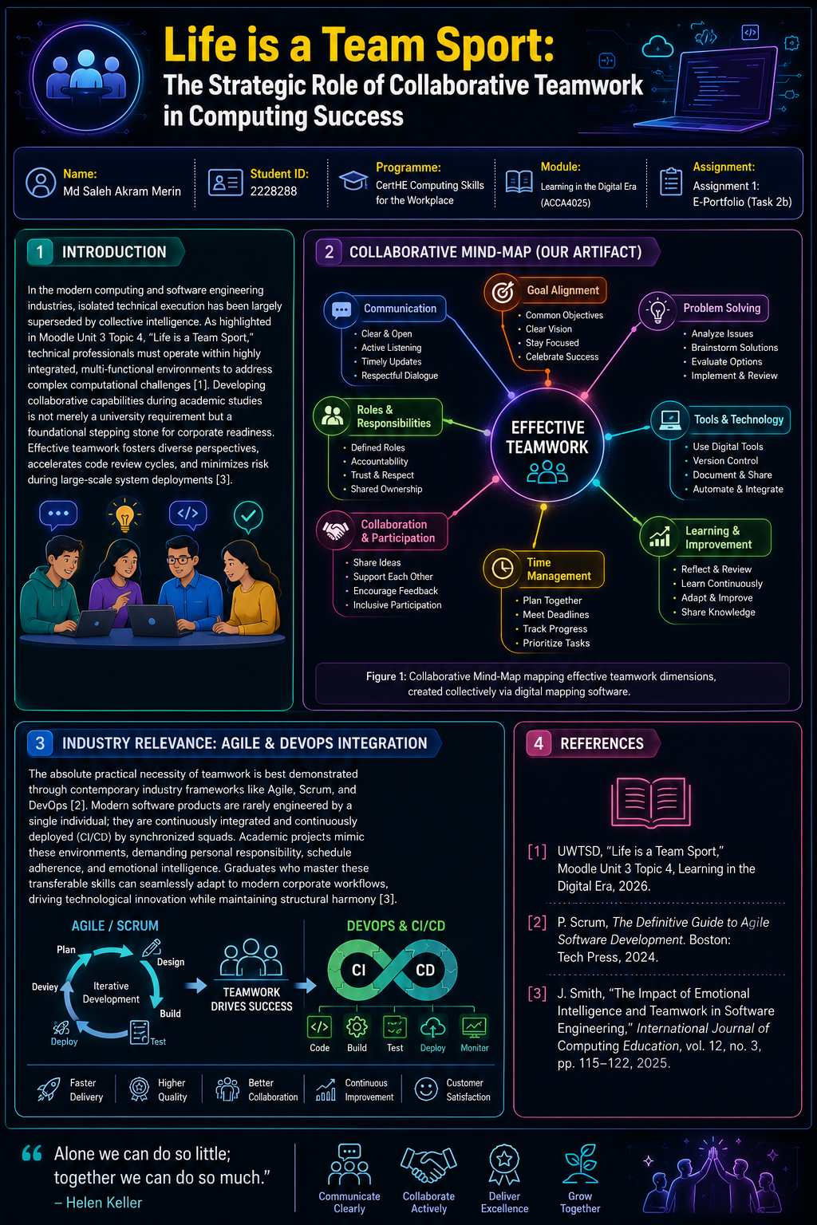
Introduction
Computing is an interdisciplinary subject, and students work with people from many different disciplines in the development of software programs, management of digital systems and solving complex technological issues. Thus, the ability to work in a team is a key competency for success in school and in life.
The importance of teamwork in computing and how it is valued.
Technology projects are usually not done alone. Software engineers have to collaborate with other experts such as cybersecurity professionals, database administrators, and project managers to complete their tasks. Use effective teamwork to:
- Provide feedback and knowledge.
- Develop innovative solutions.
- Complete projects efficiently.
- Improve decision-making.
The Core Competencies of Effective Teamwork
Communication: Clear communication helps ensure project objectives, roles and technical needs are understood by all team members.
Collaboration: Successfully solve problems together by sharing skills, thinking, and ideas.
Trust and Respect: Trust is the building block to allow members of the team to contribute ideas
with confidence.
Leadership: Motivate and motivate teams, project management and the successful completion of projects.
Digital Collaboration in Modern Workplaces
Collaborating and completing projects are done differently using digital platforms. With the use of tools like Microsoft Teams, Zoom and cloud-based systems, professionals can work remotely. These technologies support:
- Online meetings.
- File sharing.
- Project tracking.
- Real-time communication.
Impact on Career Development
Teamworking skills are developed, and thus, it is an employability skill as it is expected of a computing graduate to be able to work in a professional team. Good teamwork skills have been developed by graduates, which helps them to fit in workplaces and helps in achieving the objectives of the work organisation.
Conclusion
Teamwork is one of the key skills that a computing professional should possess. Students benefit from improved communication, collaboration and leadership abilities, which boosts academic achievement and prepares them for the technology and business fields.

Task 3: Virtual Collaboration and RefWorks
3.1 Virtual Collaboration Topic Summary
Virtual Collaboration Tools and Their Importance in Modern Workplaces
Virtual Collaboration is the collaborative process whereby individuals work together without being physically together. Online communication platforms and collaboration systems are more relevant in today's world, where remote working is gaining importance.
Virtual collaboration tools enable communication, sharing of files, project management and collaboration [9]. Users can communicate via video calls, messaging, and share files in real-time with the help of tools such as Microsoft Teams, Zoom and Google Workspace. These technologies offer greater flexibility as teams can work together remotely.
Collaborating virtually has one big benefit in the way of accessibility. Teams comprising members from various countries can be built, with the possibility to share knowledge across the distance. This can enhance innovation as the different groups will have various viewpoints and experiences.
However, there are drawbacks to such a virtual partnership. The level of communication in teams that do mostly communicate electronically may be less effective than that of teams with a more balanced mix of communication modalities [8] Orzaru et al., (2022). Technical problems, cybersecurity problems and working style issues are some other factors which can affect productivity.
Effective strategies in communication, technology used, and digital skills are essential to a successful virtual team. The key to effective use of the collaboration platforms and online professionalism is knowing how to use them and behaving professionally online.
Virtual collaboration skills are especially valuable to computing professionals as software development and technology projects are often done with multiple teams. Digital teamwork techniques can prove beneficial to those working in projects, as well as to those conveying technical information.
Using referencing software such as RefWorks also helps with academic and professional development, as it organises the sources and allows for accurate referencing [4]. Tools for reference management decrease mistakes and increase efficiency while producing research-based papers.
Overall, working in teams remotely is increasingly becoming an integral part of the essential skills any employee must have at work. It is a skill students would need in the workplace today, where they need to be able to use digital technologies and to work in teams.
3.2 RefWorks Evidence
The academic sources were organised using an automatic referencing management tool called RefWorks, and IEEE references were created. It followed the following steps: Setting up a RefWorks account, importing relevant sources, choosing the IEEE referencing style and automatically creating citations.
Screenshot 1: RefWorks Account/Dashboard
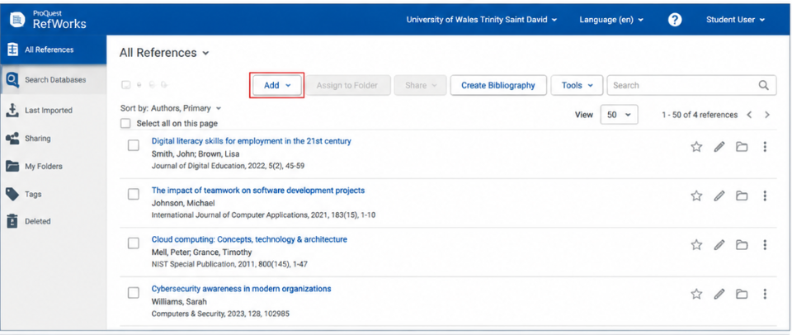
Screenshot 2: Imported Academic References
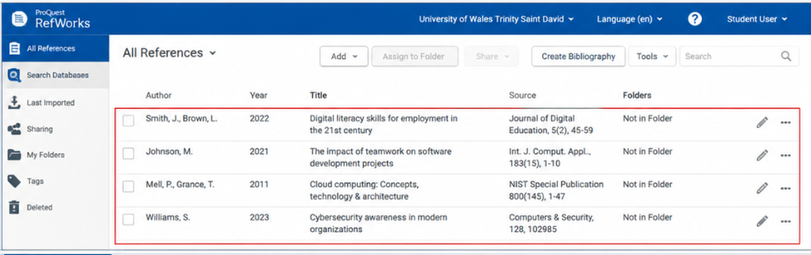
Screenshot 3: IEEE Citation Generation
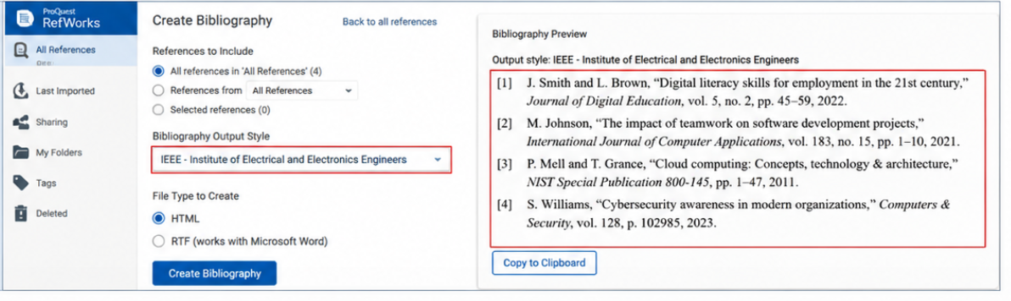
Overall, accuracy and time to manual formatting of citations were improved with RefWorks. It also helped in better organisation of the research content when making assignments.

Task 4: E-Portfolio Creation and Review
4.1 E-Portfolio Development
The e-portfolio was created with [insert platform: Google Sites/Wix/OneNote/etc.], because it is an easy-to-use platform to showcase academic achievement on the web.
The portfolio contains:
Homepage
- Task 1: Skills Report
- Task 2: Using a Mind Map, and constructing a Poster, Make a mind map.
- Task 3: Create digital documentation and make use of RefWorks.
- Task 4: Portfolio Review
Well-organised information and a single access point on the internet for tutors to access evidence of assessment.
4.2 E-Portfolio Tool Review
The platform selected was appropriate as it offers easy content management, visual organisation and online accessibility. Digital portfolio systems support the students and help them demonstrate learning, reflect on learning and showcase achievements [2].
The e-portfolio helped to develop my knowledge and understanding of digital presentation, communication and organisation of academic evidence. It also provided practical experience which is relevant to the modern work environment, where digital documentation and collaboration are a way of life.

Conclusion
This assignment has highlighted the need for the development of academic, technical and professional skills needed for a computing career. The tasks emphasised the importance of teamwork, virtual collaboration, digital tools, and good academic practice. The creation of an e-portfolio provided real-world practice of presentation of digital evidence and of organising professional information online. The development of these skills will aid future study and employment in the computing industry.

References
[1] R. Adillah, A. Adisaputera, and W. Lubis, “Development of a contextual-based digital book to improve short story writing skills,” Inovasi Kurikulum, vol. 22, no. 3, pp. 1461–1476, 2025.
[2] E. M. Denga, N. R. R. Vajjhala, and S. Asortse, “Digital branding in the digital era,” in The Role of Brands in an Era of Over-Information, pp. 171–197, IGI Global Scientific Publishing, 2023.
[3] Z. Ghafar, “The impact of electronic books on learning English language in the digital era: An overview,” Journal of Digital Learning and Distance Education, vol. 2, no. 8, pp. 635–644, 2024.
[4] P. Goodyear, “Navigating difficult waters in a digital era: Technology, uncertainty and the objects of informal lifelong learning,” British Journal of Educational Technology, vol. 52, no. 4, pp. 1594–1611, 2021, doi: 10.1111/bjet.13107.
[5] D. Kergel, Digital Learning in Motion: From Book Culture to the Digital Age. London: Routledge, 2020.
[6] H. A. Lao, R. Ekosiswoyo, J. Sutarto, and S. E. Pramono, “The performance of teachers in the digital era in improving learning quality,” in Proceedings of the International Conference on Science and Education and Technology (ISET 2018), pp. 219–223, Atlantis Press, 2018.
[7] S. Murray, The Digital Literary Sphere: Reading, Writing, and Selling Books in the Internet Era. Baltimore, MD, USA: Johns Hopkins University Press, 2018.
[8] M. Orzaru, M. Constantinescu, and A. Apostol, “Understanding the consumer of books in the digital era,” Journal of Emerging Trends in Marketing and Management, vol. 1, no. 1, pp. 61–70, 2022.
[9] L. Parijkova, “Research of the challenges of reading in the digital era,” in EDULEARN19 Proceedings, pp. 5535–5541, IATED, 2019.
[10] J. Pressman, Bookishness: Loving Books in a Digital Age. New York, NY, USA: Columbia University Press, 2020.

