Cloud-based Web services
Assignment 1

Table of Contents
Introduction 3
What is a Cloud-based Webservice? 4
What type of webservices are there? 4
REST 5
How does REST work? 5
The six constraints 5
Client Server 5
Stateless 5
Cache 5
Uniform Interface 6
Layered System 6
Code-on-demand 7
SOAP 8
Advantages of SOA 8
Disadvantages of SOA 8
Comparison 8
Conclusion 8
GraphQL 10
Query Language 10
Advantages 10
Disadvantages 11
Conclusion 11
References 12
Figures 13
Video Presentation 15

Introduction
This assignment is based on cloud-based webservices and what they are. It will also go more in-depth about certain webservices and what they can do, and what they are used for. While also comparing the difference webservices to each other.

What is a Cloud-based Webservice?
The definition of a “webservice” is not fully defined due to how large the industry is. There are multiple types of webservices that are standardised within the industry. These are REST, SOAP and GraphQL. The definition given from ‘Web Services: Why and How’: “A Web service is a networked application that is able to interact using standard application to-application Web protocols over well-defined interfaces, and which is described using a standard functional description language.” [1].
From this definition, it can be understood that a webservice is a software application that allows the communication between two devices over a network. One device is the service provider (E.g., Webserver providing a website) while the other device on the network is a user using a specific software that sends a request to the provider.

What type of webservices are there?
As referenced before. There are different standards that can be used:
- REST
- SOAP
- GraphQL
All services above all have a common similarity. They all deliver their data over API (Application programming interface) calls. Which allows devices to connect to each other to send and receive data.
Each webservice have their own strengths and weaknesses. Meaning that depending on the use case scenario where a developer needs to provide services to their clients. They need to research what they need to provide and which webservice is best suited towards that need.
While webservices can be difficult from each other. They can all be written in different programming languages but still be able to communicate between each other due to the standardisation of the webservices. This is due to the webservices using the web protocols HTTP and HTTPS to communicate and exchange data. From this, a client to server or server to server communication can be implementing without the need of specialised software. This means the development process of creating a webservice, or an application that can request webservices is more straight forward due to most webservices using the same method to communicate over a network.
Unlike programming languages, webservices provide different data formats at which it communicates with. This can be, JSON, XML, GraphQL queries and more. This means that a client setup to communicate with a provider needs to be created to request and receive data in the correct format in which the webservice provides.

REST
Between the years 1991 and 1997 the number of websites over the World Wide Web grew at an astounding rate. This made many researchers worry due to all the underlying software behind the WWW between the two years could only handle a certain number of users in mind. So clearly, they needed to find a new way to define the web standards more clearly and enhance it so that the web can continue to grow. One such researcher named Roy Fielding who set out to create six constraints or rules which called Representational State Transfer (REST) [2].

How does REST work?
While the wording of REST can be confusing. The workings of REST are quite simple. It works by having a server (which is a webservice) that has a resource and a client that can request a ‘representation’ from the server’s resources ‘state’. An example of this is that a news website stores its articles and structure within a database. And its ‘representational state’ can be a simple list of different news articles or the actual news article that holds the contents and meta data.
Using figure [F1] as another example. A client sends out specific request (E.g. Getting news data), the REST API receives the request and works with a data source to attain that data and then returns it within a text format like JSON or XML or even plain text.

The six constraints
As previously discussed, there are six constraints within the REST standard. These constraints are the fundamentals of REST and provide benefits with the usage:

Client Server
Separating out client and server allows the constraint to create standards for each version. Meaning that a server can provide backend processing and resources while the client can handle the front-end of the process. With this, different types of clients like mobile apps, web portals, specialised software applications all can use the same server without any troubles. This means clients can be further developed and evolved without affecting any other clients.

Stateless
This means that the server will not store any information about the HTTP request the client makes. From this, servers will treat every request as new. Meaning no session or history data. If a client application must be stateful, such as where the user needs to login into a service and check its authentication. Then the client needs to store all the data necessary to make the request.
Stateless protocols require less resources to process. Meaning that having a webservice that runs on lower processing machines can be beneficial due to the less processing power it uses making it easier to implement [3].
Another benefit to stateless connections is that. If a server connection or data is corrupted or out of sync with the client device. It’s easier to recover from failures. This is due to the session context being client sided instead of server sided. This also helps with the scalability of a webservice for future development and implementation.

Cache
With a cache restraint. Client to server communication must be marked as cacheable or non-cacheable. To briefly summarise what this means, it reduces the number of clients to server interactions overall. Which improves the overall performance of the system.
“Protocols, like SOAP, that only use HTTP as a convenient way to get through firewalls (by using POST for all requests) miss out on the improved performance from HTTP caching, which reduces their performance (and also slightly undermines the basic purpose of a firewall.)” [2].
Meaning that if performance is the main factor in communication between client and server. Then REST is more beneficial that a SOAP service.

Uniform Interface
The fourth constraint really separates it from the rest. Uniform interface makes interactions so simple that anyone familiar with the style will easily pickup and understand how the interface works. REST works put exposing a resource that allows clients to interact with. It uses a URI which has a unique identifier. This means that each resource exposed must have a unique identifier. An example of a URI that can be used is: “https://api.website.com/items”. Resources can be named after what type of data they supply. From the above example. It can be expected that a list of items will be returned if interacted with. From this, not only can URI be used for resources. But parameters and identifiers can be used within the URI to allow more functionality.
An example of parameters being used within REST would be:
“https://api.website.com/items?name=Hammer”
With this, not only can the resource return items, it can also use the parameter to filter and only include items that contain hammer in its name.
Parameters are not the only feature that allows this. A more restrictive version of this would be to use identifiers within the URI’s path:
“https://api.website.com/items/123” or “https://api.website.com/items/{id}”
From this a REST resource point can use this identifier to search for a specific item with the id. This could be the ID of a specific item or a category id. With this params and identifiers can be combined to add even more functionality within a webservice.
Not only can REST use the URI to receive data for specific tasks. It can receive data within the body of the HTTP request. Meaning that depending on the type of request that is used this can allow clients to send text, JSON or even XML to the server to process and pass back data.
A list of different HTTP methods that are mainly used:
- GET
- POST
- PUT
- DELETE
- UPDATE
With these resources can perform more than one task. Giving REST even more functionality to the entire webservice.
Overall, Uniform interface, is the biggest benefit to REST within the constraints. This adds the most functionality compared to other webservices.

Layered System
With this type of system. This allows REST services to have an API on one server. While having a data source on another server and authentication on another server. With this, a client does not have to worry about connecting to the right service. From this an intermediary service which connects to all services can be used to provide the full functionality of a webservice.
This gives the major benefit of having backup services if one server goes down. This means that if the connection to a server is severed due to downtime or connection issues. Another webservice can take its place which is a clone. From this less downtime can take place and more scalability can be implemented.

Code-on-demand
This constraint is optional. This means that a server can extend the functionality of a client by sending code that can be executed. An example of this is when loading a webpage. Not only do you receive HTML and CSS to view a website. But some websites also include JavaScript to add functionality to a website. With these additional features be added to the client’s functionality.

SOAP
Simple Object Access Protocol is another webservice that allows the communication between two devices. It works on multiple different network protocols. But one of the most common is HTTP. Like REST it was created to create web APIs but mainly uses XML data.
Like REST it works but using a client to server communication to request and send data. But the HTTP requests work differently. A request is first sent by a client creating an XML document. When the server receives the XML message, the server processes the request and sends back an XML package back to the client.
Unlike REST, SOAP is apart of the service-oriented architecture (SOA). With this comes its own advantages and disadvantages.

Advantages of SOA
Platform and operating system independent. Like REST, a SOA application can be developed on any device through multiple different programming languages. If the SOA applications follow the specifications, they can all communicate with each other.
Like REST, SOA is mainly using the HTTP protocol. But it can use other protocols.

Disadvantages of SOA
Due to the usage of XML. This makes SOAP easier to understand the communication between client to server. But the drawback to this is that XML can be cumbersome. Meaning that compared to other messaging formats like JSON. The message can be bloated and cause more resources to be used up in communication and processing.
Unlike REST which can use multiple different methods of message formats. SOAP is based on XML meaning that it’s fixed to that one format. Unlike REST which can use XML, JSON and other formats.

Comparison
Due to SOAP using a system which it breaks down applications into multicomponent, distributed applications without losing their security and control. REST uses a modern system called microservices which allows the system to be distributed across multiple machines to allow interactions. So unlike REST, a SOAP service cannot be scaled as well as REST webservice.
Another drawback compared to REST. Would be the no implementation of a Uniform Interface. With this REST has a big advantage over SOAP which allows it to add additional functionality to its client-server communication. This then can lead to less development to the overall platform. Unlike SOAP which has a single resource to function capability.
Another disadvantage to SOAP is the cumbersome format is uses. Due to REST being simple, flexible, and lightweight. It can be developed to suit heavy and light workloads. And can be spread across multiple services. But due to the common goal of SOAP being to connect to complex sets of computing tools. The webservices that the SOA framework supply can be quite sluggish compared to REST [4].

Conclusion
From a quote from Alexander: “SOAP was the first widely used protocol for connecting web services in a service-oriented architecture. Today, modern development of distributed applications is largely based on RESTful principles. SOAP is almost always confined to legacy platforms. One area where SOAP is still in use is in applications that handle online transactions, as it's a style of API that is more rigid and protocol driven.” [4]. What can be taken from this is that if a webservice needs to be created. If you had a choice between SOAP and REST. The best solution for modern development would be REST due to its massive advantages.

GraphQL
This webservice is the youngest out of the three. It was created internally by Facebook back in 2012 to solve a problem. This problem was the rising demand of mobile applications. But due to the limited connectivity of mobile devices back then, applications needed to decrease their requests as much as possible to optimise the speed and load time of their applications. Facebook had a huge problem with this due to how feature rich the Facebook application was. To combat this problem, Facebook created a technology called GraphQL which is a new query standard that allows them to wrap all the data needed for their application within one single query.
Like the previous two. GraphQL is a client-server webservice that allows the client to request information from the server. But unlike the previous two that use general standards of request formats like XML and JSON. GraphQL uses its own unique “query language” that allows the client to request specific data from a single endpoint.
So unlike REST which requires the client to reach out to several endpoints to gain its required data. GraphQL works by having its client query a head service which then pulls all the data into one bundle and sends it back. A good example of this comparison would be to look at [F2].

Query Language
Not to be confused with normal query languages that are similar like SQL. GraphQL version of the language, queries data from several different sources. Unlike languages like SQL which has a query each separate source (Like REST).
It uses two types of operations to create a request. A query and mutation are combined to create the whole request. Looking at [F3], we can see that the language sets out a query for a certain operation with variables.
Like REST, GraphQL does have a form of Uniform Interface that allows the query to perform GET, POST and DELETE requests. This allows the system to send, update and delete information form a database.

Advantages
GraphQL prevents any over-fetching. This means that requests only receive the data that they ask for. Unlike REST and SOAP, a poorly designed API can send back more data than the client needs. This can lead to more bandwidth usage and more resource usage. Meaning that if resources usage needs to be minimised. GraphQL is the best option.
This can also be linked to the prevention of any under-fetching where the server does not return all the required data back to the client.
Like SOAP, GraphQL visually aids data readability by having data that is graphical and declarative. This makes queries easier to understand [5]. Another addition like SOAP, is that all the data is strongly typed. Like XML with its schemas. The data within GraphQL is strongly typed due to the database schemas. This leads to a more stable API and fewer development bugs.
REST can be strongly typed but it is not natively typed. Meaning that technologies like Typescript needs to be used to add any form of typing to the overall webservice.

Disadvantages
The problem with GraphQL is that complex queries can lead to performance issues. If the client asks for too much data or nested data. This can lead to performance impacts that could lead to REST being faster than GraphQL.
For applications that do not need flexible queries that GraphQL offers. GraphQL can be overkill within the development lifecycle. This means that the better usage of a webservice would be to use the REST architecture for a simpler application.
Due to having only one endpoint. It is a lot harder to cache data for a GraphQL application. This can lead to more bandwidth and resource usage overall compared to a REST architecture.
Unlike REST and SOAP. The server cannot receive files from the client. This means that alternative solutions need to be used which create a more complex application.
Lastly, GraphQL has the steepest learning curve compared to the other two webservices. Unlike the other two applications that allow the user to easily learn while developing a system. Pre-education on the subject is needed to create a more robust system.

Conclusion
If the development team have pre-existing experience with GraphQL and need to create a quick prototype of a complex webservice. Then GraphQL is the best option out of the three webservices. This is due to its quick prototyping, and ease of development for complex data communication.
If the webservice needs to reduce its resource usage of the client to a minimum. Then GraphQL is also the best option for the webservice. But if bandwidth and resources are not an issue. REST is a very good option for creating a distributed service which allows greater functionality.
But overall, GraphQL is good for performance. While REST is the best for functionality.

References
[1] Curbera, Francisco, William Nagy, and Sanjiva Weerawarana. "Web services: Why and how." Workshop on Object-Oriented Web Services-OOPSLA. Vol. 2001. sn, 2001.
[2] Lange, Kenneth. "The little book on REST services." Dostupno na: https://www. kennethlange. com/books/The-Little-Book-on-REST-Services. pdf [4. svibnja. 2020] (2016)
[3] Lokesh Gupta. “REST Architectural Constraints”. 2022. https://restfulapi.net/rest-architectural-constraints/
[4] Alexander S. Gillis. “SOAP (Simple Object Access Protocol)”. Techtarget.com 2022. https://www.techtarget.com/searchapparchitecture/definition/SOAP-Simple-Object-Access-Protocol
[5] Khalil Stemmler. “What is GraphQL: GraphQL Introduction”. Apollographql.com 2021. https://www.apollographql.com/blog/graphql/basics/what-is-graphql-introduction/
[6] Alexsoft. “GraphQL: Core Features, Architecture, Pros and Cons”. 2019.
https://www.altexsoft.com/blog/engineering/graphql-core-features-architecture-pros-and-cons/

Figures
[F1] Simple representation of a REST API from Medium
https://medium.com/@eyesdwn/restful-api-6365d4e71da9
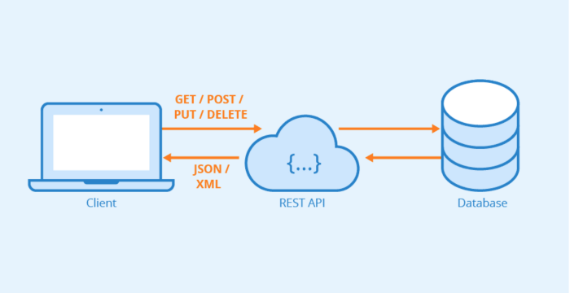
[F2] GraphQL API compared to REST example
https://www.theseus.fi/bitstream/handle/10024/340318/Thesis_Camille_Oggier.pdf
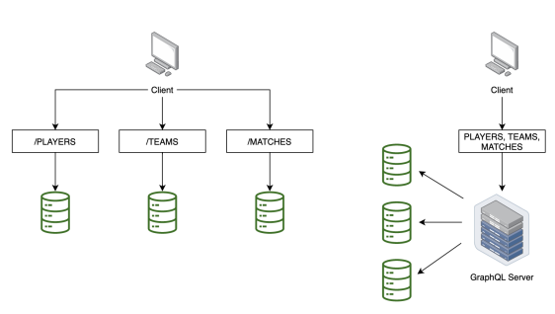
[F3] GraphQL Query
https://www.apollographql.com/blog/graphql/basics/what-is-graphql-introduction/
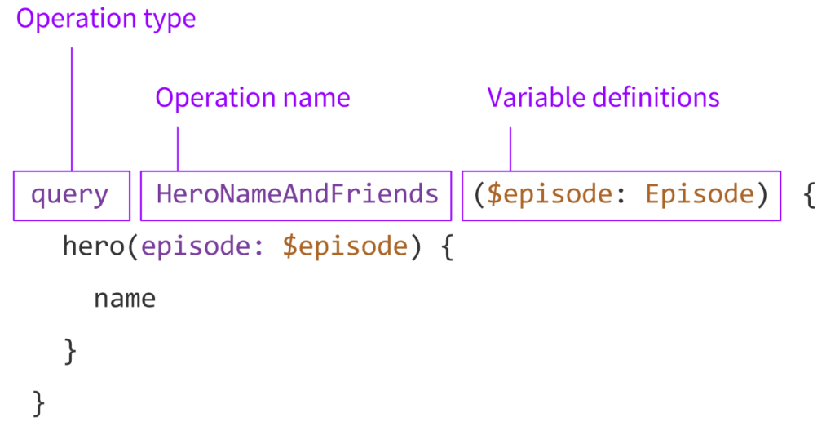

Video Presentation
https://youtu.be/5zGYRnGhZFQ

