ACCA7028 Data Security, Governance and Compliance
Semester 1, Assignment 1
Nathan Daniel Morgan
2021
Contents
Table of figures 1
Abstract 1
Task 1: Security framework investigation 2
1.1: Information Technology Infrastructure Library (ITIL) 2
1.1.1 ITIL Information Security Management System (ISMS) 2
1.2 National Institute of Standards and Technology Cyber Security Framework (NIST CSF) 3
1.2.1 Introduction to NIST CSF 3
1.2.2 Overview of the framework 3
1.2.3 The Framework Core 4
1.2.4 The framework core elements 4
1.2.5 Framework implementation tiers 5
1.2.6 Framework profile 5
1.3 The ISO/IEC 27000 family of standards 6
1.3.1 The ISO/IEC 27000-27002 6
1.3.2 ISO/IEC 27001 6
1.3.3 ISO/IEC 27002 7
1.4 Comparison 8
Task 2: RRRRadical 9
References 11

Table of figures
Figure 1 NIST framework core structure page 6
https://nvlpubs.nist.gov/nistpubs/CSWP/NIST.CSWP.04162018.pdf
Figure 2 NIST function and category unique identifiers, page 23 https://nvlpubs.nist.gov/nistpubs/CSWP/NIST.CSWP.04162018.pdf
Figure 3 RRRR logo by Nathan Morgan

Abstract
In this report three security frameworks are investigated and compared, to identify the key features of each framework to outline the differences and unique selling points of each.
The research conducted in the first section of the report will be used to design a framework for CoffeeBlue.

Task 1: Security framework investigation
In this section, three frameworks will be selected and investigated, their origins and primary functions will be researched, and a comparison will be made to highlight the key features of the information security management systems provided by each.

1.1: Information Technology Infrastructure Library (ITIL)
Information Technology Infrastructure Library is a framework that is used for ensuring the IT services align with the evolving business objectives. The framework achieves this by maintaining a library of the best practices for managing and delivering IT services [1].
The framework was initially designed in response to the rapid growth in the IT sector and the security concerns associated with digital information. The British governments department of central computer and telecommunications agency developed the framework as a set of best practices to follow to standardise a practical attempt at managing security [2], building upon the plan-do-check act [3].
The framework can be implemented within an organisation after completing the relevant training provided by the administrating company, AXELOS [4].
In the latest edition of the framework, ITIL 4. The framework sets out to incorporate the standards previous editions were built upon and incorporate more modern technological advances such as the importance of DevOps, automation, cloud, and AI [5]. This came as a major overhaul to the entire framework also incorporating agile philosophies to improve communication and collaboration.
To utilize ITIL within a company or organisation you will have to go through the training provider AXELOS and get the certification to implement the framework. The certification has 5 levels of training, with the foundation being the required level to implement ITIL within an organisation, the foundation exam tests the key concepts of the framework such as IT service management. It will be essential for implementing an ITIL compliant strategy [6].
The certification expires after 3 years and will require the participating company to renew to get the most up to date certification. An up-to-date certificate demonstrates to the public that the company is motivated to protect their infrastructure including the customers data [7] [8].
The v4 of the ITIL framework is comprised of five key functions or stages, these 5 functions are a service strategy, service design, service transition, service operation and service improvement then from these 5 functions it stems out to 34 management practices that provide guidance on concepts such as success factors, activities, information objects and general concepts. The 34 practices are grouped into 3 categories, general, service, and technical and these full under the key functions [9].

1.1.1 ITIL Information Security Management System (ISMS)
Within this report the information security management is the key area of investigation of the ITIL framework, as this is the section of the ITIL framework that protects the business from security threats [10]. ITIL teaches that the information security management is a focus at every stage of an IT departments infrastructure, teaching organisations to “protect, detect and correct” as a continuous ideology to maintain an appropriate level of security [11]. The framework will assess the risks to people, processes, and devices to continuously implement and maintain the security systems in place to reduce the threat of cyber-attacks [12].
The key concepts outlined by the ITIL security management [13]:
- Enforce digital and physical security methodologies
- Secure and update asset and patches
- Manage SSL/TLS certificates and keys of your domain
- Employee training on threat identification and reaction
- Security systems to mitigate risks from email-based attacks such as phishing
- Routine testing of the implemented systems such as risk assessments and vulnerability assessments
- A strong set of security policies.
The ITIL framework is aimed at a business of any size and will have documentation readily available relative to the size of the business as with the different sizes of a business it will carry different risks, threats, and varied needs [14].
Ultimately ITIL does not cover every aspect of security management like other frameworks attempt to do, such as ISO 27001, instead identifying the most important activities and identifying ways to interface with other service management processes [15].

1.2 National Institute of Standards and Technology Cyber Security Framework (NIST CSF)
NIST CSF is a framework designed by the NIST branch of the Unite states government and private sector organisations in collaboration, intended to create a flexible and cost-efficient framework for entities to improve their cybersecurity critical infrastructure. NIST CSF gained popularity and went international, being implemented by companies and governments around the world [16]p1.

1.2.1 Introduction to NIST CSF
NIST CSF will be more impacting for entities on a smaller or less regulated scale, spreading awareness and teaching how to implement the infrastructure from the ground up, where larger organisations may already have a security infrastructure in place [16]p3. The NIST CSF framework can be implemented within any size organisation as the framework sets out to provide guidance rather than compliance with a focus on addressing issues as a priority to manage risks before they become a hazard [16]p3.
Implementing the framework takes place through a series of steps, the organization will begin by:
- determining what levels of cybersecurity countermeasures are in place and profiling them.
- Identifying potential standards and policies.
- Communicating new requirements.
- Create new requirements [17].

1.2.2 Overview of the framework
NIST CSF can be broken down into three main concepts, the framework core, the framework implementation tiers, and the framework profiles. The intent is for each framework component to reinforce the overarching aim of aligning policy, business, and technological approaches to managing risks [16]p6.

1.2.3 The Framework Core
The core of the framework is described as a set of activities with the aim of achieving specific outcomes, applicable references, and examples of guidance to reach the desired outcome. Comprised of four elements: functions, categories, subcategories, and informative references [16]p6.
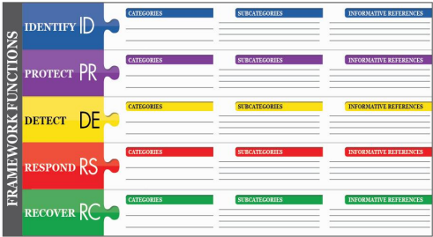
Figure 1: NIST CSF framework core structure

1.2.4 The framework core elements
- Functions
The five core functions of the cybersecurity framework are
- Identify
- Protect
- Detect
- Respond
- Recover
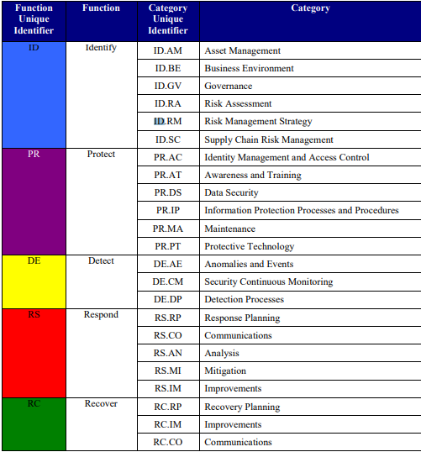
Figure 2:- Function and categories
These core functions are designed to work together to provide a high-level strategic overview of how an entity will manage the entirety of a cybersecurity risk. The functions are to be implemented concurrently and, in an attempt, to continuously form a systematic approach to address the evolving cybersecurity risks.
- Categories
An elaboration on the five core functions categorised by the cybersecurity outcomes, for example “asset management “or access control [16]p7.

- Subcategories
Further dive into each category and look at specific outcomes in a more extensive manner. The subcategories have a more directed focus at the outcome of the categories, for example investigation “the notification that was the result of an automatic detection” [16]p7.

- Informative references
Informative references are sections of standards, practices and guidelines that are used to outline methods that can be used to achieve the outcomes associated with categories and subcategories [16]p7.

1.2.5 Framework implementation tiers
When implementing NIST CSF there are tiers of implementation that must be considered to what is applicable to the target entity, with consideration to the associated risks of the entity and the strategies already implemented to manage the risks.
The tiers represent how much of the framework can be related to the entities existing strategy, to consider how much of the framework co-insides with the existing systems. For example, a tier 1 organisation has a partial implementation with limited awareness where a tier 4 organisation is one that can handle cybersecurity threats and adapt to the scenarios presented to them [16]p8-p11.

1.2.6 Framework profile
To profile an organisations current security infrastructure to accurately describe what the requirements, risk tolerance and resources the organisation has. This profile will be able to determine what is required to be implemented to reduce cybersecurity risks. The overall process can be used to compare the current state with the desired state and design a roadmap of implementation that is catered to the entity. This may involve an entity having different profiles built around the different strategic outcomes and business areas that may have unique individual needs [16]p11.

1.3 The ISO/IEC 27000 family of standards
A set of standards designed to be a comprehensive and vast set of procedures and standards, that are to be implemented at an entity of any size or sector. The framework is designed and maintained by the international organisation for standardization (ISO), the joint technical committee 1 (JTC1) [18] and the international electrotechnical commission (IEC) [19].
The framework is vast in coverage with over 50 publications, aiming to cover more than just cybersecurity threats and include issues such as privacy and confidentiality [20].

1.3.1 The ISO/IEC 27000-27002
The key focus of this investigation is the information security management systems, the framework has published various advances on the management system, to provide guidance on the evolving threats as they’re documented, and research Is published. The governing bodies aim to routinely review and update within a 5-year cycle with each part of 27000 being audited frequently to ensure the frameworks validity [21].
The ISO/IEC 27000 series of standards have several publications that are oriented around an ISMS, with the most revered being 27001 and 27002. The overarching framework is known as ISO/IEC 27000, and this covered all the sub-divisions [22].

1.3.2 ISO/IEC 27001
The 27001 is a standard with a key objective of providing guidance on the requirements for implementing, maintaining and the management of an ISMS. The framework has an emphasis on measuring and evaluating the ISMS, with guidance on adapting to the results to improve the performance. The publication states that the organisations ISMS will be designed around the needs, objectives, and security requirements of an organization with the size and structure considered [23].
The contents covered within ISO/IEC 27001:
- Context of the organisation
- Information security leadership
- Planning an ISMS
- Support
- Operation
- Performance Evaluation
- Improvement
- Annex A – List of controls and objectives
ISO/IEC 27001 is thought to be a lot more involved than other frameworks, where annex A has 13 control categories with 114 controls and 10 managements clauses to be managed by the ISMS. The framework is one of the more thorough available, with each control having an in-depth analysis of the issue with a direct means of mitigating the risk [23].

1.3.3 ISO/IEC 27002
ISO/IEC 27002 is the branch of the framework that aims to provide a code of practice for information security, outlining potential controls and mechanisms which may be implemented adhering to the guidance provided within ISO/IEC 27001, as the frameworks are intended to be implemented together [24].
As of the 2013 version of the framework there are over 14 sections amassing a total of 114 controls, with different variations being produced of the framework section tailored to niche industries such as the health sector [24].
The contents covered within ISO/IEC 27002:
- Structure
- Security policy
- Organization of information security
- Human resources security
- Asset management
- Access control
- Cryptography
- Physical and environmental security
- Operations security
- Information systems acquisition, development, and maintenance
- Supplier relationships
- Information security incident management
- Information security aspects of business continuity
- Compliance

1.4 Comparison
ITIL, NIST CSF and ISO/IEC 27000 are each developed by different governments and groups of government agencies. The ITIL framework is a natural fit for European companies as the framework was built around the laws and regulations in place were in mind during its creation, as the UK government created and manages it.
NIST CSF is often implemented to comply with federal law in the United States of America [25], as the framework is designed with the compliance of the law in mind, this gives the framework an appeal to non-federal organizations as a low cost to implement solution to comply with the law.
When considering a framework to be implemented a business will always look at the cost, ISO/IEC 27000 have an upfront cost for the training documents where ITIL and ISO costs for the certificate that is required to utilize the framework and implement it onto a business to make a business conform to the policies.
A business must look at the scope of the framework and consider if the framework is suitable for the business, ISO/IEC 27000 is suitable for any size organisation, while NIST CSF is more beneficial to a smaller organisation that is just starting to develop its security infrastructure, as implementing the core of NIST CSF will ultimately cover a lot of the same points as implementing a more robust and costly framework such as ISO/IEC 27000.
ISO/IEC 27000 has been an industry standard for a longer time than most other frameworks, but the newer frameworks may have more up to date concise information about current security threats.
A big factor that must considered is compliance, where ISO calls for compliance where NIST and ITIL are more based on recommendations as they’re more tailored to a set of best practices that aren’t compliance based that will enable the business goals to align with the IT resources [26]. The compliance aspect is often why a business may install more than one framework, pairing ISO 27000 with other more business-oriented ISMS [27]. For example, ISO and NIST have more of a focus on security while ITIL framework has an underlying focus on business objectives.
A notable element of the frameworks is that each has a focus on reflection and taking the time to ensure that in the instance of a security breach that once the breach has been remedied, a more permanent solution is crafted. The three frameworks also manage risks in a similar fashion of identify, implement, and monitor as a means for handling any risk that arises [28].
When considering a security frameworks merit, it is as strong as the way they cover new risks and threats, if a new threat is to emerge the framework must adapt to ensure there are countermeasures in place to reduce the impact of the threat and provide training and create policies to educate the staff that are likely to be managing the aftermath. Policies and guidance should be regularly updated as required.

Task 2: RRRRadical
A framework built around compliance, review, research, report and repeat as core principles. Inspiration was taken from the researched frameworks for the client CoffeeBlue.
The requirements of the client outlined a global presence that utilizes cloud to deliver IT services to the end users with a requirement to facilitate members of staff accessing the IT services from their own devices in a secure manner. The security factor of this is paramount to protect the client and staff data along with the company’s intellectual property. The RRRRadical framework calls for compliance much like iso/iec 27001, through a series of documents outlining what is acceptable and what to avoid while working, this should be reviewed periodically to identify where the security can be improved. The review procedure takes influence from the researched frameworks with each having a process that reflects on the implemented system.
CoffeeBlue has outlined their security concerns and to directly respond to them the following policies have been drawn up, to cover the essentials listed by the organisation and these could be implemented alongside a framework for integrity.
Social media policy
Over the last decade social media has changed the way businesses maintain an image with the public, allowing a platform for open communication and promotion, it is in CoffeeBlues best interest to allow staff to access and manage the platforms associated with the business in an open and secure manner. Use of social media carries many implications for the staff and business as factors such as information security will be at a higher risk because of the attack vectors these platforms create, another concern would be that staff may be less productive if they’re openly browsing social media during their work hours. This should be addressed with a policy that outlines the acceptable usage of social media, relating directly to the use of personal accounts.
Physical security policy
When working remotely through a company’s network the members of staff must remain vigilante with physical security of the devices, for example ensuring that their devices are locked when left unattended, and not to be left unattended in areas that may pose a risk to the device.
Bring your own device policy (BYOD)
When utilizing their personal devices for work purposes the members of staff should be aware that their devices accessing CoffeeBlues infrastructure can add a new level of security issues and that the maintenance and secure use of their machine is paramount to the overall security, if their devices were to be infected with viruses this may become an attack vector to the rest of the network, this also applies to keeping their software up to date to avoid exploits.
A BYOD policy can be important to ensure that the devices being used are fit for purpose and pose no risk to the information security. Considerations must also be made to the acceptable usage policy. Staff must also be aware that their devices will require additional software on their machines such as an acceptable anti-virus software solution.
Acceptable usage policy
To ensure that devices are used appropriately in the workplace, many activities during company time or while using company property will be forbidden, such as playing games at work or viewing material that is inappropriate.

Maintaining software security
The IT department will be required to ensure that all software on the network is secure and maintained to an appropriate standard, ensuring software is patched and the latest security updates are applied to ensure that the system is not compromised.
Training meetings
To ensure the staff remain up to date with the regulations and changes there should be regular meetings to ensure the staff receive sufficient training on the updated policies, to ensure they’re aware of the new guidance to reduce risk.
Review, research, report, repeat
A framework built around the core principles of Reviewing incidents, researching security vulnerabilities, reporting incidents, repeating each step to ensure they’re covered thoroughly.
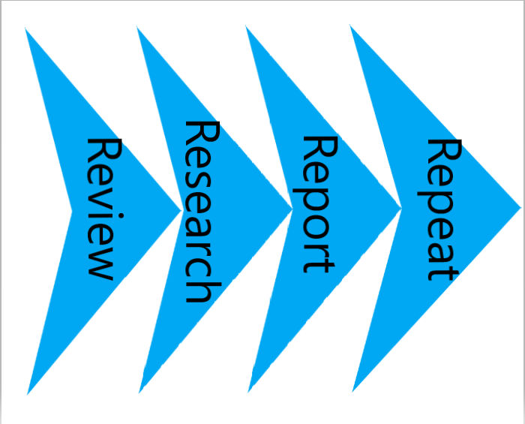
Figure 3RRRR
Reviewing incidents to analyse the relevant data such as how it happened, what the impact was, when it happened and how to ensure it is resolved and will not happen again. This process is a paramount part of incident response, reducing the chance of a similar incident occurring again. Reviewing the systems in place often will often allow for issues to be solved before they escalate.
Researching the latest threats and risks to ensure policies and software are updated as quickly as possible and where updates are not available look at reducing the impact of any exploits by potentially disabling the services or replacing them until they’re deemed safe again.
Reporting incidents is an integral part of managing risks. The faster an issue is reported, the faster it can be acted on and resolved. An example of this is an employee gets a virus on their machine via email, the virus attempts to spread by sending more emails to the employee’s colleagues to spread the virus. The faster this is reported the faster the spread can be stopped, and the damage can be repaired.
Repeating the process often will be a key factor to reviewing the system and ensuring the measures in place are effective and remain effective.

References

[1] | IBM, “IT Infrastructure Library (ITIL)”.
[2] | From 1994 Central Computer and Telecommunications Agency, “Records of the Central Computer and Telecommunications Agency and predecessors”.
[3] | G. J. Langley, R. D. Moen, K. M. Nolan, T. W. Nolan, C. L. Norman and L. P. Provost, “The improvement guide: a practical approach to enhancing organizational performance (2nd ed.).,” San Francisco: Jossey-Bass..
[4] | IBM, “IT Infrastructure Library (ITIL): Foundations”.
[5] | S. K. W. a. L. Greiner, “What is ITIL? Your guide to the IT Infrastructure Library,” 18 JANUARY 2019 .
[6] | c. &. manuels, “ITIL security management”.
[7] | S. Y. Odabaşı, “Implementation of information technology infrastructure library (ITIL) processes,” 2011.
[8] | K. Tambralli, “Information security management system (ISMS),” ITIL docs, AUG 20, 2021.
[9] | S. Kempter, “ITIL 4 IT Process Maps.,” processmaps.
[10] | K. Tambralli, “Information security management system (ISMS),” AUG 20, 2021.
[11] | H. Gunawan, “Strategic Management for IT Services Using the Information Technology Infrastructure Library (ITIL) Framework”.
[12] | M. G, “ITIL Service Strategy,” JUL 01, 2021.
[13] | S. Kempter, “IT Process Maps, ITIL 4 processes,” processmaps.
[14] | E. D, “Security Management,” ITIL docs, JUN 25, 2021.
[15] | N. M. Razieh Sheikhpour, “A best practice approach for integration of ITIL and ISO/IEC 27001 services for information security management,” Indian Journal of Science and Technology, February 2012.
[16] | National Institute of Standards and Technology, “Framework for Improving,” April 16, 2018.
[17] | A. s. Gillis, “NIST Cybersecurity Framework,” September 2021.
[18] | ISO, “ISO/IEC JTC 1”.
[19] | itgovernance, “The ISO/IEC 27000 family of information security standards”.
[20] | itgovernance, “iso2700 family”.
[21] | bsi, “ISO/IEC 27001 Information Security Management”.
[22] | The ISO 27000 directory, “An Introduction to ISO 27001, ISO 27002....ISO 27008”.
[23] | The ISO 27000 Directory, “An Introduction To ISO 27001 (ISO27001)”.
[24] | The ISO 27000 Directory, “Introduction To ISO 27002 (ISO27002)”.
[25] | “Is NIST Mandatory?”.
[26] | ELIZABETH, “NIST vs ISO Compliance: What’s the Difference?,” August 19, 2021.
[27] | R. Leal, “ISO 27001 vs. ITIL: Similarities and differences,” 2016.
[28] | “A Comparison of COBIT, ITIL, ISO 27002 and NIST,” 9th December 2013 .

