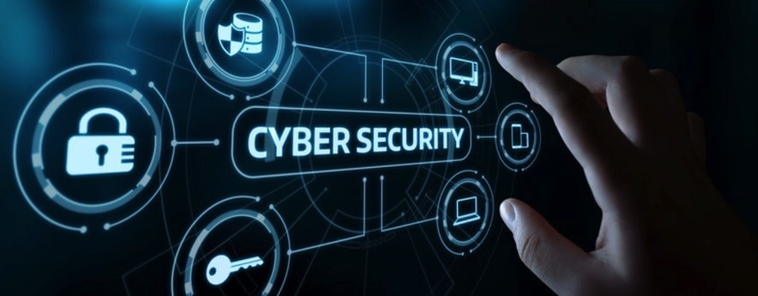

Synthesize a solution to a potential real-life scenario

Emily Stockdale
University Trinity Saint David
1906962

Introduction

BYOD (bring your own device) is becoming more common with 45% of organisations in the UK having a BYOD policy and procedure in 2018 [1]. BYOD allows employees to use their own computing devices rather than using company/organisation owned devices. This report will outline and discuss.

- Advantages of BYOD
- Disadvantages of BYOD
- An evaluation of BYOD for CoffeeCapulus
- Safe implementation of BOYD
- An appropriate backup strategy
- Safety and prevention
- Security policy

Each individual aspect will be well researched using reliable resources. This report will determine a safe way of implementing a BYOD policy and procedure to a reputable coffee shop.

Advantages

Employees:
There are many advantages to BYOD, employees are familiar with their own device(s) which could reduce training time for new and existing staff members. Research shows that productivity and morale can be increased due to the flexibility and convenience of BYOD [2].

Employers:
There are endless advantages for employers. Majority of employees will already have smart technology therefore organisations see this as an opportunity to implement the use of new technology without the financial impact of purchasing technology and smart devices. The results of a survey conducted by iPass showed that employee’s that use mobile devices for both personal and work use put in 240 hours more than those who do not [3].

Disadvantages

Although there are many advantages to BYOD there are multiple disadvantages. The main disadvantage is that BYOD poses a security risk. BYOD may have a positive financial impact when it comes to purchasing devices however the security risk posed by BYOD is mainly mobile malware which can disguise itself in applications and advertisements. As a result of the security risk posed by BYOD organisations/businesses will have to purchase antivirus protection which will have a financial impact, as a result of this the financial gain from not needing to purchase devices could be reversed. Another disadvantage to BYOD is that the devices will be from different manufacturers for example mobile devices could be Samsung, Apple, Huawei or even Nokia this means that each device will have individual operating systems which may result in needing to invest in a more advanced IT support team[4].

Evaluation

Is BOYD appropriate for Coffeecapulus
CoffeeCapulus is a coffee company which is under immense pressure to allow their staff and customers to use their personal devices to access the company’s network and resources. CoffeeCapulus would need to evaluate and differentiate which elements of the network both staff and customers would need to access. Doing this will allow the team of IT technicians to identify appropriate security measures that need to be put in place ensuring that customers do not gain access to confidential corporate information. CoffeeCapulus is concerned about protecting its intellectual properties which is worth billions, therefore they will need to invest in an effective anti-virus and security software ensuring that each element is password protected. Implementing BYOD would benefit the company as it would increase flexibility with staff and working patterns while ensuring all data is safe and secure.

Implementation

In order to safely implement BYOD within the company CoffeeCapulus must create a BYOD policy before investing in a BYOD system (see appendix 1), the policy must include the companies aims and goals for use of the system. It is important that the policy outlines what devices will not be accepted while taking into consideration the technology that the staff already have while assessing if it’s compatible with the BYOD system. It’s important that the implementation ensures that all personal data and company data can be kept separate [5].

CoffeeCapulus must consider and complete the below:
- Develop and enforce a security policy with a tiered level of remote access, for both staff and customers.
- Ensure that multi-factor authentication is implemented
- In order to protect the data and communications stored on the client’s device there must be encryption technologies
- All devices must be secured against common threats this includes laptops, PC’s, tablets and smart phones.
- Remote access servers must be kept fully secure

For security reasons CoffeeCapulus must ensure that they have features such as unenrolling devices, this gives the company the power remotely to unenroll a device if a staff member was to leave the company, this would ensure any corporate data is securely removed or in the case of a lost/damaged device. [6]

Backup Strategy

In order to protect data and information a backup strategy should be in place, an automatic backup to the company servers should be put in place. As soon as a member of staff has connected to the company WIFI a secure data back-up should commence and all data should be backed up into the server. This is a secure way to ensure backups are complete rather than relying on staff to ensure that backups have been done manually.
This allows a high level of protection and security. If someone’s device was to break, then it would mean that the data stored is backed up in the company’s system rather than lost with a device.

Security and Prevention

Malware is a threat to all electronic device’s malware is software that has malicious intent. Malware has multiple threats including viruses, worms, trojan horses and spyware. It is important that CoffeeCapulus invests in software that can detect, detain and destroy it [7]. The possible risks must be assessed when developing a security policy and implementing a new system/process. It is possible that as a company without sufficient security systems in place they may be liable for any malware attacks. Malware attacks can result in data including personal data being leaked to the public which can result in a governance incident and a fine.

There are three main types of viruses that can affect any company under any circumstance below is a breakdown of each individual type of virus that can attack an unprotected or protected device depending on the reliability of the security measures in place. CoffeeCapulus staff will be using their devices to access corporate information therefore it is important that they’re not affected by any of the below viruses as it may put their systems and company at risk.

Virus
It is the company and the user’s responsibility to ensure that their device is secure and protected from viruses. There are ways to reduce the risk of devices being threatened by a virus one of them being ensuring all software and operation systems are up to date. Ensuring that if it is a personal device there are no other users and ensuring that there is appropriate security protection provided [8]. The user must ensure that if they are browsing unsecure websites of any kind that they’re not connected to the company network.

Torjan Virus
Often disguising itself as legitimate software a torjan horse can be employed by hackers and cyber thieves. Torjans once activated can enable cyber criminals to spy on you. This also means they can steal, modify, block, copy and delete data as well as disrupting the performance of computers and or networks [9]. It important with the data and intellectual properties CoffeeCapulus are keen to ensure are protected with suitable effective security software and measures.

Worm
A worm virus is different to a common virus worms are stand-alone malicious programs that can spread through a network without human assistance. A worm virus can corrupt files and potentially steal sensitive information.

Antivirus software
In order to avoid viruses, worms and torjan’s CoffeeCapulus must ensure that they invest in antivirus software. Antivirus software is designed to detect, prevent and protect against malicious software. Another safety addition is to install security patches, companies such as Microsoft regularly release security patches. Security patches are software fixes that close security holes that could lead to viruses. The antivirus installed by CoffeeCapylus must be able to protect the users device and the company software.

Password Protection

As there will be multiple users to the BYOD service at CoffeeCapulus each element must be password protected. This must also be broken down and tiered.

Customers/clients – the customer must create an account which is password protected to access the company network this should then time out after a safe period of time, the customer should then need to log in every time they would like to access the network.

Staff – depending on the role of the staff member they will need access to different parts of the network, each layer should be password protected with permissions attached to each individual account. By doing this CoffeeCapulus are eliminating the risk of staff members accessing information that is not relevant to their role.

Without a password protected system the company is at risk of the public accessing a private domain and complies with confidentiality policies and the data protection act ensuring that data that must be kept private stays private [10].

Ransomware

If your computer gets infected with ransomware and you don’t have a backup there are three options.

- Attempt to decrypt the infected data with a decryptor
- Wipe the infected software
- Pay the ransom

Paying the ransom does not guarantee that your data will be restored up to 50% of people do not recover their data after paying ransom. A third party decryptor can be used to restore infected data however this isn’t guaranteed to work successfully [11].

Mobile Device Management Software

Mobile device management (MDM) software secures, manages and monitors mobile devices such as smart phones, tablets and laptops deployed across multiple service providers. This is something CoffeeCapulus will need to invest in ensuring that the MDM tool chosen includes data encryption, security configuration and access monitoring. The mobile device and corporate data should be contained from one single management system.

As the users will be accessing corporate data there will need to be access control features, this will ensure that the user is authorised to access specific data. BYOD could mean that staff members are working remotely and externally from a corporate environment therefore the MDM will need to be able to troubleshoot remotely and wirelessly. This avoids staff members having to appear on site when there is a technical issue. The most important element of using MDM is remote wiping, if there is a security breach or if a staff member loses their device the company must be able to remove/wipe the corporate data which is stored on the device. Ensuring that this is a feature when choose MDM software is crucial as it eliminates the risk of an unauthorised individuals gaining access to data when a device is missing. Device location tracking is also crucial as it allows a company to track where devices are this is especially important when corporate data is stored.

Security Policy

The CoffeeCapulus security policy (appendix 1) outlines:

- Corporate expectations of staff
- What staff should expect from CoffeeCapulus
- Acceptable behaviour
- Security declarations

The policy ensures that staff are aware of their role within the company and how they should correctly conduct their role using their own device. The policy outlines and explains that through using MDM CoffeeCapulus IT team have remote access to personal devices however they will only be accessed this way in the event of an IT issue or in the event that a device is lost or stolen.

Conclusion

To conclude, there are multiple pros and cons to introducing BYOD/BYOT to a company or an organisation. However, research has shown that it’s imperative that a written policy has been created along with a risk assessment before implementation. The biggest risk of BYOD is linked to security [8]. As discussed in the report there is evidence that BYOD increases productivity and morale in the workplace therefore it will have a positive impact on the workforce [3]. Future research would benefit in looking deeper into how other companies similar have implemented BYOD and the obstacles that they came across. To ensure data is correct the author would ensure that they conduct a local research project, contacting local companies to discuss their experience with implementing BYOD if they have done so. BYOD has a positive financial impact equipment wise however the effects of this may be limited as the saving on equipment will be spent on ensuring security software to ensure that the BYOD process is safe. Findings show that BYOD would be an appropriate implementation for CoffeeCapulus as it would allow staff to work remotely. To secure maximum protection a suitable MDM would ensure that all data is encrypted, confidential data is secure and devices when lost or stolen can be remotely accessed to remove all corporate data to reduce the risk of any confidentiality breaches.

Bibliography

[1] | "statista," April 2018. [Online]. Available: https://www.statista.com/statistics/586550/bring-your-own-device-by-united-kingdom-uk-businesses/.
[2] | A. M. G. C. &. S. J. French, "Current Status, Issues, and Future Bring Your Own Device (BYOD)," ommunications of the Association for Information Systems, 2014.
[3] | M. N. Singh, B.Y.O.D Genie is out of the bottle - "devil or angel", 2012.
[4] | J. Blalock, "Humming Bird Networks," 17 May 2018. [Online]. Available: https://info.hummingbirdnetworks.com/blog/are-you-aware-of-these-byod-advantages-and-disadvantages.
[5] | M. Cheatham, "Device Magic," 24 January 2019. [Online]. Available: https://blog.devicemagic.com/8-steps-successful-byod-policy.
[6] | J. G. M. S. Karen Scarfone, "Security for Enterprise Telework, Remote Access, and Bring Your Own Device (BYOD) Solutions," March 2020. [Online]. Available: https://csrc.nist.gov/publications/detail/itl-bulletin/2020/03/security-for-enterprise-telework-remote-access-and-byod/final.
[7] | J. Aycock, Computer Viruses and Malware, Canada: Springer, 2006 .
[8] | Peter.H.Gregory, Computer Viruses For Dummies, Wiley, 2011.
[9] | "What is Torjan Virus?," [Online]. Available: https://www.kaspersky.com/resource-center/threats/trojans.
[10] | J. L. Harrington, Network Security: A Practical Approach, Morgan Kaufman, 2005.
[11] | N. A. Hassan, Ransomware Revealed, Apress, 2019.
[12] | M. N. Singh, "B.Y.O.D. Genie Is Out Of the Bottle - "Devil or Angel"," December 2012. [Online]. Available: http://citeseerx.ist.psu.edu/viewdoc/download?doi=10.1.1.403.1806&rep=rep1&type=pdf.

Appendices

Appendix 1

COFFEE CAPULUS
BYOD POLICY

This document provides policies, standards and behaviour for the use of personal smart devices by CoffeeCapulus staff members with CoffeeCapulus employees to gain access to staff resources and corporate databases and services.

This policy is intended to protect the security and integrity of CoffeeCapulus data and infostructure.

Privacy expectations
We respect the privacy of our staff and understand that the devices used are also personal devices. Under no circumstances will CoffeeCapulus access your personal data. If for any reason an IT technician needs to gain access to your device, it will be done with permission.

Acceptable use:

- Definition of acceptable business use – activities that directly support CoffeeCapulus
- CoffeeCapulus allows a reasonable amount of time for staff to use their device for personal use on Company time (e.g., lunch break)
- Device may not be used at any time to
- Harass others
- Engage in outside business activities within business hours
- Store or send illegal information/material
Staff are permitted to use the device for business
- Emails
- Calendars
- Database access
- Documents
- Numbers
- Orders

CoffeeCapulus does not under any circumstances support the use of any device while driving.

Expectations/Goals from Staff

As a staff member of CoffeeCapulus you are expected to use your device securely while ensuring that all security measures are taken while ensuring all software is up to date.

Staff are expected to:
- Respond to email queries regarding CoffeeCapulus coffee.
- Take orders via email and communicate with factory staff to distribute.
- Run stock reports.
- Run financial reports
- Co-ordinate deliveries to stores
- Access and attend virtual meetings
- Access business calendars

Under no circumstances should your device be left unlocked in a public or non-public area where somebody could access the company data. As staff members you’re agreeing to allow CoffeeCapulus to download the relevant software to your device to allow you to access the corporate database to fulfil the needs of your role. Software will include MDM (Mobile Device Management Software).

This will mean that in the event of a technical issue an IT technician can access your device remotely and resolve your issue. MDM will also ensure that if your device is lost or stolen CoffeeCapulus IT team can access your device and remove all company software to ensure there are no security breaches. This also means that you are agreeing to allow CoffeeCapulus IT team to remotely access your device to remove all company data if you were to leave the company.

If for any reason you do not comply with the above expectations, you will be liable for a disciplinary hearing with a risk of formal disciplinary and in some cases immediate termination.

Expectations/goals from CoffeeCapulus

CoffeeCapulus corporate team will ensure that no personal data is accessed without permission of the end user.

- All necessary security measures for each device will be fully funded and provided by CoffeeCapulus.
- There will be a monthly audit of all devices to ensure that all devices are up to date to reduce the risk of a security breach.
- Anti-virus software and MDM software will be downloaded onto each device ensuring that all data is safe.
- Each staff member will be provided with a three-tier authenticity password. Each staff member will be provided with a secure VPN to access the CoffeeCapulus network on their device followed by a 2-factor authentication. depending on the level of access needed to each database.
- All staff will be trained in how to use the network/recourses correctly before the software goes live on their device.
- Staff will have 24/7 access to all IT resources with a technician on call out of hours.
- CoffeeCapulus will cover all expenses of any software needed in order for staff to commence their role successfully.

CoffeeCapulus will ensure that all safety and privacy is priority to all staff while also ensuring that the business and network is safe.

If for any reason a staff member loses a device, or a device is stolen CoffeeCapulus will remotely access the device to remove all relevant content. Under no circumstances will any personal data be removed or tampered with.

Appendix 2
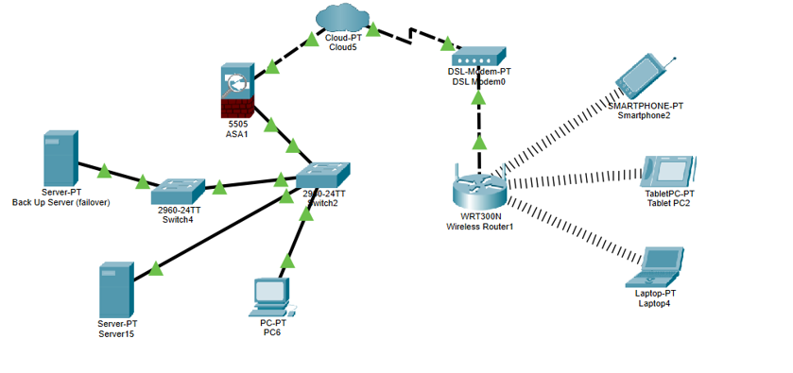

marking criteria and Student FEEDBACK

This section details the assessment criteria. The extent to which these are demonstrated by you determines your mark. The marks available for each criterion are shown. Lecturers will use the space provided to comment on the achievement of the task(s), including those areas in which you have performed well and areas that would benefit from development/improvement.

Common Assessment Criteria Applied (Assignment 1) | Marks available | Marks  awarded
1. Engagement with Literature Skills
Extent of research and/or own reading, selection of credible sources, application of appropriate referencing conventions.
You have discussed most key concepts Your research work can be benefited from more references. It would be good to use peer reviewed articles/journals. Try to utilise the university online resources and journals more. (Grade mark: 66.67%) | 15 | 10
2. Knowledge and Understanding Skills
Extent of knowledge and understanding of concepts and underlying principles associated with the discipline.
You have demonstrated understanding, however, see comments above to improve this aspect. You have not use the IEEE format. (Grade mark: 66.67%) | 15 | 10
3. Cognitive and Intellectual Skills
Analysis, evaluation and synthesis; logic, argument and judgement; analytical reflection; organisation of ideas and evidence
You report discussion address the case study and inter-relate this in most area. You also link your discussion to your appendix content. Some areas could be improved such as the conclusion; see report for more comment on this. (Grade mark: 70.00%) | 40 | 28
4. Practical Application Skills
Deployment of methods, materials, tools and techniques; application of concepts; formulation of innovative and creative solutions to solve problems.
You have done a basic design. Most key devices e.g. router and switch did not have the basic preventative measures. Functional ports were not configured on devices for testing. (Grade mark: 40.00%) | 20 | 8
5. Transferable Skills for Life and Professional Practice
Attributes in professional practice: individual and collaborative working; deployment of appropriate media; presentation and organisation.
Your work is professionally done. (Grade mark: 70.00%) | 10 | 7

Assignment Mark (Assessment marks are subject to ratification at the Exam Board. These comments and marks are to give feedback on module work and are for guidance only until they are confirmed. ) | Late Submission Penalties (tick if appropriate) |  | 63%
 | Up to four weeks late |  | 63%
 | First Attempt? |  | 63%

