

Student Name: Sadhana Kumari
Student ID:2413773

Module Name: Marketing Management
Module Code: LCMB7024_LON

Lecturer’s Name:Dr. Laila Maazouz

Term 1

Table of Contents
Element 1: Brand Extension Poster 4
Element 2: Segmentation, Targeting, Differentiation and Positioning (STDP) Analysis 5
2.1 Market Segmentation 5
2.2 Target Audience 6
2.3 Differentiation 7
2.4 Positioning 7
Element 3: Marketing Mix The 7Ps 9
3.1 Product 10
3.2 Price 11
3.3 Place 11
3.4 Promotion 11
3.5 People 12
3.6 Process 12
3.7 Physical Evidence 12
Element 4: Reflection 14
4.1 Developing the Brand Extension 14
4.2 The Poster Presentation 14
4.3 Professional Development 15
Reference List 16

List of Figures:

Figure 1: MediCare Smart Medical Box Brand Extension Poster 4

List of Tables:

Table 1: STDP Segmentation Analysis MediCare Smart Medical Box 5
Table 2: 7Ps Marketing Mix MediCare Smart Medical Box 9

Element 1: Brand Extension Poster
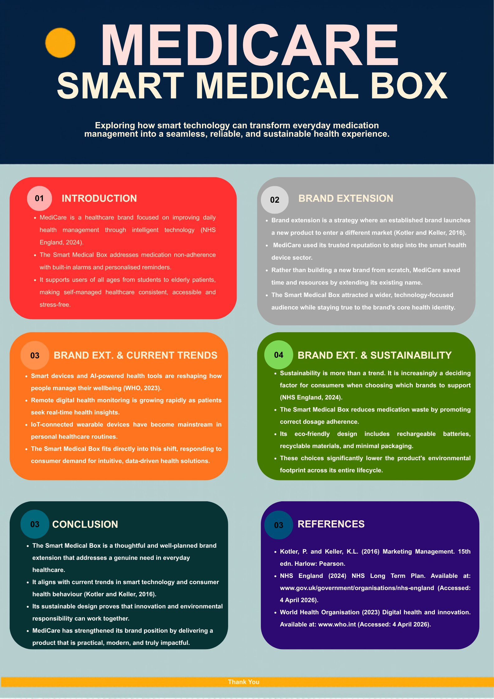
Figure 1: MediCare Smart Medical Box Brand Extension Poster

Element 2: Segmentation, Targeting, Differentiation and Positioning (STDP) Analysis

2.1 Market Segmentation
But they are based on assumptions instead of evidence when it does not use segmentation. According to Kotler et al. (2024) segmentation is finding buyer group whose different need or behaviour should be treated with a separate marketing responses In its absence, both targeting and positioning are guesswork. The Smart Medical Box has been segmented on the basis of geographic, demographic, psychographic and behavioural variables. Table 1 lists the identified segments and the audience selected from those segments.
Table 1: STDP Segmentation Analysis MediCare Smart Medical Box
Variable | Market Segments Identified | Chosen Target Audience
Geographic | UK, Europe, North America, Southeast Asia urban centres with ageing populations and high smartphone penetration | Urban adults aged 55 and above and family caregivers in metropolitan areas across the UK and Western Europe
Demographic | Adults aged 18 to 75 and above: elderly patients, carers, students, chronic illness patients | Primary: adults aged 55 to 75 managing multiple medications. Secondary: adult carers aged 30 to 55
Psychographic | Health-conscious individuals, technology adopters, sustainability advocates, people seeking independence in healthcare management | Proactive health managers who value convenience, reliability, and environmentally conscious products
Behavioural | Daily medication users, frequent NHS and GP service users, wearable device owners, app-engaged health consumers | High-frequency medication users taking two or more daily doses, with willingness to pay for premium health technology solutions

Urban centres across the UK, Western Europe, and North America represent the clearest early opportunity: these markets combine ageing populations, strong smartphone penetration, and the digital infrastructure that health technology adoption depends on. The UK carries additional weight. NHS England's Long Term Plan (2024) explicitly funds the expansion of remote health monitoring, which means the institutional environment is already oriented toward exactly what the Smart Medical Box provides.
The product serves a wider demographic than first appearances suggest. Elderly patients navigating several daily prescriptions are the obvious starting point, but adult carers managing a relative's medication and younger adults with chronic conditions both bring genuine purchasing motivation and financial means. To make the strategy workable, the primary commercial focus falls on adults aged 55 to 75 who self-manage multiple daily medications and need something dependable enough to trust and simple enough to use without support.
Age alone does not define who buys this product. The more useful portrait is attitudinal: someone who takes health management seriously, who is willing to use technology when it genuinely solves something rather than adding complexity, and who pays attention to how brands treat environmental questions. Kotler et al. (2024) document sustainability as a rising factor in purchasing decisions across health and technology categories, and the Smart Medical Box's design choices are a direct response to that shift. Behaviourally, the core segment is already using wearable devices and health-tracking apps; this product slots into an existing routine rather than requiring them to begin a new one.

2.2 Target Audience
Consider someone in their late sixties managing four prescriptions while living independently. A missed dose is not a minor slip; in some cases it is the difference between stable health and a preventable hospital stay. WHO (2023) estimates that half of all patients with chronic conditions fail to take medication as prescribed, with consequences that run from avoidable readmissions to accelerating deterioration in long-term outcomes. The Smart Medical Box is not a reminder app. It is a system designed so that following the correct regime becomes the easiest path rather than the one requiring conscious effort.
Secondary audience consists of those who care for seniors (30 – 55 years old on the behalf of elderly relatives) The number of people with frailty is increasing as the UK population ages and NHS community care capacity continues to come under pressure (NHS England, 2024). This validates consumer pressure with institutional level appetite for investment in self-care by the NHS, as The King's Fund (2023) identifies technology-enabled medication management as a top priority.

2.3 Differentiation
The existing market is largely divided between pill boxes and smartphone reminder apps, and the two rarely work together. What the Smart Medical Box offers is different in three specific ways. It does things other products at this price point cannot match: IoT connectivity, live caregiver alerts, and multilingual voice prompts (WHO, 2023). It carries credibility that a new entrant would need years to build, because MediCare's clinical history means the device does not arrive as a gadget but as a product from a brand already trusted in healthcare. And it is made in a way that matters to the people buying it: recyclable materials, a rechargeable battery, and minimal packaging are tangible signals of an environmental position, not a marketing claim (NHS England, 2024).

2.4 Positioning
The Smart Medical Box holds a clear position in the market: premium, clinically grounded, and environmentally considered, built for independent adults and the carers alongside them. Its positioning statement is: for health-conscious adults managing daily medication, the MediCare Smart Medical Box is the trusted technology solution that makes adherence reliable, connected, and environmentally responsible. Kotler et al. (2024) identify credibility, distinctiveness, and alignment with the audience's core values as the three tests any positioning must pass. This statement addresses all three: MediCare's clinical heritage supplies credibility, the product's integrated feature set provides distinctiveness, and the sustainability design choices deliver value-alignment.

Element 3: Marketing Mix The 7Ps
Borden's (1964) 4Ps were designed for physical goods sold in relatively straightforward transactions. The Smart Medical Box is neither. Booms and Bitner (1981) recognised this limitation and extended the framework to seven, adding People, Process, and Physical Evidence to capture the dimensions of delivery, experience, and trust that matter as much as the product specification in service and technology contexts. For this device in particular, the extended framework is not optional. A product that elderly users cannot configure, or that institutional buyers do not trust to handle sensitive health data, will underperform regardless of its technical quality. Table 2 shows how each of the seven elements applies.

Table 2: 7Ps Marketing Mix MediCare Smart Medical Box
7P Element | Application to MediCare Smart Medical Box
Product | Connected IoT device with compartmentalised medication trays, automated alarms, app-based refill reminders, and real-time caregiver notifications. Supports up to four daily doses, compatible with iOS and Android, with multilingual voice prompts for broader accessibility.
Price | Penetration pricing at 79.99 GBP RRP with a companion app subscription of 4.99 GBP per month, free for the first three months. NHS bulk pricing targets CCGs and care home operators. Tiered model addresses both consumer and institutional buyers (Kotler et al., 2024).
Place | Distribution via MediCare's e-commerce platform, Amazon UK, and selected Boots and Lloyds Pharmacy chains. B2B sales through NHS supply frameworks and private care networks. International rollout to EU and Southeast Asian markets in Year 2.
Promotion | Multi-channel digital campaign via Facebook, Instagram and Google Search targeting adults aged 50 and above. NHS partnerships provide clinical endorsement. PR outreach, healthcare influencer marketing, and patient testimonial videos on YouTube. NHS referral pathways as key conversion channel (WHO, 2023).
People | Customer service staff trained in health technology support and accessibility. Clinical advisors involved in product validation. Pharmacist and GP liaison officers manage B2B relationships. Remote onboarding specialists support elderly users with device setup.
Process | App-guided onboarding in under five minutes with one-click reorder. NHS procurement managed by dedicated account managers. Returns policy aligned with NHS contract terms. Cloud-based data management compliant with NHS Data Security Standards (NHS England, 2024).
Physical Evidence | Premium matte packaging with minimal plastic. MediCare logo prominently displayed. App UI designed to WCAG 2.1 accessibility standards. NHS and CE certification badges on packaging. Recyclable materials and rechargeable battery demonstrate sustainability commitment.

3.1 Product
The problem the Smart Medical Box addresses is structural, not motivational. Patients who miss doses are not careless; the tools available to them simply do not make adherence easy enough. Automated dispensing removes the need to remember whether a compartment was opened. Multi-alarm reminders fire at dose windows rather than at convenient times. Caregiver notifications mean that a missed dose does not go undetected until the next appointment. Multilingual voice prompts extend the device's reach to older users whose first language is not English, and compatibility across both major mobile platforms avoids quiet attrition from platform mismatch. Kotler et al. (2024) frame product thinking across core benefit, actual product, and augmented product. The benefit here is adherence that does not require conscious effort; the product is the connected hardware and application; and the augmented layer, covering warranty, clinical support, and NHS endorsement, is what earns the trust of buyers who are making a health-related commitment.

3.2 Price
At 79.99 GBP, the device clears the quality threshold older consumers associate with basic pill boxes while stopping well short of the price points where health technology purchases start to feel like a serious financial commitment. The strategy is deliberate sequencing: establish the habit first through the device, then generate recurring revenue through the companion app at 4.99 GBP monthly. Three free months lower the activation barrier enough that the pricing model does not interrupt the conversion. Kotler et al. (2024) note that once users integrate a product into daily routine, retention follows almost automatically. For NHS and care home buyers, a separate volume-based procurement model acknowledges that institutional purchasing involves different approval processes, budget cycles, and value criteria than individual consumer decisions.

3.3 Place
How the target demographic shops varies considerably by age and digital confidence, and a single-channel distribution approach would lose a meaningful portion of potential buyers quietly. MediCare's own website and Amazon UK cover the carers and digitally confident older buyers at low marginal cost. Boots and Lloyds Pharmacy serve a different need: the older consumer who wants to hold the product, read the packaging, and put a question to a pharmacist before spending money. That physical interaction is part of the decision for a significant portion of the primary target, and designing it out would be a commercial error. Procurement through the NHS approved device framework (NHS England, 2024) represents the largest single opportunity, combining volume with the kind of institutional credibility that feeds back into consumer trust. Expansion into EU and Southeast Asian markets, where population ageing and digital health adoption are both accelerating, follows in Year 2.

3.4 Promotion
Carers managing a relative's prescriptions and a 70-year-old managing their own are both within the target audience, but they do not use the same platforms or respond to the same messages. Facebook and Instagram carry carer outreach and reach early-adopter older users effectively; Google Search intercepts people who have already started looking and are ready to compare. Within this category, NHS endorsement outperforms every other promotional lever: WHO (2023) research consistently identifies healthcare professional recommendation as the primary driver of health technology adoption, and MediCare's clinical network makes that endorsement available rather than merely aspirational. YouTube patient testimonials and pharmacy point-of-sale materials serve the segments still outside digital search channels.

3.5 People
Engineering quality is only part of what makes a health device succeed. The other part is whether the people around it, in sales, support, onboarding, and clinical liaison roles, understand the specific challenges of the audience they are serving. Booms and Bitner (1981) are clear that in service and technology contexts, staff competence is a component of the product itself. For older adults, patient and accessible communication from customer-facing staff is not a nicety but a prerequisite for adoption. Clinical advisors embedded in the development process give MediCare's NHS positioning genuine substance. Pharmacist and GP liaison officers navigate institutional procurement with the sensitivity those relationships require. Remote onboarding specialists carry the most operationally critical function: a user whose first session with the device ends in frustration will rarely return to it.

3.6 Process
For an elderly user with limited digital experience, a setup process that takes twenty minutes is a process that ends with the device back in the box. Five-minute guided setup, one-click reorder, and automatic refill alerts are not minor conveniences; they are the difference between a product that gets used and one that does not. Dedicated NHS account managers absorb the procurement administration that would otherwise fall to clinical staff with no time or appetite for it. Cloud data management aligned with NHS Data Security and Protection Toolkit standards (NHS England, 2024) addresses the question that individual and institutional buyers alike raise first: what happens to the health data this device collects.

3.7 Physical Evidence
Entering a product category without an existing track record means the usual shortcut, past purchase satisfaction, is unavailable. Kotler et al. (2024) observe that in this situation, material cues do the persuasive work that product history would normally handle. Before the device is switched on, a buyer is already forming a quality judgement based on the weight of the packaging, the clarity of the certification marks, and the professionalism of the product materials. Premium matte packaging, NHS and CE certification badges, and a WCAG 2.1-compliant app interface each contribute to that first impression. The rechargeable battery and recyclable materials carry a different signal: that the brand has considered its obligations past the point of sale. Research increasingly confirms that this consideration is not peripheral for the target demographic but a genuine factor in whether trust is extended (WHO, 2023).

Element 4: Reflection

4.1 Developing the Brand Extension
Analytical distance makes critical writing feel manageable. This project removed it. The moment the question shifts from what did they do to what would you do, frameworks that looked coherent on paper start showing gaps. That experience of being accountable for the decisions rather than assessing someone else's is where the learning actually happened.
Segmentation showed this most clearly. I entered the exercise assuming elderly patients were the target. The STDP framework forced me to look further, and adult carers turned out to matter commercially in ways that changed the targeting and the marketing mix that followed. Kotler et al. (2024) argue that segmentation must look past demographic categories to the behaviours that predict purchase decisions. That point lands differently after applying it than after reading it.
The 7Ps reframed the project in a way I had not anticipated. People, Process, and Physical Evidence changed my understanding of what the product actually was. Booms and Bitner (1981) are right that for technology products, delivery experience is inseparable from the product. A user who cannot get the device working on day one and puts it in a drawer has not failed to adopt it. The product has failed them.

4.2 The Poster Presentation
The poster imposed a constraint that academic writing does not: there is no room to hedge, qualify, or reach for an additional paragraph when the argument feels incomplete. Every cut forced a judgement about what the analysis was actually saying at its core. More often than I expected, what remained after cutting was sharper than what I had started with. That experience changed how I think about editing written work more generally.
The delivery exposed something I had not yet properly confronted. When I am not fully confident speaking, I reach for notes, and that is what happened during the presentation. The material on the poster was stronger than how I presented it, and I was aware of that gap while it was happening. What I plan to do differently is specific: rehearse without notes until the content is genuinely available from memory rather than from a printed page, and ask someone whose feedback I trust to watch a run-through before the next formal assessment, not after.

4.3 Professional Development
What I had not done before this project was work across frameworks simultaneously rather than in sequence. Each element of this portfolio had to be consistent with the one before it: segment choices constrained the targeting, targeting shaped the positioning, and positioning determined what the marketing mix could plausibly claim. When those connections broke, the argument felt wrong even when the individual sections were technically sound. Working out where the logic had slipped and fixing it rather than moving on is what Kotler et al. (2024) mean by integrative strategic thinking. It is a skill that reads clearly in a textbook and only becomes real through practice.
Two changes for next time. First, speak directly to people in the target audience before finalising the analysis: secondary sources gave inconsistent answers about older adults' digital confidence, and direct conversations would have settled that early. Second, benchmark differentiation claims against named competitors rather than the category broadly. Stating that the product outperforms on IoT integration and caregiver alerting is more defensible when tested against a specific rival. Both improvements address the same gap: more confidence than the evidence strictly supported.

Reference List
- Booms, B.H. and Bitner, M.J. (1981) 'Marketing strategies and organisation structures for service firms', in Donnelly, J.H. and George, W.R. (eds) Marketing of Services. Chicago: American Marketing Association, pp. 47-51.
- Borden, N.H. (1964) 'The concept of the marketing mix', Journal of Advertising Research, 4(2), pp. 2-7.
- King's Fund (2023) Technology and innovation for long-term conditions. London: The King's Fund.
- Kotler, P. and Keller, K.L. (2016) Marketing Management. 15th edn. Harlow: Pearson.
- Kotler, P., Armstrong, G. and Opresnik, M.O. (2024) Principles of Marketing. 18th edn. Harlow: Pearson.
- NHS England (2024) NHS Long Term Plan. Available at: www.gov.uk/government/organisations/nhs-england (Accessed: 4 April 2026).
- Schon, D.A. (1983) The Reflective Practitioner: How Professionals Think in Action. New York: Basic Books.
- World Health Organisation (2023) Digital health and innovation. Available at: www.who.int (Accessed: 4 April 2026).
- World Health Organisation (2023) Medication adherence report. Available at: www.who.int (Accessed: 4 April 2026).

