
Programme: MSc Public Health and Social Care in Practice
Module name : Population Health and Digital Health Promotion
Module code : LCHS7009
Student Name : Jatin Makwana
Student Id : 2521166
Lecturer name : Diola Bijlhout, Dr Ping Wu
Assignment Title: Component 1 - Blogs

Table of Contents
Blog 1 (Existing Technology) 3
1. Physical Inactivity and Obesity: A Growing Public Health Concern 3
2. Wearable Fitness Trackers in Health Promotion 4
3. Evidence of Health Promotion Effectiveness 4
4. Critical Impact: Advantages and Limitations 5
5. Addressing Current Shortfalls 5
Blog 2 (Designed Technology) 7
1. Public Health Problem: Physical Inactivity among Sedentary Adults 7
2. Designed Digital Technology 7
3. Health Promotion through the Designed Technology 8
4. Impact of the Designed Technology 8
5. Addressing the Shortfalls 8
Reference list 9

Blog 1 (Existing Technology)

1. Physical Inactivity and Obesity: A Growing Public Health Concern
Physical inactivity is a significant global public health issue because it is accompanied by a significantly higher risk of obesity, cardiovascular disease, type 2 diabetes and early death (Katzmarzyk et al., 2021).
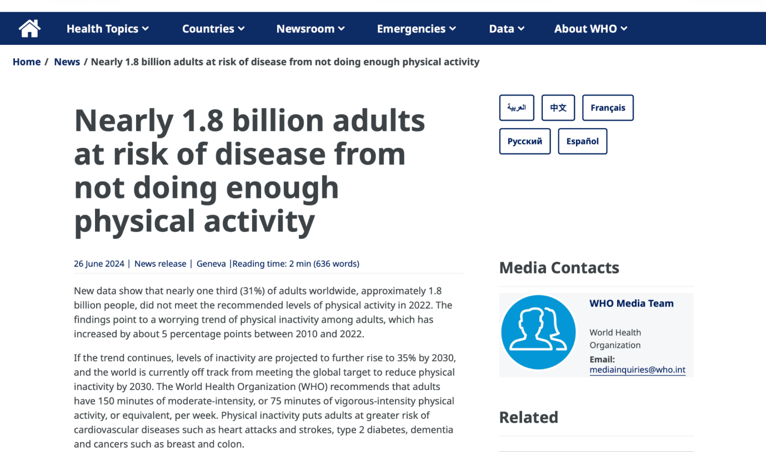
Figure 1: Globally not physically active people
(Source: World Health Organization, 2024)
The World Health Organization (2024) estimated that nearly 1.8 billion adults (31%) are not physically active enough (World Health Organization, 2024) and physical inactivity is responsible for about 1.8 million deaths every year, globally.
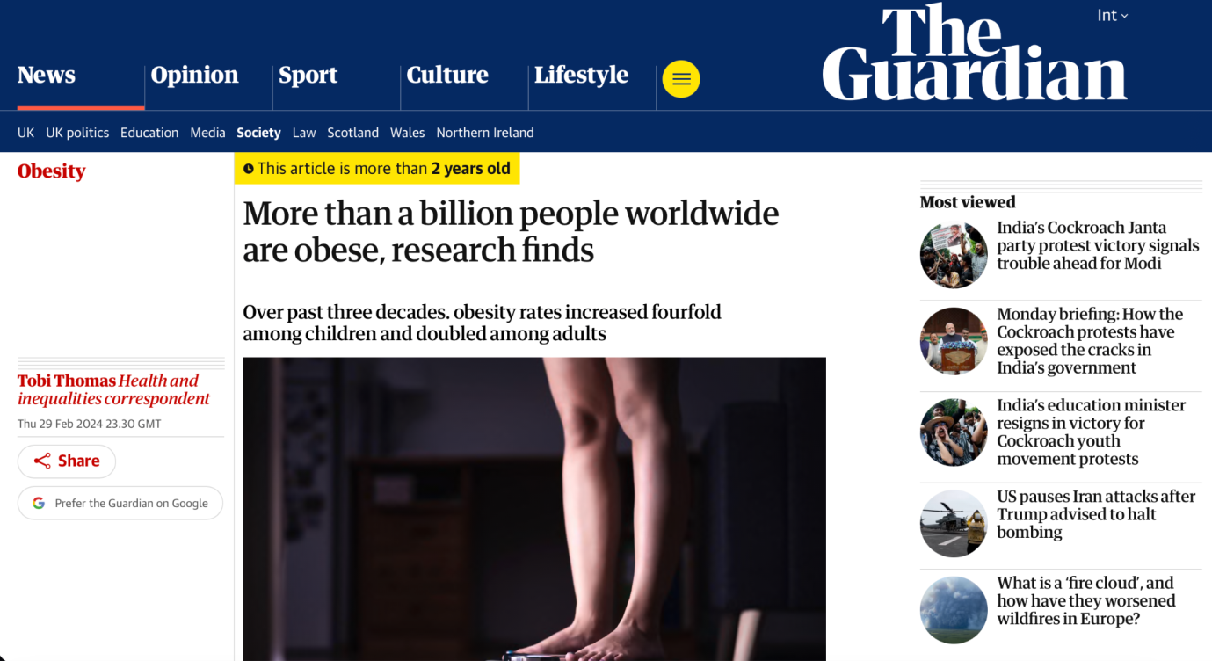
Figure 2: Global obesity people
(Source: Thomas, 2024)
Obesity is another concerning problem as over 1 billion are living with obesity all over the world (Thomas, 2024).

2. Wearable Fitness Trackers in Health Promotion
One of the most popular forms of digital health promotion technologies nowadays are wearable fitness trackers like the Fitbit, Apple Watch, or Garmin (Gammie et al., 2026). Users are given individualised health targets, reminders, progress reports and motivational notifications/rewards to reach their health targets via mobile applications (Sousa Basto and Ferreira, 2025). An example of this is the Activity Rings found on Apple Watch, which allow you to set up goals to reach every day, or when using a FitBit, getting personalised coaching and feedback on weekly performance (Apple Newsroom, 2026).

3. Evidence of Health Promotion Effectiveness
Measures such as wearable devices helped with increasing moderate-to-vigorous physical activity (MvPA) and daily step counts among adults, according to a systematic review by Ferguson et al., (2022)
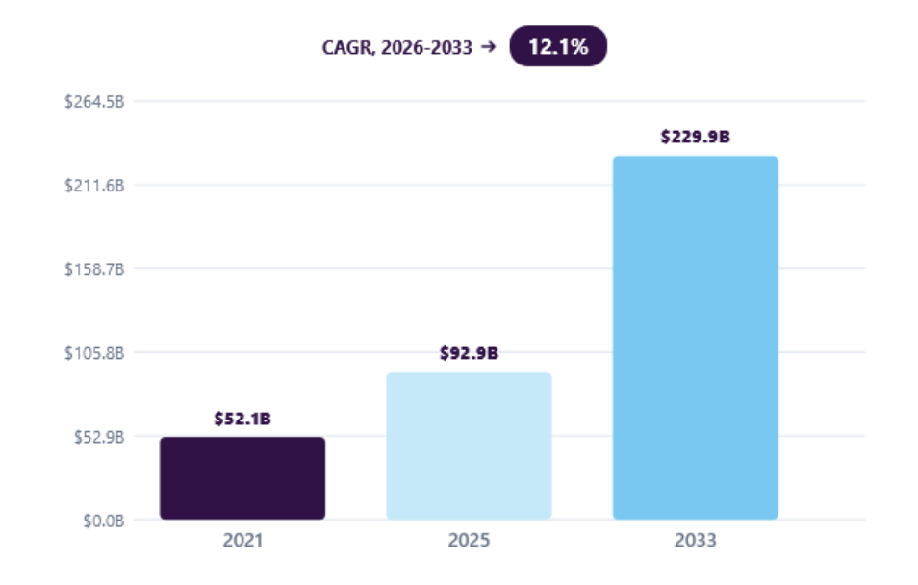
Figure 3: Global wearable market size
(Source: Grand View Research, 2024)
In addition, the worldwide wearable technologies marketplace generated more than $92.9 billion in 2025 and these gadgets are largely used for health surveillance (Grand View Research, 2024). Recent evidence also suggests that the continual feedback that occurs with wearing may help to boost awareness, accountability and motivation for the recommended levels of physical activity and therefore increase adherence.

4. Critical Impact: Advantages and Limitations
Wearable fitness trackers offer a wide range of advantages, such as ongoing health monitoring, individualised feedback, identification of sedentary departure, and motivation to track fitness via gamification (Hydari, Adjerid and Striegel, 2022). They allow people to take control of their health and give health providers insight into patient progress remotely. There are also financial barriers to the use of some PVs for those who can't afford to purchase them, and privacy concerns surrounding personal health information and data are paramount (Wray et al., 2022).

5. Addressing Current Shortfalls
Implementing public health subsidy schemes to increase the affordability of wearable fitness trackers; also the personalised AIC (personalised artificial intelligence coaching) for long term engagement, coupled with behaviour change support from health care professionals can boost the effectiveness of wearable fitness trackers (Alzghaibi, 2025). Public confidence in the use of data (data protection policies and privacy controls) would make it safer to use online.

Blog 2 (Designed Technology)

1. Public Health Problem: Physical Inactivity among Sedentary Adults
Physical inactivity is a major global public health challenge, contributing significantly to obesity, cardiovascular diseases, type 2 diabetes, hypertension, and poor mental health. Sedentary lifestyles have increased because of remote working, excessive screen time, and urban living, creating substantial healthcare and economic burdens (Goyal and Rakhra, 2024).
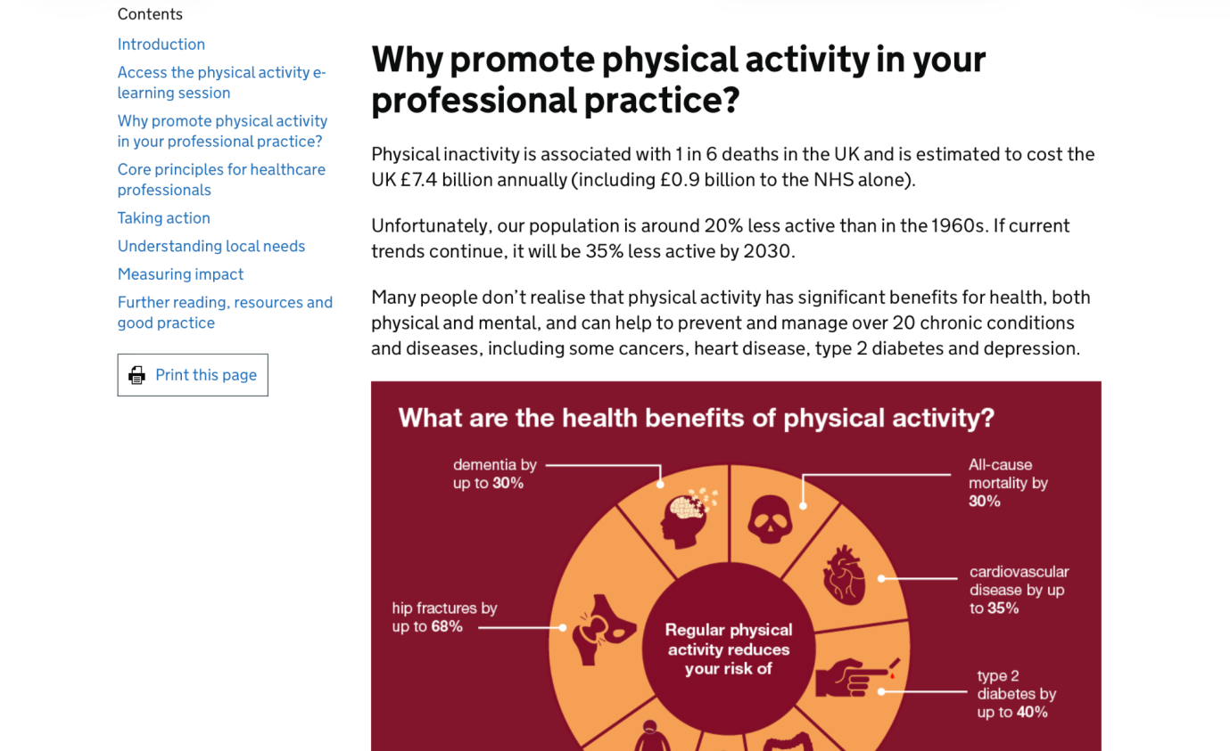
Figure 1: NHS physical inactive illness
(Source: Office for Health Improvement & Disparities, 2022)
In the United Kingdom, physical inactivity contributes to approximately one in six deaths, while Office for Health Improvement & Disparities, (2022) estimates that inactivity-related illnesses cost the NHS over £0.9 billion annually.

2. Designed Digital Technology
The proposed technology is ActiveLife AI, a gamified wearable health platform integrating artificial intelligence, wearable sensors, and community-based engagement. The platform includes five core features: an AI personal trainer that adapts exercise recommendations according to users' fitness levels and health data; smart exercise plans that automatically adjust based on daily performance and recovery. Community challenges allowing users to compete with friends and local participants; a reward system providing digital badges, discounts, or wellness points for consistent activity.

3. Health Promotion through the Designed Technology
ActiveLife AI promotes health by encouraging gradual and personalised increases in physical activity while reducing barriers such as lack of motivation, limited knowledge, and social isolation. The AI personal trainer analyses heart rate, daily steps, sleep quality, and activity history to recommend achievable goals. Smart exercise plans prevent overtraining while progressively improving fitness (Ismail Dergaa et al., 2024). Community challenges and local walking groups strengthen social support, which is recognised as an important determinant of sustained health behaviour. For example, inactive office workers could participate in neighbourhood walking competitions where weekly progress earns reward points redeemable for gym memberships or healthy lifestyle products (Ullberg et al., 2023). Such behavioural reinforcement encourages regular engagement and promotes healthier lifestyles across different age groups.

4. Impact of the Designed Technology
The proposed platform offers several advantages. Personalised AI recommendations increase exercise relevance and user satisfaction, while gamification improves motivation and long-term engagement. Social networking features reduce loneliness and strengthen accountability, particularly among sedentary adults. Wearable integration enables continuous monitoring, providing valuable real-time health insights for both users and healthcare professionals (Jafleh et al., 2024). AI-generated recommendations may occasionally lack contextual understanding of individual medical conditions (Florian Kücking et al., 2025).

5. Addressing the Shortfalls
These challenges can be reduced through inclusive and responsible design. Offering a low-cost or free basic version would improve accessibility for disadvantaged populations. Healthcare professionals should periodically review AI-generated exercise recommendations for users with chronic conditions to ensure safety (Zaleski et al., 2024). Strong data encryption, transparent consent procedures, and compliance with GDPR and relevant health data regulations would strengthen user confidence.

Reference list
Blog 1
Alzghaibi, H. (2025). Adoption barriers and facilitators of wearable health devices with AI integration: A patient-centred perspective. Frontiers in Medicine, 12(8). doi:10.3389/fmed.2025.1557054.
Apple Newsroom (2026). Get active with apple watch. [online] Apple newsroom (india). Available at: https://www.apple.com/in/newsroom/2025/04/get-active-with-apple-watch/ [Accessed 27 July 2026].
Ferguson, T., Olds, T., Curtis, R., Blake, H., Crozier, A.J., Dankiw, K., Dumuid, D., Kasai, D., O’Connor, E., Virgara, R. and Maher, C. (2022). Effectiveness of wearable activity trackers to increase physical activity and improve health: A systematic review of systematic reviews and meta-analyses. The lancet digital health, [online] 4(8), pp.e615-e626. doi:10.1016/s2589-7500(22)00111-x.
Gammie, A.J., Nichols, J.H., Egaddar, O., Becker, J., Dabla, P.K., Gouget, B., Evgenija Homšak, Korita, I., Kotani, K., Ebru Saatçi, Stankovic, S., Zihni Onur Uygun, AbdelWareth, L., Ram Vinod Mahato, Ganguly, A., Ogong’a, R.O. and Rytkönen, J. (2026). Opinion paper: Smartwatches in Healthcare: Revolutionizing health or creating data confusion? Ejifcc, [online] 37(1), p.16. Available at: https://pmc.ncbi.nlm.nih.gov/articles/PMC12882078/ [Accessed 27 July 2026].
Grand View Research (2024). Wearable technology market size | industry report, 2020-2027. [online] Grand View Research. Available at: https://www.grandviewresearch.com/industry-analysis/wearable-technology-market [Accessed 27 July 2026].
Hydari, M.Z., Adjerid, I. and Striegel, A.D. (2022). Health wearables, gamification, and healthful activity. Management science, 69(7). doi:10.1287/mnsc.2022.4581.
Katzmarzyk, P.T., Friedenreich, C., Shiroma, E.J. and Lee, I.-M. (2021). Physical inactivity and non-communicable disease burden in low-income, middle-income and high-income countries. British journal of Sports medicine, [online] 56(2), pp.bjsports-2020–103640. doi:10.1136/bjsports-2020-103640.
Sousa Basto, P. and Ferreira, P. (2025). Mobile applications, physical activity, and health promotion. BMC health services research, 25(1). doi:10.1186/s12913-025-12489-z.
Thomas, T. (2024). More than a billion people worldwide are obese, research finds. [online] The guardian. Available at: https://www.theguardian.com/society/2024/feb/29/more-than-a-billion-people-worldwide-are-obese-research-finds [Accessed 27 July 2026].
World Health Organization (2024). Nearly 1.8 Billion adults at Risk of Disease from Not doing enough physical activity. [online] World Health Organization. Available at: https://www.who.int/news/item/26-06-2024-nearly-1.8-billion-adults-at-risk-of-disease-from-not-doing-enough-physical-activity [Accessed 27 July 2026].
Wray, C.M., Lopez, L., Khare, M. and Keyhani, S. (2022). Cost-Related access barriers, medical debt, and dissatisfaction with care among privately insured americans. Journal of General internal medicine, [online] 38(4). doi:10.1007/s11606-022-07822-9.
Blog 2
Florian Kücking, Busch, D.A., Mareike Przysucha, Jan-Oliver Kutza, Hannemann, N., Jens Hüsers, Babitsch, B. and Hübner, U. (2025). Impact of AI recommendation correctness on diagnostic accuracy in clinical decision-making. International journal of Medical informatics, 207(17), pp.106223–106223. doi:10.1016/j.ijmedinf.2025.106223.
Goyal, J. and Rakhra, G. (2024). Sedentarism and chronic health problems. Korean journal of Family medicine, 45(5), pp.239–257. doi:10.4082/kjfm.24.0099.
Ismail Dergaa, Helmi Ben Saad, Abdelfatteh El Omri, Glenn, J., Clark, C., Jad Washif, Noomen Guelmami, Hammouda, O., Ramzi Al-Horani, Reynoso-Sánchez, L., Romdhani, M., Laisa Paineiras-Domingos, Vancini, R., Taheri, M., Mataruna-Dos-Santos, L., Khaled Trabelsi, Hamdi Chtourou, Makram Zghibi, Eken, Ö., Swed, S., Mohamed Ben Aissa, Hossam Shawki, Hesham El-Seedi, Iñigo Mujika, Seiler, S., Zmijewski, P., Pyne, D.B., Beat Knechtle, Asif, I., Drezner, J., Øyvind Sandbakk and Karim Chamari (2024). Using artificial intelligence for exercise prescription in personalised health promotion: A critical evaluation of OpenAI’s GPT-4 model. Biology of sport, 41(2). doi:10.5114/biolsport.2024.133661.
Jafleh, E.A., Alnaqbi, F.A., Almaeeni, H.A., Faqeeh, S., Alzaabi, M.A. and Al Zaman, K. (2024). The role of Wearable devices in Chronic disease monitoring and patient care: A comprehensive review. Cureus, [online] 16(9). Available at: https://pubmed.ncbi.nlm.nih.gov/39381470/ [Accessed 27 July 2026].
Office for Health Improvement & Disparities (2022). Physical activity: Applying all our health. [online] GOV.UK. Available at: https://www.gov.uk/government/publications/physical-activity-applying-all-our-health/physical-activity-applying-all-our-health [Accessed 27 July 2026].
Ullberg, O.H., Toivanen, S., Tillander, A. and Bälter, K. (2023). Workplace health promotion to facilitate physical activity among office workers in Sweden. Frontiers in Public health, 11(14). doi:10.3389/fpubh.2023.1175977.
Zaleski, A.L., Berkowsky, R., Jean, K. and Pescatello, L.S. (2024). Comprehensiveness, accuracy, and readability of Exercise recommendations provided by an AI-Based chatbot: Mixed methods study. JMIR medical education, 10(15), pp.e51308-e51308. doi:10.2196/51308.

