Designing a Mobile Cooperative Strategy Game for UWTSD

Student Name: | Marius-Catalin Bobitiu
Student ID: | 1813436
Module: | Usability Engineering
Module Code: | ACCB6017
Lecturer: | Fahad Ahmed

Table of Contents
Introduction 3
1. Full-Colour Interface Design 3
1.1 Development from the Wireframe Prototype 3
1.2 Visual Design and Colour Scheme 4
1.3 Interaction Design and Key Screens 4
2. Prototype Feedback and User Testing 5
2.1 Testing Method 5
2.2 Results and Thematic Analysis 6
3. Data Collection in a Working Version 7
3.1 Usage and Behavioural Data 7
3.2 Emotional and Experiential Data 7
3.3 Privacy and Responsible Data Collection 8
4. Reflective Summary 8
References 10
Appendix A – High-Fidelity Prototype Screens 10
Appendix B – User Testing Responses and Thematic Analysis 20

Table of references
Figure 1 Overview of the developed high-fidelity prototype and its interaction flow. 3
Figure 2 Full-colour storyboard showing the primary user journey through UWTSD Outbreak. 5

Introduction
This report continues the development of UWTSD Outbreak, a cooperative mobile strategy game based on the principles of Pandemic and adapted to a university setting. The first stage of the project established user requirements and personas before developing a wireframe storyboard, which was evaluated with potential users to identify usability issues and opportunities for improvement. This second stage responds to those findings through the development of a full-colour storyboard that demonstrates the main interaction sequence, visual design and intended user experience of the game.
The report discusses how feedback from the initial wireframe evaluation influenced the colour scheme, graphics and interaction design of the final storyboard. A high-fidelity prototype was also produced during this process to support the development and evaluation of the interface. Feedback collected on the final storyboard is analysed to identify both positive and negative aspects of the design and inform potential improvements. The report discusses how the final storyboard's colour palette, graphics and interaction design was affected by input received from the initial wireframe review. Simultaneously, a high-fidelity prototype was created to help the development and evaluation of the interface.

1. Full-Colour Interface Design

1.1 Development from the Wireframe Prototype
The full-colour storyboard was developed from the wireframe storyboard created and evaluated during the first stage of the project. A high-fidelity prototype was produced during this process to explore the interface screens and interaction states in greater detail before incorporating them into the final storyboard. The fundamental journey was retained, progressing from joining a game and selecting a role to identifying an outbreak, choosing an action and receiving feedback.
Feedback from the initial evaluation influenced how information and actions were presented. To reduce unnecessary cognitive demand, actions are progressively disclosed according to the player’s current situation rather than being permanently visible. Cognitive Load Theory recognises the limited capacity of working memory when processing information [1]. Selecting an affected campus therefore reveals only relevant actions while leaving the map and current game state as the primary focus.
Accessibility considerations were also retained. Important states are communicated using multiple visual cues; for example, an outbreak combines colour, a warning symbol and numerical severity rather than relying on colour alone, following WCAG guidance [2].
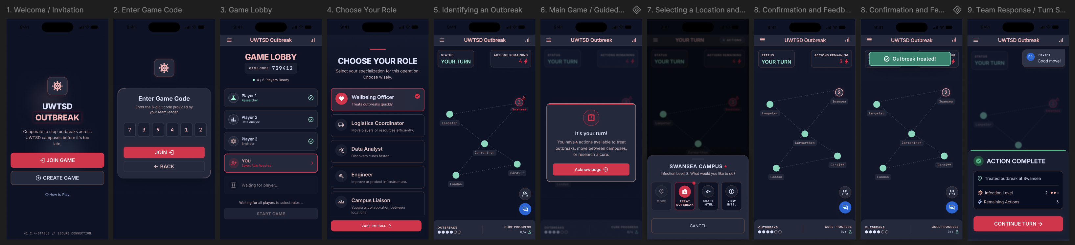
Figure 1 Overview of the developed high-fidelity prototype and its interaction flow.
Larger versions of the individual interface screens are provided in Appendix A.

1.2 Visual Design and Colour Scheme
A dark navy colour scheme was selected as the visual foundation of the interface, supported by light typography and a red/pink accent used for primary interactions and important outbreak information. Successful actions use a separate positive state, allowing warnings, ordinary information and successful outcomes to be distinguished quickly. Colour remains a supporting communication mechanism rather than the only indication of state [2].
Consistency was maintained through repeated card styles, button shapes, typography, spacing and icon treatments across joining, role selection and gameplay. Shneiderman et al. identify consistency and informative feedback as important principles for helping users understand interactions and their outcomes [3]. The restrained visual system therefore provides continuity between screens while allowing information requiring immediate attention to receive stronger visual prominence.

1.3 Interaction Design and Key Screens
The completed full-colour storyboard presents the primary interaction sequence from receiving an invitation through to completing an action during gameplay. The storyboard places individual interface screens within the context of the player’s journey and demonstrates how each interaction leads to the next.
After joining the lobby and selecting a role, contextual onboarding introduces the player’s first turn. An outbreak is then identified on the campus map and selecting the affected location reveals the actions available in that context. Consequential actions require confirmation before being committed, reducing the possibility of accidentally spending one of the player’s limited actions and supporting the principle of error prevention [2].
Following confirmation, the interface provides immediate feedback: outbreak severity decreases, the remaining action count is updated, and a success state communicates the result. Effective feedback helps users understand both the outcome of an interaction and the resulting system state [4]. The final storyboard frame summarises the action before play continues.
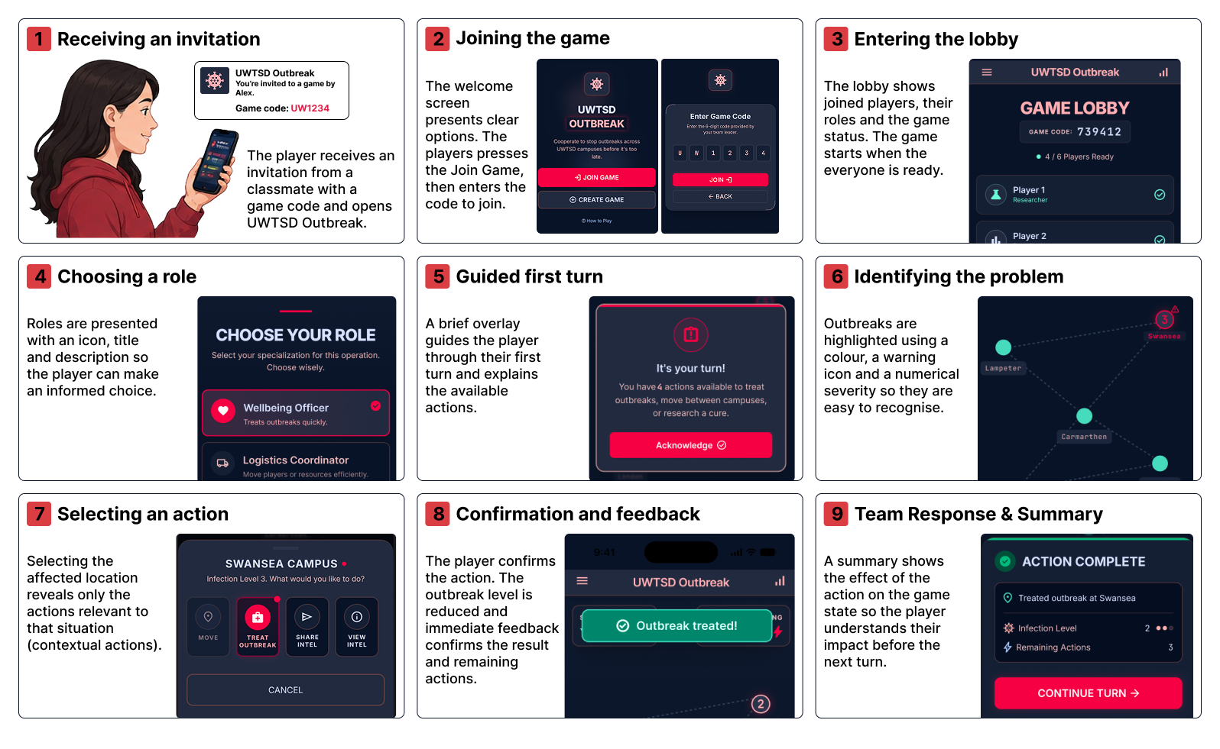
Figure 2 Full-colour storyboard showing the primary user journey through UWTSD Outbreak.

2. Prototype Feedback and User Testing

2.1 Testing Method
Following development of the high-fidelity interface and full-colour storyboard, a second stage of user testing was conducted to evaluate the revised design and identify remaining usability issues. Unlike the initial wireframe evaluation, this stage also considered participants’ emotional responses, as colour, typography, graphics and interaction feedback could now be evaluated as part of a more complete representation of the intended game experience.
Three participants from the permitted peer group evaluated the interaction sequence, including joining a game, selecting a role, identifying an outbreak and completing an action. A short questionnaire combined closed questions with open-ended responses. Participants evaluated the clarity of the interaction flow, identification of outbreaks and actions, and understanding of information such as remaining actions, outbreak severity and cure progress. They were also asked to describe how the interface made them feel and identify one improvement they would make.
The participants represented differing levels of gaming experience, reflecting the range considered through the personas developed during the first stage. Closed responses were summarised descriptively, while the qualitative comments were analysed thematically. Recurring comments were coded according to the issue or experience described before related codes were grouped into broader themes.

2.2 Results and Thematic Analysis
The results were generally positive. All three participants considered the process of joining a game, selecting a role and beginning play to be clear. When assessing whether the outbreak and required action could be identified from the main gameplay screen, one participant responded positively while two selected “Mostly”. Participants also rated their understanding of remaining actions, outbreak level, cure progress and action results. On a scale from 1 (very easy) to 5 (very difficult), all three selected 2, producing a mean of 2.0. This indicates that the information was generally easy to understand, although some improvement to its presentation remained possible.
Thematic analysis of the open-ended responses identified three themes: information hierarchy, emotional response, and support for continued play.
Theme | Evidence from responses | Design implication
Information hierarchy | Interface described as slightly busy; outbreak level easy to miss; suggestion for additional icons | Increase prominence of critical game-state information and support text with visual cues
Emotional response | Described as engaging, professional, calm and clear, but somewhat generic for an outbreak theme | Retain clarity while strengthening the game’s visual identity and sense of urgency
Support for continued play | Suggestion for a recap of the previous turn | Provide a brief summary when control returns to the player
Table 1 Themes identified from qualitative prototype-testing responses.
The first theme showed that the overall game state was understandable but that its visual hierarchy could be improved. Comments that the interface was slightly busy and that outbreak severity could be missed at a glance suggest that critical information should receive greater prominence. Additional iconography could also support faster recognition without introducing substantially more information.
The emotional responses were positive overall, with participants describing the interface as calm, clear, engaging and professional. However, describing the design as somewhat generic for an outbreak theme revealed an important design trade-off. The restrained presentation supported clarity but did not always communicate the intended urgency of the game. A future iteration could therefore strengthen the outbreak identity without sacrificing readability.
Finally, the suggestion for a previous-turn recap identified a requirement not originally prioritised in the design. In a cooperative turn-based game, players may need to regain awareness after other players have acted. A concise recap could therefore improve continuity between turns.
Overall, the testing supported the fundamental interaction structure while identifying opportunities to improve information prominence, thematic character and awareness between turns. The findings also demonstrate the value of combining numerical usability measures with qualitative feedback: the positive ease-of-understanding score alone would not have revealed the more specific issues identified through thematic analysis.

3. Data Collection in a Working Version
If UWTSD Outbreak were developed into a working application, continued evaluation would require a combination of automatically collected usage data and direct feedback from players. Prototype testing can identify usability problems before implementation, but a released version would provide evidence of how the interface performs during repeated use and complete multiplayer games. Any data collected should therefore have a defined purpose and contribute directly to future design decisions.

3.1 Usage and Behavioural Data
Automatic telemetry could record information such as game completion and abandonment rates, session duration, time spent on individual turns, actions selected or cancelled, use of help functions and role-selection frequency. Interaction events could also identify screens that users repeatedly return to or stages where players commonly leave the game. Behavioural and performance measures can provide evidence of how users interact with a system and help identify potential usability problems [5].
These measures could reveal patterns that are difficult to identify during a small usability study. For example, consistently long decision times at a particular stage could indicate difficulty understanding the available actions, while frequent cancellation immediately after selecting an action could suggest uncertainty about its consequences. Similarly, a high abandonment rate during onboarding could indicate that the joining or introductory process creates unnecessary friction.
However, behavioural data would need to be interpreted cautiously. A long turn does not necessarily indicate poor usability, as the player may instead be considering a difficult strategic decision or communicating with teammates. Analytics can therefore indicate where potential problems occur but may not explain why they occur.

3.2 Emotional and Experiential Data
Emotional responses cannot be reliably determined from interaction logs alone. Behavioural patterns may suggest frustration, hesitation or engagement, but they do not directly demonstrate what the player experienced. Direct user feedback would therefore remain necessary alongside automatic telemetry.
Short post-game questionnaires could measure perceived difficulty, enjoyment, tension, confidence and satisfaction. Optional open-ended questions could provide additional context, while periodic interviews or usability-testing sessions could investigate recurring issues identified through analytics in greater depth. Combining behavioural or performance measures with subjective measures can provide a more complete understanding of the user experience than relying on a single type of measurement [5].
This distinction is particularly important for a cooperative strategy game. Increased decision time, for example, could appear undesirable when considered purely as an efficiency measure but may instead represent an intended period of strategic discussion and tension. Combining behavioural analytics with direct experiential feedback would help distinguish desirable gameplay challenge from difficulty caused by the interface.

3.3 Privacy and Responsible Data Collection
Only information necessary for evaluating and improving the application should be collected. This reflects the data-minimisation principle of UK GDPR, under which personal data should be adequate, relevant and limited to what is necessary for its intended purpose [6]. Where possible, analytics should use anonymous or pseudonymous identifiers rather than directly identifying individual players. Players should also be informed about what information is being collected and why it is required.
Qualitative feedback requires additional consideration because open-ended responses may contain information that users did not intend to provide as behavioural analytics. Experiential feedback should therefore remain optional, and collected information should only be retained for as long as necessary for its intended purpose.
A combination of automatic telemetry and continued user research would provide a stronger basis for future iterations than either approach alone. Usage data could identify recurring behavioural patterns across a larger population, while questionnaires and usability testing could help explain the experiences behind those patterns. Together, these findings could inform future changes to onboarding, terminology, game-state presentation and interaction design

4. Reflective Summary
The development of UWTSD Outbreak followed an iterative user-centred process, progressing from initial user research and personas to wireframe storyboards, evaluation, high-fidelity interface development and further user testing. This process demonstrated that usability was not achieved through a single design stage, but through repeatedly evaluating assumptions and refining the interface in response to both usability principles and feedback from potential users.
The initial personas and scenarios helped establish different requirements relating to gaming experience, time constraints, visual communication and accessibility. These requirements influenced early decisions such as simplifying terminology, providing contextual actions and avoiding reliance on colour alone. The first evaluation then provided an opportunity to assess these decisions before progressing to the full-colour design. Usability principles including cognitive load, consistency, error prevention and informative feedback subsequently provided a theoretical basis for decisions such as progressive disclosure, confirmation of consequential actions and immediate communication of changes in game state [1], [3], [4].
The second evaluation demonstrated the importance of involving users throughout the process rather than relying solely on established design principles. Quantitative results suggested that participants generally understood the interface, with all three rating the interpretation of turn information as relatively easy. However, the thematic analysis identified issues that this numerical result alone did not reveal. Comments concerning the prominence of outbreak information, the need for additional icons and the usefulness of a previous-turn recap showed that an interface can be understandable while still having opportunities for improvement. This reinforced the value of combining measurable usability results with qualitative accounts of the user experience.
The process also highlighted that designing a game purely for usability would not necessarily produce the intended experience. A purely efficiency-focused interface might minimise confirmation steps, expose more information simultaneously and prioritise rapid task completion. In UWTSD Outbreak, however, some additional interaction can be beneficial. Confirming an outbreak treatment may reduce efficiency slightly but helps prevent the accidental use of a limited action. Similarly, strategic decision-making is expected to take time; reducing turn duration is therefore not automatically evidence of an improved experience.
The emotional feedback revealed a further tension. Participants described the interface as calm, clear, engaging and professional, suggesting that the restrained visual design supported usability. However, one participant considered it somewhat generic for an outbreak theme. Greater visual urgency could strengthen tension and engagement, but excessive warning elements, animation or visual complexity could make important information harder to interpret. Future iterations should therefore aim to strengthen the game’s thematic identity without sacrificing the clarity established through the current design.
Overall, the project demonstrated that usability theory provides useful principles for informing design decisions, but user involvement is necessary to determine how those decisions operate in context. The combination of research, iterative prototyping and user feedback resulted in a design that developed beyond the initial assumptions established during the wireframe stage. Further iteration would continue this process by using behavioural data alongside direct user feedback to refine both the usability of the interface and the intended cooperative game experience.

References

[1] | J. Sweller, “Cognitive Load During Problem Solving: Effects on Learning,” Cognitive Science, Vols. 257-285, no. 2, 1988.
[2] | World Wide Web Consortium (W3C), “Understanding Success Criterion 1.4.1: Use of Color,” 2023. [Online]. Available: https://www.w3.org/WAI/WCAG22/Understanding/use-of-color.html?utm_source=chatgpt.com. [Accessed 2026].
[3] | B. Shneiderman, C. Plaisant, M. Cohen, S. Jacobs, N. Elmqvist and N. Diakopoulos, Designing the User Interface: Strategies for Effective Human-Computer Interaction, Hoboken, NJ: Pearson, 2022.
[4] | D. A. Norman, The Design of Everyday Things: Revised and Expanded Edition, New York: Basic Books, 2013.
[5] | T. Tullis and W. Albert, Measuring the User Experience: Collecting, Analyzing, and Presenting UX Metrics, Morgan Kaufmann, 2022.
[6] | Information Commissioner’s Office, “Principle (c): Data minimisation,” 15 August 2026. [Online].

Appendix A – High-Fidelity Prototype Screens
Appendix A presents the individual high-fidelity interface screens developed during the full-colour design process. These screens are shown at a larger scale than in the main report to provide a clearer view of the visual hierarchy, interface elements and interaction states used throughout the prototype.
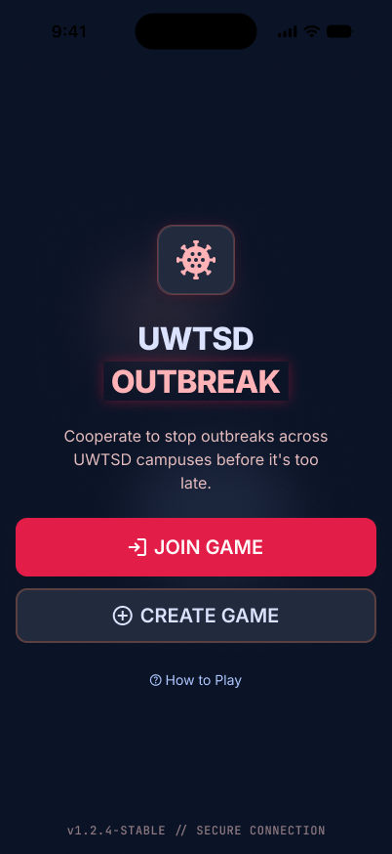
Figure A 1 Welcome and game invitation screen.
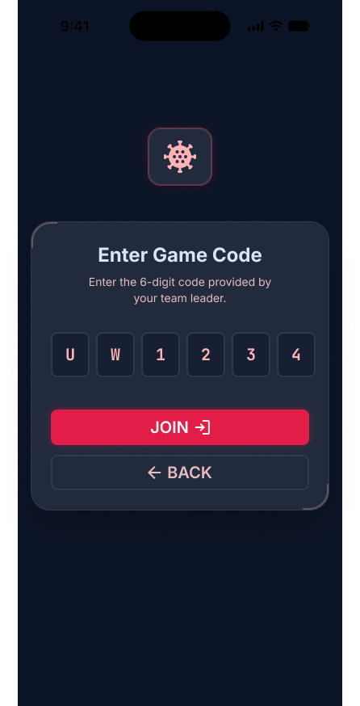
Figure A 2 Game code entry screen.
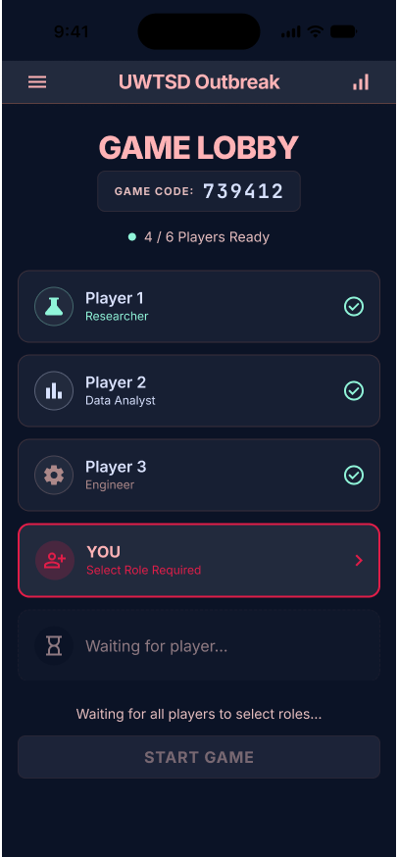
Figure A 3 Multiplayer game lobby.
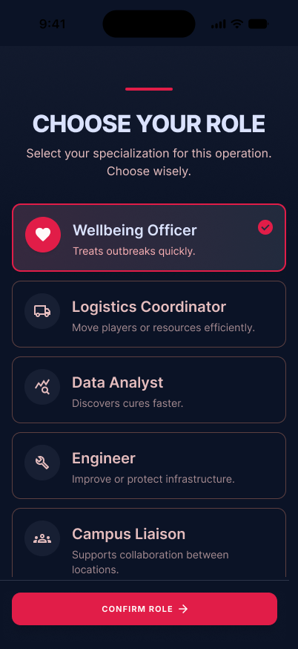
Figure A 4 Player role-selection screen.
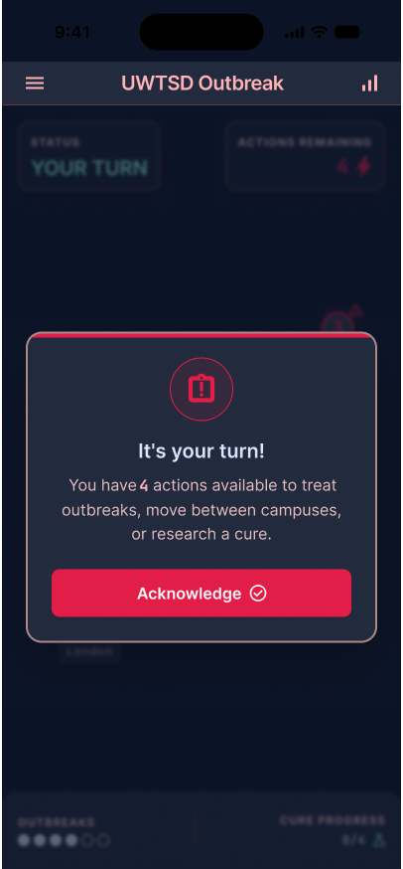
Figure A 5 Guided first-turn interface.
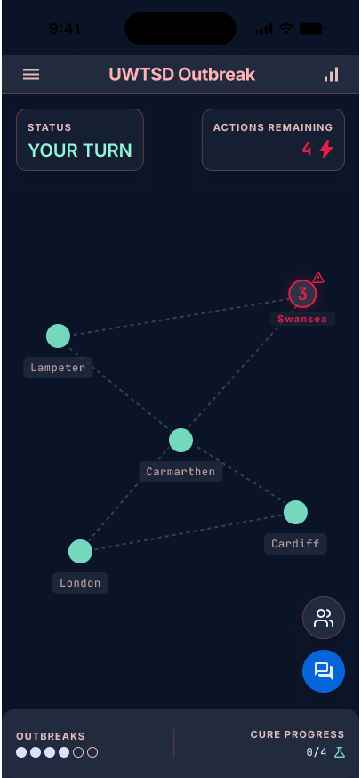
Figure A 6 Main game interface showing an active outbreak.
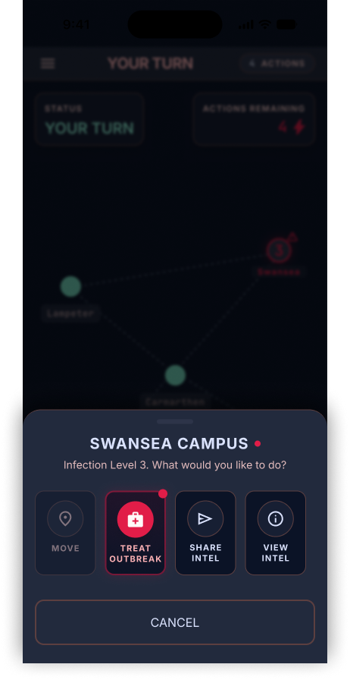
Figure A 7 Contextual action-selection interface.
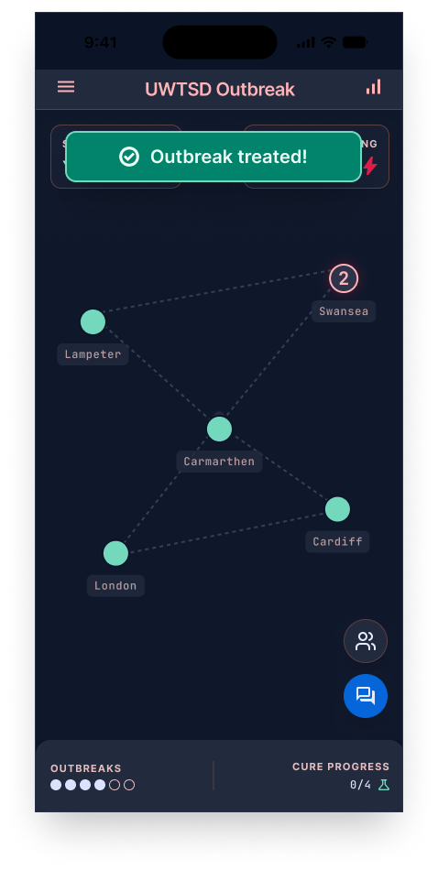
Figure A 8 Outbreak treatment and system feedback.
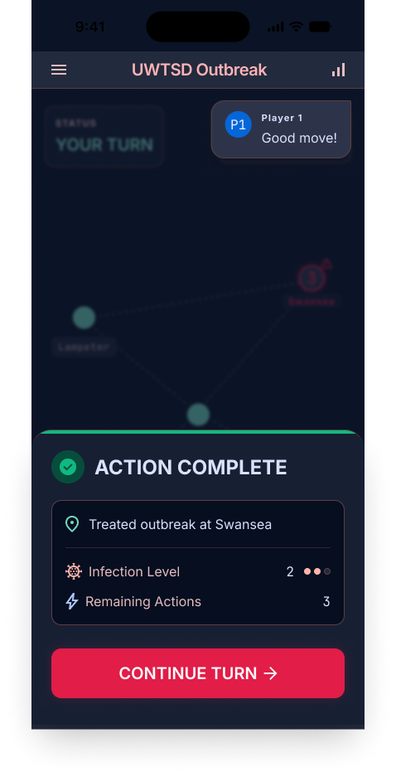
Figure A 9 Action-complete and turn-summary screen.

Appendix B – User Testing Responses and Thematic Analysis
Appendix B presents the anonymised responses collected during the evaluation of the full-colour storyboard. These responses were used to support the thematic analysis presented in Section 2.2. Participants are identified numerically to maintain anonymity.
Participant 1
Q1: Looking through the game screens, was it clear what you would need to do to join a game, choose a role and begin playing?
A: Yes
Q2: When looking at the main game screen, could you easily identify the outbreak and understand what action you should take?
A: Mostly
Q3: How easy was it to understand the information shown during a turn, such as remaining actions, outbreak level, cure progress and the result of an action?
A: 2
Scale: 1 = Very easy, 5 = Very difficult.
Q4: How did the visual design make the game feel to you?
A: Engaging and professional, but a bit busy.
Q5: If you could change one thing about the interface before the game was released, what would you change and why?
A: Make the outbreak level stand out more, it’s easy to miss at a glance.
Participant 2
Q1: Looking through the game screens, was it clear what you would need to do to join a game, choose a role and begin playing?
A: Yes
Q2: When looking at the main game screen, could you easily identify the outbreak and understand what action you should take?
A: Mostly
Q3: How easy was it to understand the information shown during a turn, such as remaining actions, outbreak level, cure progress and the result of an action?
A: 2
Scale: 1 = Very easy, 5 = Very difficult.
Q4: How did the visual design make the game feel to you?
A: Calm, engaging. Everything was nice.
Q5: If you could change one thing about the interface before the game was released, what would you change and why?
A: Add simple icons next to the text so it’s easier to follow quickly.
Participant 3
Q1: Looking through the game screens, was it clear what you would need to do to join a game, choose a role and begin playing?
A: Yes
Q2: When looking at the main game screen, could you easily identify the outbreak and understand what action you should take?
A: Yes
Q3: How easy was it to understand the information shown during a turn, such as remaining actions, outbreak level, cure progress and the result of an action?
A: 2
Scale: 1 = Very easy, 5 = Very difficult.
Q4: How did the visual design make the game feel to you?
A: Calm and clear, but a bit generic for an outbreak theme.
Q5: If you could change one thing about the interface before the game was released, what would you change and why?
A: Add a quick recap of the last turn so it’s easier to jump back in.

