
Module code: BMBM6024 | Module: Strategic Management and Sustainability

Strategic Analysis and Sustainable Strategy Development: NVIDIA Corporation

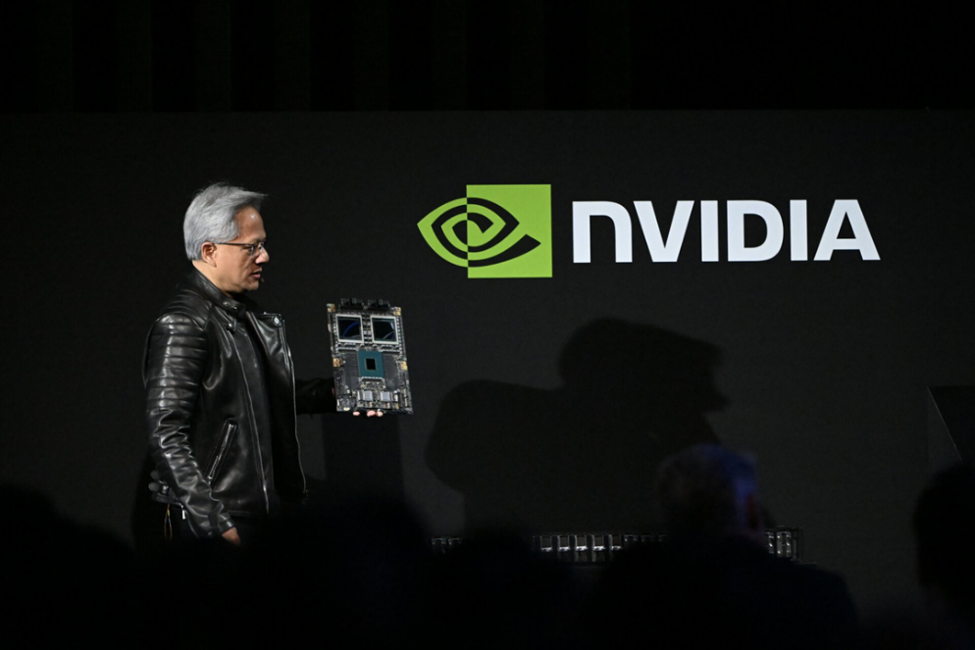

Name: Zihao Xiong (Enzo)
Student number: 2405686
Lecturer: Robyn Griffiths
Submission Date: 2025.03.21
Words account: 2388
University of Wales Trinity Saint David

Executive Summary
This analysis examines NVIDIA's evolution from a gaming GPU manufacturer to a dominant AI infrastructure leader. The company has achieved unprecedented success, with market capitalization reaching approximately $3.7 trillion (Investing.com, 2025), driven primarily by surging demand for AI chips and its powerful CUDA ecosystem which creates significant competitive advantages (Wang, 2024). However, NVIDIA faces substantial sustainability challenges as the semiconductor industry accounts for approximately 2.8% of global greenhouse gas emissions (L, 2024), and data centres powered by AI chips are projected to consume more than 10% of global electricity by 2030 (Tran, 2025). Unlike competitors such as Intel targeting carbon neutrality by 2040, NVIDIA lacks a defined net-zero strategy (Panettieri, 2025), raising questions about the authenticity of its environmental commitments. Simultaneously, the company's competitive landscape is intensifying with growing threats from AMD, Intel, and cloud providers developing custom silicon (Sayegh, 2024), while heavy dependency on TSMC for manufacturing creates significant supply chain vulnerabilities (Byteplus, 2025). This analysis recommends developing a comprehensive sustainability strategy with clear targets, accelerating energy-efficient chip design, strengthening supply chain sustainability, and investing directly in renewable energy infrastructure, while expanding software capabilities and diversifying manufacturing partnerships to maintain competitive advantage.

Content
Executive Summary 2
1. Introduction 4
2. External Analysis 5
2.1 PESTEL Analysis 5
2.2 Porter's Five Forces Analysis 7
3. Internal Analysis 9
3.1 SWOT Analysis 9
3.2 Value Chain Analysis 11
4. Sustainability Assessment & Strategic Tensions 12
5. Strategic Recommendations 14
6. Conclusion 16
Reference list 17

1. Introduction
NVIDIA has undergone a remarkable transformation from a specialized graphics card manufacturer into a multifaceted technology leader driving the global AI revolution (Jadhav, 2025). Since its 1993 founding by Jensen Huang, Chris Malachowsky, and Curtis Priem, the company has expanded far beyond gaming graphics to establish dominant positions in artificial intelligence, data centres, and professional visualization. The company's pioneering development of the Graphics Processing Unit (GPU) in 1999 not only revolutionized PC gaming but created the foundation for its current leadership in AI computing (Gannatti, 2025). While NVIDIA currently dominates with approximately 80% of the discrete GPU market (Disfold, 2024), it faces increasingly significant challenges on multiple fronts: intensifying competition from traditional rivals and technology giants developing custom silicon, growing geopolitical tensions affecting its supply chain, and substantial sustainability concerns as data centres are projected to consume up to 9% of U.S. power generation by 2030 (Kann, 2024). NVIDIA's strategic decisions in addressing these challenges will determine whether it can maintain its dominant position in the rapidly evolving AI and computing markets.

2. External Analysis

2.1 PESTEL Analysis
Political: U.S.-China tensions significantly impact NVIDIA through export controls that divide countries into three tiers with varying access to advanced GPUs (Irwin, 2025). These restrictions limit NVIDIA's access to Chinese markets, historically important revenue sources. Simultaneously, the U.S. CHIPS Act and EU Chips Act now include sustainability provisions, presenting both opportunities and regulatory pressures (Tran, 2025). NVIDIA has publicly criticized these restrictions as potentially "undermining America's leadership" (Irwin, 2025), indicating tension between geopolitical realities and business objectives.
Economic: The AI boom has driven extraordinary financial performance, with Q3 2024 revenue reaching $35 billion—a 94% year-over-year increase (L, 2024). However, this growth may not be sustainable long-term, with industry analysts predicting a cyclical downturn beginning in 2026 (Octopus, 2024). Evidence of double-ordering among top customers could be artificially inflating current demand, creating a potential bubble effect. As Octopus Intelligence (2024) warns, "We certainly want to be given the most favoured nation treatment. So certainly, we are ordering more than we have use for." NVIDIA's R&D investments remain crucial for maintaining technological leadership, with $7.81 billion spent in 2023 compared to AMD's $5.73 billion (Lorence, 2024).
Social: Approximately 55% of companies currently use AI, with another 45% planning future adoption (Gannatti, 2025). This widespread integration raises important ethical concerns regarding AI's societal impact. Jensen Huang has acknowledged these concerns, advocating for responsible AI development through safety measures including thorough testing, human oversight, and explainability requirements (Ian, 2024).
Technological: NVIDIA's competitive advantage stems largely from its CUDA platform, creating significant switching costs for developers (Wang, 2024). Wang (2024) argues that "CUDA is still a giant moat for NVIDIA," while Grace (2024) explains how CUDA enables thousands of cores to handle multiple tasks simultaneously, creating a fundamental architectural advantage. However, scholars like Clark (2025) contend that traditional Moore's Law scaling is reaching physical limits, suggesting the need for alternative computing paradigms. This technological tension creates both opportunities and threats for NVIDIA's continued dominance. Emerging alternatives including Google's TPUs, AMD's MI300X chips, and custom silicon from cloud providers represent growing competitive threats (Sayegh, 2024).
Environmental: The semiconductor industry's environmental impact is substantial, with manufacturing being extremely resource-intensive. A single 12-inch wafer fab consumes 100-200 MW of power (Tran, 2025), while NVIDIA reported 3,692,423 metric tons of CO2 equivalent emissions in FY2024 (L, 2024). Although NVIDIA's Blackwell GPUs are 25 times more efficient than predecessors (Kann, 2024), Duque (2021) argues that incremental efficiency improvements may be insufficient given exponential AI growth, creating a fundamental tension between technological advancement and sustainability.
Legal: NVIDIA faces increasing regulatory scrutiny regarding its market dominance, with potential antitrust investigations by the U.S. Department of Justice (Goldman, 2024) and China's State Administration for Market Regulation examining the company's compliance with laws related to its 2020 acquisition of Mellanox Technologies (Sayegh, 2024). Additionally, the European Commission's proposed Artificial Intelligence Act will establish the world's first comprehensive AI regulatory framework, potentially affecting how NVIDIA's technologies can be deployed and utilized (NOERR, 2021).

2.2 Porter's Five Forces Analysis
Threat of New Entrants: Low to moderate due to high capital requirements, with semiconductor fabrication facilities costing upwards of $10 billion (Business Review, 2024). However, tech giants developing custom silicon represent a moderate threat as they have both necessary resources and strategic incentives to reduce dependence on NVIDIA.
Bargaining Power of Suppliers: Moderate, as NVIDIA relies heavily on Taiwan Semiconductor Manufacturing Company (TSMC) for advanced chip production (Byteplus, 2025). While KraneShares (2024) argues that this partnership has been crucial to NVIDIA's technological leadership, Byteplus (2025) counters that concentration risk poses an existential threat if geopolitical tensions affecting Taiwan escalate. This dependency is a significant vulnerability in NVIDIA's otherwise strong competitive position.
Bargaining Power of Buyers: High, with Microsoft and Meta each acquiring approximately 150,000 H100 chips in 2023, and four companies (Microsoft, Meta, Google, Amazon) accounting for nearly 40% of NVIDIA's revenue (Tremayne-Pengelly, 2024). While their ongoing development of custom chips may reduce dependency on NVIDIA, Sayegh (2024) contends their immediate need for high-performance AI capabilities creates mutual dependence, complicating the power dynamic.
Threat of Substitutes: Moderate and growing, with Application-Specific Integrated Circuits (ASICs), Field-Programmable Gate Arrays (FPGAs), and neuromorphic computing systems like SpiNNaker offering potentially more efficient alternatives for specific applications (Marks&Clerk, 2024). Neuromorphic systems particularly aim to mimic brain structure and function, potentially providing more energy-efficient AI computation. However, Wang (2024) argues that NVIDIA's comprehensive CUDA ecosystem creates significant switching costs that limit the immediate threat from these substitutes. This tension between technological alternatives and ecosystem lock-in represents a growing challenge to NVIDIA's long-term market position.
Industry Rivalry: High and intensifying, with AMD emerging as NVIDIA's most direct competitor, Intel entering the discrete GPU market, and cloud providers developing custom silicon. Disfold (2024) notes NVIDIA still controls over 80% of the GPU market, but Sayegh (2024) argues that "The next phase of the AI chip race will hinge on balancing performance, efficiency, and cost," suggesting NVIDIA's dominance cannot be taken for granted.
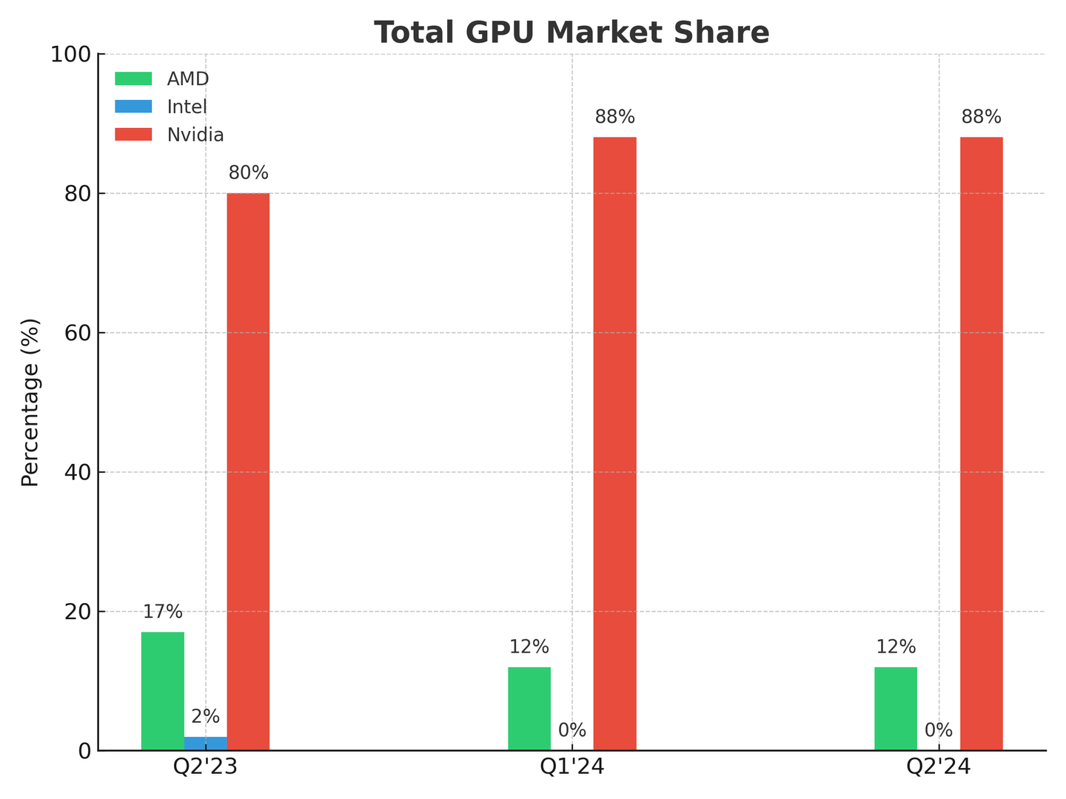
Source from: (Taube, 2025).
The external analysis reveals significant tensions and contradictions in NVIDIA's operating environment. While political factors create market access challenges, economic and technological factors have driven extraordinary growth. However, this growth may not be sustainable given increasing environmental pressures and intensifying competition. These external tensions directly shape NVIDIA's strategic options and necessitate careful internal capability development.

3. Internal Analysis

3.1 SWOT Analysis
Strengths: NVIDIA's dominant market position is supported by its strong CUDA ecosystem, creating significant switching costs for developers (Wang, 2024). The company's fabless business model allows it to focus on design expertise rather than capital-intensive manufacturing (Lrwin, 2025), while substantial R&D investments ($7.81 billion in 2023, nearly double AMD's spending) sustain technological leadership (Lorence, 2024).
Weaknesses: Despite its strengths, NVIDIA faces significant vulnerabilities, including heavy reliance on TSMC for manufacturing (Byteplus, 2025) and concentration of revenue among few large customers (Tremayne-Pengelly, 2024). Its premium pricing strategy has been criticized as potentially unsustainable, with White (2024) reporting rumors that the RTX 5090 could cost $2,000-$2,500, potentially alienating even high-end customers. Most critically, the company lacks a comprehensive sustainability strategy despite the industry's substantial environmental impact (L, 2024).
Opportunities: Beyond the rapidly growing AI market (projected to increase 38% in 2025 according to Gannatti, 2025), NVIDIA can expand into new sectors including automotive, healthcare, and edge AI (Business Review, 2024). The company's recent $700 million acquisition of Run: ai for cloud orchestration software (Mazumdar, 2024) demonstrates its ability to enhance capabilities through strategic acquisitions.
Threats: The competitive landscape is intensifying with AMD, Intel, and cloud providers all developing alternatives to NVIDIA's products (Sayegh, 2024). Export restrictions limiting Chinese market access (Irwin, 2025) and emerging computing paradigms such as neuromorphic computing (Marks&Clerk, 2024) present additional challenges. FutureTech.media (2025) reported on potential market disruption from DeepSeek, exemplifying how emerging players could rapidly change competitive dynamics.
This SWOT analysis reveals critical connections between external factors and internal capabilities. NVIDIA's strengths in technology and R&D position it well to address competitive threats, but its supply chain weaknesses and sustainability gaps create vulnerabilities that could undermine its market position over time.

3.2 Value Chain Analysis
NVIDIA's value chain reflects its fabless business model, with an emphasis on design rather than manufacturing. While this approach has enabled capital efficiency, it also creates dependence on manufacturing partners. The company employs a premium pricing strategy for high-end products (Jadhav, 2025), which has historically succeeded but may become increasingly vulnerable to competition.
The company's flat organizational structure with Huang directly managing 40 reports facilitates faster decision-making but potentially limits oversight (Goover, 2024). This structure, combined with generous stock-based compensation that has created substantial employee wealth, presents both advantages in talent attraction and potential challenges in maintaining motivation (Clover HR, 2024).
Most significantly, the value chain analysis reveals NVIDIA's heavy investment in technology development, with Jensen Huang claiming progress "way faster than Moore's Law" (Trueman, 2025). However, this emphasis on technological advancement has not been matched by equivalent investment in sustainability integration throughout the value chain, creating a strategic imbalance that may become increasingly problematic as environmental concerns grow.

4. Sustainability Assessment & Strategic Tensions
NVIDIA's current sustainability initiatives reveal a disconnection between the scale of its environmental impact and its strategic response. While the company has committed to achieving 100% renewable electricity for its offices and data centres under operational control by fiscal year 2025 (L, 2024), it notably lacks a defined net-zero target date. Panettieri (2025) highlights that the term "net zero" appears only three times in its 59-page Corporate Responsibility Report and never with a specific company goal, contrasting sharply with Intel's commitment to carbon neutrality by 2040 (Tran, 2025).
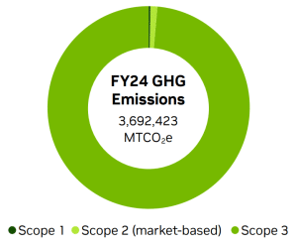
Source from: NVIDIA's Emissions Data (L, 2024)
This limited approach creates a fundamental strategic tension. While NVIDIA portrays itself as environmentally conscious, independent analysis by Zewe (2025) reveals that the electricity demands of AI-driven data centres are growing at unprecedented rates. Sar (2024) notes that server manufacturing alone generates approximately 1300 kg of CO2 per unit, emissions often excluded from corporate reporting. These criticisms suggest NVIDIA's approach may be more oriented toward public relations than genuine environmental impact reduction.
This sustainability gap creates three strategic tensions that NVIDIA must address:
- Innovation vs. Resource Intensity: While technological advancement drives NVIDIA's business model, each generation of more powerful chips increases resource consumption throughout the value chain. Duque (2021) argues that semiconductor companies must fundamentally reimagine chip design to reduce carbon footprint rather than pursuing purely performance-driven innovation.
- Growth vs. Environmental Impact: NVIDIA's extraordinary growth has created significant shareholder value but also substantially increased environmental impact. Kann (2024) questions whether chip efficiency improvements can offset the exponential growth in AI energy demand, creating a fundamental sustainability dilemma.
- Competition vs. Collaboration: Addressing industry-wide sustainability challenges requires collaboration, but intensifying competition creates incentives for proprietary solutions. Guillaume Le Gouic (2024) argues for industry standardization and shared sustainability approaches, contrasting with the competitive dynamics driving NVIDIA's business strategy.
These tensions highlight the need for a more comprehensive strategic approach that integrates sustainability directly into NVIDIA's core business model rather than treating it as a peripheral concern.

5. Strategic Recommendations
Based on the preceding analysis, four strategic recommendations emerge that address both NVIDIA's competitive position and sustainability challenges:
5.1 Develop an Authentic Net-Zero Strategy: NVIDIA must establish a clear net-zero emissions roadmap with specific interim milestones, addressing all scope emissions including its supply chain and the use of its products in data centres. Appointing a dedicated Chief Sustainability Officer would signal commitment and ensure integration of environmental considerations into strategic decision-making. While critics might argue this could constrain growth, Kapoor et al. (2024) present evidence that semiconductor companies that integrate sustainability into core strategy create competitive advantages through operational efficiencies, regulatory readiness, and improved stakeholder relations.
5.2 Accelerate Energy-Efficient Chip Design: Energy efficiency must become a primary design consideration rather than a secondary benefit. While Huang notes, "We have to continue to drive the generational performance up significantly, so we can drive down the energy consumed" (Panettieri, 2025), NVIDIA should explore alternative computing paradigms beyond traditional GPU architectures. Clark (2025) argues that Moore's Law scaling is reaching fundamental physical limits, suggesting NVIDIA must pursue more radical innovation in chip architecture to balance performance with sustainability.
5.3 Transform Supply Chain Sustainability: As a fabless company, NVIDIA should leverage its market power to drive sustainability improvements throughout its supply chain. TSMC, which used 16 TWh of electricity in 2022 (Tran, 2025), represents both a vulnerability and opportunity for environmental impact reduction. Guillaume Le Gouic (2024) outlines specific strategies including distribution lineup optimization, standardization, and integration of distributed energy resources that NVIDIA could require from manufacturing partners. This approach would reduce Scope 3 emissions while simultaneously mitigating supply chain risks.
5.4 Expand Software Leadership While Diversifying Manufacturing: NVIDIA should strengthen its software ecosystem advantage through continued CUDA development and strategic acquisitions like Run: ai (Mazumdar, 2024) while simultaneously diversifying manufacturing partnerships beyond TSMC. While Wang (2024) argues CUDA creates an enduring competitive moat, Marks&Clerk (2024) presents evidence that emerging computing paradigms could eventually challenge NVIDIA's GPU-centric approach. This balanced strategy would maintain NVIDIA's differentiation while reducing geopolitical vulnerabilities.
These recommendations directly address the strategic tensions identified earlier. By authentically integrating sustainability into its business model, NVIDIA can transform environmental challenges into competitive advantages while securing its market leadership for the long term.

6. Conclusion
NVIDIA stands at a critical juncture, balancing extraordinary AI-driven success with intensifying sustainability challenges and competitive threats. The tension between these forces will define the company's future trajectory. While NVIDIA's technological leadership and market position remain strong, the disconnection between its environmental impact and sustainability strategy creates an increasing vulnerability.
The strategic recommendations provided offer a pathway to transform this vulnerability into a competitive advantage by authentically integrating sustainability into NVIDIA's core business model. However, implementation will require fundamental shifts in strategic priorities, organizational structure, and resource allocation. Most critically, NVIDIA must move beyond viewing sustainability as a compliance or public relations issue and embrace it as a core strategic driver.
The company has demonstrated remarkable adaptability throughout its history, evolving from a gaming-focused GPU manufacturer to an AI infrastructure leader. This proven capacity for strategic transformation provides confidence that NVIDIA can successfully navigate the sustainability challenges ahead. However, as FutureTech.media (2025) warns, market dominance is not invulnerable to disruption, and NVIDIA's future success depends on its ability to anticipate and adapt to rapidly evolving technological, competitive, and environmental dynamics.

Reference list
- Business Review, H. (2024). NVIDIA (NVDA) : Porter’s Five Forces Industry and Competition Analysis (2nd Edition). [online] Hivelr. Available at: https://www.hivelr.com/2024/10/nvidia-nvda-porters-five-forces-industry-and-competition-analysis-2nd-edition/ [Accessed 15 Mar. 2025].
- Byteplus. (2025). Where does nvidia produce their chips? [online] Available at: https://www.byteplus.com/en/topic/383868?title=where-does-nvidia-produce-their-chips [Accessed 15 Mar. 2025].
- CBM (2024). NVIDIA PESTEL ANALYSIS. [online] CBM. Available at: https://canvasbusinessmodel.com/products/nvidia-pestle-analysis [Accessed 15 Mar. 2025].
- Chauhan, H. (2025). Prediction: Nvidia Will Beat the Market. Here’s Why. [online] The Motley Fool. Available at: https://www.fool.com/investing/2025/03/12/prediction-nvidia-will-beat-the-market-heres-why/ [Accessed 15 Mar. 2025].
- Cimino, A. (2024). Here’s Nvidia’s Biggest Problem Right Now. [online] The Motley Fool. Available at: https://www.fool.com/investing/2024/05/29/heres-nvidias-biggest-problem-right-now/ [Accessed 15 Mar. 2025].
- Clark, S. (2025). The End of Moore’s Law? AI Chipmakers Say It’s Already Happened. [online] VKTR.com. Available at: https://www.vktr.com/ai-technology/the-end-of-moores-law-ai-chipmakers-say-its-already-happened/ [Accessed 15 Mar. 2025].
- Clover HR (2024). How NVIDIA’s Organisational Culture Drives Its Success. [online] Clover HR. Available at: https://www.cloverhr.co.uk/blog/nvidia-organisational-culture/ [Accessed 15 Mar. 2025].
- Disfold (2024). How Nvidia’s Business Compares with its Competitors - Disfold Blog. [online] Disfold Blog. Available at: https://blog.disfold.com/nvidia-compares-competitors/ [Accessed 15 Mar. 2025].
- Duque, T. ed., (2021). How Can Next-Gen Computer Chips Reduce Our Carbon Footprint? [online] News Center. Available at: https://newscenter.lbl.gov/2021/12/01/can-chips-reduce-carbon-footprint/ [Accessed 15 Mar. 2025].
- Foelber, D. (2025). 5 Reasons Why Nvidia Is Still in a League of Its Own. [online] The Motley Fool. Available at: https://www.fool.com/investing/2025/03/07/buy-nvidia-ai-growth-stock-long-term/ [Accessed 15 Mar. 2025].
- FutureTech.media (2025). In a surprising turn of events, Nvidia, the leading player in graphics processing units (GPUs), has experienced a staggering $593 billion drop in market value, marking the largest single-day loss in corporate history. The tech giant, renowned for its innovative advancements in AI and gaming hardware. [online] Linkedin.com. Available at: https://www.linkedin.com/pulse/nvidia-experiences-unprecedented-593-billion-loss-deepseek-9z7of/ [Accessed 15 Mar. 2025].
- Gannatti, C. (2025). The Future of AI: How NVIDIA’s Vision Is Shaping Our World | WisdomTree. [online] Wisdomtree.com. Available at: https://www.wisdomtree.com/investments/blog/2025/01/16/the-future-of-ai-how-nvidias-vision-is-shaping-our-world [Accessed 15 Mar. 2025].
- Goel, S. (2023). What does Nvidia do: Business model analysis. [online] The Strategy Story. Available at: https://thestrategystory.com/2023/01/05/what-does-nvidia-do-business-model-analysis/#google_vignette [Accessed 15 Mar. 2025].
- Goldman, D. (2024). Nvidia is suddenly in trouble. [online] CNN. Available at: https://edition.cnn.com/2024/09/04/tech/nvidia-is-in-trouble/index.html [Accessed 15 Mar. 2025].
- Goover. (2024). Jensen Huang’s Leadership at Nvidia: A Comprehensive Analysis. [online] Available at: https://seo.goover.ai/report/202406/go-public-report-en-abfbcc7b-d3fe-43df-bba7-8225436cc068-0-0.html [Accessed 15 Mar. 2025].
- Grace, T. (2024). Why’s Nvidia such a beast? It’s that CUDA thing. [online] Fierce Electronics. Available at: https://www.fierceelectronics.com/ai/whys-nvidia-such-beast-its-cuda-thing [Accessed 15 Mar. 2025].
- Guillaume Le Gouic (2024). Empowering Sustainability: 4 strategies to significantly reduce the Semiconductor Industry’s carbon footprint. [online] Schneider Electric Blog. Available at: https://blog.se.com/sustainability/2024/02/23/empowering-sustainability-4-strategies-to-significantly-reduce-the-semiconductor-industrys-carbon-footprint/ [Accessed 15 Mar. 2025].
- Hsiao, E. (2024). NVIDIA CEO Jensen Huang: AI and Sustainability Dual Engines Driving a New Era. [online] The Icons - The icons dedicated to the icons. Available at: https://theicons.net/2024/07/02/nvidia-ceo-jensen-huang-dual-engines-of-ai-and-sustainable-development-drive-the-new-era/?utm_source=facebook&utm_medium=social&utm_campaign=promotion [Accessed 15 Mar. 2025].
- Ian (2024). Jensen Huang’s Views on AI Ethics and Responsibility. [online] Pressfarm. Available at: https://press.farm/jensen-huangs-views-on-ai-ethics-and-responsibility/ [Accessed 15 Mar. 2025].
- Investing.com (2025). NVIDIA’s SWOT analysis: chip giant’s stock rides AI wave amid challenges. [online] Investing.com UK. Available at: https://uk.investing.com/news/swot-analysis/nvidias-swot-analysis-chip-giants-stock-rides-ai-wave-amid-challenges-93CH-3976839 [Accessed 15 Mar. 2025].
- Irwin, K. (2025). US Further Restricts Nvidia AI Exports, Caps GPU Purchases for Select Nations. [online] PCMag UK. Available at: https://uk.pcmag.com/ai/156245/us-further-restricts-nvidia-ai-exports-caps-gpu-purchases-for-some-nations [Accessed 15 Mar. 2025].
- Jadhav, S. (2025). NVIDIA’s Marketing Strategy: Analyzing the Marketing Mix and Key Campaigns. [online] StartupTalky. Available at: https://startuptalky.com/nvidia-marketing-strategy/ [Accessed 15 Mar. 2025].
- Kann, S. (2024). Can chip efficiency slow AI’s energy demand? [online] Latitude Media. Available at: https://www.latitudemedia.com/news/catalyst-can-chip-efficiency-slow-ais-energy-demand/ [Accessed 15 Mar. 2025].
- Kapoor, B., Toy, K., Garcia, C. and Gold-Dworkin, R. (2024). Chip in for semiconductor sustainability. [online] Kearney. Available at: https://www.kearney.com/industry/technology/article/chip-in-for-semiconductor-sustainability [Accessed 15 Mar. 2025].
- KraneShares. (2024). NVIDIA’s Rapid Rise Fueled by Chip Giants TSMC and SK Hynix. [online] Available at: https://kraneshares.com/nvidias-rapid-rise-fueled-by-chip-giants-tsmc-and-sk-hynix-2/ [Accessed 15 Mar. 2025].
- L, J. (2024). Nvidia’s $35B Q3 Revenue: Record AI Growth Meets Rising Environmental Challenges. [online] Carbon Credits. Available at: https://carboncredits.com/nvidia-35b-q3-revenue-record-ai-growth-meets-rising-environmental-sustainability-challenges/ [Accessed 15 Mar. 2025].
- Lanhee, J. (2025). Nvidia-Supplier Hon Hai’s Profit Misses as AI Doubts Persist. [online] Yahoo Finance. Available at: https://finance.yahoo.com/news/nvidia-supplier-hon-hai-profit-062111708.html [Accessed 15 Mar. 2025].
- Larsen, R. (2023). Exploring Nvidia’s Business Model and Revenue Streams | Untaylored. [online] www.untaylored.com. Available at: https://www.untaylored.com/post/exploring-nvidia-s-business-model-and-revenue-streams [Accessed 15 Mar. 2025].
- Law, M. (2024). Nvidia: The Powerhouse Driving Global Digital Transformation. [online] Technologymagazine.com. Available at: https://technologymagazine.com/articles/nvidia-the-powerhouse-driving-global-digital-transformation [Accessed 15 Mar. 2025].
- Lenihan, R. (2024). Nvidia’s biggest problem might be about to get even worse. [online] TheStreet. Available at: https://www.thestreet.com/investing/stocks/nvidias-biggest-problem-might-be-about-to-get-even-worse [Accessed 15 Mar. 2025].
- Lorence, J. (2024). Comparing the R&D Investments of Major Semiconductor Players. [online] Mrlcg.com. Available at: https://www.mrlcg.com/resources/blog/comparing-the-r-d-investments-of-major-semiconductor-players/ [Accessed 15 Mar. 2025].
- Lrwin, L. (2025). What is Nvidia’s ‘fabless’ business model and how has it helped the company? [online] Quora. Available at: https://www.quora.com/What-is-Nvidias-fabless-business-model-and-how-has-it-helped-the-company [Accessed 15 Mar. 2025].
- macrotrends. (2025). NVIDIA - 21 Year Stock Price History | NVDA. [online] Available at: https://www.macrotrends.net/stocks/charts/NVDA/nvidia/stock-price-history [Accessed 15 Mar. 2025].
- Marks&Clerk. (2024). 102jalr-Neuromorphic challenge to Nvidia? [online] Available at: https://www.marks-clerk.com/insights/latest-insights/102jalr-neuromorphic-challenge-to-nvidia/ [Accessed 15 Mar. 2025].
- Mazumdar, S. (2024). Nvidia acquires Run:ai in a $700 million deal | Digital Infra Network. [online] Digital Infra Network. Available at: https://digitalinfranetwork.com/news/nvidia-acquires-runai-700-mn-deal/ [Accessed 15 Mar. 2025].
- Morgan, C. (2024). Nvidia: The ‘Winner Takes All’ Strategy in Action. [online] Ainvest. Available at: https://www.ainvest.com/news/nvidia-winner-takes-all-strategy-in-action-241210106edca26792e7b1dd/ [Accessed 15 Mar. 2025].
- NOERR (2021). European Commission proposes world’s first ever regulatory framework on artificial intelligence (AI). [online] Available at: https://www.noerr.com/en/insights/european-commission-proposes-world's-first-ever-regulatory-framework-on-artificial-intelligence-ai [Accessed 15 Mar. 2025].
- Octopus (2024). NVIDIA’s Emerging Challenges: A Dive into the Future of AI Dominance | By Octopus Competitive Intelligence Agency. [online] Octopus Competitive intelligence agency Octopus market Intelligence company & competitor analysis solutions. Available at: https://www.octopusintelligence.com/nvidias-emerging-challenges-a-dive-into-the-future-of-ai-dominance/ [Accessed 15 Mar. 2025].
- Osman, J. (2024). Can Nvidia’s ‘Hyper Moore’s Law’ Spark An AI Revolution?. Forbes. [online] 8 Nov. Available at: https://www.forbes.com/sites/jimosman/2024/11/07/can-nvidias-hyper-moores-law-spark-an-ai-revolution/ [Accessed 15 Mar. 2025].
- Panettieri, J. (2025). Nvidia AI Chips: Blackwell GPU Shipments, Energy Efficiency, Data Center Sustainability and Net Zero Reality Checks - Page 2 of 2 - Sustainable Tech Partner for Green IT Service Providers. [online] Sustainable Tech Partner for Green IT Service Providers. Available at: https://sustainabletechpartner.com/vertical-market/technology/nvidia-ai-chips-energy-efficiency-data-center-sustainability-and-net-zero-reality-checks/2/ [Accessed 15 Mar. 2025].
- Parkin, J. (2025). The DeepSeek Disruption: NVIDIA’s Biggest AI Challenge Yet? - Agility PR Solutions. [online] Agility PR Solutions - Media Relations... Streamlined. Available at: https://www.agilitypr.com/pr-news/pr-tech-ai/the-deepseek-disruption-nvidias-biggest-ai-challenge-yet/ [Accessed 15 Mar. 2025].
- Pradhan, M. (2025). Nvidia’s Stock Tanks Due to AI Market Volatility: Here’s What History Says Happens Next. [online] The Motley Fool. Available at: https://www.fool.com/investing/2025/03/13/nvidias-stock-tanks-due-to-ai-market-volatility/ [Accessed 15 Mar. 2025].
- Reiff, N. (2020). How Nvidia Makes Money. [online] Investopedia. Available at: https://www.investopedia.com/how-nvidia-makes-money-4799532#citation-42 [Accessed 15 Mar. 2025].
- Restack. (2023). Nvidia Neuromorphic AI Hardware Updates | Restackio. [online] Available at: https://www.restack.io/p/neuromorphic-ai-hardware-answer-updates-cat-ai [Accessed 15 Mar. 2025].
- Sar, Y. (2024). The Silent Burden Of AI: Unveiling The Hidden Environmental Costs Of Data Centers By 2030. Forbes. [online] 16 Aug. Available at: https://www.forbes.com/councils/forbestechcouncil/2024/08/16/the-silent-burden-of-ai-unveiling-the-hidden-environmental-costs-of-data-centers-by-2030/ [Accessed 15 Mar. 2025].
- Sayegh, E. (2024). The AI Chip Race: Who Can Compete With Nvidia? Forbes. [online] 11 Dec. Available at: https://www.forbes.com/sites/emilsayegh/2024/12/11/the-ai-chip-race-who-can-compete-with-nvidia/ [Accessed 15 Mar. 2025].
- Shaw, A.A. (2024). Value Chain Analysis of Nvidia. [online] SCM Insight. Available at: https://scminsight.com/value-chain-analysis-of-nvidia/ [Accessed 15 Mar. 2025].
- Shilov, A. (2024). Intel spends more on R&D than Nvidia and AMD combined, yet continues to lag in market cap — Nvidia spends almost 2X more than AMD. [online] Tom’s Hardware. Available at: https://www.tomshardware.com/tech-industry/intel-spends-more-on-r-and-d-than-nvidia-and-amd-combined-yet-continues-to-lag-in-market-cap-nvidia-spends-almost-2x-more-than-amd [Accessed 15 Mar. 2025].
- Sinaga, G. (2024). NVIDIA’s Breakthrough Beyond Moore’s Law and Its Impact on AI Leadership Strategy. [online] Twimbit.com. Available at: https://twimbit.com/about/blogs/nvidias-breakthrough-beyond-moores-law-and-its-impact-on-ai-leadership-strategy [Accessed 15 Mar. 2025].
- Staff, V. (2023). NVIDIA sees highest patent filings and grants during May in Q2 2024. [online] Verdict. Available at: https://www.verdict.co.uk/nvidia-patent-activity/ [Accessed 15 Mar. 2025].
- Swayne, M. (2025). As NVIDIA’s Quantum Day Nears, Analysts Suggest Event is More Than a Gesture. [online] The Quantum Insider. Available at: https://thequantuminsider.com/2025/03/07/as-nvidias-quantum-day-nears-analysts-suggest-event-is-more-than-a-gesture/ [Accessed 15 Mar. 2025].
- Taube, S. (2025). Nvidia Competitors: Who Are the AI Chip Alternatives? [online] NerdWallet. Available at: https://www.nerdwallet.com/article/investing/nvidia-competitors [Accessed 15 Mar. 2025].
- Tran, B. (2025). Semiconductor Manufacturing Energy Consumption: How Green Is the Chip Industry? (Latest Stats). [online] PatentPC. Available at: https://patentpc.com/blog/semiconductor-manufacturing-energy-consumption-how-green-is-the-chip-industry-latest-stats [Accessed 15 Mar. 2025].
- Tremayne-Pengelly, A. (2024). Nvidia’s Market Cap Surpasses $3T: Here Are the Largest Buyers of Its A.I. Chips. [online] Observer. Available at: https://observer.com/2024/06/nvidia-largest-ai-chip-customers/ [Accessed 15 Mar. 2025].
- Trueman, C. (2025). Jensen Huang says Nvidia’s AI chips are outpacing Moore’s Law. [online] Datacenterdynamics.com. Available at: https://www.datacenterdynamics.com/en/news/jensen-huang-says-nvidias-ai-chips-are-outpacing-moores-law/ [Accessed 15 Mar. 2025].
- TTconsultants. (2023). Check Out Patent Portfolio For Nvidia Corp.: Key Insights. [online] Available at: https://ttconsultants.com/articles/what-did-the-patent-landscape-of-nvidia-corp-look-like/.
- Vanzo, R. (2025). Artificial Intelligence (AI) Adoption Rates Appear Low, but This AI Leader Could See a Massive Surge in Demand in the Next 3 Years. Here’s Why. [online] The Motley Fool. Available at: https://www.fool.com/investing/2025/03/09/artificial-intelligence-ai-adoption-rates-nvidia/ [Accessed 15 Mar. 2025].
- Wang, J. (2024). CUDA is Still a Giant Moat for NVIDIA. [online] Weightythoughts.com. Available at: https://weightythoughts.com/p/cuda-is-still-a-giant-moat-for-nvidia [Accessed 15 Mar. 2025].
- Werner, J. (2024). TSMC To Double Production Based On Nvidia Numbers And Overall Demand. Forbes. [online] 7 Nov. Available at: https://www.forbes.com/sites/johnwerner/2024/11/07/tsmc-to-double-production-based-on-nvidia-numbers-and-overall-demand/ [Accessed 15 Mar. 2025].
- White, M.J. (2024). Nvidia might double down on its controversial pricing strategy. [online] Yahoo Tech. Available at: https://www.yahoo.com/tech/nvidia-might-double-down-controversial-124702118.html [Accessed 15 Mar. 2025].
- Zewe, A. (2025). Explained: Generative AI’s environmental impact. [online] MIT News | Massachusetts Institute of Technology. Available at: https://news.mit.edu/2025/explained-generative-ai-environmental-impact-0117 [Accessed 15 Mar. 2025].

