MANAGEMENT TEAM
CertHE Skills for the Workplace: BMSW4006 Module Leader: Hossein Shokri
STUDENT: OKSANA MRSIC (2131895)
UNIVERSITY OF WALES TRINITY ST. DAVID

TABLE OF CONTENT:

- MANAGEMENT TEAM: ___________________________________________
- BUSINESS DESCRIPTION AND HISTORY: ___________________________
- BUSINESS STRUCTURE: _________________________________________
- KEY MILESTONE: _______________________________________________
- EMPLOYEE TERMINATIONS ARE HANDLED BY THE MANAGER: ________
- THE SUCCESS OF THE ORGANISATION: ____________________________
- EXECUTIVE SUMMARY: __________________________________________
- REFERENCES: __________________________________________________
- APPENDIX______________________________________________________

MANAGEMENT TEAM

The company's most significant asset is its staff, which is looked after by the manager. Managers have the impression that employees are fully equipped to do their everyday tasks. They are also responsible for designing a welcoming environment that draws and retains skilled workers (Robert, 2022). Managers are responsible for a variety of tasks, including hiring, maintaining relationships with employees, and creating workplace standards. The manager does all essential responsibilities in businesses like our recently established London Locum Limited. Managers specialise in areas, such as sourcing and recruiting, rewards and benefits, administration, all legalisation, etc.

BUSINESS DESCRIPTION AND HISTORY

Our dental staffing group aids in offering our regulars a high-quality dental workforce. We also propose a variety of office provision roles to suit your staffing needs. We aim to source appropriate, fully competent applicants to help accomplish any dental practice requirements. We are an extremely appreciated and already recognized team on the dental board. We can ensure that our team has the right candidates to choose from. Our company offer a full recruitment agency solution at competitive prices. Our objective is to create a network of private dental clinics all over London to scope to the not extended people and deliver great services to disadvantaged people of various populations.

As a newly opened London Locum Limited company, we will be required to do more as we have a team and we just bringing in new business at the same time. The leadership aspect will obviously be missed at this point, but constantly developing start-ups we must try each month to find time to work on our business, not just IN it, so that the development of our company's vision and strategy doesn't suddenly stop. Unquestionably, invoicing and managing is most important in these early phases since the company needs money to expand, but if you can set yourself a few hours once a month to examine your goal, that may be all you need to stay on course. (Sands, 2022) Once your company is profitable, a good leader will use that money to increase profits by investing in the infrastructure of the business, more employees, staff training, new hiring technology to make your team more effective, and finally, quality marketing, which in our opinion offers the highest return.
The companies eventually build in had flat management structures, a lot of genuine staff engagement and places where the staff looked forward to coming to work. We intended to maintain strong communication with our workers about the direction of the company as one of the business principles. We conducted monthly team meetings where we present all the company statistics, announce new goals and projects, and encourage questions from the team. We also advised the staff to use this as an opportunity to offer new suggestions for how the company might operate more effectively. The team felt more a part of the environment as a result and many ideas and methods that improved the company were also developed as a result. As a business leader, you'll never be able to know everything that can be done to make your company better, but by encouraging your employees to share ideas, you'll have a more comprehensive understanding of what the company can achieve.
We always try to follow the lead and look within first if something functions or goes wrong to learn from it and move forward. But it's also a great skill if you can identify the factors that have contributed to your achievement. If you're not sure how it happened, seek the specifics of how and why.
Many business owners have used their own poor experiences to act differently from their previous employer and gain from this negative learning.
We always check by asking people about their opinions on team management. Simply we wish our company to grow with solid principles.

ORGANISATIONAL CHART

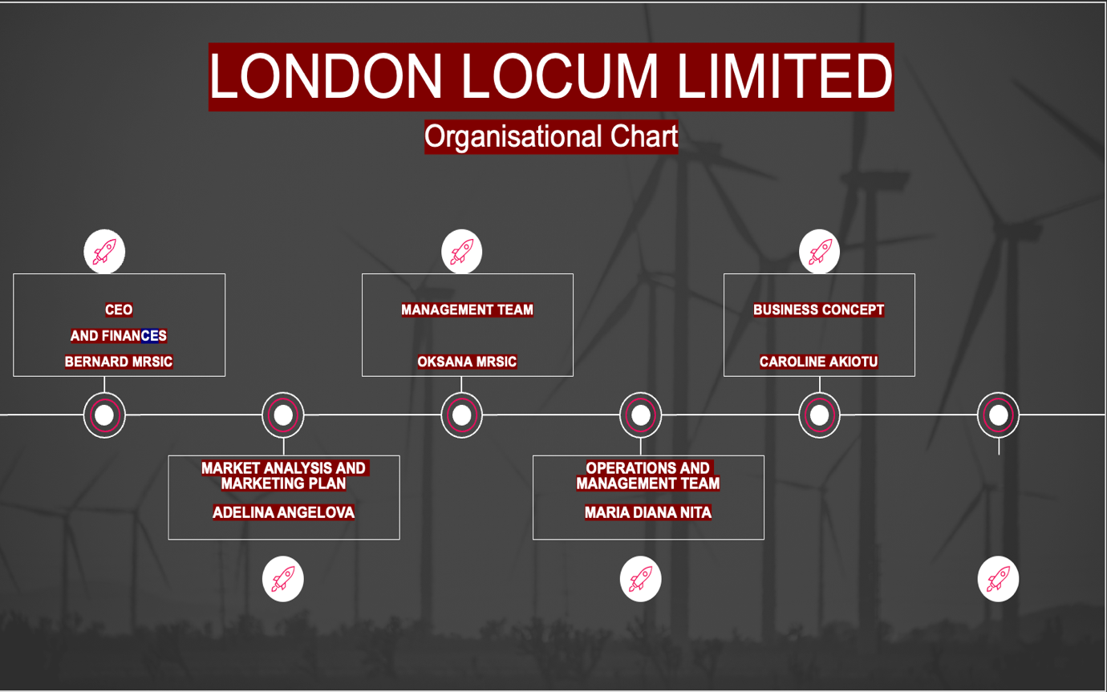

- CEO AND FINANCES: BERNARD MRSIC
Bernard is an expert. He manages an organization's financial and administrative operations, communicates with stakeholders, and advises on key projects.
- MANAGEMENT TEAM; OKSANA MRSIC
Oksana Mrsic has been a dental therapist for 8 years. She is perceptive and detail oriented.
She also spent two years as a TCO, lecturing patients and dental professionals about oral health and assisting in the selection of software to streamline appointment scheduling. She obtained manufacturer accreditation to educate dental assistants and other hygienists on a new appointment-booking system.
3. BUSINESS CONCEPT: CAROLINE AKIOTU
Caroline Akiotu has been an administrative assistant for six years since earning her business administration certificate. And the business concept assistant for the last three years. She handles customers, events, travel, and executive scheduling.
4. MARKET ANALYSIS AND MARKETING PLAN: ADELINA ANGELOVA
Customer service is the key to marketing campaign success. Connecting with your consumers helps you understand their demands and business voice, which improves your product. Adelina Angelova's has an eight-year marketing career and has focused on customer service.
5. OPERATIONS AND MANAGEMENT TEAM: MARIA DIANA NITA
Operations managers supervise all company operations. Maria Diana Nita redesigned the UK region's Supply Chain and Logistics division to satisfy organizational goals for the last five years. She led and inspired 100 multidisciplinary professionals.
Evaluated customer, delivery, and employee data.
Formulated, managed, and implemented supply chain activities from London to Europe to satisfy strategic goals and company regulations.

BUSINESS STRUCTURE

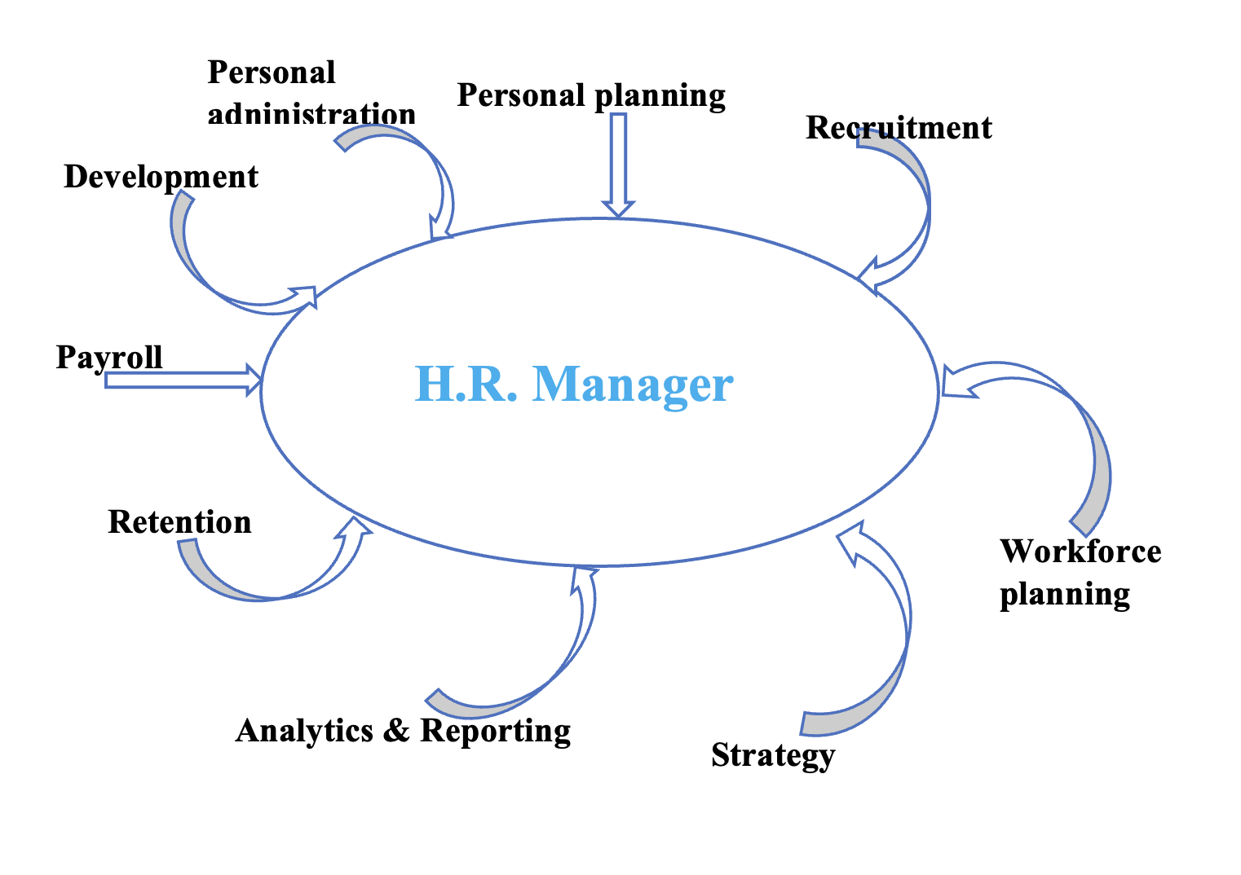

Personal Planning guarantees that the association has the exact number of workers with the essential experiences in all areas to accomplish the set objectives.
Enrollment is also referred to as talent acquisition because it defines all the actions a team needs to accomplish to reach new staff to profit the corporation.
Workforce Planning is mostly to ensure that your staff is arranged as professionally as possible to avoid holdups and congestion where they shouldn’t exist.
Personnel Management- Describes all the managerial tasks and procedures that fall within a sector’s space. It is involved in the creation of contacts and managing digital personnel files.
Development- Ensuring that management team and personnel crews help staff get restored at what they do, which includes creating durable performance organization processes and exposed values of the response.
Payroll- The manager must take caution in workforce and wage accounting. It happens either entirely in-house or moderately subcontracted and is held mutually with a software provider or tax specialist.
Preservation consists of all the procedures the management sector takes to hold staff and lower the firm’s overall abrasion rate.
Analytics & Recording- Personnel-related decisions informed by hard data are necessary for every modern management department. It includes having entree to a person's analytics to control worker headcount, progress rates, and prices.
Plan- Management is guaranteed to succeed if their focus on strategy and not much truly
on them, which includes creating time to be involved and implement initiatives.
Services
We can ensure that our dental nurses are fully qualified and have developed their craft over years of working with some leading clinics. We are confident that we can service your practice, reducing the need to disrupt your patients unnecessarily. Our team has highly skilled people who will make the journey to finding a new associate for your practice as simple as possible.

KEY MILESTONE
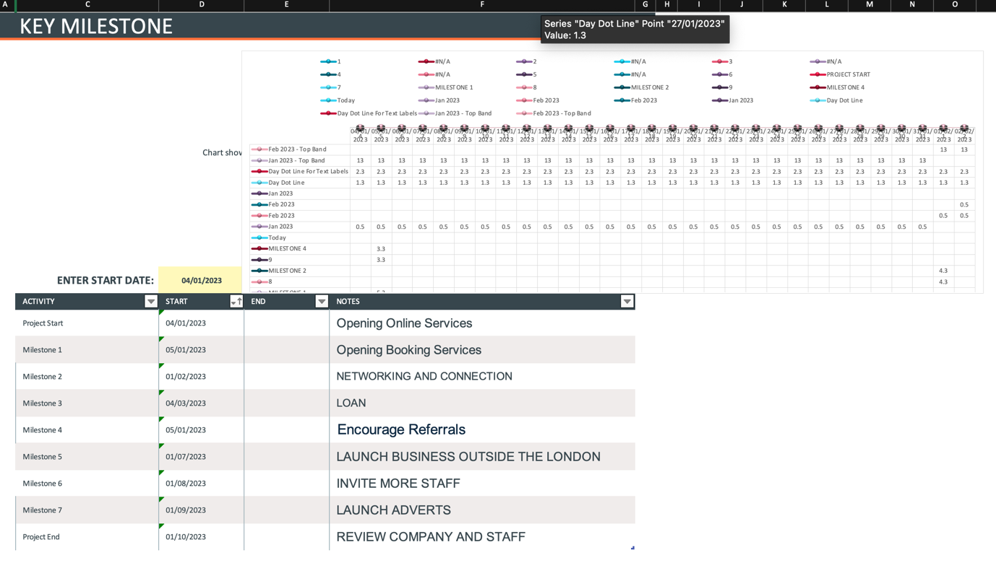

EMPLOYEE TERMINATIONS ARE HANDLED BY THE MANAGER

The function of the management team is crucial when it comes to firing an employee. Even though many businesses would like to avoid firing employees, occasionally it is necessary. During these times, management members make sure everything runs efficiently and professionally (Chron.com, 2011). Additionally, they strive to guarantee that all parties are handled fairly and according to the rules of the law. The manager representative must be present throughout the termination. A supervisor or a representative may explain the grounds for the termination to the fired employee while the latter takes notes and watches. The purpose of the manager is to act as an impartial third party. The employee must be told why their actions contravened a law, regulation, or corporate policy by the official present during the termination. Once the in-person termination meeting is over, human manager work is not over. It is expected that the manager will write up a summary of the discussion and put it in the file for the former employee. In the case of a lawsuit alleging discrimination or something less malicious, like a request to be hired back later, this evidence of how each party responded during the discussion may be important (Chron.com, 2011).

THE SUCCESS OF THE ORGANISATION

The manager must be viewed in terms of the organization's overall strategic goals rather than as a separate lens that adopts a unit-based or micro approach. The objective is to approach the management team holistically such that there are no fragmented tactics, and that the policy is completely integrated with the company goals.

For instance, the company risks losing not just from the period that workers spend in training but also from a loss of direction if the training demands of the staff are only fulfilled by routine training on various themes (Doyle and Stern, 2006). Therefore, an organisation that is serious about its policies will make sure that learning is based on approaches that are both targeted and current.

To guarantee the effective use of people and higher returns to the companies in terms of return (Return on Investment) for each pound spent on them, manager practice must be linked with the overall strategy. Without such a design, enterprises risk losing out on the potential of their human resources. And this is not encouraging for the firm's future development.

The manager does all essential responsibilities in small businesses. Responsible for hiring, managing employee connections, and developing workplace policies. Management specialists also specialise in areas such as sourcing and recruiting, rewards and benefits, administration, legalisation, etc. When a company is profitable, a good leader will use that money to invest in the infrastructure of the business and make your team more effective. As a business leader, you'll never be able to know everything that can be done to make your company better, but by encouraging your employees to share ideas you'll have a comprehensive understanding of what the company can achieve.

EXECUTIVE SUMMARY

Our group is a temporary and permanent dental recruitment agency run by a dental professional with over 8 years of experience. We specialise in providing temporary dental nurses and other regional dental professionals. We interview all our candidates and occasionally meet with the dental practises to have the best chance of finding a good fit. We always seek qualified and passionate dental nurses across the region to join our team. We have the best package where one receives excellent pay rates, support from an area manager, bonus schemes, paid travel, parking, and an in-house health and well-being program. We require our dental nurses to be experienced in various front-of-house systems. Our team is entirely patient-oriented. Management team considerations for recruitment are behavioural skills, which include leadership, management of relationships with others, flexibility, personal work, and meticulousness at work. Our funding requirements are cash available and already sunk into the project, solid commercial agreements, credit enhancement, and loan terms and conditions. We intend to have the best strategy so that we can have a connection with the right funders for our project.

REFERENCES:
- Chron.com. (2011). What Is the Role of HR During an Employee Termination? [online] Available at: https://smallbusiness.chron.com/role-hr-during-employee-termination-10085.html. [Accessed 28 Nov. 2022].
- Doyle, P. and Stern, P. (2006). Marketing management and strategy. Harlow: Financial Times Prentice Hall.
- Marcousʹe, I. (2003). Business studies for AS. Teacher’s book. London: Hodder & Stoughton.
- Pilbeam (n.d.). OCR Customer Service: NVQ Level 2.
- Robert, J. (2022). What Role Do Human Resources Play? [online] Available at: https://business360plus.com/2022/11/18/what-role-do-human-resources-play [Accessed 28 Nov. 2022].
- Sands, N. (2022). Leadership or Management - What’s More Important to a Growing Recruitment Business? [online] Davidson Gray. Available at: https://www.davidsongray.co.uk/leadership-or-management-whats-more-important/ [Accessed 28 Nov. 2022].
- Susan Derek, N. (2002). Define and Deliver Outstanding Customer Service. Edition 2.

APPENDIX:


