Reflection On Moodle 5101
And Development of My
Critical Thinking Skill

BY
Nargas Ahmadzai 2106756
Developing workplace critical thinking
BMSW 5101
Lectures by Zahra Mohammadnazari

Introduction

Reflection is the best way to review your learning, knowledge and understanding of your achievements. This help individuals recognise their strength and weaknesses regarding their outcomes from any project and develop their skills. Learning from previous experience is the best way to achieve better in future. Reflective models are available to support the process of reflective writing. Gibbs’s reflective cycle effectively manages every reflective report and conclusion step. I am writing my reflective report on BMSW 5101 Moodle using Gibb’s reflective cycle to analyse each step with a brief explanation.

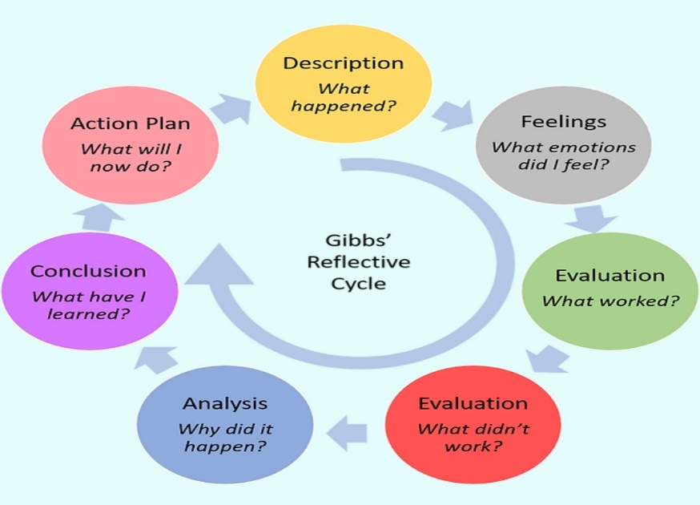

(Gibbon, 2019)

Description

The module (BMSW5101) developing critical thinking in the workplace is a collection of management theories on how businesses utilise these theories in their work to achieve their goals. This includes Henry Fayol’s 14 principles which are mostly operating in company management. The module explains the process of conflict resolution in businesses and how businesses prioritise the values, beliefs and attitudes of employees and their customers and critical literature reviews.

Feelings

Critical thinking is a wide area of knowledge that covers more academic views. The management theories and the principles to utilise in business for effectiveness were more challenging for me. I have searched a range of scholarly articles to expand my understanding of these topics. I enjoyed comparing articles for increasing my knowledge regarding attitudes, beliefs, and values and how these are important in the workplace.

Evaluation
This module focused more on management theories which are effective for success and development in the workplace. I acknowledged that any business cannot be successful without proper management. The survival of companies relies more on critical thinking and adopting the correct theory in their management. I have learnt during my lectures that these theories were made years ago but are still utilised in business because they were based on effective critical thinking.

Analysis
Decisions always require critical thinking and judgmental and understandable argument to conclude the problem with a last long solution. Every industry must research before the act because critical thinking expands our knowledge and support our views to provide the best explanation.

Conclusion

This module was very interesting and challenging at in same time. The challenge was comparing articles, reading, and observing the author’s opinions to understand more about critical thinking. The interesting part of this module was that I have learnt the right definitions and impacts of attitudes, beliefs and values related to the workplace. I have understood that the values of staff in the previous companies were not much considerable as Taylor’s management theory argued how work was more important than workers in the workplace. The effectiveness of the conflict resolution process in business is the key success of employee satisfaction and motivation.

Action plan

This module has taught me very important theories and principles that widened my knowledge of different situations in the workplace. Effective management is the main source of an established business. I feel more confident that my values, attitudes, and beliefs are my rights in the workplace.
Facing any challenge and conflicts is common in the workplace however, this module expands my understanding of how critical thinking can help to be positive and communicate well to solve any issue.
Critical thinking needs more research and logic to prove your views and suggestions. At the start of this module, the topic of critical thinking was very unfamiliar to me however, my understanding is developed now and for future projects, I can confidently think critically and analyse any challenges more effectively in my workplace.

References
- Gibbon, Jonathan (2019) "We do not learn from experience. we learn from reflecting on the experience, LinkedIn. wix.com. Available at: https://www.linkedin.com/pulse/we-do-learn-from-experience-reflecting-loreta-pivoriunaite (Accessed: November 10, 2022).

- Cole & Kelly, 2011: Taylorism and scientific management, lecture notes, developing critical thinking workplace BMSW5101_BIRM, UWTSD, Delivered 15 OCT.

