THE CULTURE AND CONTEXT OF SKY.

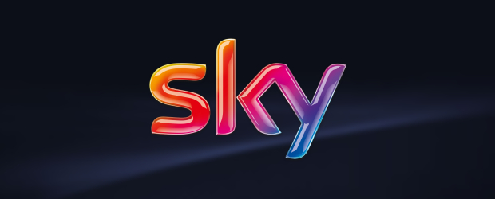

Workplace Culture and its Impact on Organisational Efficiency: BMSW5105

Presented by Samantha Davis
1812476

Executive Summary
The following report has identified the Workplace Culture within Sky Ltd the report will highlight the external factors currently affecting them as identified through using a PESTLE Analysis tool. By aligning The Cultural Web within the organisation, the report will also analyse Sky ‘s Workplace Culture and how it is affecting their success.
Sky’s Corporate Social Responsibility (CSR) and Ethical behaviour will be researched to identify how their behaviour portrays them in the global market.
The report will also identify the Skills and values an individual would need to possess to succeed in Sky. Finally, the report will close with a conclusion and a list of recommendations based on the findings throughout.

Contents
No table of contents entries found.

Introduction
The following report is going to be looking at the workplace culture and its impact on organisational efficiency within Sky Ltd. The findings of the report will be broken down into 4 sections
- The report will look to introduce Sky and include a timeline over the past 30 years of their growth and changes.(Appendix 1)The report will also highlight the importance of a PESTLE analysis and explain the three external factors which are currently affecting Sky.
- Secondly, they will look at The Cultural Web and align and identify Sky’s workplace culture. in this culture tall report will identify the elements are added to their success.
- The report will also look at Sky’s ethical stance and it will give you examples of their ethical/unethical behaviour.
- From these finding the report will recommend the skills and attributes needed for an employee to successfully work within the organisation.
The report will conclude with a list of recommendations to enhance their culture and an overall conclusion after evaluating the findings.
All references will be referenced using Harvard system.

Findings 1.0
“Europe’s leading direct-to-consumer media and entertainment company” (Sky Group - Europe’s leading direct-to-consumer media and entertainment company, 2020)
In 1989 Sky was launched giving the UK viewers their first Satellite TV service with the premier of Sky One. In 1990 after an equal merger with British Satellite Broadcasting BskyB was born and continued its success and growth until 2014 when after acquiring Sky Italia and Sky Deutschland they once again changed their name and became Sky Plc. Throughout the various mergers and acquisitions the Sky logo has remained and continues to be recognised around the world.
(Logo, 2020)

SKYS headquarters are based in the UK and they also have offices in 7 other countries including Austria, Belgium, Germany, Ireland, Italy Portugal, Spain and Switzerland and are currently responsible for employing 32,000+ employees.
They have a customer base of 24 million and are generating a 13.6 billion revenue. Since 2007 Jeremy Darroch has been the groups CEO with Stephen van Rooyen being the Executive Vice President & Chief Executive Officer, UK & Europe, (Our leadership, 2020)
In 2018 Rupert Murdoch’s three-decade reign at Sky TV is to end after his company 21st Century Fox announced it would sell all of its shares in the British broadcaster to the US media firm Comcast. Which resulted in Sky becoming part of the Comcast NBCUniversal family. (Rupert Murdoch's Sky reign to end as Fox sells all shares to Comcast, 2020)
There are 2 main environmental analysis tools that are used regularly around the word to identify the various external factors that can affect an organisation these are SWOT and PESTLE. For the purpose of this report the researcher is going to be focussing on a PESTLE Analysis. A PESTLE Analysis focusses on 6 factors that together or individually can have an impact on an organisation, these factors are
- Political – What is happening politically? Employment Law, Tax Policy Trade, Environmental guidelines and Political Stability.
- Economical – What is happening economically? Is there economic growth/decline, unemployment, wages/pensions/cost of living and exchange rates
- Sociological- What is happening socially? What are the cultural expectations, population growth career attitudes?
- Technological – What is happening with technology?
- Legal- What is happening legally? Are there new laws, how do they affect import/ export?
- Environmental -What is happening environmentally?
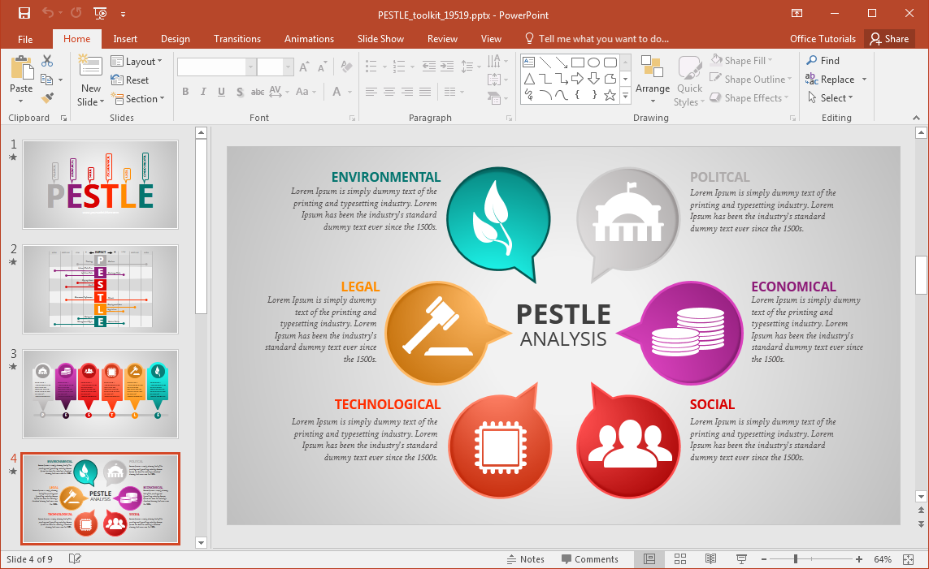
(Powerpoint,2020)
By carrying out a PESTLE Analysis Sky can identify the external factors that are currently impacting them and can then come up with an action plan to help eliminate these factors and to continue to grow. The PESTLE Analysis can help Sky with their business plan and guide their decisions for the companies aims and objectives and help with their marketing strategy.
The PESTLE Analysis may also highlight the need for a change in their organisation culture.
With everything that is going on in the world right now maybe the biggest thing to affects organisations is the killing of George Floyd. This unnecessary death has caused a lot of upset around the world and has created the movement ‘Black Lives Matter’.
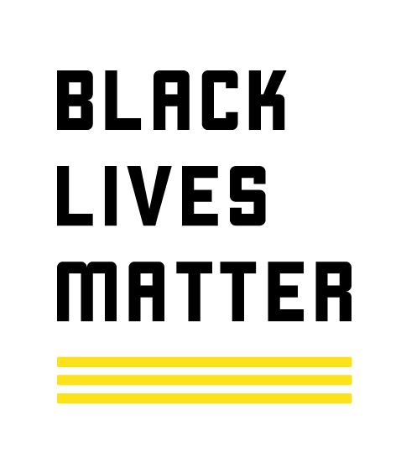
(Black Lives Matter, 2020)
“There have been statements of support and pledges of donations to the Black Lives Matter movement and civil rights groups from a wide range of industries, from finance and food to fashion and entertainment. (Black Lives Matter: Do companies really support the cause? 2020)
“Sky has announced a series of commitments to help tackle racial injustice. To ensure the commitments are delivered, Sky will invest £10million per year across its markets for each of the next three years, and its work will be overseen, implemented and measured by new diversity action and advisory groups.” (Sky commits £30m to support the fight against racial injustice and invest more in diversity and inclusion, 2020)
Sky’s commitments to support anti-racism and improve diversity and inclusion:
- Improve Black and minority ethnic representation at all levels- Sky will work hard to create a permanent change by improving all minority ethnic representation within the company especially at the senior management level. They are also going to invest in their managers to guarantee they have a clear understanding of diversity and inclusion so that they can engage their department staff and colleagues. To ensure this is successful Sky will put various targets in place to measure and monitor the success and progress.
- Make a difference in communities impacted by racism- Sky will collaborate and work closely the diversity action and advisory groups. They will support communities affected by racism. They will be active in the fight for racial equality and are committed to the long-term success of this.
- Use the power of Sky’s voice and platform to highlight racial injustice – This will include Sky developing new content. They will also air the documentary Eight minutes and 46 seconds; the killing of George Floyd that will run on 15 June across Sky Documentaries, Sky One, Sky Witness and Sky Atlantic simultaneously. Sky will also put this across YouTube as free content allowing everyone the opportunity to watch it.
Sky Sports will do more to drive change and is committed to this across all Sky Sports platforms and channels .At the moment you can see this movement being supported through the live premiership football games being shown on Sky Sports.
To help deliver these commitments, new diversity action and advisory groups will be created at Sky. The Diversity Action Group will be made up of diverse colleagues from across Sky and chaired by Sky’s CEO, UK & Europe, Stephen van Rooyen. The Diversity Advisory Group will be made up of independent external contributors and will advise Sky on how it can best deliver real and lasting change, both internally at Sky and externally in communities impacted by racism. (Sky commits £30m to support the fight against racial injustice and invest more in diversity and inclusion, 2020)
Sociological
- Growing demand to watch across various platforms.
- Changing customer needs.
- Competitors subscription deals and original content.
Sky are facing stiff competition from their competitors with the likes of BT, Virgin Media, Amazon and Apple T.V all competing for Sky’s customers. Their competitors are offering excellent signup deals, original content and Amazon have even managed to successfully gain the right to air live some of the Premiership football fixtures. Sky are trying to overcome these factors and are changing the way they do things by merging and collaborating with Now T.V, YouTube, Spotify and Netflix.Due to these new and exciting offers which are more often than not cheaper than a sky subscription Sky need to get their thinking caps on and come up with some new and exciting innovations and packages for new and existing loyal customers.
Covid- 19
The biggest threat to any organisation around the word currently is the current pandemic Covid 19. Un fortunately for most companies Covid will affect them in more ways than one and across various external factors. Sky’s operations have been affected in many ways. They have lost customers and income due to their customers no longer being able to afford their subscriptions. They have had to pause thousands of subscriber’s sports packages as there are no live sports games to transmit which will also affect Sky financially as the will lose out on millions of pounds in marketing and sponsorship. Due to government guidelines and lockdowns they have had to furlough their staff and readdress the way they operate to be able to continue their operations. Filming has been halted which not only has financial implications but also means that Sky are not producing and new content.
In the face of this pandemic Sky are doing what they can to remain positive and still help all customers. They are prioritising calls from their vulnerable and isolated customers, those over 70 and key workers. They are also liaising with Universal and Disney to bring the cinema home to you by bringing brand new movies to the Sky store and introducing Disney+ to Sky Q.
Simon Raggett Managing Director has also said that Sky Business venues will not charging them for their Sky Sports packages until the government allows them to reopen. (Sky Business - customer update, 2020)
While Sky is doing all this to positively help their customers and business partners, they are going to be facing the financial impact of Covid 19 for a while yet.
Covid19 is also impacting Sky’s Technology through many ways as they are unable to send engineers out to do repairs or installations, their phone lines cannot deal with the demand of the customers and by having so many staff on furlough or working from home.
Buchanan and Huczynski, (2017) tells us that “the world out there influences the world in here”

Covid has identified how the external factors are affecting organisations around the world. The only positive to come from this pandemic is that companies like Sky are being given food for thought on ways they can remain at the top of their game whilst changing their operations and internal culture to represent the necessary changes.

2.0
An Analysis of Sky’s workplace culture using the Cultural Web.
“Organisational culture is the way that things are done in an organisation the unwritten rules that influence individual and group behaviour and attitudes factors which can influence organisational culture include the organisation structure the system processes by which work is carried out their behaviour and attitudes of employees the organisations values and traditions and the management and leadership styles adopted” (CMI,2020)
There are various management figures that have studied organisational culture over the years who include Edgar Schein and Charles Handy. Probably being the most recognised is Gerry Johnson and Kevin Scholes who came up with:
The Cultural Web.

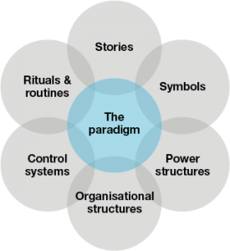

(Johnson and Scholes, 1992)

These six interrelated elements from the Paradigm. The Cultural Paradigm is the core of the web. The paradigm is the core beliefs and motivations of the organisation. It is supported by six cultural elements:
- Stories
- Rituals and Routines
- Symbols
- Organisational Structure
- Control Systems
- Power Structures (Cultural Web | Art of change making, 2020)
By aligning The Cultural Web within Sky’s organisation not only does it become easier to understand their culture, but it can also help them improve it.
Stories
Glass store.co.uk (2020) and Indeed.co.uk (50 results for Sky | Indeed.co.uk, 2020) both tell us about staff feelings and reviews of working within the company
Some of the pros are it is a great company to work for, very focused on teambuilding, good pay, free sky, fabulous benefits, get to meet celebrities, subsidise food and drink and excellent pay
The cons of working in the company are long hours, do not like the location of headquarters and work and get boring sometimes.

Symbols
Some of the symbols that represent Sky are their brightly coloured logo, and their vans that you see driving around the country, all technicians have the same Sky logo on their uniform and whenever you see bus stops or market media big poster boards you always recognise the Sky logo as it is bright and colourful and vibrant
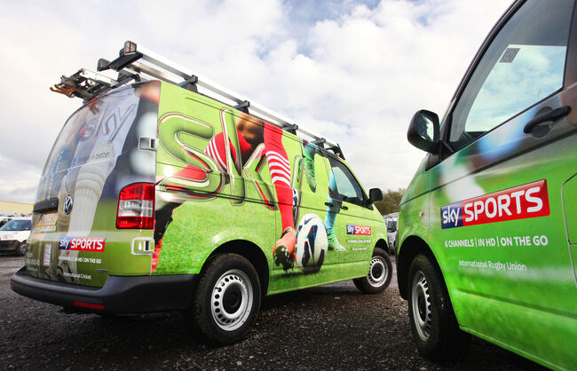

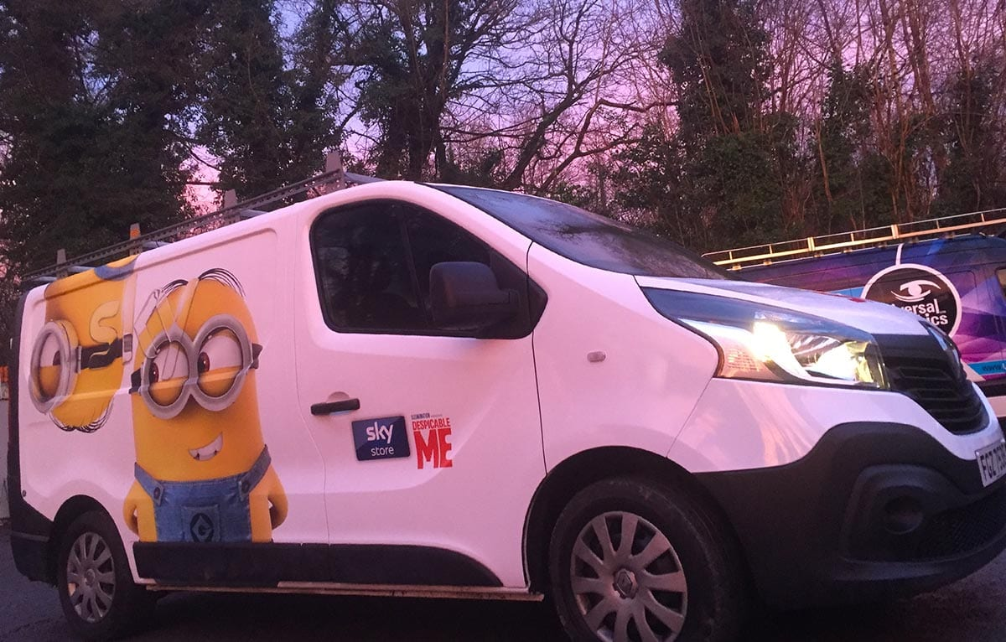

Organisational Structure
Jeremy Durroch is the Group Chief Executive Officer ,Stephen Van Rooyen is Vice President and Chief Executive Officer of the UK and Europe based markets, Andrea Zappia is the Executive Vice President and Chief Executive Officer of New business and market and business, Jason Armstrong is the Group Chief Financial Officer , Debbie Klein is the Group Chief Marketing, Corporate Affairs and People Officer and then you also have various Chief Executive Officers of the European branches. (Our leadership, 2020)

Sky have a mission and that is the believing in better is how we can approach everything we done

Sky’s workplace culture believes that to serve their customers their employees need to represent them. They believe in treating everyone with respect and equality. Internally Sky have six networks to champion diversity and offer support with-
- Women @Sky
- Parents @sky
- Armed Forces@ Sky
- Body and Mind @Sky
- Multi Culture @Sky
- LGBT+ @ Sky
Sky also believe in offering work experience and internships for the younger generation as they believe that they will bring new and innovative ideas to the team.
Sky believe in diversity as different people with different perspectives make Sky a better business.
They have also been voted in the Times top 50 employees for women. (The Times Top 50 Employers for Women 2019 winners| Global Senior Executive Jobs | The Times & The Sunday Times, 2020)
Sky also promote the gender pay gap and they are proud to pay their fair share of taxes and have paid up at €1.8 billion last year alone.
All of these indicate that Sky have an excellent workplace culture.

3.0 Ethics and CSR
In order to challenge what you are doing in your place of work, sometimes it’s necessary to take a step back and “bring the outside in”. (How 5 Companies Bring their Values to Life - Engage for Success, 2020)

“A responsible organisation conducts business ethically and takes account of its economic, social and environmental impact.” (CIPD, 2019)

“To engage in CSR means that, in the ordinary course of business, a company is operating in ways that enhance society and the environment, instead of contributing negatively to them. As important as CSR is for the community, it is equally valuable for a company. CSR activities can help forge a stronger bond between employees and corporations; boost morale; and help both employees and employers feel more connected with the world around them.” (Corporate Social Responsibility (CSR), 2020)

To ensure that Sky are acting responsible they have implemented a Responsible Sourcing Policy (App 2) which includes the following
Supplier Requirements:
- Complying with the law is non-negotiable
Environmental Management:
- Single use plastic
- Cut emissions and waste
- Good environment management is good business
Ethical and Social Responsibility
- Treat everyone fairly and equally
- Coming into work should be a choice
- Fair pay for sensible hours
- Workers are an appropriate age
- Work should not harm your health
- Communicate with transparency and openness
- Working with us and the wider supplier chain to continuously grow

Sky have also introduced the Modern Slavery Act and the Gender Pay Gap.
We want to have the biggest impact, on the issues that matter most. So our work is aligned with the relevant UN Sustainable Development Goals. (Sky,2020)
There are 4 main areas of CSR THAT Sky need to be practising well within and they are
- Workplace
- Marketplace
- Environment
- Community
By adhering to their policies and acting responsibly Sky are portraying themselves as being true to their values and beliefs.
By making these policies available to everyone Sky are holding themselves accountable for their behaviours and actions out in these 4 areas.

4.0 Employee attributes
“Employee engagement is a workplace approach resulting in the right conditions for all members of an organisation to give of their best each day, committed to their organisation’s goals and values, motivated to contribute to organisational success, with an enhanced sense of their own well-being.” (How 5 Companies Bring their Values to Life - Engage for Success, 2020)
Sky is proud of the way they interact with their customers and employees and believe that all their actions and decision making are focused on their core values .Sky and Sky News pride themselves on the following core values
:: We are bold
:: We are rebellious
:: We have a competitive spirit that drives us to be first and best
:: We earn trust by behaving with integrity
:: We are pioneers and innovators
:: We celebrate success together
:: We put people at the centre of everything (Sky News policies and standards, 2020)

To bring back the content and innovation to all our customers better connect them to more of what they love Sky believes they need:
- To be fair responsible
- Forward-looking a fast last
- Customer lead and simplify
- Creative and action orientated and
- collaborative and inclusive

To fulfil these values Sky, believe in doing the right thing, they believe in building a better tomorrow and they believe in making things better and simpler for all customers. Sky believe in new ideas and making them happen and they also believe we are better when we all work together.
Values Attitudes and Beliefs are the foundations of how individuals or organisations behave. They are important in the way we act, treat peers, approach situations.
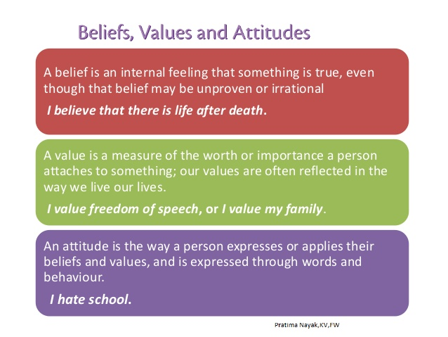 (Beliefs, values and attitudes, 2020)
“Employees have their own values when they walk in the door, and they are influenced everyday by the values they experience in your organisation. Understanding the values currently at play is essential to put your wanted culture into action. (Barrett values centre 2020)

It is important when applying for a job within any organisation that you familiarise yourself with the company’s vision, mission statement and values as you would need to have similar values and attitudes to succeed.
Employability skills are essential when applying for a promotion or a managerial role in the workplace. ”The manager will want to find out about what motivates you, what skills you have and whether you are the sort of person the organisation will want as a future manager”. (morgan, 2017)
“We have a core set of behaviours that unite us and describe how we work together. Throughout the selection process, we will be looking for evidence of how you demonstrate each of them. (Applying with Sky? Here is their Top Tips! 2020) They are:
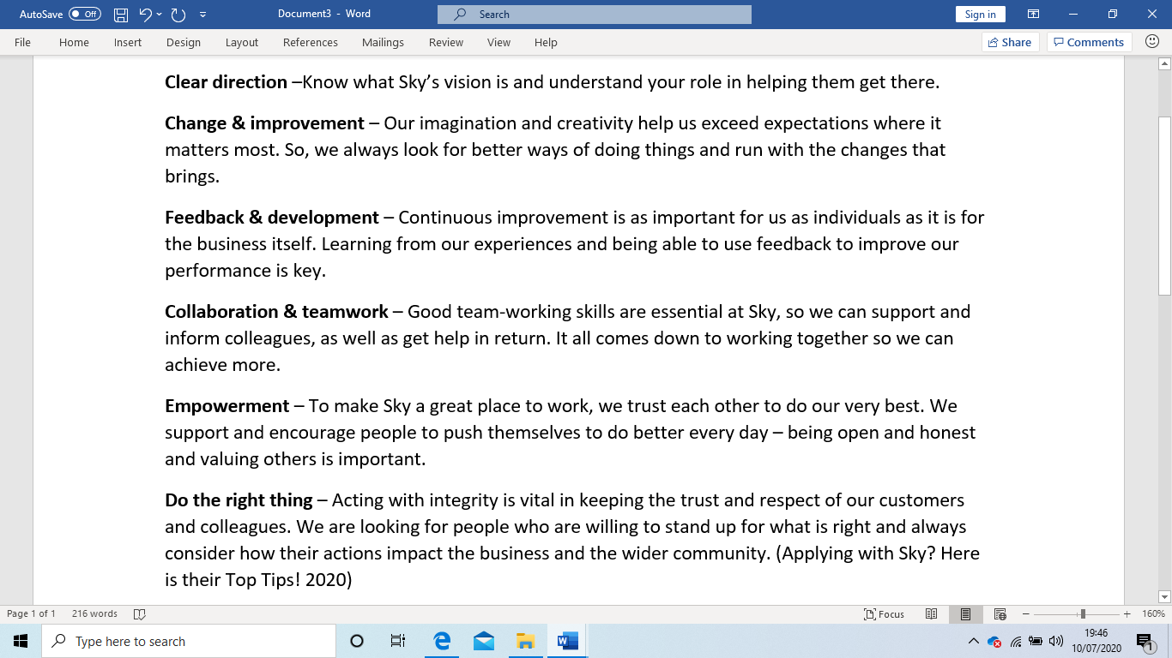
“Good communication matters at work because few jobs are solo acts. It takes communication to work on a team, and even people working alone must report to their bosses. If you run a business, you have to tell employees what's expected of them.” (Smallbusiness.chron.com, 2019)

To better understand one’s values and attitudes/ what skills and attributes they have an individual can take the Barrett Personal Values Assessment.

Conclusion
Recommendations
- Management to review glass door.co.uk and indeed.co.uk to see the staff feedback this is more likely to be honest it off then as they are external site number to
- Seek to include a collaboration with virgin media or Amazon to include their services via the sky Q box this will help with a vision to be accessible to all
- Due to COVID- 19 look at ways to reduce subscriptions in the hope of retaining customers.
- Put more marketing and advertising into promoting all the behind-the-scenes and good deeds that Sky do from their charity work to their environmental sustainability.
- Research Edgar Schein and Charles Handy Cultural thinking tools to see if there are any areas that would complement an already excellent Workplace Culture.

Appendices
- Sky’s History
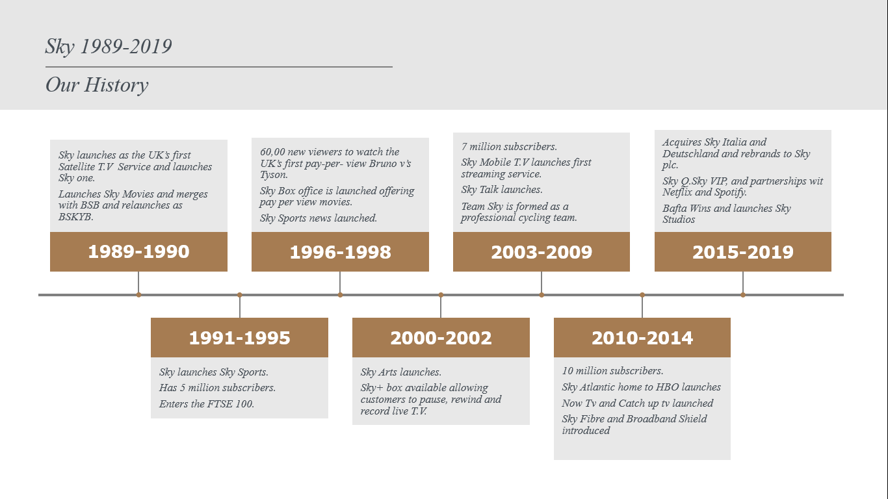
- Responsible Sourcing Policy
https://static.skyassets.com/contentstack/assets/bltdc2476c7b6b194dd/bltdbcc76a2a1c287c6/5aec463aa2198ce642ae097c/Sky%20Responsible%20Sourcing%20Policy%202018.pdf
- Sustainability Policy
https://static.skyassets.com/contentstack/assets/bltdc2476c7b6b194dd/blt7d4e5d5dc78de8cf/5bd73deb76ba81625f90d550/Sustainable%20Development%20Goals_2018.pdf

References
Logo, S., 2020. Sky Plc Vector Logo Download For Free. [online] SeekVectorLogo. Available at: <http://seekvectorlogo.com/sky-plc-vector-logo-ai/> [Accessed 5 July 2020].
Skygroup.sky. 2020. Sky Group - Europe’S Leading Direct-To-Consumer Media And Entertainment Company. [online] Available at: <https://www.skygroup.sky/> [Accessed 5 July 2020].
Skygroup.sky. 2020. Our Leadership. [online] Available at: <https://www.skygroup.sky/our-leadership> [Accessed 8 July 2020].
the Guardian. 2020. Rupert Murdoch's Sky Reign To End As Fox Sells All Shares To Comcast. [online] Available at: <https://www.theguardian.com/media/2018/sep/26/rupert-murdochs-sky-reign-to-end-as-fox-sells-all-shares-to-comcast> [Accessed 8 July 2020].
Bbc.com. 2020. Black Lives Matter: Do Companies Really Support The Cause?. [online] Available at: <https://www.bbc.com/worklife/article/20200612-black-lives-matter-do-companies-really-support-the-cause> [Accessed 9 July 2020].
Skygroup.sky. 2020. Sky Commits £30M To Support The Fight Against Racial Injustice And Invest More In Diversity And Inclusion. [online] Available at: <https://www.skygroup.sky/en-gb/article/sky-commits-30m-to-support-the-fight-against-racial-injustice-and-invest-more-in-diversity-and-inclusion> [Accessed 9 July 2020].
2020. [online] Available at: <https://blacklivesmatter.com/> [Accessed 9 July 2020].
Free-power-point-templates.com. 2020. [online] Available at: <http://www.free-power-point-templates.com/articles/wp-content/uploads/2016/11/pestel-template-for-powerpoint.png> [Accessed 9 July 2020].
Skyforbusiness.sky.com. 2020. Sky Business - Customer Update. [online] Available at: <https://skyforbusiness.sky.com/sb/portal/business/uk/campaigns/update> [Accessed 9 July 2020].
Managers.org.uk. 2020. [online] Available at: <https://www.managers.org.uk/~/media/Files/PDF/Checklists/CHK-232-Understanding-organisational-culture.pdf> [Accessed 9 July 2020].
Leadershipcentre.org.uk. 2020. Cultural Web | Art Of Change Making. [online] Available at: <https://www.leadershipcentre.org.uk/artofchangemaking/theory/cultural-web/> [Accessed 9 July 2020].
Global Senior Executive Jobs | The Times & The Sunday Times. 2020. The Times Top 50 Employers For Women 2019 Winners| Global Senior Executive Jobs | The Times & The Sunday Times. [online] Available at: <https://appointments.thetimes.co.uk/article/times-top-50-employers-for-women/> [Accessed 9 July 2020].
Skygroup.sky. 2020. Our Leadership. [online] Available at: <https://www.skygroup.sky/our-leadership> [Accessed 9 July 2020].

Indeed.co.uk. 2020. 50 Results For Sky | Indeed.Co.Uk. [online] Available at: <https://www.indeed.co.uk/companies/search?from=discovery-cmp-front-door&q=SKY> [Accessed 9 July 2020].
Glassdoor.co.uk. 2020. [online] Available at: <https://www.glassdoor.co.uk/index.htm> [Accessed 9 July 2020].
Johnson, G., Whittington, R., Scholes, K., Angwin D., and Regnér, P. Exploring Strategy, tenth edition, Pearson Education (2014), p. 156
Engage for Success. 2020. How 5 Companies Bring Their Values To Life - Engage For Success. [online] Available at: <https://engageforsuccess.org/how5companiesbringtheirvaluestolife> [Accessed 10 July 2020].
Static.skyassets.com. 2020. [online] Available at: <https://static.skyassets.com/contentstack/assets/bltdc2476c7b6b194dd/bltdbcc76a2a1c287c6/5aec463aa2198ce642ae097c/Sky%20Responsible%20Sourcing%20Policy%202018.pdf> [Accessed 05 July 2020].
Sky News. 2020. Sky News Policies And Standards. [online] Available at: <https://news.sky.com/info/policies-and-standards> [Accessed 05 July 2020].
Investopedia. 2020. Corporate Social Responsibility (CSR). [online] Available at: <https://www.investopedia.com/terms/c/corp-social-responsibility.asp> [Accessed 05 July 2020].
CIPD. 2020. CIPD The Professional Body For Human Resources And People Development. [online] Available at: <https://www.cipd.co.uk/> [Accessed 05 July 2020].
Static.skyassets.com. 2020. [online] Available at: <https://static.skyassets.com/contentstack/assets/bltdc2476c7b6b194dd/blt7d4e5d5dc78de8cf/5bd73deb76ba81625f90d550/Sustainable%20Development%20Goals_2018.pdf> [Accessed 10 July 2020].
Mindtools.com. (2020). Personal SWOT Analysis Making the Most of Your Talents and Opportunities. [online] Available at: https://www.mindtools.com/pages/article/newTMC_05_1.htm [Accessed 05 Jul. 2020].
Belbin.com. (2020). The Jul. 2020]. Nine Belbin Team Roles. [online] Available at: https://www.belbin.com/about/belbin-team-roles/ [Accessed 7 Jul. 2020]
Smallbusiness.chron.com. (2020). What Are the Benefits of Effective Communication in the Workplace?. [online] Available at: https://smallbusiness.chron.com/benefits-effective-communication-workplace-20198.html [Accessed 1 Jul. 2020].
VERCIDA. 2020. Applying With Sky? Here's Their Top Tips!. [online] Available at: <https://www.vercida.com/uk/articles/applying-with-sky-here-s-their-top-tips#:~:text=Collaboration%20%26%20teamwork%20%E2%80%93%20Good%20team-working%20skills%20are,trust%20each%20other%20to%20do%20our%20very%20best.> [Accessed 10 July 2020].
Morgan, P. (2017). The business student's guide to study and employability. London [etc.]: SAGE Publications, p.52.
Slideshare.net. 2020. Beliefs, Values and Attitudes. [online] Available at: <https://www.slideshare.net/pratimanayak39/beliefsvalues-and-attitudes> [Accessed 05 Jul 2020].
Barrett Values Centre. (2020). Barrett Values Centre | Your Organisation, Thriving. [online] Available at: https://www.valuescentre.com/ [Accessed 5 Jul. 2020].

