Data Handling & Business Intelligence

Module code: LCBB5000

Assessment 2 – Data Analysis & Visualisations

Student Name: Svetoslav Hristov Radev
Student ID: 2030542

Table of Contents
Part 1 3
The processing and interpretation of data 3
Pre-processing 3
Examination of the collected data 4
Part 2: 11
Text mining & analysis 11
Initial reporting 11
K-means clustering and interpretation 13
Text and data mining techniques 15
SPSS and Excel advantages and disadvantage 16
Reference list 18

Part 1

The processing and interpretation of data
According to the information that was presented, a number of different factors have an effect on the crime rate in the United Kingdom. The dataset has been analyzed in great detail in order to figure out the myriad of ways in which the different parts of it communicate with one another. It has also proven effective in assessing the crime rate in various locations all around the world. It was found that the Southern and Northern regions were the most relevant variables in the existence of the data and its varied repercussions. Specifically, it was found that the Southern and Northern regions were the most essential variables. The number of men and the amount of money that men spend each year are two of the most important criteria to consider when determining the accuracy of these graphs (Bansal, 2021). When designing the graphics, each and every one of these factors was taken into consideration. The importance of the crime rate for a million people can be better understood by conducting an analysis of multiple components of the dataset. Those who have completed their education have a greater chance of finding employment than those who have not, as shown by the percentage of the total population that is unemployed. When wage considerations are taken into account, the options that are available to salaried workers or certain categories of workers are analyzed. The magnitude of a state's population is directly proportional to the number of states that have researched and examined its values. In addition to this, the percentage of the population that has incomes that are lower than the minimum wage is taken into account. Because of this, having this knowledge and its combined effects is beneficial for examining a variety of critical parts, and it has strategic benefits for comprehending its implications, which analyze both the positive benefits and the numerous ramifications of the entire model. As a result, having this knowledge and its combined effects is beneficial for examining a variety of critical parts, and it has strategic benefits for comprehending its implications.

Pre-processing
Before data that is unstructured or unorganized can be analyzed, it must first be pre-processed, which is where the term "pre-processing" originates from. There are a number of different reasons for this. The application of particular values for procedures has originally resulted in the elimination of inconsistencies in the data. The values 0 and 1 that were previously assigned to the North and South directions have been changed to the corresponding string values. If the number is higher than around 100, then the rate of crime is considered to be high; if it is lower than around 100, then the rate of crime is considered to be moderate. Regression analysis was also done, with the crime rate as the independent variable and all other variables except for that particular column as the dependent variable. In addition to the implications for the economy, it is of the utmost importance to have a solid grasp on the significance of the crime rate in regard to the interpretation of the numerous values it carries (Bennett and Ouazad, 2020). In this particular instance, the data interpretation was carried out with the assistance of Excel's IF and PIVOT tables, in addition to other other significant tools. In order to evaluate the crime rate and determine its unique significance in relation to the other aspects of the decision-making process as a whole, a wide range of tactical judgments and concrete pieces of evidence were utilized.

Examination of the collected data
Data analysis is the primary process that must take place before unstructured data can be transformed into useful information. It can, for instance, assist in identifying the elements that influence data quality and explaining how to better utilize and influence it. This is just one of the many applications it can have. These criteria are necessary in order to provide data that is free of ambiguity and can, for instance, be used to better understand the constituent parts of this relationship.
Youth unemployment and crime rate
Sum of CrimeRate | Column Labels
Row Labels | Northern | Southern | Grand Total
Northern | 40.97% | 25.69% | 66.66%
Southern | 30.82% | 2.52% | 33.34%
Grand Total | 71.79% | 28.21% | 100.00%

Table 1: Youth unemployment and crime rate
(Source: created by the learner)
Statistics on criminal activity and the impact of youth unemployment were used to compile the data presented in the table above. The fact that young people in the Northern region have a joblessness rate of 40.97% clearly has a positive effect on the overall crime rate in the Northern region. It is estimated that 30.82 percent of young people living in the southern region are responsible for the region's higher crime rate.

Figure 1: Youth unemployment and crime rate
(Source: created by the learner)
In order to get a more in-depth understanding of how adolescents contribute to criminal behavior, the following interpretation can be explored and implemented with the help of a bar chart to represent the data.
MoreMales and the crime rate
Sum of CrimeRate | Column Labels
Row Labels | Northern | Southern | Grand Total
Northern | 45.96% | 20.70% | 66.66%
Southern | 33.34% | 0.00% | 33.34%
Grand Total | 79.30% | 20.70% | 100.00%

Table 2: MoreMales and the crime rate
(Source: created by the learner)
The higher proportion of male residents in the Northern and Southern regions is likely to blame for the higher crime rates in those regions. As can be observed, people who engage in these kinds of activities make up around 44.96% of the population in the Northern region, whereas only upto 33.34% of the population in the Southern zone does so.

Figure 2: MoreMales and crime rate
(Source: created by the learner)
A good and practical approach of dividing Northern and Southern regions into geographic areas for the purpose of measuring the various crime rates created by the presence of more men in society is depicted on the area map that can be found above.
Crime rate across region

Sum of CrimeRate | Column Labels
Row Labels | High | Moderate | Grand Total
Northern | 42.93% | 23.73% | 66.66%
Southern | 19.37% | 13.97% | 33.34%
Grand Total | 62.30% | 37.70% | 100.00%

Table 3: Crime rate across region
(Source: created by the learner)
It has been demonstrated that the rate of violent crime is significantly higher in the Northern and Southern regions of the United States compared to the rest of the country. Given these circumstances, 42.93 percent of the crimes that have been committed in the area are seen as being more serious than the 23.73 percent of the offenses that have been categorized as moderate. In comparison to the 19.37% rate of high crimes, the Southern region only has 13.97% of intermediate crimes.

Figure 3: Crime rate across region
(Source: created by the learner)
The findings drawn from the data that was used to categorize crimes according to location are analyzed, as can be seen in the graphic that is shown above. Because of this, the impact that these crimes have in these kinds of settings contributes to the ambiguity that exists.
Crime rate of the males and the youth
Row Labels | Sum of Males | Sum of Youth
High | 51.32% | 50.96%
Moderate | 48.68% | 49.04%
Grand Total | 100.00% | 100.00%

Table 4: Crime rate of the males and the youth
(Source: created by the learner)
The data in the table above demonstrate that males and younger people make up an equal share of the population of people who commit violent crimes. In addition, the percentage of males who have higher crime rates is around 51.32%, whereas the percentage of guys who have lower crime rates is just around 48.68%. When compared to the percentage of young people who engage in less serious criminal behavior, the proportion of young people who commit more serious crimes is significantly greater, standing at 50.96%.

Figure 4:Crime rate of the males and the youth
(Source: created by the learner)
The numbers in the following table have been projected into the relevant bar chart data as shown above in order to better understand the significance of the data and the values that are associated with its interpretation.
Dependency

SUMMARY OUTPUT
Regression Statistics
Multiple R | 0.827164383
R Square | 0.684200916
Adjusted R Square | 0.559795216
Standard Error | 19.17008367
Observations | 47
ANOVA
 | df | SS | MS | F | Significance F
Regression | 13 | 26274.52 | 2021.117 | 5.499755 | 3.62E-05
Residual | 33 | 12127.24 | 367.4921
Total | 46 | 38401.76
 | Coefficients | Standard Error | t Stat | P-value | Lower 95% | Upper 95% | Lower 95.0% | Upper 95.0%
Intercept | -258.3036314 | 192.4354 | -1.34229 | 0.188665 | -649.816 | 133.2091 | -649.816 | 133.2091
Youth | 0.864982195 | 0.353186 | 2.449086 | 0.0198 | 0.14642 | 1.583544 | 0.14642 | 1.583544
Region | 0.569661318 | 12.04365 | 0.0473 | 0.962559 | -23.9333 | 25.07266 | -23.9333 | 25.07266
Education | 6.431185894 | 3.750328 | 1.714833 | 0.095754 | -1.19891 | 14.06129 | -1.19891 | 14.06129
ExpenditureYear0 | 0.712709172 | 0.20199 | 3.528437 | 0.001254 | 0.301757 | 1.123661 | 0.301757 | 1.123661
LabourForce | 0.107708854 | 0.122808 | 0.877052 | 0.386799 | -0.14215 | 0.357563 | -0.14215 | 0.357563
Males | -0.183826438 | 0.236565 | -0.77707 | 0.442654 | -0.66512 | 0.297468 | -0.66512 | 0.297468
MoreMales | 17.33920029 | 15.83577 | 1.094939 | 0.281471 | -14.8789 | 49.55731 | -14.8789 | 49.55731
StateSize | -0.098946497 | 0.11444 | -0.86461 | 0.393492 | -0.33178 | 0.133883 | -0.33178 | 0.133883
YouthUnemployment | -0.091727901 | 0.461323 | -0.19884 | 0.843611 | -1.0303 | 0.846841 | -1.0303 | 0.846841
MatureUnemployment | 0.687760671 | 0.994911 | 0.691279 | 0.494225 | -1.3364 | 2.711922 | -1.3364 | 2.711922
HighYouthUnemploy | -4.498056942 | 10.82134 | -0.41567 | 0.680345 | -26.5142 | 17.51812 | -26.5142 | 17.51812
Wage | 0.191891937 | 0.089505 | 2.143934 | 0.039499 | 0.009793 | 0.37399 | 0.009793 | 0.37399
BelowWage | 0.55335581 | 0.206926 | 2.674174 | 0.01156 | 0.132362 | 0.97435 | 0.132362 | 0.97435

Table 5: dependency based on the independent and dependent variable
(Source: created by the learner)
The crime rate and the juvenile population have a statistically significant link at p=0.02, which is less than 0.05. The coefficient value of 0.86, on the other hand, indicates that the value is significant. The regional components have limited statistical importance because the location of a crime site has no influence on its rate. The percentage of people with a college degree or higher is another relevant factor, but statistically negligible. The cost and crime rate have a statistically significant (p=0.001) relationship. As proven by this greater relevance with the relevant database, many components can have a good impact on data relevance. Both of these factors are more important. Both the wage and crime rates are significant due to the significance of p=0.03 (Catlett et al., 2019). As this figure clearly shows, there is a statistically significant positive relationship between these two factors. As a result, the report investigated the possible links between various values and how they are perceived by the public. Findings like these provide a more in-depth knowledge of the data and the factors that surround it.
When trying to figure out how to deal with these issues, it is essential to take into account all of the many factors that contribute to the high crime rate in the country. There are a lot of different factors. This might not be a problem as long as there aren't any issues with the operational measurement and data or analysis (Cox et al., 2020). If we assume a higher crime rate, we may estimate that there will be around 51.32% more crimes committed per million people living in the area or approximately 5,13,200. The actions of approximately 48.68% of the population who are considered moderate have had an impact on roughly 48,000 persons.

Part 2:

Text mining & analysis
The survey questions and data collected from children can be analyzed in great detail with the help of the SPSS tool (Catlett et al., 2019). The ease of use of the program, in addition to its many other features, demonstrates that it possesses a number of advantages over MS Excel, which was before utilized in the company.

Initial reporting
The following are some of the methods in which the data can be analyzed to determine its inherent frequency as well as their statistical significance:
ice_cream
 |  | Frequency | Percent | Valid Percent | Cumulative Percent
Valid | Vanilla | 95 | 47.5 | 47.5 | 47.5
Valid | Chocolate | 47 | 23.5 | 23.5 | 71.0
Valid | Strawberry | 58 | 29.0 | 29.0 | 100.0
Valid | Total | 200 | 100.0 | 100.0

Table 1: Frequency of Ice cream flavours
(Source: created by the learner)
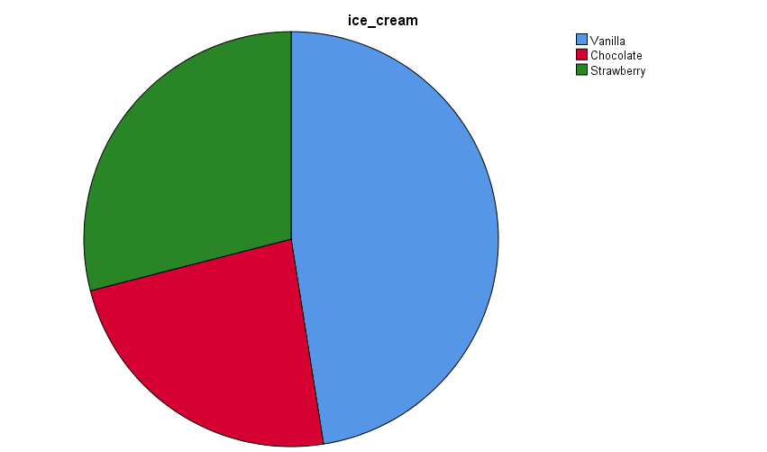
Figure 1: Pie chart for the ice cream flavours
(Source: created by the learner)

1) How many students like vanilla flavour?
Ninety-five percent of the two hundred students who took part in the trial said that they preferred the vanilla flavor. According to the research, almost half of the students, approximately 47.5% of them, choose this flavor above the others.
2) How many students are Male and Female?
Gender
 |  | Frequency | Percent | Valid Percent | Cumulative Percent
Valid | Male | 91 | 45.5 | 45.5 | 45.5
Valid | Female | 109 | 54.5 | 54.5 | 100.0
Valid | Total | 200 | 100.0 | 100.0

Table 2: Frequency of Gender
(Source: created by the learner)
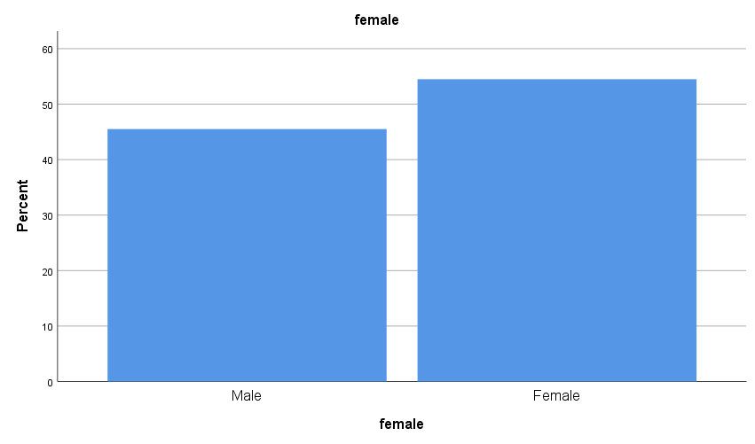
Figure 2: Bar chart of Gender
(Source: created by the learner)
3) What are the Mean and Median of participants who like chocolate and strawberry flavour?
Statistics of Chocolate flavour ice-cream
ice_cream
N | Valid | 47
N | Missing | 0
Mean |  | 2.00
Std. Error of Mean |  | .000
Median |  | 2.00
Mode |  | 2
Std. Deviation |  | .000
Variance |  | .000
Std. Error of Skewness |  | .347
Std. Error of Kurtosis |  | .681
Range |  | 0
Minimum |  | 2
Maximum |  | 2

Table 3: Statistics of Chocolate flavour ice-cream
(Source: created by the learner)
Statistics of strawberry flavour ice-cream
ice_cream
N | Valid | 58
N | Missing | 0
Mean |  | 3.00
Std. Error of Mean |  | .000
Median |  | 3.00
Mode |  | 3
Std. Deviation |  | .000
Variance |  | .000
Std. Error of Skewness |  | .314
Std. Error of Kurtosis |  | .618
Range |  | 0
Minimum |  | 3
Maximum |  | 3

Table 4: Statistics of Strawberry flavour ice-cream
(Source: created by the learner)
One can use the data that is provided below to determine the average and median number of people who prefer strawberry and chocolate ice cream respectively.

K-means clustering and interpretation
K-means clustering is useful for resolving issues in machine learning and data science platforms because it works efficiently and offers a lot of value. Within the scope of this investigation, a comprehensive examination of the multiple student Puzzle-video and gender factors will be carried out utilizing three separate clusters. Based on the findings of the cluster analysis, one can reach the following conclusion:

Initial Cluster Centers
 | Cluster
 | 1 | 2
video | 29 | 74
puzzle | 26 | 66
female | 1 | 0

Iteration Historyª
Iteration | Change in Cluster Centers
Iteration | 1 | 2
1 | 21.990 | 18.383
2 | .739 | .631
3 | 1.084 | .969
4 | .215 | .219
5 | .285 | .262
6 | .000 | .000
a. Convergence achieved due to no or small change in cluster centers. The maximum absolute coordinate change for any center is .000. The current iteration is 6. The minimum distance between initial centers is 60.216.

Final Cluster Centers
 | Cluster
 | 1 | 2
video | 45 | 58
puzzle | 44 | 60
female | 1 | 1

ANOVA
 | Cluster |  | Error |  | F | Sig.
 | Mean Square | df | Mean Square | df | F | Sig.
video | 8700.783 | 1 | 54.579 | 198 | 159.415 | .000
puzzle | 12815.244 | 1 | 51.116 | 198 | 250.709 | .000
female | .030 | 1 | .250 | 198 | .120 | .729
The F tests should be used only for descriptive purposes because the clusters have been chosen to maximize the differences among cases in different clusters. The observed significance levels are not corrected for this and thus cannot be interpreted as tests of the hypothesis that the cluster means are equal.

Number of Cases in each Cluster
Cluster | 1 | 95.000
Cluster | 2 | 105.000
Valid |  | 200.000
Missing |  | .000

Table 5: Cluster analysis for video Puzzle and gender-based on prefered ice cream flavour
The investigation was terminated after the sixth iteration due to the presence of extremely minor changes in cluster centers, as shown in the table above. For movies and puzzles, for example, ANOVA tables elaborate on statistically significant cluster changes and p-values. However, the gender of the subjects exhibited no statistical significance at p 0.05. The test results clearly show statistical measurement and the distinction between two major clusters based on the three variables chosen for the test case.

Text and data mining techniques
Data mining can be used to predict future actions, grasp the data's insights, and move forward with strategic decisions that can be used to boost data management efficacy. Furthermore, test mining is a comparable process that evaluates a large volume of text data to assess relevant knowledge and interpret that information in light of real-world demands. Data mining methods like pattern tracking, categorization, and other comparable approaches, for example, will improve inventory management and customer purchase forecasts (Karthikeyan et al., 2019). This will deliver more benefits by ensuring that the company's stock levels are maintained at the busiest season of the year. Machine learning-based regression and prediction algorithms, on the other hand, can be incredibly useful in estimating income or sales. These business management approaches aid in ensuring that the operations of the sales departments are aligned with the business processes. There are additional advantages in terms of company finance, allowing for the use of tried-and-true methods.
Other text mining techniques, such as sentiment and content analysis, natural language processing (NLP), and other forms of natural language processing (NLP), are essential for effectively exploiting relevant text data for business goals. Consider employing sentiment analysis techniques to investigate customer thoughts on a certain brand's items as they surface on social networking platforms, for example. It is also beneficial for studying legal documents of organizations, allowing for the establishment of a clear fraud detection strategy using text analysis. The NLP method, which can be linked to a customer survey and employed in a certain way, can be used to assess customers' needs and requirements.

SPSS and Excel advantages and disadvantage
SPSS is a significant data analysis program that may be used to gain insights from a range of sources. As a result, developing a superior business strategy based on such data would be important to the organization's capacity to implement effective business strategies. Both of these tools, however, have advantages and limitations. It will be evaluated using the following criteria:

Tools | Advantages | Disadvantages
SPSS | - The program offers a simple user interface.  - The sophisticated statistical method can be completed without difficulty.  - It allows for more information to be processed  - It decreases the probability of inaccuracy, and self-explanatory aspects aid in evaluation  - The output is easily recordable and evaluated later results effectively | - The software would require a significant financial investment to obtain.  - The complexity of the visual depiction is the source of the difficulty.  - Text mining and the application of advanced data mining technologies are not possible.  - Data outputs from previous versions do not always work in subsequent versions.  - Has some superfluous and repetitive components that should have been deleted to make a more useful user interface (UI).
Excel | - Excel also supports a large range of mathematical formulas, and its ability to work with data in string or text format makes it a helpful tool.  - The application excels at handling quick computations, creating balance sheets, and other critical duties.  - Excel makes data organization easier in ways that other database systems cannot.  - Multiple user assistance is available, which is beneficial to the business.  - Many useful add-ons are available, allowing for sophisticated activities such as data processing and on-the-fly calculations. | - It lacks advanced data analysis skills and is not based on a specialized data analysis tool.  - When working with large databases, this tool has considerable limitations; for example, leading data can occasionally cause application crashes.  - The application's formula may necessitate specialized knowledge.  - The software does not detect handling errors, and inaccurate information given by the user is not updated.  - When multiple persons can access the software at the same time, the program's security is jeopardized.
Table 6: Advantages and disadvantages of Excel and SPSS
(Source:Sönmez, 2019))

Reference list
Bansal, D., (2021). Real-Time Data Acquisition in Human Physiology: Real-Time Acquisition, Processing, and Interpretation—A MATLAB-Based Approach. Academic Press.
Bennett, P. and Ouazad, A., (2020). Job displacement, unemployment, and crime: Evidence from danish microdata and reforms. Journal of the European Economic Association, 18(5), pp.2182-2220.
Cox, D.R., Newton, A.M. and Huuse, M., (2020). An introduction to seismic reflection data: Acquisition, processing and interpretation. In Regional Geology and Tectonics (pp. 571-603). Elsevier.
Catlett, C., Cesario, E., Talia, D. and Vinci, A., (2019). Spatio-temporal crime predictions in smart cities: A data-driven approach and experiments. Pervasive and Mobile Computing, 53, pp.62-74.
Karthikeyan, U. and Vanitha, M., (2019). A Study on Text Recognition using Image Processing with Datamining Techniques. International Journal of Computer Sciences and Engineering, 7(2), pp.1-6.
Li, Q., Li, S., Zhang, S., Hu, J. and Hu, J., (2019). A review of text corpus-based tourism big data mining. Applied Sciences, 9(16), p.3300.
Rahman, A. and Muktadir, M.G.,(2018). SPSS: An Imperative Quantitative Data Analysis Tool for Social Science Research.
Rowan, Z.R., Schubert, C.A., Loughran, T.A., Mulvey, E.P. and Pardini, D.A., (2019). Proximal predictors of gun violence among adolescent males involved in crime. Law and human behavior, 43(3), p.250.
Sönmez, H., (2019). An examination of needs analysis research in the language education process. International Journal of Education and Literacy Studies, 7(1), pp.8-17.

