Crypto Wall and how to avoid losing your files and a brief history of computer viruses

1 History of Viruses
Early into when computers started to come out people already started to try and slow down computers the 1st virus that was made and worked successfully was the “creeper system” [1]The virus which was a virus that copied itself over until the hard drive was full was written by Bob Thomas [2] Ray Tomlinson then made reaper which deleted creeper files [1] these were made as part of an experimental computer program

1.1 what is a virus
A virus is a type of harmful software designed to alter how computers work and to spread from one computer to another. A virus inserts or attaches itself to a valid program or document that supports macros in order to run its code. The system software may be disrupted by a virus if it alters or deletes data during this process, among other unexpected or unwanted outcomes. [3]
1.2 early viruses
some of the earlier viruses from 1974 were wabbit or rabbit viruses [4] These were quite similar to the creeper system virus it was named wabbit due to the speed it duplicated itself on the computer the virus is commonly known as a Dos attack which stops the user from performing actions (denial of service) on the user’s computer, Another computer virus was made in 1988 which was more advanced that a lot of previous viruses it was called the ping-pong virus [5] is discovered at a university in Italy, the virus would duplicate itself as a 1KB bad cluster due to this the MS-DOS [6] would not overwrite the disk which allows the virus to duplicate itself on other executable files
2.1 What is a Crypto wall
Crypto wall is used to encrypt files on a vulnerable computer, and users must pay a ransom normally in cryptocurrency to get the decryption key. Crypto wall is usually found in spam emails, malicious online advertisements, a hacked websites these are frequently used to spread Crypto wall. When the Crypto wall is activated, it encrypts any files on the disc that has a certain extension and leaves files with information on how to pay a ransom and obtain the decryption key.
2.2 what is crypto
Crypto is a type of currency used for trading online which requires a crypto wallet to use unlike physical currency crypto is a digital asset that is on a decentralized network which allows them to be outside the control of governments and central authorities crypto is made by “mining” this is when your computer using its power to solve complicated mathematical problems which generate “coins” which is the currency these are normally very long strings of numbers and letters each coin has a different value, for example, a lot of people mine BTC or bitcoin which is the current most expensive currency for some time at the peak 1 bitcoin was worth over 65,000 USD [7]
3.1 common ways you get infected
The most common ways Crypto Wall was spread put to different users was by being sent around on untrusted internet sources the likes of open networks or the Wi-Fi in Starbucks, using random USBs which could contain a virus or malware, opening spam emails and clicking any links they have, or downloading the PDF files on them, downloading free games and other free executable files
3.2 what gets infected
The most common file types to get infected ate in Table 1 seen below these files are most commonly infected because they are user files which due to them being user made could mean they are the only copy of these files making users want to recover these files due to them being more valued by the user this makes the user want to pay the ransom to get the files back
[8]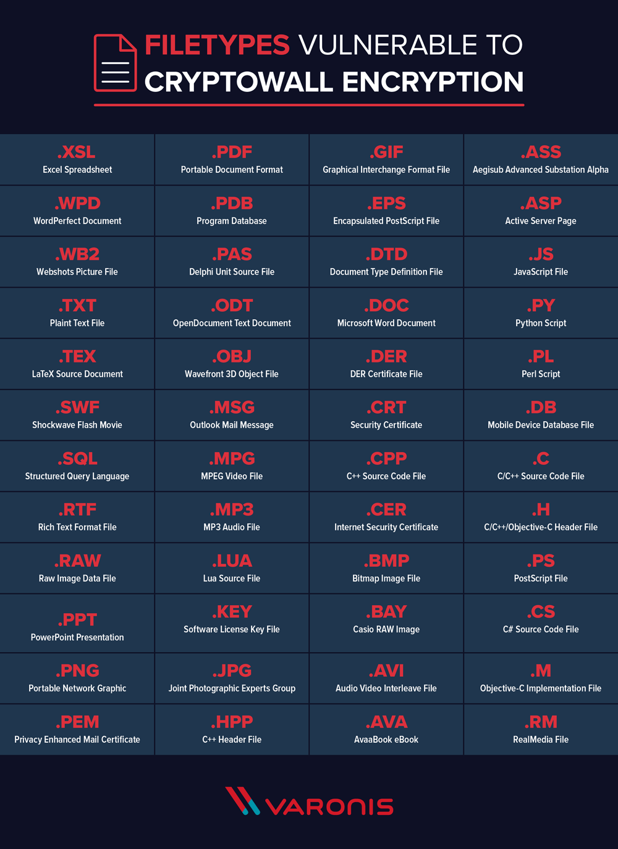
3.3 How to prevent infection
To prevent infections setup a anti-virus some of the most common anti-virus software used is Malwarebytes, CCleaner, notron365 and windows defender along with this having a storage system to backup data is always handy commonly people use cloud storage to do this due to how easy it is to set up and maintain but these do come with a monthly cost if you need a lot of storage [9]
3.4 What to do if you get infected
the guidelines if you get infected are to not pay the ransom due to you not likely getting the files back or being sent a recovery key instead fully close the computer and disconnect your LAN cable or Wi-Fi adaptor if you have one on then reboot your computer in safe mode once in safe mode remove all temporary files and download an anti-virus and run it once it has run and quarantined the virus you should be safe to reconnect to the internet and reboot your PC normally [10]

Further reading
creeper system - https://www.techslang.com/definition/what-is-the-creeper-virus/
wabbit - https://malwiki.org/index.php?title=Wabbit
Ping-pong virus - http://virus.wikidot.com/pingpong
Crypto - https://www.kaspersky.com/resource-center/definitions/what-is-cryptocurrency
spam emails - https://www.cisco.com/c/en/us/products/security/email-security/what-is-spam.html

References

[1] | R. H. Thomas, “Core war: Creeper and reaper,” BBN, December 1974. [Online]. Available: https://corewar.co.uk/creeper.htm. [Accessed 7 November 2022].
[2] | “The First Computer Virus of Bob Thomas Explained: Everything You Need to Know,” History computer, 4 January 2021. [Online]. Available: https://history-computer.com/the-first-computer-virus-of-bob-thomas/. [Accessed 4 November 2022].
[3] | j. mott, Intelligent Technical Solutions, March 2022. [Online]. Available: https://www.youtube.com/watch?v=PnOmViQTF7M. [Accessed 21 October 2022].
[4] | [Online]. Available: http://catb.org/~esr/jargon/html/W/wabbit.html. [Accessed 6 November 2022].
[5] | “archive of Zonealarm,” 12 July 2001. [Online]. Available: https://www.f-secure.com/v-descs/pingpong.shtml. [Accessed 01 November 2022].
[6] | “MS-DOS,” britannica, [Online]. Available: https://www.britannica.com/technology/MS-DOS. [Accessed 04 November 2022].
[7] | statista, [Online]. Available: https://www.statista.com/statistics/326707/bitcoin-price-index/#:~:text=Bitcoin%20BTC%2FUSD%20price%20history%20up%20until%20October%2020%2C%202022&text=Bitcoin%20(BTC)%20price%20again%20reached,65%2C000%20USD%20in%20November%202021.. [Accessed 09 November 2022].
[8] | M. Buckbee, “The State of CryptoWall in 2018,” varonis, 1 June 2018. [Online]. Available: https://www.varonis.com/blog/cryptowall. [Accessed 20th October 2022].
[9] | “How to avoid computer viruses,” Santander, 27 September 2022. [Online]. Available: https://www.santander.com/en/stories/how-to-avoid-computer-viruses. [Accessed 2 November 2022].
[10] | “How to prevent and remove viruses and other malware,” Microsoft, [Online]. Available: https://support.microsoft.com/en-us/topic/how-to-prevent-and-remove-viruses-and-other-malware-53dc9904-0baf-5150-6e9a-e6a8d6fa0cb5. [Accessed 4 November 2022].

