Luca Redfern-Hawkins
Proposal
Optical illusions, complexity, tessellations
2104751
Surface pattern and textiles
Work count: 2424
Julia Lockheart

The three keywords that I will be focussing on are: Optical illusions, complexity, and tessellations. These key words have been chosen as a focus of study, as it can be argued they all demand special effort and challenge on the part of the artist and viewer to compose and see art and design in new orientations and perspectives.

This Proposal will aim to describe optical illusions and how they are utilised in art and design as well as real world scenarios through history. I will then move to the meaning and use of complexity in art and its importance to human development. I will finally progress to discussing the origins, functions, and variations of tessellations. In conclusion, I will assimilate and combine the three key words; optical illusions, complexity, and tessellations to locate an area of study and develop a focused research question. I will reference and touch upon relevant artists, designers, theorists, and philosophers such as M.C Escher, Epicharmus, Protagoras and Aristotle to explain and validate my points.

Notan is a Japanese word meaning dark light. It focusses on the interaction between a positive light space and a dark, negative space, recognising the importance of both a shape and its background (Bothwell & Mayfield 1992). Excellent examples of Notan can be found in optical illusions, complexity, and tessellations.

Key Word One: Optical Illusions.
Field (2018) writes elements of art are like ingredients that make up an image. Field (2018) believes the elements; point, line, shape, value, form, texture, space, and colour come together to form a composition. In addition, principles that apply across all art and design, balance, proportion, contrast, repetition, rhythm, pattern, movement, emphasis, unity, and variety will be discussed. Optical illusions combine all the principles and elements to produce an image that challenge and intrigue the eye and the mind (Stickels & Honeycutt, 2018). How the mind perceives these illusions are individual and still not fully understood (Shapiro & Todorovic, 2017). The origin of optical illusions has been a heated topic of debate throughout history. For the proposed essay, illusions are considered both in the context of how things are viewed and psychology.

Some experts and historians theorise optical illusions originate from art and architecture of ancient Greece, using the example of rooftops of Greek temples which from below the roof appeared curved when in fact it was simply slanted (see fig 1). Around the time of 5th century BC, philosophers such as Epicharmus and Protagoras were looking at optical illusions, trying to explain and understand them and the nature in which they form and how they are observed.

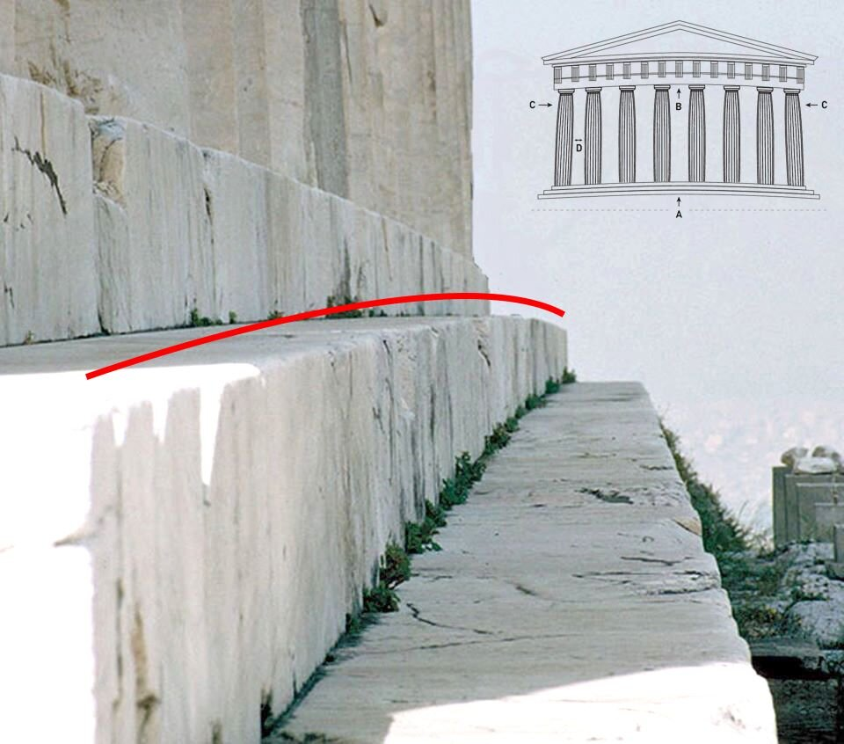

(Figure 1)
Illusions have been intriguing people since first known. The description and understanding on basic optical illusions by Aristotle (384-322 BC), who documented his discoveries and ideas in a book called- Parva Naturalia, translates to short treatises on nature.
Aristotle stated, ‘the aim of art is to represent not the outward appearance of things but their inward significance’.
The book itself documented the observations of people seeing optical illusions such as faces in pattern, after images, as in a visual image, that lasts longer in time than the exposure, and motion aftereffects such as the waterfall illusion.

An optical illusion has a primary function, to confuse and trick the mind and eyes (Stickels & Honeycutt, 2018). Humans live in three-dimensional reality, giving the need for the brain and eyes to know depth, shading, and lighting to orientate and understand their position and positions of external objects, people, and things. Using these principles, they create images and art that disorient the brain and eyes into thinking something is moving or happening even in a still image.
There are three main types of optical illusions:
- Literal illusion, an image is comprised of other images to create itself, such as a person’s face constructed from pieces of fruit (Shupliak 2004), or the size of an object appears different from its observational size.

- Physiological illusions, which is simply stated as seeing something that is not truly there. Using patterns or copies of an image, the brain creates pathways and links throughout the pattern meaning that visually things will be seen that are not truly there, as the brain tries to make sense and fill in the gaps. The eyes and brain’s natural blind spots create an area to be utilised to make things that exist to disappear.

- Cognitive illusions, which based on common thinking errors or what is called a thinking trap, such as an impossible triangle that breaks its own angle law but still resembles the shape, examples below.

There are multiple examples to natural and real-world applications of illusions and optical illusions, some of them are useful and productive for society, others are to simply lighten up the world. An example in health, researchers such as Brian Wansink and Koert van Ittersum were researching the Delboeuf illusion, which in simple terms is two solid circles of the same size, but both have an outer ring of different sizes, which makes the inner circles appear a different size. Their research was focusing on how a larger plate will make an amount of food appear smaller, and a smaller plate will make food look larger. This gave them the tools to understand how plate size can change people’s volume of food they consume and in turn impact peoples portion size (McClain et at 2014).

Key Word Two: Complexity.

For hundreds of years academics, philosophers and artists have wanted to understand what complex is and why humankind are drawn to complex visuals and experiences (McCormack & Gambardella 2022). Complexity in art combines: art, creativity, psychology and science (McCormack, J., Gambardella, C. 2022), and “complex” can be used to describe some of the qualities of art, the unique features that that makes artwork genuine art (Yevin 2006).

The creation and emergence of the word complexity first came from the Latin word complecti (encircle) being the past participle of the word complexus, which simply meant surrounding or encompassing. This was then adapted and then incorporated into the French Language (17c) to translate as ‘complexe’ which led to the definition within the Oxford Dictionary of complexity being “the state of being formed of many parts; the state of being difficult to understand” (Oxford English Dictionary). Having many meanings and ways of using and introducing the word into text and situation can be complex within itself. The general and main definition of complexity can be described as the state of quality of being intricate or complicated, or a factor involved in a complicated prosses or situation (Oxford English Dictionary).

Many situations, objects and processes can be complicated. However, for something to be considered complex, other factors and situations that have comparisons and links to that context would also have to be simple or basic. For example, sending a rocket into space can be argued to be incredibly complex, whilst on the other hand, small air powered toy rockets allow many people to understand how they work, whilst still incorporating key fundamentals of physics such as thrust, aerodynamics and weight capacity. Both examples apply the same idea, but the two examples could not be more different in terms of complexity and scale. A scientific study on how individuals perceive complexity in art found there is no measure to judge art by, as it is judged by multiple individual factors (McCormack & Gambardella 2022).

Complexity is used to help decipher and determine the difficulty of a situation or problem, often being controlled, and measured by space and time (memory and application of knowledge/skills) and how much it needs and takes to solve a problem. McCormack & Gambardella 2022 state if art is too complex and unreadable or too ordered individuals quickly lose interest (McCormack & Gambardella 2022). Many researchers and theorists believe that by continually making things more complicated the brain learns faster and more efficiently allowing for better understanding of new and simple concepts (Laura 2019). For example, completing and trying complex puzzles give the brain the intuition and natural calculation to solve simple and intermediate puzzles with speed and little effort. This experiment has been tested on humans, animals, and different fish to see if cognitive learning and environmental adaptation would change in speed if the situations were either more or less complex over time, thus proving that harder scenarios make better thinkers and understanding/ comprehension of solving complex situations and problems (Laura 2019).

Key Word Three: Tessellations.

One of Humanities’ first great civilizations, called The Ancient Sumerians, take credit for many of the modern advancements we have today, dating back to the 4000 BCE, being pioneers in math’s, writing, farming, and astronomy. This civilization was based between two large rivers that helped give water from floodplains, the rivers being Tigris and Euphrates located in present day Iraq and Syria. A place that too many seems impossible to grow much food and crops or enough to sustain a civilization at that time. One of the things that modern society uses and appreciates from the first civilization are tessellations, used by the Sumerians as art and tiles for their walls during the 5th and 6th BCE, is now a widely used practice and technique in art, design, and many other areas of modern life.

The simple explanation to what a tessellation is described as a two-dimensional or three-dimensional surface that is covered or encompassed by geometrical shapes (or tiles) without any overlaps or gaps. A good example of a tessellation would be a jigsaw puzzle, as each piece fits perfectly with each other in all angles and sides. The origin of the word tessellation comes from the Latin word and term tessera which simply means small tile or stone. The ancient romans are famous for their tiling’s and mosaics in which they called tessellate, which is made up of the small tiles tessera. Typically, these tiled Mosaics would be made using the main principles of tessellations following a repeating pattern with no gaps or overlaps.

Tessellations in themselves require a fair amount of math’s and angles to create and to work out. There are different types and functions to tessellation, and for each type of math’s, angles, and geometric shapes change. There are many of types of tessellations:

- Regular tessellations. These are tiled patterns that consist of a single repeated shape of the same size. Nevertheless, the only shapes that fit into this category of regular tessellations would be triangles, squares, and hexagons. An example would be a simple square tiled floor, which is placed evenly in columns and rows.

- Semi-regular tessellations which embody a similar concept to regular however, in this version there are even gaps across the pattern, which in this case would be called the negative space (Bothwell & Mayfield 1992). Those spaces/gaps make up a whole new shape, so the end repeat pattern would consist of two shapes that have no gaps or overlap, created initially by only rearranging one singe shape so it still repeats with gaps.

- Irregular tessellations, which can be described as infinitely repeating shapes, though the shapes that form it do not have to be the same shape or size but do not have to have any gaps or overlaps.

There are additional forms of tessellations. Yet, they are not as widely used or known.

Tessellations have many uses in the world, many of which may not be noticeable, and others will be obvious. Some examples would be in architecture and buildings, right from the tiles on the floor, the bricks and blocks in the wall and external panels. These examples all follow the principles and rules to tessellations but respectively different ways of application in each example. Tessellations can be useful for measuring distance and working out parameter in math’s over the area of a shape or land mass.

Maurits Cornelis Escher (1898-1972), considered by many as the godfather of tessellations, an artist most notably famous around the world for his impossible drawings, incorporating tessellations, perspective, and metamorphosis. His most famous works being Ascending and Descending, and relativity. Over his life he amassed 448 lithographs, woodcuts, and engravings and over 2000 drawings and sketches, being someone that had mastered the art of tessellations and all of the complex maths that comes with it.

In conclusion, I have introduced three main key words; optical illusions, complexity, and tessellations aiming to assimilate them and their concepts, to develop a research question. I have chosen these three as key words and a future focus of study as it can be argued they all demand unique effort and challenge on the part of the artist and viewer to compose and see art and design in new orientations and perspectives.

Tessellations, complexity, and optical illusions can be viewed as having science, psychological and creative methods of image making and pattern making, using forms, angles and geometric shapes to trick and twist reality. In addition, all three can manipulate the mind into thinking something else other than what is, or a complex shape in tessellation that puzzles the viewer into questioning if it is possible or not? All have purpose to either confuse or stetch the mind, have a function or job, and in most cases to just purely to look aesthetic.

Field (2018) believes the elements of art and design; point, line, shape, value, form, texture, space, and colour come together to form a composition. In addition, principles apply across all art and design, balance, proportion, contrast, repetition, rhythm, pattern, movement, emphasis, unity, and variety. This is the case for both tessellations and optical illusions being underpinned by history and mathematics, in the sense that they both use shapes and geometrics to form the image or patten, but also have factors such as scale, angles and repletion. In art and design as a whole, maths is very important because it is the base on which ideas and image come to fruition. For example, maths has influenced, and in areas defined conceptual tools, as in tools such as linear perspective, use of symmetry and complex mathematical shapes, such as a polyhedral or a mobius strip. Maths in art and design can also be used for created ratios and sizing that naturally appeal to the masses. When all three of the key words are combined together, they all direct towards combining art with science and psychology, utilising complexity within the endless repeat patterns in tessellations and the shapes and form used in optical illusions.

This leads me to a possible area of study and a research question: How geometrics and maths impact pattern?

References.

Bothwell, D., Mayfield, M. (1992). Notan, The Dark-Light Principal of art and design. Dover Publications. New York.

Field, J. (2018) An illustrated field guide to the elements and principles of art and design. First edition. Hot Iron Press. USA.

McClain, A., Van Den Bos, W., Matheson, D. et al. (2014) Visual illusions and plate design: The effects of plate rim widths and rim colouring on perceived food portion size. International Journal Obesity. 38 (5). 657-662.

McCormack, J., Gambardella, C. (2022) Complexity and aesthetics in generative and evolutionary art. Genetic programming and evolvable machines. 23, 535-556.
Shapiro, A., Todorovic, D. (2017) The Oxford Compendium of Visual Illusions. Oxford Scholoraship.

Stickels, T., Honeycutt, B. (2018) The Art of Optical Illusions: Deceptions to Challenge the Eys and Mind. Imagine. UK.

Yevin, I. (2006). Complexity Theory of Art: Recent Investigations. In: Minai, A.A., Bar-Yam, Y. (eds) Unifying Themes in Complex Systems. Springer, Berlin, Heidelberg.

Laura, A. (2019) The main approaches to the study of the difficult life situation in socio-psychological research. European Journal of research and reflection in educational sciences. (Pg.3)

