
BA Business Management
Module: Strategic Management and Sustainability
Module code: LCBB6015

Automotive Industry Trends and Strategy Formulation:
BMW Group UK

Lecturer: Mr. Nadeem Mirza
Student name – Alexandra Volosciuc
Student ID - 2229637

Executive Summary
BMW Group UK is commercially strong but financially strained: 170,051 vehicles registered in 2025, over a quarter battery-electric, remaining the UK's best-selling premium marque (BMW Group UK, 2026), yet Group EBT fell 6.7 per cent amid tariffs and a weakening Chinese market (BMW Group, 2026b). Three pressures dominate: Chinese manufacturers now hold 14–16 per cent of UK registrations (Global Banking and Finance, 2026); the ZEV Mandate outpaces organic demand, driving discounting the SMMT (2026) calls unsustainable; and BMW's Neue Klasse platform still needs to convert engineering achievement into commercial advantage. The proposed strategy combines faster Neue Klasse rollout, UK production investment, and digital/service differentiation, backed by an implementation plan to rebuild margin through 2030.

Table of Contents

1. Introduction 4
2. Company Background 4
3. Strategic Intent 4
4. Current Company Performance 5
5. Strategy Analysis 6
6. Strategy Formulation 8
7. Conclusion and Recommendations 10
References 12

1. Introduction

Strategy, per Johnson, Scholes and Whittington (2017), is an organisation's long-term direction and resource configuration to build competitive advantage — a framing especially relevant in automotive manufacturing, where firms commit to platforms years ahead of market certainty. Grant (2021) argues structured planning helps close the gap between intent and actual resource allocation. But Mintzberg's (1978) deliberate/emergent distinction is a useful check: plans rarely survive contact with reality, and much of what counts as "strategy" is improvisation under pressure — a pattern visible in BMW's recent handling of regulatory and competitive shocks. The report analyses BMW Group's position in the UK automotive industry, focusing on addressing electrification, digitalization, and competition, and concludes with a practical implementation plan. BMW Group, headquartered in Munich, manufactures premium brands like BMW, MINI, Rolls-Royce, and BMW Motorrad, with a substantial manufacturing presence in the UK.

2. Company Background
BMW began in 1916 as an aircraft-engine manufacturer, moving into motorcycles and then automobiles from 1928 (BMW Group, 2026a) a history that still underpins its engineering credibility. The modern Group spans four brands (BMW, MINI, Rolls-Royce, BMW Motorrad) across four segments, including Financial Services, which is now a genuine earnings driver: leasing made up 40 per cent of new business by mid-2025 (BMW Group, 2025; Forbes, 2026).
The four-brand structure lets BMW span multiple premium tiers while sharing platforms to control costs. In the UK, this is backed by over £3 billion invested since 2000 across Oxford, Swindon and Hams Hall, with Oxford converting to all-electric MINI production by 2030 (BMW Group, 2023). BMW was the UK's second best-selling marque and top premium brand in 2025, competing against Mercedes-Benz, Audi and Jaguar Land Rover, with newer pressure from Tesla and BYD.

3. Strategic Intent
BMW's vision — mobility "more human, intelligent and responsible" — rests on three pillars: brands and electrification, technology, sustainability (BMW Group Investor Relations, 2026). The concrete target behind it is roughly 50 per cent EV sales by 2030, with MINI faster still (BMWBlog, 2026), but EV share actually dipped from 17.9 per cent (2025) to 17.7 per cent in H1 2026 (BMWBlog, 2026), with nothing suggesting the needed acceleration is underway. Sustainability runs alongside electrification: net zero by 2050, with 40 million tonnes of CO₂ savings targeted by 2030 (BMW Group, 2026c), delivered via solid-state batteries and Neue Klasse.
Against the UK, the picture is more encouraging: the ZEV Mandate requires 33 per cent BEV sales in 2026 (SMMT, 2026), and BMW UK's 28.1 per cent 2025 share sits closer to that than the global average — though achieved through discounting SMMT calls unsustainable. The gap is being closed through margin sacrifice, not demand growth.

4. Current Company Performance
BMW's 2025 results show resilience under strain rather than straightforward success. Group revenue was €133.5 billion, down 6.3 per cent; earnings before tax fell 6.7 per cent to €10.2 billion; net profit dropped 3.0 per cent to €7.45 billion (MarkLines, 2026). The Automotive segment's EBIT margin narrowed from 6.3 to 5.3 per cent — still within target, but only just — with tariffs and softer Chinese demand cited as the main causes (BMW Group, 2026b). Figure 1 sets the two years side by side.
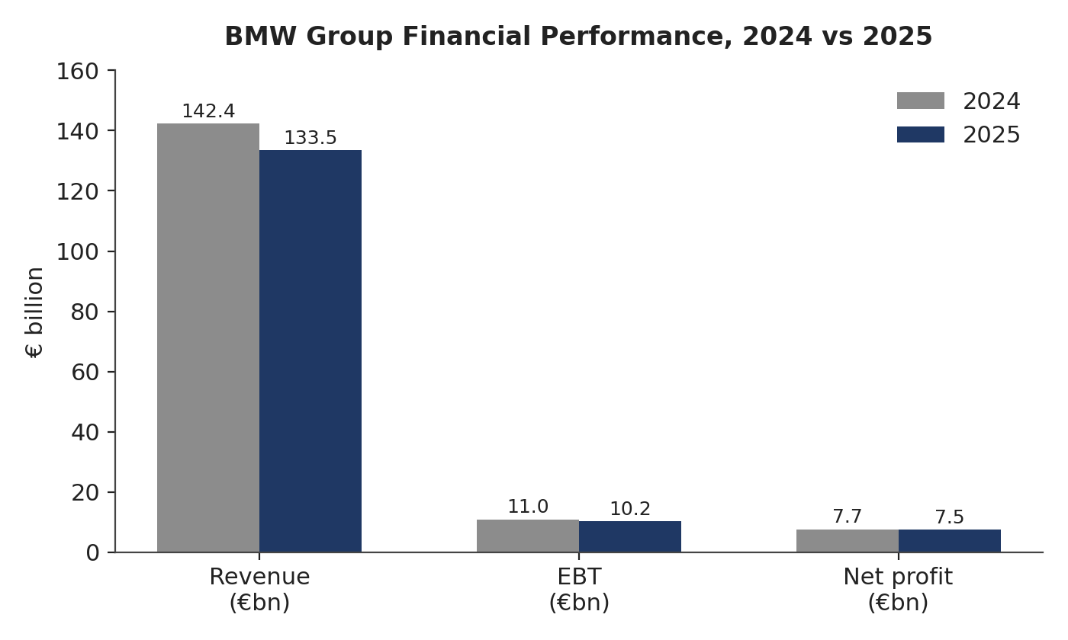
Figure 1: BMW Group financial performance, 2024 vs 2025. Source: compiled from MarkLines (2026) and BMW Group (2026b).
BMW Group UK recorded 170,051 registrations in 2025, remaining the second best-selling marque overall (BMW Group UK, 2026), though BMW-brand registrations fell slightly (125,265 to 122,723) — growth was carried by MINI. BMW and MINI reached 28.1 per cent BEV share, close to the ZEV Mandate's 33 per cent threshold, as BMW's global EV share slips. BMW holds its ground against Mercedes-Benz, Audi and JLR, but BYD overtook BMW and Tesla in UK EV sales, part of a surge pushing Chinese brands to 14–16 per cent of UK registrations (Regit, 2026). Sustainability progress is self-reported and warrants skepticism.
Sector-wide, the ZEV Mandate forces average EV discounts of roughly £11,000 per vehicle (SMMT, 2026), and the 2025 JLR cyberattack cost the UK economy £1.9 billion (Infor, 2026), alongside high energy costs and persistent inflation. BMW UK's 2025 position looks solid on paper but structurally pressured.

5. Strategy Analysis

External Analysis
A PESTEL review shows several forces converging on BMW UK at once, and it is worth noting upfront that political and legal factors overlap here almost entirely — the ZEV Mandate is simultaneously a piece of legislation and a political flashpoint, which is a fair criticism of PESTEL as a framework: its six categories are not always as distinct as the acronym implies. Figure 2 summarises the analysis.
Factor | Key evidence | Implication for BMW UK
Political / Legal | ZEV Mandate requires 33% BEV sales in 2026, rising steeply; EU rules-of-origin changes threaten £1.4bn sector tariff exposure from 2027 (SMMT, 2026) | Forces continued EV investment and discounting; UK–EU trade terms remain a live risk
Economic | Bank Rate held at 3.75%; GfK consumer confidence at –21, lowest in a year; yet 91% of buyers report stable affordability confidence (Trading Economics, 2026; Money4Cars, 2026) | Mixed signals — macro sentiment weak, but purchase intent more resilient than headline confidence suggests
Social | Weakening brand loyalty; growing consumer acceptance of Chinese brands (Regit, 2026) | Premium status alone no longer guarantees customer retention
Technological | Software-defined vehicles; Neue Klasse E/E architecture; solid-state battery development from 2027 (BMW Group, 2026d) | Genuine differentiation opportunity if delivered on schedule
Environmental | Net zero by 2050; interim CO₂ targets; iX3 supply-chain CO₂e cut of 35% (BMW Group, 2026c) | Supports brand positioning but invites scrutiny of self-reported progress
Legal | Substantially overlaps with Political factors above | —
Figure 2: PESTEL summary — BMW Group UK. Source: compiled from SMMT (2026), BMW Group (2026c, 2026d), Trading Economics (2026), Money4Cars (2026), Regit (2026).
Porter's Five Forces (Figure 3) shows BMW UK under intense pressure across all five dimensions: rivalry is very high (Mercedes, Audi, JLR, Tesla and BYD all contesting overlapping segments); new-entrant threat is high, since Chinese manufacturers built UK distribution networks in roughly two years rather than the traditional decade; buyer power is rising, driven by price-transparency platforms and ZEV Mandate-fuelled discounting; supplier power is moderate-to-high, concentrated in battery and semiconductor supply; and substitute threat is moderate via a resurgent used-car market. The framework captures this competitive intensity well but says less about the pace of disruption — a limitation worth noting.
Force | Intensity | Rationale
Threat of new entrants | High | Chinese manufacturers (BYD, MG, Chery) have built UK distribution networks within c. 2 years
Bargaining power of buyers | Rising | Price-comparison platforms and ZEV Mandate-driven discounting shift leverage to buyers
Bargaining power of suppliers | Moderate–High | Battery and semiconductor supply concentrated among a small number of global suppliers
Threat of substitutes | Moderate | Resurgent used-car market (c. 8m UK transactions forecast for 2026) offers a lower-cost alternative
Competitive rivalry | Very High | Mercedes, Audi, JLR, Tesla and BYD all contest overlapping premium/EV customer segments
Figure 3: Porter’s Five Forces — BMW Group UK. Source: compiled from SMMT (2026), Regit (2026), Autotrader (2026).

Internal Analysis
A SWOT analysis (Figure 4) sets BMW UK's internal position against the external pressures identified above.
Strengths | Weaknesses
Strong brand equity; established UK manufacturing base; Financial Services as a genuine profit pillar (40% of new business is leasing) | Core BMW brand registrations declined in 2025; Automotive EBIT margin under pressure; EV share behind global 2030 target
Opportunities | Threats
Neue Klasse-led differentiation through software and digital services; UK BEV share already close to ZEV Mandate threshold | Chinese price competition (BYD, MG); post-2027 UK–EU tariff exposure; softening UK consumer confidence
Figure 4: SWOT analysis — BMW Group UK. Source: compiled from BMW Group (2025, 2026b), SMMT (2026).
A VRIO assessment (Figure 5) helps distinguish which of these strengths actually sustain advantage rather than merely existing. Brand equity is valuable, rare and difficult to imitate, and BMW is organised to exploit it — a genuinely sustained advantage. Financial Services capability is valuable and reasonably rare but not especially hard for well-resourced rivals to replicate, making it more of a temporary edge. The Neue Klasse software architecture is valuable and currently rare, but whether it proves durably hard to imitate is simply not yet knowable — competitors are pursuing comparable architectures, and the honest answer is that this advantage remains unconfirmed rather than secured.
Resource / Capability | Valuable? | Rare? | Costly to imitate? | Organised? | Competitive implication
Premium brand equity | Yes | Yes | Yes | Yes | Sustained advantage
Financial Services / leasing platform | Yes | Yes | No | Yes | Temporary advantage
Neue Klasse software architecture | Yes | Yes | Unconfirmed | Yes | Potential, unproven advantage
Figure 5: VRIO analysis — BMW Group key resources and capabilities. Source: author’s analysis, compiled from BMW Group (2025, 2026d).
Value Chain analysis adds relatively little beyond what the UK manufacturing discussion in Section 2 already covers, so it is not repeated in full here. A BCG Matrix is deliberately omitted too: without segment-level market share and growth data that BMW does not disclose publicly for BMW, MINI and Rolls-Royce individually, plotting them would involve more assumption than analysis — a scope decision rather than an oversight.

6. Strategy Formulation
Rather than a generic "continue developing EVs" recommendation, the strategy rests on three pillars built on existing BMW capability. First, tie Neue Klasse's software-defined architecture to revenue by selling software — driver-assistance upgrades, connected features — through BMW's existing Financial Services leasing infrastructure rather than building a separate digital business.
Second, deepen the battery ecosystem BMW has built over a decade: the CATL relationship (since 2012) is extending into decarbonisation and traceability via Battery Passport and Catena-X (Electric Cars Report, 2026); Solid Power gives BMW input on solid-state development (Solid Power, Inc., 2026); and AI-driven testing with the University of Zagreb is cutting production cycles (Electrive, 2026). Extending this into UK operations strengthens supply chain resilience using relationships that already exist.
BMW acknowledges its limitation in competing in a price war against BYD or MG due to their cost structures but aims to focus on enhancing ownership experience through software longevity, brand heritage, and financial service packages to close the gap in the UK BEV market share.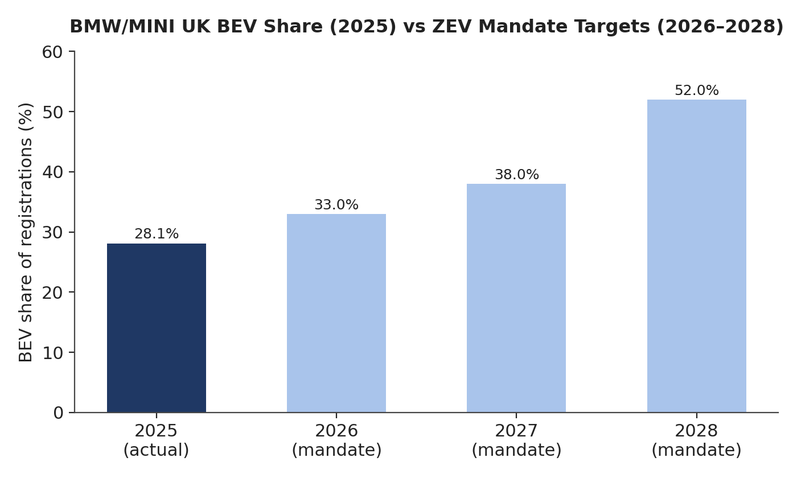
Figure 6: BMW/MINI UK BEV share (2025) against ZEV Mandate targets, 2026–2028. Source: compiled from BMW Group UK (2026) and SMMT (2026).

Implementation Plan
Turning these three pillars into practice requires a phased approach, summarised in Figure 7: foundation-building in 2026–2027, production and sourcing scale-up in 2027–2028, and consolidation of the experience-based positioning from 2028 to 2030.
Phase | Timeline | Key actions | Lead responsibility
Phase 1: Foundation | 2026–2027 | Embed digital-service subscriptions into leasing contracts; extend CATL/Solid Power collaboration to UK battery sourcing | BMW UK commercial team; Financial Services
Phase 2: Scale-up | 2027–2028 | Scale Neue Klasse production at UK-adjacent sites; roll out decarbonised battery framework across Oxford conversion | BMW Group Production; Oxford plant leadership
Phase 3: Consolidation | 2028–2030 | Embed experience-based positioning; track retention and residual-value outcomes against Chinese competitors | BMW UK marketing and customer experience teams
Figure 7: Implementation roadmap — BMW Group UK strategy, 2026–2030. Source: author’s analysis.
Resourcing draws on BMW's existing capex allocation toward Neue Klasse and battery capacity rather than new capital, with the software-services layer led by a small cross-functional unit spanning BMW UK, Financial Services, and the group's existing digital hubs. Leadership sits with BMW Group UK's commercial team for market execution, coordinating with Munich on platform decisions. Figure 8 sets out the KPIs against which progress should be judged.
KPI | Target | Measurement point
Digital-service attach rate on new leases | 25% by end of Phase 1 | Quarterly, BMW Financial Services reporting
UK BEV share vs ZEV Mandate threshold | At or above mandate level each year | Annual, against SMMT registration data
Proportion of EV sales reliant on discounting | Year-on-year reduction | Annual, internal sales data vs SMMT benchmark
UK residual value retention vs Chinese competitors | Outperform sector average | Annual, third-party residual value indices
Figure 8: KPI dashboard — strategic implementation. Source: author’s analysis.
The main risks are execution risk on the solid-state battery timeline, continued softness in Chinese demand, and the possibility that UK–EU tariff negotiations fail to resolve before January 2027. Figure 9 plots these by likelihood and impact: Chinese price competition and ZEV Mandate discount pressure sit in the highest-priority quadrant, already materialising rather than merely anticipated.
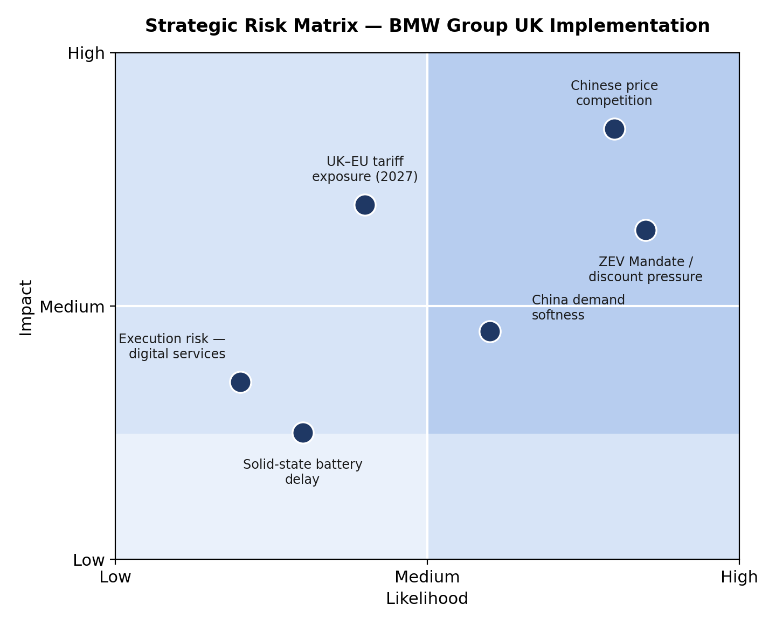
Figure 9: Strategic risk matrix — BMW Group UK implementation. Source: author’s analysis, informed by SMMT (2026) and Global Banking and Finance (2026).
Kotter's (1996) change model offers a reasonable structure for building organisational buy-in around the digital-services shift, though its linear, staged assumptions sit awkwardly with an industry moving as fast as this one — a limitation worth acknowledging rather than ignoring.

7. Conclusion and Recommendations
Despite its strong position in the UK market, BMW Group faces challenges such as narrowing margins, lagging EV market share targets, and unsustainable discounting practices to meet ZEV Mandate thresholds. The company's strategy is suggested to focus on leveraging existing capabilities like financial services infrastructure, battery partnerships, and software-defined vehicle architecture to compete on ownership experience and software longevity rather than price. Recommendations include embedding digital-service subscriptions into leasing contracts, incorporating UK manufacturing into BMW's decarbonized battery traceability program, and shifting focus from chasing EV volume through discounting to sustaining a premium position through value. While execution risks remain, this strategy aims to provide BMW with a defensible path forward.

References
BMW Group (2023) MINI Plant Oxford goes electric: £600m investment for all-electric MINI production in the UK. Press release, 11 September. Available at: https://www.press.bmwgroup.com/united-kingdom/article/detail/T0436869EN_GB (Accessed: 9 August 2026).
BMW Group (2025) Robust business model – resilient performance: BMW Group on track to meet full-year targets. Press release, 31 July. Available at: https://www.press.bmwgroup.com/global/article/detail/T0451620EN (Accessed: 9 August 2026).
BMW Group (2026a) BMW Group History. Available at: https://www.bmwgroup.com/en/company/history.html (Accessed: 9 August 2026).
BMW Group (2026b) Stable Group earnings thanks to consistent strategy: BMW Group on track. Press release, 12 March. Available at: https://www.press.bmwgroup.com/global/article/detail/T0456175EN (Accessed: 9 August 2026).
BMW Group (2026c) BMW Group Strategy. Available at: https://www.bmwgroup.com/en/company/strategy.html (Accessed: 9 August 2026).
BMW Group (2026d) The Neue Klasse: The BMW Group enters a new era. Available at: https://www.bmwgroup.com/en/company/neue-klasse.html (Accessed: 9 August 2026).
BMW Group Investor Relations (2026) BMW Group Investor Relations Presentation, January 2026. Available at: https://www.bmwgroup.com/content/dam/grpw/websites/bmwgroup_com/ir/downloads/en/2025/investor-presentation/BMW_Investor_Presentation_2025.pdf (Accessed: 9 August 2026).
BMW Group UK (2026) BMW Group UK leads the premium segment in 2025. Press release. Available at: https://www.press.bmwgroup.com/united-kingdom/article/detail/T0454784EN_GB (Accessed: 9 August 2026).
BMWBlog (2026) BMW wants EVs to jump from 17.7% to 50% of sales by 2030. Available at: https://www.bmwblog.com/2026/08/01/bmw-wants-ev-share-nearly-triple-2030/ (Accessed: 9 August 2026).
Electric Cars Report (2026) BMW and CATL deepen EV battery partnership with focus on decarbonisation and battery passport. Available at: https://electriccarsreport.com/2026/02/bmw-and-catl-deepen-ev-battery-partnership-with-focus-on-decarbonisation-and-battery-passport (Accessed: 9 August 2026).
Electrive (2026) Project Insight: AI enhances battery cell test production at BMW. Available at: https://www.electrive.com/2026/04/20/project-insight-ai-enhances-battery-cell-test-production-at-bmw (Accessed: 9 August 2026).
Forbes (2026) BMW Group | Company Overview & News. Available at: https://www.forbes.com/companies/bmw-group (Accessed: 9 August 2026).
Global Banking and Finance (2026) Chinese carmakers increase pressure on UK auto industry rivals. Available at: https://www.globalbankingandfinance.com/chinese-carmakers-piling-pressure-uk-rivals-auto-industry (Accessed: 9 August 2026).
Grant, R.M. (2021) Contemporary Strategy Analysis. 10th edn. Hoboken, NJ: Wiley.
Infor (2026) UK automotive industry in 2026. Available at: https://www.infor.com/en-gb/blog/uk-automotive-2026-ev-revolution-disruption (Accessed: 9 August 2026).
Johnson, G., Scholes, K. and Whittington, R. (2017) Exploring Strategy: Text and Cases. 11th edn. Harlow: Pearson Education.
Kotter, J.P. (1996) Leading Change. Boston, MA: Harvard Business School Press.
MarkLines (2026) BMW Group EBIT down 11.5%, net profit down 3.0% in 2025. Available at: https://www.marklines.com/en/news/341626 (Accessed: 9 August 2026).
Mintzberg, H. (1978) 'Patterns in strategy formation', Management Science, 24(9), pp. 934–948.
Money4Cars (2026) UK car affordability in 2026: interest rates, fuel prices, and a realistic monthly budget. Available at: https://money4cars.co.uk/guides/uk-car-affordability-2026-interest-rates-fuel-costs (Accessed: 9 August 2026).
Regit (2026) Chinese car brands overtake Japanese rivals in UK sales. Available at: https://www.regit.cars/car-news/chinese-car-brands-overtake-japanese-rivals-in-uk-sales (Accessed: 9 August 2026).
SMMT (2026) Automotive calls for urgent action as ZEV targets and trade threats put sector at risk. Available at: https://www.smmt.co.uk/automotive-calls-for-urgent-action-as-zev-targets-and-trade-threats-put-sector-at-risk (Accessed: 9 August 2026).
Solid Power, Inc. (2026) Solid Power appoints Uwe Breitweg to Board of Directors. Form 8-K, 1 July. Available at: https://www.sec.gov/Archives/edgar/data/0001844862/000110465926079956/tm2619489d1_ex99-1.htm (Accessed: 9 August 2026).
Trading Economics (2026) United Kingdom Consumer Confidence. Available at: https://tradingeconomics.com/united-kingdom/consumer-confidence (Accessed: 9 August 2026).

