4.0
Within this chapter I will be focusing on my findings from the primary research previously conducted. For my primary research I conducted a survey which was created on google forms and accessed by social media. In order to receive as much information as possible I aimed to reach 100 participants however only reached 55. Throughout this chapter I will analyse my findings and compare and contrast them against pre-existing literature found within my literature review in aim deepen this comparative analysis of the treatment of male and female offenders within the criminal justice system within England and Wales. The analysis will be structured in deductive coding which successfully fit each of my primary research questions into categories that corollate with my literature review. These groups will be; the prevalence of male and female offenders within the criminal justice system in England and Wales, the difference in treatment of male and female offenders and the public perception on the treatment of male and female offenders within the criminal justice system in England and Wales. A qualitative analysis method will be used throughout this chapter in order to focus on words, texts or phrases provided in the open-ended why sections provided by participants within the primary research. The qualitative analysis method which will be focused on will be content analysis which will evaluate patterns within the data that can blend quantitative into primary qualitative analysis.

4.1
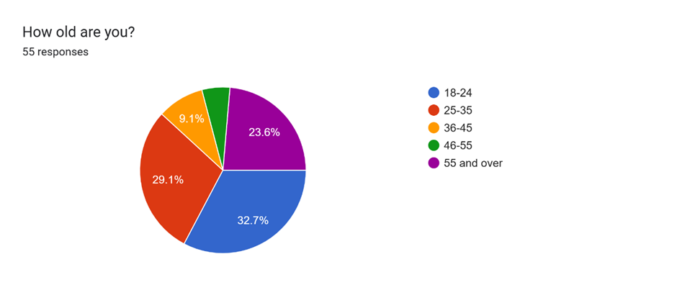
The above graph provides a pie chart providing the ages of participants, stating that the majority of the research data was provided from participants from the ages 18-24, closely followed by those of ages of 25-35. Although the age groups 18-24 and 25-35 are the typical age of the participants there is also a wide range of ages who have participated with participants from every age group provided, therefore providing a wide range of opinions and thoughts on each of the following questions asked within the survey.

4.2
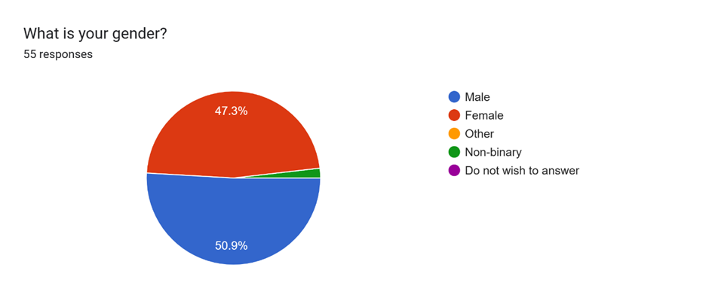
The following question and last question which is based off of personal information from the participants is that of gender. This question was incorporated into the survey due the question title of this research being based around gender; the treatment of male and female offenders within the criminal justice system in England and Wales. As provided from the pie chart above, the majority of participants was males, which account for 50.9% (28) of the participants from this survey, closely followed by 47.3% (26) females and only 1.8% (1) participants identified as non-binary. This pie chart, along with the previous one which focus on age, presents diversity amongst the participants and the data collected from the survey.

4.3a
The first group of collected data which will be analysed is the data that fits under the topic of the prevalence of male and female offending within England and Wales. The first question within the survey that fits under this data is as follows;
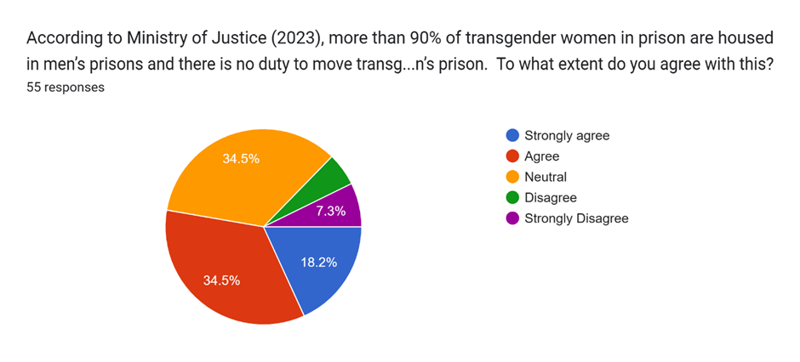
This pie chart presents the percentage of participants who have agreed with the statement which reads; ‘According to Ministry of Justice (2023), more than 90% of transgender women in prison are housed in men’s prisons and there is no duty to move transgender offenders to a woman’s prison’. The majority of the participants selected either ‘agree’ or ‘neutral’ providing that both of these choices accounted for 34.5% of the participants each. Leaving 18.2% of the participants selecting ‘strongly agree’, 7.3% of the participants with strongly disagree and therefore leaving 5.5% of the participants selecting disagree. Therefore providing that just over a half of the participants agree or strongly agree with this statement. The data collected under this question suggests that the public perceive the prison housing of transgender women into a male prison to be fair treatment of these female offenders even if it goes against the offenders wishes to identify as women.
In terms of critically analysing the treatment of male and female offenders within the criminal justice system in England and Wales, it goes without saying that although the majority of the data within this primary research suggests that the public is behind this statement, this statement should be deemed as unfair treatment of transgender offenders as it essentially goes against their basic human rights.

4.3b
The next question within this category from the conducted primary research requires the participants views and opinions on the impact imprisonment has on reoffending rates.
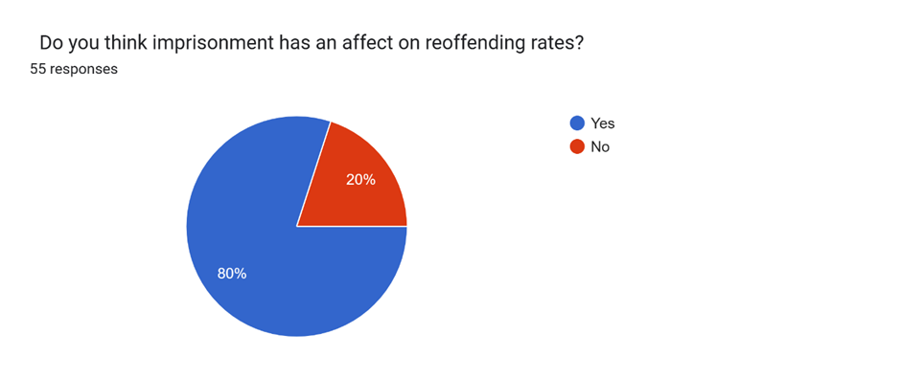
As presented in the pie chart above 80% of the participants have stated to believe that imprisonment does have an effect on reoffending rates, leaving 20% believing the opposite. This piece of data provides that the publics perception on reoffending rates correlates with that of Clarke (2023). Clarke (2023) provides that adults who had served less than 12 months were in fact subject to a reoffending rate of 53.9%. Although this primary data aligns with the pre-existing literature provided by Clarke (2023), UK Gov (2023) suggests that over time the statistical rates of reoffending have fluctuated, therefore providing an inaccurate basis on the understand of whether reoffending is rising or declining.
In terms of this data, participants where also asked their opinion on why they believe/ do not believe imprisonment has an effect on reoffending. Within the data that has been collected on this question there is a reoccurring mention of the lack of support provided to offenders for once they return to life outside of prison. Examples of these answers are;
“They know that they’ll have a roof over their heads, not worrying about rent and bills, they get meals 3 times a day”.
“People sometimes leaves prison with nowhere to go and reoffend to get off the streets. Relationships can form in prison that encourage reoffending”.
“There is little investment (in terms of wellbeing physically, emotionally and financially) for individuals imprisoned. Without this assistance people who have been excluded from mainstream society, will usually reoffend. The only social circle who accept them or can provide for them are like them. Either offenders or career criminals. The state does not”
“From experience I know for a fact that there is no adequate rehab provided for us prisoners”.
This data suggests that the publics perception on reoffending rates could be eased by providing more offenders with support after their release. Although there is ‘The Female Offender Strategy Delivery Plan’ which is currently being enforced to reduce women’s offending from 2022 to 2025, Hinds (2023), there is lack of evidence that provides a reoffending strategy as prepared for male offenders release as there is for females, portraying a substantial difference in the treatment of male and female offenders.
4.4a
Moving on to the following section this data have been divided into is that which is concerned with the difference in treatment between male and female offenders throughout the criminal justice system within England and Wales.
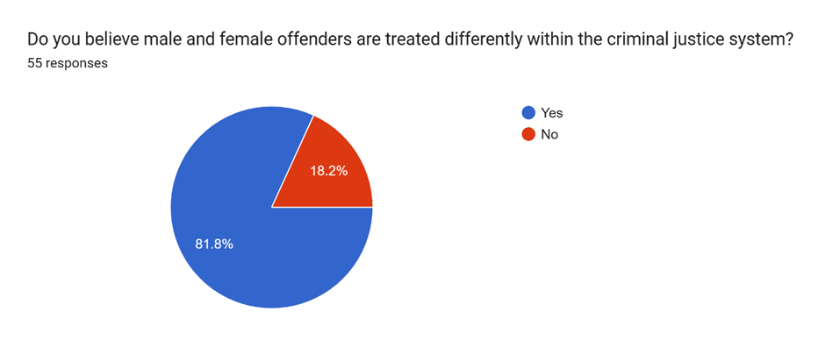
This section of the survey questioned the participants on their view of whether male and female offenders are treated differently within the criminal justice system and why. 81.8% of the participants stated that they believe that offenders are in fact treated differently, leaving only 18.2% believing the opposite. Although it is typically believe that the criminal justice system is an equal one, the public have expressed that they believe quite the opposite and the data collected provides that the publics perception presents the belief that females are treated with more leniency in accordance with male offenders.
“More sympathy towards female offenders, whereas males typically get harsher sentences for similar crimes”.
“Women tend to get away with offences than men and get lighter sentences for the same crime that a male has committed”.
“Because of their (women’s) biological needs”
“As a prison officer I believe that women get less time compared to males for the same offences”.
However, in terms of women receiving lesser punishments for committing the same crimes as men, subsequently, in terms of gender related crime it is evident to propose that females, as statistically proven, are less inclined to commit crimes, especially violent crimes due to factors such as evolutionary pressure. Comparatively, male offenders have been statistically proven6 to commit crimes, conventional or serious, suggesting males have a stronger link to criminality than females. Parliamentary recorded statistics from 2019 elaborate the proposed theories with the following statistics: In 2019, women were recorded most likely to be convicted of TV licence evasion. Among those convicted of TV licence evasion, 74% were female, accounting for 30% of all female convictions. In terms of male offenders, there was a 98% male prosecution rate for sexual offences and a 93% male prosecution rate for possession of weapons (UK Parliament 2022).
4.5a
The final section of this analysis chapter is based off of the publics perception of the treatment of male and female offenders in England and Wales.
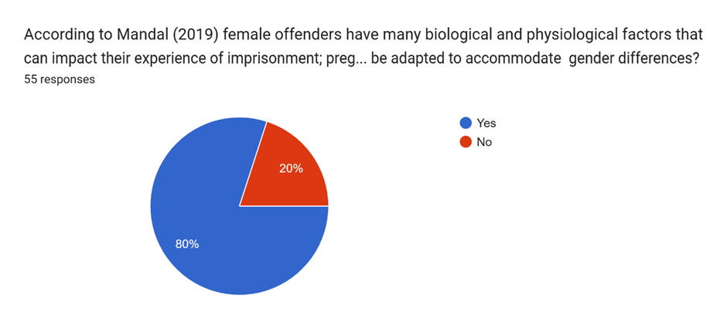
Within this section of the survey participants are proposed with the following; According to Mandal (2019) female offenders have many biological and physiological factors that can impact their experience of imprisonment; pregnancies, hormonal changes and women being primary care givers are prime factors which can cause difficulty to women who are imprisoned. Do you think prison environments should be adapted to accommodate gender differences?
80% of the participants believed that prison environments should be adapted to accommodate gender differences, providing reasonings why, these reasons include;
“It’s only fair someone’s biological needs are met, we can’t help what our bodies are designed to do”.
“Men and women’s bodies and brain are completely different. Women need more care because there bodies change so much. Pregnancy and menopause are huge hormonal changes that need attention that men do not need”.
“As there are many different genders all should be accommodated. The prison sector is very outdated as an institution only recognising male and female”.
“People will have to deal with life changes whether they are in prison or not, they should get just the same medical care as they would if not in prison, the hardship of prison should remain”.
Although female criminologists have increased in recent times, Menis (2020) states that criminology has been noted to have had a lack of concern within the subject of women criminals, simply due to the topic being labelled as male-dominated and a genderless construct. Not only has there been a lack of criminologist interest on women offenders there is also a lack of detailed documents concerning and recording the experiences of women in prison therefore providing the suggestion that criminal justice system is solely interested with males who offend.
Although females are presented with repercussions of theories such as double deviance, females are becoming recognised as more vulnerable, not just in terms of sentencing but also in terms of acting as a serving offender due to their biological and physiological needs, (Worral 1990). Due to this recognition plans like ‘The Female Offender Strategy Delivery Plan 2022-25’ are now in place. In terms of the ‘The female offender strategy delivery plan 2022-25’, the United Kingdom government have four aims to which they are committed to achieving. These aims consist of improved community sentences and earlier intervention, making custody for females more effective, overall reducing the amount of females from going to prison and an effective resettlement of women prisoners leaving prison and settling back in their community (UK GOV 2023).
4.6
This chapter has evaluated the public perception of the treatment of male and female offenders within the criminal justice system throughout a series of data collected via a social media accessed survey. The survey has overall implied that the primary data along with preexisting data, that the criminal justice system is inevitably going to provide different treatment to offenders based solely on the offender in questions gender, no matter how equal the criminal justice system attempts to be. Whether this be based off of the assumption that males are more violent than females, or that females are typically treated lesser than males within the criminal justice system due to the biological and physiological factors.

