Netbeans Installation with Glassfish Server

- Navigate to: https://netbeans.org/downloads/8.0.2/
- Download ‘Java EE’
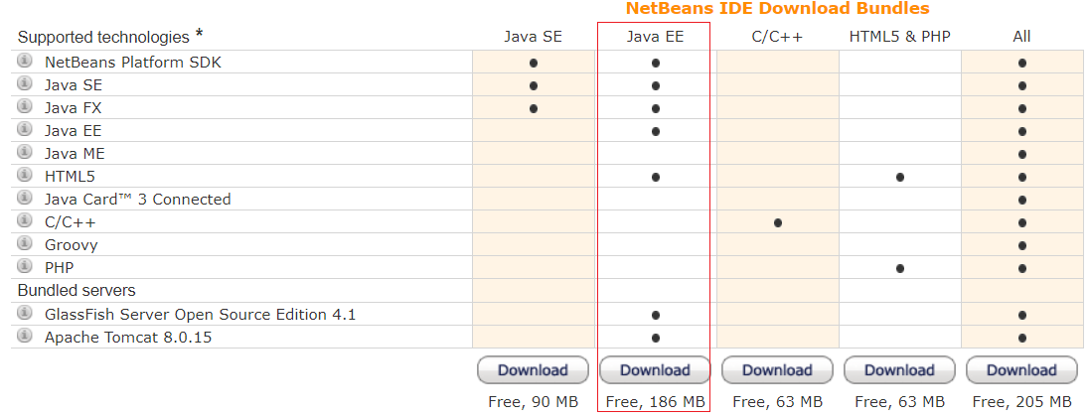
- Once the ‘netbeans-8.0.2-javae-windows.exe’ has downloaded, run the file
- Ensure ‘GlassFish Server’ is ticked
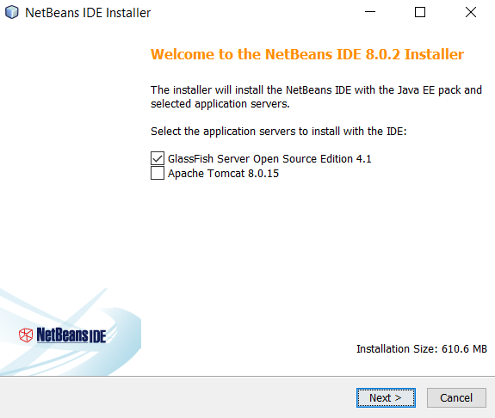
- Accept the terms in the license agreement
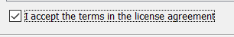
- Accept the terms in the license agreement. Install JUnit
- Next > Next > Install

Testing installation by creating a Web-App

- Open Netbeans
- Start a new project: Select ‘Java Web > Web Application’
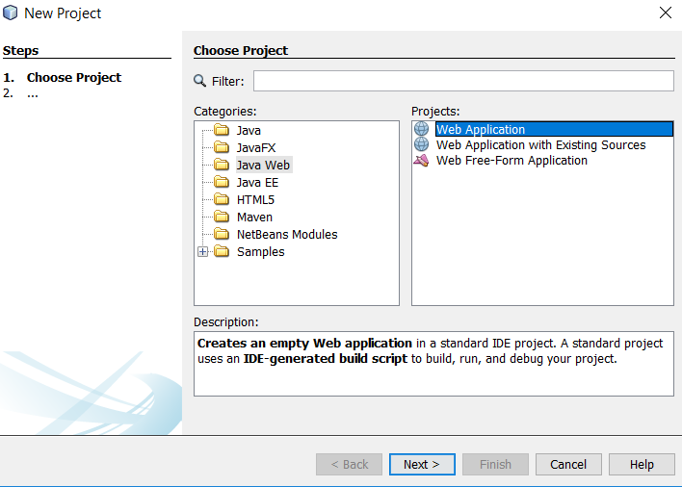
- Next > Next > Next > Finish
  - The new web App will now be created
- Right click the web app > new > RESTful Web Services from Patterns
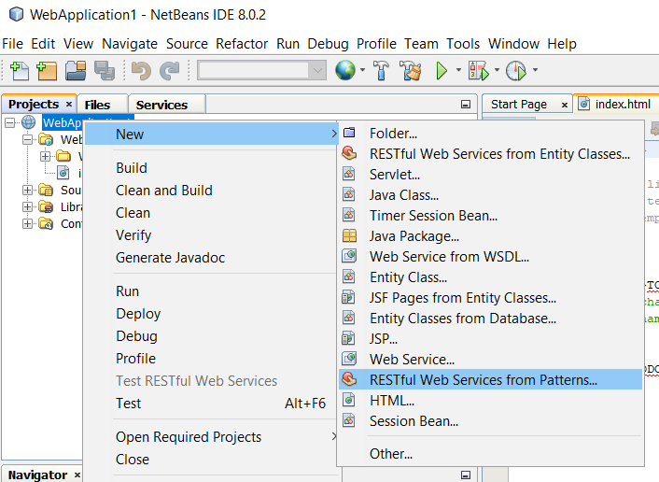
- Select pattern:
  - Simple Root Resource
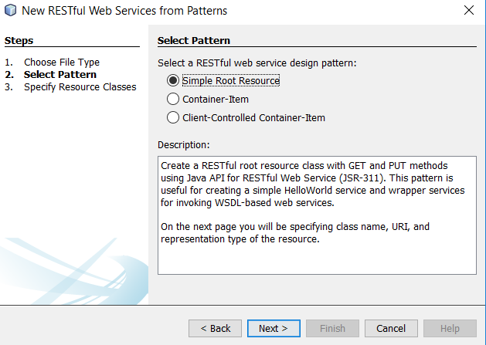
- Complete the following sections of the ‘Resource Classes’
  - Resource Package: helloworldResource
  - Path: /helloWorld
  - Class name: helloWorld
- Finish
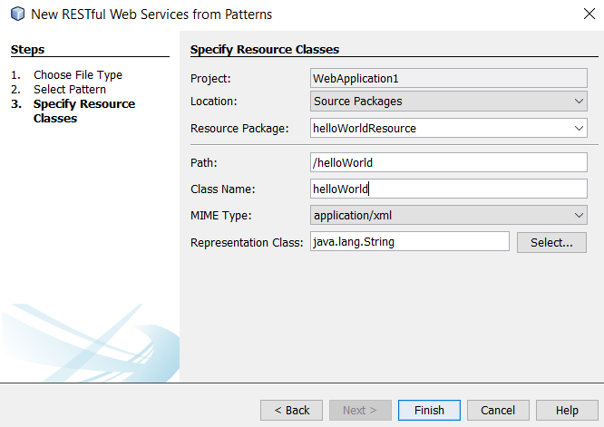
- Within the ‘helloWorld.java’ file complete the following in the ‘public String getXml’:
  - Comment out the ‘throw new UnsupportedOperationException()’
  - Add:
    - return "<html><body><h1>Hello World</h1></body></html>";
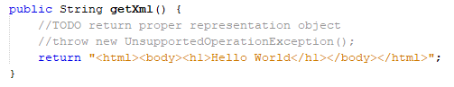
- Right click the web app > build
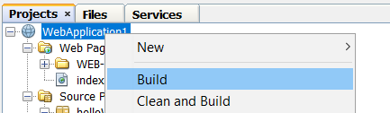
- Right click the web app > Test RESTful Web Services > ok
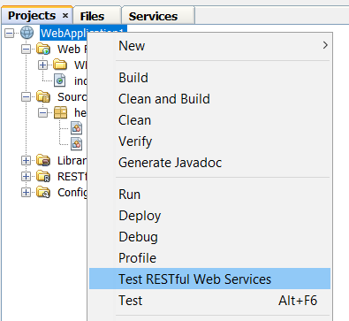

- Select ‘Locally Generated Test Client’
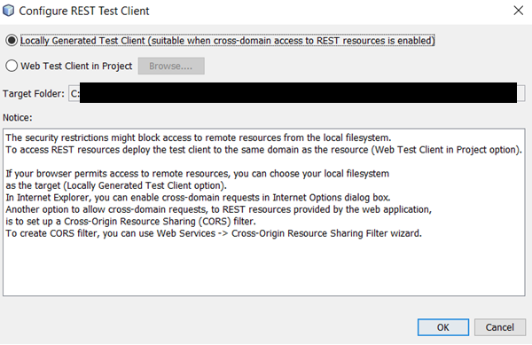
- A browser will open; it may prompt you to accept the blocked content
  - Accept the blocked content
  - If after one minute the page does not render, refresh the page
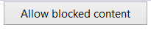
- Once the page renders
  - Click ‘helloWorld’ on the left
  - Click test on the right
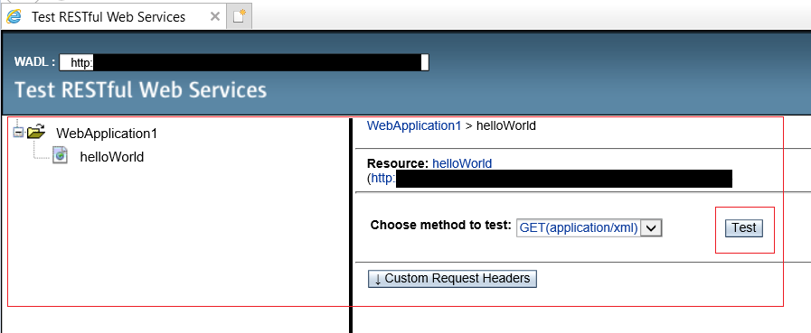
- A successful test will provide the following response


