Essential Academic and Employability Skills

As we progress through life, we develop different skills that assist us. These skills can be categorised as “soft skills” and “hard skills”. Refer to figure 1 for examples of each.
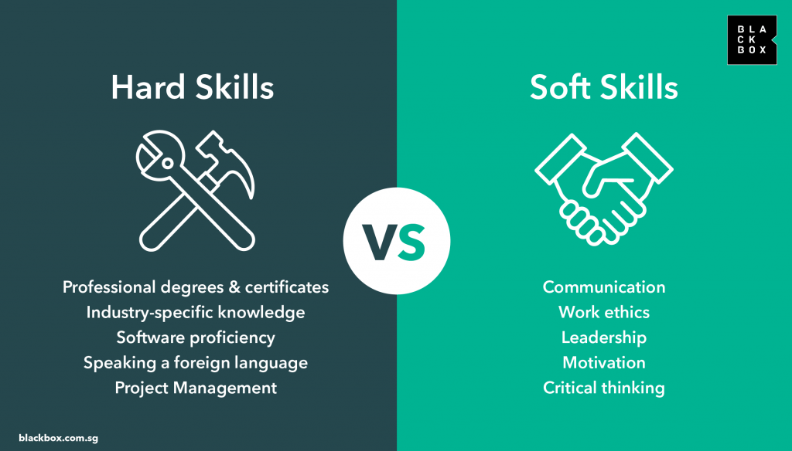
As the title suggests, Academic skills and employability skills are skills that assist you in these walks of life, however they are not exclusive, and developing the essentials of both can help you in the workplace and the classroom [1].
One example of an academic and employability skill is that of time-management. This will benefit me in my future career as being able to work to deadlines and manage work effectively will be invaluable. Being seen as organised and dependable will allow me to go far in my chosen career [1] [2].
There is also the point that developing these skills, even without the necessary need to use them is beneficial to our mental health, which then in turn improves our competency, and development of these skills, as found by Calvo and Garcia. [3].
Another skill that will assist me in my career is that of team working. The ability to work with others is extremely important in many organisations [2], especially as society adopts a more inter-disciplinary way of working, different teams must know how to work together [4]. Additionally, critical thinking is also an essential skill that will assist me in my career, as well as life. The ability to understand and think rationally about a situation, and to make decisions based of that rationale is a very valuable skill to have [1] [2].

References

[1] | High5Test, “High5Test,” [Online]. Available: https://high5test.com/academic-skills/. [Accessed 23 05 2023].
[2] | SkillsYouNeed, “Employability Skills: The Skills You Need to Get a Job,” [Online]. Available: https://www.skillsyouneed.com/general/employability-skills.html. [Accessed 25 05 2023].
[3] | J. C. A. C. a. G. M. García, “The influence of psychological capital on graduates’ perception of employability: the mediating role of employability skills,” Higher education research and development, vol. vol. 40, no. no. 2, pp. p.293-308, 2021.
[4] | S. Cottrell, Skills for success: personal development and employability, 4th edition, London: Red Globe Press, 2021.

.

