

Marketing Management LCMB7024
Olena Kokorieva
Student ID 2239903
Lecturer: Haoran Liu
Portfolio: Brand Development

Word Count: 2635 words

Introduction 3
Element 1: Poster 4
Element 2 – Segmentation, Targeting, Differentiation and Positioning (STDP) 6
2.1 Segmentation 6
2.2 Targeting 7
2.3 Differentiation 8
2.4 Positioning 8
2.5 Conclusion 10
Element 3 – Marketing Mix (7Ps) 10
3.1 Product 11
3.2 Price 11
3.3 Place 12
3.4 Promotion 12
3.5 People 13
3.6 Process 14
3.7 Physical Evidence 14
3.8 Conclusion 15
Element 4 – Reflection 15
References 17

Introduction
Chanel is one of the world’s leading luxury fashion brands, recognised for its heritage, craftsmanship, exclusivity and timeless design. Founded by Gabrielle Chanel in 1910, the company has developed a strong global presence across fashion, beauty, watches and jewellery (Chanel, 2025). However, the luxury fashion industry is increasingly influenced by changing consumer expectations, environmental concerns and growing pressure to reduce waste and extend product life cycles (Kotler et al., 2024).
In response to these changes, this portfolio proposes the Chanel Circular Boutique, a sustainable brand extension based on the principles of the circular economy. The concept would allow customers to trade in authentic Chanel products, purchase certified pre-owned items, and access professional restoration and personalisation services. This develops Chanel's existing commitment to product durability and repair while creating new opportunities for sustainable business growth (Chanel, 2026).
The portfolio develops a marketing strategy for the proposed extension through Segmentation, Targeting, Differentiation and Positioning (STDP), followed by the 7Ps marketing mix. Finally, it reflects on the development of the sustainable brand extension and the poster presentation experience.
.

Element 1: Poster
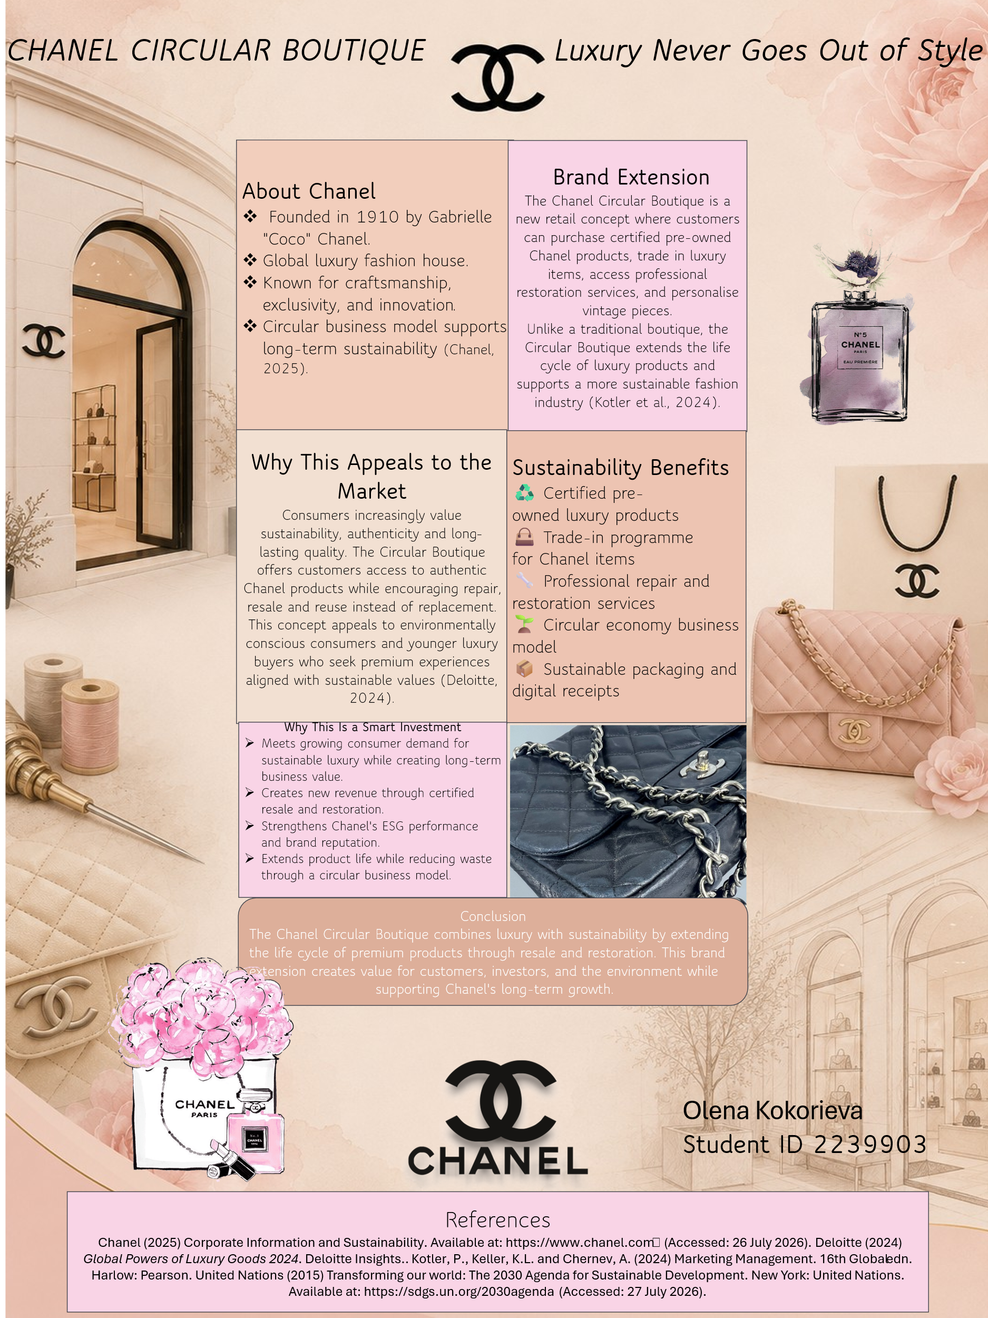

Element 2 – Segmentation, Targeting, Differentiation and Positioning (STDP)
The Segmentation, Targeting, Differentiation and Positioning (STDP) process enables organisations to identify groups of consumers with different needs, select attractive target markets and develop a distinctive value proposition for them (Kotler et al., 2024; Kotler and Keller, 2016). Effective segmentation and positioning are particularly important in competitive markets because they allow organisations to concentrate their marketing activities on customers whose needs and preferences are most closely aligned with the brand's value proposition (Wedel and Kamakura, 2000). For the proposed Chanel Circular Boutique, STDP is particularly important because the concept must attract sustainability-conscious consumers while protecting Chanel's established image of exclusivity, craftsmanship and luxury (Chanel, 2025).

2.1 Segmentation
Market segmentation involves dividing a broad market into groups of consumers who share similar characteristics, needs or purchasing behaviours (Kotler et al., 2024). Consumer markets can commonly be segmented using geographic, demographic, psychographic and behavioural variables, allowing companies to develop more relevant marketing strategies for different customer groups (Kotler and Keller, 2016). Furthermore, effective segmentation should identify groups that are sufficiently distinctive and commercially valuable to support targeted marketing activities (Wedel and Kamakura, 2000). The Chanel Circular Boutique would therefore combine all four segmentation approaches rather than relying on a single customer characteristic.
Table 1. Market Segmentation for Chanel Circular Boutique
Segmentation | Target Characteristics | Relevance to Circular Boutique
Geographic | London, Paris, Milan, New York | Major luxury markets with established Chanel presence
Demographic | Mainly 25–55, middle-to-high income | Luxury purchasing power and interest in sustainable consumption
Psychographic | Sustainability-conscious, values quality, heritage and exclusivity | Interested in circular luxury without losing premium experience
Behavioural | Existing Chanel owners, pre-owned buyers, vintage collectors | Potential users of trade-in, restoration and certified resale
Source: Author's own analysis based on Kotler et al. (2024) and Chanel (2026)

2.2 Targeting
The primary target market for the Chanel Circular Boutique would be existing and aspiring Chanel customers aged approximately 25–55 who value luxury, authenticity and sustainability. Sustainability and circular consumption are becoming increasingly important in purchasing decisions, particularly among younger luxury consumers (Deloitte, 2023; Kotler et al., 2024; Gasulla Tortajada et al., 2024).
Existing Chanel customers are particularly attractive because they may already own products suitable for trade-in, restoration or personalisation. Chanel's existing repair and restoration services demonstrate the importance of product longevity and provide a strong foundation for developing longer-term customer relationships (Chanel, 2026).
A secondary target market would include vintage collectors and high-income Chanel customers who value heritage, rarity and craftsmanship. For these consumers, the main attraction would be access to distinctive authenticated pieces rather than lower prices. A selective targeting approach would also help protect Chanel's exclusivity, which is fundamental to luxury brand positioning (Kapferer and Bastien, 2012).

2.3 Differentiation
The main competitive advantage of the Chanel Circular Boutique would be brand-controlled authenticity and restoration. Differentiation allows a company to create competitive advantage by offering distinctive value that customers perceive as superior to competing alternatives (Kotler et al., 2024).
Luxury resale platforms already provide authentication services. For example, Fashionphile uses expert authentication and digital certificates, while The RealReal combines specialist knowledge with technology to authenticate luxury products (Fashionphile, 2026; The RealReal, 2026). However, these platforms authenticate products from multiple brands, whereas Chanel has a unique advantage as the original creator of its products.
The Circular Boutique could combine Chanel-controlled authentication with trade-in, resale, restoration and personalisation. Chanel already provides specialist repair and restoration through CHANEL & moi, including Restoring Care for handbags (Chanel, 2026). Therefore, the proposed extension would build on Chanel's existing capabilities while providing a complete circular luxury experience that competitors cannot easily replicate.

2.4 Positioning
The Chanel Circular Boutique should be positioned as a premium circular luxury experience, rather than a traditional second-hand service. Effective positioning creates a distinctive place for a brand in the minds of target consumers compared with competing alternatives (Kotler et al., 2024). The extension would maintain Chanel's core values of exclusivity, craftsmanship and heritage while adding sustainability, authenticity and product longevity.
Unlike independent resale platforms, the Circular Boutique would offer products authenticated and restored directly by Chanel, increasing customer trust and protecting the brand's premium positioning. This approach also supports Chanel's existing focus on craftsmanship, repair and extending product life (Chanel, 2026).
A suitable positioning statement is:
“For luxury consumers who value authenticity, craftsmanship and sustainability, Chanel Circular Boutique offers a trusted way to restore, personalise, trade and rediscover Chanel pieces, giving timeless luxury a new life.”
This positioning allows Chanel to enter the circular luxury market without competing primarily on lower prices, protecting its exclusivity while supporting sustainable growth.
Perceptual Map of Chanel Circular Boutique and Luxury Resale Competitors
 |  | High Luxury / Exclusivity
 | FASHIONPHILE  High authentication standards,  but not brand-owned |  | CHANEL CIRCULAR BOUTIQUE  Chanel-controlled authentication,  restoration, trade-in and resale
Low Brand  Control |  |  |  | High Brand  Control
 | Vestiaire Collective  Peer-to-peer luxury resale  with authentication services | The RealReal  Luxury resale using expert and  technology-supported authentication
 |  | Lower Luxury / Exclusivity
Figure 2. Perceptual Map of Chanel Circular Boutique and Luxury Resale Competitors
Source: Author's own analysis based on Chanel (2026), Fashionphile (2026), The RealReal (2026) and Vestiaire Collective (2026).

2.5 Conclusion
Overall, the STDP analysis demonstrates that the Chanel Circular Boutique has a clear market opportunity among luxury consumers who value authenticity, sustainability and craftsmanship. By targeting selected customer groups and differentiating through Chanel-controlled authentication, restoration and personalisation, the extension can maintain the brand’s exclusivity while supporting circular consumption. Its premium positioning therefore provides a strong foundation for sustainable growth and long-term customer relationships.

Element 3 – Marketing Mix (7Ps)

Figure 3. Marketing Mix (7Ps)
Source: Author's own illustration based on Booms and Bitner (1981), Kotler et al. (2024).
The marketing mix provides a framework for developing and implementing a marketing strategy by combining controllable marketing elements. While the traditional marketing mix consists of Product, Price, Place and Promotion, the extended 7Ps framework also includes People, Process and Physical Evidence, making it particularly suitable for businesses that combine products with customer services and experiences (Booms and Bitner, 1981; Kotler et al., 2024). The 7Ps framework is therefore appropriate for the Chanel Circular Boutique because the proposed extension combines physical luxury products with authentication, restoration, personalisation, trade-in and resale services. Each element must support Chanel’s premium positioning while contributing to the extension’s sustainability objectives.

3.1 Product
The product element refers to the goods and services offered to satisfy customer needs and create value (Kotler et al., 2024). For the Chanel Circular Boutique, the core offer would combine certified pre-owned Chanel products with trade-in, authentication, restoration and personalisation services. This makes the extension more than a traditional resale concept because customers would receive a complete brand-controlled circular luxury experience.
The service would build on Chanel’s existing repair and restoration capabilities while extending them into resale and trade-in. Customers could bring previously owned Chanel items to selected boutiques, where products would be authenticated, assessed and professionally restored before resale. Personalisation could also add emotional value, for example by restoring a vintage handbag passed from a mother to her daughter. This supports Chanel’s image of craftsmanship and product longevity while encouraging reuse rather than replacement (Chanel, 2026).
The proposed product strategy therefore combines functional value, emotional value and sustainability, helping Chanel differentiate the extension from independent luxury resale platforms.

3.2 Price
Price plays an important role in communicating product quality, value and brand positioning (Kotler et al., 2024). The Chanel Circular Boutique should therefore adopt a premium value-based pricing strategy, where prices reflect authenticity, craftsmanship, product condition, rarity and the additional value created through Chanel-controlled restoration and certification.
Certified pre-owned products should be priced below comparable new Chanel items but remain premium enough to protect the brand’s exclusivity. Rare vintage or limited pieces could command higher prices because of their scarcity and heritage value. Restoration and personalisation services could also be priced according to the complexity of the work required.
A trade-in system could provide customers with Chanel store credit based on the product’s condition and resale potential. This would encourage customers to return unused products while supporting future purchases. Importantly, the strategy should avoid excessive discounting, as luxury brands depend on exclusivity and perceived value rather than price competition (Kapferer and Bastien, 2012). Overall, premium pricing would support profitability while maintaining Chanel’s luxury positioning.

3.3 Place
Place refers to how products and services are distributed and made accessible to target customers (Kotler et al., 2024). The Chanel Circular Boutique should use a selective distribution strategy to maintain exclusivity and control over the customer experience. Initially, the concept could be introduced in major luxury markets such as London, Paris, Milan and New York, using selected Chanel boutiques or dedicated Circular Boutique spaces.
Physical locations are particularly important because customers may want Chanel specialists to assess, authenticate and restore valuable products in person. Chanel already provides repair and restoration services through selected boutiques, demonstrating that specialist aftercare can be integrated into its existing retail network (Chanel, 2026).
Digital channels could support the physical boutiques by allowing customers to book appointments, track restoration progress and browse certified pre-owned collections online. Combining carefully selected physical locations with digital services would provide convenience while protecting Chanel’s premium and exclusive brand image.

3.4 Promotion
Promotion communicates the value of a brand and helps influence customer awareness, attitudes and purchasing decisions (Kotler et al., 2024). The Chanel Circular Boutique should use an integrated promotional strategy that combines Chanel’s traditional luxury image with messages about craftsmanship, sustainability and product longevity.
Digital channels, including Chanel’s website, social media and email marketing, could introduce the service and show the restoration journey of selected products. Storytelling would be particularly effective. For example, a campaign could follow a vintage Chanel handbag passed from a mother to her daughter and professionally restored by Chanel, demonstrating both emotional value and sustainability.
In-store events could also allow customers to meet Chanel craftspeople, learn about restoration and discover selected vintage pieces. Influencer and celebrity partnerships should remain highly selective to protect Chanel’s exclusivity. Rather than promoting the Circular Boutique primarily as a cheaper way to purchase Chanel, communication should emphasise heritage, authenticity and giving timeless products a new life, supporting both Chanel’s premium positioning and sustainability objectives (Kapferer and Bastien, 2012; Chanel, 2026).

3.5 People
People are particularly important in service marketing because employees directly influence customer experience, trust and perceptions of service quality (Booms and Bitner, 1981; Kotler et al., 2024). For the Chanel Circular Boutique, customers would interact with trained luxury advisers, authentication specialists and skilled craftspeople throughout the trade-in, restoration and resale process.
Employees should receive specialist training in Chanel heritage, sustainability and circular services so they can clearly explain product condition, valuation and restoration options. Chanel’s existing repair services already emphasise specialist craftsmanship and preservation of its creations, providing a strong foundation for the proposed service (Chanel, 2026).
Personal interaction would also help differentiate Chanel from online resale platforms. For example, when a customer brings in a valuable vintage handbag, a Chanel adviser could explain its history, discuss restoration options and provide personalised recommendations. This premium service would strengthen customer trust, emotional connection and long-term loyalty.

3.6 Process
Process refers to the procedures and activities through which a service is delivered to customers. A well-designed service process can improve customer experience, consistency and efficiency, particularly when several interactions are involved (Bitner, Ostrom and Morgan, 2008).
For the Chanel Circular Boutique, the process should be simple and transparent. Customers would first bring a Chanel product to a boutique or book an appointment online. A specialist would authenticate the item and assess its condition. The customer could then choose between restoration, personalisation or trade-in. Traded products would be professionally restored, quality-checked and prepared for certified resale. Chanel already uses expert assessment and quality checks within its existing repair and restoration services, providing a practical foundation for this process (Chanel, 2026).
Customers could also track restoration progress digitally. A clear process would reduce uncertainty when customers hand over valuable products, strengthen trust and provide a consistent premium experience.

3.7 Physical Evidence
Physical evidence includes the tangible elements and environment through which customers judge the quality and credibility of a service. The physical surroundings can influence customer perceptions, behaviour and the overall service experience (Bitner, 1992).
The Chanel Circular Boutique should maintain Chanel’s elegant and exclusive boutique environment while introducing visible elements of circularity. Certified pre-owned products could be displayed with information about their history, authentication and restoration, allowing customers to understand the value behind each piece. Customers could also receive an official Chanel certificate confirming authenticity and any restoration completed.
Sustainable packaging and digital receipts could further support the environmental purpose of the extension. These elements would complement Chanel’s existing focus on product care and longevity (Chanel, 2026). Importantly, the Circular Boutique should still look and feel luxurious rather than like a traditional second-hand store, ensuring that sustainability strengthens rather than weakens Chanel’s premium image.

3.8 Conclusion
Overall, the 7Ps marketing mix provides an integrated strategy for launching the Chanel Circular Boutique while protecting Chanel’s luxury positioning. Premium pricing, selective distribution and exclusive promotion maintain brand value, while skilled employees, transparent processes and a luxury boutique environment support customer trust and experience. Importantly, sustainability is integrated throughout the strategy rather than treated only as a promotional message, helping Chanel combine circular consumption with long-term competitive advantage (Athwal et al., 2019).

Element 4 – Reflection
Developing the Chanel Circular Boutique was an interesting experience because it helped me understand how marketing theories can be applied to a realistic business idea. At the beginning, I found it challenging to develop a sustainable brand extension that was original but still appropriate for an established luxury brand. Through research, I realised that sustainability does not necessarily mean creating completely new products. Extending the life of existing luxury products through restoration, trade-in and resale can also create customer and business value.
Developing the STDP analysis improved my understanding of how different customers may value the same service for different reasons. For example, younger consumers may be attracted by sustainability and more accessible entry into luxury, while existing Chanel customers and vintage collectors may value craftsmanship, rarity and emotional attachment. The 7Ps analysis also helped me recognise that successful marketing depends on the complete customer experience rather than the product alone. Price, employees, boutique environment and the restoration process must all support Chanel’s premium positioning.
Preparing the poster presentation was particularly useful for developing my communication skills. Initially, I included too much information because I wanted the poster to explain every part of the idea. However, I learned that a poster should support the presentation rather than replace it. I therefore reduced the amount of text, used bullet points and focused on the main benefits for customers, investors and sustainability.
Delivering the presentation also encouraged me to explain the concept through practical examples rather than simply repeating marketing theory. One example I particularly liked was a mother giving her vintage Chanel handbag to her daughter. Instead of replacing the bag, Chanel could restore and personalise it, allowing the product to continue its life while maintaining its emotional value. This example helped me communicate the meaning of circular luxury in a simple and memorable way.
The project also developed my research and critical-thinking skills. I discovered that Chanel already provides repair and restoration services, so I had to reconsider how my proposal would provide additional value. This helped me refine the idea into a broader circular model combining authentication, trade-in, certified resale, restoration and personalisation.
In future projects, I would improve my time management and conduct competitor and market research earlier in the development process. I would also practise my presentation several times before delivering it to improve timing and confidence. Overall, this assessment has strengthened my understanding of sustainable marketing, brand development and customer experience, while also improving my ability to transform academic theory into a practical marketing strategy.

References
Athwal, N., Wells, V.K., Carrigan, M. and Henninger, C.E. (2019) ‘Sustainable luxury marketing: A synthesis and research agenda’, International Journal of Management Reviews, 21(4), pp. 405–426. https://doi.org/10.1111/ijmr.12195.
Bitner, M.J. (1992) ‘Servicescapes: The impact of physical surroundings on customers and employees’, Journal of Marketing, 56(2), pp. 57–71. https://doi.org/10.2307/1252042.
Bitner, M.J., Ostrom, A.L. and Morgan, F.N. (2008) ‘Service blueprinting: A practical technique for service innovation’, California Management Review, 50(3), pp. 66–94. https://doi.org/10.2307/41166446.
Booms, B.H. and Bitner, M.J. (1981) ‘Marketing strategies and organization structures for service firms’, in Donnelly, J.H. and George, W.R. (eds.) Marketing of Services. Chicago: American Marketing Association, pp. 47–51.
Chanel (2025) The House of CHANEL. Available at: https://www.chanel.com/gb/about-chanel/ (Accessed: 1 August 2026).
Chanel (2026) Investing in Circularity. Available at: https://www.chanel.com/gb/sustainability/investing-in-circularity/ (Accessed: 3 August 2026).
Deloitte (2023) Global Powers of Luxury Goods 2023: Game Changing Steps in Luxury. Deloitte Global. Available at: https://www.deloitte.com/global/en/Industries/consumer/analysis/gx-cb-global-powers-of-luxury-goods.html (Accessed: 3 August 2026).
Fashionphile (2026) FASHIONPHILE Certified: Authentication for Luxury Items. Available at: https://www.fashionphile.com/pages/certified (Accessed: 11 August 2026).
Gasulla Tortajada, E., Moreira, A.C., Duarte, P. and Silva, S.C. (2024) ‘Circular economy and sustainability in luxury fashion consumer behavior: A review and research agenda’, International Journal of Consumer Studies, 48, e13089. https://doi.org/10.1111/ijcs.13089.
Kapferer, J-N. and Bastien, V. (2012) The Luxury Strategy: Break the Rules of Marketing to Build Luxury Brands. 2nd edn. London: Kogan Page.
Kotler, P., Armstrong, G., Harris, L.C. and He, H. (2024) Principles of Marketing. 19th edn. Harlow: Pearson.
Kotler, P. and Keller, K.L. (2016) Marketing Management. 15th edn. Harlow: Pearson.
The RealReal (2026) Frequently Asked Questions. Available at: https://www.therealreal.com/faq (Accessed: 9 August 2026).
Vestiaire Collective (2026) How trustworthy is Vestiaire Collective? Available at: https://faq.vestiairecollective.com/hc/en-gb/articles/25918378635025-How-trustworthy-is-Vestiaire-Collective (Accessed: 7 August 2026).
Wedel, M. and Kamakura, W.A. (2000) Market Segmentation: Conceptual and Methodological Foundations. 2nd edn. Boston, MA: Kluwer Academic Publishers.

