Visan Elena Bianca
Student ID: 2108538 | Module leader: Paul Ranson
Component 2 Research methods
BMSW4003 Certificate of Higher education in skills for workplace ; Digital skills and research methods

Contents
Slide 1 2
Slide 2 Introduction 3
Slide 3 Angela Duckworth’s 4
Slide 4 DIKW Framework 6
Slide 5 Collection of data 8
Slide 6 Information 9
Slide 7 Knowledge 11
Slide 8 Windsom 13
Slide 9 Growth mindset 15
Slide 10 Conclusion 16
Slide 11 Referances 17
Slide 12 Appendix 1 18

Slide 1

This Report is about digital skills and research methodology. In order to complete this report and demonstrate my skills I will use primary and secondary data from my CRAAP test, also I will speak About Angela Duckworth grit score and DIRKT. Also in order to demonstrate my digital skills and transform data to information I will use Excel and PowerPoint.
Slide 2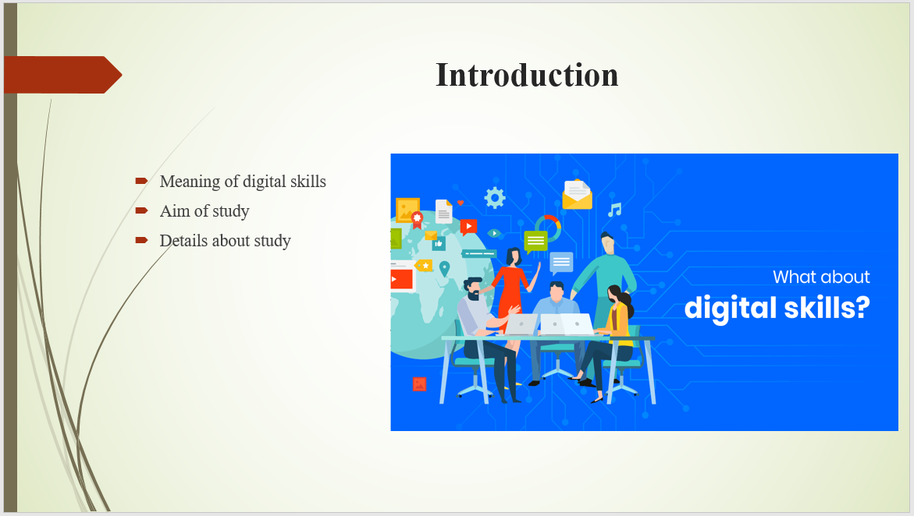
- Digital skills are an ability that is used for handling digital device and network in order to access and manage information
- The present study helps to enhance the skills and abilities pertaining to digital skills and determine range of issues facing for the same.
- The present PPT will help to determine the meaning of DIKW and CRAAP framework that help to evaluate the primary data.

Slide 3

- The research is based upon Angela Duckworth’s work where she assumes that grit is an indicator of achievement during an academic level
- By using this model, the relevancy can be showed and determine the results in effective manner.
- As per Cambridge dictionary, grit is all about courage and determination rather than difficulty. Similarly, she also describes grit is all about enthusiasm and hard work that help people to attain the defined aim and met the reality.
- In addition to this, she also added that sticking with things over the long term affect the approaches negatively. That is why, people remain unsuccessful and this in turn cause negative impact over their performance.
- Angela also stated that people become successful when they have courage to take risk to face any challenge so that effective results can be determined.
- Moreover, sharing new views from the research, the lady also explained that talent is hardly a sponsor of success and it is a combination of passion and perseverance for an important goal.
- There are mainly five characteristic describe by the author which involve openness, conscientiousness, extroversion, agreeableness and Neurotic.
- At last, she also claimed that it is not easy to build people grit because it is an idea of growth mind-set which is also developed by Carol Dweck that affect the results as well.

Slide 4
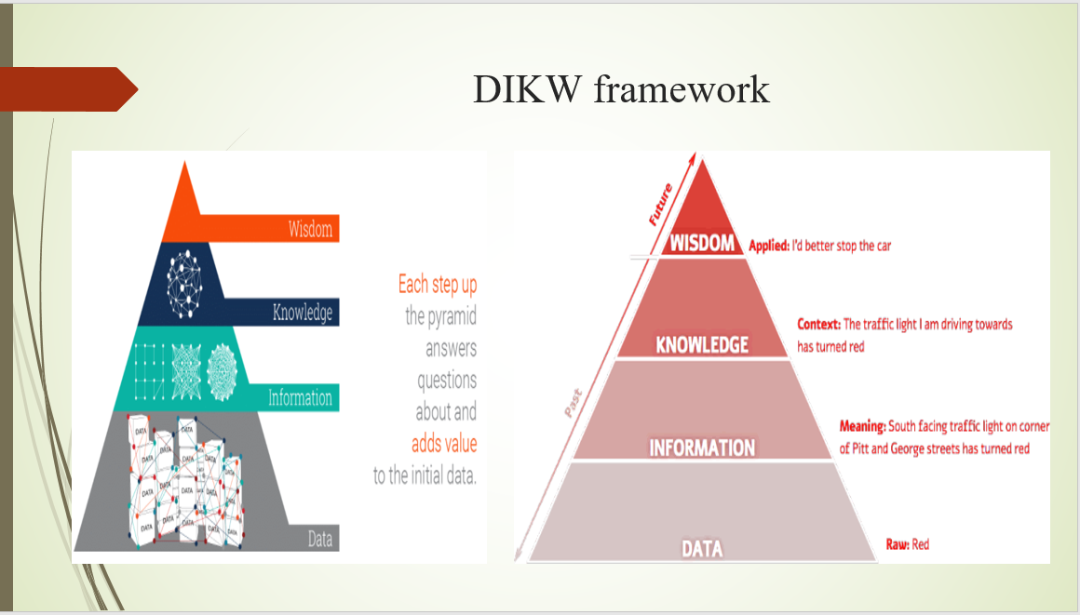
- DIKW is a triangular framework that help to conduct the research in an effective manner.
- The model is also serve as a circular framework that assist to understand the free flow of data within an organization.
- In order to extract insights and value from all type of data, the model is best suited to understand about the data and its purpose.
- It is used as a pyramid shape where at different level, facts and intelligence are used to derive a valid result.
- Data is also characterized in term of different images which in turn address range of properties like article, current situation etc.
- Still, there is no proper distinction identified within this framework in term of information and data, so the data can be used for other terms.
- Once, the data can be transformed into an information and as per the time, it can have transformed into knowledge due to data.
- This is considered as an easy way that help to understand the information and explained the needs as well. So, it can be stated that it is a simplest way to understand an information in order to compare data with someone else that assist to increase knowledge.
- At the last stage i.e. wisdom, the data is actually involving critical judgment of a collected data that provide effective analysis regarding selected data. Thus, it helps to make decision effectively so that effective results can be derived by critically analysed the data.

Slide 5
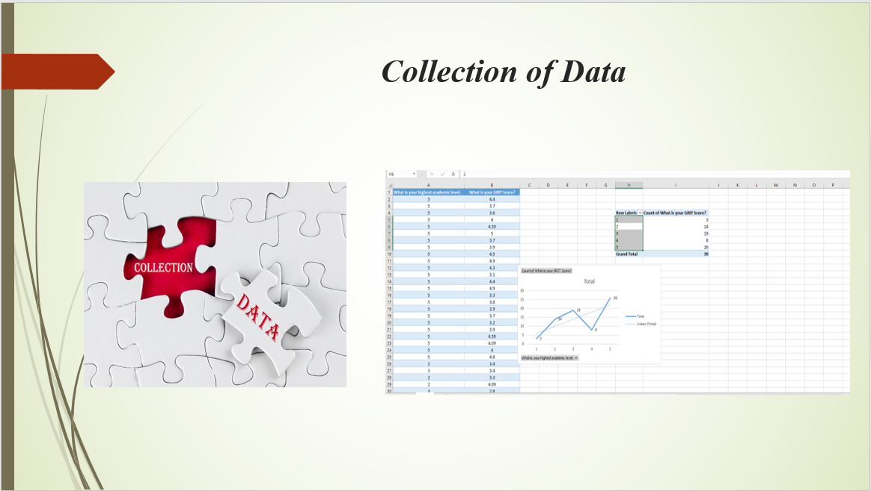
- As per the first step of DIKW framework, the data is collected which will be further transformed into an information.
- In the present study, primary research has been used in which online survey is conducted through the means of online platform.
- The study is based upon two questions and the two set of quantitative data export into an excel by considering the answer of selected respondents. This in turn help to identify the answers and determine the relationship between all.
- As per the first question i.e. what is your grit score? Therefore, to determine the answer, all selected participants must have to visit the online site that helps to understand the score rate in two decimals.
- Another question is related to what is your highest academic level and this can be gained by using comparison chart.

Slide 6
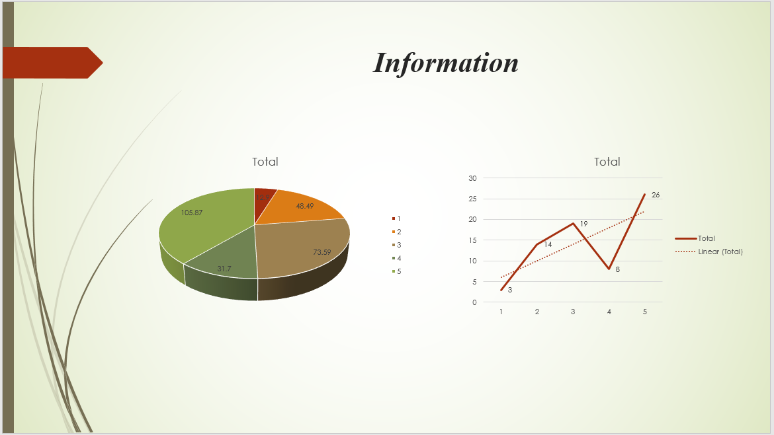

- As per the second layer of pyramid, the primary data can be converted into an information and by using visual images, data can be transformed that help to understand the views of people.
- In order to generate the visual images, transfer the whole form information into an excel that provide effective results.
- For that, generate a pivot table that assist to create a mean as well as average, sum in order to generate an effective result. This help to understand the chart and relationship between both variable.
- Also, with the help of above chart, it has been analysed that the students who have 1 academic level have 3 candidates and the highest academic level is 5 in which there are 26 students or participants. Moreover, with 2 academic level, there are 14 participants who gain the same grit score. That is why, it can be state that minimum score rate is 1 in which 3 respondents are got the same level whereas 26 of them gain 5 academic level.
- In this, two type of chart are presented such that pie chart which reflect the number of highest academic level and the grit score for each level. However, on the other side, through scatter diagram, trend line has been added which clearly reflect that Grit vs academic level and line shows upward direction.
- Thus, the result reflected that grit influence academic level achievement because changes of trend line is in upward direction. Also, as per the 70 student’s views, it has been analysed that changes in grit always influence the academic level.

Slide 7
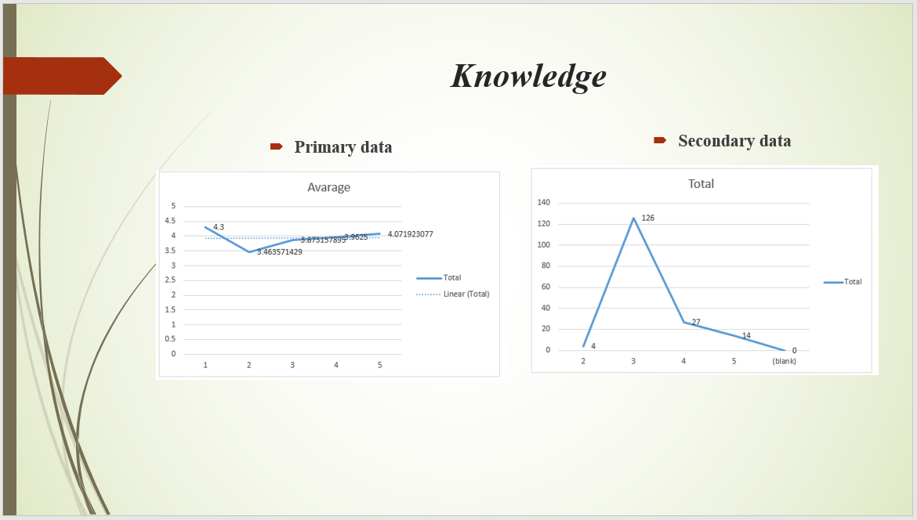
- In accordance with the information to knowledge, it has been analysed that the data is not as convincing due to lack of response.
- Through the above comparison, it can be stated that the average score rate is fluctuate when the academic level increases but the positive trend line reflected that there is a positive relationship between both variables. Further, as per the secondary data, the academic level is 2 and the are 4 grit score whereas 3 academic level have the highest level of score rate i.e. 126. Therefore, it can be stated that majority of the students have the highest 3 academic level and this positive trend line shows the positive relationship in which changes in one variable will definitely affected the second one.
- Also, the trend line reflected the positive response from the data and that is why, it can be stated that there when the grit score changes the level of academic also influenced. In addition to this, under secondary data collection method, all the information is exported into an excel which in turn shows that there is a positive relationship between both variables which in turn reflected that when there is higher grit that refers to higher academic level.
- In addition to this, it can be stated that with the change in grit score, there is a direct influence analysed within academic level. There are five different level of academic and this can be impact over the griot score that might affected.
- Therefore, it can be stated that if more data can be collected by considering the physical characteristic, more reliable data can be generated that help to improve the results and derive better outcomes.

Slide 8
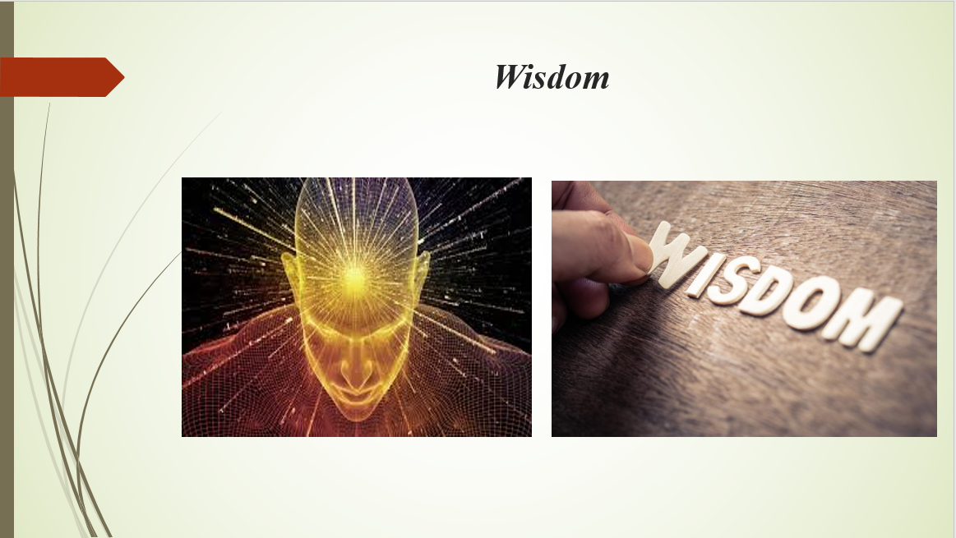
- As per the last step of DIKW framework, there is need to apply the critical thinking abilities in order to derive the better outcome. Further, it is all about to answer the question i.e. why do something and what is best.
- In the context of present study, both information and knowledge can be contextualized with regard to wisdom. This refers to if the individual have an information, then there is a need to get a knowledge and this in turn bring wisdom to life that assist to derive better outcomes.
- As per the chosen book from Angela Duckworth where it has mentioned that grit is a huge indicator of achievement and provide social insights as well. Similarly, through the chosen data and analysis, it has been also determined that grit score influence y the academic level and higher the grit score means higher education level that is also proved by Angela Duckworth’s theory.
- That is why, if the data and information are related to each other and knowledge as well as wisdom are connected with each other then it helps to attain the future goals.

Slide 9
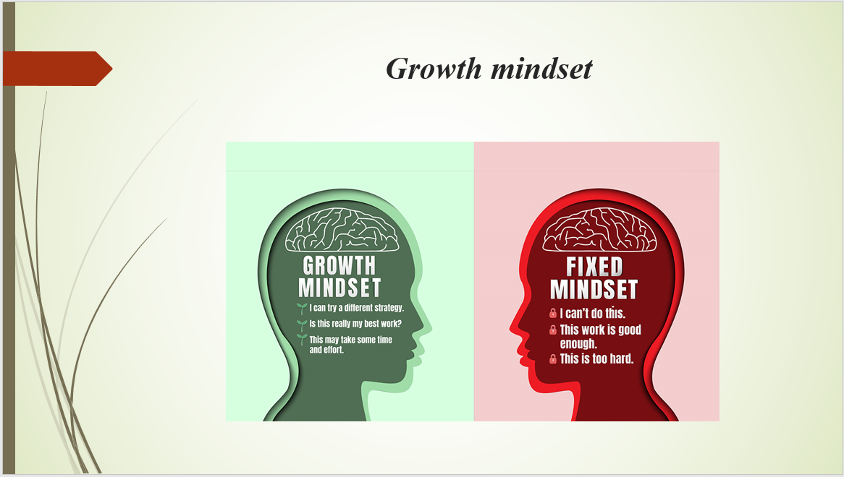
- The meaning of growth mind set refers to the individual’s intellectual ability that can developed according to time. However, there are categories in which the individual mind set is divided i.e. fixed and growth
- Through this factor, the grid score is directly related because people with growth mind set are more likely to be strong and more grit.
- Also, it is depending upon the individual learning where different mind set plays various role and that is why, it can be compensate for lack of talent and without it, resilience affect the overall growth in negative manner.
- In addition to this, Angela let focused that failure is not finish point but learning is a curve and that is why, there is a need to realize working on a goal which cause direct impact and also let people engaged towards each other.
- Hence, through positive mind set, the growth options can be increased and there is a need to focused upon this that help to improve ourselves. Along with this, growth mind set also assist to improve the skill over a time and this might affect the results into negative manner.

Slide 10
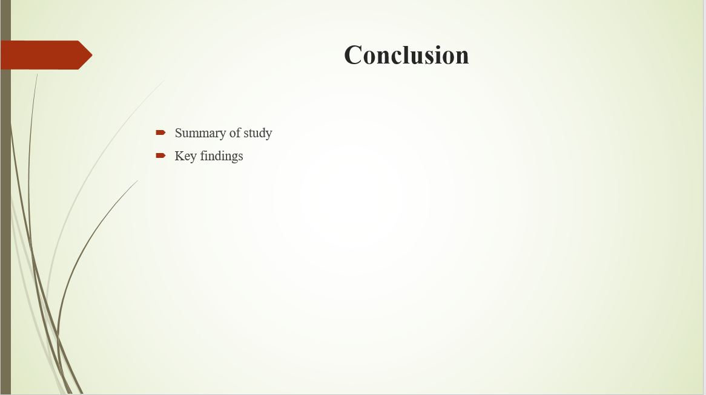
- By summing up above, it has been concluded that DIKW model is well suited in order to determine the knowledge so that effective decision can be taken.
- Also, the PPT concluded that by considering all the relevant factor of the framework, the data can be evaluated and provide effective results.
- Moreover, it can be summarized that there is a string relationship between academic level and grit score which can be analysed through exporting data into excel in order to derive better outcomes.

Slide 11

Cormier, D. L., Dunn, J. G. and Dunn, J. C., 2019. Examining the domain specificity of grit. Personality and Individual Differences. 139. pp.349-354.
Credé, M., 2018. What shall we do about grit? A critical review of what we know and what we don’t know. Educational Researcher. 47(9). pp.606-611.
Duckworth, A. L., Quinn, P. D. and Tsukayama, E., 2021. Revisiting the factor structure of grit: A commentary on Duckworth and Quinn (2009). Journal of Personality Assessment. 103(5). pp.573-575.
Hodge, B., Wright, B. and Bennett, P., 2018. The role of grit in determining engagement and academic outcomes for university students. Research in Higher Education. 59(4). pp.448-460.
Mason, H. D., 2018. Grit and academic performance among first-year university students: A brief report. Journal of Psychology in Africa. 28(1). pp.66-68.
Park, D. and et.al., 2020. The development of grit and growth mindset during adolescence. Journal of Experimental Child Psychology. 198. p.104889.
Zisman, C. and Ganzach, Y., 2021. In a representative sample grit has a negligible effect on educational and economic success compared to intelligence. Social Psychological and Personality Science. 12(3). pp.296-303.

Slide 12


