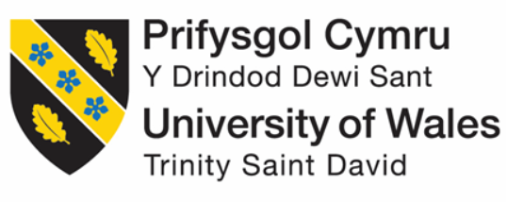

Module Name: Independent Project
Module Code: BMTP6015
Project type: Consultancy

Student Name: Tao Jones
Student Number: 2302087
Module Tutor: Scott James
Word count: 3223

Table of Contents
Introduction: 3
Methodology Overview: 4
Key findings and Analysis: 5
Evaluation of Project Success: 10
Conclusion: 12
Limitations and Recommendations: 13
Appendices: 15
References: 32

Element three – Project Findings

Introduction:
In this element will critically evaluate the outcomes of the project “Improving the Workplace culture at Castle Bingo.” Assessing whether the objectives and the implementation of initiatives achieved their intended outcomes. The main aim of the project was to examine and strengthen the workplace culture within the organisation.
The project’s objectives were improving staff engagement and morale, formalise recognition practices, enhance cross-departmental teamwork and communication to address retention issue.
These objectives were structured utilizing Doran, (1981) Smart Framework to ensure clarity, measurability, and evaluative accountability within the project timeline.
This project was undertaken within Castle Bingo. Putra (2024) emphasises that internal culture closely relates to the overall service quality, as employee attitudes and engagement are not peripheral but fundamentally influence organisational performance and customer satisfaction.
In customer facing environments such as Castle Bingo is characterised by shift-based, unsocial hours, high demands that can pose ongoing challenges such as employee fatigue, reduced morale, increases staff retention.
Pressures like these can create workforce instability when staff are not satisfied and can place additional strain on the organisation. (Park and Min,2020; Brien, Thomas, and Hussein 2015). Reinforcing the importance of this project.
The findings section presents analysis of qualitative and quantitative survey data and feedback. That mainly focuses on employee engagement, communication, recognition, and teamwork that corresponds with the project objectives.

Methodology Overview:
This project utilized a mixed method approach to assess and evaluate the impact of staff-focused initiatives at Castle Bingo. The integration of using quantitative and qualitative data strengthened analytical depth and enhanced credibility through methodological triangulation. (Harrison, Reilly, and Creswell 2020).
The quantitative element involved a staff survey that was distributed to all departments and feedback discussions for post implementation of the initiatives. In the survey, used Likert-scale questions to assess key variables that aligned with the project objectives.
Comparing baseline and post-intervention feedback facilitated assessment of change over the project period and supported numerical evidence to evaluate against the success criteria.
Qualitative element consisted of open-ended questions and feedback discussions. These methods allowed for employees to further elaborate on their perceptions that provided context behind scaled and scores responses, offering deeper insight into underlying dynamics of the culture. The qualitative responses identified recurring patterns and themes. Which is further explored within findings.
Participants included over 50 respondents. The survey was sent out to all staff across departments within Castle Bingo to ensure broad organisational representation.
However, participation was voluntary to encourage honest responses. As result final sample, consisted of employees who voluntarily chose to engage with the research representing self-selected yet operationally diverse group.
During the research process ethical considerations were important, especially given the sensitivity of organisational culture and employee perceptions of the practices of both operations and management. Survey responses were collected anonymously and reported in aggregate way to protect confidentially. Saunders, Lewis, and Thornhill (2019) highlights that maintaining anonymity is widely recognised in organisational research, given that employee's attitudes towards communication, leadership, recognition practices are being explored.
All data was used strictly for project purposes and was not linked to disciplinary procedures or performance appraisal, reducing perceived risk and encourage honest responses that fundamentally promotes trust and integrity without being concerned for negative consequences. (Israel,2020)
During the research process, there were some data collection challenges encountered. Coordinating and completion of survey proved more time consuming than anticipated as staff availability was influenced by personal commitments, and shift patterns.
It was more of a challenge than anticipated to access organisational data regarding retention and absenteeism. Similarly, arranging feedback discussions across different schedules required flexibility to not disrupt operations.

Key findings and Analysis:
A total of 52 employees within Castle Bingo participated in the survey, that represents staff across different departments within the organisation. The diversity of respondents is prominent when analysing workplace culture, as the distribution of both customer-facing and operational support roles, captures different employee’s perspectives that enables broader view of how workplace culture is experienced across different functional departments within the organisation.
The substantial proportion of responses came from bar and catering employees 32.7%, followed by bingo staff of 15.4% with smaller numbers from the other departments. Additionally, 57.7% identified as female and 40.4% male, which is balanced representation of employee’s views.
To elaborate, understanding the experiences of staff is particularly important as Bamidele (2022) highlights that workplace culture is not experienced through uniformly but is shaped through responsibilities, working conditions and interactions with both customers and colleagues. In which allows for more balanced interpretation of cultural dynamics in the workplace, providing more comprehensive data that strengthens the reliability and credibility of the research. (See appendix A)

Findings one: Employee Engagement and Morale:
In the survey, asked employees whether they feel proud to work at Castle Bingo and feel motivated in their role to assess the overall engagement and morale. Establishing this was important for gathering research on how staff perceive their relationship with Castle Bingo.
The results indicate a high number of responses of neutral specifically, 65.4% of respondents. 17.3%. selected “agree” followed by, 11.5% said disagree. In addition, 55.8% of neutral responses when asked they feel motivated. (See appendix B.)
Majority of the responses were neutral, suggests employees do not strongly expressed dissatisfaction, but do not demonstrate having strong organisational commitment either. Linking back to the project objectives, to improve staff morale the neutral responses suggest morale may not currently a strong point.
These findings indicate that the workplace at Castle bingo is operationally functional but not highly motivating workplace environment where it appears staff is satisfied to do their roles effectively, they do not report strong motivation or pride.
One explanation for this pattern, by research many shift-based and customer facing roles, employees may prioritise completing their work duties rather than developing strong emotional and commitment to organisation (Sernag.et.al,2024). From theoretical perspective, Herzberg’s Motivation Theory (1959). Which means workplace conditions prevent dissatisfaction but do not necessarily foster motivation.
Findings two: Recognition
In the survey, asked whether employees feel recognised for their work. This question was included as recognition is a prominent driver of employee morale, motivation, and retention. (Tenney, 2024) Understanding whether staff feels acknowledged for their hard work this particularly, important in relation to project objectives as it aims to add additional recognition practices but also aimed to identify if recognition exist and how consistently it is within the organisation. (See appendix C).
Similarly, the results shown a strong concentration around midpoint. With 65.4% selecting (3) neutral, with smaller proportions said disagree 19.2% and 5.8% agreed when asked if they feel recognised for their work. This suggests that in organisation recognition is not strongly experienced by most employees that works in the company. Qualitative responses reinforced this with consistent theme of inconsistent and limited recognition practices.
One person said:
“Honestly, not really kitchen staff work extremely hard, especially when short staffed, and it often feels unnoticed” Another respondent highlighted: “The cleaning team is overlooked, when everything is clean and running smoothly, I feel it goes unnoticed but if something is missed it gets picked up quickly”
Operational factors could influence this pattern. Dumitriu (2025) states, in fast-paced environments is frequently focused more maintaining good service quality. Under these conditions recognition become secondary to operational priorities, with feedback more on issues rather than performance, employees perceive their work as expected and not valued.
Aligning with, Blau (1964) ‘Social Exchange theory’ refers to employees are more likely to deliver commitment and discretionary effort when they feel valued, in this case recognition is inconsistent indicating that employees feel lower emotional investment in their roles.
From results, neutral responses and qualitative feedback suggests that there is limited recognition within the organisation. The findings implies that employees do not feel consistently recognised, with many staff efforts go unnoticed especially during busy period or less visible roles and suggests that recognition practices are not considered strong within the organisation.

Findings three: Communication and Teamwork Dynamics.
The combination of qualitative and quantitative questions include: “Teamwork between departments works well,” “Communication is clear and effective” and “what improvements would strengthen teamwork between departments?” The intention of these is to assess and evaluate how employee’s perspectives on how good the communication and collaboration functions, if it supportive or is their barriers exist across the multiple departments at Castle Bingo. In which also central to the project objectives of strengthening cross-departmental teamwork and communication. (See appendix D)
From quantitative results for both questions show around the midpoint of the Likert scale. 73.1% of respondents selected neutral while 19.4% agreed, followed by 3.8% strongly agreed that teams work well between departments. For communication 71.2% said neutral with smaller numbers specifically, 13.5% said agree.
Qualitative responses reinforce the pattern of recurring themes regarding communication, and departmental separation.
One respondent said: “Departments don’t communicate enough, everyone gets stressed and busy” Another said, “Better communication could help, sometimes catering can feel separate from the main floor.” Other employees said the need for stronger collaboration for example, “More team-building activities so staff can interact outside of work.”
The qualitative responses suggest that there are high pressure roles such as Catering, where employees have reported that their areas feeling expected to manage high demands independently during busy sessions. Operational pressures can also contribute to this perception, as during peak times communication tends to prioritise service demands rather than collaborative engagement, resulting in departments are feeling unsupported.
To further support this, Tuckman’s (1965) model emphasises better teamwork develops through interaction and shared working experiences, when there are limited opportunities to communicate, or understand each other roles the less likely to function cohesively. This suggests that, as departments often feel alone contributes to weaker team cohesion.
The predominance of neutral responses suggests that within the organisation teamwork and communication are perceived as operationally functional enough to complete tasks. But relational cohesion and shared understanding from teams could be significantly improved. As a result, departments operate in isolation reducing overall workplace support. These findings, directly link back to project objectives of strengthening teamwork and communication as they highlight clear gaps in how the organisation teams interact.
Findings four: Work pressures and retention.
In survey, asked “How do unsocial hours impact your well-being and motivation.” This was included to examine how working conditions influence employee retention motivation and wellbeing. Understanding how hours can affect staff was relevantly important in relation to the project of addressing retention concerns. (See appendix E)
The quantitative results, 40.4% agreed and 15.4%, strongly agreed followed by 36.5% selected neutral that the unsocial hours do have negative impact. Qualitative responses reinforce this by employees frequently highlighting fatigue, hard for work-life balanced while others emphasised family responsibilities and personal commitments. For example, one said “Late finishes can be tiring, especially when shifts change week to week.”
These findings suggest that the work hours, form a big part of employee’s experiences. While expected within leisure environments. High job demands, unsocial hours, can reduce motivation when not balanced with adequate support.
This reflected in, the retention data supports this with 61.5% of people selected neutral when asked if they intend to stay in the organisation over the next 12 months, indicating uncertainty rather than strong commitment.
The findings reveal that the workplace culture is operationally functional clearly, there is some areas considered as weak and presents opportunity to improve. Notably, responses to the question regarding to the biggest factor affecting the workplace culture, (See appendix F). Identified recurring themes that links back to the findings that been mentioned, reinforcing the importance of the project and objectives.
This includes lack of recognition where employees feel unnoticed for their contributions, communication challenges. Others reported staffing levels and pressures of demand contributing to stress and reduce morale. Referring to survey, asked employees what suggestions they have to improve staff morale, some responses said the need for more recognition, improve communication, need for more team interactions.
These insights directly informed initiatives that were developed to address some of issues. These initiatives were not based on assumptions but input from survey findings ensuring they reflect on the needs and perspectives.
This included the introduction of staff suggestion board in which to strengthen communication. increased opportunities for team cohesion by implementing activities like staff quiz, and development of more recognition practices to acknowledge staff contributions.

Evaluation of Project Success:
The outcome of this project achieved partial success when comparing against its original objectives and success criteria. Evidently, the most progress was seen in strengthening cross-department teamwork and improving communication with reasonable improvement observed in staff morale, and post implementation feedback reinforces, with staff highlighting greater interaction and increased openness in communication etc. Although some outcomes were constrained by factors beyond the time and scope of this project.
The staff quiz that took place to strengthen teamwork and improve staff morale emerged to be one of the most effective initiatives during the implementation phase. Small prize was included for the winning team, participations levels was seen to be strong with staff across different departments participating, despite the activity took place was after shift (10pm). Significantly, some employees also attended outside their working hours. This indicates a strong voluntary engagement and suggests opportunities for informal interactions is valued. (See appendix H).
Feedback discussions also reinforced its effectiveness, with employees reporting that they “Really enjoyed the staff quiz.” This shows that they appreciated the opportunity to bond with colleagues they do not usually work with.
Observationally, changes in day-to-day interactions were noted following implementation for example, the communication and cooperation were seen to be lot stronger during peak times. In which suggests, there were positive change, and contributed meaningfully to strengthen teamwork and collaboration rather than a purely social activity.
Furthermore, recognition practices also contributed to staff morale that were seen as a positive during the implementation phase. Small incentives were given out.
For example, £20 gift voucher was awarded to a member of staff that acknowledged how hard they worked during one of the busiest shifts within the month. This was well received and reinforces the importance individual efforts. In the feedback discussion employees said even small gestures were appreciated and created more of positive working atmosphere.
Moving on, the introduction of staff suggestion board and informal feedback discussions were effective as employees had the chance to share their thoughts, concerns, and ideas. Employees highlighted that they felt more comfortable raising their issues, this implies that there was improvement in openness and trust between employees. These outcomes indicate a positive movement towards strengthening communication across the workplace.
Being, critically honest the objective of reducing 5% turnover was unfortunately not achieved, as two employees redesigned from their roles during the project period. This indicates that while teamwork and morale improved in some respects, retention outcomes are constrained by broader organisational factors.
Earlier findings from the survey also specify uncertainty among staff regarding long-term commitment. Validating, the complexity of improving turnover through short-term interventions alone.
Also, findings from survey and discussions identified that workload demands, working hours etc remain ongoing problems, indicating that wider operational factors continue to influence turnover outcomes beyond the project scope.
Time constraints represented a substantial challenge during this project. Fewer team activities were delivered than initially planned, limiting opportunities to sustain engagement across departments and build on earlier improvements.
While the staff quiz establishes some benefits in strengthening interaction and teamwork, the absence of repeated or more activities restricted the ability to implement these into everyday working practices. Potentially, more delivery may have strengthen participation across shifts, reinforce collaborative behaviours, and support wider organisational impact beyond the initial intervention phase. Additionally, factors like operational demands, and limited implementation phase hinder opportunities to determine behavioural change or assess longer-term improvements in retention and morale.
One unexpected outcome of this project was the level of openness through the survey, suggestion board, and feedback discussions. Employees were engaged on sharing their honest thoughts and perspectives on the overall workplace culture including recognition, work demands, communication challenges and so on. This level of engagement indicated staff valued having a space to voice their perspectives and reinforces the importance of creating a safe space. Suggesting that the process of this contributed positively to more open work environment.

Conclusion:
To conclude, this project aimed to assess and improve the organisational culture at Castle Bingo through the implementation on practical and staff-focused initiatives to strengthen morale, communication, and teamwork. The findings revealed the workplace culture is operationally functional however there are several areas required improvement, particularly recognition, cross-departmental communication, and collaboration. Survey data and discussions highlighted that staff often felt work hard goes unnoticed, and communication can be weak during busy periods. These findings reinforced the importance of addressing both structural and interpersonal aspects of organisational culture.
The implementation phase shown reasonable progress in several areas. For example, initiatives like staff quiz contributed effectively for cross department interaction and staff morale, and the feedback discussions and suggestion board contributed of making supportive and open working environment. Recognition practices were also received positively. These outcomes demonstrate the value of staff focused initiatives in improving employee working experiences and strengthens relationships within the culture.
However, not all objectives were fully achieved while the improvements that been mentioned were evident, the aim of reducing staff turnover was not met within the project period. Overall, the project demonstrated workplace culture be positively influenced through staff-informed strategies. Although, sustained organisational commitment and longer time is required to achieve long-term change. Additionally, findings and observation provided valuable insights into workplace challenges and offer strong foundation for continued cultural development within the organisation.

Limitations and Recommendations:
There were limitations that affected implementation and evaluation phases. One limitation was the project period. Workplace culture emerges gradually through persistent behavioural change. (Iskamto,2023)
The brief period made it difficult to determine whether reported gains in morale, teamwork and communication were sustained over time. Although, short-term outcomes were effective through survey findings, observation, and feedback discussions for future project a longer implementation and evaluation period would have enabled a stronger assessment of long-term organisational impact.
Moreover, Castle Bingo operates within a leisure shift-based environment not all employees participated consistently during the project for example, not all employees engaged with the survey, or participated in feedback sessions. This resulted uneven participation across departments. For instance, 32.7% of employees from the bar and catering engaged in the survey, whereas only 5.8% of book sales staff participated. This could be addressed in future projects by giving employees more time to engage and incorporating opportunities for feedback into regular working practices.
Access to organisational data was another limitation, at the planning stage of this project, this was not considered to be constraint due to initial manger support Although observable improvements were noticed during the project period. Retention and absenteeism data could not be fully accessed due confidentially of the organisation and data protection regulations. This restricted the ability to evaluate whether improvements translated into measurable organisational outcomes.
Methodologically limitation should also be considered, as the research relied more on self-reported data, the absence of follow-up survey limited to evaluate changes. For future research could be strengthened by adopting more methods such as follow-ups survey, interviews, focus groups etc.
Based on these, there are recommendations for the organisation. Castle Bingo should continue including opportunities for departments collaboration including team-building activities. Formalising recognition practices consistently is also recommended. Additionally, improving communication through clearer operational updates, regular briefings and maintaining feedback platforms e.g. suggestion board would foster more of positive working environment.

Appendices:

Appendix A: Visual representation of different departments.

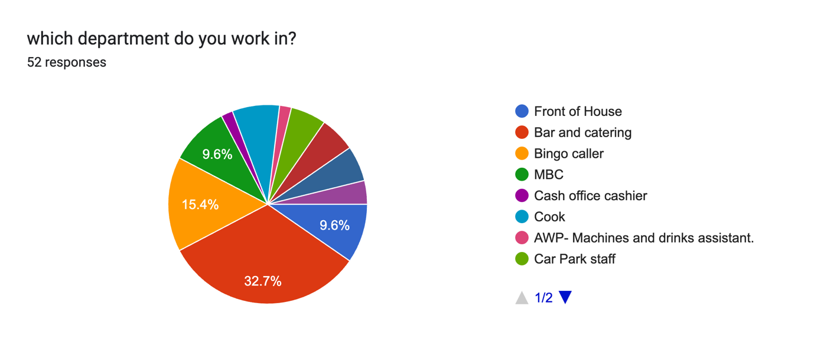

Appendix B: Employee Morale and Engagement.

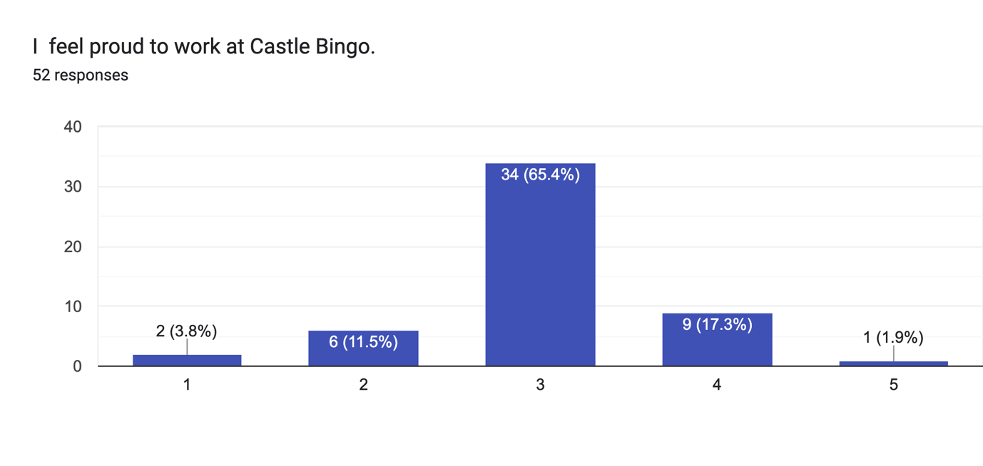

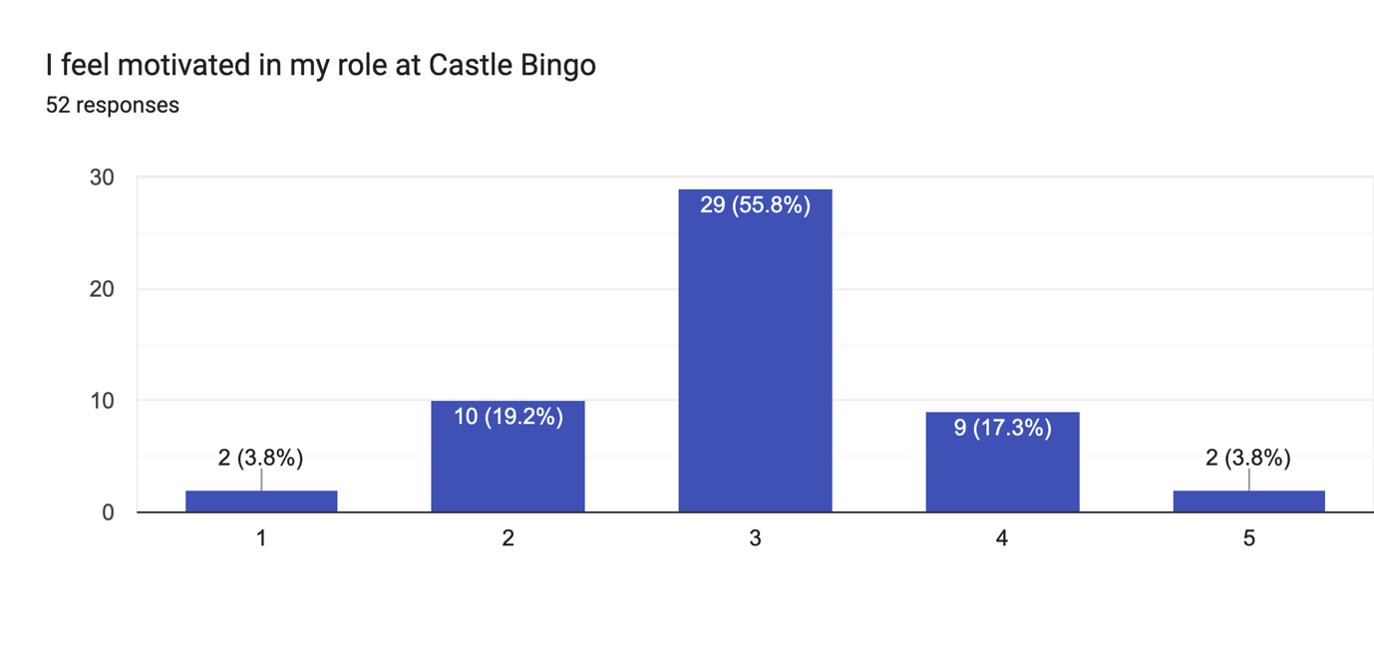

Appendix C: Recognition:
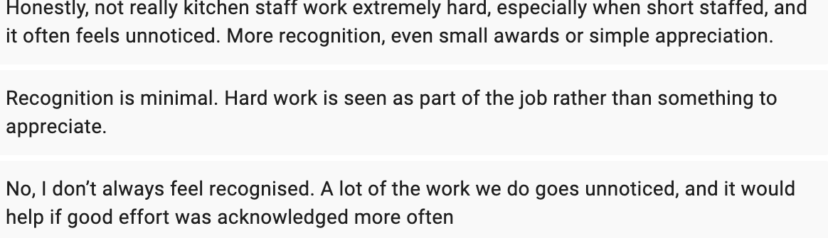
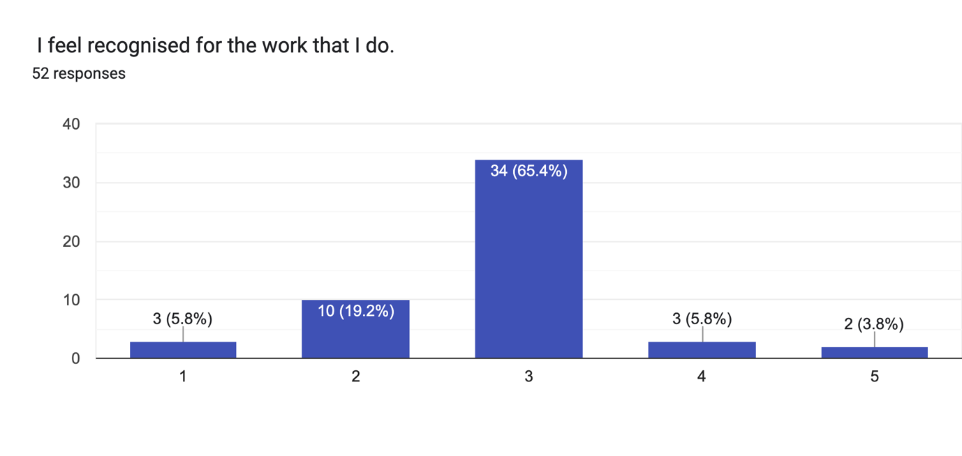

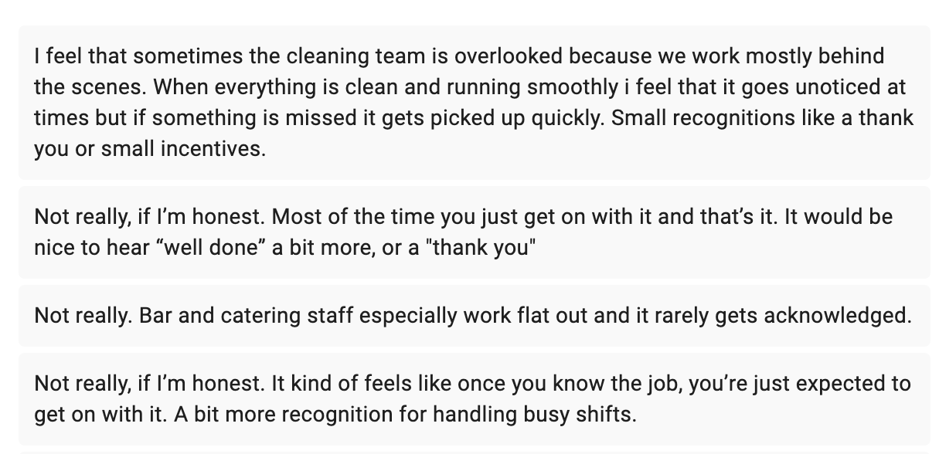
Appendix D: Communication and Teamwork Dynamics.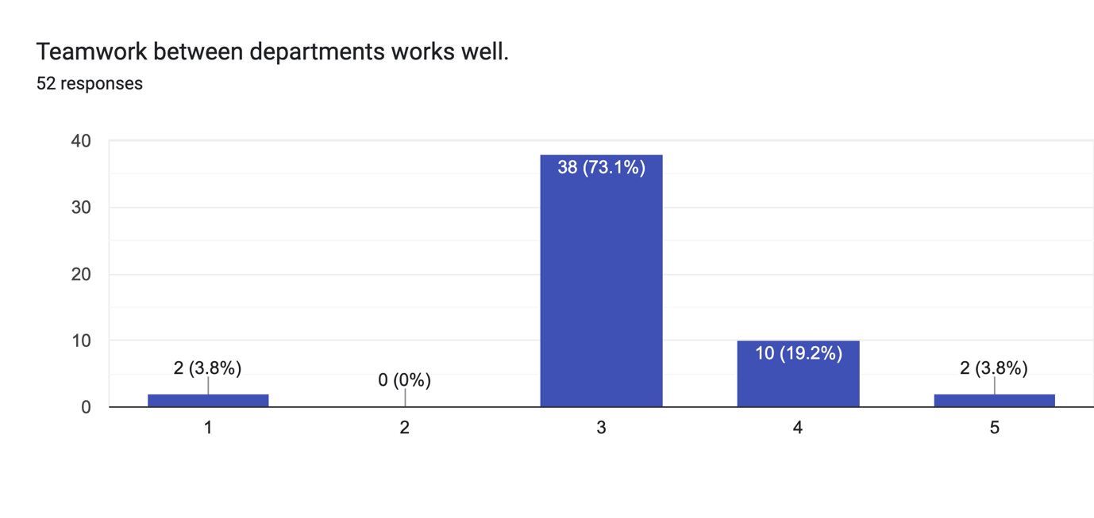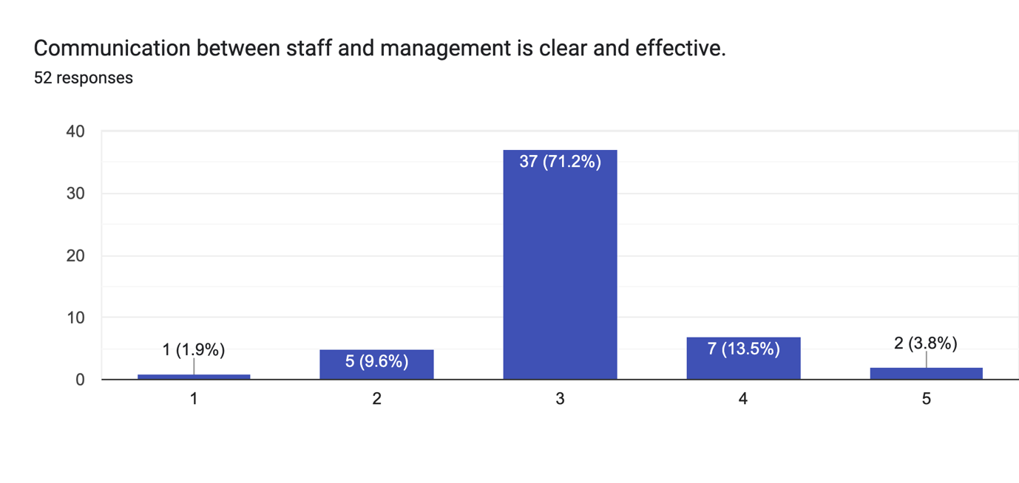

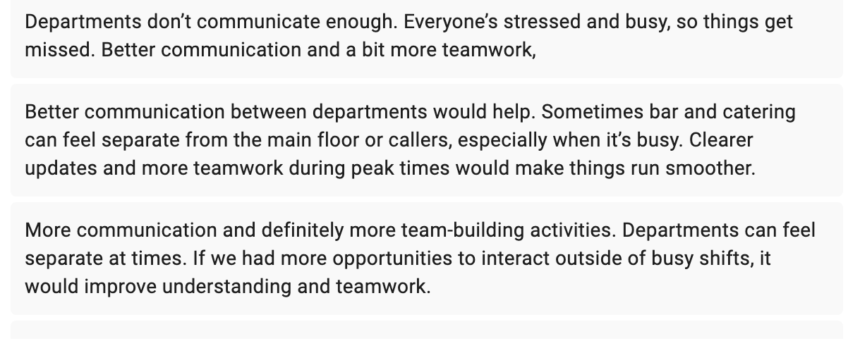

Appendix E: Work environment and retention.
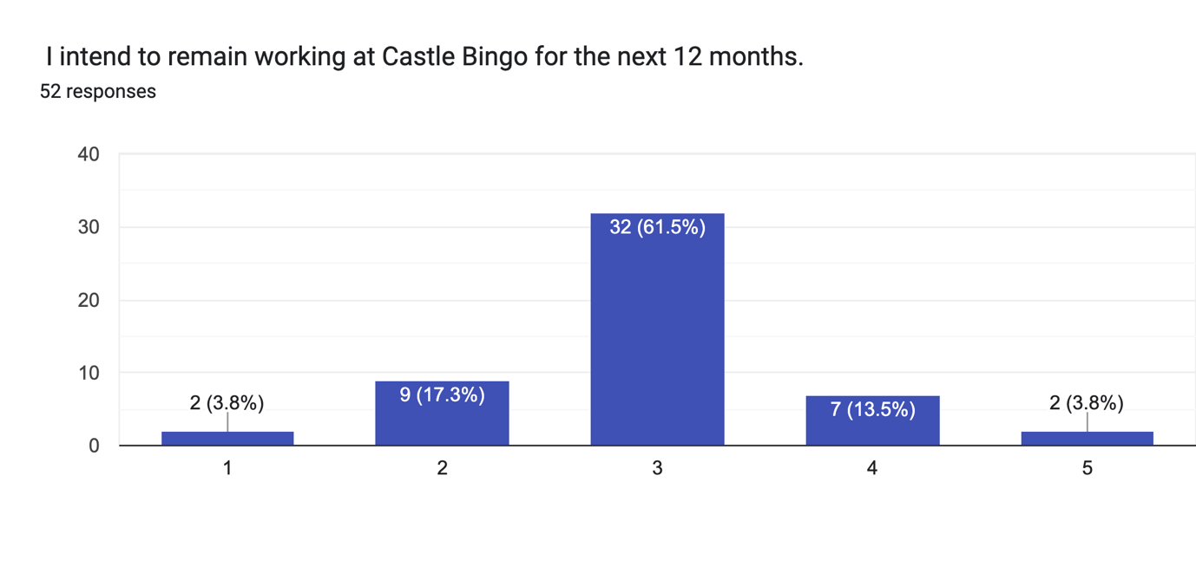
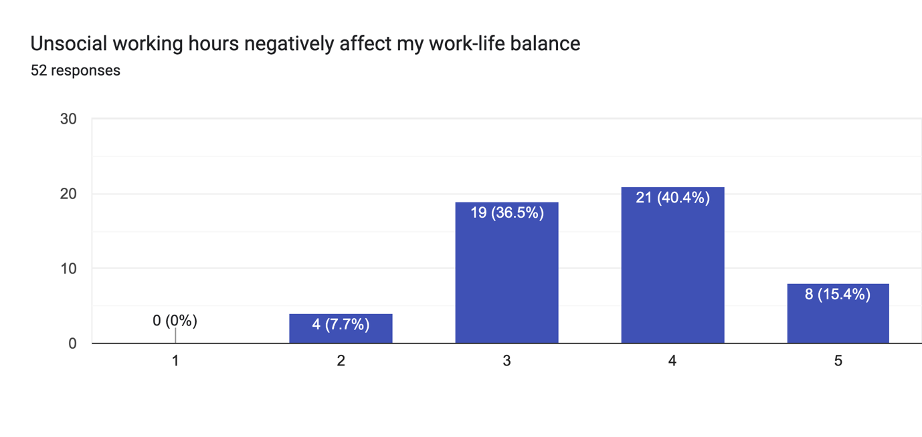
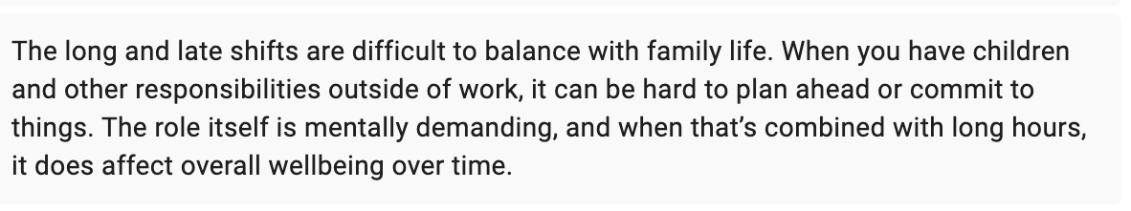
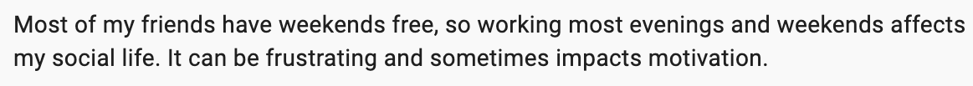
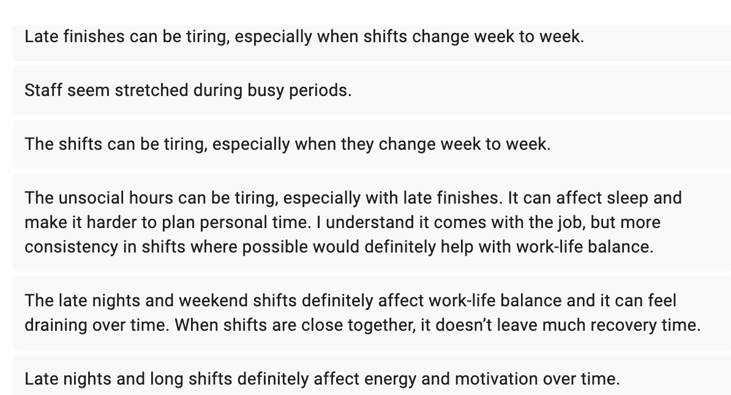

Appendix F: “Biggest factor affecting workplace culture” responses:

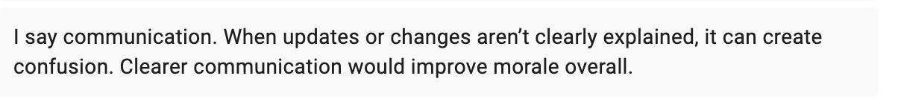
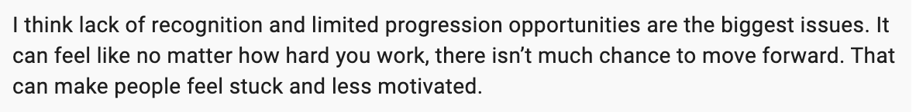

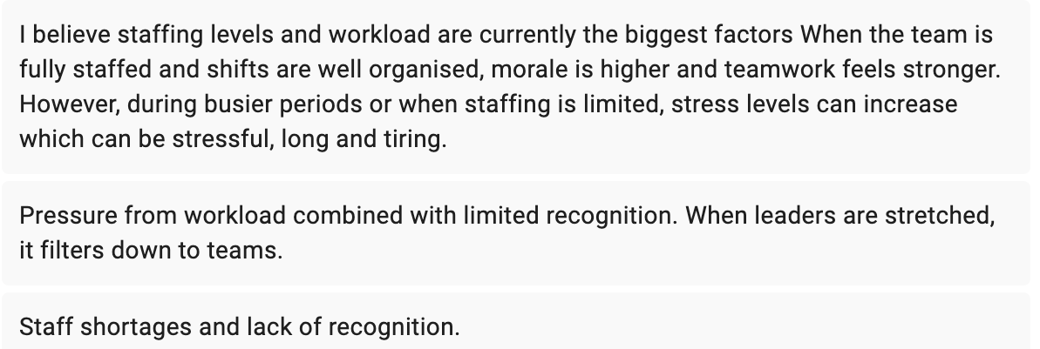

Appendix G:” What suggestions do you have for improving staff morale?” Responses: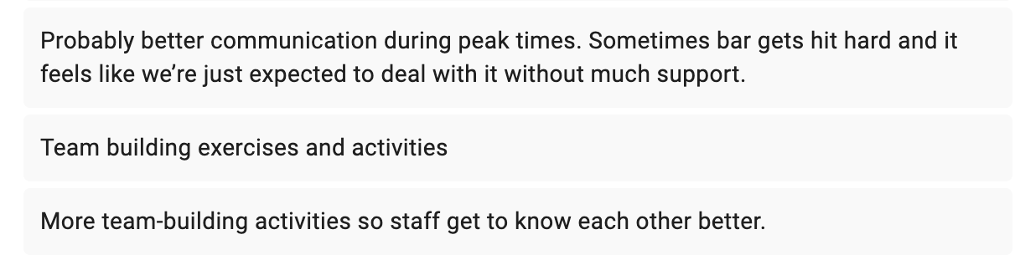
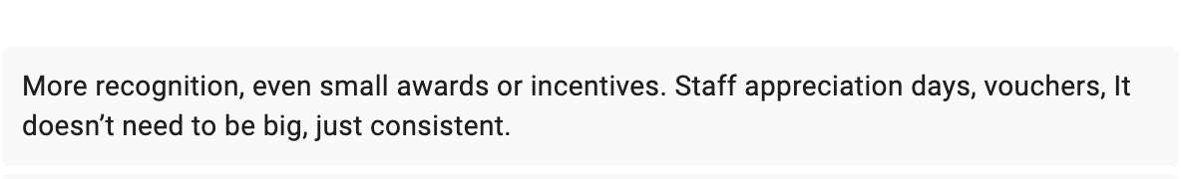
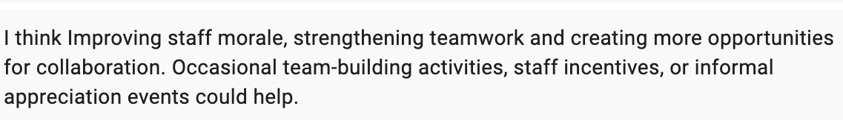
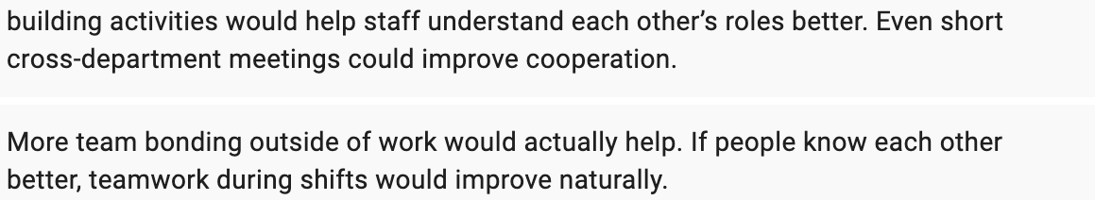
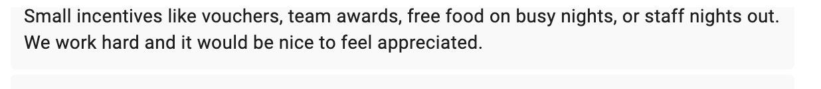
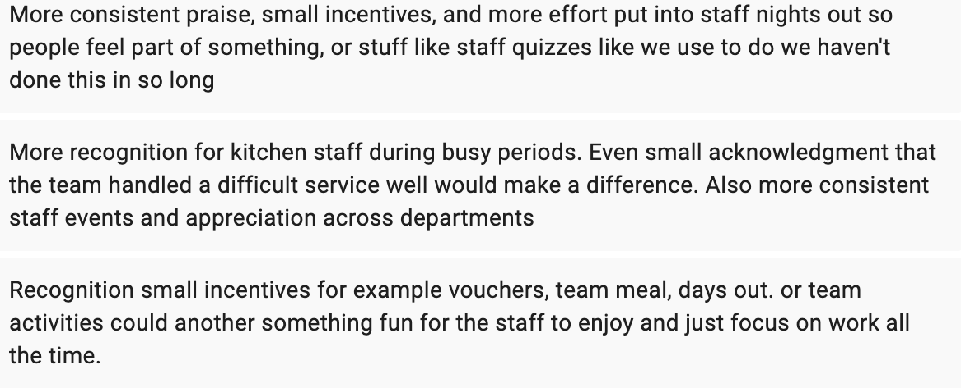

Appendix H: Evidence Quiz Night.
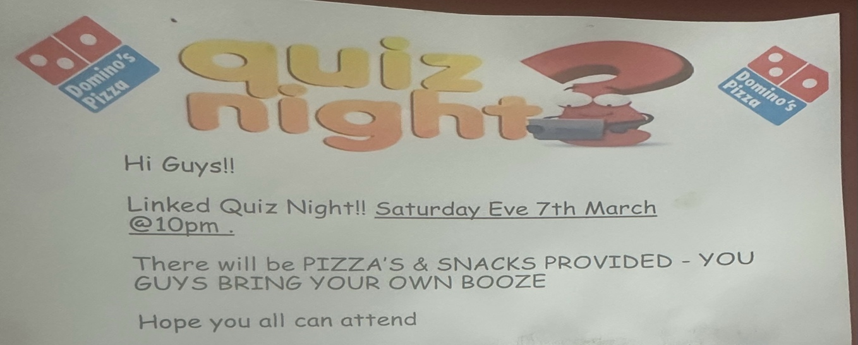

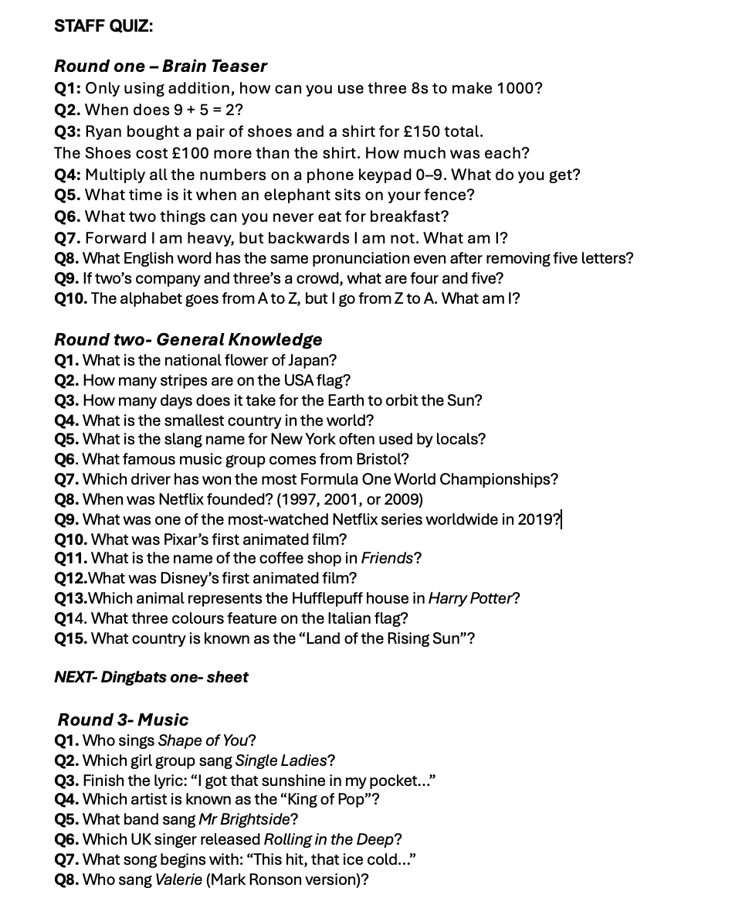

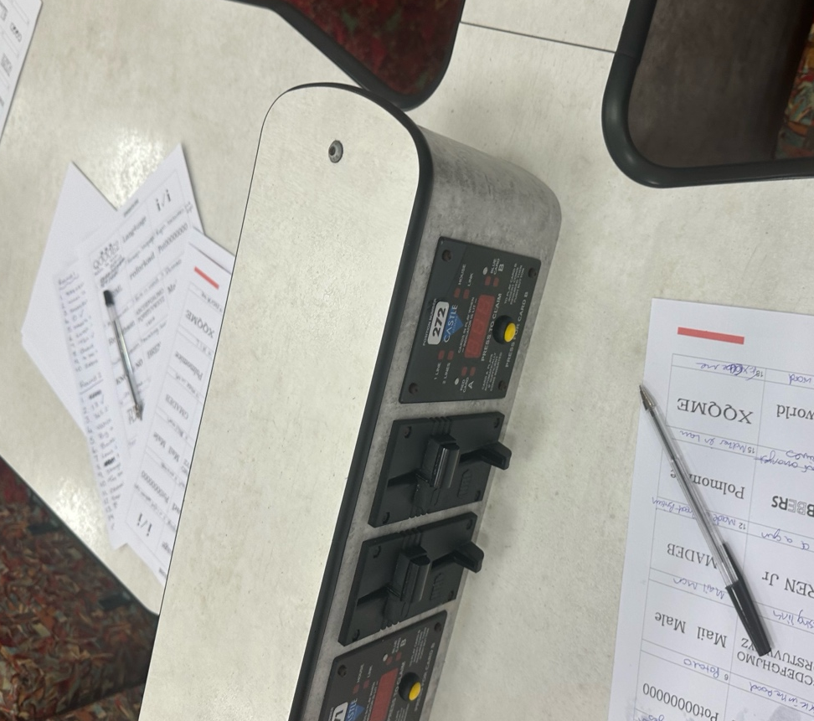
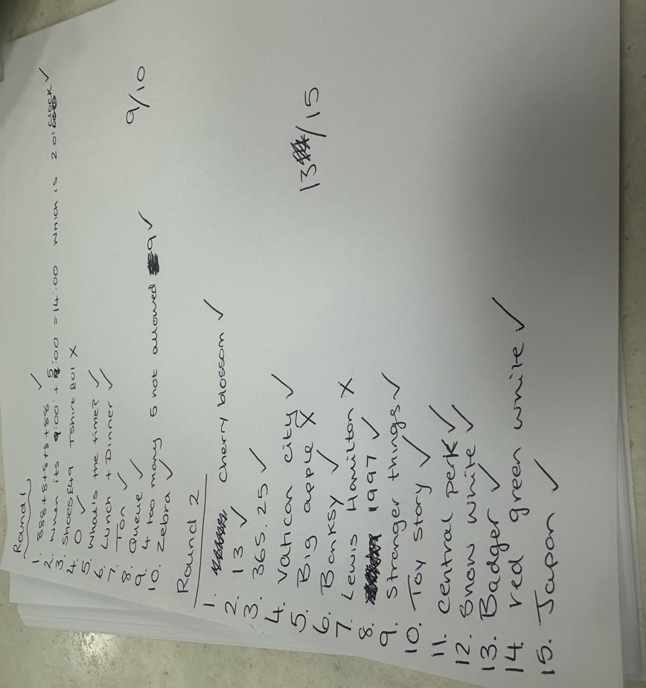

The staff quiz was inclusive activity, where departments competed against each other, in an informal and relaxed setting. This staff quiz encouraged interaction beyond normal working roles. Food and free drink were provided. This activity showed strong involvement and engagement across all the different departments, it created competitive but friendly atmosphere and highlighted teamwork, communication, and team cohesion.
This activity show how simple initiatives can positively support employee morale and strengthen workplace relationships. Reinforcing evaluation that teambuilding can strengthen workplace culture by improving engagement, communication, and collaborative working.
Staff quiz results:
The catering team came 1st scoring 30/35 across all rounds. Followed by book sales came 2nd with scoring 27/35. Then Front of House coming in 3rd place scoring 24/35.

Appendix I - Presentation slides:
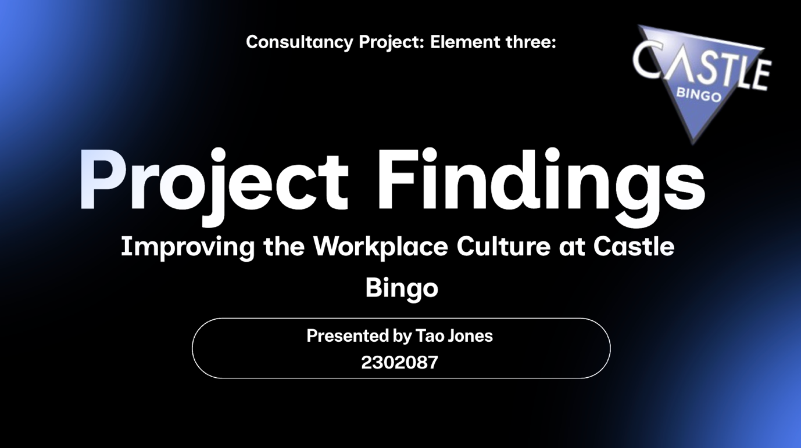
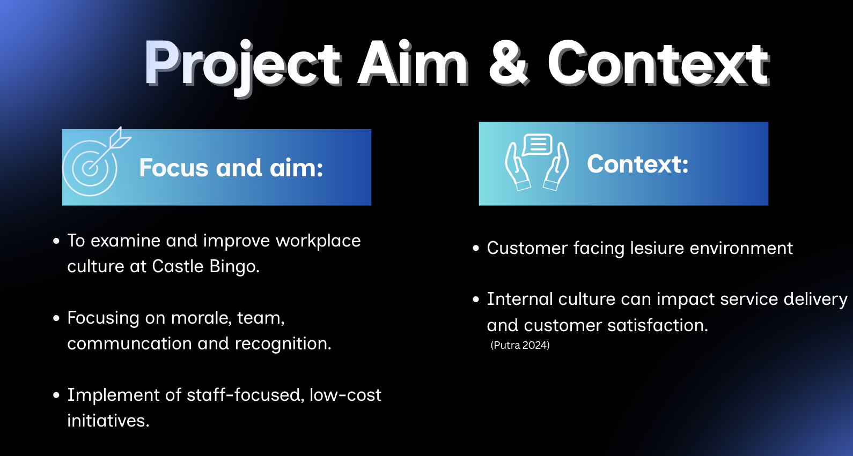

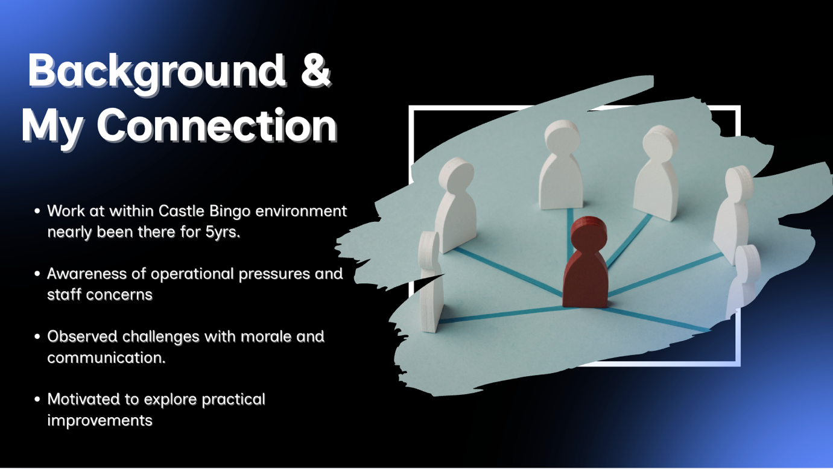
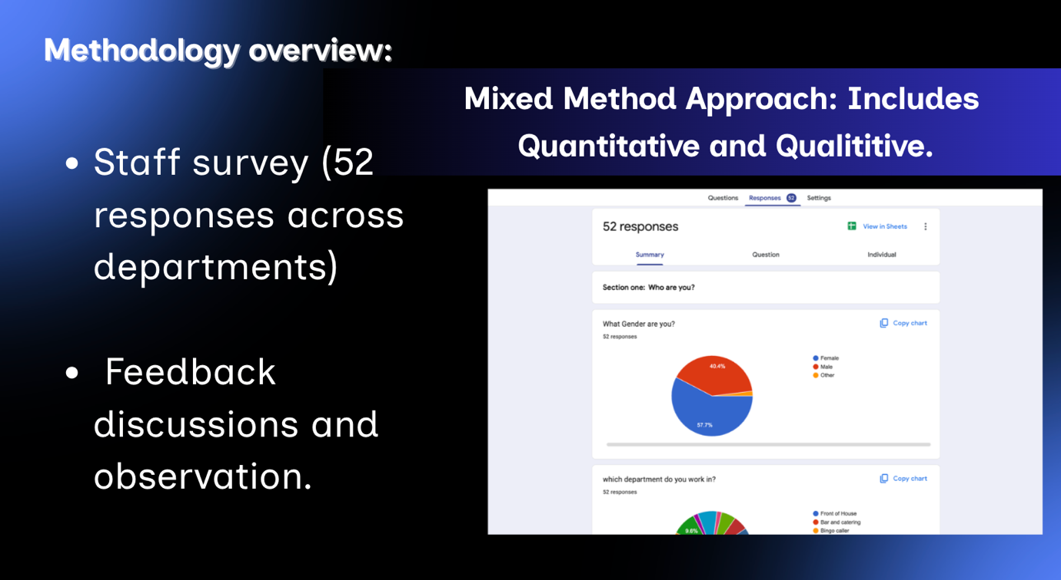

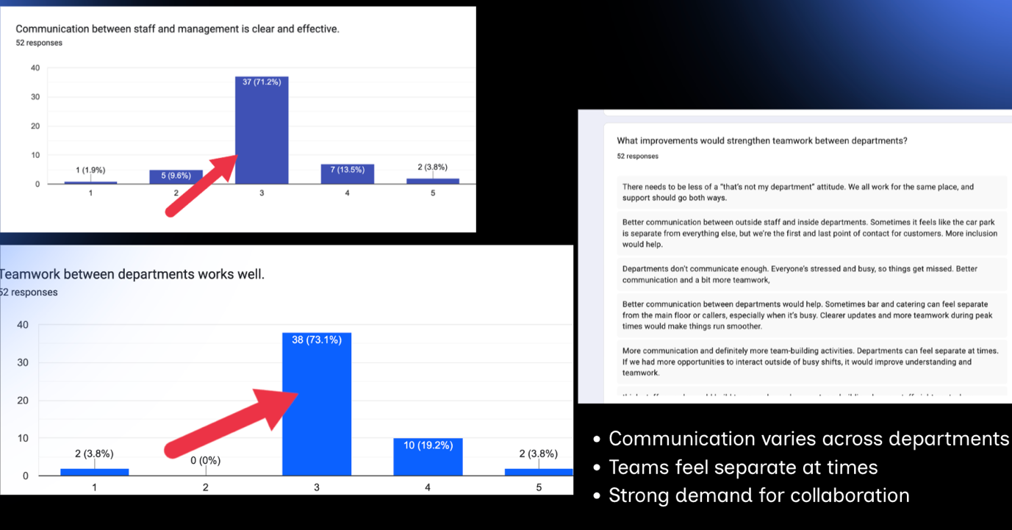
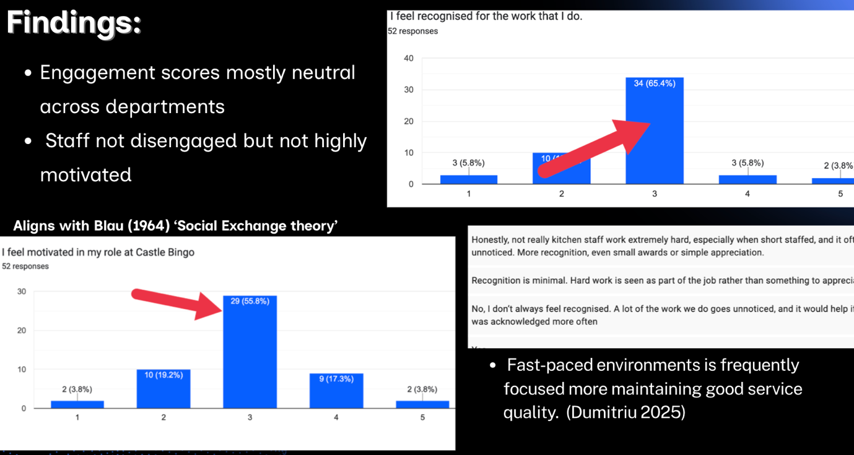

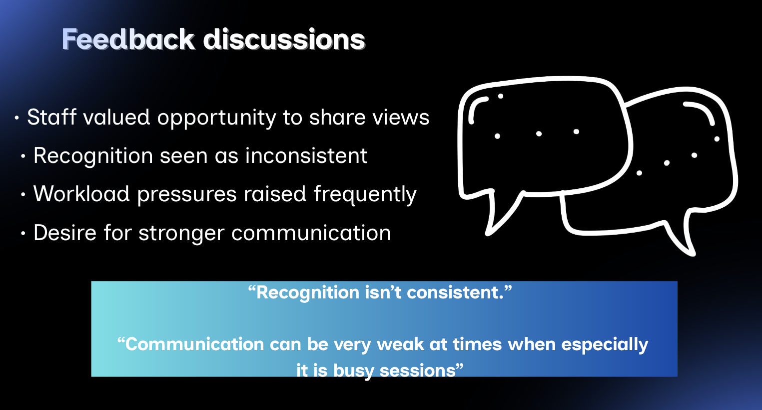
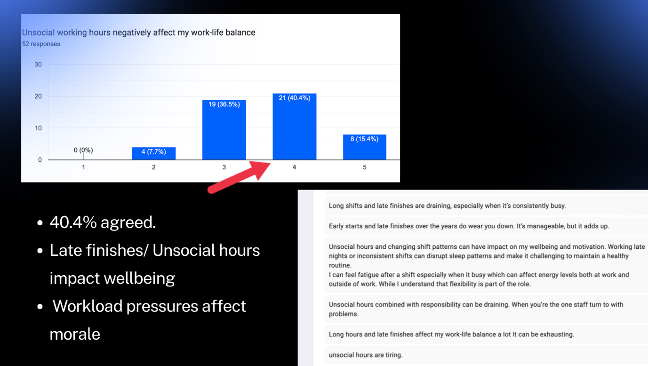

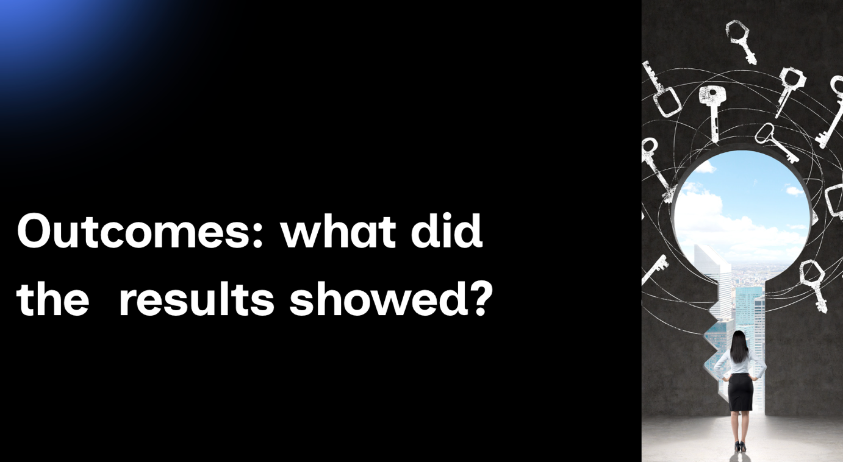

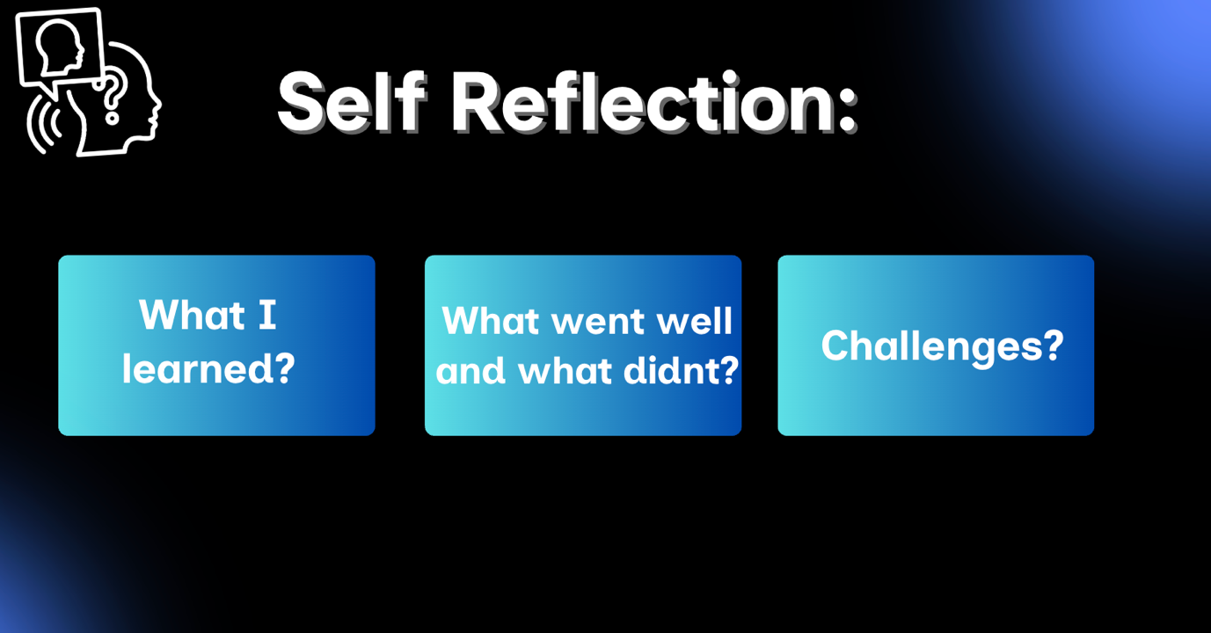

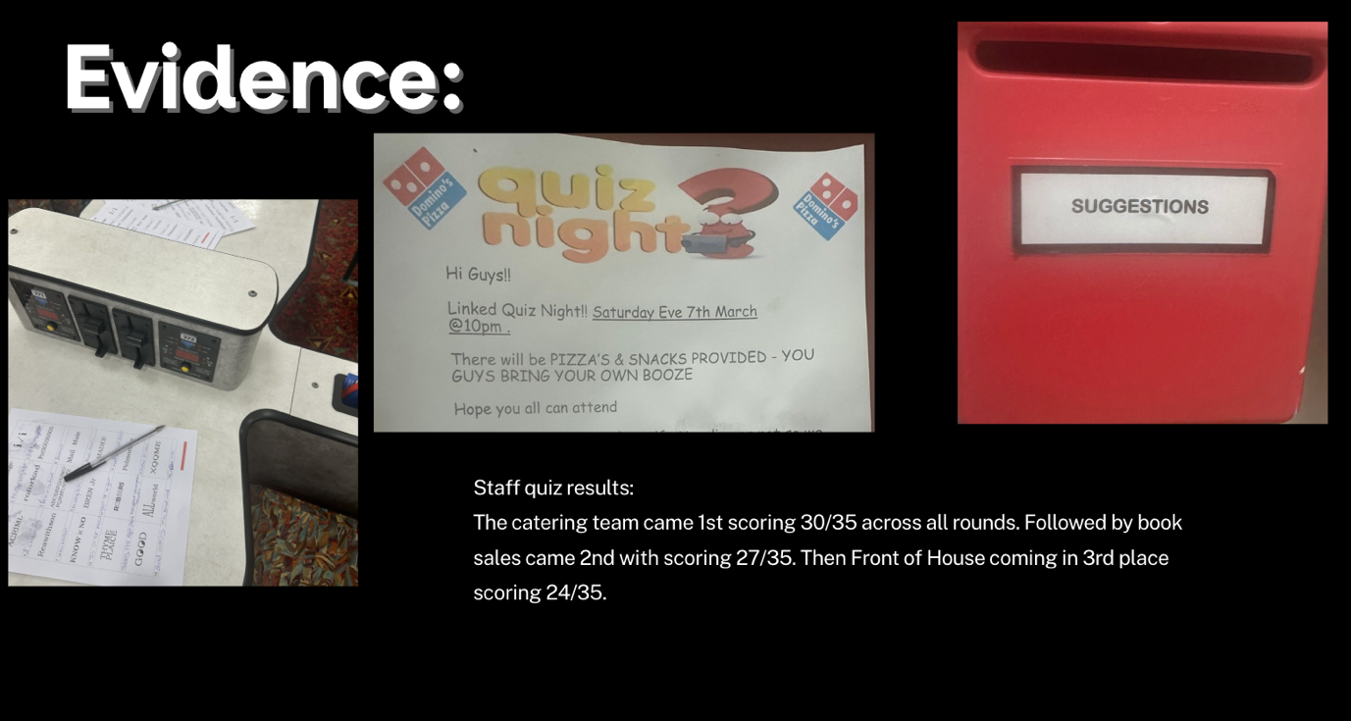



References:
Bamidele, R., 2022. Organizational culture. Industrial sociology, industrial relations, and human resource management, 1(1), pp.109-122
Bingo, C. (2025). Castle Bingo. (online) Castle Bingo. Available at: https://castle.bingo/home (Accessed 23. Feb 2026)
Brien, A., Thomas, N., and Hussein, A.S., (2015). Turnover intention and commitment as part of organizational social capital in the hotel industry. Journal of Human Resources in Hospitality & Tourism, 14(4), pp.357-381.
Dumitriu, S., Bocean, C.G., Vărzaru, A.A., Al-Floarei, A.T., Sperdea, N.M., Popescu, F.L. and Băloi, I.C., (2025). The role of the workplace environment in shaping employees’ well-being. Sustainability, 17(6), p.2613
Harrison, R.L., Reilly, T.M. and Creswell, J.W., (2020). Methodological rigor in mixed methods: An application in management studies. Journal of mixed methods research, 14(4), pp.473-495.
Iskamto, D., (2023). Organizational culture and its impact on employee performance. International Journal of Management and Digital Business, 2(1), pp.47-55.
Mensah, S.A.B., (2025). Analyzing the Impact of Promotions on Employee Performance. Dama Academic Scholarly Journal of Researchers, 10(3), pp.01-26.
Nickerson, C. (2025). Herzberg’s two-factor theory of motivation-hygiene. [online] Simply Psychology. Available at: https://www.simplypsychology.org/herzbergs-two-factor-theory.html. (Accessed 3. March.2026)
Park, J. and Min, H.K., (2020). Turnover intention in the hospitality industry: A meta-analysis. International journal of hospitality management, 90, p.102599.
Putra, D.M., (2024). The role of organizational culture on employee performance through job satisfaction and work motivation. Journal of Entrepreneurship & Business, 5(1), pp.55-68.
Saunders, M.N.K., Lewis, P. and Thornhill, A., (2019). Research methods for business students. 8th edn. Harlow: Pearson.
Serang, S., Ramlawati, R., Suriyanti, S., Junaidi, J. and Nurimansjah, R.A., (2024). The role of ethical leadership on employees’ behaviours and commitment to the organisation. SA Journal of Human Resource Management, 22, p.2373.
Tenney, M. (2024). How Recognition Affects Employee Motivation. (online) People Thriver - We help your people to thrive. Available at: https://peoplethriver.com/how-does-recognition-affect-employee-motivation/. (Accessed. 2.March 2026)
Yamao, S., (2024). Social exchange theory. In A guide to key theories for human resource management research (pp. 274-279). Edward Elgar Publishing.
Zirar, A., Muhammad, N., Upadhyay, A., Kumar, A. and Garza-Reyes, J.A., (2025). Exploring lean team development from the Tuckman’s model perspective. Production Planning & Control, 36(4), pp.442-463.

