What is it?
Bullying is when an individual or a group of people cause upset to others. This can happen in many ways, such as online through social media, where people send nasty messages and make other children feel alone. It can happen in school or afterschool clubs, or even at home. Bullying can cause many problems for a child, from mental health issues to long term behavioural issues.
There are different types of bullying.
There’s physical, where children will fight and cause harm to others. There is verbal bullying, such as name calling and taunting the child, so they feel upset, alone and scared.
There is also cyber bullying, where one or more children will send messages of hate and abuse.
Bullying could also be done at home by siblings or other family members, which may not be noticed as much. Bullying could also include pressuring another child into doing things they are not comfortable with but encouraging them to do so to get friends.
Children are more vulnerable when being bullied so will be more at risk of getting into trouble because of bullying.

BULLYING
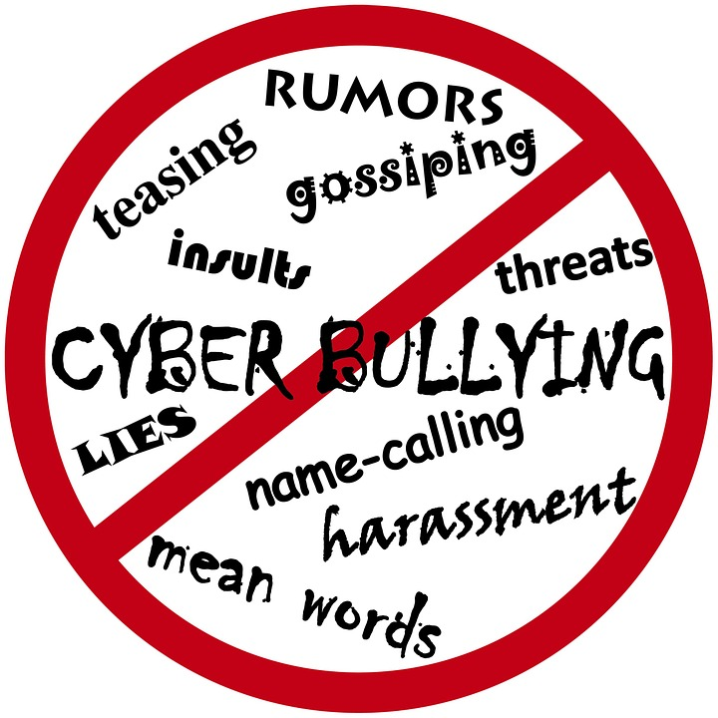
Examples of Bullying
- Name calling
- Negative comments
- Teasing
- Fighting
- Pinching
- Kicking
- Leaving a child out of events
- Not talking to the child
- Singling the child out
- Isolating the child from other children
- Peer pressuring a child into doing things they wouldn’t normally do
- Spreading rumours
- Threatening
- Ganging up on an individual or vulnerable group
- Making fun of a person

Signs of bullying

Each child will respond differently to bullying. If you notice your child acting differently or not engaging with you or wanting to be alone. These are likely signs the child is being bullied. The below are some of the effects on the child’s health: -
- Under eating
- Over eating
- Quiet
- Not wanting to socialise
- Spending most of their time alone
- Anxiety
- Depression
- Some may become violent
- Change in sleeping patterns
- Not wanting to do things they once enjoyed
- Self-harm/ Suicidal thoughts
- Missing school
- Complaining of illnesses to avoid going out
- Bruises or other injuries, often
- Lower school grades
Younger children
Brothers/ sisters
Who can the bullies be?
Anyone can be a bully, but some people may not always be considered
Team mates
Lola’s Story
Bullying began when she was 8 after suffering from anxiety at the age of 4.
“As time went on I then began feeling very depressed. I found it difficult to go school. I had no motivation and I didn't want to leave my bed as I felt worthless to everyone”
Lola was blackmailed, couldn’t get involved in activities, feeling depressed causing her to have an eating disorder.
“After contacting Childline I felt like a weight had lifted from my shoulders. I had kept everything bottled up for months.”

Childline (2019)

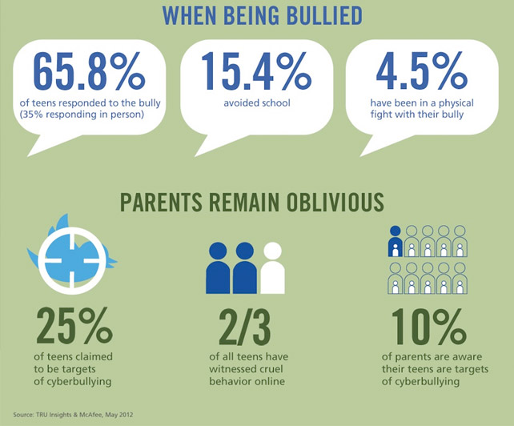
Short term effects
- Unhappy
- Insecure
- Feeling of worthlessness
- Feelings of being alone
- Not good enough
- Physical reminders
- Withdrawn behaviour
Long term effects
- Unable to trust
- Anxiety and depression
- Relationship issues
- Less chance of work progression due to not feeling good enough
- Difficultly dealing with life problems
- Reminders of the past effecting the victim’s adult life
- Children who get bullied usually hide the fact they are being bullied, due to the bullies threatening them, or because they are too scared and embarrassed to confide in anyone.
- As the bullying gets worse the child feels isolated and feels they have nobody to help them. So, they will just hope it goes away.
- Children find it difficult to trust people especially when they have been made to feel nobody will listen to them. The child needs to be supported and helped through bullying. By being there for them to talk to, and to help encourage them.
Cousins
Other family members
School friends
Older children
Neighbours
Treatments/ Interventions for bullying victims

Counselling
- Helps a child talk about how they feel, build confidence and trust in other people.
- Counselling can be done individually, and potentially in small groups where the child can meet other children going through the same problems as them. This can help build new friendships and stop children being isolated.
- Counselling can be done in school and outside
- Family can be involved in counselling, with younger children, doing activities and playing games are included in counselling sessions
- These sessions are to help the child understand that bullying is not acceptable, children are taught how to deal with bullying, and to help them understand there are people around to help them.
- Therapists help find strengths of the child, and help them believe in themselves and what they are good at
Cullinan, C.C. (2018)
Cognitive Behaviour Therapy (CBT)
- From age 8 is effective for this therapy
- Can be done individually, in a group or with family members.
- Encourages and shows the child how to relax
- CBT is a good therapy for children because it can help them think differently, and how they see themselves. Can help remove the negativity and feel more confident and happier.
- Teaches children about coping with challenging situations
- Can take up to 20 sessions to see changes.

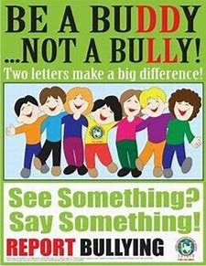
37% of all victims developed social anxiety and 36% developed depression

The child should not respond to cyber bullying
Confide in someone they trust
Children should try and stay with close friends for support around bullies
Try and brush off the bully by smiling and standing up for themselves, even though hard when in the situation
Remind the child they are loved and supported
Try and encourage the child to show confidence around the bully, this may stop them from targeting your child.
Good therapy (2018)

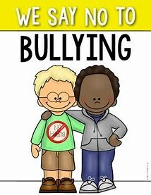
Self-help & Advice

6% of children bullied daily
1-4 children get bullied regularly

40% of young children bullied in the last 12 months

24% of bullied children are kept off school due to parents

26% have been called names
18% excluded from groups

15% of bullied children, get excluded from school within 12 months

Disabled children twice as likely to get bullied

Research as above from the Anti-Bullying Alliance in 2016 with over 13,000 pupils aged between 7 and 15 across 44 schools in the UK.
National Children’s bureau (2017)


Help and Advice
help@nspcc.org.uk
https://www.childline.org.uk/
Freephone 24h helpline: 0800 1111
https://www.themix.org.uk/
Freephone: 0808 808 4994
https://www.nationalbullyinghelpline.co.uk/
Call: 0845 22 55 787

References
Childline (2019) Bullying Lola’s story. Available at: https://www.childline.org.uk/get-involved/real-life-stories/bullying-lolas-story/

Cullinan, C.C. (2018) Taking your child to a therapist. Available at: https://kidshealth.org/en/parents/finding-therapist.html

Good therapy (2018) Bullying support. Available at: https://www.goodtherapy.org/learn-about-therapy/issues/bullying/bullying-support

National Children’s bureau (2017) Anti bullying Alliance, Prevalence of bullying. Available at: https://www.anti-bullyingalliance.org.uk/tools-information/all-about-bullying/prevalence-and-impact/prevalence-bullying?gclid=EAIaIQobChMIvq60u-3Z3wIVS5PtCh1wFQdKEAAYASAAEgJ03PD_BwE

UK wristbands Ltd (2017) Bullying statistics in 2017. Available at: https://www.ukwristbands.com/bullying-statistics

https://www.bing.com/images/search?view=detailV2&ccid=QIgO%2BYDK&id=9AB42883B81AD5D5B94B38727FA34A13DD0D4A08&thid=OIP.QIgO-YDKTxMkOtD97t28kAHaJm&mediaurl=http%3A%2F%2Fnewsite.gba.edu.kw%2Fwp-content%2Fuploads%2F2018%2F04%2F2.jpg&exph=780&expw=602&q=Stop+Bullying+in+Schools&simid=608004700065303986&selectedindex=22&ajaxhist=0&vt
https://www.bing.com/images/search?view=detailV2&ccid=s%2fDHJt2S&id=83F16560908592916150BBAEE53812F6CE8EF22F&thid=OIP.s_DHJt2S2L__s-nvnLfgjwHaGI&mediaurl=https%3a%2f%2fiic2015.files.wordpress.com%2f2015%2f01%2f11.jpg&exph=532&expw=642&q=bullying+details&simid=608039837214835740&selectedIndex=0&ajaxhist=0

