
Digital Skills And Research Methods BMSW4003
Lecturer : Balendran Kandasemy
Andreia Buliga 2018956

Contents
Abstract 2
Introduction 2
Literature Review 3
Primary Research 4
Methodology & Sampling 4
Results 4
Limitations of the study 7
Conclusion 7
References 7
Appendix A 9
Appendix B 9

Abstract
This research will discuss about the impact of the Virtual Learning Environments on the students of UWTSD it’s a qualitative and quantitative research that aims to identify how students are coping with the virtual learning (online), this data is essential to understand learners needs. The impact of implementing the VLE Course at UWTSD. According to UWTSD there are over 25.000 students across 17 campuses in rural and city locations. In my research of the VLE I have conducted a questionnaire for approximately 30 students that aims to find out what are the experiences of the students that are learning virtually using Teams, Moodle, online library etc. whether it has a positive or negative on their learning.

Introduction
UWTSD is an employment-focused university who is dedicated to ensure that their students with diverse background are developing the academic knowledge and practical skill to succeed within their career. “Known for our friendliness, UWTSD ranked 1st in the UK for Course and Lecturers in the Whatuni Student Choice Awards 2020.” (UWTSD, 2010)
VLE (Virtual Learning Environments) it is web based and accessible to both lecturers and students, is used for the students to improve digital skills to access remote courses for example if university provides online courses, they can study remotely using VLE. It is a very essential the development of this skill for individual development of a student. The active learning in the students promotes skills of critical thinking as essential for use or transfer of the classroom knowledge gained among the critical thinking.
Components of VLE
The major components of the VLE are the entire mapping is “Eight-Dimensional E-Learning Framework”, constructive alignments in the students and Technological framework.
According to Martelloniet al. (2018), the VLE is used for developing the awareness of its value as the effective evaluation between the students as well as it helps in improving the digital quality and skills among the students. The virtual people and the online communities are the group of the students who are firstly speaking by the internet in-order-to learn and explore more. As explained by the Ahmadet al.(2019), online communities are also becoming complement as the carrying out communications in the “real-life” by the students and teachers who are known to each other regarding the learning aspects.

Literature Review
I have conducted a research study to find out what others have found in their universities about the impact of VLE case study. It is based on material from Jenny Barker and Peter Gossman at university of Cumbria. In their research they have found that the use of VLE
has an impact on the achievement of students, that the use of a VLE encourages independent learning, and that the use of a VLE increases students’ motivation to learn. (Jenny Barker and Peter Gossman). This data confirms that use of a VLE encourages independent learning with the opportunity to learn informally at a time, place, and step to suit the learner providing flexibility for students to fit course work around busy lives (see JISC, 2007)
The literature review also provides evidence that the use of a VLE increases students’ motivation to learn, promotes communication and collaborative learning, via the use of forums, chat and email for discussion and that the direct feedback is highly motivating. (JISC, 2009b). This data suggests that VLE has a positive impact on student learning.
I have read from another article who has also conducted a research project for the impact of VLE on students at Kingston University who is based on UK, It discusses the features of the VLE that are most valued by students (including their evaluation of more flexible modalities of learning); how students integrate the VLE with other learning and studying activities; and the specific ways in which various learning styles and approaches affect VLE use.
A negative impact of VLE is that the web-based instruction does now allow students to socialize and interact very well to one another which usually happens in a traditional classroom. Therefore, the students can be less satisfied with the learning procedure.
A positive impact on VLE is that more students can take park and complete their studies as there is no need to travel, for example if they have children or have a busy schedule and are not able to study but just online from home.

Primary Research
I have carried a quantitative research survey in form of e-questionnaire using Microsoft Forms, and the analysis was carried out by using excel to generate a quantitative data of the information gathered from the survey. I have sent message to my colleagues in class to complete the survey which only takes 1 minute and 35 sec. to complete, also I have sent to the students of UWTSD in-order-to gather the information on the impact of VLE students.

Methodology & Sampling
The methodology used for this research was throw teams survey which helped me to understand what categories of students finds more useful the use of VLE for example the different group of age, gender etc. the sampling was used by random students of UWTSD I have used my Teams group and WhatsApp group to ask students of UWTSD to take part of the online survey.
The questionnaire I have created had multiple section which was open questions, closed question, and sub - question, to which respondents of the questionnaire could select a point on a Likert scale. It was given to students to complete within 2 weeks to make sure I have many samples to use in my research.

Results

During the 2 weeks of the survey, 38 questionnaires were completed by the UWTSD student, 20 female and 17 male students. I will show my results using graphs.
Q1.
This result shows that 54% out of 38 students were female who completed to survey.

Q2.
This survey shows that the highest rated age group where between 26 to 35 with a 46% and also 35% where between 18 to 25 and only 19% where between 36 to 45 who completed the survey there results show that there where no students over the age of 46 .
 | 18 to 25 | 26 to 35 | 36 to 45 | Over 46
Age-category | 13 | 17 | 7 | 0

Q3.
These results show that most students are using Moodle as part of their studies and only 10 students who indicated that they use it occasionally.

Q4. Most of the students where given instructions before starting their classes to use Moodle efficiently but only 4 out of 37 students indicated that they had difficulties when accessing Moodle/

Q5 Students has shown that they are able to use Microsoft office 365, 27% of the students where extremely confident on their use of office 365, 35% were confident ,24% of students where neither confident or unconfident of their use, 11% of students indicated that where unconfident on using office 365, and only 3% which is one student who said that was very unconfident.

Q6. 43% of students has agreed that the remote learning is efficient, 19% of students strongly agreed and 22% where neutral which means it makes no difference for them 11% of students disagreed that the remote learning is efficient and 5% ( only 2 students ) strongly disagreed.

Q7. Most of the students said that they would like to see additional services provided by the VLE, this is withing the UWTSD university for example more articles to help with essays, etc 26 students out of 37 wanted to see more services by the VLE 6 students where not interested In seeing more services and 4 students where neutral.

Q8. The students has showed an even answer as in 35% prefer origonal class and 30% prefer remote the other 35% of students where neutral this means that for them is good either way being online or in the original class.

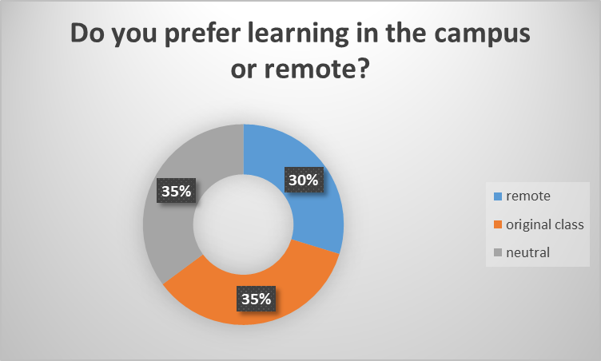

All questionnaire results were anonymous, the students that took part where informed of this before completing the survey.

Limitations of the study
There are many limitations on the study case as an online student I am not able to go to the university to talk face to face to students and tell them that they should take part of a survey in order to have more samples but is also possible by using social media just that the response is not as high as it could be.
If you cannot see the student, you lose verbal communication and make the student not interested to engage in surveys, therefore it is more difficult to engage electronically and convey their enthusiasm, but with the good use of communication it can also be done.
It also has limitations due to the time available to conduct this survey, as people take time to respond.

Conclusion
This data that I have collected across the survey has showed that the VLE has a positive impact on the students of UWTSD this means that most of the students are happy to study from home either because it motivates them more or because is more convenient as they can do more from home if they have a busy life, the only negative impact is that there is no real connection with the students and engagement with the lecturers, they cannot get to know each other as in a traditional classroom and interact, meet to practice for group presentation in class but it is also possible online.
In my own opinion as a student of UWTSD I also enjoy studying from home, is more difficult that being in a traditional classroom because if you are distracted with very little things for example children around you can affect the way you understand the topics that are teacher in class but if you are not able to leave home then is very convenient to study remotely.

References

Coursehero, n,d “digitall skills” the VLE definition” -
Available online at: https://www.coursehero.com/file/60857231/Digital-skillsdocx/
( Accessed on 27 March 2021)

Íkala vol.22 no.3 Medellín Sep./Dec. 201 - Available online at: http://www.scielo.org.co/scielo.php?pid=S0123-34322017000300479&script=sci_arttext&tlng=en ( Accessed on 27 March 2021)

Jenny Barker and Peter Gossman (2013), University of Cumbria “the impact of VLE article” available online at https://core.ac.uk/download/pdf/29422368.pdf (Accessed on 27 March 2021)

JISC, (2007) “ Abstract” Available online at URL:
https://www.tandfonline.com/doi/full/10.1080/02671520701651797 (Accessed on 28 March 2021)
UWTSD,(2010) Students – Available online at URL: https://uwtsd.ac.uk/about/#:~:text=The%20UWTSD%20Group%20includes%20Coleg,in%20rural%20and%20city%20locations. (Accessed on 28 March 2021)
University of warwich, 2010 “ limitations” learning through technology”- Available online at URL: https://ials.sas.ac.uk/ukcle/78.158.56.101/archive/law/resources/enhancing-learning-through-technology/vles-faq/four/index.html (Accessed on 5 May 2021)

Appendix A
This is some of the exercises we were given to complete in class. I have taken parn in more activities but this are the only I can provide at the moment.
https://uowtsd-my.sharepoint.com/personal/2018956_student_uwtsd_ac_uk/Documents/Digital%20Skills/DSR%20task%201.docx

DSR New.docx

DSR task 1.docx

my Presentation.pptx

Appendix B
In this group message I have sent my link to the students of UWTSD to answer my survey of virtual learning environment. I have also sent them via Whatsapp.
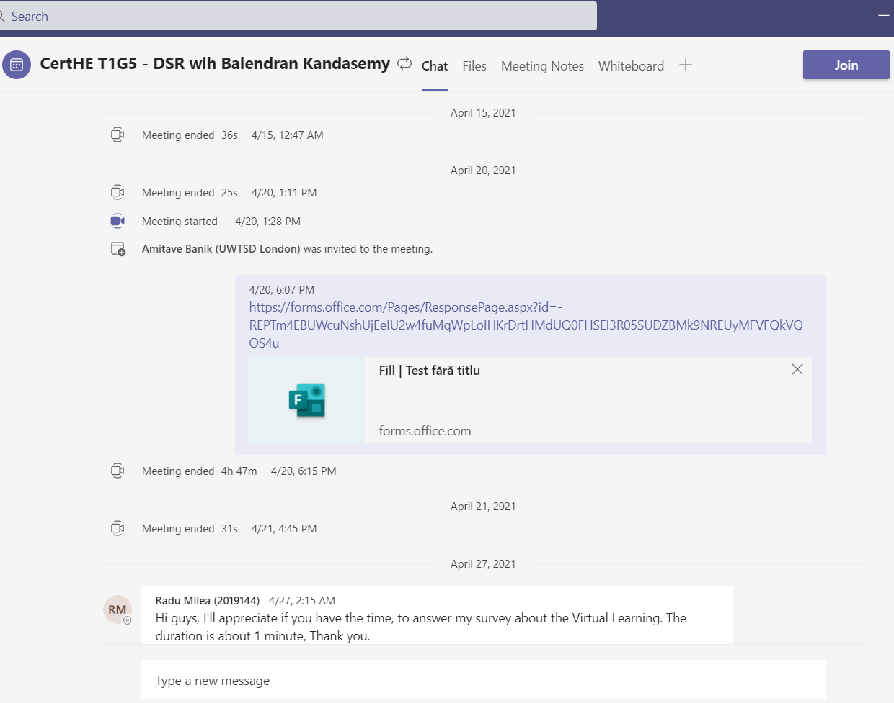
This is the outcome of my survey in excel, from this data I have created the above charts of information.
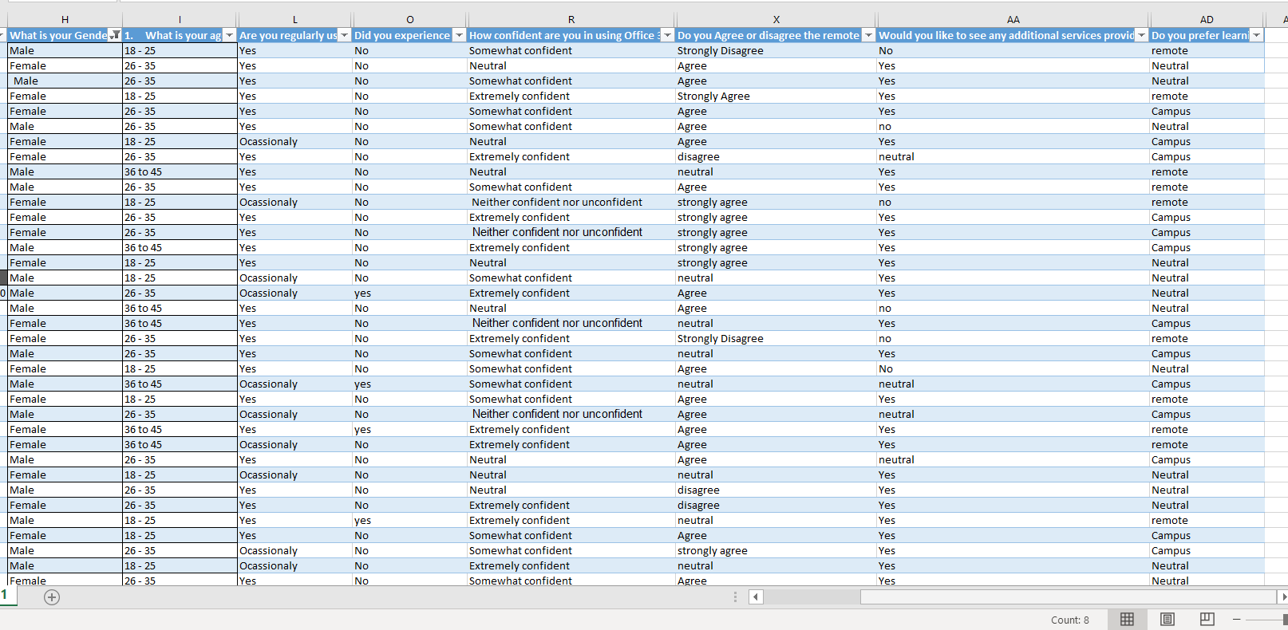
Appendix 1. Questionnaire of VLE
- What is your Gender?
Male

Female

- What is your age category?
18 - 25

26 – 35
36 - 45
Over 46

- Are you regularly using the VLE as part of your learning?
Yes

No

Occasionally

- Did you experience any difficulties accessing the VLE?
Yes

No

If so, please give details.
- How confident are you in using Office 365 Online?

Very confident
Confident

Neither confident nor unconfident

Unconfident

Very unconfident

- Do you Agree or disagree the remote learning via Teams is efficient?
Strongly Agree

Agree

Neutral

Disagree
Strongly Disagree

- Would you like to see any additional services provided via the VLE?
Yes

No

if so, please give details

- Do you prefer learning in the traditional class or remote?
Traditional class

Remote

Neutral

This is my online questionnaire, I have used Office Forms.https://forms.office.com/Pages/ResponsePage.aspx?id=-REPTm4EBUWcuNshUjEeIU2w4fuMqWpLoIHKrDrtHMdUQ0FHSEI3R05SUDZBMk9NREUyMFVFQkVQOS4u

