ADFM4018

Interpreting A
Screenplay

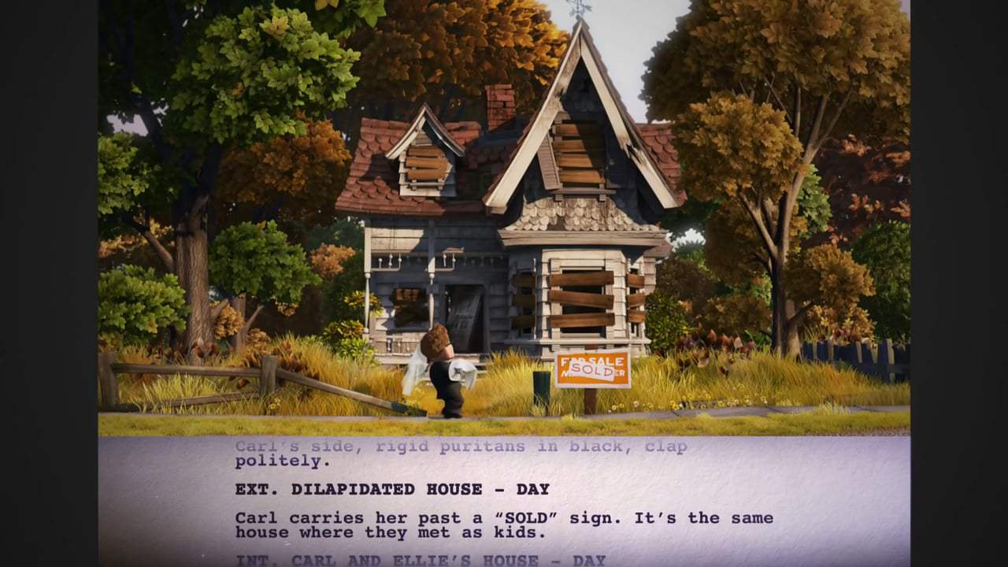
Up (2009), dir. Pete Docter.

MODULE HANDBOOK
2019-2020

Interpreting A Screenplay

Overview
Visualising the written word

Highlights

- The tyranny of the majority - why challenge conventions?
- Alternative voices – innovators and entrepreneurs
- Inconsistency and the auteur
- Meaning in dialectical montage

Level 4 module – 10 credits

Assessment - 100% - Portfolio

Teaching is by lecture, seminar and, where appropriate, hands-on workshop.

Module Tutors;
John Hill, Zena Martin, Nikki Davies

Please make an appointment with your tutor for a tutorial if you have additional questions not covered in the sessions. If you need to consult the course team urgently, please email the staff member concerned. Additional support times / production surgery will be indicated on your timetable. The room will be available at this time and there will be a member of staff available for support and to answer questions.

Module Outline
AIM(S)
- The aim of the module is to express the visual translation of the written word.
LEARNING OUTCOMES

Upon successful completion of this module, a student should be able to demonstrate the ability to:

- Identify and review a range of relevant creative practices

- Express and defend methodologies and actions within the context of a production team

CONTENT
This must be accompanied by a short, academically rigorous essay of fifteen hundred words, summarising the learning activity during the module and predicting where this newfound knowledge might be most useful to the student.

Indicative content
- Indicating the visual arcs within a story
- Classifying thematic elements
- How emotional tones are recorded
- Underscoring and contrasting
- Physical asset identification
- Digital assets and nomenclature
- Marking up a screenplay

The following software/hardware may be used on this module:

Adobe InDesign, Adobe Photoshop, Adobe Illustrator, Microsoft Word.

ASSIGNMENT OUTLINE

Assignment Tasks

You are asked to complete three interrelated tasks in this module.

Task One

Individually, you will use a given screenplay and discover how to line it in a recognisable industry format, creating an accordion album portfolio that explores its opening scenes. You are asked to produce imaginative responses and detailed options for these scenes. The scene is to be designed as a full scale set and should contain the following:

- Reference images
- Sketches & technical drawings
- Set ideas
- Props
- Composite images

Task Two

You will be asked to collaborate in groups of two, to devise a dressing plan for one scene from a chosen screenplay. There will be a range of screenplays to choose from, pick one that best suits your pairing then line it.

Implement this dressing plan in a chosen location where you have freedom to customise the space. As a set decorator for the lined scene, you will be sourcing found elements which can be adapted to create visual hints and add depth to the scene. The outcome from this part of the project will be a series of stills photographs of the final set.

Task Three

As a key part of the assignment, you should write a short, academically rigorous essay of fifteen hundred words, summarising the learning activity during the module and predicting where this newfound knowledge might be most useful to you. This will be submitted via Turnitin.

Feedback

Feedback Date 20 days after the date of assessment

Feedback is an essential part of all education and training programmes. It helps learners to maximise their potential at different stages of training, raise their awareness of strengths and areas for improvement, and identify actions to be taken to improve performance. Feedback can be seen as informal (for example in day-to-day encounters between teachers and students or trainees, between peers or between colleagues) or formal (for example as part of written or clinical assessment). However, there is no sharp dividing line between assessment and teaching in the area of giving feedback on learning. Feedback is part of the overall dialogue or interaction between teacher and learner, not a one-way communication.

During your studies you will therefore receive feedback in many ways, including the following:

- Dialogue between lecturers and students in formal classes.
- Direct questions and responses from teachers inside and outside formal classes.
- Email correspondence between teachers and students.
- Interactions between students and teachers using the module message board on Moodle.
- Informal comments and responses to pitches and presentations in classes.
- Comments and annotations added to written submissions, such as essays and reflective journals.
- Formal written feedback in response to assignments recorded on the summative
- Assessment module feedback forms.
- You will have an opportunity to discuss your feedback with your tutor.
- Feedback will be returned on assessed work within 20 working days of submission.

MODULE TIMETABLE

** You will be expected to conduct non-assessed tasks as part of your development on this module. This will include filming outside of the classroom environment. **

Module Evaluation

At the end of this module, you will be asked to complete a module evaluation form. Please refer to the anticipated learning outcomes when making your evaluation.

SCHEME OF WORK

 | Indicative Content | Time | Date | Room
1 | - Interpreting A Screenplay – Overview – Assignment Brief  - How screenplays work – Transformation, Conflict & Character  - Breaking down a screenplay | 1000-1300
2 | - Design and storytelling  - Visualizing concepts and metaphors  - Presentation – work in progress | 1000-1300
3 | - Character research  - Building characters’ worlds  - Externalizing the character | 1000-1300
4 | - Studio versus location  - Inventing everything or augmenting everything  - Presentation – work in progress | 1400-1700
5 | - Realism versus stylization  - Truth and representation  - Art and abstraction | 1000-1300
6 | - Colours and textures  - Creating mood to enhance the story  - Presentation – work in progress | 1000-1300
7 | - Conflict and contrast  - Visualizing conflict in sets  - Using contrast for storytelling | 1000-1300
8 | - Presentation – work in progress  - Plenary – writing the reflective essay | 1400-1700
Portfolio Submission Deadline: Monday 9th March, 2020
9 | - Feedback on Portfolio submissions | Feedback tutorials week commencing 16/03/2020

This scheme of work is indicative and subject to change

MODULE RESOURCES

Reading List:

Essential

Barnwell, J., 2016. Production Design for Screen. Bloomsbury Publishing.
McIver, G., 2016. Art History for Filmmakers: The Art of Visual Storytelling. Bloomsbury Publishing.

Recommended

Whitlock, C., 2010. Designs On Film: A Century of Hollywood Art Direction. It Books.

Rizzo, M., 2015. The Art Direction Handbook For Film & Television. Focal Press.

Thompson, K. and Smith, J., 2017. Film Art: an introduction. McGraw-Hill Education.

Web Sites
http://www.filmdesigners.co.uk
https://adg.org/

Note: Students will also be directed to project-specific resources during the course of the module when they are available and appropriate.

