Logbook Workshop Skills

Bayram Buyukertas
2104373
Workshop skills/Learning in the digital era
Electrical and Electronic Engineering

Week 1:
I began this module by firstly going over everything that would be covered. I was shown a document detailing everything I needed and what had to be done over the next few weeks. I need to simulate a single supply, non-inverting amplifier with a gain of 3 circuit on proteus and test it, recording all results on a word document, then I need to build the same circuit on breadboard repeating the testing and results process, but this time I would be using the universities lab equipment instead of proteus’ testing function to test for the results. Finally, I will be building up and testing my own PCB.
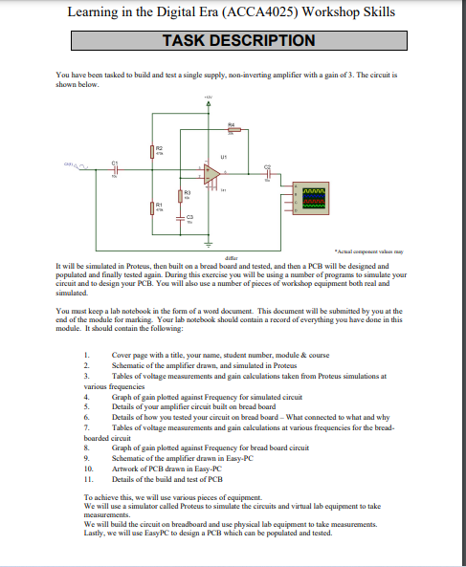
I carried on this lecture by having my first glimpse of proteus, searching for the components I would be using, building up small circuits and overall getting used to the software.

Week 2:
In this lecture, I started off building the circuit onto proteus. After last week’s session, I got to grips with using proteus and had an idea on how to use it.
After building the circuit, I edited thee properties of each component (power, capacitors, resistors etc.) so that they all had the correct values.
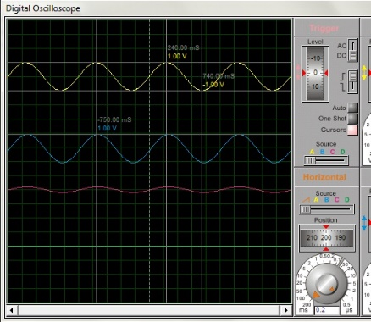
Once everything was correct, I clicked the run button where the oscilloscopes visual waveform screen popped up. I adjusted the frequencies of the waves and the positions so that it was as visually clear to me so I could take accurate readings.
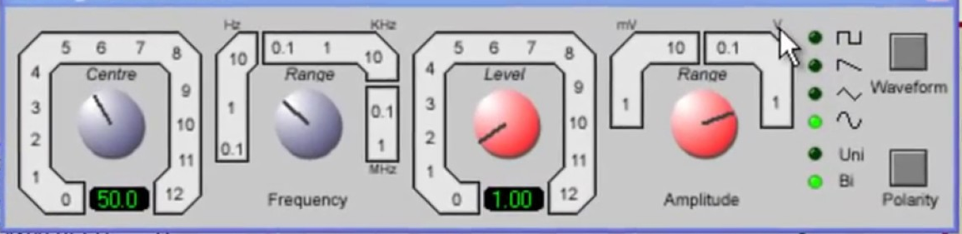

Using the scales above I was able to begin testing. I adjusted the centre to change the value of frequency as I was testing different frequency values. Once I needed higher value frequencies, I would adjust the range scale to get higher values.
Week 3:
Carrying on from last week, I finished of testing the circuit and recording my results on to a word document. Changing the frequency (Hz), I managed to find a very good range of voltage reading. I changed the frequency to find the closest result I could find as possible. These were my results. Using my results, I was able make a graph of gain, where I was able to see the peak of my results and also the rise and decrease.

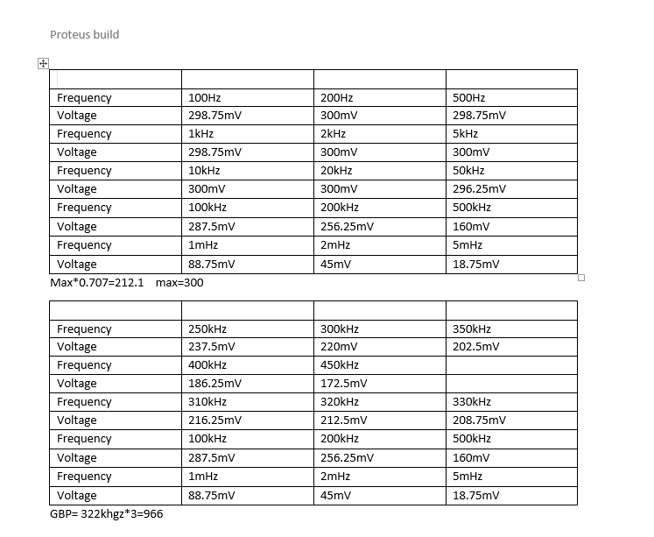

Week 4:
Starting off with breadboard. I spent most of this lecture learning how to use breadboard and how to test using a multimeter. I learned how to position wires on breadboard and how to link them to make the circuit run correctly. Using the small circuit, I built up I practised testing by using multimeter probes and crocodile clips, I was able to find the voltage (volts), current (amps) and resistance (ohms). It was really good practice.
Week 5:
This week we built up our module circuit up on the bread board.
I found myself struggling a lot to get this done as I was still not as familiar with working with breadboards as I would have liked to be. Also it was a much bigger circuit so I was having a hard time to fully work it out. Luckily I had my tutor Gary to demonstrate with an example circuit on how to fully piece together a working circuit on breadboard, which really helped me to finish of mine.
Week 6:
As I was having difficulties building up the circuit on the breadboard, I did not have time to test it last week. So today I began by testing my circuit using a multimeter. I connected my circuit to the earth, and also to the power. I then connected my multimeter and following all safety precautions I began testing. Following the same testing routine as we did with the proteus circuit I managed to get the following results, where I was able to fully compare and see the difference in my results.
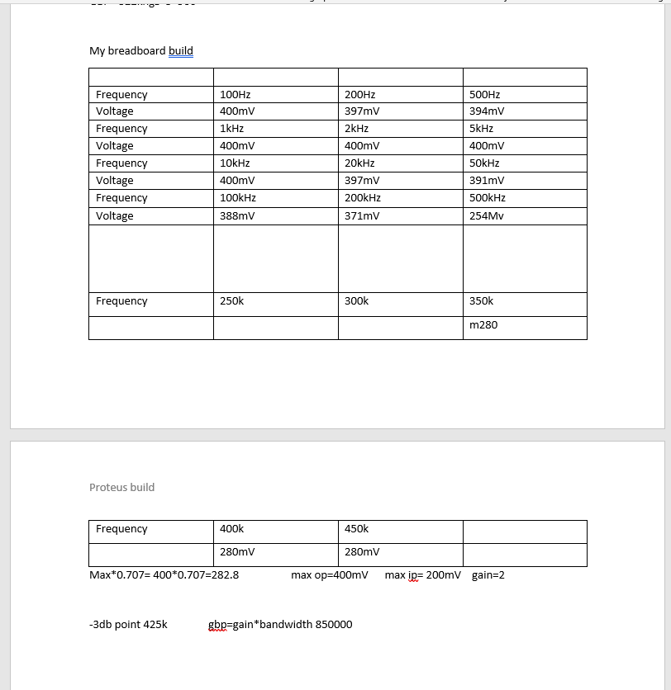
Week 7:
I started this lecture of by getting shown how to build up circuits using easy pc.
I found it very similar to using proteus so I found it fairly easy to put together the circuit with no practice runs.
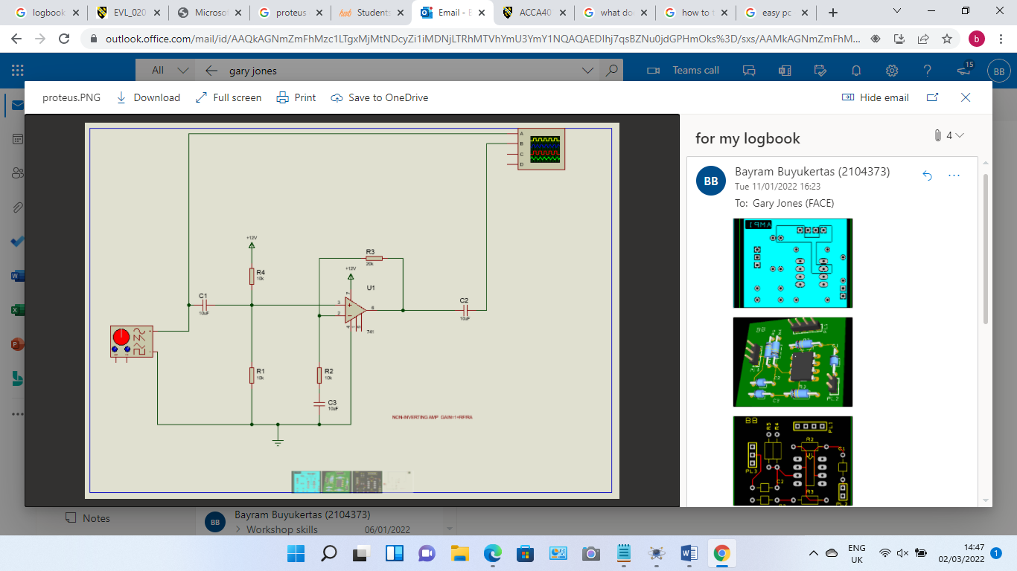

Week 8:
Now that the circuit was built, I was able to piece together the overall draw and layout of the circuit.
I found it quite difficult keeping my circuit neat whilst keeping it in the frame space, but in the end I managed to get there. I give the circuit the title on the top left hand corner of the front side of the circuit AMP1. I also signed off the back top left side of the circuit BB to show it is my circuit board.

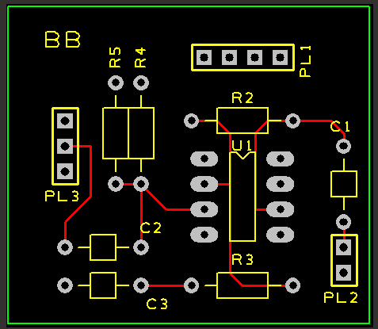
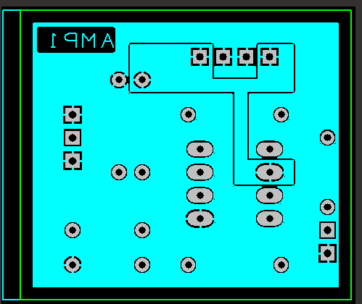

here you can see a 3D view of what my circuit board is going to look like
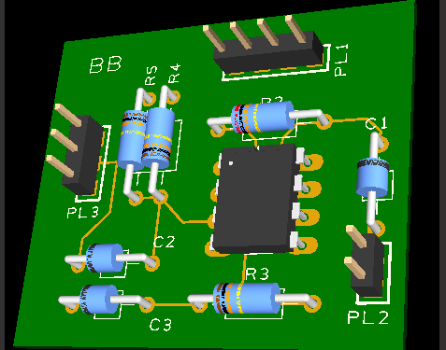

Week 9:
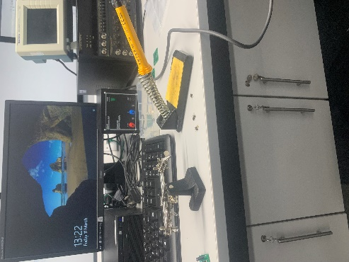
My pcb arrived so I was finally able to solder the components onto it. As I was not familiar with soldering before, I had a quick demonstration on how to solder safely and effectively. Using my spare pcb’s, I had a few practice runs where I was able to fully get the hang of it and to properly redy me for my final piece. When I was ready I began with my main pcb. I think I managed to solder the components together well however I did find myself struggling to keep the components tight to the board, But overall am happy with the outcome. Here is my finiished pieced all soldered and wired ready to begin testing.

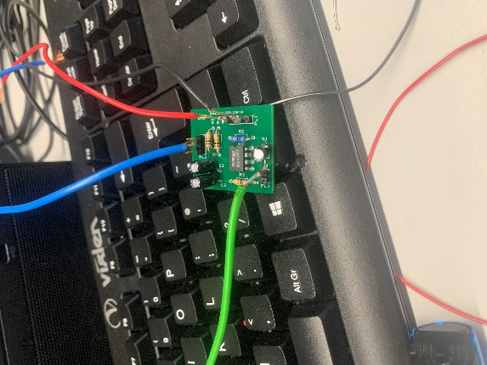
jhfjfhfhjfhjf

After wiring up my pcb to the oscilloscope using testing hooks and probes, I began testing. I tested it with a range of results starting at 100hz up to 20khz to the point where my voltage readings peaked at 302 mV. Using my max voltage reading of 302mVand MULTIPLYING it by 0.707 I was able to gather the reading 213.514. After recording the rest of my results my closest reading I was able to find to 213.514 was when I measured at 275kHz where it read 210Mv. This means my 3db point lies at 275kHz. My max op pk-pk was 280mv and and max ip was 121Mv I had a gain of 2.3. gbp= gain*bandwitch=275k*2.3=632,500gbp. Here is the table of my results.

Frequency | 100Hz | 200Hz | 500Hz
Voltage | 280 mV | 292mV | 296mV
Frequency | 1kHz | 2kHz | 5kHz
Voltage | 300mV | 300mV | 302mV
Frequency | 10kHz | 20kHz | 50kHz
Voltage | 302mV | 302mV | 298mV
Frequency | 100kHz | 200kHz | 500kHz
Voltage | 290mV | 256mV | 136mV
Frequency | 1mHz | 2mHz | 5mHz
Voltage
Max302*0.707=213.514

Frequency | 250kHz | 300kHz | 350kHz
Voltage | 226mV | 196mV | 171mV
Frequency | 400kHz | 450kHz
Voltage | 164mV | 149mV
Frequency | 275kHz
Voltage | 210mV
Frequency

