Emma Lawrence
Student Number - 2123569
Module Number - BMSK4013
Module Title – Management Communication

Statement of Confirmation of Authenticity
By the act of making this submission, the student declares that this is the work of the student named above. The work has not, in whole or in part, been knowingly presented elsewhere for assessment, or where assessment has been built on a previous assessment, this has been identified. Where materials have been used from other sources it has been properly acknowledged. If this statement is untrue, the student acknowledges that an assessment offence has been committed. Attention is drawn to the plagiarism and unfair practice policies of both the University and of ILM.

Contents
Definition of communication 1
Models of Communication 2
Verbal and Non-Verbal communication 4
Trust 5
Dealing with difficult communications 6
Motivation 6
Self-Evaluation 7
References 8

Definition of communication
The goal of communication is to transfer information from one party to another. Communication, according to Merriam-Webster, is the process or act of exchanging, expressing, or transmitting information and ideas through writing, speaking, and gestures. The keys to effective communication are in the hands of both parties. The expresser must deliver messages clearly, and the receiver must pay close attention. When the correct purpose of the message is communicated and comprehended, effective communication occurs. Active listening is required of both speakers and listeners.
There are five types of communication they are verbal communication, nonverbal communication, written communication, visual communication and listening.
- Verbal communication includes all forms of communication that include spoken words or unspoken words, such as sign language. To avoid misconceptions and maximise interest while speaking, it is critical to learn how to properly communicate your thoughts verbally. Use acceptable words, speak clearly, know your audience, answer appropriately, and use an appropriate tone when speaking.
- Non-verbal communication - What is stated is only half the battle; the other half is in what isn't expressed. Your tone, facial expressions, body language, hand motions, and eye contact are all examples of this. When you become aware of what the rest of you is doing while you speak, you may make corrections and finally use all the appropriate nonverbal cues to convey your argument.
- Written communication is a type of verbal communication, yet it differs so much from spoken verbal communication that it deserves its own category. Anything you write or type can be considered written communication, including letters, emails, notes, messages, billboards, and even a message written in the sky! It is critical to recognise your audience, your purpose, and to maintain consistency throughout your written message when communicating in writing.
- The delivery of information, messages, and points through graphical representations or visual assistance is known as visual communication. Slide presentations, diagrams, physical models, sketches, and illustrations are some popular examples. When you combine visual communication with verbal, nonverbal, and written communication, you create a very powerful method for your message to be received and comprehended.
- Listening is an incredibly crucial component of communication and mastering the art of listening is essential if you want to be a great communicator. Remember that listening is more than just hearing or respectfully waiting your turn to talk. As others are speaking, you should practise active listening, which includes activating your thoughts and focusing closely on what they are saying.
There are numerous communication barriers that can arise at any point of the communication process. Barriers may cause your message to get twisted, costing both time and/or money by producing confusion and misunderstanding.
- Stress - If you are stressed, it is likely to show in your tone and ability to listen effectively. You may be quickly irritated or have difficulty explaining your opinions.
- Body Language - The use of inappropriate body language gives the wrong message. Check that what your limbs, face, and eyes are doing corresponds to how you want to be viewed.
- Physical - Physical distractions are objects that can obstruct communication. The surroundings can be a fundamental physical distraction - the room may be too hot or cold, or the chairs may be unpleasant. A person sitting or standing behind a desk or lectern instantly establishes a physical barrier between sender and receiver.
- Time and space are also impediments to good communication. When an organization's departments are geographically separated, immediate, face-to-face contact becomes much more difficult. The time difference between co-workers on different countries can be a major communication obstacle in multinational organisations.

Models of Communication
The communication model is a methodical description of the procedure that aids in the comprehension of the human communication process. Models symbolise and conceptualise the process. They also assist in simplifying the intricate process of chatting and determining where and with whom communication takes place. Communication models are classified into three basic categories: linear, interactive, and transactional. Each model provides a distinct viewpoint on the communication process.
The following terms are frequently used in communication models:
- Message - A message is the information that a person receives from a source. When you write an email or give a speech, you are communicating a message.
- Source / Sender - This person depicts the person who is conveying a message to a recipient. It refers to where or whom information comes from.
- Receiver - The receiver represents the person who is receiving the communication. For example, when you listen to a speech, listen to a podcast, or study written content, you're the receiver in the process of communication.
- Noise - Noise is defined as any component that disrupts a communication flow and prevents the receiver from receiving the intended message. Physical noise, such as horn sounds or loud music, and encoded messages that cause a distraction in a channel are examples of this.
- Channel - Channels are mediums for communicating a message to a specific audience. Phone conversations, text messages, emails, video, radio, and social media are all examples of this.
- Encoding - This entails selecting the appropriate words and order to convey the desired information to an audience or receiver. To improve message encoding, the sender might mentally visualise the communication from the receiver's point of view.

One model of communcation I came across was the Shannon and Weaver. The Shannon Weaver model of communication was developed in 1948 when Claude Elwood Shannon and Warren Weaver published "A Mathematical Theory of Communication" in the Bell System Technical Journal. Shannon was a mathematician from the United States, but Weaver was a scientist. The mathematical theory was eventually dubbed the Shannon Weaver model of communication or the "mother of all models." This linear model is more technological than others.

Berlo’s Model of Communication
Berlo's model extends the Shannon and Weaver model. It breaks down the communication process into four steps: source, message, channel, and receiver. According to the model, key aspects such as the social structure and cultural background might influence communication between two people. As a result, the elements governing the message sent by the source influence how the information is decoded by the recipient.
David Berlo, an American communication theorist, developed Berlo's model in 1960, expanding the Shannon-Weaver model of communication into clear and separate pieces. Based on the Shannon-Weaver communication paradigm, Berlo's model is a one-way or linear communication framework.
David Berlo's SMCR Model of Communication represents communication in its most basic form. SMCR is an abbreviation for Sender, Message, Channel, and Receiver. Berlo's SMCR Model of Communication (1960) highlights the several components that comprise the basic communication process. This communication tool can be utilised for more efficient communication because it emphasises message coding and decoding.

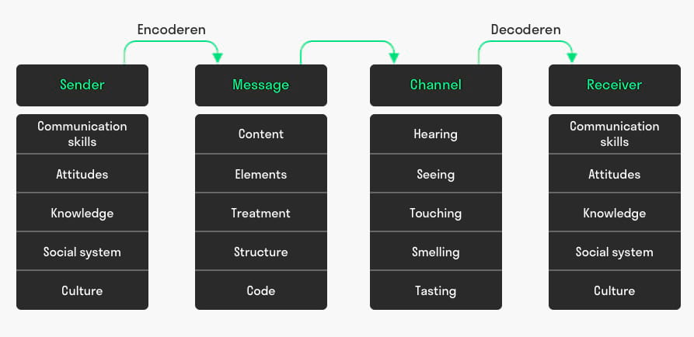

Verbal and Non-Verbal communication

Communication is the act of interacting with others and exchanging ideas. There are two types of communication: verbal communication and nonverbal communication. People convey their thoughts, ideas, and feelings using spoken or written words in verbal communication. Nonverbal communication employs nonverbal techniques such as body language, which includes facial emotions, gestures, and more.
Verbal Communication
Throughout talks, presentations, and everyday conversations, people utilise verbal communication to express themselves in a variety of ways. The effectiveness of this communication technique varies. It will be determined by several factors, including the volume of your voice, the tone you use, the clarity of your speech, and the calibre of the words you use. The response you receive will most likely give you a sense of how effective your communication is.
Consider your target audience and how you may change your message so they will pay attention and comprehend you to assist enhance the efficacy of your communication. With verbal communication, you have a lot of leeway in changing your message if you believe it is ineffective.
To do so, you must first confirm that your intended message has been sent. It is possible that the people with whom you are attempting to speak will misinterpret your words or the intent behind those statements.
The effectiveness of your communication is dependent on both the listener and yourself, and you have no influence over the listener—but you can strive to make your message as clear as possible. Nonverbal communication must also be considered in this process.
Non-Verbal Communication
Nonverbal communication is communication that occurs without the use of words. Nonverbal communication, although emphasising spoken words, can sometimes contradict them.
Tone of voice, body language, and eye contact are the three basic characteristics of nonverbal communication, and each has an impact on how people perceive your message.
- Tone of Voice - Your voice's loudness, pitch, and speed convey your emotions. It can assist others in determining if you are upset, confident, angry, and so forth.
- Body Language - Body language is the most obvious form of nonverbal communication. That might reveal a lot about how you feel to someone. If you have your arms folded when someone is speaking to you, they will likely believe you are not interested in what they are saying, however if you face the speaker with your arms at your sides, you will appear more interested.
- Eye contact - Establishing eye contact indicates to a speaker that you are engaged in their message. It can also help you stay interested in the conversation and grasp what the speaker is saying.
- Communication skills - whether vocal, nonverbal, or written, are essential in all parts of life. Understanding the differences between verbal and nonverbal communication is essential for improving your communication abilities. Understanding communication cues, such as keeping eye contact and employing body language that indicates interest in what the speaker is saying, can go a long way towards achieving effective communication.

Trust
Building trust at work is essential if you want to be a successful employee, manager, or leader. Often, the first step in establishing trust is to establish rapport.
It will be more difficult to interact and collaborate with your peers or colleagues if you lack trust.
You might be passed over for promotions in favour of someone more reliable. In severe circumstances, a lack of trust can bring your entire team or company to its knees.
When we talk about trust, we are referring to:
- Being able to feel secure and confident when dealing with someone.
- Being capable to foresee how someone will conduct themselves in various situations and be trustworthy.
- gaining a degree of reputation that has grown over time.
Some people are inherently gifted at establishing trust. Others may be unfamiliar with the process of establishing trust.
Employees in high-trust organisations are 74% less stressed. The inverse is also true. Working in a low-trust workplace can be stressful for everyone involved.
A boss or manager who does not trust you is less likely to allow you to operate on your own terms. They will be more prone to micromanage you and scrutinise your job.
Co-workers who do not trust you are unlikely to collaborate or assist you. You are also unlikely to be invited to after-work gatherings or functions. It is critical to establish and sustain confidence in teams from the start. Others may view you as less trustworthy if your credibility begins to erode. Because individuals are hesitant to befriend untrustworthy people, your workplace perception may continue to deteriorate. Trust is more vital than ever now, with more employees working from home as part of a virtual team. A remote workforce must be highly trusted.
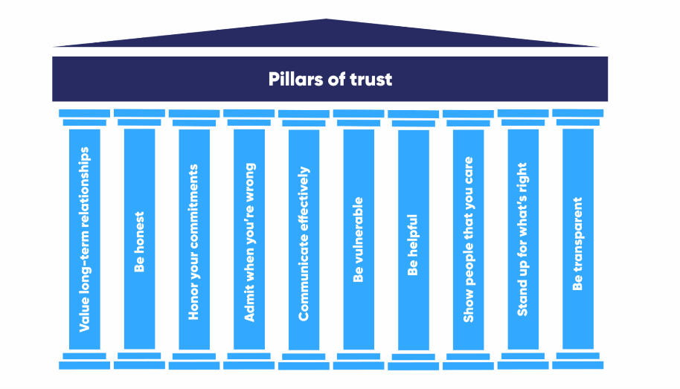

Dealing with difficult communications
It is human nature for most people to avoid conflict and possibly uncomfortable circumstances. Individuals often find it easier to postpone sharing anything they believe would be contentious or negative, deferring communication and allowing the issue to worsen. Putting off tough communication circumstances, on the other hand, frequently leads to feelings of frustration, guilt, annoyance with oneself, rage, a loss of self-confidence, and, eventually, increased stress and worry.
There are a few factors that make communication seem difficult.
- Emotion - When confronted with unexpected news, we may become disturbed, annoyed, angry - or incredibly delighted and excited. It is beneficial to recognise how we react emotionally to things and to consider different methods in which emotions might be regulated if necessary. Similarly, when communicating facts that may have an emotional impact on another person, it is helpful to anticipate that impact and modify what we say or write accordingly.
- Change - People react to change in different ways. If feasible, consider the positive aspects of the shift and the potential opportunities that it may bring. It is healthier for an individual's well-being if they can embrace change as positively as possible, reducing stress and anxiety.
Emotions and transitions can make communication difficult, regardless of whether it is planned or unforeseen. Little techniques like being aggressive, emphatic, well-prepared, and open to bargaining might help you deal with a challenging talk. Therefore, it is critical to listen, employ proper verbal and nonverbal communication, and remain calm and attentive. Communicating gets simpler when we are relaxed. Take some deep breaths and attempt to maintain a calm demeanour; others will follow suit if you do. Maintain your focus on what you want to say and do not deviate or become distracted from the reason you are talking.

Motivation
Maslow's hierarchy of needs is a theoretical model that describes numerous human motivators based on our basic needs and desires. Because of its utility in the workplace, this theory has gained popularity among business leaders and intellectuals. Managers can apply this approach to encourage people, boost job happiness.
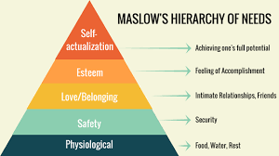

Douglas McGregor, a social psychologist, established two opposing hypotheses in the 1960s that explained how managers' beliefs about what motivates their employees can influence their management style. He dubbed them Theories X and Y. These theories are still relevant today.
Theory X managers have a negative perspective of their employees, assuming that they are intrinsically unmotivated and resent their work. This management style presupposes those employees:
- They produce work that they dislike.
- Avoid taking on responsibility and require regular guidance.
- To deliver work, they must be controlled, forced, and intimidated.
- Every stage must be supervised.
- Are not motivated to work or ambition, and hence must be tempted by rewards to attain goals.
Organizations that use the Theory X approach, according to McGregor, typically have numerous tiers of managers and supervisors to oversee and direct personnel.
Theory Y managers have a positive attitude towards their employees and employ a decentralised, participatory management approach. This enables managers and team members to form more collaborative, trusting relationships. This management style presupposes that employees are:
- They are willing to work on their own initiative.
- Greater decision-making power.
- They are self-motivated to finish their tasks.
- They enjoy taking charge of their work.
- Seek and take responsibility and require little guidance.
- Consider your job to be both fulfilling and difficult.
- Address challenges in a creative and imaginative manner.
Although both management styles can drive employees, the effectiveness of each is primarily dependent on your team's requirements and desires, as well as your organization's goals.

Self-Evaluation
GOAL | ACTIONS | TARGET DATE
To further develop my skills and qualities | - Complete university course  - Practise skills from home | October 2023
Keep up to date with university work | - Allow myself o complete tasks without rushing.  - Being organised and understand what is required and when its required.  - Motivate myself to get on with task | Ongoing throughout 2023
Become more motivated to achieve good grades in my course | - Attend all lectures where possible.  - Complete work to a good standard and on time.  - Become more involved in course activities and group tasks. | Ongoing throughout 2023

Before beginning this programme, I did not believe in the efficacy or utility of self-assessment instruments. After completing multiple self-assessment activities, I realised that, as simple as they may appear, certain exercises are quite tough since they force me to evaluate myself from several perspectives. I was surprised to discover that I am truly adaptable enough to challenge my deeply ingrained thoughts and beliefs. This module has assisted me in identifying my flaws, which I intend to address in order to progress personally and professionally. They include my management abilities and my proclivity to base my actions and decisions on a fixed set of ideas and habits, thereby ignoring alternative alternatives. I've also learned to value the importance of my prior experiences, which I believe I should analyse more thoroughly and share with others in order to develop greater self-awareness. I understand how difficult it can be for a leader to organise numerous people with diverse ideas, points of view, personalities, and backgrounds, which may easily lead to ineffective, long-lasting confrontations. When I asked myself how I would respond to a coworker who refuses to compromise because she believes her ideas are always the best, I immediately imagined myself avoiding any form of direct confrontation due to my peaceful nature. However, there are times when withdrawing from a conflict would do more harm than good. I concluded that the best way to argue with someone who believes they are always correct is to collaborate by addressing my concerns with her and encourage her to find a solution that works for both of us. I wish to become familiar with various organisations' codes of conduct in order to gain a better knowledge of what employers expect from their employees in terms of ethical behaviour.

References

- The Difference Between Verbal and Nonverbal Communication | Social-02-19T23:17:58+00:00, 2021-last update. Available: https://socialskillscenter.com/the-difference-between-verbal-and-nonverbal-communication/ [Mar 8, 2023].
- Communicating in Difficult Situations | Serengeti-11-26T11:24:47+01:00, 2019-last update. Available: https://serengetitech.com/careers-blog/communicating-in-difficult-situations/ [Mar 8, 2023].
- Shannon and Weaver Model Of Communication. 2018.
- Barriers to Effective Communication | SkillsYouNeed.
- How to Build Trust in the Workplace: 10 Effective Solutions. Available: https://www.betterup.com/blog/how-to-build-trust [Mar 8, 2023].
- What is Maslow's motivation theory (and how to use it at work)?. Available: https://uk.indeed.com/career-advice/career-development/maslow-motivation-theory [Mar 8, 2023].
- What is the communication model? (With how it works). Available: https://uk.indeed.com/career-advice/career-development/the-communication-model [Mar 7, 2023].
- JANSE, B., -02-28T06:45:20+00:00, 2023-last update, David Berlo's SMCR Model of Communication Theory explained. Available: https://www.toolshero.com/communication-methods/berlos-smcr-model-of-communication/ [Mar 7, 2023].
- NAIR, M., -05-02T11:00:10+00:00, 2020-last update, Definition of Communication. Available: https://www.uopeople.edu/blog/effective-communication-techniques/ [Mar 7, 2023].
- TEAM, M.C., -01-20T00:00:24.230Z, 2023a-last update, Theory X and Theory Y - Understanding People's Motivations. Available: https://www.mindtools.com/adi3nc1/theory-x-and-theory-y [Mar 8, 2023].
- TEAM, M.C., -01-20T00:00:24.230Z, 2023b-last update, Theory X and Theory Y - Understanding People's Motivations. Available: https://www.mindtools.com/adi3nc1/theory-x-and-theory-y [Mar 8, 2023].

