Assignment 2: The importance of effectively monitoring guest service approaches
Name: Md. Mustakim Miah Burhani
Student Number: 2246150
The module title is Hospitality and Guest Service Management (BMIH4003).
Programme: BA International Hotel Management
Lecturer’s Name: Dale Clarke. BA(Hons), DET, MA, MSc, PhD candidate
Submission date: Wednesday 15th November 2023
Word count: 1500

Introduction:
Monitoring guest service entails identifying important indicators and analysing changes over time. This assists in identifying areas for improvement before complaints emerge, resulting in better consumer experiences. Monitoring projects aids stakeholders in understanding the project, lowers the chance of failure, promotes systematic management, and analyses implementation progress. Monitoring guest service techniques in the hotel business aids in the proper handling of complaints, reduces human error, and improves service quality by recognising client expectations. This assignment analyses two international hotel brands in the hospitality business: Hotel Holiday Inn and Six Senses. It gives context by investigating their successful monitoring of guest service approaches.
Table contents: reputation management, service culture, brand consistency, hotel standards, customer loyalty, future technological impacts, service failure, conclusion, and recommendations
Reputation Management: Hospitality companies recognise the importance of quality in their products or services and treat their customers like kings. A positive customer experience improves loyalty and referrals, with 69% of consumers suggesting a brand after having a positive experience. Hotels must respond to both positive and negative guest reviews, as reviews influence buying decisions, and fake reviews can harm a firm's reputation.
"The activity of influencing stakeholder perceptions and public debates about a business and its brands is known as reputation management. Monitoring perceptions and interactions, reacting to reputation challenges, and proactively exploiting chances to improve reputation" (Gartner, 2023)’’
The Six Senses Hotel emphasises elegance and a healthy experience. The Holiday Inn prioritises cost and convenience.
TripAdvisor, a travel information and review website, plays a crucial role in online reputation management by assisting customers in gathering travel information, posting reviews, and engaging in interactive forums. The website's "Traveller Ranking" ranks places of interest and tour operators based on traveller reviews, ensuring a positive online reputation.
‘’Your volume of TripAdvisor reviews impacts your competitive positioning Negative reviews always outweigh positive ones: which is why responding is critical. (Revenue Hub, 2023)’’
In 2019, Travelodge faced a fake review scandal on TripAdvisor, with some hotels receiving hundreds of 5-star reviews. At two Travelodge hotels, 48% and 40% of the 5-star reviews came from first-time contributors, while 3-star reviews were lower. A red warning badge was issued to warn travellers about potential manipulated reviews.
It can affect the following business functions: communications, marketing, legal, customer experience, sales, and loyalty (Gartner, 2023):

Service Culture: A service culture is a business culture that prioritises customer service, offering value, and a positive work environment. It helps a company stand out in a competitive industry, boosts productivity, and improves client retention. To cultivate a service culture, businesses must establish clear expectations, define their vision, set goals, seek feedback, hire the right employees, incorporate training, and create a reward system. Benefits include improved sales, customer retention, employee engagement, and job applicants. Monitoring guest service is crucial, as it involves integrating customer happiness into the product development process.
The four characteristics of service are intangibility, inseparability, variability, and perishability (Kotler and Keller, 2007). Six Senses, part of IHG Hotels & Resorts, is a leader in community, sustainability, emotional hospitality, wellness, and crafted experiences. As a holiday inn, it offers high-quality service and amenities at reasonable prices, revolutionising the industry and becoming the nation's largest accommodation business.
‘’Service culture is an action or performed task that takes place through contact between the guest and employees of the service organisation (Ford and Sturman, 2020)’’
Brand consistency: Hotels can manage consistency by introducing clear guidelines, maintaining consistent training across locations, maintaining consistency across communication channels, engaging with customers in all methods, and using Mystery Shoppers. Branding is important as it represents the values and experiences of a hotel, helping to outdo competitors, open new revenue channels, and help guests become advocates and ambassadors. It is crucial to engage with customers in all communication methods and use Mystery Shoppers to ensure consistency.
Hotel Six Sense and Hotel Holiday Inn use brand consistency analysis tools to evaluate their internal and external situations. Hotel Six Sense uses SWOT analysis to identify strengths, weaknesses, opportunities, and threats ( Darmawan, D., and Grenier, E., 2021), while Hotel Holiday Inn uses Porter's five forces analysis to understand competitors' brands and external challenges. (Holiday Inn Resort, 2023)
Hotel standard: Hotel star rating systems like AA, Forbes Travel Guide, Australian Auto Clubs, and HOTREC assess a hotel's positives. A 5-star rating requires exceptional services and accommodations, including personalised services, elite locations, and high-end amenities. Other requirements include 24-hour room service, heated pools, jacuzzis, natural vegetation, manned lobby areas, concierge services, turndown services, and multi-cuisine restaurants. Hotel standards include service, amenities, materials, fixtures, and branding. NQA conducts certification audits for organisations with ISO certification in the hospitality industry.
Six senses: luxury resorts, wellness spas, and five-star hotels. Six Sense. Nothing shouts. The aim is for guests to want for nothing and remember everything.
Holiday Inn offers high-rise, full-service plaza hotels and low-rise, full-service hotels, providing a variety of services for its customers.
Customer loyalty: customer loyalty is the likelihood of a company's current and past customers continuing to patronise it. To retain customers, businesses often invest heavily in marketing and customer service. Strategies to boost loyalty include maintaining low prices and offering multi-purchase discounts. To improve loyalty, companies should be reliable, give more, be candid, and use technology while being caring and expressive. Rewards is an example of a successful loyalty programme where customers can redeem points for free drinks, food, priority service, and birthday bonuses. To run an effective loyalty programme, companies should keep it simple, monitor data to prevent fraudulent activities, offer tangible rewards, and implement a tiered system. Improving the Customer Lifetime Value Quotient (CLTV) is also crucial for maintaining customer value.Hotel Six Senses operates as a premium hotel brand, providing tourists with a sustainable and emotional experience (Armstrong et al., 2014). Hotel Holiday Inn, on the other hand, is a mid-range hotel that caters to mid-range tourists and offers services based on their position.
SixSenses Properties is offering a 10% commission on published rates for trade partners booking for IHG Rewards members. They allow bookings up to 50 weeks in advance for availability and pricing, allowing guests to explore new destinations confidently.
Holiday Inn Club Vacations Incorporated has been recognised for its exceptional customer service by J.D. Power for the second consecutive year and has achieved Diamond Elite status, the highest tier in the IHG One Rewards loyalty programme, earned by staying 70 qualified nights or earning 120,000 qualified points in a calendar year.
Future technological impacts: The paper examines the future technological impacts of hotel trends, including AI and virtual reality, lifestyle changes, and the COVID-19 pandemic. It highlights the importance of technology strategies, their implementation, and the role of the organisation's technology environment. The research, based on qualitative interviews with hotel practitioners, reveals that technology will continue to influence guest service and customer relationship management. The future of hotels will see a shift towards contactless technology, self-service systems, and robots for room service and housekeeping. A survey by Oracle and Skift found that 26% of travellers prefer self-service hotels, and 47.1% prefer personal greetings. Robots are expected to enhance efficiency and reduce human contact. The industry will also see a shift towards digital news amenities, smart rooms, and advanced room customization.
Service failure:
High-end hospitality resorts face financial consequences from service failures like burned bulbs, broken TVs, and malfunctioning air conditioners. To recover, they must act quickly, apologise, and solve the problem. Reducing churn is crucial to preventing dissatisfied customers from switching to competitors. Tools like Net Promoter Score, Customer Satisfaction Index, Net Promoter Profitability Index, and Customer Experience Management can measure customer satisfaction levels. Customer service staff must understand loyal customers and offer solutions quickly. Service recovery refers to systematic efforts to repair faults and maintain consumer trust, playing a critical role in achieving satisfaction and loyalty.
"Don’t forget to appreciate your existing customers! It’s 7Xmore expensive to get a new customer than to retain an existing one. (Forbes, 2019).’’The MICHELIN Guide provides an expert assessment of the Six Senses Douro Valley hotel in Lamego, offering recommendations for booking the world's top hotels.
Holiday Inn Upper Midscale Hotel offers guests peace of mind with the IHG® Clean Promise, ensuring high levels of cleanliness in well-maintained, clutter-free rooms. If guests find anything unclean upon check-in, they are promised to rectify the situation."Service failure refers to the inability to meet customer expectations regarding standard service delivery’’ (Palmer, 2001)’’
Conclusion:Monitoring processes in business involves tracking project progress and taking action when milestones are reached. Understanding the customer journey and using technology can improve the customer experience. HiTouch used audit insights to improve customer service by identifying enthusiastic consumers and directing resources towards excellent experiences. Connecting with a professional team can help achieve success in monitoring customer service. The assignment explores tools, segmentation, targeting, positioning, and differences between monitoring guest service approaches and presents web analysis tools used by both organisations.
Recommendations:1. Businesses should implement staff training, digital marketing strategies, and a hotel PMS system.
2. Constant inventory control and cost-saving strategies can manage rising costs.
3. Housekeeping challenges should be managed effectively, and contactless services can be provided through technology.
4. Negotiating long payment terms with vendors and suppliers can maintain business.
5. Secure data storage is crucial for credibility and attracting guests.
6. Guest reviews and loyalty programmes(general, coalition, chain stores, online shopping rewards, Scrip, trading stamps) can increase the customer base.
7. Chatbots can enhance guest experiences and increase bookings.
8. Utilising software for business insights and revenue management can help make informed decisions.

Reference list.
1. Jian, Y., Yu, I. Y., Yang, M. X., & Zeng, K. J. (2020). The impacts of the fear and uncertainty of COVID-19 on environmental concerns, brand trust, and behavioural intentions towards green hotels Sustainability, 12(20), 8688.
2. Goleman, D., Boyatzis, R., and McKee, A. (2013). Primal Leadership: Unleashing the Power of Emotional Intelligence. Massachusetts: Harvard Business Review Press.
3. Herrity, J. (2022), Top 10 Communication Skills for Career Success. Available at: https://www.indeed.com/careeradvice/resumes-cover-letters/communication-skills (accessed September 13, 2023).
4. . Dolce, A. (2018) Service isn’t Hospitality [video]. Available at https://www.youtube.com/watch?v=qkU3uwWyAn8. (Accessed: 7th September 2023) .
5. Moreno-Perdigon, M. C., Guzman-Perez, B. and Ravelo Mesa, T. (2021) ‘Guest satisfaction in independent and affiliated to brand hotels’, International Journal of Hospitality Management, Vol. 94, p. 102812.
6. Wilson, A., Zeithaml, V.A., Bitner, M.J., and Gremler, D.D. (2016) Services Marketing: Integrating Customer Focus Across the Firm (3rd ed.) McGraw Hil.
7. Jaiswal, D., & Kant, R. (2018) Green purchasing behaviour: A conceptual framework and empirical investigation of Indian consumers Journal of Retailing and Consumer Services, 41, 60–69.
8. Desai, V., and Vidyapeeth, B., 2019. Digital marketing: A review International Journal of Trends in Scientific Research and Development, 5(5), pp. 196–200.
9. Pizam, A., International Encyclopaedia of Hospitality Management, Butterworth-Heinemann, London, 2011.
10. Nick, D, Frommer’s England and the Best of Wales 2012, John Wiley & Sons, New York, 2011.
11. Dowd, M. (2018) What are the duties of a guest service agent?. Available at:https://work.chron.com/duties-guest-service-agent-19946.html (Accessed: 7th September 2023) 12.Montgomery, D. (2016) ‘The Meanings of Destination: A Q Method Approach’, Journal of Travel Research, Vol. 56, No. 6, pp.793-807.
12. Solomon, M. (2019). Heart of Hospitality. New York: Select Books, Inc.
13. Petersen, L. (2019). Uncontrollable variables that affect the hospitality industry. Available at: https://smallbusiness.chron.com/uncontrollable-variables-affect-hospitality-industry38795.html (Accessed: September 8, 2023) 4.
14. Keystone Hospitality (2020): History of the Hotel Industry [Video] Available at: https://www.youtube.com/watch?v=gh70iWrXObo&t=1s (Accessed: September 7, 2023)
15. Collins Dictionary (2022) Skill Available at: https://www.collinsdictionary.com/dictionary/english/skill (accessed: 13th
September 2023).
16.GCFLearnFree.org (2018): Hard Skills vs. Soft Skills [video] Available at:
https://www.youtube.com/watch?v=0FFLFcB9xfQ (Accessed: September 13, 2023).
17.Institute of Hospitality (2022) Hard and soft skills – what’s the difference?. Available at: https://www.instituteofhospitality.org/professional-development/hard-and-soft-skills-whats-the-difference/ (Accessed: 13th September 2023).
18. LinkedIn (2023) What are the key challenges of customer loyalty programme management? Available at https://www.linkedin.com/advice/1/what-key-challenges-best-practices (Accessed September 13, 2023)
19. Marriott Bonvoy (2023) Marriott Bonvoy Benefits Available at: https://www.marriott.com/en-gb/loyalty.mi (Accessed May 30, 2023)
20. Rose, J. (2020): 10 tips for making a good first impression in hospitality | Talk Business Available at: https://www.talkbusiness.co.uk/2015/11/06/10-tips-for-making-a-good-first-impression-in-hospitality/ (Accessed: September 13, 2023).
21. Luxury resorts, wellness spas, and five-star hotels: Six senses, 2023 Luxury Resorts, Wellness Spas, and Five-Star Hotels | Six Senses Available at: https://www.sixsenses.com/en (accessed May 16, 2023).
22. Millward, L., 2020. "That cross-country 1969 VW squareback and holiday inn affair": lesbian mobility. Journal of Lesbian Studies, 24(3), pp. 298–310. Patel, P., 2019. Exploring Strategies to Attract AsainTravelers in Ontario, California

Appendix
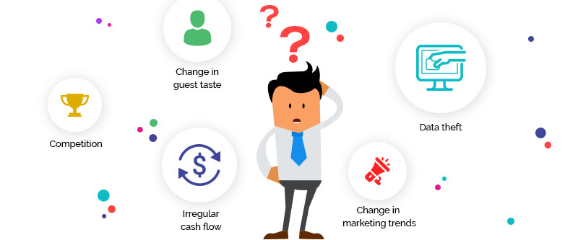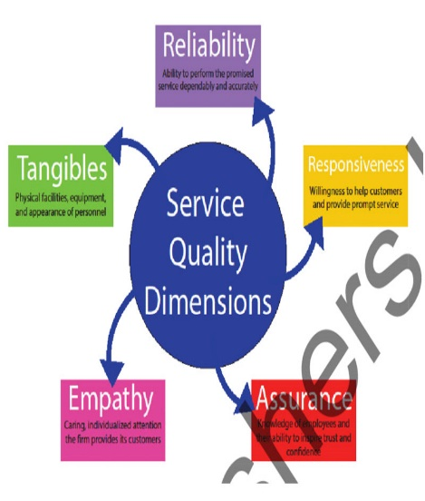
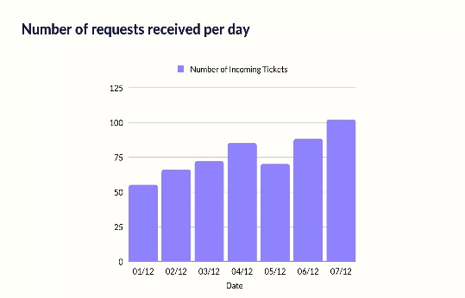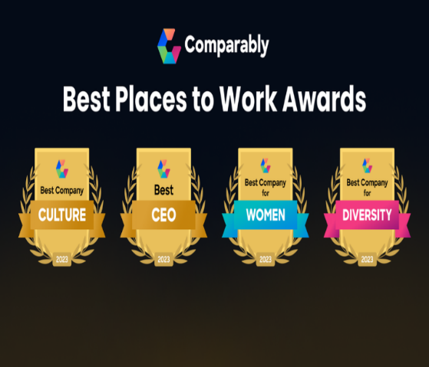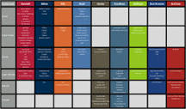
Loyalty programs
General | Cashback reward program, Cashback website, Rebate card
Coalition | Aeroplan, Air Miles, Belly, Drop, More Rewards, Plenti, Scene+, Student Edge, Student Price Card.
Chain stores /  supermarkets | Everyday Rewards, Flybuys (Australia), Flybuys (New Zealand), Hudson's Bay Rewards, Nectar, PC Optimum, Speedpass, Tesco Clubcard, Triangle Rewards.
Frequent-flyer/  programs (list) | AAdvantage, Asia Miles, Aeroméxico Rewards, EuroBonus, Flying Blue, KrisFlyer, Magsformiles, MileagePlus, Mileage Plan, Miles & More, Miles & Smiles, Norwegian Reward, Qantas Frequent Flyer, Qualiflyer, SkyMiles, JetBlue TrueBlue, Velocity Frequent Flyer.
Hotel programs | Choice Privileges, Hilton Honors, IHG Rewards Club, Marriott Bonvoy, World Of Hyatt, Wyndham Rewards
Online rewards | Rakuten Rewards, Ibotta, Swagbucks, PayPal Honey, RetailMeNot
Scrip | Canadian Tire money,Disney Dollars, My Coke Rewards, Pepsi Stuff
Trading stamps | Blue Chip Stamps, Green Shield Stamps, S&H Green Stamps
Categories: | Customer loyalty programsCredit card rewards programsHotel terminology

