

Assessment 1

Online portfolio of set exercises (E- portfolio)

MODULE NAME: CHANGEMAKERS: CREATIVITY AND VALUE CREATION

MODULE CODE: (BMHP5014_LON)

LECTURER NAME: Eleni Koutsogeorgou
STUDENT NAME: MARYAN MOHAMMED (2029256)

TABLE OF CONTENT
- Introduction……………………………………………………...
- Artefact one…………………………………………………….
- Artefact two……………………………………………………….
- Conclusion …………………………………………………………
- References…………………………………………………………….

Introduction
This project is based on the need of supporting children with Down Syndrome and educating parents what are special needs and why more Special Educational Teachers (SEN) are needed in schools. SEN teachers support teachers to help children with special educational needs and disabilities. (National Career Service, 2021) in order for this project to be successful, two artefacts are going to be used which are a poster and an Elevated Pitch which will be addressed to everyone who lives in the community including the parents.
The main goal is to identify what is the meaning of down syndrome and how does that affect the children. The important roles that SEN teachers have in children with special need’s lives. help in advocating the active role and leadership skills that are needed to support children with Down Syndrome. The reason why this topic was chosen is to raise awareness and educate the parents, the locals about the needs of children with down syndrome, and why SEN teachers are needed in this case. come up with a project that will help bring out more SEN teachers that are willing to support these children by teaching them. Majority of the children with Down syndrome don’t receive the amount of education and attention they are supposed to receive.
It is important to know that Down Syndrome is not a disease and having one does not indicate that you are sick or that you have a disease. Having Down Syndrome just shows that your brain functions differently than the others. Most parents that have special need children find it hard to provide them with the proper education needs they need hence why this conference will go in depth on what can be done to help the parent and the children.
The Poster is talking about a conference that will be held in the area specifically for children with special needs and educate the public about what down syndrome is and how does that affect the children. The conference will be held by two speakers which are the department of educational specialist and SEN teacher specialist. No registry is required, everyone is welcomed. This includes, Teachers, students, graduates, parents, the local chief, the prime minister, and many others.
Creating a pitch and a poster about children with DOWN SYNDROME will help families and the caregivers to deal with it easily. Educating them how they can be treated, guide them to other helpful resources, diagnostic tests, and screening tests. Educate them about what are the causes and the risk factors.
Artefact 1. CONFERENCE POSTER
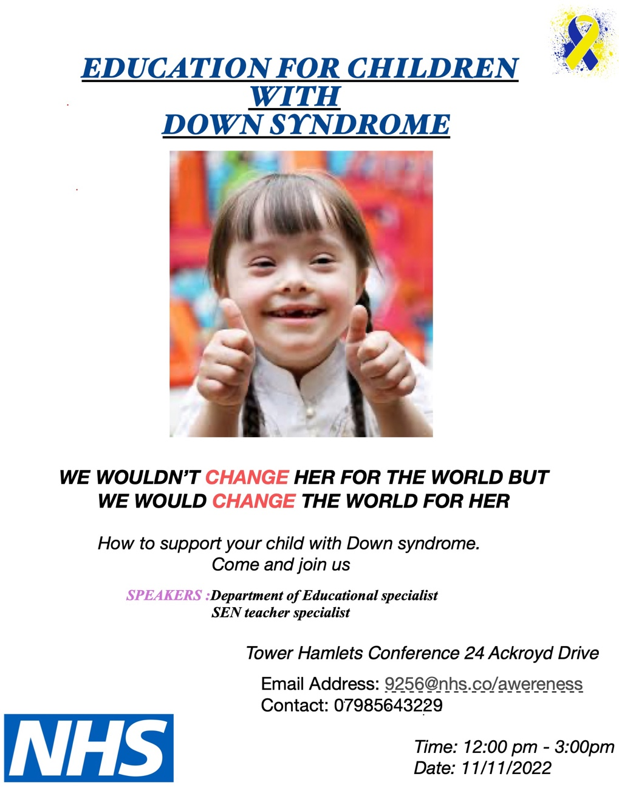

This poster is all about Educating the families, parents, and the caregivers about what down syndrome is and the causes and risk factors, what can be done so that their needs can be attended to. What are the treatments and how can the parents and the caregivers of children with down syndrome be helped.
What is a down syndrome.
It is stated that down syndrome is when a child is born with an extra chromosome. This can be by any chance because of a change in the sperm or egg before they are born. They determine how a baby’s body forms and functions as it grows during the pregnancy and after they are born. Another name for Down Syndrome is called Trisomy 21. This changes how the baby’s body and brain develop which can cause both mental and physical challenges for the baby. (CDC, 2021)
There are 3 types of down syndrome. this are. Trisomy 21, Translocation Down Syndrome and the Mosaic Down Syndrome. they all have different meanings and different ways on how they can be treated. Not every down syndrome child is the same. They all need different types of care and support. When it comes to these types, majority cannot tell the differences because they have the same feature and behaviour. (CMDSS, 2022)
Reasons why SEN teachers are needed in mainstream schools and also establishing SEN schools is because they identify the needs in the children with learning difficulties. This can ensure that they are fairly represented in the school curriculums and classes. They receive the attention they need from the teachers. Having SEN teachers helps “lift learning barriers for special need children.” (Chatta, 2021)
Every October, Down Syndrome Awareness Month is celebrated. There are different types of events, each unique and to their own. Everyone that has a Down Syndrome come together to raise awareness, to rid the myths surrounding the syndrome. for example, having a Down Syndrome excludes you from achieving your dream. Some believe that it is a long-term disease that cannot be rid of which is not a good thing to say. Every year, on this month. Different types of themes are made to raise awareness for Down Syndrome. this year’s theme was inclusion means. Everyone gathered at the event to talk about what inclusion means to them and their children.
Common treatments for Down Syndrome
NHS provides a lot of helping guidelines that will advise new parents on what to do and how to attend the needs of their children with Down Syndrome., how to help children and young people with Down Syndrome to fight off the society’s discrimination and help prevent depression on these young kids, they provide support for adults too and other health conditions. They offer free diagnostic sessions where the parents can come in with their children to be tested. They also offer free screening tests which includes a combination of blood test which measures the number of substances the mother has in her blood and an ultrasound which creates a picture of the baby.
Importance of supporting children with SEN teachers
Having SEN teachers at schools is important because if a child has a learning disability and they need extra support, then the special educational provision should be made available. (Senploy 2021). When the SEN teachers are there and are identifying the learning difficulty a child is going through in class as soon as possible, this ensures that they are fairly represented in class and their needs are attended to from the teachers. Main focus for this conference is to address the main importance of having SEN teachers in schools which lifts the learning barriers for specific students. (Chattalearning 2021)

Artefact 2: ELEVATED PITCH
Hello, good afternoon, dear parents, department of school specialist, speakers. professionals, and my local community. Thank you all for being here in this special conference that I held. My name is Maryan. I am one of the school special needs local authorities. I have been working with special needs children for almost 6 years now. it has been a great journey full of experiences.
Working with special need children has always been a dream of mine. Every child is special. They are all talented, smart, energetic, and full of enthusiasm. These children play a very important roles in our lives. Our job is to Educate them really well, making sure their needs are being attend to. No child is different than the other. It doesn’t matter what that child has. Every child is entitled to being treated according to their common standards. To attend to their standard obligations, every adult needs to ensure their fulfilment.
Children with down syndrome need extra support to learn the skills others have. this can be a basic speech, reading and writing, communication skills, physical interactions. There are different types of down syndrome and not every child is the same which is why SEN teachers are important to have in every mainstream schools. My 4-year-old cousin has a down syndrome. He goes to a mainstream school. He is very charismatic and loves learning new things, does not miss any school activities, even though the teachers in that school attend to his every need, he still requires extra support.
I realised that he doesn’t actually connect with the other children. He is always to himself and always doesn’t want to do anything rather just play all by himself. This can affect his social growth. Majority of the mainstream schools in this local area don’t have SEN teachers, especially the school my cousin goes to I know that our dear parents don’t want their children to miss any of their classes and that they should pass their exams at all times.
We should understand that, having an extra support teacher for your special need child does not make them any less different than the other children. Infact this will help them learn new ways to communicate with children their age. A parent will pack extra clothes for their special need child in case they pee on themselves or make their clothes dirty but unfortunately their need is not attended to. I have witnessed a couple times my cousin coming back home with wet pants and a pampers that hasn’t been changed for a quite a long period of time and I am sure this case has happened a lot in schools. To avoid such situation, I am requesting the school administrates and the department of school specialist to request the need of having more SEN teachers for the mainstream schools.
SEN teaching assistant their role will be to encourage the children in the social and academic processes of the school. They help the children to become more independent learners. Learning to grow gradually, learn in their own pace. There are many programs that can help your special need children to be able to make new friends and be able to do more outdoor school activities with the help of teaching assistants.
We can also raise money for the special need children, a day where we get to celebrate their uniqueness and them being here amongst us. With the help of my team members, we have come up with a special need children youth club whereby they get to do all sorts of activities. This will help them improve their communication skills, learning speech. SEN teachers are also a part of this youth club. They in fact play a big role in it. They provide care and support for the children, making sure their needs are attended to. We can raise money for the special need children to take them to the zoo following the safety guidelines. This youth club provides for the children. All of the money goes to special need children’s charities.
As parents and the department of special need education. here is how you can help us bring this youth club to live. We would like to request sponsors that will help us in funding maybe even a bus that will take the special needs children to the zoo. This will help the outdoor activities to be much more comfortable than instead using the public transport. We can have musical instruments along the way to keep them occupied and safe enjoying their journey. This can also be to their benefit as it will help them improve their abilities it can be some sort of therapy for them.
NHS is offering donations for the children with down syndrome. they are also offering advice to the parents and the caregivers, how their needs should be attended to. They offer diagnostics as well as treatments.
I would like to thank you all so much for your time and attention. We are really excited to bring this special need children youth club to live. Very much excited about this project and we really hope that you will support us in our efforts for the sake of our children, for the sake of this local tower Hamlet to improve their needs.

REFERENCES
CDC, (2022). What is Down Syndrome available at :( https://www.cdc.gov/ ) (accessed 23 Nov 2022)
CMDSS, (2022). Types of Down Syndrome. are there different types of Down Syndrome? available at: ( https://cmdss.org/ ) (accessed 23 Nov 2022)
CDC, (2022) Facts about Down Syndrome. available at: ( https://www.cdc.gov/ ) (accessed 23 Nov 2022)
DSE, (2020) inclusive education for individuals with Down Syndrome. available at: ( https://library.down-syndrome.org/en-gb/ ) (accessed 23 Nov 2022)
National today (2022) down syndrome awareness month October available at : ( https://nationaltoday.com/ ) ( accessed 23 nov 2022)
NHS inform (2022). Illnesses and conditions. Available at: ( https://www.nhsinform.scot/ ) (accessed 23 Nov 2022)
NHS (2022) how to help children and young people? available at: ( https://www.nhs.uk/ ) (accessed 23 Nov 2022)
NICHD, (2022) what are common treatments of Down Syndrome? available at: ( https://www.hhs.gov/ ) (accessed 23 Nov 2022)
Special Olympics (2022) Importance of Down Syndrome Awareness month available at: https://www.specialolympics.org/ ) (accessed 23 Nov 2022)
special educational needs (SEN) teacher n.d available at:
( https://nationalcareers.service.gov.uk/ ) (accessed 23 Nov 2022)
Senploy, (2021) the importance of supporting children with SEN teachers. Available at: ( https://www.senploy.co.uk/ ) (accessed 23 Nov 2022)
Teaching personnel (2022) what roles does an SEN teacher should have in class? Available at: ( https://www.teachingpersonnel.com/ ) (accessed 23 Nov 2022)
What is SEN? (2022) available at: ( https://chattalearning.com/ ) (accessed 23 Nov 2022)
WEBMD, (2020). Down Syndrome, causes, symptoms, diagnosis, and treatment. Available at: ( https://www.webmd.com/ ) (accessed 23 Nov 2022)
World Down syndrome day (2022) advocating the rights of people with Down Syndrome. available at: ( https://www.worlddownsyndromeday.org/ ) (accessed 23 Nov 2022)

