
Master of Business Administration
Student Name: Bansi Jigneshbhai Vadaliya
Student Number: 2427834
Module Name: Strategic Management (LCMB7003)
Lecturer Name: Amare Desta
Date: December, 2025

Contents
STRATEGIC EXPANSION PLAN: OURA'S MARKET ENTRY INTO INDIA 3
SECTION 1: SELECTION OF ORGANIZATION AND TARGET MARKET 3
1.1 Introduction 3
1.2 The Organization: OURA and the Oura Ring 3
1.3 Why OURA is fit to the strategy analysis. 4
1.4 India is the Target Market: Market Opportunity and Strategic Rationale. 4
1.5 Market Entry issues and Strategy. 5
SECTION 2 COMPREHENSIVE STRATEGIC ANALYSIS 6
2.1 Macro-Environmental Analysis: PESTEL Framework 6
2.2 Industry and Competitive Analysis: Porter's Five Forces 8
2.3 SWOT Synthesis and Strategic Insights 9
2.4 Insights and Strategic Implications 10
SECTION 3: STRATEGY DEVELOPMENT AND FORMULATION 11
3.1 Strategic Direction and Rationale 11
3.2 Strategic Positioning: Ansoff Matrix 11
3.3 Market Entry Mode 11
3.4 Competitive Strategy: Porter's Generic Strategies 12
3.5 Strategic Fit and Capability Assessment e.g. VRIO Framework 12
3.6 Strategy Implementation Components 13
3.7 Risk Analysis and mitigation. 14
SECTION 4: PERFORMANCE EVALUATION FRAMEWORK 15
4.1The Balanced Scorecard for OURA's India Expansion 15
4.3 Triple Bottom Line Integration: Social and Environmental Impact 16
4.4 Monitoring and Mechanisms of Governance 17
4.5 Recommendations 18
4.6 Conclusion to Performance Framework 19
REFERENCES 20

STRATEGIC EXPANSION PLAN: OURA'S MARKET ENTRY INTO INDIA

SECTION 1: SELECTION OF ORGANIZATION AND TARGET MARKET

Introduction

This report examines OURA, the pioneering digital health company behind the Oura Ring, and proposes India as a strategically significant market for international expansion. The analysis draws upon financial reports, proprietary company data, academic literature and contemporary industry research to construct a compelling, evidence-based case for both the organization and the target market. This introductory section establishes why OURA represents an ideal subject for strategic analysis and why India—despite current operational challenges—offers exceptional growth potential.

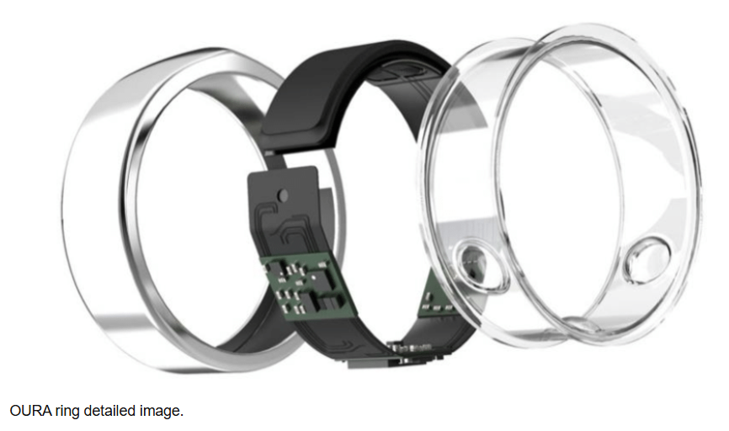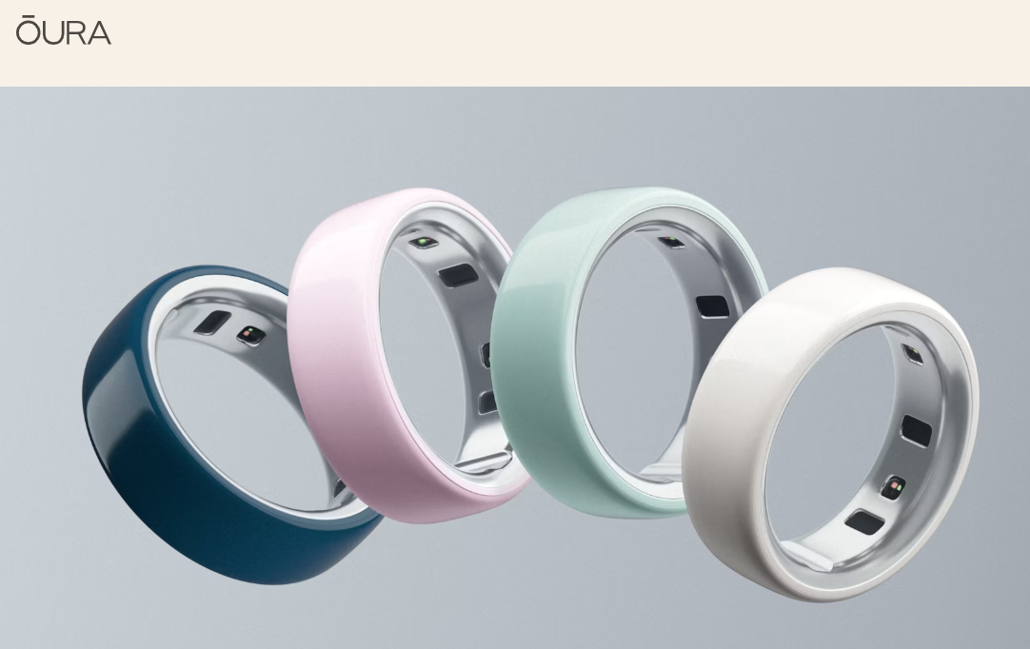

Source: (Malakhatka, Osman and Lundqvist, 2021), (Oura Health, 2025)

1.2 The Organization: OURA and the Oura Ring

According to (Oura Support, 2025) the Oura Ring adds to the digital health space with the help of its tiny and unobtrusive design that allows tracking the sleep, heart rate, body temperature, and stress levels all day long. As far as I can understand, Oura is not focused on style or plenty of functionality as many other smartwatch devices are. In my opinion, its mobile application based on subscription can be considered as strategic value-added since it can convert complex biometric data into easy-to-understand and effective health insights which can be applied in the daily wellbeing of people.
According to (Reuters, 2025) OURA is a digital health brand that has grown to become a globally known brand initially based in Finland but with San Francisco as the headquarters of the company. According to (Business wire, 2025) the business realized revenue of about US$ 500 million in 2024 and is expected to reach about US 1 billion in 2025 owing to high market demand and growth capacity. As (Forbes, 2025) points out, in 2025, OURA was boosted by a big Series D financing round and the company was estimated at about US11 billion. This financial impetus, according to my readings, has helped OURA to venture into the clinical oriented areas, especially that of women health.

1.3 Why OURA is fit to the strategy analysis.
Based on my readings OURA is a compelling example of a strategic analysis as it functions at the point of convergence of digital health, wearable technology, and subscription-based business models, which is why it is applicable in implementing such approaches to strategic analysis as PESTEL, SWOT, VRIO, and Porters Generic Strategies. In my opinion, OURA is further complicating the notion of basic fitness tracking by focusing on biometric accuracy, sleep science, and preventive health, especially its shift into women health.

1.4 India is the Target Market: Market Opportunity and Strategic Rationale.
According to (IMARC Group, 2024) the market of wearable technology in India was estimated to be USD 2.37 billion in 2024 and would expand with tremendous growth in the next decade due to the rise in health awareness, penetration of Smartphones, and disposable incomes. According to (Grand View Research, 2025) wearable market in India will experience a CAGR of almost 19 per cent, which indicates long-term needs of connected health devices. In my interpretation, this expansion is in line with the mission of OURA, which is preventive healthcare and information-based wellness.
Based on what I have read, the high number of urban population in India, increasing corporate wellness trends, and rising market share of women in digital health products and services present high targets in OURA. To my mind, the features of OURA that help to track sleep, stress, and health of women make the company well-positioned to cater to premium consumers and institutional buyers as opposed to the mass low-cost segment.
Table 1: India Wearable Technology Market Size and Forecast
Year | Market Size (USD Billion)
2024 | 2.37
2025 | 2.82
2030 | 6.90

Source: IMARC Group (2024); Grand View Research (2025).

1.5 Market Entry issues and Strategy.

According to (Ministry of Electronics and Information Technology, 2023) the Digital Personal Data Protection Act in India underpins stringent provisions regarding the processing of sensitive health and biometric data, and this presents a compliance issue to OURA since it has constant physiological surveillance; in my own interpretation, additional legal review may be given to the company as per the medical device laws that are applied in India. According to (IMARC Group, 2024) competition in the Indian wearable market is fierce and global competitors like Apple and Samsung as well as powerful domestic brands are competing with one another by relying on price and integration of the ecosystem.

SECTION 2
COMPREHENSIVE STRATEGIC ANALYSIS

2.1 Macro-Environmental Analysis: PESTEL Framework
PESTEL framework assists in evaluating the external forces that influence the India entry of OURA (Johnson, Whittington and Scholes, 2019). There is an increasing support of digital health, although the Digital Personal Data Protection Act stipulates rigid data regulations (Ministry of Electronics and Information Technology, 2023). The demand is driven by growing middle-income groups and wellness consciousness, but the high price elasticity of demand moves OURA into the affluent customer segment (IMARC Group, 2024). Mobile-first customers and the increasing lifestyle diseases in India also make the users of OURA app-based and preventive health solutions more favourable (DataReportal, 2025; Grand View Research, 2024).

Source: (Self-Created)

Pestle Framework
Political
In my opinion, India’s generally stable political environment supports long‑term planning for a premium health technology product like the Oura Ring. The Ministry of Electronics and Information Technology (2023) explains that the Digital Personal Data Protection Act 2023 imposes strict conditions on handling sensitive personal and biometric data, directly affecting how Oura collects, stores and processes health information, while the Central Drugs Standard Control Organization (2023) indicates that some health‑related wearables may fall under Indian medical device regulations, meaning Oura must carefully review its product classification and any registration requirements.

Economic
According to IMARC Group (2024), the market of wearable technologies in India was about USD 2.37 billion in 2024 and is projected to expand with a significant impetus in the next decade as the level of income increases and more people are becoming health-conscious. The reason is that I believe that high price elasticity is still present in the broader population and the implication of this is that Oura needs to target high-income urban consumer groups and may need to implement instalment plans or company subsidy programs to make the product easier to adopt.

Social
According to IMARC Group (2024), increased focus on fitness, stress management, and preventive healthcare is also the major reason behind the use of wearable devices in India. In my perception, the shift in the attitude towards the health of the Indian women, their sleep quality, and psychological wellbeing is what can make social conditions under which the ideas of Oura sleep analytics and sleep and wellbeing qualities among women can find a very strong response among the Indian consumer population.

Technological
According to DataReportal (2025), the number of smartphone users, as well as mobile internet usage, in India reaches hundreds of millions, and the majority of the population use mobile devices to access digital services. I believe that this digital infrastructure, which is mobile-first, will serve the business model of Oura, but only in the case the application is optimised to accommodate popular Android devices and different network environments.

Environmental
I suppose that the rising social and government anxieties about sustainability in India will put more focus on the problem of packaging waste, battery waste disposal, and wearable technology brands recycling.

Legal
According to Ministry of Electronics and Information Technology (2023), the Digital Personal Data Protection Act will provide Indian users with powerful rights to personal data and necessitate express consent, definite purport constraint, due reasonable security protection, and prospective data localisation of the selected categories of data. According to Central Drugs Standard Control Organization (2023), where any of the Oura features have any clinical or diagnostic claims, further regulatory approvals or compliance requirements can be imposed under Indian medical device rules.

2.2 Industry and Competitive Analysis: Porter's Five Forces

Threat of New Entrants
According to IMARC Group (2024), in India, the threat of new entrants in the wearable market is moderate since one can easily launch simple fitness bands and leave the mass segment open. Nonetheless, the transition to the high-end health-analytics would require advanced sensors, powerful algorithms and clinical connections, which would create obstacles and provide some safeguarding to OURA.

Bargaining Power of Buyers
The buyer power is strong as the Indian consumers can easily alternate between a good local brand such as Noise and boAt and such global brands as Apple and Samsung (IMARC Group, 2024). This implies that OURA has to have a clear explanation of why it charges premium because it is more accurate, has features and clinical credibility that are unique to women.

Suppliers Bargaining Power.
IMARC Group (2024) has declared that the power of suppliers is medium, as not all biometric components are specialized yet the rest of the electronics supply chain can be used. Companies that outsource at scale have the ability to negotiate with suppliers and gain less reliance on single suppliers in the long run.

Threat of Substitutes
The threat of substitutes is also strong because with the inexpensive fitness bracelets, health applications and traditional health care services, many of the most fundamental needs can be satisfied. Although they might not have sophisticated analytics, these alternatives restrict the extent to which such high-end brands as OURA can charge prices.

Competitive Rivalry
According to IMARC Group (2024), competition in the mass market is high, and the brands compete based on price and features. The lower end has fewer technologically advanced players which implies less direct competition and OURA more leeway to differentiate as compared to the overall competition.

2.3 SWOT Synthesis and Strategic Insights

From my understanding, integrating insights from the PESTEL and Porter’s Five Forces frameworks into a single SWOT assessment helps to clarify OURA’s overall strategic position in India.​

Strengths: I believe OURA has a distinct technological and image edge in my opinion due to its clinically proven biometric algorithms and robust premium brand, particularly when offering the functionality features specific to the female health. I suppose that its emphasis on privacy of data and strong financial support also favor trust, regulatory relationship and further investment in India.

Weaknesses: In the generally price-sensitive Indian market, I believe poor brand recognition, distribution and high pricing will limit the penetration of OURA in India. In my knowledge, complicated data and legislation needs and reliance on trustworthy application connectivity also increase expenses and restrict attractiveness in areas with substandard connectivity.

Opportunities: In my opinion, the high pace of development of the digital health industry in India and the increasing popularity of sleep, stress, and women health present a great opportunity to OURA, and its proposal can be in demand. I suppose alliances with hospitals, corporates, telemedicine platforms and integration with the government digital health schemes may help it grow and lower its localisation expenses.

Threats: I assume that the high price pressure will be maintained due to the intense competition of global and local wearables, as well as aggressive low-cost offerings. According to my guesses, the long-term data security worries, potential stricter policies and the appearance of new health-analytics competitors capable of competing with OURA may erode the data-driven edge of the latter.

Figure 1: India Digital Health Market Growth (2024–2033)

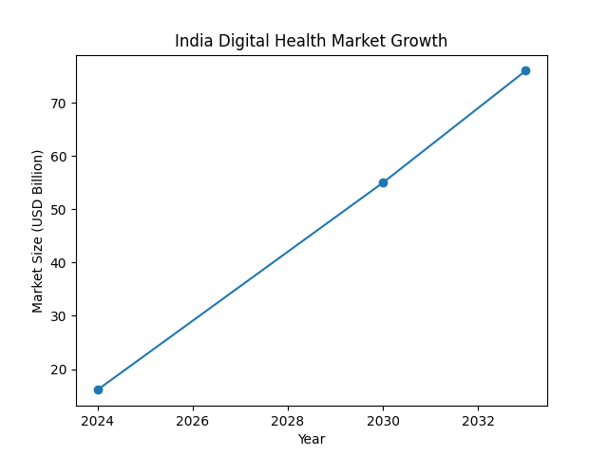
Source: IMARC Group (2024).

2.4 Insights and Strategic Implications

According to IMARC Group (2024), the optimal opportunity OURA has in India is to pursue a focused premium approach, and not pursue the entire mass market. High-income city residents and institutional customers like hospitals and corporations put higher value on the accuracy and clinical validation and data protection, which are also the core of the advantages of OURA in the field of health and women health analytics.

According to the ministry of Electronics and Information Technology (2023), more strict health and data-privacy regulations make entry more complicated but enable well-regulated companies to gain additional trust by exhibiting high compliance. Another point that IMARC Group (2024) makes is that India is quite diverse in the region and socio-economically, and localized policies are more effective than one, blanket national strategy. Combined together, this information leads to an area of focus-differentiation entry, which is based on healthcare-corporate-wellness partnerships, close regulatory coordination and selective experimentation to fine-tune the approach over time.

SECTION 3: STRATEGY DEVELOPMENT AND FORMULATION

3.1 Strategic Direction and Rationale
In my opinion, the OURA strategic direction in India can be understood as the most as the development of the market and not the new venture. The company is also, in my opinion, taking an existing product the Oura Ring and transferring it into a new country rather than developing another device or venturing into a different line of business. In my opinion, it makes sense since the underlying technology is already validated, and the increase in the demand of digital health tools in India will allw OURA to geographically expand without a significant change of the product.

3.2 Strategic Positioning: Ansoff Matrix
Ansoff (1957) describes the Ansoff Matrix as a way of setting growth strategies based on how products and markets are combined, and this helps clarify OURA’s overall direction. From my understanding, the India move fits a market development strategy, because OURA plans to introduce its existing Oura Ring into a new country rather than create a completely new device.​

I assume that only limited technical adjustments are needed for the Oura Ring to work well in India. In my opinion, India’s large, tech‑savvy population and rising health awareness make the current product a good match for the market, while focusing on market development allows OURA to expand geographically without heavy extra R&D spending. From my understanding, this approach suits OURA’s existing strengths and subscription‑based business model.

In my view, OURA should therefore concentrate on building strong distribution channels, adapting marketing to local preferences, forming local partnerships and meeting Indian regulatory requirements, rather than redesigning the core product. I believe that selected user‑experience upgrades—such as accurate ring sizing, health insights tailored to India’s climate and lifestyle, and localization of women’s health features—will still need targeted investment to deliver a high‑quality experience for Indian users.

3.3 Market Entry Mode

According to IMARC Group (2024), India is an effective entry point of premium health-tech brands through strategic alliances, which explains why a partnership-based entry with a smaller direct-to-consumer (DTC) channel is an ideal fit to OURA. By collaborating with the corporate wellness and digital health providers and platforms, working with the hospitals, which are privately owned would assist OURA in establishing a credible presence, regulation and access to their target users, as well as a controlled DHC presence in a market where well-off urban consumers become increasingly comfortable with online purchases would help OURA secure brand positioning and relationships. Comprehensively, this integrated strategy enables OURA to enter the market at a slow pace, handle risk and scale with a demand and regulatory change.

3.4 Competitive Strategy: Porter's Generic Strategies

Porter (1985) cites that firms in the competitive markets can perform effectively on the basis of cost leadership, pervasive differentiation, and a focused orientation. According to IMARC Group (2024), in the wearable industry of India, cost leadership does not apply to premium brands such as OURA because local competitors have prevailed at the low-cost, functional hardware. Likewise, wide differentiation would demand both resources and scale that smaller high-end brands cannot compete with, particularly when it comes to fighting large ecosystem-centered competitors like Apple and Samsung.

In the case of OURA, a narrowed down differentiation strategy will be more appropriate. Its advantages are in the clinically proven algorithms and the high-accuracy biometric tracking, which was developed in research partnership with UCSF and Stanford (Oura Blog, 2025). According to Forbes (2025), due to the overall health functions of women in OURA, including menstrual cycles, pregnancy, and perimenopause, there are voids that have not been adequately filled in India. Besides, with good privacy guarantee and regulatory compliance, one can create trust among the consumers (Ministry of Electronics and Information Technology, 2023). As pointed out by IMARC Group (2024), OURA can increase its value proposition by integrating into larger health ecosystems, such as the collaboration with digital health platforms, corporate wellness programs, and medical institutions; at the same time, the minimalistic design of the ring and the aspirational branding need to strengthen the image of the product as premium in the Indian market.

3.5 Strategic Fit and Capability Assessment e.g. VRIO Framework

Barney (1991) writes that the VRIO model assists in establishing whether the resources and capabilities of a company can sustain a competitive advantage. OURA has its proprietary biometric algorithms and women-focused features, which are both not common and extremely desirable in the wearable industry in India (Oura Blog, 2025; Forbes, 2025). Good data privacy policies and compliance with the regulations create consumer trust (Ministry of Electronics and Information Technology, 2023), whereas its app-based system and collaboration with the broader digital health make it easy to scale (IMARC Group, 2024). Combined with its luxury branding, these unique features ensure that OURA will have a strong base to sustain a permanent competitive advantage in the luxury wearable market in India.
Value: According to Oura Blog (2025), the proprietary biometric algorithms used by OURA have offered the highest level of accuracy on health and sleep data, which has established a solid value chain in the high-end wearable market of India. Additional value is that women health analytics, including menstrual cycles, pregnancy and perimenopause, is a highly underserved target audience, which Forbes (2025) adds. Good data privacy and regulatory compliance create user confidence and legal safety (Ministry of Electronics and Information Technology, 2023), whereas the use of the app platform and the connection to the broader digital health services increase scalability and engagement with OURA (IMARC Group, 2024).
Rarity: According to Oura Blog (2025), the presence of clinically proven algorithms and prominent features related to women health are yet to be common in the Indian wearable market. According to Forbes (2025), the use of integrated women-focused analytics is not common with rivals, and the premium brand name and minimalist design of rings offered by OURA are unique in terms of targeting style-conscious urban shoppers. The combination of submissive data systems, accurate analytics, and integration of ecosystem enables the offer of OURA challenging to locate among local and international competitors.
Imitability: According to Oura Blog (2025), the algorithms of OURA are expensive and are not easily replicated since they undergo clinical validation, expert knowledge and continuous experimentation with such partners as Stanford and UCSF. According to Forbes (2025), the copying of health analytics of women requires clinical cooperation, high integrity of privacy, and advanced software. Other brands like premium branding, minimalism and deep integration with apps, corporate wellness programmers and healthcare networks are also difficult to imitate and require time and investment to develop.
Organisation: According to Oura Blog (2025), OURA is organized to take advantage of its resources by utilizing a subscription model, strong platforms and customer support. According to IMARC Group (2024), its analytics is deployed efficiently with the help of healthcare partnerships and digital health integration. Best use of regulatory compliant data will help in legal compliance and consumer trust which demonstrates that OURA is organizationally ready to make the best of its strengths in the Indian market.

3.6 Strategy Implementation Components
According to IMARC Group (2024), the premium wearable market in India is improving, and OURA must consider a combination of luxurious and robust e-commerce to reach their target consumers. According to the Ministry of Electronics and Information Technology (2023), it will be important to follow the DPDP Act and the medical device regulations to the latter, whereas Grand View Research (2025) suggests the use of the region-specific campaigns, the use of culturally appropriate messages, and the use of local languages and content. DataReportal (2025) emphasizes the importance of smooth Android app and compatibility with digital health solutions, which is facilitated by the collaboration with hospitals, corporate wellness plans and research institutes, and constant monitoring of performance (Oura Blog, 2025; IMARC Group, 2024).

3.7 Risk Analysis and mitigation.
The major risks are regulation, price sensitivity and operations. Regulatory risk is minimized through compliance with DPDP Act through consent mechanisms, privacy-by-design, and local data storage (Ministry of Electronics and Information Technology, 2023). Affordability is controlled with the help of tiered pricing, EMI and corporate offers (Central Drugs Standard Control Organization, 2023; IMARC Group, 2024). The operational and cultural risks are alleviated by regional fulfilment, localisation and reliable logistics, Hindi support and heat, monsoon related sleep problems and women health features (Grand View Research, 2024; Forbes, 2025; Kumar, Singh and Patel, 2025).

SECTION 4: PERFORMANCE EVALUATION FRAMEWORK

4.1The Balanced Scorecard for OURA's India Expansion
According to Kaplan and Norton (1996), Balanced Scorecard transforms the strategy into quantifiable goals in four perspectives namely, financial, customer, internal processes, and learning and growth. In the case of OURA entering India, it can be used to connect its high-end status with specific, measurable objectives that encompass not only business outcomes, but also the market trustworthiness, which is especially needed by the digital health companies entering the regulated emerging markets (IMARC Group, 2024).
Financial Perspective
As IMARC Group (2024) notes, premium wearables are reliant on a combination of the sales of the device and the subscription revenue. Revenues upsurge, subscription conversion, contribution margin, customer lifetime value and average revenue per user metrics demonstrate whether the operations of OURA in India are not only profitable and in line with its pricing and targeting strategy.
Customer Perspective
According to IMARC Group (2024) and Porter (1985), in competitive health-tech marketplace, a sustainable differentiation is formed on a foundation of trust, customer satisfaction and healthy partnerships. Such indicators as Net Promoter Score, brand recognition in wealthy urban settings, the number of active users and the quality of their relationships with hospitals and corporate customers demonstrate the extent to which OURA is known as a serious health tool instead of a fitness gadget.
Internal Process Perspective.
According to IMARC Group (2024), a high-quality delivery experience, that is, low turnover and timely customer service are key to keeping the premium experience in the competitive market of India. Another concern that is highlighted by the Ministry of Electronics and Information Technology (2023) is the fact that the strict implementation of the Digital Personal Data Protection Act implies that data security, as well as the possibility to prove the compliance with the requirements, are vital internal performance indicators.
Learning, Growth, and Triple Bottom Line
Kaplan and Norton (1996) argue that the long-term benefit relies on learning over a lifetime and ability to build capabilities and Elkington (1997) further argues that it should include the social and environmental performance. In the case of OURA it entails making local talent, marketing Indian-focused, creating health-specific insights and partnerships in India, and social measures of women health participation and local health activities (Forbes, 2025) and environmental initiatives like recyclable packaging, reduced carbon emissions, and sustainable supplier practices.

4.3 Triple Bottom Line Integration: Social and Environmental Impact
Although the Balanced Scorecard measures the strategic and operational performance, the Triple Bottom Line (TBL) model is a model that measures the social and environmental contributions in addition to the financial returns (Elkington, 1997). In the case of OURA, the implementation of TBL in India means that the decisions regarding the expansion are made with consideration of both the commercial success and the beneficial impact on society and environment, at the time when the consumers and regulators place an ever-increasing emphasis on responsible corporate behaviour (IMARC Group, 2024).
4.3.1 Social Impact Metrics
The social impact strategic objective is to improve the quality of health outcomes of the population and respond to the underserved health needs especially those of women. As pointed out by Forbes (2025), menstrual, pregnancy, and perimenopause tracking is under-served in India, which is a business opportunity and a health issue to the population. The main indicators are to deliver 100,000 Indian women such features by the Year 3, hold five awareness campaigns every year on sleep, stress, and women health, and collaborate with NGOs to promote community wellness (IMARC Group, 2024). Also, the Ministry of Health and Family Welfare (2023) stresses the need to ensure the availability of health interventions, which justifies the intention of OURA to introduce at least one subsidised programme to serve consumers with lower incomes and those who are health-conscious. All these indicators promote brand credibility and also meet significant social needs.
4.3.2 Environmental Impact Measures.
The environmental target is to reduce the footprint of OURA in the supply chain and product lifecycle. According to IMARC Group (2024), there is a growing demand among emerging market consumers to be responsible in everything they do. Its major goals are to cut the amount of carbon emissions per device by 10% with regional fulfilment centres, involve 20 percent of its users in the recycling of their devices, launching the Indian market with 100 percent recyclable packaging and making sure that all its key suppliers adhere to the sustainability requirements (Elkington, 1997). These actions complement financial and operational objectives and contribute to the sustainable behavior of the global economy and the responsible brand image of OURA, as well as support such an attitude.

4.4 Monitoring and Mechanisms of Governance

OURA needs to have strong governance in order to achieve strategic, operational and ethical objectives of its expansion in India. Kaplan and Norton (1996) observe that associating performance measures with a sense of individual accountability will make organisations monitor performance progress and also respond promptly to issues. In the case of OURA, it will be the process of integrating financial, customer, operational, social, and environmental KPIs of the Balanced Scorecard and Triple Bottom Line into a single control system.

IMARC Group (2024) emphasizes that closer and near real-time observation is particularly relevant in the new market where regulations can change rapidly, as well as customer demands. The management dashboards that OURA will be able to utilize are capable of tracking revenue, subscription, customer satisfaction, delivery time, product returns, service response time, and adherence to the Digital Personal Data Protection Act (Ministry of Electronics and Information Technology, 2023). It will be solved promptly with the help of regular reporting cycles and an obvious escalation route at the time, which contribute to the sustainability of the day-to-day stability.

There should also be governance regarding the social and environmental commitments of OURA. According to Elkington (1997) and IMARC Group (2024), the reviews concerning the women health programs, public health campaigns, sustainability efforts, and supplier environmental performance should be conducted periodically. This control not only helps in regulatory compliance but helps in motivating more trust among the users and partners, which will enhance the long-term reputation and long-term sustainability of OURA in India.

4.5 Recommendations
- Target Premium Segments
Focus on the high-end urban customers and institutional clients and rely on the OURA clinical validation, women health abilities and good data-privacy position to be unique among local and global competitors (IMARC Group, 2024).

- Partnership-Based Market Entry.
Develop the plan of entry with the help of partnerships with hospitals, corporate wellness agencies and digital health platforms in a manner that grants OURA the credibility, corresponding regulatory support and point of presence in the broader health system of India (IMARC Group, 2024).

- Regulated Direct-to-Consumer Strategy.
Creating a selective online direct-to-consumer channel with marketing that is locally customized will enable OURA to safeguard its premium brand, capture market insights and develop in a measured way without uncontrolled operation and logistics risks (IMARC Group, 2024).

- Good Governance and Management.
Have clear dashboards and periodic audits to monitor financial, customer, operational, social and environmental performance with a high rate of compliance, data safety and managerial responsibility (Kaplan and Norton, 1996; Ministry of Electronics and Information Technology, 2023).

- Adaptation Social, Environmental, and Local.
Invest in women health programme, community health outreach and sustainability in its operations, development of local talent and cultural adaptation, creation of brand credibility and responsible long-term development in India (Elkington, 1997; Forbes, 2025; Kaplan and Norton, 1996).

4.6 Conclusion to Performance Framework

This strategic analysis has considered the India expansion of OURA in terms of PESTEL, Porters five forces, ansoff, Porters generic strategies, RBV, the balanced scorecard and the triple bottom line (Johnson, Whittington and Scholes, 2019; Porter, 1985; ansoff, 1957; barney, 1991; Kaplan and Norton, 1996; Elkington, 1997). According to the evidence provided by the industry, the digital health and wearable market is expected to increase to about 2924 per cent CAGR through 2030 in India with a lot of potential in premium segments among the affluent urban and institutional segments, which OURA can tap into its strengths in women health and sleep analytics (IMARC Group, 2024; Grand View Research, 2024; Forbes, 2025; Oura Blog, 2025).

The proposed solution is a partnership-based, selective Direct-to-Consumer hybrid entry, with specific differentiation according to validated algorithms and biometric accuracy, female health characteristics and strict data protection (IMARC Group, 2024; Central Drugs Standard Control Organization, 2023; Ministry of Electronics and Information Technology, 2023). The Balanced Scorecard and Triple Bottom Line offer a consistent system of performance, which includes financial, customer, process, learning, social and environmental indicators, such as subscription growth, institutional partnerships, data-privacy compliance, women health engagement and sustainable operations (Kaplan and Norton, 1996; Elkington, 1997; IMARC Group, 2024; Forbes, 2025).

REFERENCES
- Ansoff, H.I. (1957) ‘Strategies for diversification’, Harvard Business Review, 35(5), pp. 113–124.
- Barney, J. (1991) ‘Firm resources and sustained competitive advantage’, Journal of Management, 17(1), pp. 99–120.
- Business Wire (2025) Oura reports strong revenue growth driven by global demand. Available at: https://www.businesswire.com (Accessed: 8 December 2025).
- Central Drugs Standard Control Organization (2023) Medical Device Rules and Regulatory Guidance. New Delhi: Government of India.
- DataReportal (2025) Digital 2025: India. Available at: https://www.datareportal.com (Accessed: 10 December 2025).
- Elkington, J. (1997) Cannibals with Forks: The Triple Bottom Line of 21st Century Business. Oxford: Capstone.
- Forbes (2025) ‘Oura’s expansion into women’s health and digital wellness’. Available at: https://www.forbes.com (Accessed: 9 December 2025).
- Grand View Research (2024) India Wearable Technology Market Analysis. Available at: https://www.grandviewresearch.com (Accessed: 12 December 2025).
- Grand View Research (2025) Global Digital Health and Wearable Devices Market Forecast. Available at: https://www.grandviewresearch.com (Accessed: 12 December 2025).
- IMARC Group (2024) India Wearable Technology Market: Industry Trends, Share and Forecast. Available at: https://www.imarcgroup.com (Accessed: 11 December 2025).
- Johnson, G., Whittington, R. and Scholes, K. (2019) Exploring Strategy. 12th edn. Harlow: Pearson Education.
- Kaplan, R.S. and Norton, D.P. (1996) The Balanced Scorecard: Translating Strategy into Action. Boston: Harvard Business School Press.
- Kumar, R., Singh, A. and Patel, N. (2025) ‘Cultural and operational challenges in digital health adoption in India’, International Journal of Health Technology Management, 18(2), pp. 145–162.
- Ministry of Electronics and Information Technology (2023) The Digital Personal Data Protection Act 2023. New Delhi: Government of India.
- Ministry of Health and Family Welfare (2023) National Digital Health Mission Framework. New Delhi: Government of India.
- Oura Blog (2025) The science behind Oura’s biometric algorithms and women’s health insights. Available at: https://ouraring.com/blog (Accessed: 9 December 2025).
- Oura Support (2025) How the Oura Ring works. Available at: https://support.ouraring.com (Accessed: 8 December 2025).
- Porter, M.E. (1985) Competitive Advantage: Creating and Sustaining Superior Performance. New York: Free Press.
- Porter, M.E. (2008) ‘The five competitive forces that shape strategy’, Harvard Business Review, 86(1), pp. 78–93.
- Reuters (2025) ‘Oura’s growth strategy and global digital health expansion’. Available at: https://www.reuters.com (Accessed: 8 December 2025).
- Statista (2025) Wearable technology market revenue in India. Available at: https://www.statista.com (Accessed: 11 December 2025).
- World Health Organization (2023) Digital Health Strategy and Global Framework. Geneva: WHO.

