Experimental Strategies – M5X01707

Self Evaluation

The task for this module ‘Experimental Strategies’, was to develop our individual practice by risk-taking, pushing ourselves to experiment with new techniques and strategies. Our projects were completely self-directed with an open brief, allowing us to focus on whatever we wanted.
For my project, I wanted to push myself to try something I am not familiar with and step out of my comfort zone. Therefore, I will be taking my photos for the project using Polaroid film. Throughout this process, I have been reading “The Polaroid Years”. The book offers an insight to the history of the polaroid. Personally, I’ve always liked how images turn out when using polaroid film, giving the final photos a vintage appeal, which cannot be achieved using digital. Working with a polaroid can be unpredictable at times, images can often turn out over or under exposed - if not set to the correct setting. This can be potentially be an occurrence in my project, however this module is made to experiment and try new techniques.
For my project, I took inspiration from photographer, Ansel Adams, and captured nature with my polaroid camera, during its seasonal change. Experimenting with nature - the natural light, moving objects, sunlight, and how they work when shooting with a polaroid.
For each polaroid, I experimented with something different and unique, in order to see how they would react and how much the image altered. The strategies I used for each include; deconstruction, microwave, cleaning products, exposure to light, and cutting.

First of all, I began by putting a polaroid in the microwave.
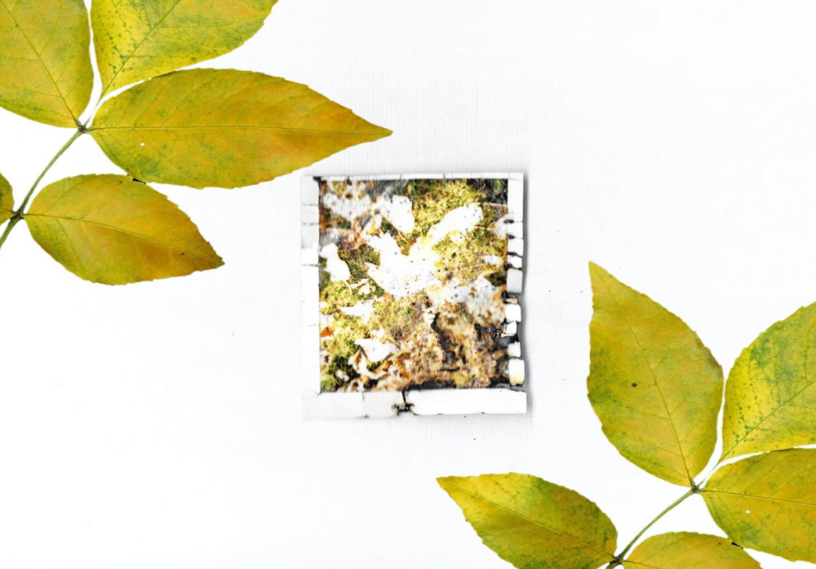

This technique came from German Photographer, Oliver Blohm. The microwave appeared to shrink the polaroid, as well as cracking the plastic and leaving burns, just as expected. The image seemed to also become more exposed and unclear. Personally, I would like to try this technique again in future as I believe that I could achieve better, clearer results.
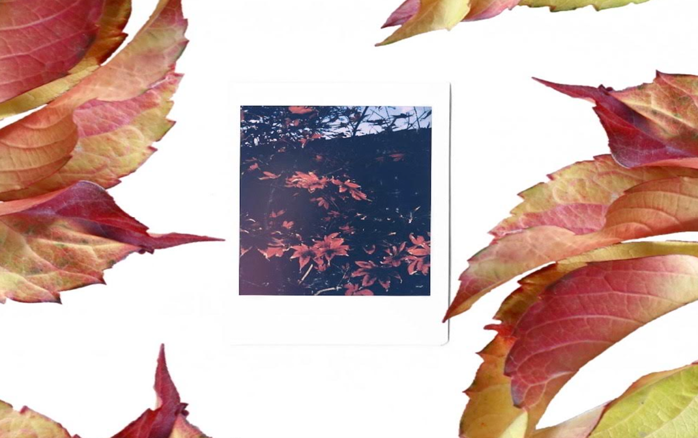
Next, I exposed to sunlight. Removing the plastic from the front of the polaroid – exposing to the sunlight.

The image appeared to have a purple tint to it, as well as show an ever so slight light leak to the left.
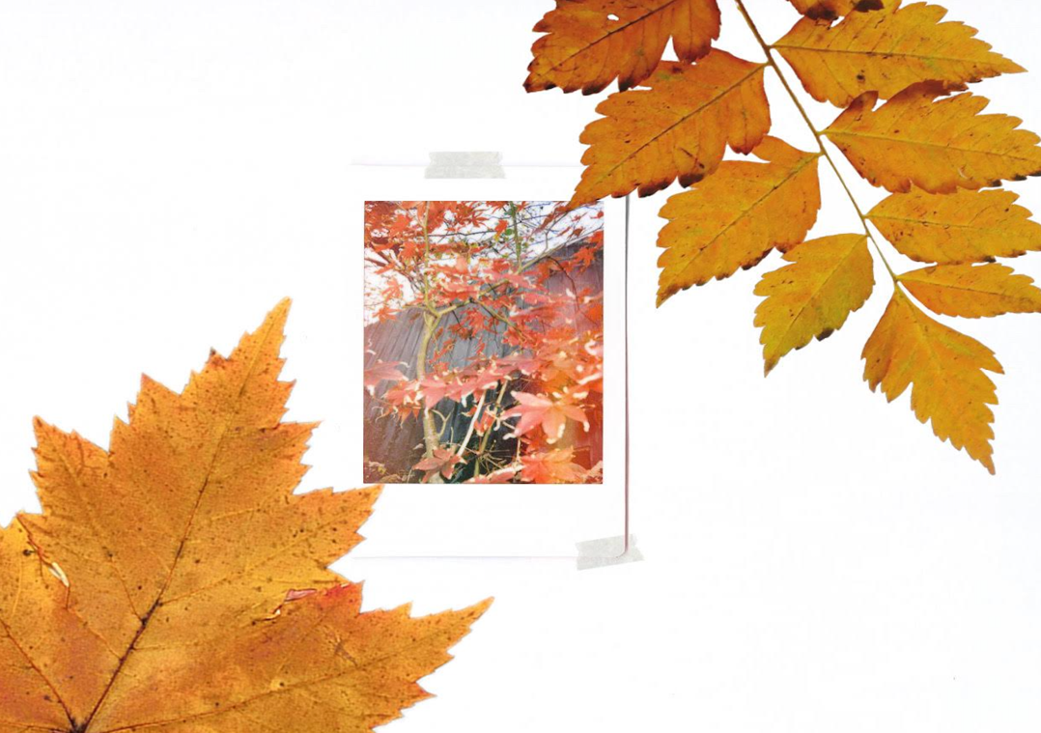

The image above is manipulated using a vary of cleaning products. Just like previously, I removed the plastic in order for the products to become more effective. The products leaked through to the ink creating a prominent leak. Products I incorporated include; washing up liquid, anti-bacterial spray and soda crystals.
For the last two, I experimented with deconstructing and cutting.
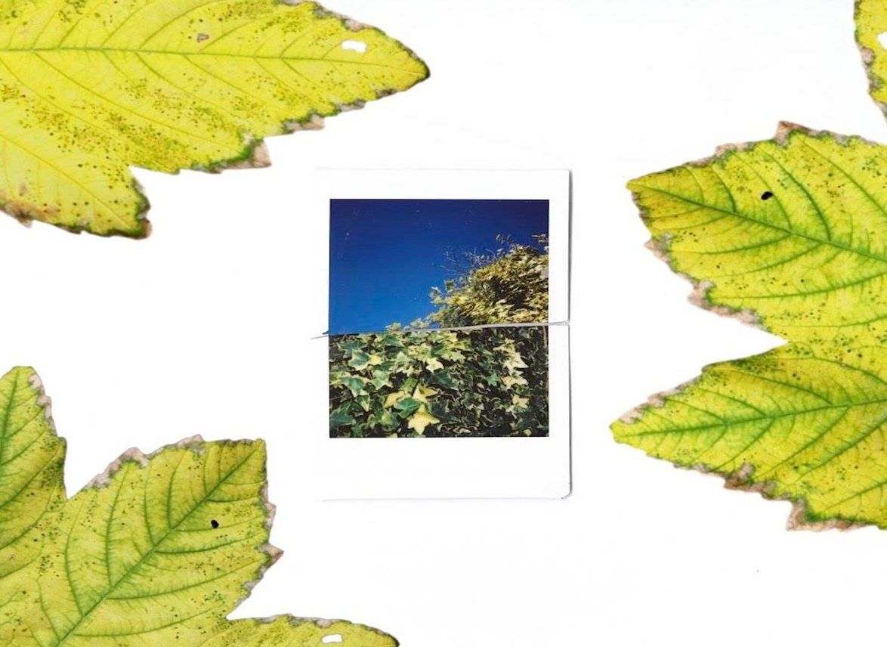

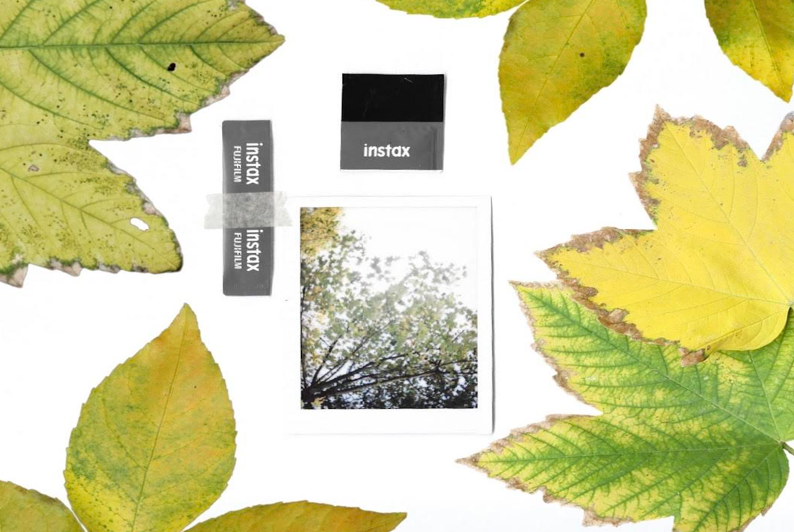

I really like how two different images fitted together appears. The colours really contrast with each-other. I will definitely continue with this technique in the future.
Overall, I am very happy with how my 5 images turned out. I have thoroughly enjoyed experimenting and stepping out of my comfort zone. There are so many more ways in which you can experiment using polaroid’s, which I would like to carry on in future projects. Researching different artists who use polaroid photography has really opened my eyes to a world outside of digital.

