
Application of Academic Tools
Enhancing Learning, Planning, and Productivity in University
Balapitathees Sivarajah (2521909) | 1/19/26 | Academic Skills – COMPUTING

Table of Contents
Introduction: 2
1 Presentation Skills and reflection: 2
1.1 Initial PowerPoint Presentation 2
2 Self evaluation and Progression 5
2.1 Self evaluation of academic skills 5
2.2 SMART Action Plan Table 7
3 Action plans and Gantt charts 8
3.1 Personal Goal – Action Plan and Gantt Chart 8
3.2 Assignment Planning - Action Plan and Gantt Chart 11
4 Use of tools to enhance productivity 13
4.1 Electronic Calendar 13
4.2 Finances and Budgeting 14
4.3 Data visualisation using Excel – Bar Chart and Pie Chart 16
Conclusion 19
List of References 20

Introduction:
This report demonstrates the academic skills developed throughout the module. It includes evidence of presentation skills, self evaluation activities, action planning and the use of digital tools to support learning. Each section contains examples of completed tasks, including screenshots, tables, and charts. The aim of the report is to show progress, describe how these skills have been applied and reflect on how these skills will support future academic study and success.

Presentation Skills and reflection:
During the module, an introduction PowerPoint presentation was created to discuss my background, interests, and goals. Four screenshots from this presentation are included as evidence

Initial PowerPoint Presentation
The initial PowerPoint presentation provided an opportunity to develop essential communication and presentation skills. The presentation focused on introducing myself to the audience, including my background, interests, and academic goals. When designing the slides, I prioritised clarity by using simple layouts, consistent formatting, and minimal text. This helped ensure that the audience could follow the key points without distraction. Visual elements such as photographs, icons, and headings were used to support the spoken explanation and make the slides interactive.
Figures 1-1, 1-2, 1-3, and 1-4 show evidence of my PowerPoint Presentation. I learned the importance of structuring content logically. The slides were organised in a sequence that introduced who I am, my personal interests, my academic journey, and my future ambitions. This helped create a smooth flow and ensured that the audience could understand the narrative without confusion. I also paid attention to readability by choosing appropriate font sizes and avoiding overcrowded slides.
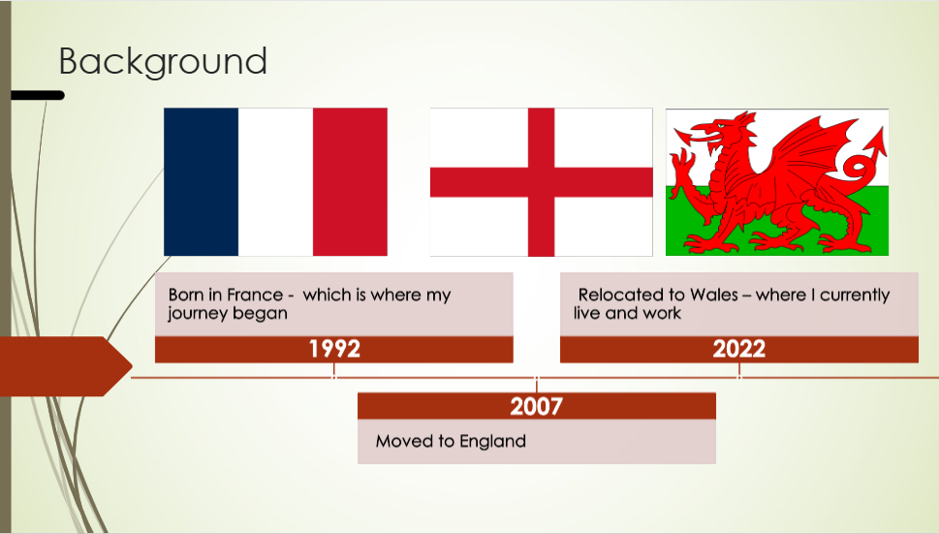
Figure 1-1 : PowerPoint Slide 1 - Background


Figure 1-2: PowerPoint Slide 2 - Interests & Hobbies

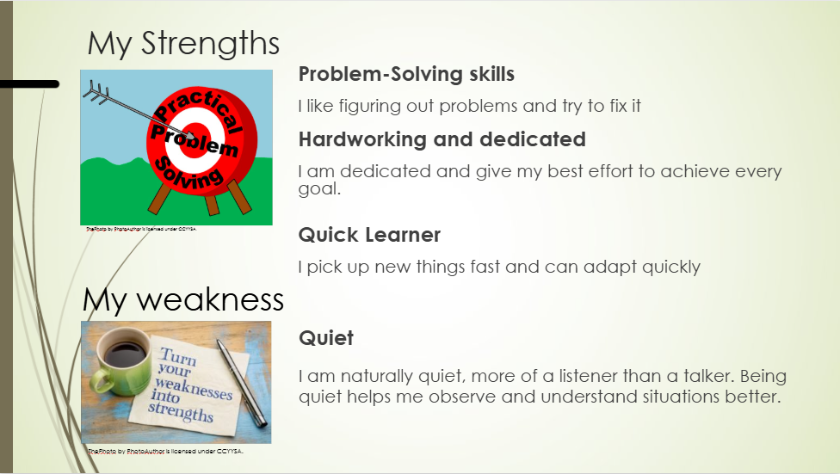
Figure 1-3 : PowerPoint Slide 3 - Strengths & Weakness

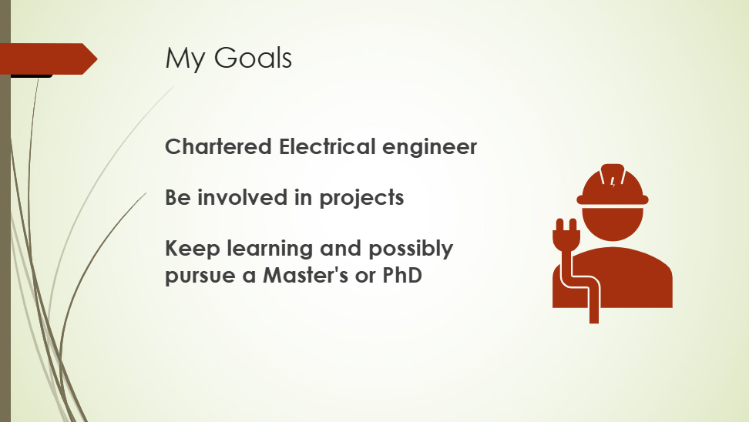
Figure 1-4 : PowerPoint Slide 4 - Goals
While presenting, I learnt the value of practise. Rehearsing the slides improved my familiarity with the content and made it easier to speak clearly. Although the presentation was completed successfully, I noticed that nerves affected my confidence, especially at the beginning [1]. This experience highlighted that confidence improves with repeated exposure to presenting and by preparing more thoroughly in advance.
Reflecting on the experience, there are several areas for improvement. Improving my speaking pace, maintaining eye contact, and using more expressive body language would strengthen future presentations [2]. Adding a few more slides or expanding certain points could also make the presentation more detailed and engaging. Despite these challenges, the task helped build a strong foundation for future academic presentations by improving my ability to structure information, use digital tools effectively, and communicate ideas clearly.

Self evaluation and Progression
Conducting self evaluation exercises allow me to understand personal strengths and weaknesses. Throughout the module, a range of self‑evaluation activities were completed to reflect on current abilities and identify areas for improvement. These activities supported a deeper awareness of how I learn, how I manage tasks, and which skills require further development to succeed in university. The insights gained from this process create the basis for the targeted action planning and skill‑building strategies discussed in the following sections.

Self evaluation of academic skills
Figure 2-1 shows the completed self evaluation form used to assess a range of academic skills. Each statement was rated on a scale from 1 to 5, with higher scores indicating stronger agreement. The results highlighted key strengths such as analytical thinking, organisation, and motivation, while also identifying areas for improvement including presentation confidence and reading complicated texts. This evidence supports the reflective analysis in Section 2.1 and forms the basis for the SMART action plans that follow. It also confirms that a visual learning style is most effective for me, as I learn best through diagrams, demonstrations and hands-on activities.
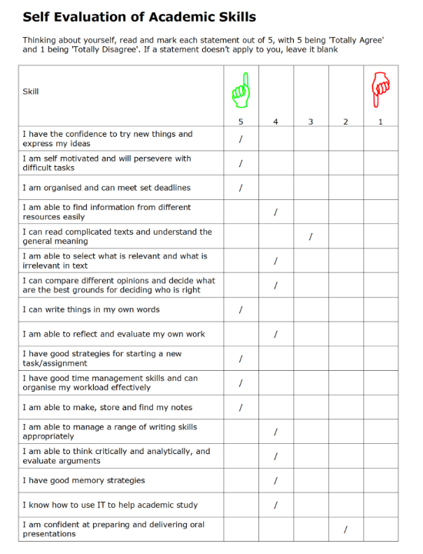
Figure 2-1: Self-evaluation results
From the evaluation outcomes, two weaknesses were selected for targeted improvement. The first was presentation confidence, which can be strengthened through regular practise [1], increased exposure to speaking opportunities, and constructive feedback. The second was reading and interpreting complicated texts, particularly understanding the general meaning of the material is highly academic [3]. To address these areas, SMART action plans were developed.

SMART Action Plan Table
The action plan for improving presentation confidence involved engaging in weekly practice sessions, obtaining tutor feedback, and monitoring progress through reflective notes. Success would be measured by increased fluency, reduced anxiety, and improved performance during assessed presentations. The action plan for improving reading and interpreting complicated texts focused on developing active‑reading strategies, such as annotating key points, summarising paragraphs in simpler terms, and using academic glossaries to clarify unfamiliar vocabulary. Progress would be monitored by improved understanding during independent study and greater confidence when engaging with complex academic material.
Development Area | Specific | Measurable | Achievable | Relevant | Time‑Bound
Presentation Confidence | Improve confidence when delivering presentations through regular practice and feedback | Track confidence levels, and feedback from peers/tutors during practise sessions | Listen to Podcast on how to speak with confidence, rehearse slides and seek feedback. | Important for assessed presentations and future academic communication | Achieve improvement within 12 weeks.
Reading and Interpreting Complicated Texts | Improve ability to understand the general meaning of complex academic texts | Monitor understanding through summaries, notes, and improved understanding during independent study | Use active reading strategies such as annotating, highlighting key points, and using glossaries | Supports success across all modules that require reading academic material | Implement tactics consistently and review progress after 4 weeks.

Table 2-1 : SMART Action Plan Table for two weaknesses

Action plans and Gantt charts
Action plans and Gantt charts are essential tools for organising tasks, managing time effectively, and ensuring that goals are achieved in a structured and realistic manner. [4] In a real-life context, these tools assist breaking down complex goals into manageable steps, allowing progress to be monitored and adjusted where necessary. This section demonstrates how action planning and timeline visualisation can support both long term personal development and short term academic task, such as completing a report. Firstly, a personal goal is analysed and translated into a detailed action plan accompanied by a Gantt Chart. This is followed by a second example that applies the same structured approach to the planning and execution of an academic assignment. Together, these examples highlight the value of systematic planning in maintaining focus, improving productivity, and achieving successful outcomes.

Personal Goal – Action Plan and Gantt Chart
The personal goal selected for this section is to pass the Foundation Year successfully and progress to complete the Bachelor of Engineering (Hons) in Electrical and Electronic Engineering. This goal reflects a long-term academic and career aspiration and has been broken down into ten structured steps to support achievement.
- Complete the Foundation Year and understand all modules (Computing, Maths , Academic Skills), applying the knowledge gained to future B.Eng. studies.
- Engage fully with all learning resources and attend all lectures, laboratory sessions and tutorials, using textbooks and online materials to strengthen engineering fundamentals.
- Seek academic support when needed by asking questions in class and using study skills and maths tutorial groups.
- Complete coursework assignments well ahead of deadlines by breaking them down into smaller tasks and scheduling them using a Gantt Chart to improve quality and reduce stress.
- Revise and research key engineering topics regularly , especially mathematics and physics, to build a strong foundation for the degree programme and retain essential knowledge.
- Develop practical engineering skills through active participation in laboratory work, hands-on activities, and any available engineering projects to gain technical experience and confidence.
- Monitor academic progress consistently by reviewing tutor feedback and tracking grades to identify areas for improvement and maintain high performance.
- Prepare thoroughly for exams by producing revision plans, practising past papers.
- Plan ahead for progression into Year 1 by researching upcoming modules, understanding future requirements, and strengthening study habits for higher level engineering work.
- Review the B.Eng. Electrical and Electronic Engineering programme requirements to understand module expectations, assessment criteria, and learning outcomes.

Personal Goal Action Plan Table (Excel)
Using Microsoft Excel, I created an action plan table that feeds into creating a Gantt Chart. This action plan table includes the ten steps outlined above, each with a defined start date, end date, and an automatically calculated duration column. The table provides a clear overview of the timeline for achieving the personal goal of successfully completing the Foundation Year and progressing into the Bachelor of Engineering (Hons) in Electrical and Electronic Engineering. By organising the steps in this format, the table serves as a foundation for visualising the goal through a Gantt chart and supports effective time management and progress tracking. Please refer to Figure 3-1 for the personal goal action plan table used to produce the Gantt Chart.
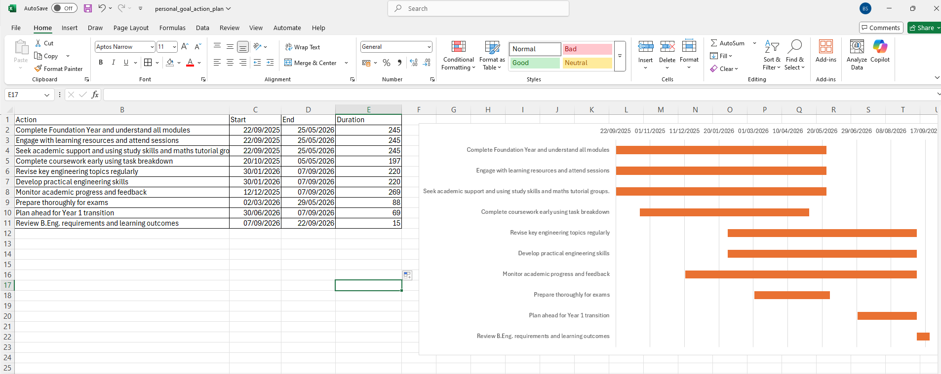
Figure 3-1 : Personal Goal Action Plan Table (Excel)

Personal Goal - Gantt Chart
The Gantt Chart translates the ten step action plan into a visual monthly timeline, demonstrating how the personal goal will be achieved over a twelve month period. Assigning each step to a specific duration ensures that progress is spread evenly throughout the year, reducing stress or pressure, and supporting consistent academic performance. This timeline highlights the logical sequencing of tasks, beginning with completion of foundation year and gradually moving toward revision, skill development, and preparation for progression into Year 1. By mapping each stage onto a clear schedule, the Gantt Chart reinforces effective time management and provides a practical framework from monitoring progress towards the successful completion of the foundation year. Please refer to Figure 3-2 for the personal goal Gantt chart, which visually represents the timeline and sequence of actions outlined in the action plan.
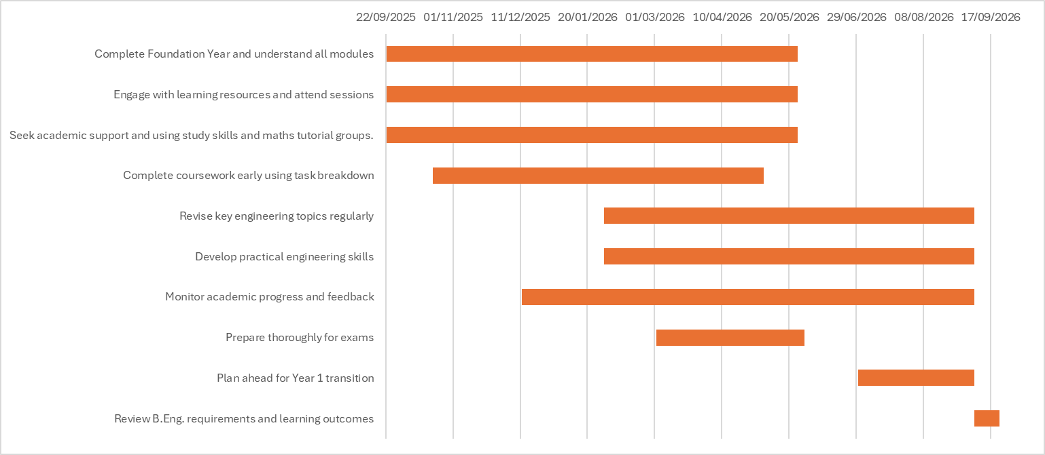
Figure 3-2 : Personal Goal Gantt Chart (Using Excel)

Assignment Planning - Action Plan and Gantt Chart
To demonstrate the planning for executing an assignment, the process of completing this report was selected. The assignment was broken down into ten key stages, each representing a critical phase in producing a high quality submission. The timeline follows a monthly structure, similar to the personal goal plan in Section 3.1. However, the assignment’s full duration was scheduled for four-weeks.
- Review the assignment brief and understand all requirements.
- Gather evidence including screenshots, notes, and self‑evaluation results.
- Draft Section 1: Presentation Skills and Reflection.
- Draft Section 2: Self‑Evaluation and SMART Action Plans.
- Draft Section 3: Action Plans and Gantt Charts.
- Draft Section 4: Use of Tools to Enhance Productivity.
- Create all required tables, charts, and Excel outputs.
- Format the report professionally, including headings, table of contents, and layout.
- Insert IEEE references and finalise citations.
- Proofread, revise, and submit the completed report.

Assignment Action Plan Table (Excel)
This action plan table highlights the ten key stages involved in completing this assignment, with each task sequenced to reflect the logical flow of report development [5]. In contrast to the personal goal plan, which spans several months, this assignment was completed within a four week timeframe. The table was created using Microsoft Excel and includes start and end dates, task descriptions, and calculated durations. This structure supports efficient time management, ensures that each section of the report is completed in order, and provides a base for creating the assignment Gantt Chart shown in Figure 3-4.
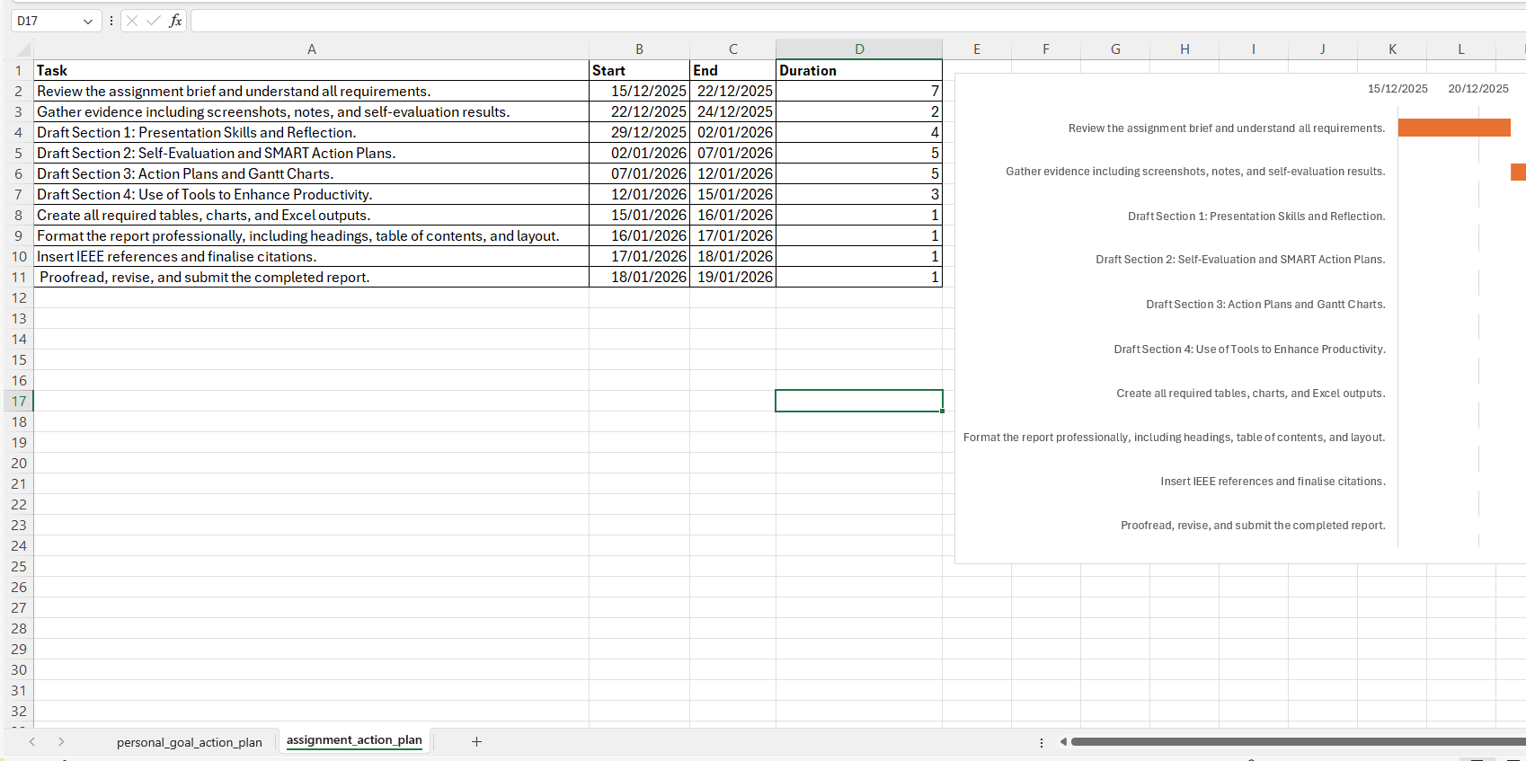
Figure 3-3: Assignment Action Plan Table (Using Excel)

Assignment Gantt Chart
The Gantt Chart shown in Figure 3-4 below, visually represents the assignment planning timeline with each of the ten key stages mapped across a four week period. In contrast to the personal goal chart, which spans several months, this chart reflects the condensed nature of assignment execution. Each task is sequenced to follow the logical flow of the report, from initial brief review to final proofreading and submission. The visual layout supports efficient time management, helps monitor progress, and ensures that each section of the report is completed in a timely and organised manner.

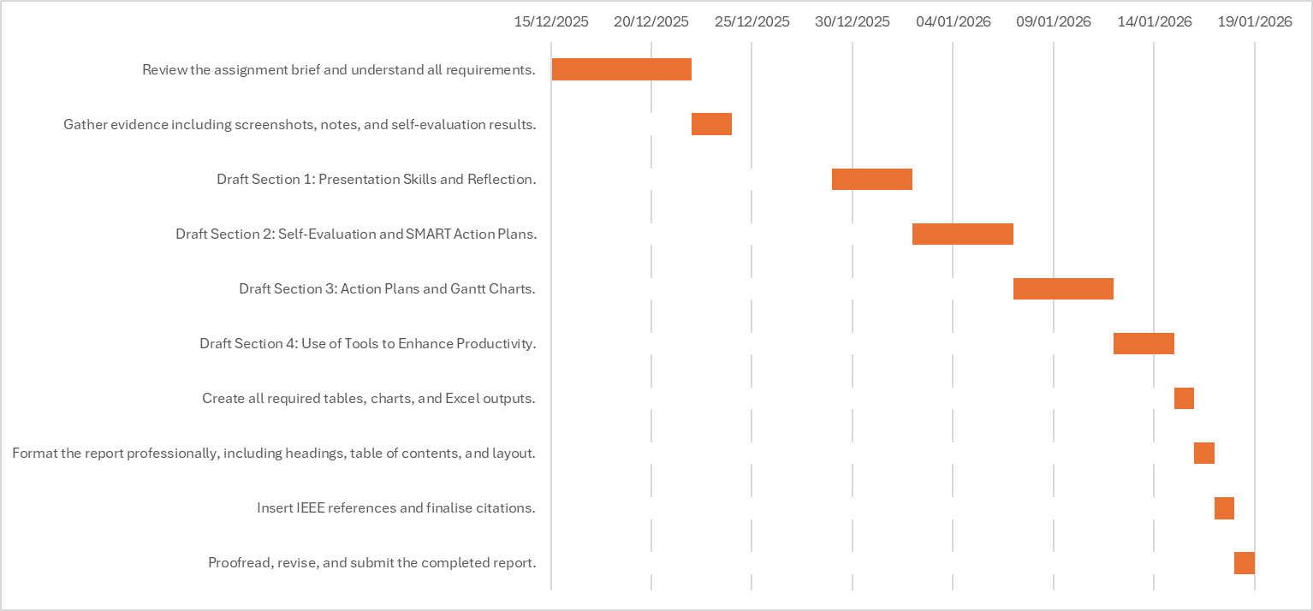
Figure 3-4 : Assignment Gantt Chart

Use of tools to enhance productivity
Effective time management and data organisation are crucial for academic success. Throughout the module, a series of digital tools were used to support productivity, including electronic calendars for scheduling tasks and spreadsheets for managing numerical data. These tools helped structure daily activities, monitor progress, and maintain control over academic and personal responsibilities. [3] This section presents evidence of how these tools were applied, demonstrating the ability to plan effectively and handle data using appropriate software.

Electronic Calendar
Figure 4-1 shows a screenshot of my iPhone Calendar, to demonstrate how daily tasks and academic commitments are managed, in this example, throughout January. Events such as lectures, assignment deadlines, gym sessions, meal planning, and appointments are colour‑coded and scheduled across the month. The calendar supports time management by providing a clear overview of upcoming responsibilities and helping to balance academic work with personal routines. Using a digital calendar ensures that tasks are not missed and allows for easy adjustments when plans change.
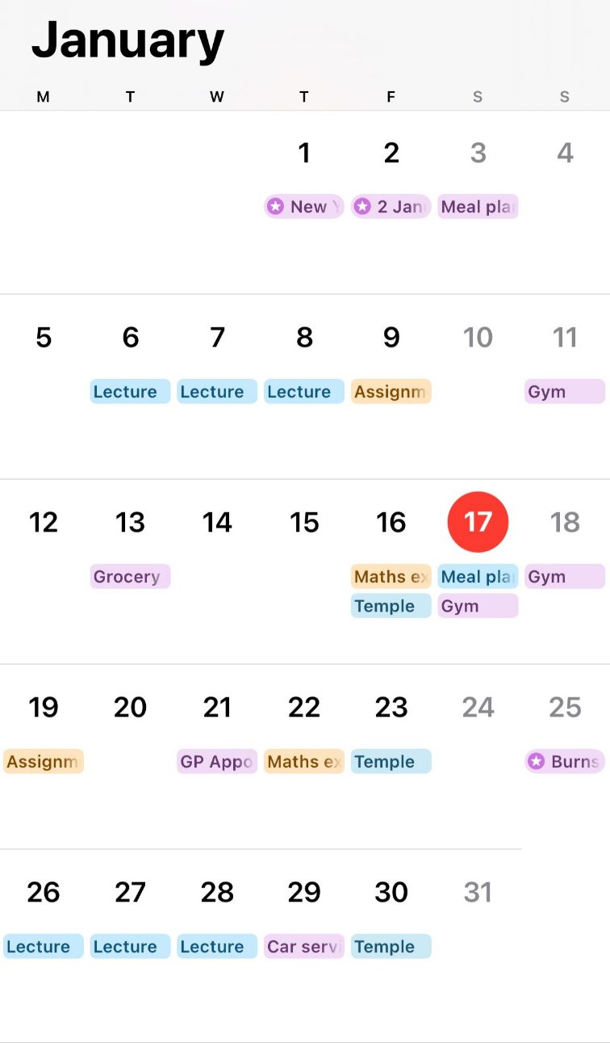
Figure 4-1:iPhone Electronic Calendar

Finances and Budgeting
Figure 4-2 below demonstrates the use of Microsoft Excel to manage and calculate monthly finances. The spreadsheet includes income and expenditure, organised into categories such as housing, utilities, transport, and entertainment. Formulas were used to calculate totals, differences, and remaining balances. A bar chart titled “Expense review” visually represents outgoing costs, making it easier to interpret spending patterns. This evidence shows the ability to use Excel for financial planning and highlights the importance of budgeting in student life.

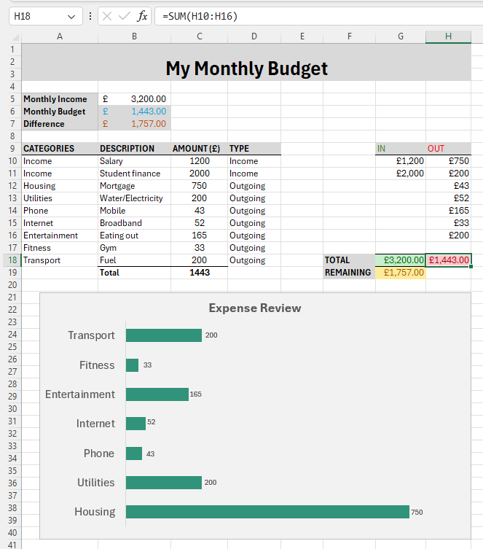
Figure 4-2 : Evidence of using Excel to keep track of my finances and budgeting

Data visualisation using Excel – Bar Chart and Pie Chart
To demonstrate the ability to present data professionally, Microsoft Excel was used to input, organise and visualise a dataset related to monthly electricity usage. This process involved creating a structured table and generating a bar chart to display the data clearly and effectively. The dataset includes twelve data points indicating electricity consumption (in kWh) for each month of the year, allowing for straightforward comparison and identification of seasonal trends.
Further demonstrating the ability to present data, a pie chart was also created using Microsoft Excel to visualise the distribution of weekly study time across Foundation Year subjects. The dataset includes five categories: Maths, Computing, Academic Skills, Engineering Science, and Revision/Practise Papers. Each category was assigned a percentage based on typical weekly study habits, enabling a clear representation of how much study time is allocated across different subjects.

Bar graph plot – home electricity usage per month
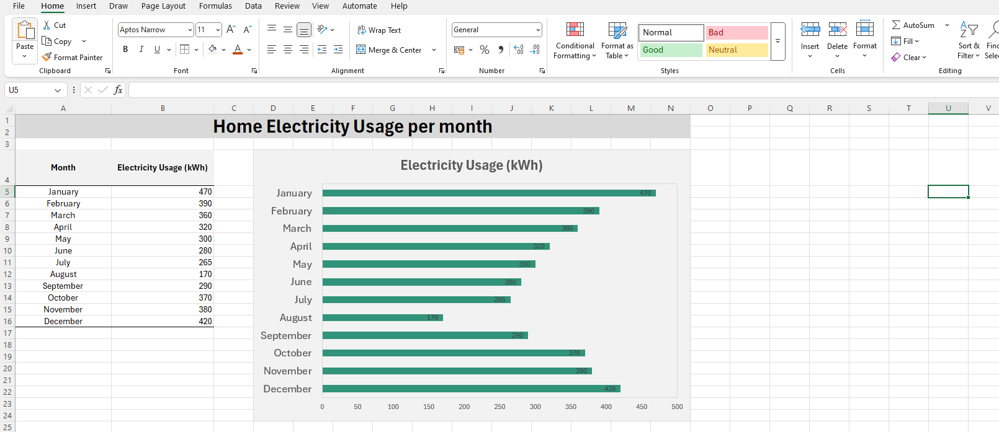
The below Figure 4-3 provides evidence of using Microsoft Excel to input and organise the monthly electricity usage dataset. The table includes labelled months and corresponding kWh values, demonstrating the ability to structure numerical data effectively before visualisation. Excel was used to format the table, ensure accuracy, and prepare the dataset for generating the bar chart. Please see below Figure 4-3 for evidence of using Excel to present home electricity usage per month.
Figure 4-3 : Evidence of using Excel to present home electricity usage per month.
The following figure 4-4 shows the bar chart which illustrates electricity consumption for each month of the year, allowing clear comparison across the twelve data points. The visual representation indicates seasonal variation, with higher usage during colder months (January, December) and lower consumption in Summer (June, July, August). This chart highlights the importance of using Excel to convert raw numerical data into a clear, meaningful visual display which supports interpretation and trend analysis.
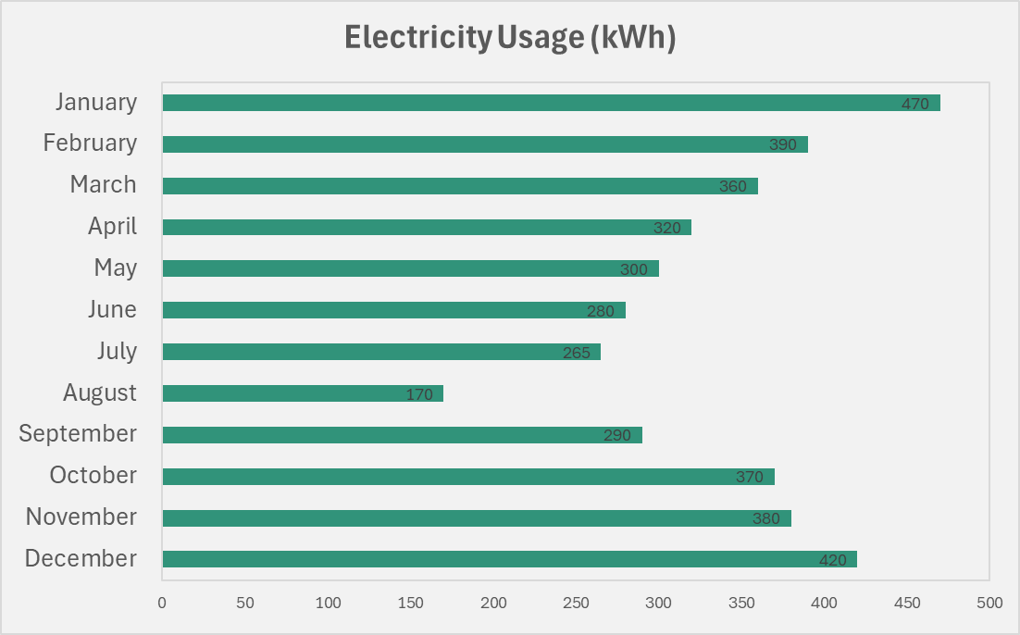
Figure 4-4 : Bar Chart - Home Electricity Usage (kWh) per month

Pie Chart – weekly study time by subject
Figure 4-5 below demonstrates evidence of using Microsoft Excel to input and organise the dataset, to generate the pie chart. The table includes labelled subjects and their corresponding percentages (%), demonstrating the ability to structure categorical data effectively. Excel was used to calculate proportions and prepare the dataset for visualisation before producing the final chart.

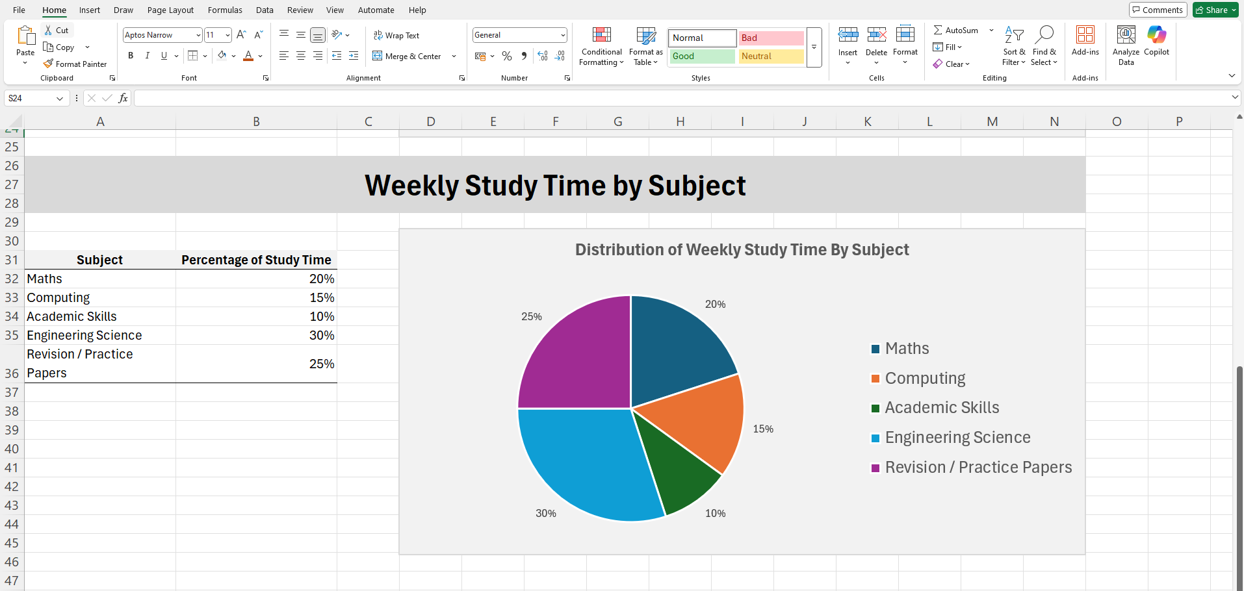
Figure 4-5 : Evidence of using Excel to create pie chart for weekly study time by subject

Figure 4-6 shows the pie chart which illustrates the proportion of weekly study time allocated to five Foundation Year subjects. Each segment represents a percentage of total study time, providing a clear visual comparison between subject areas. The chart outlines Maths and Computing as the largest components, reflecting their importance within the programme.

Figure 4-6 : Pie Chart showing weekly study time by subject

Conclusion
This report has highlighted the importance of development and application of key academic skills throughout the module. From improving presentation confidence and self evaluation to creating structured action plans and using digital tools such as Microsoft Excel, iPhone calendar to increase productivity, each section reflects meaningful progress. The use of SMART goals and Gantt charts supported effective planning, while Excel and electronic calendars enhanced time management and data organisation. Visualisation tools such as bar charts and pie charts indicated the ability to present information clearly.
Together, these skills form a strong foundation for future academic success. By continuing to apply structured planning, reflective practise and digital tools, I will be better prepared to meet the requirements of higher level study and progress confidently into the Bachelor of Engineering (B.Eng. Hons) in Electrical and Electronic Engineering.

References

[1] | J. Smith, How to Be Confident, HarperCollins, 2022.
[2] | J. Copus, Brilliant Writing Tips for Students, Palgrave Macmillan, 2009.
[3] | K. McMillan and J. Weyers, How to Write for University: Academic Writing for Success, Pearson, 2014.
[4] | J. Clear, Atomic Habits: An Easy & Proven Way to Build Good Habits & Break Bad Ones, Penguin, 2018.
[5] | M. Reid, Report Writing, Palgrave Macmillan, 2012.

