
Applied Leadership and Management in the Workplace
Module Assignment Submission
Student Name: | Leanne Thomas
Student Number: | 2318789
Module No: | BMSK4013
Module Title: | Management Communication

Statement of Confirmation of Authenticity
By the act of making this submission, the student declares that this is the work of the student named above. The work has not, in whole or in part, been knowingly presented elsewhere for assessment, or where assessment has been built on a previous assessment, this has been identified. Where materials have been used from other sources it has been properly acknowledged. If this statement is untrue, the student acknowledges that an assessment offence has been committed.
Attention is drawn to the plagiarism and unfair practice policies of both the University and of ILM.

Table of Contents
Section 1.0 Introduction
2.0 What is Communication
3.0 Methods of communication
4.0 Formal and Informal Lauguage
5.0 what is Motivation
6.0 Four Motivation Theories
7.0 My Communication Questionnaire
8.0 Appendix A Personal Development Plan

Section 1.0
Introduction
I have enjoyed learning about the different types and style of communication and motivation. I have included different concepts of types and styles of communication and including Intrinsic and extrinsic motivation. I have conducted a questionnaire and Personal Development Plan to help me improve on my communication.
What is Communication
Duck, S & McMahan, D.T, (2015) stated "Communication is the transactional use of symbols and signs that can be conveyed, impacted, directed, and comprehended and used within the framework of personal and working relationships."
In the Health Care setting we have to use many forms of communication with colleagues, outside agencies and the different people we support who have many different forms of disabilities. Another colleague said to me when I first started out in care, that care or support workers have to have many different faces and these will change throughout the day. At first I didn’t quite understand what she meant by it, until one day I got it and the saying was so true and has stuck with me for the last 23 years. What she meant by this was you will walk into different places and interact with different people and your face and voice will have to soften when your speaking to someone who has dementia. Your body language and words will change when someone when you are in a situation when dealing with another person who is having a schizophrenic episode and is threating to take theirs or your life. Your tone will have to be more forceful when you are asking grown men to leave an apartment of a vulnerable lady when they have taken it over as a drug den. Your communication style changes weather you are in a formal setting in a work place and as I have experienced the higher the ,adder you climb the more formal you have to become. The formality changes completely and your more relaxed and become more the person you are when you are out with friends having dinner.
Methods of Communication
I plaint
- I plaint is a written document where we communicate about the people we support and their everyday life. The information we record and document can be used in a court of law as this protects us and the people we support.
- Care plan - a written document within I plaint that outlines the health and social care needs of the individuals. It is a person centred document that informs us about their past and how they choose to live there future.
- Risk assessments again within I plaint We have risk assessments put in place to communicate any risk factors we may come across this could be anything from a swimming pool in the back garden or any threat the individual we support having aggressive behaviour.
This all works as it keeps us safe, supported and protected within the work place. There is no negative feedback for this process as it works well and keeps everyone unformed and on the same page.
Work diary
- We keep a log of home improvement appointments, the person we supports appointments and any outside agency appointments.
- This helps us run the shift appropriately and is a fundamental part of how we manage to keep the workplace organised.
Person we supports diary
- We keep a quick to hand record of what activities the person has done throughout the week. It helps us to prevent boredom by the same activity’s being completed over and over again.
This is how we manage all of the activities for the 5 gentlemen we support to help us enhance their lives and maintain organisation with all twenty staff. It is repetitive as this information would also be found on I plaint but in a busy house this is a much quicker way to get the information quickly.
Staff Rota
- We are allocated a person that we must support for that day. This ensures the shift runs smoothly from the minute you come into work.
Communication book
- Important information regarding any changes would be documented here. For example if staff need to read any new documents or any radar tasks need to be completed. This can also be in a medication has changed or altered it would be documented here.
We read this every morning and if you have had days off we read it all from the last day you worked. This helps us stay in the loop and keeps us informed of any changes that have been implemented.
I find this form of communication works well, as we all work different days and times. It keeps us all on the same page and enhances the communication within my service. We all need to initial once read so no one can say that they did not receive this information.
Face to face
- Communication throughout shift
- Supporting individuals
- One to ones
- Yearly appraisals
- Work meetings
- Sickness reviews and return to work
- Training
Emails
- Training
- Meeting information
- Work calendas
- Work communication and information
- Weekly work briefs off the CEO
- Speaking to outside agencies social workers etc
Intranet
- Organizational policies and procedures
- Organizational jobs
- Organizational information regarding Dimensions
- Training
Phone
- Speaking with families
- Speaking with GP, nurses, dentist
- Speaking with outside agencies

Teams
- Training
- Meetings
- communicating with colleagues
Picture cards/boards and word boards
- Communication showing picture cards
- Communication through a picture board
- Communication through word boards
Brail
- Communication through brail
Sign language and Makaton
- Communicating through sign language or Makaton
All of these communication methods are highly effective and efficient within the health care work place and we need to use all of these to help maintain a well organised work environment. I was quite shocked at how many different communication methods we use compared to other companies.

What’s App
- We use this to keep in touch and ask questions if we need the information from when someone else was in work on that particular day.
This is the only one I feel that does not work as it can be miss used by outing people who have called in sick or to belittle another staff member. It also infringes on your days off so I mute this chat when I am not in work.
Formal and Informal Language
Importance:
Formality sets the tone of the message and ensures that the communication is appropriate and accurate to the setting and audience that receive it.
- Formal Language is used in professional, academic, or official contexts to display respect and clarity.
  - Example: A letter to a job application:
“Dear Mr. Smith, I’m writing to express my interest in the advertised position…”
- Informal Language is suitable for casual and social conversations with friends, family, or close colleagues.
  - Example: A text to a friend:
“Hello, just wanted to see if you’re free to meet this weekend!”
Using informal language in a work setting can cause miscommunication or make you seem unprofessional or disrespectful. The same as if you were talking to a family member or friend in a professional or formal manner they would question why you were being so formal and that could come across that you angry with them.
Language with Different Audiences Importance:
Different audiences have varied levels of understanding, background knowledge, and expectations.
Example: Explaining a new care plan approach in supported living
- To a regulatory agency or healthcare board:
“We’re implementing a person-centred care model that will aligns with CIW (Care Inspectorate Wales) standards, to enhance and individualized support plans, outcome-based tracking, and multi-disciplinary coordination to enhance the individuals quality of life.”
- To support staff or care workers:
Putting each individual at the centre of their care is our main goal. This entails developing individualised plans according to their top priorities and cooperating daily to support their objectives.
Adapting language ensures transparency, builds trust, and improves cooperation across professional and frontline teams. This also helps everyone to feel included and formal inclusivity and enhances equality.
Structure for Different Audiences
- For Senior Management or Commissioners: Begin with an overview of the main results (such as increased resident autonomy or regulatory compliance), then list the cost-effectiveness and strategic advantages in bullet points.
- Regarding Frontline Support Staff:
Give a thorough explanation that includes the rationale behind the change, the new routines, the implications for their role, and step-by-step instructions.
A well-defined framework facilitates accurate information processing, comprehension, and action by each individual.
4. Content for Different Audiences
Information must be relevant to each audience’s specific role and needs.
Example: Announcing a new digital care planning system
- For senior managers: Focus on compliance, data accuracy, and improved monitoring and reporting of outcomes.
- For support staff: Emphasize ease of use, time-saving benefits, and how it improves resident care planning.
- For residents and families: Highlight increased transparency, involvement in care decisions, and better communication.
5. Tone with Different Audiences
The tone expresses attitude and can have a significant impact on how communications are comprehended.
- Professional Tone: Communicates responsibility and deference.
For example, "We have taken immediate steps to address the concerns raised and are committed to continuously improving our services" could be written in a letter addressed to an inspector or social worker.
- Friendly Tone: Encourages trust and collaboration.
For example, you could write to a support staff member, "Thanks so much for stepping in yesterday—you really made a difference for Client A!"
Different Modes of Communication with Different Audiences and Situations
Selecting the appropriate mode guarantees that the message is understood and applicable for the right circumstance. For example:
- Email: Suitable for formal, documented communication (e.g., keeping outside agencies or managers informed).
- Phone/Video Calls: Useful for real-time discussions or sensitive topics (e.g., meetings or emergencies)
- Text/WhatsApp: Good for quick, informal updates or clarifications among colleagues.
I completed the communication quiz and my highest score showed that I am an assertive communicator. This did not surprise me as I know I can be direct when communicating.
What is motivation
Ryan, R. M. & Deci, E. L. (2000) describe this as an action is a results from motivation. They have three primary motivators and these are needs, values, and goals. By applying these three motivators this will help individuals maintain motivation.
Intrinsic and Extrinsic Motivation
My examples:
Intrinsic Motivation
A student studies business and management in the workplace because they are excited to be learning about a new course that interests them.
Extrinsic motivation
A student studies business and management in the workplace as they want to earn more money and good grades and own their own business.
Feature | Intrinsic Motivation | Extrinsic Motivation
Source | Internal. | External.
Rewards | Engagement, passion, enthusiasm, fulfilment, joy. | Acknowledgment, praise,  Salary, rewards and appreciation
Persistence | Sustainable and would be more likely to stick at it. | Could stop if the reward was removed.
Example | Learning CPR for fun. | Learning CPR for a job.

Motivation Factors | Positive Influences | Negative Influences
Management Style | Empowering, team focused,  Respectful, helpful, honest, transparent. | Toxic, Negative, micromanagement, neglectful and ambiguous.
Job Description | Growth, constructive feedback, positive work environment, good work life balance. | No progression, negative feedback, bullying, bad work life balance.
Work Environment
Team Dynamics | Good communication, feeling like part of a team, trust, respect and strong leadership. | Bad communication, not feeling like part of a team, no trust or respect and a poor leadership.
Training | Training courses, learning new skills to progress and to help you in the current role. | No training, no progression.
Recognition and Feedback | Positive recognition, good feedback, appraisals and one to ones. | No recognition, bad feedback, no appraisals or one to ones.
Four Motivation Theories
Maslow’s Hierarchy of Needs
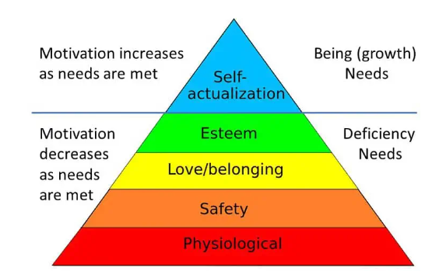
Maslow. A. (1943)
McLelland’s Three Needs Theory
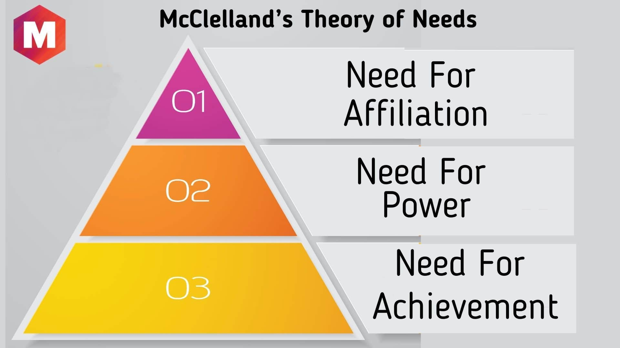
McClelland, D. C. (1965).
Herzberg’s Hygiene Theory
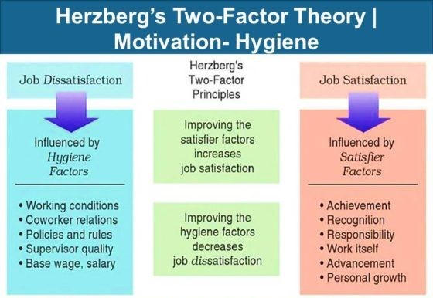
Herzberg, F. (1960).

McGregor’s X and Y Theory
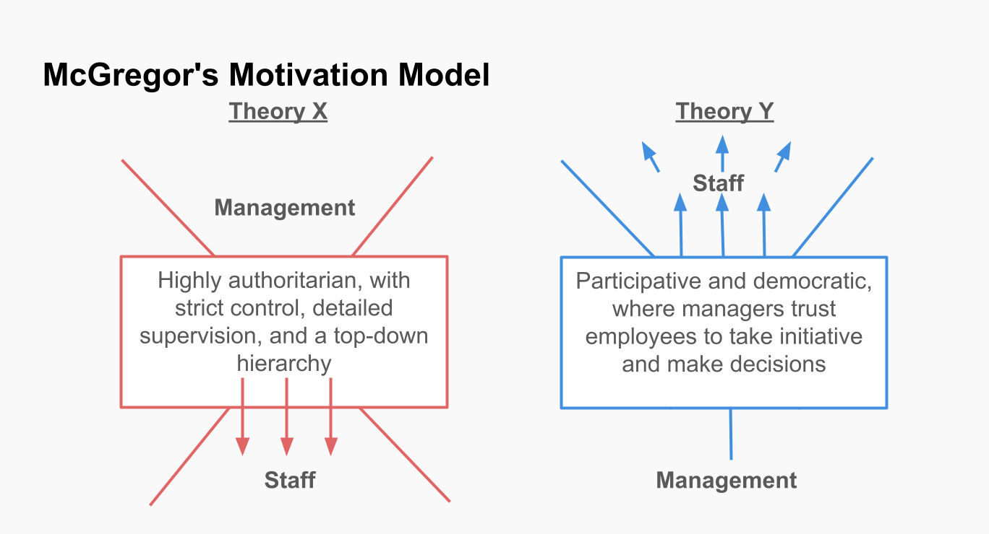
McGregor. (1964)
The Things That Set Them Apart
Maslow: A comprehensive hierarchy of human wants, ranging from the most fundamental to the most advanced.
McClelland: Highlights three distinct demands that people acquire as a result of their experiences in life.
Herzberg divides workplace elements into two categories: "if present, causes true satisfaction" (motivators) and "if absent, causes
- McGregor: Explains how motivating others is influenced by two opposing managerial attitudes (X vs. Y).

The most effective model for assisted living is Maslow's Hierarchy of Needs.
- Prioritises meeting residents' basic needs before tackling higher-order objectives
- Physiological: diet, sleep patterns, and easily available housing
- Safety: a steady setting with obvious health and mobility assistance
- steps that direct person-centred planning:
- Provide for necessities (food, shelter, safety)
- Talk about love and belonging (through community service, family visits, and friendships).
- Develop self-esteem through constructive criticism and opportunities to contribute.
- Promote self-actualization through interests, life skills, and autonomous decision-making.
- Open and honest communication
- "We prioritise social connections, confidence building, and personal goals after ensuring everyone's routine and safety."
- Adaptable for both employees and residents:
- As supports are built, residents ascend the pyramid.
- Employees gain from the same framework (safe working conditions → team identity → acknowledgement → career advancement).

My Communication Questionnaire
Q1w
I am able to express my ideas in a clear and concise manner.
- Answered: 18
- Skipped: 0
Answer Choices | Responses
1 | 0.00%  0
2 | 5.56%  1
3 | 5.56%  1
4 | 33.33%  6
5 | 55.56%  10
TOTAL | 18
Q2w
I actively listen to others without interrupting and show I understand what they’re saying.
- Answered: 18
- Skipped: 0
Answer Choices | Responses
1 | 0.00%  0
2 | 0.00%  0
3 | 0.00%  0
4 | 33.33%  6
5 | 66.67%  12
TOTAL | 18
Q3w
I consider others' feelings and viewpoints when I communicate.
- Answered: 18
- Skipped: 0
Answer Choices | Responses
1 | 0.00%  0
2 | 0.00%  0
3 | 0.00%  0
4 | 22.22%  4
5 | 77.78%  14
TOTAL | 18
Q4w
I speak with confidence and assertiveness, even in difficult situations.
- Answered: 18
- Skipped: 0
Answer Choices | Responses
1 | 5.56%  1
2 | 11.11%  2
3 | 16.67%  3
4 | 27.78%  5
5 | 38.89%  7
TOTAL | 18
Q5w
I use eye contact, gestures, and tone of voice effectively to reinforce my message.
- Answered: 18
- Skipped: 0
Answer Choices | Responses
1 | 0.00%  0
2 | 5.56%  1
3 | 11.11%  2
4 | 38.89%  7
5 | 44.44%  8
TOTAL | 18
Q6w
I change my communication style depending on who I am talking to.
- Answered: 18

- Skipped: 0
Answer Choices | Responses
1 | 0.00%  0
2 | 0.00%  0
3 | 0.00%  0
4 | 27.78%  5
5 | 72.22%  13
TOTAL | 18
Q7w
I give feedback to others in a respectful and constructive way.
- Answered: 18
- Skipped: 0
Answer Choices | Responses
1 | 0.00%  0
2 | 5.56%  1
3 | 5.56%  1
4 | 22.22%  4
5 | 66.67%  12
TOTAL | 18
Q8w
I keep conversations interesting and engage others in the discussion.
- Answered: 18
- Skipped: 0
Answer Choices | Responses
1 | 0.00%  0
2 | 0.00%  0
3 | 16.67%  3
4 | 16.67%  3
5 | 66.67%  12
TOTAL | 18
Q9w
Thank you and please expand on your answers if you wish and provide any feedback that you think would help me improve
- Answered: 4
- Skipped: 14
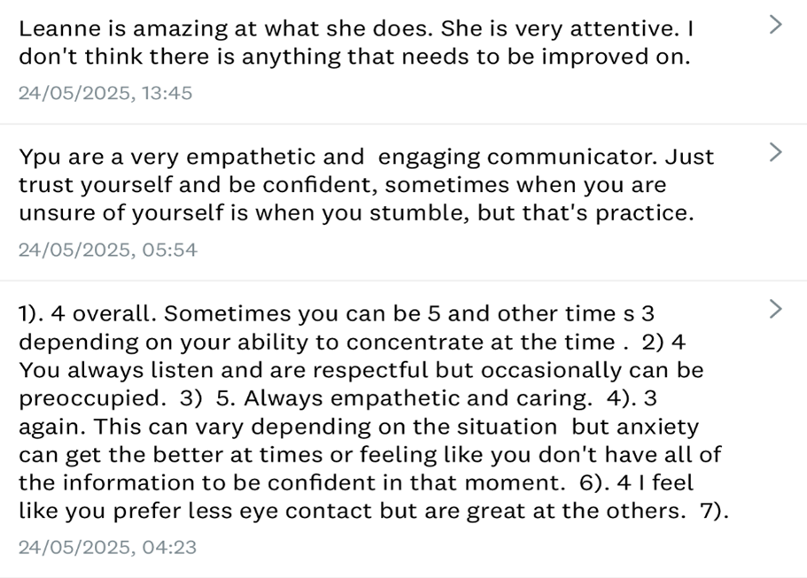

Personal Development Plan
Goals to Develop | How will you achieve them | Who can help me to achieve this | Evidence | Dates of when you will achieve this Goal
I am able to express my ideas in a clear and concise manner. | I need to have more confidence. I need to believe in myself and slow down and think before speaking. | Myself, University, tutor, fellow students, work manager, colleague, my family and friends | I will build confidence and my ability to believe in myself with continuing the Business and management course. My mind is 100 miles an hour all of the time so I need to breathe and think before I speak. | Ongoing
I speak with confidence and assertiveness, even in difficult situations. | Again I need to have more confidence. I need to believe in myself and slow down and think before speaking. | Myself, University, tutor, fellow students, work manager, colleague, my family and friends | I will build confidence and my ability to believe in myself with continuing the Business and management course. My mind is 100 miles an hour all of the time so I need to breathe and think before I speak. | Ongoing.
I use eye contact, gestures, and tone of voice effectively to reinforce my message. | I find it hard to give eye contact even with love ones as it makes me feel uncomfortable. I will try and use more eye contact in future. | Myself, University, tutor, fellow students, work manager, colleague, my family and friends | Starting with family I will try and give eye contact and then continue with colleagues. | Ongoing.
I give feedback to others in a respectful and constructive way. | Due to not currently being in a management roll, I don’t have the authority to give feedback on a daily basis. | Myself, University, tutor, fellow students, work manager, colleague, my family and friends | I will speak to colleague and try to improve any feedback and in a more efficient way. I do feel that I am always respectful of every one I encounter. | Ongoing.
I keep conversations interesting and engage others in the discussion. | I try to keep my personal life to myself so generally I only talk about work issues. | Myself, University, tutor, fellow students, work manager, colleague, my family and friends | I will open up a little more to keep conversations interesting and ensure everyone is involved in the discussion. | Ongoing.

References
Duck, Steve, and David T McMahan. Communication in Everyday Life. SAGE Publications, 1 Dec. 2016.
Herzberg, F. The Motivation-Hygiene Concept and Problems of Manpower. Personnel Administration. 1964.
Maslow, Abraham. A Theory of Human Motivation. Psychological Review, 1943, pp. 370–396.
McClelland, D. C. Achievement Motivation Can Be Developed. Harvard Business Review, 1965. Accessed 31 May 2025.
McGregor, Douglas. The Human Side of Enterprise. New York, McGraw-Hill, 1960.
Ryan, Richard M, and Edward L Deci. Self-Determination Theory: Basic Psychological Needs in Motivation, Development, and Wellness. New York, Guilford Press, 2017.

