Carol Wheelwright – 1811089

Graduate Diploma in Professional Learning SLD/PMLD

Module Title: Diversity of Learning

Module no: M6X02187

Gather evidence for a case study of a pupil, identifying the pupil’s learning styles(s), the impact of their disability on their learning and development.

Statement of Special Educational Needs

The Statement of Special Educational Needs was written by the Local Authority in collaboration with professionals from Education, Health and Social Services in accordance with Section 324 of the Education Act 1996. Kora’s statement is reviewed on an annual basis to ensure that the educational provision is still relevant and meets Kora’s needs.

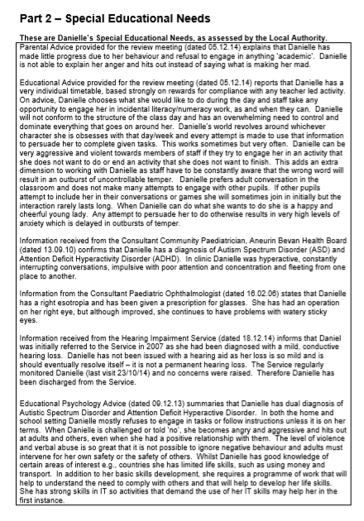

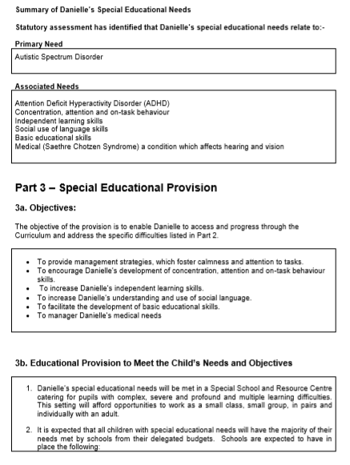

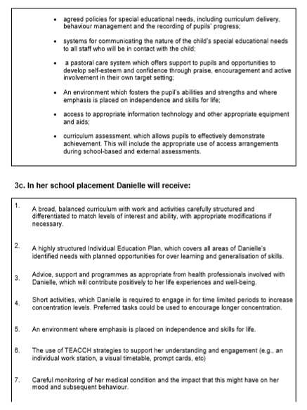

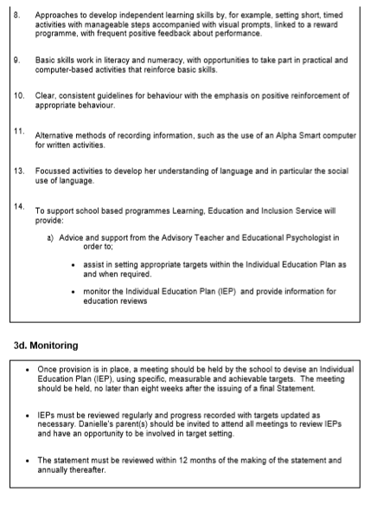

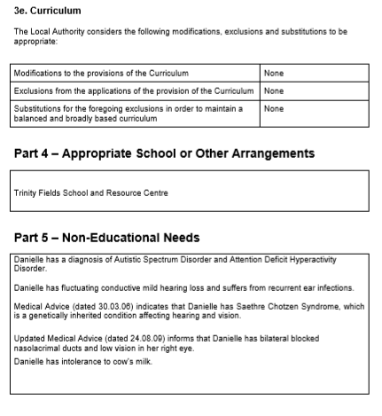

Annual Review Report

In accordance with the guidance offered in the current SEN Code of Practice, Kora’s Statement of Special Educational Needs is reviewed annually. The school has implemented a pupil centred approach; the parents, pupils, school, Local Authority and all professionals involved consider both the progress the pupil has made over the previous twelve months and whether any amendments need to be made to the statement.

The report was written by Kora’s class teacher and shared with all professionals and parents prior to the review meeting.
School Report for Person Centred Review

School
Name of Pupil | Kora

“Know” …  You can do it!  Ambitious, Capable Learners  (Mathematics, Language, Literacy and Communication: inc. Welsh) | Comments/Assessments  Kora expresses her opinions confidently and in front of a range of audiences. She organises what she wants to say and emphasises key points so that listeners can understand. She will give reasons and provide appropriate answers to questions to extend her ideas or accounts by including relevant details. Kora speaks clearly and often adopts a specific role, using appropriate language and varying expression to help the listeners. Kora uses language appropriate to more formal situations, for example, when she is leading an assembly or presenting information to her class. She thoroughly enjoys presenting her ideas about her personal projects!  Kora can read and write extended texts independently for sustained periods. She is able to use punctuation which relates to sentence structure and construct complex sentences. Kora is able to write texts for different purposes using appropriate structure and layout such as lists, numbered points, tables and bullet points. She also uses visual clues such as photographs and images to enhance her work. She is able to find information and ideas from web pages and use different search methods.  Kora talks about what she is going to write and re-reads and improves her writing to ensure that it makes sense. She can use lots of on-screen functions such as font, colour, cut, paste and size to present her work in ways to interest the reader and enhance its meaning. Kora organises her writing into logical sequences or sections and uses paragraphs effectively. She uses appropriate vocabulary, including subject-specific words and phrases. She also uses different sentence structures, including complex sentences showing relationships of time, or cause. Kora is able to use the full range of punctuation to guide the reader in complex sentences such as commas, bullet points, speech marks and apostrophes for possession.  Even though the majority of Kora’s writing is composed on the computer, she has shown that she can produce handwriting which is clear and legible with some occasional inconsistencies in size.  Kora can use every day mathematical language to talk about her own ideas and choices. She is able to devise and refine informal, personal methods of recording her work. Kora can read and write numbers accurately and use mental recall of number facts.  Kora has a good understanding of money and has shown that she is able to calculate the cost of group activities and items in a shop. She understands that all items have a value however; she does not always show that she can determine what can be bought within a given budget.  Kora understands the standard units of measure that can be used and can identify when they would be used. She has a good understanding of time and is able to order significant events throughout the year. Kora is able to gather and present data and extract and interpret information from lists, tables, diagrams and graphs.
Annual Aim: To complete literacy and numeracy based tasks that are adult led.
“Enjoy” life and be happy!  Healthy, Confident Individuals  (Health and Wellbeing, THRIVE, Multi agency links) | Comments/Assessments  Kora is a confident young lady who expresses her wants and needs clearly. She enjoys being in a class with peers who she considers to be her friends. She enjoys talking about her interests; often giving everyone an impromptu update on the latest event that she’s planning! Kora is confident when presenting her ideas to the rest of the class and enjoys having a captive audience.  Kora can sometimes struggle to regulate her emotions and has a strong personal sense of what is fair or unjust. She has become much more receptive to staff who attempt to reason with her and situations can usually be defused quite quickly. The usual cause of Kora’s distress is when she is ‘interrupted’ and has to stop working on her personal projects for example, at the end of the day when her taxi is called but she hasn’t finished what she’s working on or if the internet connection fails and she is therefore unable to access information on the internet. These incidents have become much less frequent and staff who know Kora well are able to appease her by encouraging her to talk about the situation and rationalise her response.  Kora spends the majority of her time working on her personal projects at the computer; she does not enjoy going outside during the day and prefers to spend her break times in class. She will request drinks and food at set times during the day but is reluctant to get these items for herself!
Annual Aim: To become more independent at break and dinner times.
“Yourself” …  Be ready for life!  Creative, Enterprising, Ethically Informed Citizens.  (Digital Competency, Independence, Transition, Work Awareness | Comments/Assessments  Kora is one of the most creative pupils I have ever taught! She has a wonderful imagination and produces some excellent personal projects.  The majority of Kora’s projects are created on the computer. She recognises that online actions have consequences and she can identify simple rules to keep herself safe however, she struggles to accept that certain websites are blocked in school because of their content and that this is a measure to keep pupils safe from inappropriate materials. She is able to simply explain that digital technology can be used to communicate and connect with others locally and globally and talks about different forms of online communication such as email and messaging. Even so, her preferred method of communication with ‘celebrities’ is a written letter which she can put in the post.  Kora is very particular when saving files to a specific location and using an appropriate file name. She organises her work efficiently and is always able to find her work at a later date.  Kora is able to select appropriate software to complete tasks in order to use text, image, sound and animation. Her PowerPoint presentations are excellent and she can demonstrate a range of editing and formatting skills to word processed documents.  With regards to Kora’s independence, she can carry out many tasks for herself however, she often chooses not to! She will hang her coat up each morning but insists that a member of staff puts her lunch in the fridge for her and then ‘serve it’ to her at lunch time. Occasionally she will get herself a drink but she needs a lot of encouragement to do so! She is completely independent when tending to her own personal hygiene in school.
Annual Aim: To talk about and consider her transition plans.

1a. Please indicate (where appropriate) current levels of attainment.
PIVATS data attached Yes (specify date of assessment )
May 2018

1b. Progress
What are the pupil’s strengths? What progress have they made over the last year?
- Kora has completed two Level 1 Agored Cymru modules in ICT (using Word and PowerPoint). She continues to demonstrate excellent IT skills.
- Kora is a talented and creative young lady who has demonstrated excellent literacy skills through her script and letter writing.
- Kora maintains many positive relationships with staff in school and initiates interactions with them.

What is working?
- Kora completes her ‘work’ in her own workstation which is equipped with a computer. She does not leave the classroom unless she is completing an errand or wants to initiate a conversation with a member of staff. She talks about her work with enthusiasm and is keen to share her ideas with staff.
- Kora has become much more tolerant of others eating in the classroom and in her presence.
- Kora is interacting more with her peers in class and is keen to share her interests with them, she always includes them in her projects and gives them leading roles in her plays.

What is not working? How could this be improved?
- Kora does not complete directed tasks that are set by the teacher. She will occasionally offer her opinion during discussions and answer questions verbally which demonstrates that she is listening to what is going on around her. Many strategies have been used to generate Kora’s interest in the work but she remains focussed on the personal projects that she is working on. The work that Kora produces is used to evidence other accredited modules.
- Kora continues to plan excursions and events; these usually come to a natural conclusion however, on occasion, Kora struggles to accept that trips to Disneyland will not actually be taking place. Staff continue to work with Kora to help her consider what is ‘fact or fiction’ and she has become more accepting of the reasons why such trips cannot take place.
- Kora continues to find it difficult to interpret and understand the support that staff give to other pupils; particularly those with somewhat challenging behaviours and limited communication skills. If a situation is taking place in the corridor, she will often question staff’s actions and attempt to control the situation. Staff who Kora knows well continue to support her during these times and attempt to rationalise and explain what is actually happening.
- At times, Kora can dominate the classroom. If a lesson is taking place, she expects everyone to stop what they are doing and to listen to what she has to say. Her peers are very understanding and staff can usually negotiate a more appropriate time for her to present her work to the class.

Provision to meet the pupil’s needs
2a. Please summarise the provision / resources put in place by school to address the pupil’s additional learning needs.
Kora’s needs are met in X Special School. The setting offers opportunities to work as a small class, small group, in pairs and individually with an adult.

2b. Is the pupil disapplied from any lesson / subject? Yes (specify below) No
2c. Are access arrangements required for assessments / examinations?
Yes (specify below) No
Have they been approved? Yes (specify below) No

2d. Is there a care plan in place? Yes (attach copy) No
2e. Is there a risk assessment in place? Yes (attach copy) No
4. Please provide the following information regarding LA funded additional support:
Number of hours per week
Is the support shared? | Yes No
Please attach: | Copy of timetable Yes  Appendix 5 Yes

5. Does the pupil receive LA funded transport to school?
(Do not include routine transport arrangements e.g. regular school bus).
Yes No
Is transport still required?
Yes No
- Additional comments.

I thoroughly enjoy having Kora in my class. We have developed a positive relationship and I enjoy supporting her with her creative projects. She likes to add things to my ‘to-do list’ and set deadlines for the work to be done!
Kora’s creativity and work ethic are excellent. There’s not a minute in the day when she isn’t working towards her own goals. Next year, I look forward to supporting Kora with her transition plans for the next stage of her life.

Signed | Teacher
Date | 28/03/2019
Designation

One-page Profile

The one-page profile was written by Kora’s class teacher. Kora was encouraged to participate in the process of collating the information but the majority of its content has been derived from what staff already know and understand about Kora.
The one-page profile captures all of the important information about Kora; it helps the staff who work with her to build better relationships by truly understanding what really matters to her and the best way to support her in school.

Name: Kora
DOB: xxx Age: 18
Teacher: xxx


One Page Profile

The things that people like and admire about me…
- I have a fantastic imagination and memory.
- I am really good at using the computer; I can use lots of programmes independently.
- I am a fantastic event’s organiser.
- I am very caring and always try to act in the best interests of the pupils in school.
- I have a great sense of humour.
- I am very determined and self-motivated.

How can you support me?
- I don’t usually like doing things for myself but I will hang my coat up if you give me a gentle reminder.
- I don’t usually respond well to direction but I’m willing to negotiate if you can help me to see the benefits of doing something.
- I find it hard to understand why certain websites are blocked in school; remind me that the council put restrictions in place to keep children safe.
- I don’t like doing the work that my class mates do; I’m allowed to work on my personal projects during the day and demonstrate my skills this way.
- I sometimes say things/words which aren’t true/appropriate; ask me if it’s fact or fiction or appropriate.
- Please don’t expect me to stop what I’m doing straight away, give me some warning. At the end of the day, I need at least 15 minutes warning that the buses are going to be called.
Things that are important to me:
- My family are important to me. I live with my mum.
- I really enjoy working on the computer at my own workstation. I don’t like it if people move my things or alter my search history on the computer.
- I always eat my dinner at 12 o’clock and I bring my own lunch in from home. I’m lactose intolerant.
- I am a fantastic organiser of events! I need people to ‘play along’ with my plans even if they don’t think that it’s real!
- It’s important that I can build trusting relationships with staff who help me to feel safe.
- I value routine and structure in my day. If things are going to change, give me plenty of warning.
- There are staff in school who know me well so when I’m feeling anxious or agitated, these people can usually help me.
- I need staff to take an interest in my work. I like it when people take the time to read my scripts and itineraries!

Thrive Action Plan

The Thrive Approach provides a way of working with children and young people that supports optimal social and emotional development. Kora has participated in individual Thrive sessions with a trained practitioner. An action plan and targeted strategies have been shared with staff who work with Kora on a day-to-day basis.

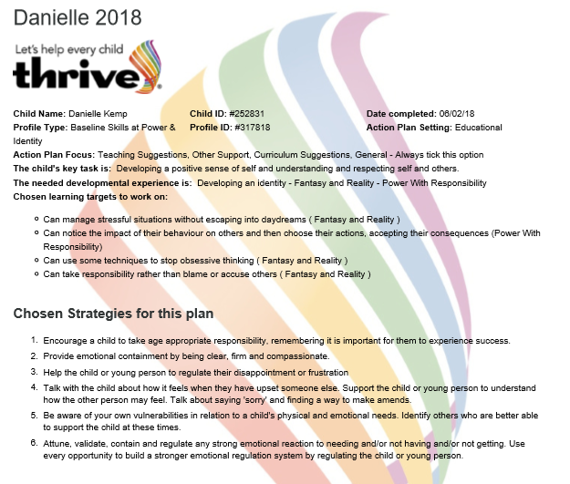

Individual Education Plan

All pupils in the school have an Individual Education Plan (IEP) which outlines the key targets for learning. Kora’s IEPs are written by her class teacher and reviewed at the end of every half term. They reflect her educational priorities.
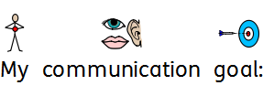
X School and Resource Centre

Respond positively and thoughtfully to new ideas and alternative points of view
Learning together in a changing world
Creating Success for All

Keys to Success
Going for Gold!
Anelu am aur!
Name: | Kora |  | Teacher |  | Teacher |  | Date Issued | May 2019


 |  | Mathematics |  |  |  | Languages, Literacy and Communication
 |  | I will work out the total cost by adding and subtracting. |  |  |  | I will use a variety of punctuation marks in my writing.
 |  | I will accept when I need help to manage my feelings.
 |  | I will improve and edit my work.
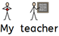

Successful Futures |  |  |  | Mathematics |  |  |  |  | Target
K- ‘Know’…You can do it! –  Ambitious, Capable Learners  (Mathematics, Language, Literacy and Communication: inc Welsh) |  |  |  | Kora will add and subtract totals less than £100 using correct notation, e.g. £28.18 + £33.45 (some verbal support) |  |  |  |  | LNF Y5
 |  |  |  | Literacy |  |  |  |  | LNF Y5
 |  |  |  | Kora will use the full range of punctuation to guide the reader in complex sentences, e.g. commas, bullet points, speech marks and apostrophes for possession (some verbal prompting) |  |  |  |  | LNF Y5
E- ‘Enjoy’ life and be happy!  Healthy, Confident Individuals  (Health and Wellbeing, THRIVE, Multi agency links) |  |  |  | Kora will notice when she needs help to manage her feelings in order to avoid acting impulsively. |  |  |  |  | Health and Wellbeing  Experiences  PS2
Y- ‘Yourself’ …Be ready for life!  Creative, Enterprising, ethical informed citizens  (Digital Competency, Independence, Transition, Work Awareness |  |  |  | Kora will give an opinion about her own work and suggest improvements, e.g. spot mistakes and use editing tools to improve her work. |  |  |  |  | DCF Y3

Individual Behaviour Plan

The Individual Behaviour Plan (IBP) contains strategies that are appropriate and specific to Kora. The class teacher will have responsibility for reviewing and updating the IBP as well as ensuring that the strategies are used consistently by all staff who work with Kora. The IBP is written in accordance with the whole-school Behaviour Policy.
Background Information

Kora has a diagnosis of ASD and Exotropia in her right eye.
She is a chatty and animated young lady who enjoys the world of Nickelodeon characters. She has an incredible imagination and uses the characters from her favourite Nickelodeon programmes in her personal projects. She also enjoys using the computer. Kora is encouraged to participate in all work activities but is reluctant to do so. Kora has built relationships with her peers; she enjoys her own company and adult engagement but on her own terms. Kora can sometimes say things that may not always be true (see risk assessment). She will respond to being asked whether it is fact or fiction.

General Behaviour triggers:
The following situations/incidents may trigger the behaviours as detailed below:
- Being on her period and/or feeling unwell
- Websites being blocked or technical issues with her computer
- Other pupils shouting or harming staff or peers
- Being asked to do something that she doesn’t want to
- Transitioning from one place to another; especially outside or out of the school grounds
- Being asked to come off the computer when she is working on something and/or wants to complete what she is doing
- Staff giving direction to other pupils or attempting to ‘guide’ them away from an area. Kora will often call this ‘bullying’ or ‘abuse’.

Essential Information for managing
- A consistent approach is essential when managing Kora’s behaviour and where possible advice should be sort from those members of staff who work with her on a day to day basis or know her well.
- Any agreements made should be honoured at all times – Kora is getting better at compromising.
- It is unlikely that Kora will agree to do any teacher-directed tasks. Kora should always be given a choice as to whether or not she would like to participate and encouraged to do so. If Kora shows signs of distress after the initial request, further requests should be kept to a minimum and not given in a direct manner.
- Kora doesn’t usually respond well to direction but she is beginning to negotiate if you help her to see the benefits of doing something.
- Don’t expect Kora to stop what she’s doing straight away, give her some warning. At the end of the day, she needs at least 15 minutes warning that the buses are going to be called.

Behaviour | Possible triggers | Action
Throwing objects.  Hitting, kicking, biting, grabbing and scratching.  Causing injury to staff or herself.  Saying something deemed to be untrue (see risk assessment).  Wandering off or running away.  Demanding attention from staff.  Dominating the whiteboard or ‘taking over’ a lesson.  Shouting at staff. | Being on her period and/or feeling unwell.  Websites being blocked or technical issues with her computer.  Other pupils shouting or harming staff or peers.  Being asked to do something that she doesn’t want to do.  Transitioning from one place to another; especially outside or out of the school grounds.  Being asked to come off the computer when she is working on something and/or wants to complete what she is doing.  Staff giving direction to other pupils or attempting to ‘guide’ them away from an area. Kora will often call this ‘bullying’ or ‘abuse’.  Being told that one of her planned trips isn’t going to happen. | A calm approach works well during times of frustration and it’s important that a member of staff who knows Kora well is asked to support.  Direct Kora to her workstation. Remove any objects that may be thrown.  Kora is developing her skill of compromising; if she is unresponsive ask her ‘what can we do about this?’ or ‘what can I do to help?’  Kora may talk in the third person and take on the persona of ‘Kora’ (this is an Avatar from a Nickelodeon series). Tell Kora that ‘I’m not talking to Kora’ and remind her that Kora is fictitious and cannot control her actions.  If Kora attempts to hit, kick or bite, use the script “we’re friends and friends don’t hurt each other”. Remind Kora that you are trying to help her and that she doesn’t need to shout.  If Kora uses words such as ‘bullying’ or ‘abuse’ remind her to think carefully about her choice of words. Ask if a scenario she has shared is “Fact or Fiction’’ (see risk assessment).  Kora should be shadowed by a staff member at all times. She sometimes likes to go to the photocopier on her own but it’s important that a member of staff checks on her as technical problems with the photocopier can cause her to become distressed.  It’s important to identify when Kora is feeling anxious and to ensure that she is given the time and attention that she requires. She also needs to be told that if you can’t give her the attention she wants right now that you will spend time with her ‘in x minutes’ or at a specific time i.e. “I’ll come and work with you at 10:15”. “I’m doing this now; I will work with you in 10 minutes”.  Kora will attempt to ‘argue her point’ to get her own way. If the conversation is ‘going round in circles’, tell Kora that “I’m not talking about this anymore”.

Shared and agreed with parents on: | Signed by parents:
Signed by teacher: | Review date: 31/09/19

End of Year Report

Kora’s class teacher writes an annual report which is sent to Kora’s parents/carers at the end of each year which details Kora’s achievements and progress. Kora is also encouraged to reflect on her achievements throughout the year.

The format of Kora’s report differs from the standard form used across the 14-19 department because Kora follows a bespoke curriculum.

Name | Kora |  | DoB
Class |  |  | Year | 13
Attendance | Possible | Actual | %

X School and Resource Centre

14-19 Learning Pathways School Report 2019

Languages, Literacy and Communication

Kora expresses her opinions confidently and in front of a range of audiences; she enjoys telling staff and visitors about the projects that she’s working on in class. She will occasionally lead an assembly based upon a theme of her choice. She organises what she wants to say and emphasises key points so that listeners can understand. She will give reasons and provide appropriate answers to questions to extend her ideas or accounts by including relevant details. Kora speaks clearly and often adopts a specific role, using appropriate language and varying expression to help the listeners. Kora uses language appropriate to more formal situations, for example, when she is introducing herself to visitors or presenting information to her class. She thoroughly enjoys presenting her ideas about her personal projects and uses digital images and videos to enhance her presentations!

Kora can read and write extended texts independently for sustained periods. She is able to use punctuation which relates to sentence structure and construct complex sentences. Kora is able to write texts for different purposes using appropriate structure and layout such as lists, numbered points, tables and bullet points. She also uses visual clues such as photographs and images to enhance her work. She is able to find information and ideas from web pages and use different search methods. Kora talks about what she is going to write and re-reads and improves her writing to ensure that it makes sense. She can use lots of on-screen functions such as font, colour, cut, paste and size to present her work in ways to interest the reader and enhance its meaning.

Kora organises her writing into logical sequences or sections and uses paragraphs effectively. She uses appropriate vocabulary, including subject-specific words and phrases. She also uses different sentence structures, including complex sentences showing relationships of time, or cause. Kora is able to use the full range of punctuation to guide the reader in complex sentences such as commas, bullet points, speech marks and apostrophes for possession. Even though the majority of Kora’s writing is composed on the computer, she has shown that she can produce handwriting which is clear and legible with some occasional inconsistencies in size.

Next steps

Listen to teacher directed presentations and respond, giving views on what the teacher has said.

Mathematics and Numeracy

Kora can use every day mathematical language to talk about her own ideas and choices. She is able to devise and refine informal, personal methods of recording her work. Kora can read and write numbers accurately and use mental recall of number facts. She uses ordinal numbers when writing lists to show the position of items.

Kora has a good understanding of money and has shown that she is able to calculate the cost of group activities and items in a shop. She understands that all items have a value however; she does not always show that she can determine what can be bought within a given budget.

Kora understands the standard units of measure that can be used and can identify when they would be used. She has a good understanding of time and is able to order significant events throughout the year. Kora is able to gather and present data and extract and interpret information from lists, tables, diagrams and graphs.

Next steps

Make comparisons between prices and understand what is meant by ‘best value’ for money.

Health and Wellbeing
Kora is a confident young lady who expresses her needs and wants clearly. She enjoys being in a class with peers who she considers to be her friends however, she prefers to work independently in class. She enjoys talking about her interests; often giving everyone an impromptu update on the latest event that she’s planning! Kora is confident when presenting her ideas to the rest of the class and enjoys having a captive audience. She spends the majority of her time in school planning a variety of events and trips; this includes writing guest lists, letters, itineraries and schedules. When planning these fictional events, Kora does not always distinguish between reality and fantasy.

Kora has a strong personal sense of what is fair or unjust. She can communicate her feelings with staff and notices when she needs help to manage her feelings in order to avoid acting impulsively. Kora interacts politely with staff and is cooperative and compliant most of the time. She is very good at negotiating with staff; she will express her point of view and is beginning to accept a compromise.

Kora has become increasingly tolerant and considerate of her peers; she will eat her lunch with others in class and accept most of their music choices. She enjoys having fun and has a great sense of humour.

Kora has developed her independence skills; she can carry out many tasks for herself but often requests staff to do them for her! She is completely independent when tending to her own personal hygiene in school. She will request drinks and food at set times during the day; she is encouraged to carry out these tasks for herself.

Digital Competency

Kora has a wonderful imagination and uses her ideas to produce some excellent personal projects on the computer. Her ICT skills are excellent. She recognises that online actions have consequences and she can identify simple rules to keep herself safe however, she struggles to accept that certain websites are blocked in school because of their content and that this is a measure to keep pupils safe from inappropriate materials. She can search for content on the internet including images, videos and information and use these in her work. She is able to simply explain that digital technology can be used to communicate and connect with others locally and globally and talks about different forms of online communication such as email and messaging but shows little interest in using these.

Kora has worked towards Agored Cymru Units in word processing and letter writing. She is able to plan and draft letters then proof read and revise them as necessary. She is very good at editing her work as a member of staff reads it out aloud. Kora uses a variety of editing and formatting techniques and tools; she can create tables, insert images and copy and paste information. She knows how to combine text and graphics to make her work appealing to an audience. Kora is very particular when saving files to specific locations and when using an appropriate file name. She organises her work efficiently and is always able to find her work at a later date.

Pupil’s Comments
I like using the computer to do my work. I like my friends in class.


Class Teacher’s Comments

I thoroughly enjoy having Kora in my class. We have developed a positive relationship and I enjoy supporting her with her creative projects. She likes to add things to my ‘to-do list’ and set deadlines for the work to be done!

Kora’s creativity and work ethic are excellent. There’s not a minute in the day when she isn’t working towards her own goals.

Moving forward into her last year at school, I look forward to supporting Kora with her transition plans so that she is fully prepared for the next stage in her life.
Signature | Teacher | Date | 01/07/2019

Risk Assessment

Kora’s Individual Behaviour Plan (IBP) states that Kora can make accusations about staff and/or her parents when she is distressed or upset. The risk assessment outlines the strategies or actions to be taken in these instances.

X School and Resource Centre

Risk Assessment - Kora
Identified Incidents that may occur | Specific Persons affected | Action to be taken if incident occurs
Kora using words that may be inappropriate.  Kora telling stories she believes to be true.  Kora using words that she may not understand e.g. bullying.  Kora making accusation. | Kora  Staff | If Kora uses words or phrases that may be deemed inappropriate a log will be kept in her chronology book. It will be explained to Kora that the use of the word or phrase is not appropriate and work may be done around the subject.  School staff will continue to work with Kora to reinforce the concept of Fact and Fiction. Staff are aware of the characters that Kora refers to on a regular basis. When Kora says things that staff deem to be un true, she will be asked ‘’Is this Fact or Fiction’’.  Kora will often call staff names or accuse them of being a bully if she is not allowed to do what she wants to do or is asked to complete work. Kora does not always understand the concept of some words that she uses so work will be done with Kora to develop her understanding.  If Kora is engrossed in an activity at the end of the day, she may say that she doesn’t want to go home. She can get agitated if she’s rushed or reminded several times that her taxi is waiting.  Kora might say that her mum ‘beats’ her or make other similar false accusations about her parents. Staff who know Kora well can often tell if what she is saying is fictitious and can ask her if what she is saying is ‘Fact or Fiction’. If Kora makes accusations of this nature, the safeguarding lead must be informed immediately.

Matrix – Cognitive Functioning

The Matrix is completed by Kora’s class teacher and submitted to the Local Authority by the school leadership team; the following documents help to determine the level of funding that is allocated to the school. This also identifies whether or not a pupil may need 1:1 support.

Due to Kora’s high level of aggressive behaviours, the class in which Kora is placed is always provided with an additional member of staff.

School – MATRIX

Cognitive Functioning Score Sheet

Child’s Name: Kora Primary Need: ASD (As identified on statement)

Score | A  0 | B  1 | C  2 | D  3 | E  4
Cognitive Functioning | Moderate learning difficulties has or will be working within National Curriculum levels | Severe  Working within P7 - 8 | Severe plus additional  Working within P4 -6 | Profound and Multiple  Working at P3 | Profound and Multiple plus  Working within P 1- 2
Engagement | The pupil will engage in most tasks, with minimal supervision across all environments | Pupil will engage in tasks of their own choosing, but needs support to engage in adult led activities. | The pupil requires considerable encouragement and prompting to engage in all tasks in class | With considerable encouragement & prompting the pupil can be engaged in a teacher directed task for up to 2 minutes | The pupil will only engage in tasks momentarily. Adult needs to support pupil in presenting task and focusing on task. Pupil requires ongoing encouragement.
Behaviour | Refer to Behavioural Needs Assessment
Communication  Expressive Language | Pupil can usually make themselves understood in most situations even though their communication skills may be limited (e.g. 1 or 2 word phrases) | Communication is very limited and the pupil can only be understood by those who know him/her well. Speech may be assisted by some simple signs. Can communicate no and yes. | Pupil may copy words and phrases using echolalia.  Pupil has vocalisations with intonations and one or two simple signs e.g. Toilet, drink. | Pupil has no speech and is only able to use a communication system with the assistance of an adult | Pupil has no speech or signing. They may use, for example, eye pointing, head turning, vocalisation & gestures as the primary mode of communication
Communication  Receptive Language | Comprehension of speech is adequate for most circumstances. | Follows simple directions accompanied by gestures. | Comprehension at the two word level | Pupil is working on the single word level of comprehension – can require PECs objects of reference, symbols etc | Pupil requires access to technological aids e.g. ACS, environmental controls
Sensory  HI | Pupil has good hearing or has intermittent hearing loss e.g. glue ear | Pupil has moderate hearing loss | Pupil has severe loss or profound loss with Cochlear implant | Pupil has profound hearing loss and uses BSL or alternative | Pupil has total hearing loss and visual loss and requires MSI intervention
Sensory  VI and VI involvement | Pupil has vision of 6/12 or better but has a diagnosed visual condition monitoring and school to be alerted on transfer | Pupil has vision of 6/18 affecting academic attainment and access to the curriculum. Monitoring and support where necessary. Modification of materials. | Pupil has vision of 6/24 or less which is significantly affecting attainment and access to the curriculum. Monitoring and support where deemed necessary and modification of materials | Pupil is registered blind but can still access print.  If vision is primary need up to 50% of support will ensure access to curriculum and social integration and mobility are addressed. | Pupil is registered blind and accesses the curriculum through non visual means eg Braille Full time support is given for those learning Braille
 | If vision is part of complexity of need support will be dependant on assessment and VI will work to support teaching staff
Manual Handling | Refer to Pupil Handling Risk assessment
Toileting | Pupil can request to use the toilet and can manage with minimal supervision | Pupil needs prompting. Occasional accidents may occur | Pupil fairly independent but needs basic adult assistance or supervision e.g., basic hygiene & fastenings | Pupil is not independent in toileting and requires direct adult support e.g. lifting onto toilet | Pupil is in nappies or pads and is totally dependent upon adults to change and clean them
Dressing | Pupil performs most dressing tasks but needs help, supervision or prompts at times e.g. help with fastenings, verbal guidance | Pupil performs the majority of the task with an adult providing assistance | Pupil provides assistance but wit an adult completing the majority of the tasks | Pupil is totally dependent on an adult for dressing | Pupil unable to weight bear, requires the assistance of 2 adults to support dressing
Feeding | Pupil needs occasional assistance e.g. cutting food, positioning | feeding needs close monitoring because of potential to over eat or to ensure pupil has a balanced diet  May have feeding clinic involvement | Pupil is an active participant but requires frequent assistance e.g. loading spoon, guiding food to mouth, steadying a cup or mug | Pupil is unable to actively assist in bringing food or drink to mouth. They may also regurgitate, leak or fail to swallow food continually or at times. Will have feeding clinic involvement | Pupil needs to be fed by gastric or nasal gastric tube. Will have feeding clinic involvement
Medical Needs | Pupil may need access to medication for a high incidence medical condition e.g. inhaler for asthma | Pupil requires daily oral medication at regular intervals. | Pupil requires occasional emergency interventions by trained adults and monitoring of condition. For example pupil with epilepsy | Pupil requires positioning. Medication needs to be given by Gastro tube or other routes (not Orally)  Pupils medical condition requires close supervision throughout the day. | Pupil may require oxygen or suction and ongoing medical intervention throughout the day. Pupil may have tracheotomy.

Matrix – Challenging Behaviour

Challenging Behaviour - Kora

Only the first priority is scored. Behaviours are scored with different weightings as indicated below.

1 Masturbation, undressing, smearing, vomiting (Self injurious), Cutting Self (Self injurious).

10 | 20 | 30 | 40 | 45 | 50 | 55 | 60 | 65 | 70
Less than 1 month | 2 times a week | 3 times a month | Once a week | 1-2 week | 2-3 times a week | Once a day | 1-3 times a day | 3-5 times a day | Over 10 a day

2 Self injurious behaviour Most behaviours but exclude the above.
Pinching, head banging, biting, scratching, gouging, hitting themselves with objects, pulling out their hair.

10 | 20 | 30 | 40 | 45 | 50 | 55 | 60 | 65 | 70
Less than 1 month | 2 times a week | 3 times a month | Once a week | 1-2 week | 2-3 times a week | Once a day | 1-3 times a day | 3-5 times a day | Over 10 a day

3 Eating inappropriate objects

30 | 35 | 40 | 45 | 50 | 55 | 60 | 65 | 70 | 75
Less than 1 month | 2 times a week | 3 times a month | Once a week | 1-2 week | 2-3 times a week | Once a day | 1-3 times a day | 3-5 times a day | Over 10 a day

4 Runs away

50 | 55 | 60 | 65 | 70 | 75 | 75 | 75 | 75 | 75
Less than 1 month | 2 times a week | 3 times a month | Once a week | 1-2 week | 2-3 times a week | Once a day | 1-3 times a day | 3-5 times a day | Over 10 a day

5 Other aggressive and demanding behaviours unless already identified. All presenting behaviours to be accounted for.

Kicking 25
Pushing 25
Head butting
Tantrums 50
Pinching 30
Hair pulling
Damages property 20
Smears
Verbal abuse 50
Scratching 20
Biting 45
Throws objects 25
Screams 40
Tears down displays 15
Hitting 45
Spitting
Swears 15
Climbs
Refusal to move or co-operate 80
Others (Please identify)

< 1 min | 00 | 00 | 00 | 00 | 00 | 00 | 00 | 00 | 10 | 20
1-2 min  Duration | 00 | 00 | 00 | 00 | 00 | 00 | 10 | 15 | 20 | 30
2-4 min | 00 | 00 | 00 | 05 | 10 | 15 | 20 | 25 | 30 | 40
4-10  min | 00 | 05 | 10 | 15 | 20 | 25 | 30 | 40 | 40 | 50
10-20 min | 10 | 15 | 20 | 25 | 30 | 35 | 40 | 45 | 50 | 60
20-30  min | 20 | 25 | 30 | 35 | 40 | 45 | 50 | 55 | 60 | 70
30-45  min | 30 | 35 | 40 | 45 | 50 | 55 | 60 | 65 | 70 | 80
45-60 min | 40 | 45 | 50 | 55 | 60 | 65 | 70 | 75 | 80 | 90
> 1 hour | 50 | 55 | 60 | 65 | 70 | 75 | 80 | 85 | 90 | 95
 | < 1 month | 2 X’s month | 3 X’s  month | 1 a week | 1-2 a week | 2-3 a week | 1 a day | 1-3 a day | 3-5 a day | > 10 a day

Frequency

Matrix – Behavioural Assessment

Behavioural Needs Assessment
Name: Kora |  | DOB: xxx | Date: 27.07.19
 |  | Identify Behaviour | Score
Challenging Behaviour |  | Vomiting | 40
Self-injurious Behaviour |  | Pinching, biting and scratching. | 10
Eating Inappropriate Behaviour |  | n/a | 0
Runs Away |  |  | 75
All other aggressive and challenging behaviour |  | See challenging behaviour assessment | 485
Low Risk  Requires no IBP. Is managed using usual classroom procedures. 1-100. | 10 | Any other relevant information:
Moderate Risk  Requires no IBP. 100-200. | 20
Moderate/High Risk  Requires IBP. Requires assistant of 1 supporting adult. 200-300. | 30
High Risk  Requires input of 2 or more adults at regular intervals. 300 plus. | 40

