Making the Invisible Visible: Interactive Jewellery Design for Endangered Marine Species

Major: art and design
Student: Zhou Xiaoxiao

Contentst
Abstract
I.Introduction
1.1Research Background
1.2Research Questions
1.3Aims & Objectives
1.3.1Exploring Material Narratives
1.3.2Creating Interactive Experiences
1.4Significance
II.Theoretical Framework
2.1 Environmental Art and Ecological Aesthetics
2.2 Material Narrative
2.3 Wearable as Medium
2.4 Participatory and Immersive Experiences
III. Literature & Case Studie
3.1Examples of art made from recycled materials
3.2Examples of eco-friendly jewellery design
3.3Summary and Critique
Ⅳ. Research gaps
Ⅴ.Methodology
5.1 Research methodology framework
5.2 Visual Ethnography
5.3 Design Development Process
5.4 Audience Research
Ⅵ. Design Practice
6.1 Concept Development
6.2 Sea Turtle Necklace Design
6.3 Coral Jewellery Design
VII. Exhibition Design
7.1 Immersive Classroom
7.2 Visual storytelling
7.3 Interactive Mechanism
7.4 Audience Feedback

Figure Content
Figure 1. Robert Smithson’s ‘Land Art’
Figure 2. El Anatsui’art work
Figure 3 Vik Muniz’art work
Figure 4.Bario Neal’s Jewellery
Figure 5. Fonderie 47’s ring
Figure 6. work of artists Barbara Franc
Figure 7. work of artists Thomas Deininger
Figure8. Sea Turtle Jewellery Design
Figure9. Three Sea Turtle Jewellery Designs
Figure10.Three coral jewellery designs
Figure11.Research1
Figure12.Research2
Figure13.Research3
Figure14.Research4

Abstract

This paper is about designing interactive jewellery that displays problems facing endangered marine life in a new way through wearable art. In light of the problems caused by marine plastic pollution and climate change and species decline, this study will apply the theories of environmental art, material narrative and interactive design to create jewellery centered on sea turtles and corals to explore how jewellery can be used as a medium for environmental education. Qualitative research methods, such as visual ethnography, creative practice and audience research, will be used in the design practice to develop two series of interactive works with recycled plastics, biodegradable and thermochromic materials: a sea turtle necklace that integrates plastic waste to show marine pollution, and colour-changing coral jewellery to metaphorise coral bleaching. At the same time, an immersive multi-screen exhibition area and QR-code interactive modules will be added to engage the audience more actively. The results show that material narrative and interactive experience can effectively arouse the emotions and increase the cognitive depth of the audience in learning about marine ecological problems, and thus contemporary jewellery has moved beyond its traditional decorative function to become a means of social participation and ecological education. Expand the expressive space for eco-jewellery design in this study and provide a feasible wearable medium to help disseminate public ecological education and environmental awareness.

Keywords

interactive jewellery design; endangered marine species; material narrative; ecological aesthetics; marine environmental protection; wearable media

- Introduction

  - Research Background

The first purpose of this paper is to study how jewellery design can be employed to disseminate information about problems in the marine environment and the protection of endangered species, particularly endangered marine life. In light of the problems of marine pollution and climate change, this study will use materials and jewellery design to help people experience the damage to the environment they cannot directly see. The two main pieces of jewellery in the project are a sea-turtle necklace filled with plastic waste to represent the actual problem of plastic pollution in the sea, and a piece of coral jewellery that changes colour under different environments or due to human interaction, serving as a metaphor for coral bleaching. Recycle materials and senses to create more meaningful jewellery products in this way.
The ways in the project are visual ethnography, creative exploration and action research. Immersive Displays and audience interactions are used to collect feedback data via behaviour observation and questionnaires. Next, thematic and content analyses will be carried out to gauge how the audience thinks and feels about it, and how well they have grasped it. Based on the above research, some jewellery designs have incorporated interactive features and story elements to arouse emotions in the audience and inspire them to think about how their own behaviour can damage the environment. Further explore the functions of contemporary jewellery in this study and create a new medium for social practice and expression that prompts people to contemplate their relationship with nature.

1.2 Research Questions

This paper will investigate how contemporary jewellery has been used recently to convey messages about the environment, and specifically examine endangered species and the degree to which human-induced pollution in the sea has been addressed. Now that jewellery is no longer only for decorating oneself, some people have also started using it to discuss various other matters in life and society, such as the beauty of life and environmental concerns.

How does jewellery critically convey environmental issues relating to endangered animals?

This paper will investigate whether jewellery can expand the traditional concept of displaying the beauty of nature and be used to express the harsh reality of species extinction, habitat loss, resource depletion, etc. Research will explore how materials (such as waste, synthetic substitutes or biodegradable elements) and formal deconstruction and symbolic absence challenge anthropocentrism to make ecological loss visible and emotionally urgent.

To what extent can interactive design transform audience awareness from passive observation to ethical engagement?

Jewellery does not have to be interactive to grab the public's attention and make people think. Determine whether such involvement can motivate people to take responsibility and whether it will be a short-lived phenomenon.

Based on the above answers, this project intends to explore the expressive capabilities of jewellery as a tool for representation and to create a critical-experiential experience of the severe environmental crisis by investigating how viewers can feel their own place in a changing natural world.

  - Aims & Objectives

Based on the above answers, this project intends to explore the expressive capabilities of jewellery as a tool for representation and to create a critical-experiential experience of the severe environmental crisis by investigating how viewers can feel their own place in a changing natural world.

1.3.1 Exploring Material Narratives

Study the environment information contained in different kinds of materials, such as recycled plastics, waste materials, biomaterials, etc., that can be taken from these materials. Materials serve as both the medium of creation and a part of the story, and ecological crises are referenced through 'contaminated materials' or life cycles and transience are shown by biodegradable materials. The purpose is to turn 'material selection' into a form of critical design language.

1.3.2 Creating Interactive Experiences

The goals of this project are to add an interactive feature to the design of jewellery, such as making the piece change according to changes in one's environment when worn, or allowing users to scan a QR code for additional information and thus participate in their own creation process. Interactivity will also help improve the user experience and enhance the communication of information; thus, they will be more aware of changes in their environment while wearing these pieces and thus feel a closer connection with them.

  - Significance

The work mentioned in this study is moving beyond the traditional notion of ornamentation for jewels and is now trying to incorporate new concepts, such as societal ideals and other ideas, into the Design of jewellery. By adding material stories and interactive design, jewellery can be used to spread ideas and raise awareness about social problems instead of simply being beautiful. This study investigates the role of material selection, structural form and wearing methods in conveying meaning; for instance, to address environmental problems, materials such as recycled and alternative materials are used; to convey the themes of endangerment and disappearance, fragmented and unstable formal languages are selected.

Therefore, this study can inspire designers to reconsider the traditional design logic focused on "beauty" and pay more attention to non-traditional aesthetic qualities such as discomfort, tension and absence in their work to enhance the critical nature and expressive depth of the works. Design of jewellery is now viewed as an expression of social participation and ideas; at the same time, the construction of form should also take into account social responsibilities.

Small-scale, wearable designs for jewellery can be used in environmental communication to present abstract and complex ecological problems in a tangible and relatable way, as shown in this paper. Jewellery is less like posters and videos in terms of the traditional modes of communication; it is closer to the body, portable, suitable for interaction, and thus has had a long-lasting impact in daily life.

At the same time, this study will also investigate how design can display 'invisible environmental problems', such as the accumulation of pollution, species decline, or ecosystem disruption. Through emotional and experiential modes of expression, design can move the hearts and minds of people, making them more aware of endangered animals and the problems of environmental degradation. Finally, this paper wants to show that the design can present information and also, to some extent, modify the public's attitude and behaviour, thereby promoting the dissemination of environmental awareness throughout society.

II.Theoretical Framework

Ecological art, material culture study and participatory design theory are used to construct the theoretical basis of this paper. First, ecological art points out the problems of the environment through art and wants to draw people's attention and interest to these issues. Therefore, the purpose of art is no longer to please the eyes and emotions, but to guide society towards reform and progress.

Secondly, the material culture theory studies what the materials mean. Waste in this study refers to both the physical material and symbols of the problems caused by the environment. Embed plastic waste in the structure of jewellery, and the material itself will serve as a medium for telling stories, thereby making people aware of environmental issues through sight and touch.
Furthermore, wearable design theory emphasises the importance of the body in perception and experience. As a medium in direct contact with the body, jewellery transforms environmental information from ‘external observation’ into ‘bodily experience’, thereby strengthening emotional connections. Interactive design theory further suggests that audience participation enhances the depth and memorability of information transmission. Through immersive spaces and interactive mechanisms, this study transforms the audience from passive observers into active participants.

In short, this study has combined theories of ecological art, material narrative and interactive experience to provide a theoretical basis for future design practice and audience research.

2.1 Environmental Art and Ecological Aesthetics

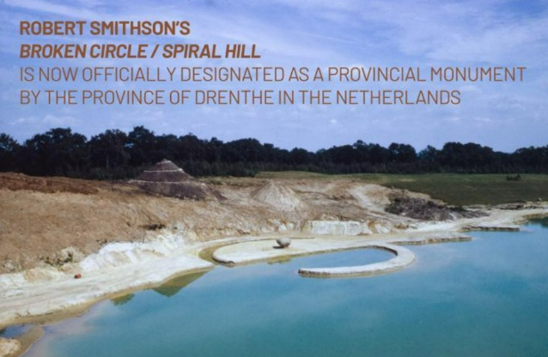
Environmental art does not want to portray nature through art anymore; instead, it wants to interact with the ecosystem proactively and uses materials and space to connect people with nature. Robert Smithson's Land Art is concentrated in nature, as shown in the works above. (Figure 1), making time, erosion and changes in the landscape an integral part of the creative process, thereby highlighting the impact of human behaviour on ecosystems. Furthermore, ecological aesthetics represents a new approach to aesthetics, marking a shift in creative practice from an ‘anthropocentric’ to an ‘ecosystem-centred’ perspective. Berleant argues that aesthetic experience should be understood as a form of engagement rather than detached observation, where humans are not separate from the environment but part of it. Arnold Berleant, The Aesthetics of Environment (Philadelphia,1992) Art will not only aim for aesthetic pleasure but also attach importance to the process, connections and ethics. Many contemporary artists today have been using biodegradable materials, recycled resources and participatory practices to raise awareness of the environmental crisis. Ecological aesthetics has further proposed that "beauty" is no longer just about harmony and pleasure; destruction, unease and imbalance can also be considered beautiful sensations that are more likely to prompt viewers to think about the ecological crisis in life. As a result, by introducing environmental art and ecological aesthetics into design, the traditional model of aesthetics is broken; thus, new works that are visually appealing and socially responsible can be produced to address environmental problems, such as the protection of endangered animals, in a more effective way.
Figure 1. Robert Smithson’s ‘Land Art’

2.2 Material Narrative

Recently, due to changes in Design trends, materials have moved away from being strictly functional and now also hold deep cultural and symbolic connotations. The study of material culture is the study of how people make sense of the world through the objects they create and use. (Miller, D. 2005) According to material culture theory, people's ideas about the world are formed by the objects and materials they interact with, and these materials also carry the history, society and environment of their time. Therefore, in the design for environmental issues, the materials are no longer just "things to be used" but are also integral to the story.

Materials are not passive substrates, but are active constituents of a world-in-formation.( Ingold, T. 2007)The origin, attributes and mode of use for the materials will all affect their meaning. Natural materials are generally associated with "nature" and "life", and industrial materials usually indicate human activities and technology. Designers' conscious selections of materials also serve to create a new system of language. Biodegradable materials can be viewed as having a life cycle and an end-of-life; ecosystems are delicate, so pollution caused by non-biodegradable materials will be prolonged and permanent. Relocating materials in design can be used to reinterpret everyday objects and evoke a sense of the place.

The meaning of waste in design. When discarded materials, such as plastic and metal scraps or electronic waste, are included in the Design context, they are no longer regarded as 'useless objects' but have become necessary symbols. The above changes show that there is an overabundance of consumer goods and waste in modern society, as well as "invisible pollution".

We are emotionally connected to the materials and objects that surround us. (Chapman, J. 2005) Under the theme of endangered animals, waste can be directly linked to the ecological crisis. Marine plastic can be used to create jewellery, and this can also be viewed as an expression of the existence crisis for marine life; damage and disorganisation in the material structure of such jewellery can be interpreted as a loss of species and an ecological disaster. Thus, waste will no longer be viewed as a simple design material but as a visual language for expressing problems of the environment.

As a result, the focus of material narrative is to convert 'matter' into 'meaning', prevent the design from being limited to form, and achieve connection with the audience at the conceptual and emotional levels to spread environmental awareness and ideas.

2.3 Wearable as Medium

In the present day, design and art have moved away from traditional notions of ornamentation; thus, jewellery is now being used as an expression medium for abstract thoughts and societal concerns. Jewellery is close to the body, and thus the body itself becomes an important part of meaning transmission, unlike a picture or sculpture.

Firstly, jewellery is also worn on the body and has a special way of conveying messages. Instead of being fixed, these works of art are constantly exposed to people's daily lives and moved around; thus, they have become part of people's lives. The person wearing it is a user who can also convey his or her environmental concerns through their body. For example, when wearing a piece of jewellery made from waste materials, one is not only wearing something elegant but also also indirectly making people pay more attention to the source of the materials and environmental problems.

Second, jewellery is no longer viewed as a means of adornment but rather as a mode of experiencing life. As Malcolm Barnard argues, “fashion and adornment are forms of communication” that convey meanings beyond aesthetics (Barnard, 2002)Through its appearance, style, colour or other features and designs, the way people feel when wearing something can be changed, and this change can also be perceived physically. A typical case is a display that shows the current level of marine pollution in real time and makes such problems more concrete for the public.

Wearable media will likely enhance the sense of community among the people. Jewellery is often visible in public places and is therefore frequently talked about by the public. Given the current environment, there will be some interactions; at that time, people's thoughts and ideas will also be spread more widely in public opinion.

Therefore, jewelry can be worn in various ways in design to expand its functional scope, and at the same time, it provides an embodiment platform that expresses environmental concerns more deeply; that is to say, it moves from visual display to a complete living experience centered on participation and communication.

2.4 Participatory and Immersive Experiences

Participation and immersion are now the main ways to improve the sense of understanding and emotion in people's hearts from contemporary art and design. Aesthetic experience is not detached contemplation but active engagement” (Berleant, 1992)Compared with the previous model of one-way viewing, this type of way can motivate audiences to engage more actively and experience the art through their own body movement and spatial conditions to gain a deeper sense of the subject.

Combine space installations and wearable designs to encourage active participation and interpretation by the audience in the work. Instead of simply being exposed to information passively, people make their own interpretations by moving around, looking at things, etc. For example, the same jewellery can be presented in many design variations, and people may learn and feel that the shape is not uniform after seeing how it changes when it is viewed at different angles. This participation is a kind of physical contact, but it is also a form of thinking; therefore, visitors may be more likely to think about endangered animals and the environment.

The work will be shown on the school's three-screen immersive classroom in a surround-view environment to create an all-encompassing experience space. The screens on the left and right display the three design versions of the same work, and both are full of sights. This way of presentation does not have to be from a single perspective; instead, it can be seen as a sense of being 'enveloped' to further emphasize the presence and urgency of the environmental problems at hand.

Compare the various Design modes to see how they differ formally, and learn about the different emotions they can elicit. For example, one design may focus on the polluting nature of a material, and another can present its fragmentation and lack of form; thus, environmental problems can be shown in many ways. At the same time, an immersive space can also enhance the sense of time and continuity, allowing viewers to gradually gain an all-encompassing understanding of the work through their experience in and around the space.

In short, participatory and immersive experiences will boost people's interest in life and turn problems such as the environment into something people can experience rather than just learn about. Through physical participation and spatial awareness, design can more effectively evoke emotions and trigger the critical thinking of the audience to increase the impact of campaigns for the protection of endangered animals.

III. Literature & Case Studies

3.1Examples of art made from recycled materials

Recently, with the rise of art and design, some people have started making art by using materials that will be thrown away. With the increase of marine pollution and resource waste caused by plastic waste, more and more artists have started creating works of art based on these "rubbish" and "waste", materials are not static objects but are caught up in the fluxes and flows of the materials of the earth” (Ingold, 2007) carrying critical commentary and narratives. Such works can also give new ideas to the function of materials and make problems in the environment that were previously unknown more visible and understandable for the public through images.

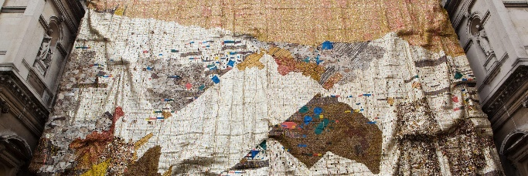
El Anatsui, an artist, (Figure 2) has made large-scale works of art out of recycled bottle caps and scrap metal that resemble fabric, and has also raised concerns about consumerism, colonial history and resource recycling through his art. His works show how materials have a remarkable ability to regenerate and are deeply affected by the global consumer system.
Figure 2. El Anatsui’art work

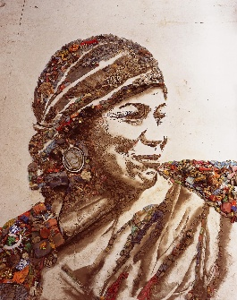
Vik Muniz (Figure 3) has also taken materials from landfill sites and created collages of famous paintings in his work titled "Pictures of Garbage", which are then photographed. In a creative way, the waste is given a new visual life, and at the same time, the connection between marginalised groups in society and environmental problems is pointed out; thus, art has the power to engage in social and ecological reform.
Figure 3 Vik Muniz’art work

In the area of marine pollution, the artist Angela Haseltine Pozzi conducted the 'Washed Ashore' project, gathering plastic waste from the beach and constructing large-scale works of art that depicted marine life such as turtles and fish. These works directly convert materials of marine pollution into the form of endangered species to help the audience intuitively feel the damage done to the marine environment by human behaviour.

The artist group Studio Swine has also created a system of materials for jewellery and product design from recycled marine plastics and given them artistic and functional values. The work has provided a model for material exploration, sustainable design and the prospects of future manufacturing.

Although the above art and design practices can help tackle environmental problems by reusing waste materials, most of the works are still limited to visual expressions. Audiences are generally limited to being 'viewers' and do not have further interactive experiences or opportunities for behaviour change. Therefore, this study will build on the above foundations to investigate the integration of waste materials, jewellery design and interactive mechanisms. Through wearable forms, it will connect with the audience's emotions and deepen their understanding; thus, the expressive power of environmental art in the current era will also be expanded.

3.2 Examples of eco-friendly jewellery design

Nowadays, more and more designers have been considering the environmental issues in the design of contemporary jewellery and are selecting materials and production methods that promote "sustainability"; thus, it has become both a requirement for production and a feature of the design.

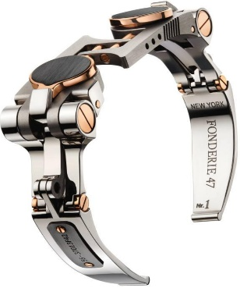
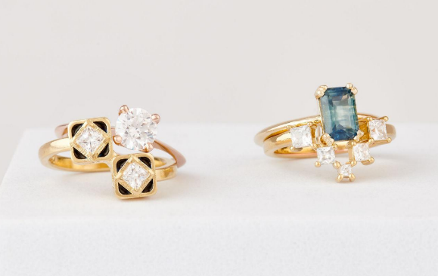
Bario Neal (Figure 4)is a well-known US-based artisan jewellery company that has been implementing ethical-sourced materials and green-friendly production processes. The brand is well-known for its jewellery and engagement rings, as well as stylish everyday jewellery; at the same time, it has also built an open-supply chain system for hand-made products. The Brand discloses the materials and sources of this more openly. Its parts are mainly made of recycled metals, ethically sourced metals and conflict-free diamonds, and are all hand-made to reduce the carbon footprint. Waste Reuse – Fonderie 47(Figure 5): This brand transforms recycled weaponry (such as parts from AK-47 rifles) into jewellery, changing ‘instruments of violence’ into objects that ‘symbolise peace’.
Figure 5. Fonderie 47’s ring
Figure 4.Bario Neal’s Jewellery

The above examples show that the purpose of ecological jewellery is not only to use environmentally friendly raw materials but also to convey deep values through jewellery. Recycled metals and other waste materials have been used to build a new ethical supply chain and a circular design system, and now these materials are used to express environmental problems. The above work provides certain support for the current project and shows how materials and designs can be used to make endangered animal and ecological problems into three-dimensional, wearable art.

3.3Summary and Critique

Although new environmentally friendly jewellery has made some achievements in selecting materials and production processes, it is still lacking in terms of public interest and ecological friendliness. Fonderie 47 and Bario Neal are typical cases; although both brands use environmentally friendly materials and promote social causes, they still focus on fixed exhibits and consumption, with little interactive opportunity.

First of all, in terms of interactivity, such jewellery designs are still relatively limited to the levels of "being looked at" and "being worn". Although the materials have symbolic meanings themselves (such as Fonderie 47 turning weapons into jewellery or Bario Neal promoting ethical sourcing), they are generally just information that the audience passively receives without actively participating in meaning creation through viewing. The works do not provide more direct ways for the audience to learn or experience in their daily lives through structural changes, trigger mechanisms or participation experiences. Therefore, the spread of their narratives is driven more by brands than by audience experiences.

Secondly, in terms of behavioural change, many of these designs are only aimed at "raising awareness" and fail to inspire people to act. Fonderie 47 is a typical case: Although it presents anti-violence and social responsibility in its material translation, its high-end positioning restricts the target audience and thus reduces the diffusion scope of environmental and social messages. At the same time, although Bario Neal promotes a sustainable supply chain and ethical consumption model, its model is still contained within the consumer system; As Ezio Manzini notes, “sustainability calls for a radical change in lifestyles, not only in products” (Manzini, 2007)the audience serves mainly as a 'buyer' and is not guided to change their behaviour or lifestyle.

Therefore, the above cases indicate a problem in current environmentally friendly jewellery design: a lack of connection between 'expressing meaning' and 'modifying behaviour'. Design can express values but is not guaranteed to inspire people to act. Based on the above, this study aims to address the deficiencies in current practices by adding interactivity and immersive experiences to make the audience active participants in learning about environmental issues, thus stimulating their emotions and behaviours toward these problems.

Ⅳ. Research gaps

Based on the analysis of the current situation in academia and other countries, it is clear that although there has been some study of eco-art and sustainable design, research on jewellery design has mostly focused on the substitution of materials and changes in form, without giving sufficient attention to interaction mechanisms and the experience of the audience. Many of these works still fall into the category of symbols and are thus less effective in promoting a deep understanding of or awareness about environmental problems among the public.

In the area of interactive art, while some are very engaging for viewers, they have not yet been combined with wearable devices. Jewellery is a kind of personal media that is also emotionally and communally significant, but this value has not been used to create environmental action.

Based on the above analysis, the innovation of this study is the combination of jewellery design, waste materials and interactive mechanisms. Immersive Displays and Audience Participation can turn abstract problems of the environment into tangible experiences for people. Thus, the audience will be able to "see" the environmental problems themselves, feel emotionally connected to them, and thus strengthen their environmental awareness.

Ⅴ.Methodology

A practice-oriented qualitative research method is used in this study to explore the expressive effects of interactive jewellery design through visual ethnography, creative practice research and action research. Qualitative research is particularly suitable for investigating meanings, experiences and interpretations, as it “is concerned with understanding the meanings which people attach to phenomena” (Denzin and Lincoln, 2011)Firstly, visual ethnography will be used to collect and analyse visual materials related to marine pollution and endangered species to provide visual references and contextual support for the design.

Second, creative practice research serves as the main way of research by integrating it with creation through material experimentation and the design-production process. Disposed-of plastics and other recycled materials will be used in the construction of the jewellery. At the same time, action research is also a cycle of design-exhibition-feedback for optimisation and improvement of the work.

In addition, this study will conduct audience research to gather data through questionnaires and behaviour observation about viewers' cognitions and emotions when watching these works. Based on the above data, conduct thematic and content analysis to summarize the audience's feedback and assess the effectiveness of the Design.

Based on the above, the focus of this paper will be on the design results as well as the reflection and modifications made in the process to enhance both the depth and accuracy of the research.

5.1 Research methodology framework

The main way this paper will conduct research is through qualitative methods, and we will focus on the perception, experience and sense-making processes of the audience, not on quantitative analysis of the data. Therefore, this way is suitable for studying how design affects people's emotions and cognitions, especially in the field of environmental issues and the depiction of endangered animals; it helps us understand how individuals interpret the meaning of materials, forms, and interactive experiences more profoundly.

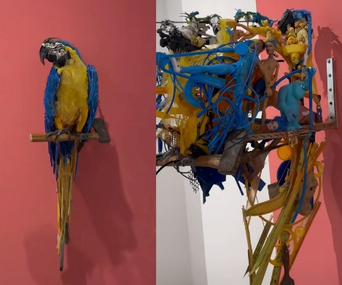
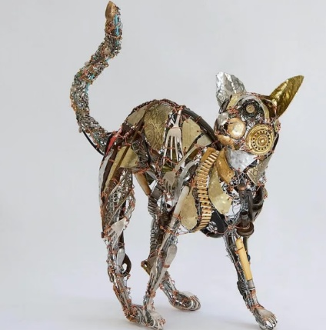
First, we will take some cases to study existing examples of eco-friendly jewellery design, such as Fonderie 47 and Bario Neal, as well as the work of artists Barbara Franc (Figure 6)and Thomas Deininger(Figure 7) in creating animal figurines from discarded materials. We will study the strategies and deficiencies of these works in terms of material use, expression of meaning and dissemination methods. The above will provide theoretical and practical support for this project and help to build an important awareness.
Figure 7. work of artists Thomas Deininger
Figure 6. work of artists Barbara Franc

5.2 Visual Ethnography

This study uses visual ethnography and collects, observes, and analyzes pictures to learn about the visual characteristics of the sea and some endangered animals, as well as their culture and nature. Visual ethnography is a kind of research that takes pictures as its main way of inquiry and explores the relationships between people and their environments through the language of pictures.

The collection of marine images in this project will also serve as a basis for the research of the design. Sources of images include documentaries, photographs, news pictures and visual materials published by relevant environmental organisations, such as marine ecology images from National Geographic and the WWF. The above pictures are all real-life cases of marine pollution, plastic waste, coral bleaching, etc.

Based on the above observations and analyses of the pictures, several key visual elements can be identified: colour (muddy blue-green and dark colours), form (fragmented, tangled, stacked), and spatial relationships (crowded, overlapped, intrusive). The changes in the ecological environment can be reflected in the forms and materials of the next round of jewellery design. Plastic in the sea is at its least dense in a floating state, and these structures have developed into translucent layers; Entangled shapes of marine life can also be fashioned into jewellery in linear or bound forms.

Moreover, visual ethnography also refers to the surrounding context of images; that is, these pictures do not simply show what is visible but also how it is displayed. Therefore, this paper will also investigate how these images affect the public's understanding of marine problems, and whether they have heightened the awareness of these issues or given them a romanticized image. Therefore, the redesign will not be too straightforward, and in creating art, new ways of presenting visuals can be employed to express deep ideas.

Collect and analyse marine images to obtain design ideas and ideas for this work; thus, the jewellery will be inspired by real-life environments and sensitive to the problems faced by endangered animals and marine ecosystems at a visual and emotional level.

5.3 Design Development Process

Design begins with a general plan; then, certain endangered species are selected; finally, a finished product is created, and this cycle of improvement will be repeated. design ability is not simply a matter of applying systematic procedures but involves a reflective and iterative process of problem framing and solving” (Cross, 2011)Sketches and conceptual designs for the initial application of the marine elements derived from visual ethnography were hand-drawn to establish a design language; at the same time, renderings of the final results were produced in the middle stage based on material selection and structural feasibility; finally, the entire expression was improved by integrating interactive components and display mechanisms.

5.4 Audience Research

Conduct audience research in this study to evaluate how well the work presents environmental problems, specifically the preservation of endangered animals, and what impact it has on the audience's understanding, emotions and behaviour. The two forms of collection for this study are questionnaires and observations.

A QR code will be placed near the artwork to show the questionnaire for visitors at any time during the immersive exhibition for quick participation and feedback. Thus, people will feel more free and willing to express their thoughts on the work at any time after viewing it. The main contents of the questionnaire are as follows: the audience's choice of different materials in the work of art, their emotional responses (such as unease, resonance or awe), and whether the work of art has led to further reflection or a wish to take action (e.g., giving attention to environmental protection or changing behaviour). Use both open-ended and multiple-choice questions in the questionnaire to gather subjects' feelings and other detailed reasons for the design, providing support for assessing how effective the design is.

Combine questionnaires and behavioural observation to explore how the audience expresses themselves and what they do in real life. In this way, one can know whether interactive design and immersive display have increased people's awareness of environmental problems and what problems still exist in the current designs for driving behaviour changes.

Ultimately, the findings of this audience research will be used to reflect on design strategies and provide a basis for further optimising jewellery as a medium for environmental communication.

Ⅵ. Design Practice

6.1 Concept Development

Based on marine ecology, this project will address problems of plastic pollution, species endangerment and ecological imbalance in the sea, and pay close attention to the existence of marine life such as sea turtles and coral reefs. in every outthrust headland, in every curving beach, in every grain of sand there is the story of the earth” (Carson, 1955) The sea is a place of life and, at the same time, one of the environments that have been significantly altered by human activities. Therefore, this study will attempt to make these 'invisible crises' tangible through jewellery design in a visual and physical manner.

In the Design, marine pictures and visual ethnographic research have been consulted to create images such as polluted waters, marine life entangled in plastic, and coral bleaching. These pictures are very different in appearance; on the one hand, there are the soft shapes of nature, and on the other hand, there are unsightly man-made garbage.

In short, the Design selects visual characteristics such as 'entanglement', 'overlay', 'fragmentation', and 'fading', and then realises these features through jewellery structures and materials. For example, linear structures can represent the constraints of plastic on life, and translucency and colour gradients may be used to show the gradual degradation of ecosystems. Through this translation from images to designs, the works will have both a grounding in reality and a certain depth.

6.2 Sea Turtle Necklace Design

At the centre of this Design is a sea turtle, and it is facing the issue of marine plastic pollution in the sea. As a species particularly vulnerable to such threats, sea turtles often die from ingesting plastic or becoming entangled in waste; all too frequently, there are reports of them being trapped in fishing nets, and as such, they are highly symbolic and topical at present. By adding "pollutants" to the form of a sea turtle, this work hopes to blend nature and artificial objects and reveal how human activities have significantly changed the ecosystem to cause serious damage to life in the sea. Rather than presenting pollution as an external visual feature, this design goes further to incorporate the language of 'entanglement'. A structure-of-fishing-nets simulation will be used to show how the sea turtle's body has been trapped due to the ecological crisis, conveying a sense of urgency and oppression.

The materials for the construction of the work are recycled plastics and metals. Recycled plastics are used to make objects, but they are also a result of pollution in the sea; additionally, because of their translucent and irregular nature, they look different and feel different as well as other "foreign objects". The metal structure is to support and connect; in doing so, it has an industrial nature that is in opposition to the organic form and suggests a conflict between nature and artifice. Additionally, fine-threaded materials that resemble fishing nets (such as metal wire or recycled fibres) have been added to the design, and these are used to cover certain parts of the sea turtle in a wrapped or entangled way to create a sense of entrapment and make the issue more tangible.

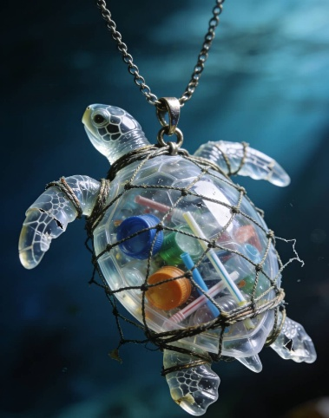
Structurally, the work is in an inline design, and plastic elements are embedded in the form of a turtle so that the pollution appears to be 'part of the body' rather than an external addition. At the same time, both the external 'fishing net structure' and the internal embedded materials also create a dual relationship of internal and external oppression: that is to say, there are visible constraints on one hand and invisible intrusions on the other; thus, they add a sense of layering and conceptual depth to the work. The above structure seeks to present many kinds of damage caused by pollution to living things and suggests that such harm is unavoidable and long-lasting. (Figure8)
Figure8. Sea Turtle Jewellery Design

In addition, It has a transparent resin/plastic layered structure and embeds micro garbage such as bottle caps inside. It is a round or nearly round shape, so it will not harm the body. A QR code will be placed in the middle of the turtle's stomach, and when scanned, it will open a page from the popularisation of science-based protection for sea turtles. It supports some interactive functions, such as sharing turtle pictures and steps, participating in the marine garbage collection project, etc.

Based on the above design, this paper has developed three different styles of sea turtle necklace designs to study how they differ in visual language and what kind of messages they can convey about the environment. First of all, the ornamental/luxurious style version is built on the structure of transparent resin embedded with microplastic waste, but it has been enhanced to look more luxurious by adding a high-gloss metal edge, gem-like gradient materials and decorative details. However, this 'superficial beauty' is in opposition to the internal pollutants, and thus has created a tension between aesthetics and crisis. It can attract the attention of the public and make them consider the environmental harm caused by consumerism at the same time. (Figure9)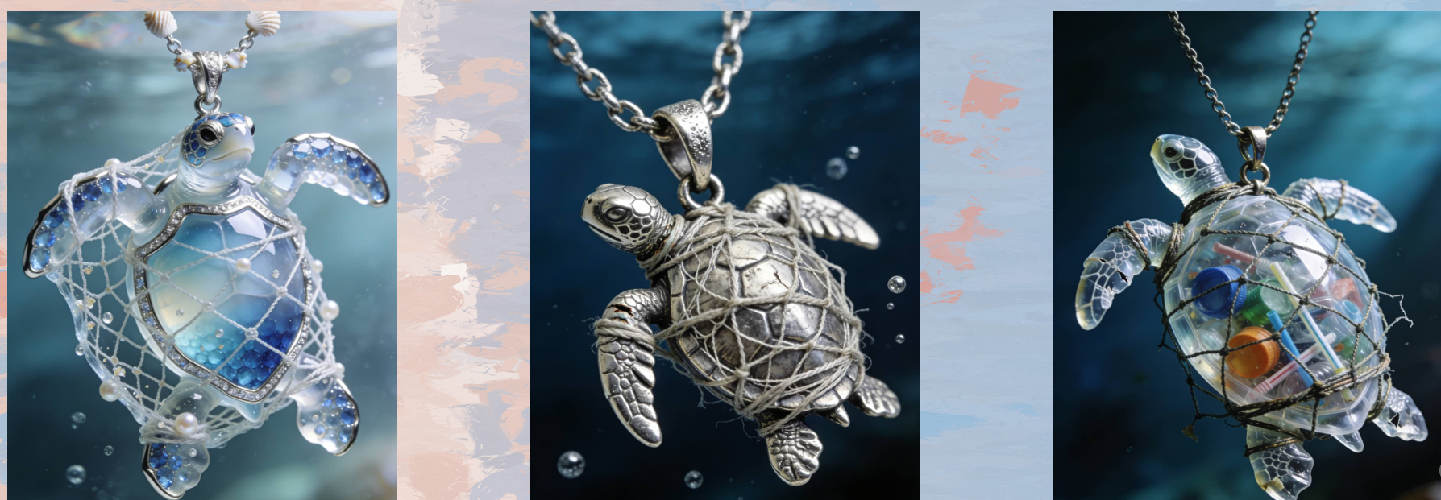
Figure9. Three Sea Turtle Jewellery Designs

Secondly, in terms of vintage/aged aesthetic design, metal ageing techniques and low-saturation colour schemes can be used to create a sense of time passing visually. The surface shows signs of oxidation and wear; thus, it can evoke a sense of history and the symbol of material decay. At the same time, the 'fishing net structure' around the turtle's body in this edition is denser and more substantial, thus intensifying the visual impact of confinement and oppression, and also indicating the prolonged accumulation and structural nature of marine pollution. This Design is intended to reduce decorative expression and focus more on telling a story, giving the work a commemorative and critical tone.

The third way is a material-driven design that focuses on displaying the characteristics of the recycled materials and their applications in real life. This version takes recycled plastic as its main material, retains the original irregular shape and colour of the plastic, and then embeds or exposes micro-waste such as bottle caps and fragments in a more intuitive way to make the 'pollutants' the visual focus. Compared with the first two designs, this version has reduced formal processing and prioritised the authenticity and recognisability of the materials. Therefore, the work has a sense of urgency and a strong social message, thus moving viewers to think about the problem of marine pollution in life.

In short, the three designs work together to offer support for the visual strategy and mode of expression: the opulent style provides an emotional starting point for an 'attraction-reflection' approach; the vintage style adds a layer of 'temporal narrative'; and material-oriented design shows real-life situations 'directly'. The above multi-level Design will expand the expression scope of jewellery in the field of environmental education and help more people gain knowledge of change in a progressive way.

6.3 Coral Jewellery Design

Based on the design, this work studies the changes in coral reefs that occur due to a warming climate. Coral bleaching is generally caused by a rise in water temperature and other environmental problems, so corals lose their light-giving algae and are no longer able to live. Thus, it has lost its original character and is no longer as abundant as before. In light of the above, a slow-moving but enduring ecological crisis is now expressed visually and experientially through alterations in colour and shape.

The three kinds of wearable jewellery in the design practice are: a necklace, a bracelet and stud earrings. All of them are on different scales and by different means of wear to create multiple paths for expression. The necklace has a symmetrical division of coral, and on one side are rich colours, while on the other they are bleached; this contrast can be seen to represent changes in the environment over time. The bracelets are also module-based, with different colours and shapes of coral units arranged alternately to form a sense of a visual rhythm, such as an 'ecological cycle', and thus hint at changes in the environment. The design of the stud earrings is also relatively simple, and a colour gradient from bright to pale is used to show how coral bleaching gradually spreads over time.

Materials and Craftsmanship: Recycled plastic material has been used to make these pieces, and the materials themselves are also part of the environmental discourse. After being reshaped, the material is light in colour, porous, and semi-transparent; although it is based on the nature of coral, it also has a fabricated quality and does not fully resemble coral in its appearance.

In addition, some are designed to change over time, such as those with thermochromic materials that change colour due to temperature or photochromic coatings that respond to light. Miniature display devices are sometimes placed on the back side of the design to present real-time ocean temperature data in a visual form that is easy to understand. Jewellery can change colour according to the surroundings or other conditions to create an interaction with data and present a visual effect of coral bleaching.

At the practical level, when people wear or see these works, they will be exposed to changes in colour due to different types of jewellery; necklaces display general contrasts, bracelets show the process of development, and earrings are relatively subtle. In the design above, the ecological problem is presented in many forms and is more all-encompassing. Through the combination of materials, data and dynamic changes, this design creates an immersive and critical wearable medium to gradually make the audience aware of the fragility of coral ecosystems and the actual impact of climate change through an aesthetic experience. (Figure10) 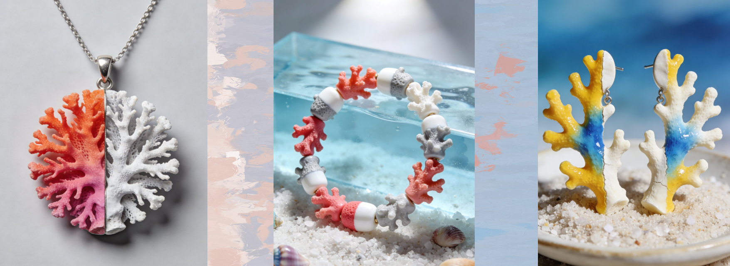
Figure10.Three coral jewellery designs

Summary

The two design case studies are about sea turtles and coral reefs, and they show different kinds of problems in the marine environment: the first is direct harm caused by pollution, and the second is a slow change in the environment. Together, they build a narrative system of 'invasion' and 'disappearance', thus making jewellery serve as an experience medium for conveying environmental concerns rather than just as objects of art.

VII. Exhibition Design

7.1 Immersive Classroom

An 'immersive classroom' will be used for this exhibition to construct a whole-sensory environment by installing multiple screens that show extended, continuous pictures. A few times, instead of a traditional single-screen or static display method, many designers have used multiple screens to distribute images, videos and other design contents in all directions and created a decentralized visual narrative system.

The three screens in practice are arranged around the audience to provide a full-immersion surround-viewing experience. The left and right screens are showing different design versions or the development of the same work, and we need to actively construct meaning through movement and comparison. The above many viewpoints are linked together, and at the same time, this changes the environmental discourse from being about 'the external expressions of pollution' to a multi-dimensional system that shows 'the internal impact on living organisms' and finally 'the symbolic meaning of materials themselves'.

An expanded sense of place is formed to provide a deeper sense of the surroundings through all senses. Viewers need to turn their heads, move their bodies, or stop watching on different devices, and thus the act of viewing is also part of the experience. At the same time, a surrounding-sound effect can be added to increase the sense of immersion in the environment; thus, the viewer will be enveloped by the scene as if they were "in the middle of it" and, consequently, gain a deeper understanding of the marine ecological crisis and move their emotions.

Moreover, multiple screens can show different times at the same time. Different Screens can show either synchronous or offset visual content. Dynamically, this Design is now a space for continuous observation rather than an object.

In short, a multi-screen, immersive experience in the immersive classroom can increase the sense of sensory stimulation for exhibitions and also provide people with an active and space-aware way to learn about environmental problems, thus helping them gain a deeper understanding of the works through both their physical and perceptual experiences.

7.2 Visual storytelling

Use visual stories to present designs of jewellery in motion and create new experiences for people through new time and space. The first type of medium for environmental protection videos is that they provide background information and offer viewers an overall understanding of the ecological problems addressed in the works during their viewing.

The contents of the selected videos are marine pollution, sea turtles entangled in garbage, and coral bleaching caused by high-temperature water. Combine real-life scenes and design images to create a sense of "reality in design". For example, show footage of marine life caught in plastic and then display the structure of a piece of jewellery to connect these problems in the real world with the design of such jewellery and increase the works' appeal.

Also, the large screen shows more jewellery in detail. Some concrete structural features are shown, such as embedded plastic debris, tangled fishing nets and material textures; they are not usually seen in daily life but are eye-catching. The first purpose of increasing the size is to improve the formality of the illustration; it can also act as an ideological guide to draw attention to the problems of environmental disorder. For example, when magnified, small plastic particles can show a variety of forms and are scattered everywhere in nature and man's lives.

Combine environmental footage and close-up shots to create a multi-level narrative visual system for this work. Thus, in addition to showing the Design, the audience can also understand the ecological environment and urgent problems that necessitate this Design, spreading the message of environmental protection and stirring the emotions of the people.

7.3 Interactive Mechanism

The main interactive device in this project is QR codes, and traditional jewellery is now viewed as 'participatory communication platforms' rather than mere 'objects of observation'. A QR code can be set up inside the belly of the sea turtle in the Design of a sea turtle necklace, and it can also carry some information. Scan the QR code to open the education website, read about the protection of sea turtles and the problems of pollution and threats they face.

Several other interactive functions of the QR code include exchanges of steps for a virtual turtle avatar and donations to marine litter cleanup projects. This Design combines digital media and physical jewellery to turn viewers into participants, and thus enables them to feel a sense of responsibility for the environment through behavioural changes. In this way, the design can also be applied in practice and serve to motivate behaviour based on consciousness.

At the same time, an interactive mechanism will extend the application scope. The QR codes can spread information outside the exhibition hall and across many other places, so the work will be seen by more people. Therefore, the extensible design strategy will serve as a new link between reality and the virtual world for environmental information.

7.4 Audience Feedback

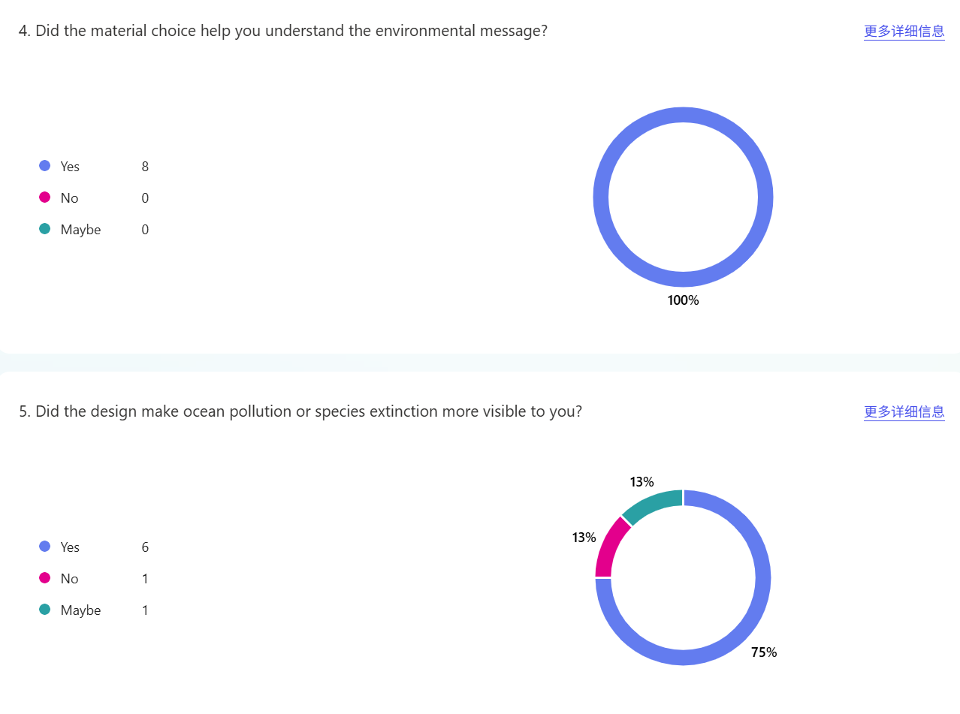
Based on the above surveys and the interview results, we have gathered some basic data on what the audience knows, feels, and wants to do. Based on the above results, most of the audience members have grasped the environmental problems shown in the artwork. For example, when asked whether the materials helped you learn about the environmental message, all 100% of the respondents replied 'yes', and thus it can be concluded that the selected materials were very effective in transmitting the intended content.（Figure11）
Figure11.Research 1

Design Preferences for Turtle Necklaces: Different Styles of Turtle Necklaces Resulted in Different Results. Among them, the third design (material-oriented version) had the highest selection rate (about 50%), so it can be seen that more people are aware of and have encountered designs that address pollution directly. At the same time, some of the audience members also thought that this Design "can show the seriousness of the problem in an intuitive way" and was therefore visually metaphorical. （Figure12）
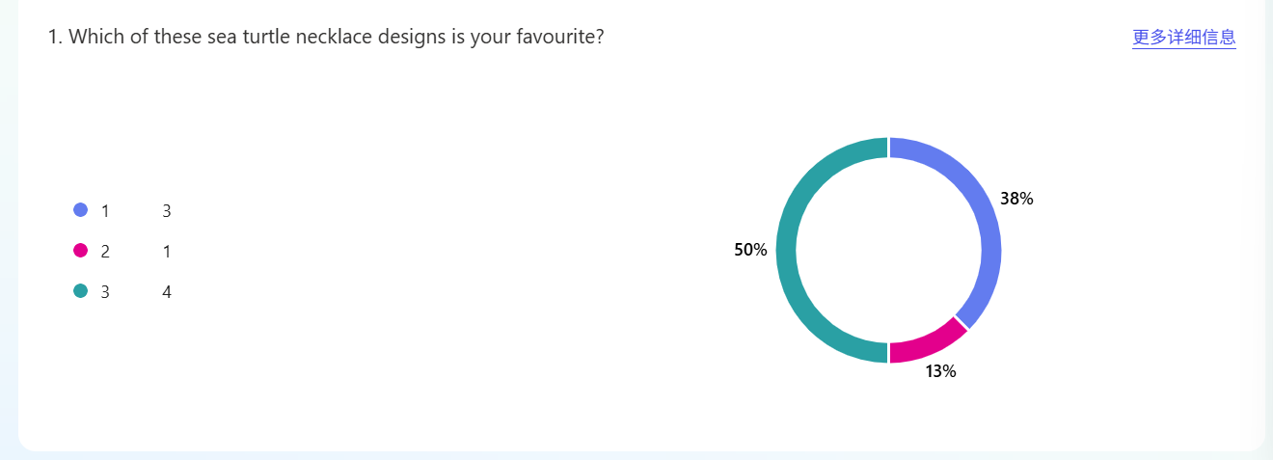
Figure12.Research 2

Audience emotions and other reactions were all mixed. On the one hand, some viewers used words such as "Amazing" and "Creative" to express their admiration for the aesthetic qualities of the work; at the same time, others felt "uncomfortable" and were stimulated into thinking. Some viewers have also pointed out that the work has made them feel 'responsible for plastic waste' and is thus more likely to inspire environmental awareness in people. （Figure13）
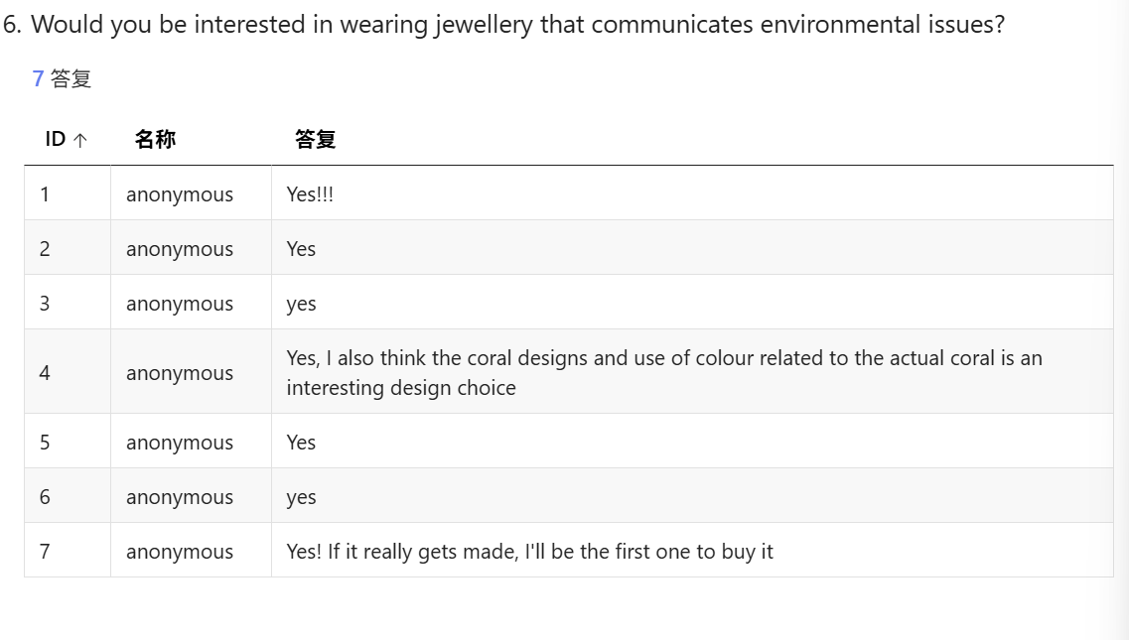
Figure13.Research3

All of the respondents were positive about the "jewellery with environmental themes" and expressed a desire to wear or purchase such items, in terms of behaviour. It can be seen from the above that by combining environmental issues with the Design of wearable products, more consumers will be attracted and driven. （Figure14）
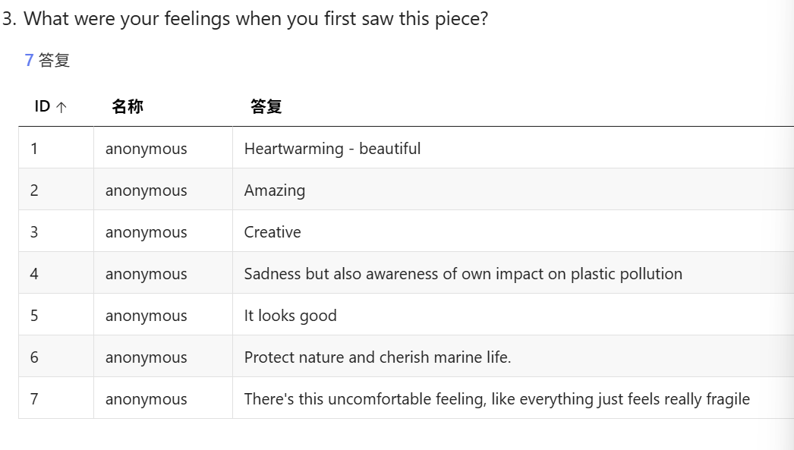
Figure14.Research4

There are some defects in the study as well. For example, a small sample size and a relatively homogeneous group of people may reduce the generalizability of the results. Although the audience knows about the problems and is somewhat interested in them, this interest has not yet resulted in behavioural changes, such as joining related activities.

In short, based on the feedback from the audience, this project is highly effective in its use of visual language and emotional impact; specifically, the application of materials and symbolism has received enthusiastic praise. At the same time, the interactive functions have the potential to increase the behavioural effect in the future, but further development is needed in terms of long-term interest and practical application.

Barnard, 2002, p. 29 Barnard, M. (2002) Fashion as Communication. 2nd edn. London: Routledge
Berleant, 1992, p. 4 Berleant, A. (1992) The Aesthetics of Environment. Philadelphia: Temple University Press.
Chapman, J. (2005) Emotionally Durable Design. London: Earthscan, p. 63
Cross, 2011, p. 3 Cross, N. (2011) Design Thinking: Understanding How Designers Think and Work. Oxford: Berg.
Carson, 1955, p. 1 Carson, R. (1955) The Edge of the Sea. Boston: Houghton Mifflin.
Denzin and Lincoln, 2011, p. 3 Denzin, N.K. and Lincoln, Y.S. (2011) The SAGE Handbook of Qualitative Research. 4th edn. London: SAGE
Ingold, T. (2007) ‘Materials against materiality’, Archaeological Dialogues, 14(1), p. 12
Ingold, 2007, p. 12 Ingold, T. (2007) ‘Materials against materiality’, Archaeological Dialogues, 14(1), pp. 1–16.
Miller, D. (2005) Materiality. Durham: Duke University Press, p. 5
Manzini, E. (2007) Design, Ethics and Sustainability. Milan: Edizioni POLI.design.
Philadelphia: Temple University Press, 1992

