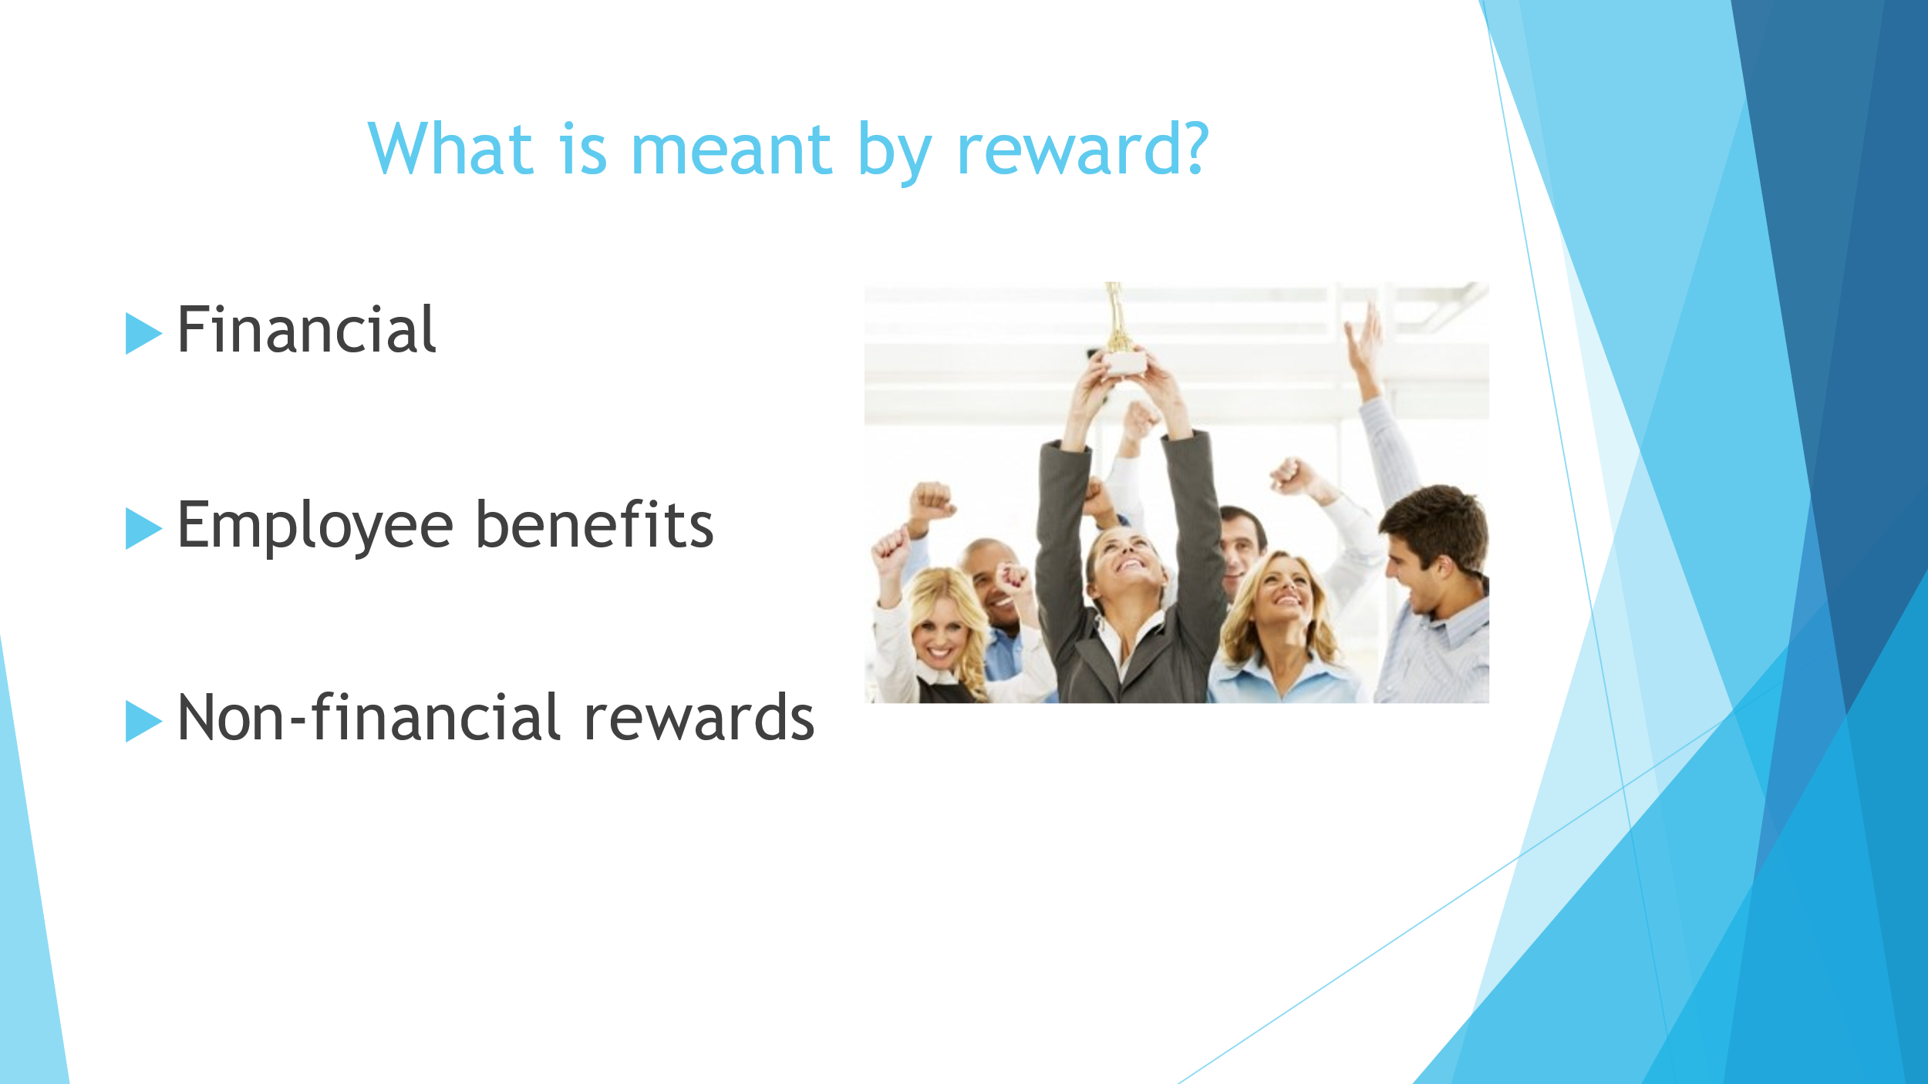
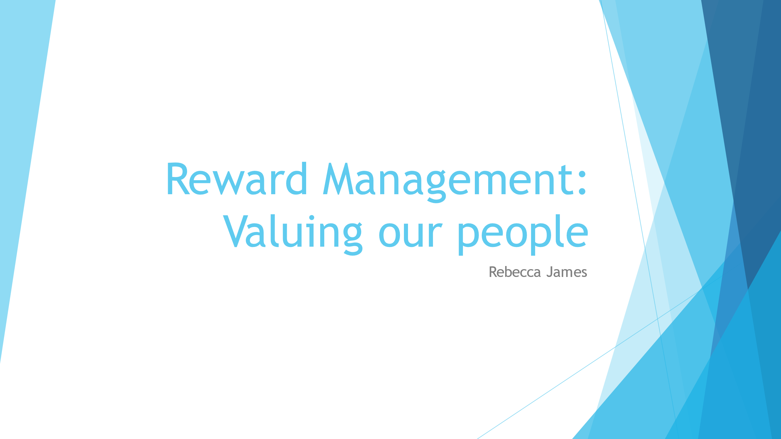

1.1 Reward is a system that incorporates financial rewards, employee benefits together with non-financial reward to create one total reward package (Martin, Whiting and Jackson, 2010, P188). Having a rewards policy in place that is in line with organisational goals can help to motivate employees to perform to their best which can lead to better productivity which has positive outcomes for business such as revenue (Martin, Whiting and Jackson, 2010, P188).
Rewards associated with pay can include:
Individual based pay rate
Pay scheme based on business results
Share incentive plan
Non-pay benefits can include
Pension plan
Training and development opportunities
Holidays (Martin, Whiting and Jackson, 2010, P189)
Reward schemes are put in place to influence employee behaviour, to attract and retain staff and to motivate them to produce their best work (CIPD, 2022, A). Positive reward schemes can be developed to reward work that is valued by the organisation. For example, taking an inclusive approach of offering a broad reward package to employees including non-financial benefits such as holidays together with financial benefits such as bonuses (CIPD, 2022, A).
Recently, at my own organisation, I was involved in the development of a career pathways and promotions framework. This reward supports the firms culture surrounding its value of professional development.
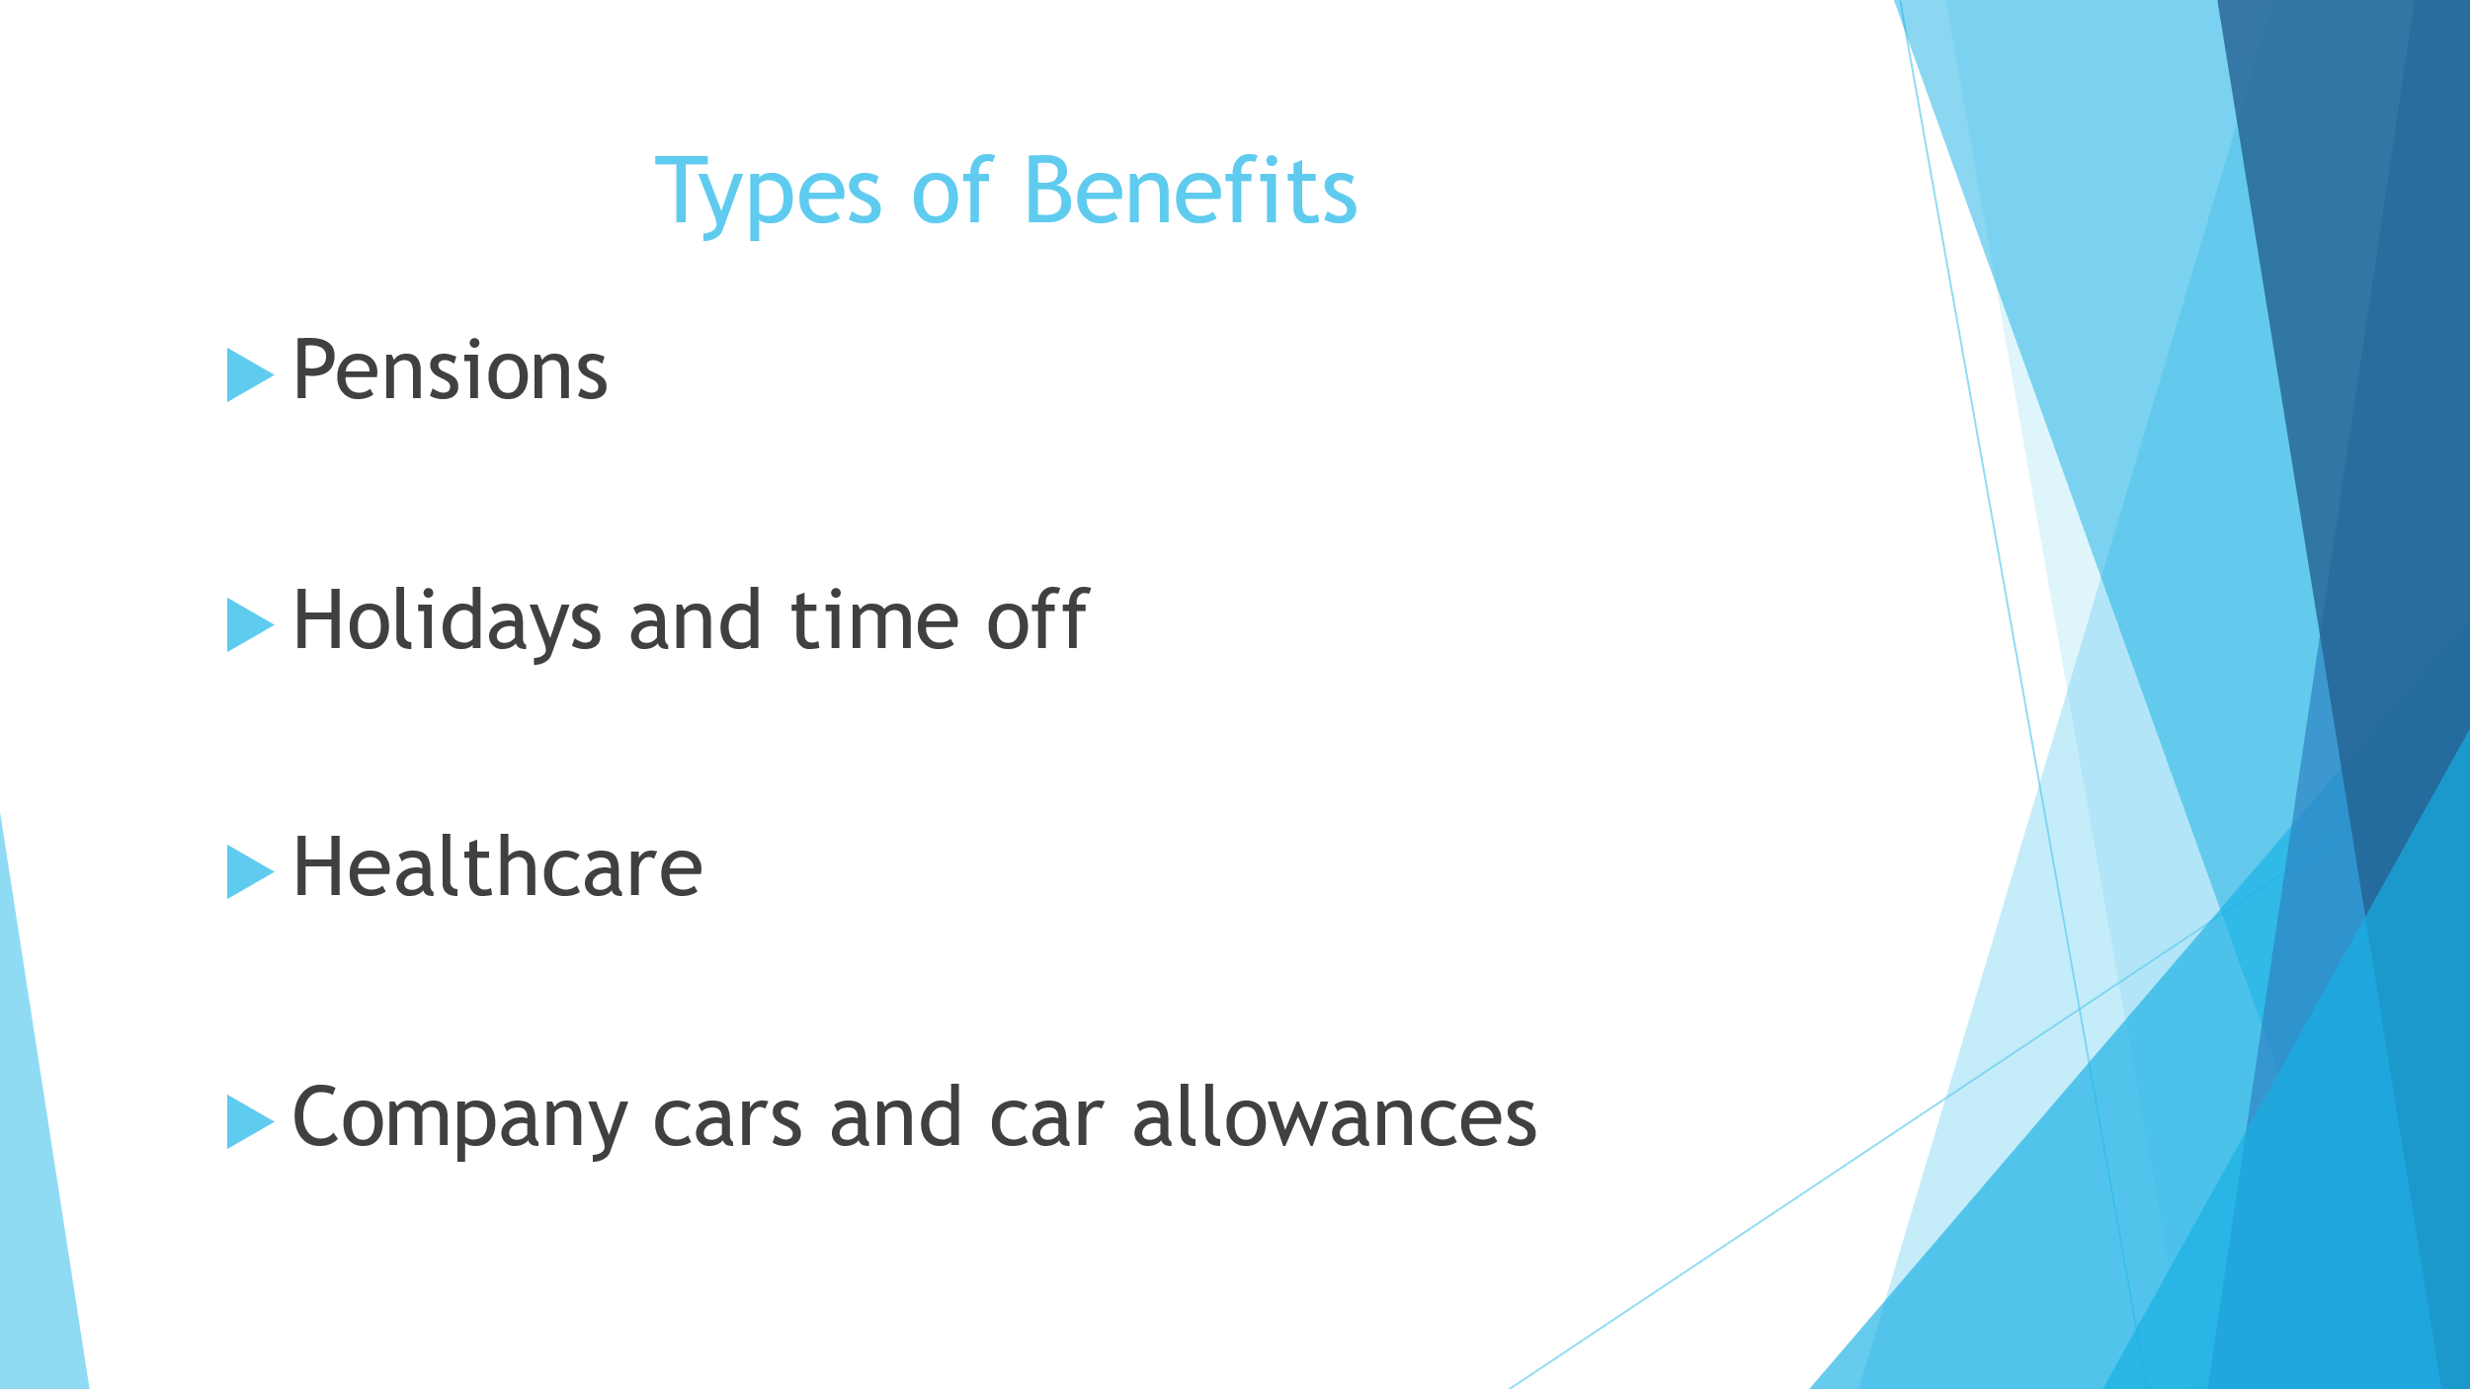
1.2, 1.4 There are many different types of benefits that impact organisational performance and approach to reward. Benefits are often utilised to attract and retain staff, aid wellbeing and influence employee behaviours. Benefits are non-cash provisions that are offered to employees to motivate them in achieving organisational goals (CIPD, 2022, B).
Firstly, there are pensions, these are legal required however, some employers offer workplace pensions as an enhanced pension option for their employees.
Second of all, paid holidays are another benefit that is required by law in that there is a statutory minimum requirement however, employers often offer enhanced holiday packages over the statutory minimum. For example, some employers may offer additional paid holidays after 2 years’ service as a way to retain staff. There are also statutory entitlements to paid time off for maternity, paternity, adoption, parental and bereavement leave (CIPD, 2022, B). Again, employers have the option to offer above the statutory minimum requirement, for example, Virgin offer their employees up to 12 weeks full pay during maternity as opposed to the statutory minimum (Virgin).
Furthermore, there are additional benefits surrounding healthcare that are appealing to employees and help to improve wellbeing which can lead to many positive outcomes for business. For example, employee assistance plans, eye care vouchers and occupational sick pay.
Finally, many employers offer their employees a company car or car allowance to purchase a car or reimburse them via a milage allowance.
Today, due to the covid-19 pandemic, many employers have been prompted to review their healthcare benefits and how they can improve and maintain the wellbeing of their staff (CIPD, 2022, B). The cost of living crisis is another external factor that is encouraging employees to review their benefits packages to support employees who may fall into hardship as a result of inflation (CIPD, 2022,B ).
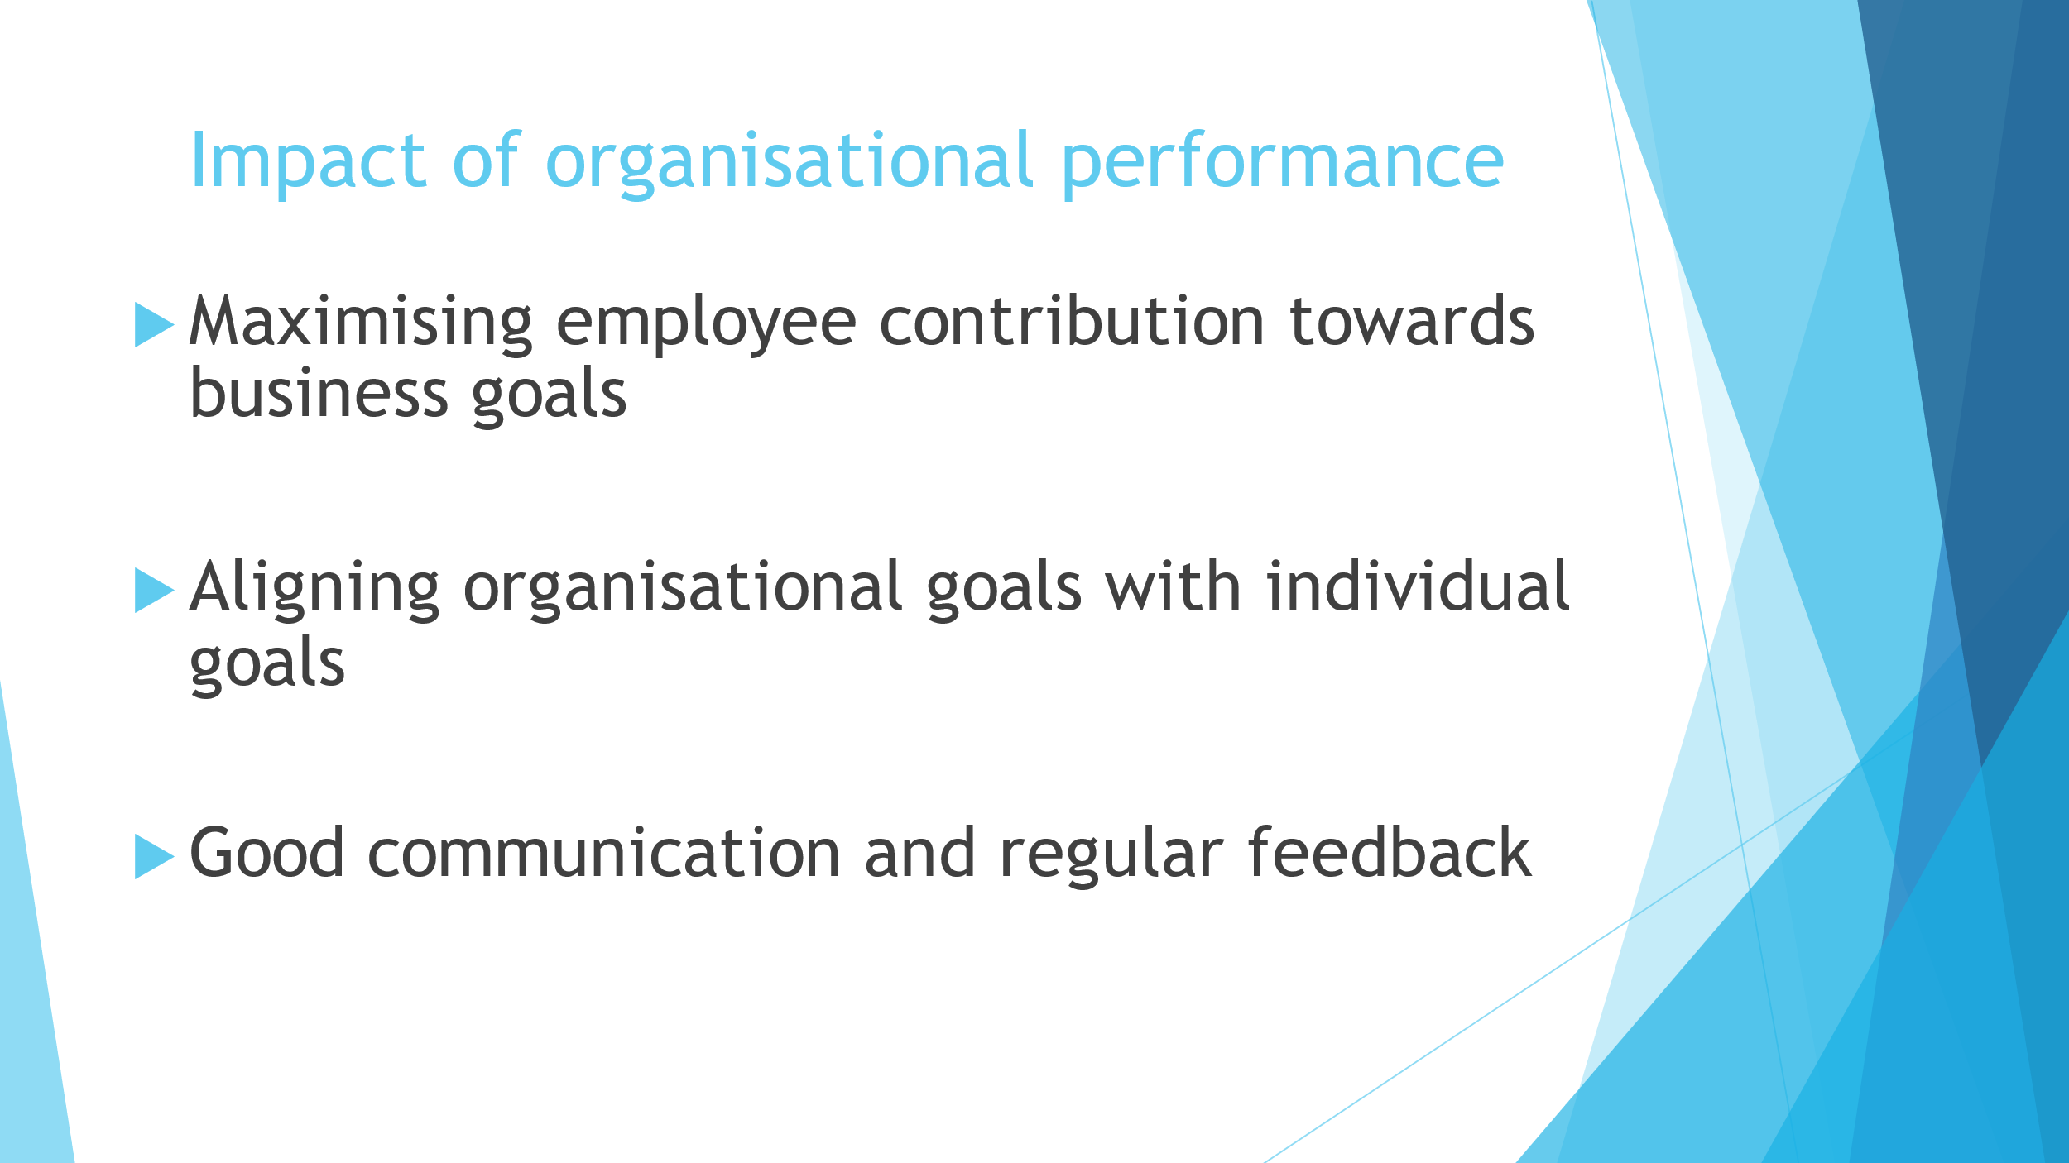
1.3 Organisational performance has a large impact on the approach to reward. Performance management means to maximise the value that employees contribute toward organisational goals (CIPD, 2022, C). Organisational goals and type of work carried out by employees and the values of the employees themselves should align with each other to achieve high organisational performance (CIPD, 2020).
Effective performance management involves clear communication of organisational and personal goals that are linked together and regularly reviewed throughout processes such as performance reviews or regular meetings between line manager and employees (CIPD, 2020). Where employees can see their success aligning with the success of the business, this can motivate employees to continue achieving business goals (CIPD, 2020).
By allowing for good performance management practice, employers will allow for good performance to be recognised which is a great benefit under reward policies (CIPD, 2021).

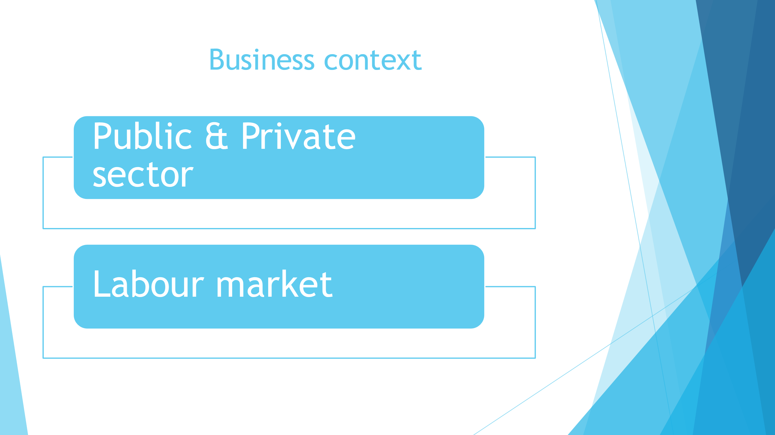
2.1 The business context contributes to the design of reward in many ways. Firstly, the sector of the organisation will determine what an organisation is able to offer in terms of reward.
In the public sector where money is controlled by the public, there are restrictions in the financial rewards they can offer to retain and attract staff. For example, budgets and pay caps can make it difficult to offer rewards such as bonuses or salary increases in comparison to competitors in the private sector (Lewis, Hays Public Services). Therefore, the public sector benefit from considering alternatives to their rewards packages such as holidays, vouchers or flexible working for example. With the current cost of living crisis, offering working from home as an option could support employees who are struggling with the cost of fuel and commuting to work (Mayne, People Management, 2022). Alternatively, where working from home is not an option there are benefits including discounts, childcare voucher schemes and travel discounts that could be offered to staff who are struggling in the current crisis (Lewis, Hays Public Services). However, many professionals desire their work to be worthwhile and feel they are making a difference to people’s lives and this alone is appealing to public sector jobs in healthcare or local government for example (Lewis, Hays Public Services).
Alternatively, the public sector are able to provide more in terms of financial benefits to attract and retain staff. High money packages such as salary or bonuses are often seen as appealing in the private sector. Recently, 60 companies in the UK began agreed to take part in a trial of a 4 day working week with no loss of pay in a bid to attract and retain staff (Jolly, The Guardian, 2022).
The labour market is also another factor to consider that influences the design of rewards. For example, following the COVID-19 pandemic, the expectations of employees changed which saw an increase in freelance workers (People Management, 2022). Gig economy workers are seeking a better work-life balance and more meaningful work, therefore rewards packages that revolve around finance will not necessarily benefit organisations in terms of motivation (Firstup). It can be beneficial for organisations to offer learning and development opportunities for gig economy workers as a way of attracting and retaining staff. This can support them to find further employment opportunities when their role expires (Firstup).
Similarly, the values of Generation Z revolve around corporate social responsibilities such as a green purpose or the feeling of giving something back (Deloitte). Therefore, organisations design their rewards in line with these values such as discounts or allowances for public transport and paid voluntary days.
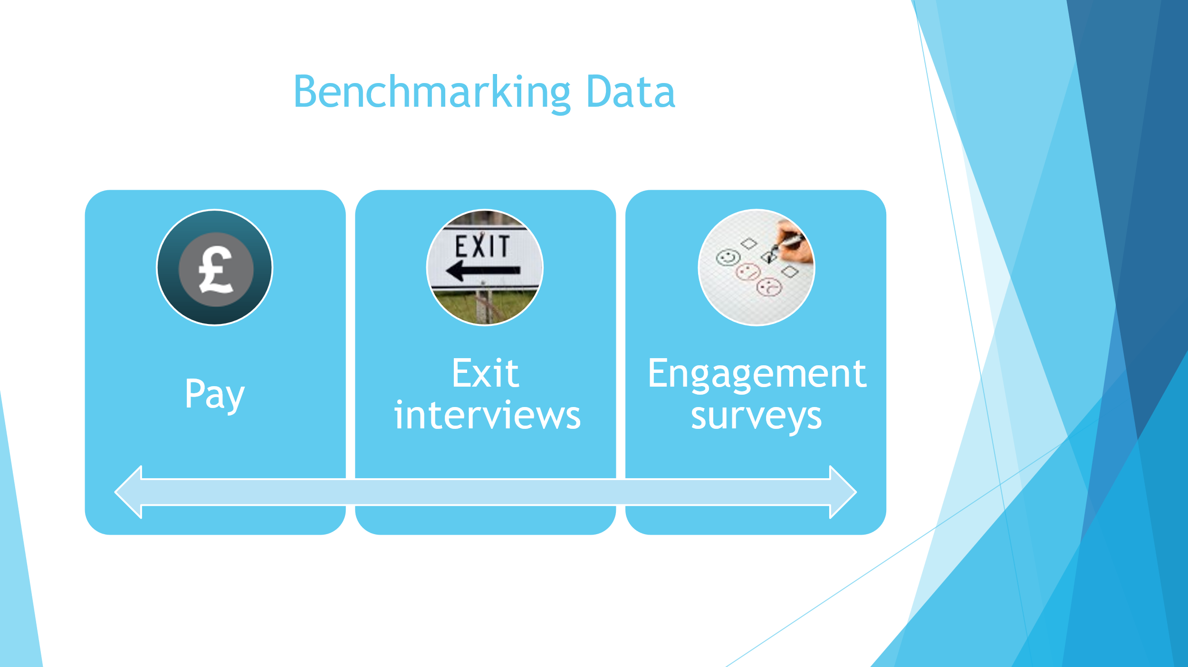
2.2 & 2.4 Benchmarking is important for organisations to ensure they remain competitive. It can support organisations to secure the very best talent available and ensure they offering rewards and pay in line with competitors (Lewis, Hays Public Services).
Data for benchmarking can be gathered and used in different ways by organisations. Firstly, data for benchmarking in relation to pay can be gathered internally through the job evaluation process. This process helps to review current jobs and their importance within an organisation and then gathering data externally to compare the pay of similar roles to that in other organisations (CIPD, 2021, C). Job evaluation schemes help to develop clear, orderly pay and grading structures that are in line with Equal Pay legislation which is why this is a favoured approach of employers (CIPD, 2021, C). External data in regards to pay can be found using sources such as the Office of National Statistics who publish a yearly report on the measures of employee earnings, using data from the Annual Survey for Hours and Earnings.
Data for benchmarking can be also be gathered through exit interviews which is also useful in the design of reward. For example, at my organisation we would ask the employee their reasons for leaving, this can provide us with data on what is important to employees in terms of reward and help us to understand what other organisations are offering that is appealing to employees.
Staff engagement surveys are also a good way to gather data for benchmarking. This can help to understand if employees feel motivated and fulfilled in their job to be able to establish appropriate rewards to improve job satisfaction (CIPD, 2021, D). However, this is not always reliable due to the psychological contract. Employees need to feel safe in order to be honest therefore the data gathered might not be true therefore, it may be more beneficial to make surveys anonymous (CIPD, 2021, D).
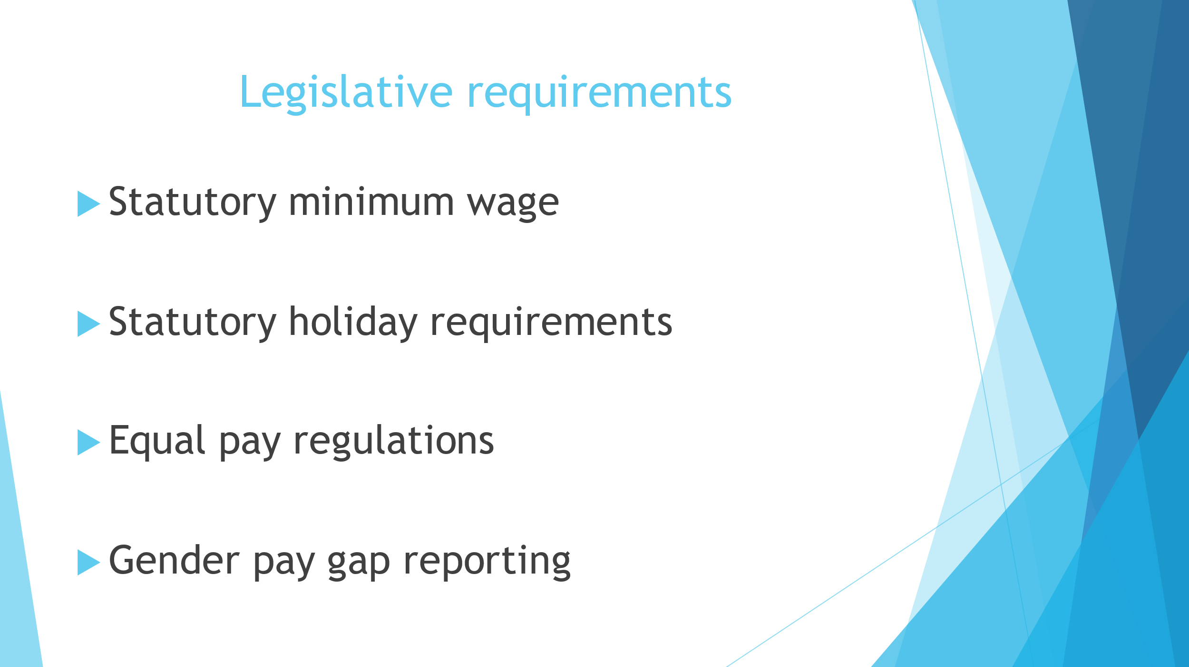
2.4 There are also legislative requirements to consider when developing reward strategies. Firstly, when reviewing rewards in relation to pay, it’s important to be aware of the national minimum wage as this will impact rewards such as bonus and tips. The National Minimum Wage Act 1998, gives employees the right to receive a minimum hourly rate of pay (Daniels, 2012, P71). The National Minimum Wage can include payment of a bonus however, payment of tips and gratuities cannot be used to make up the NMW (Daniels, 2012, P72).
Next, there are also regulations around the paid holiday. Employees are entitled to a minimum level of holiday, rest periods and reasonable working hours under the Working Time Directive (Daniels, 2012, P64).
Under the Working Time Regulations 1998, employees are entitled to 5.6 weeks’ paid leave which is to include eight UK public bank holidays. Workers must be paid the equivalent of a week’s pay for each week of leave (Daniels, 2012, P64). Employees must not work over and average of 48 hours per week over a 17-week period unless they give their consent to opt out of this arrangement (Daniels, 2012, P67).
Equal Pay regulations form part of the Equality Act 2010 and this states that the terms and conditions of employment must be equal between men and women who are employed on like work, work rated as equivalent or work of equal value. It is important to note that equal pay relates to all terms and conditions of employment and is not solely based on salary (Daniels, 2012, P97).
For employers to ensure compliance, they must undergo regular pay reporting. The purpose of pay reporting is to encourage employers to reward people fairly (CIPD, 2021). It is required by law for all large UK businesses to disclose their data on earnings by gender. Their report must also include their data on CEO pay compared with the pay for their workforce. For smaller businesses, it is voluntary for them to produce a statement on their gender pay gaps (CIPD, 2021).
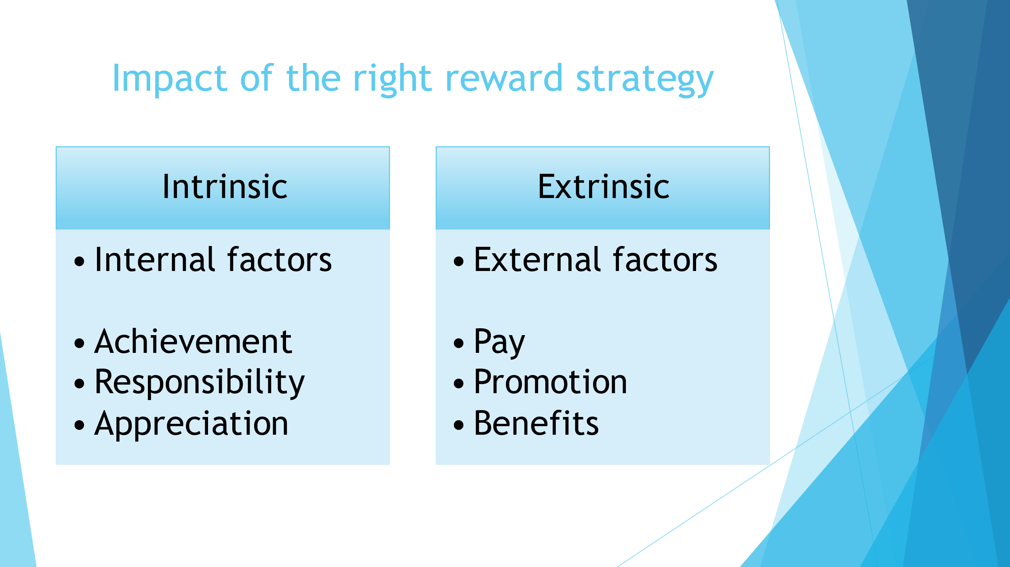
1.5 For reward strategy to contribute to organisational performance, organisations should consider what motivates people to perform. The factors that motivate people will vary depending on their needs and where they might be in their life-stage, therefore they will be expected to be rewarded differently (Martin, Whiting and Jackson, 2010, P195). Either intrinsically via internal feelings of achievement, responsibility and appreciation or extrinsically by external factors such as salary, promotion and benefits (Martin, Whiting and Jackson, 2010, P195). For example, an employee beginning their career may find salary as the most important factor, whereas employees with children might see work-life balance as the most important factor (Martin, Whiting and Jackson, 2010 P195).
Intrinsic motivation is strongly connected to the importance of work for people and this can result in more engaged and committed employees (Rees and French, 2013, P264). Therefore, pay related rewards can sometimes be harmful to motivation. For example, in the theory of equity whereby employees who compare their rewards with others can become demotivated if they perceive their reward to be unfair. However, if pay rewards are delivered effectively, these can have a positive impact on intrinsic motivation (Rees and French, 2013, P264).
There is much evidence to suggest that extrinsic motivation is only effective in short-term motivation. Therefore, it is important to have a total reward scheme that is suitable for all people at all stages in their life to improve employee and organisational performance (Martin, Whiting and Jackson, 2010, P195).
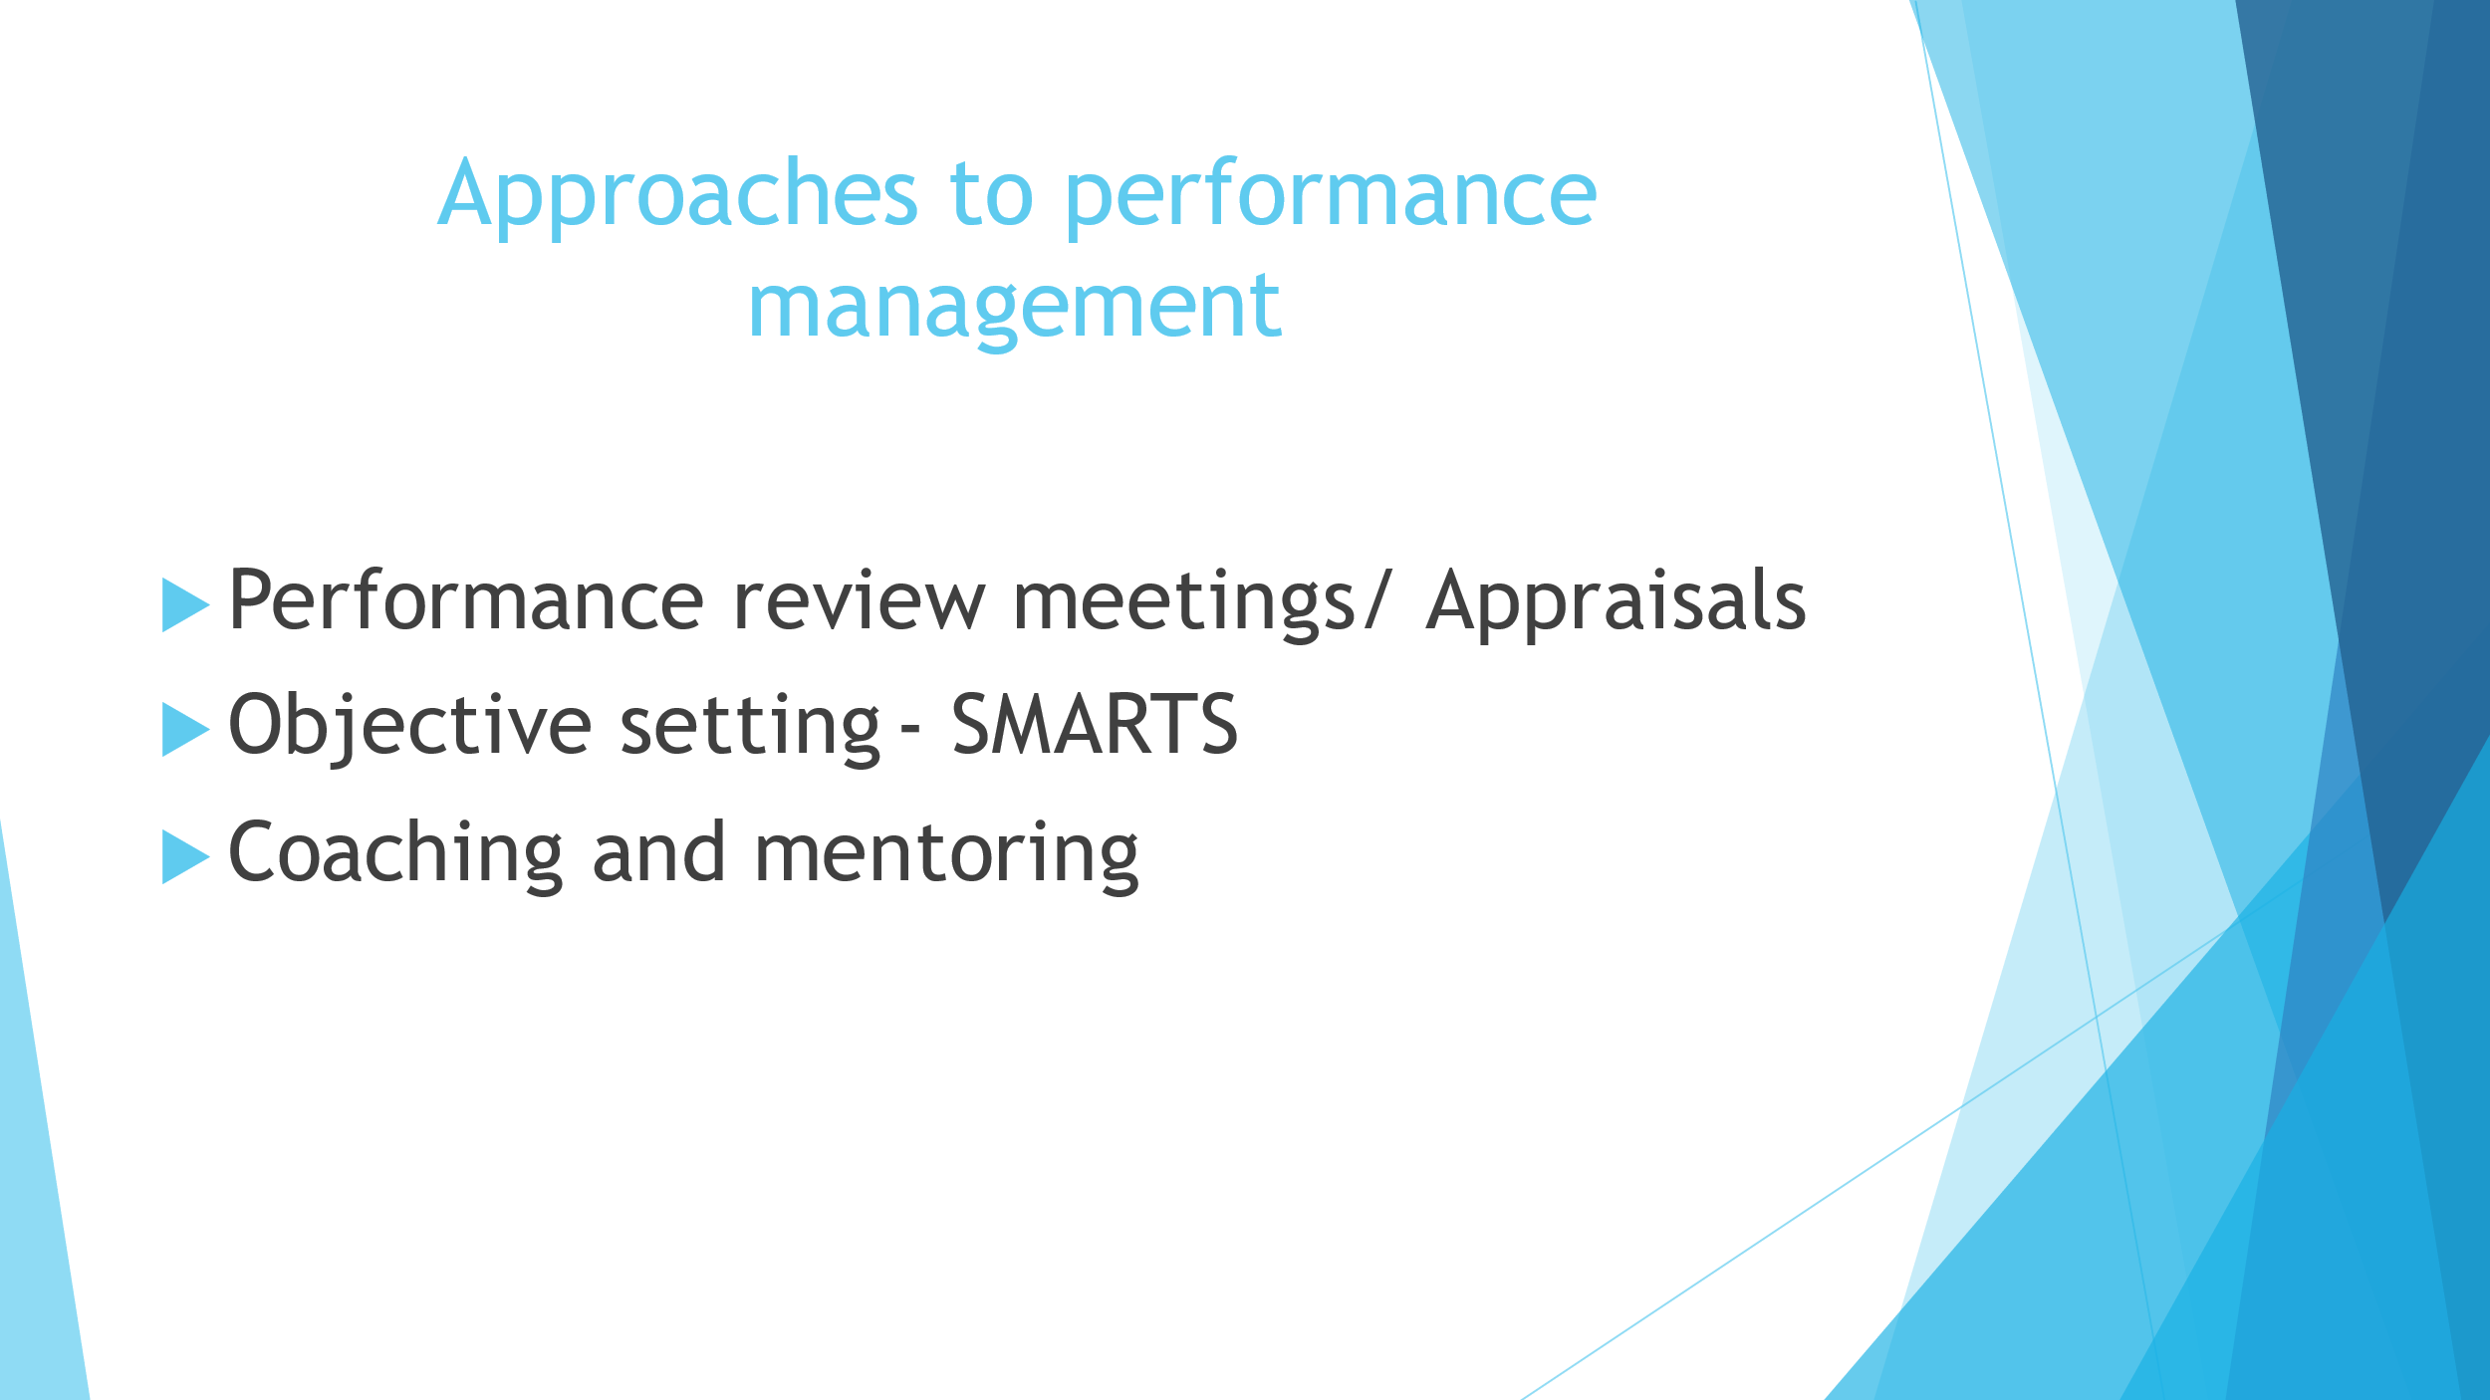
3.1 There are many different approaches to performance management. Firstly, the most common approach to performance management is appraisals. Appraisal meetings are put in place to review employees recent performance and providing feedback on their strengths and areas for improvement (Martin, Whiting and Jackson, 2010, P160). It is considered to be a positive approach to providing feedback to employees on performance which has proven to increase employee motivation which ultimately improves organisational performance (Martin, Whiting and Jackson, 2010, P160). On the other hand, appraisals take a retrospective approach in managing performance rather than being pro-active in ensuring employees are working to their potential (Martin, Whiting and Jackson, 2010, P 160). Successful appraisals also depend on the role of the line manager to carry out regular reviews and have relevant training in people management activities. For line managers, appraisals that are carried out correctly, are able to support them in making effective reward decisions in relation to pay or benefits from information obtained from appraisals (Martin, Whiting and Jackson, 2010, P163).
During an appraisal managers could take the approach of objective-setting to agree SMARTS (Specific, Measurable, Agreed, Realistic, Time-bound, Stretching) objectives with employees in line with achieving organisational goals (Martin, Whiting and Jackson, 2010, P171).
Moving on, coaching and mentoring is another approach taken to manage performance. Coaching and mentoring is a development approach whereby one-to-one conversations are used to improve individual’s skills, knowledge or work performance (CIPD, 2021, B). Coaching and mentoring focuses on specific skills and usually a mentor will share their knowledge and experience within a specific area to help an individual improve over a specific period of time however, it can be adopted by managers as an ongoing management style (CIPD, 2021, B). While this approach benefits learning and development and organisational performance, it is dependent on line managers carrying out an effective process and it can raise conflicts due to the need for distance and impartiality during the coaching period (CIPD, 2021, B).
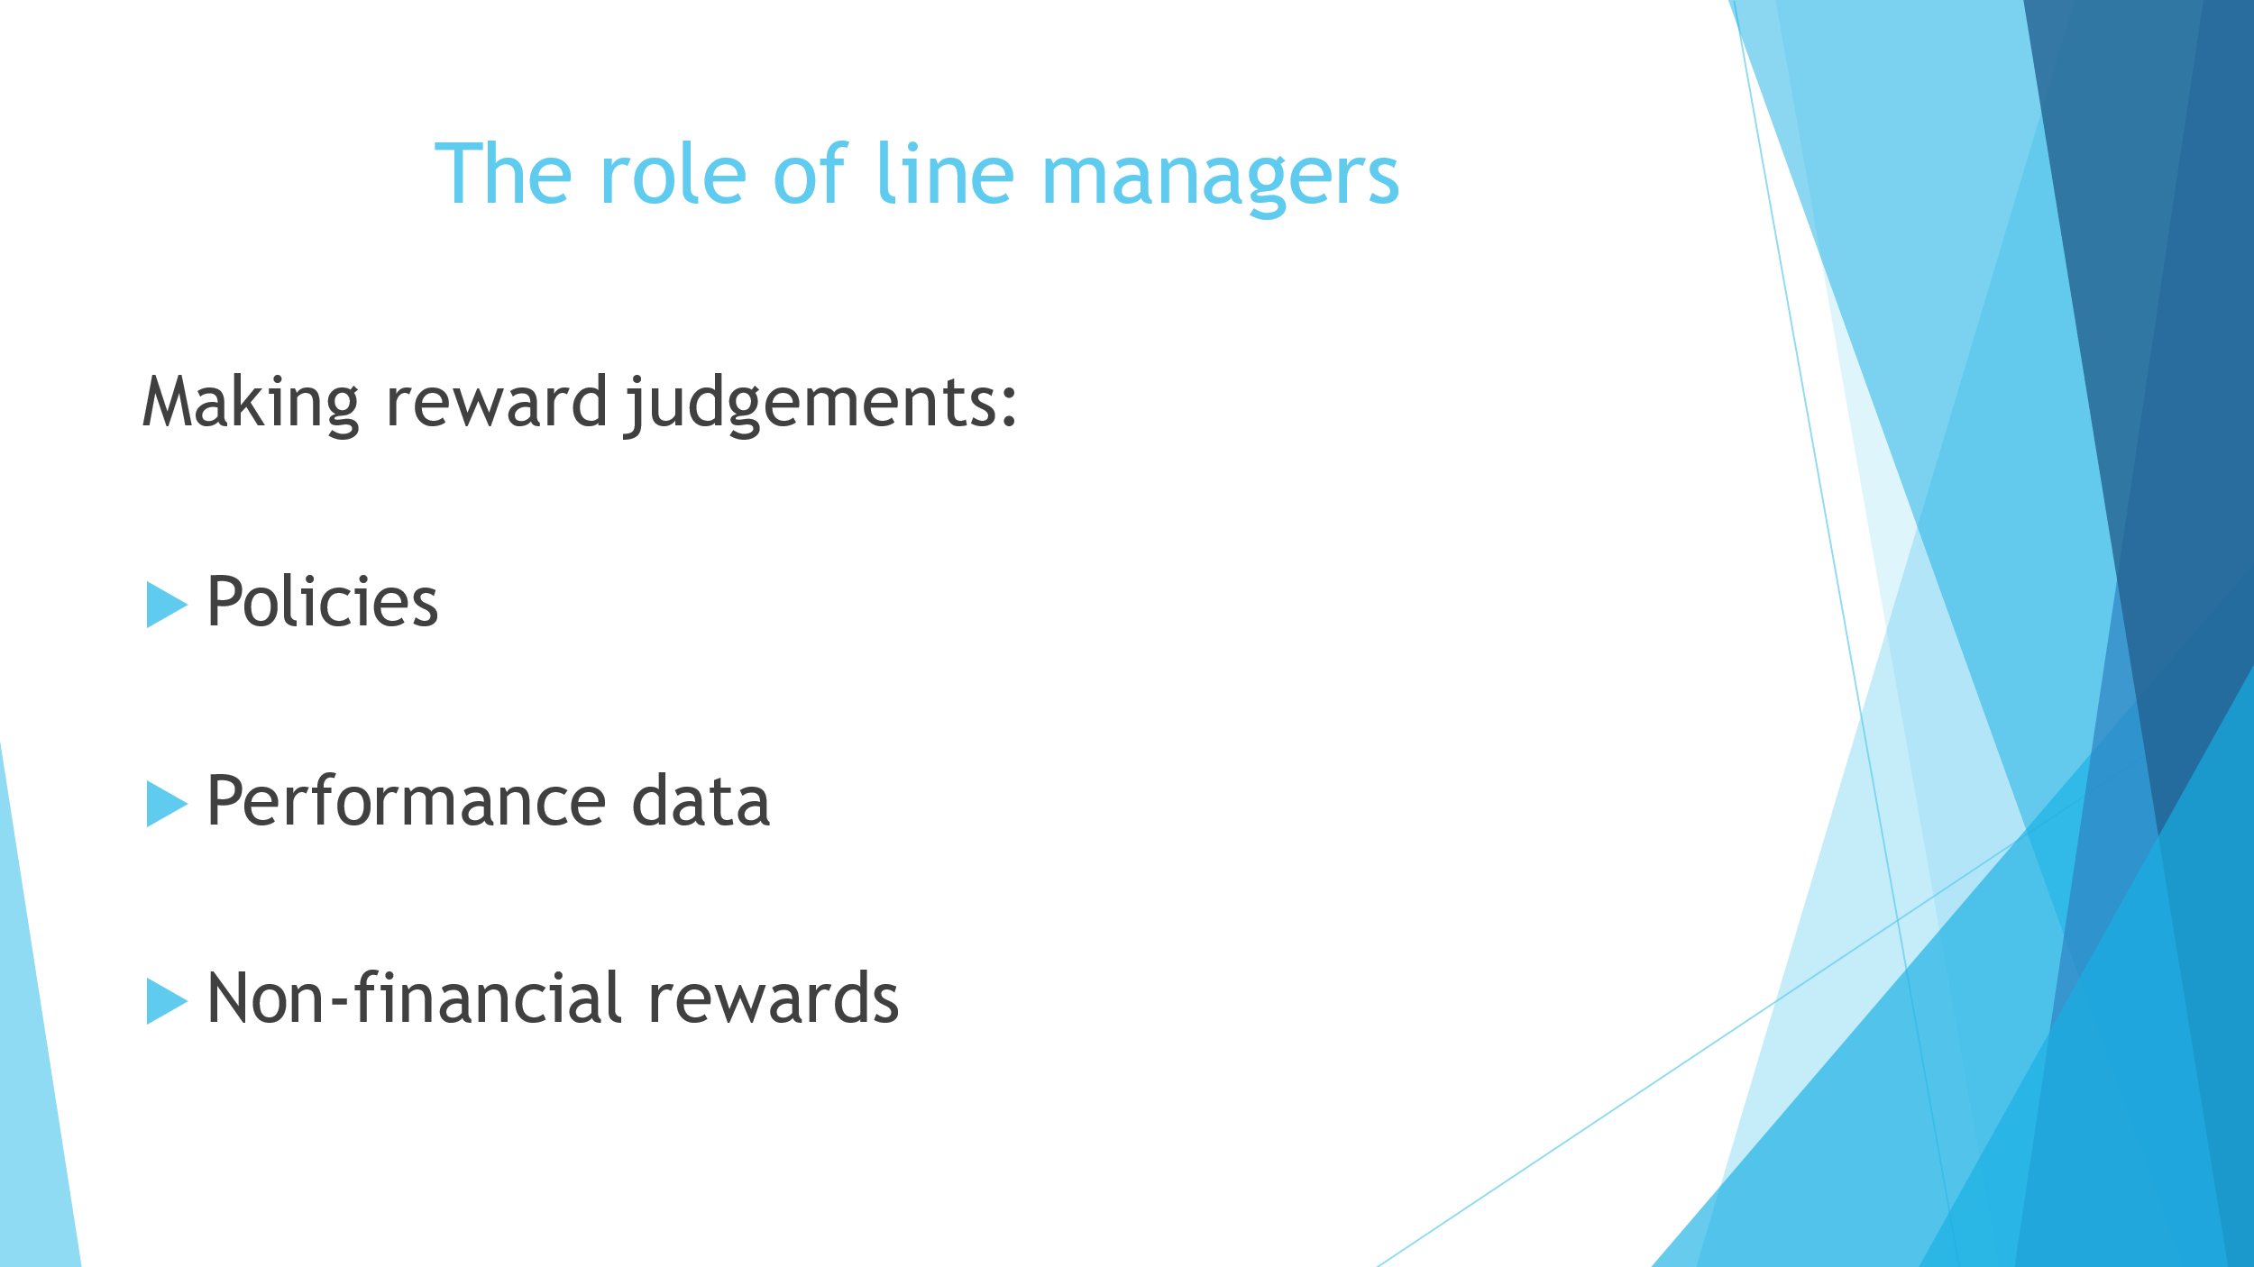
3.3 The success of performance depends on line managers to complete performance management tasks effectively and make effective reward decisions following these processes (CIPD, 2022).
Managers can make effective reward judgements by following policies. Setting out a clear policy on the reward strategy, will aid managers in understanding what behaviours and performances can be rewarded. A policy on reward can also help managers to understand how employees should be rewarded which will ensure their judgements are consistent (CIPD, 2022, A).
Managers can also benefit from performance data to make reward judgements, for example, regular performance reviews with employees can establish targets that have been met and how individuals are performing in order to be rewarded accordingly (CIPD, 2020).
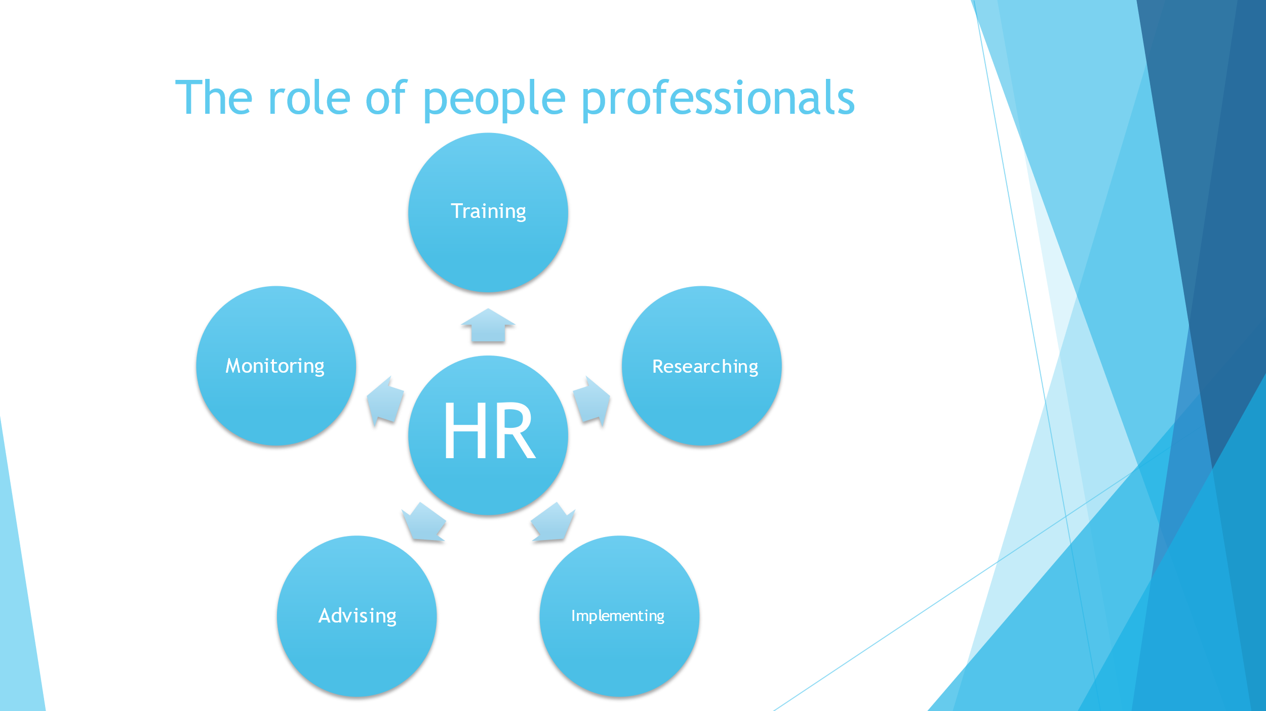
3.2 The role of people professionals in terms of reward is vast and in large organisations there may be a specialist reward team designated to managing reward strategy, systems and approaches. On the other hand, smaller businesses will often depend on general HR practitioners to advise them on reward (Martin, Whiting and Jackson, 2010, P208).
People practitioners can support line managers to make appropriate judgements by advising them on best practice in terms of developing reward packages that align with the current labour market and legislation (CIPD, 2022, A). People practitioners can also advise managers on making fair decisions in relation reward in ensuring the rewards package is inclusive. For example, taking a total reward approach to include rewards that will support all employees no matter where they are in their life stage (CIPD, 2021, A).
People practitioners are also able to provide managers with training in handling performance management activities such as appraisals and encourage best practice in setting objectives, providing feedback and rewarding achievements (CIPD, 2020).
Line managers can also depend on people practitioners to carry out research in terms of the labour market and benchmarking for pay reviews and job evaluations to ensure managers can make well informed decisions in pay (CIPD, 2020).
Furthermore, people professionals can guide line managers when implementing reward schemes and support them in reviewing reward packages through employee satisfaction surveys and obtaining regular feedback from employees (CIPD, 2020).
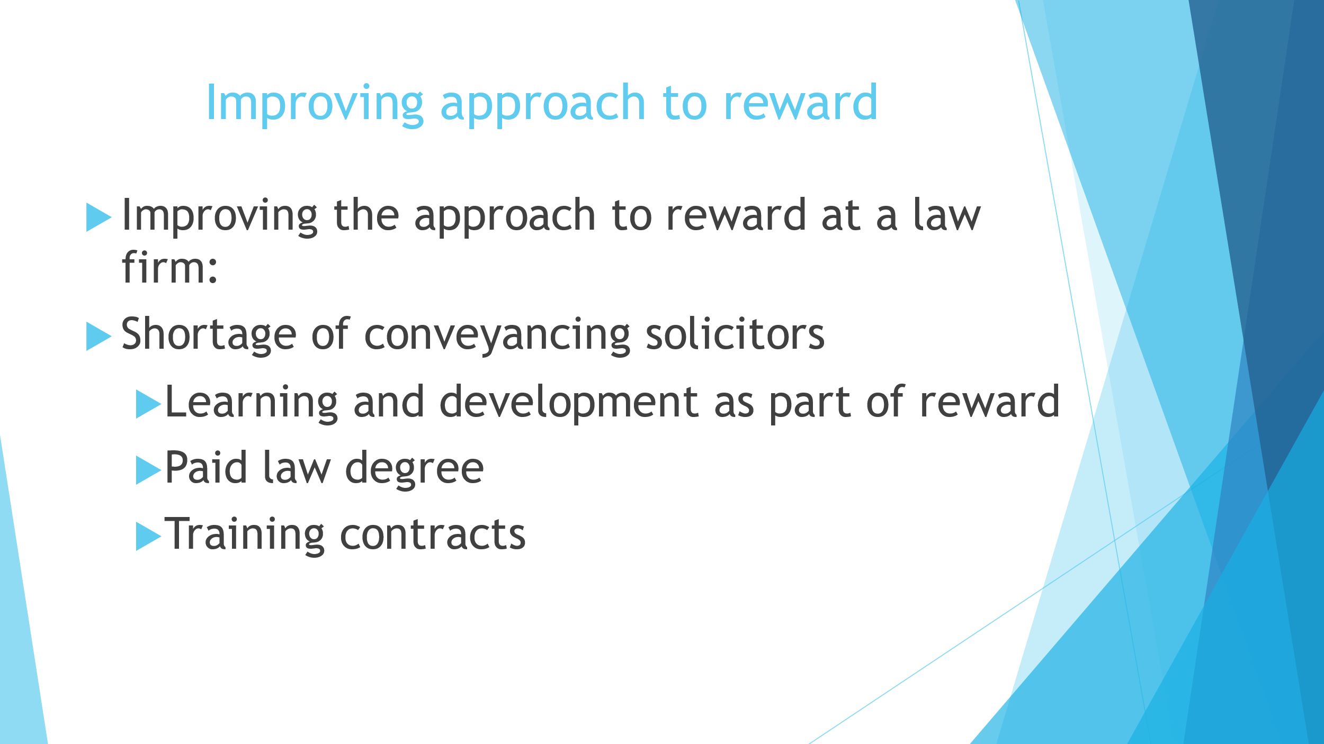
2.3 Due to the effects of COVID-19, law firms have experienced a high demand for residential conveyancing solicitors (Reyes, The Law Society Gazette, 2021). With the increase in demand, it has become increasingly difficult to recruit talent, with many conveyancing solicitors reluctant to leave their current employment. This was due to uncertainty during the pandemic and also others feeling committed to their employers who took care of them during the pandemic (Reyes, The Law Gazette, 2021).
At my organisation we have taken steps to improve this and attract the best talent in conveyancing. Firstly, I have supported my organisation with research and benchmarking to understand what our competitors are offering conveyancing solicitors in terms of pay, the role itself and benefits. We recently carried out a pay review using data from the Office of National Statistics Employee Earnings 2021 report and inflation reports to ensure that not only our conveyancing solicitor salaries were in line with inflation and competitors but all our employees to ensure equal pay for all.
As part of my research I carried out surveys to understand what is important to our current employees. The data from this survey showed that the majority of solicitors would like to have learning and development opportunities and opportunities to further career. I also looked into what other law firms are offering on recruitment and this included undergraduate placement schemes, trainee solicitor opportunities and the option of working flexibly over locations.
With this in mind, I would suggest improving our learning and development opportunities and re-develop the terms of which employees can apply for training contracts. We could offer opportunities for unqualified individuals to be paid to complete their law degrees. To ensure equality and fairness, these opportunities would need to be rolled out to existing legal advisors and therefore we would need to develop a process for existing employees to apply or express interest to ensure that all have the opportunity to progress within the firm.

Word Count: 3596
Bibliography
Coaching and mentoring factsheet, CIPD, 2021, Available at: https://www.cipd.co.uk/knowledge/fundamentals/people/development/coaching-mentoring-factsheet#gref (Accessed: 11 April 2022) (B)
Employee benefits, CIPD 2022, Available at: https://www.cipd.co.uk/knowledge/fundamentals/people/benefits/factsheet?pdf=true Accessed: 10 April 2022) (B)
Employee engagement, CIPD, 2021, available at: https://www.cipd.co.uk/knowledge/fundamentals/relations/engagement/factsheet (Accessed: 12 May 2022) (D)
Half of employees pushing to work from home to save on fuel costs. Research reveals, Mayne, People Management, 2022, available at: https://www.peoplemanagement.co.uk/article/1753594/half-employees-pushing-work-home-save-fuel-costs-research-reveals (Accessed: 12 May 2022)
Human Resource Practice, Martin, Whiting and Jackson, 5th Edn, 2010, CIPD, London
Is benchmarking the key to attracting and retaining public sector talent, Lewis, available at: https://www.hays.co.uk/blog/insights/is-reward-benchmarking-the-key-to-attracting-and-retaining-public-sector-talent- (Accessed: 12 May 2022)
Job evaluation and market pricing, CIPD, 2021, available at: https://www.cipd.co.uk/knowledge/strategy/reward/market-pricing-factsheet (Accessed: 12 May 2021) (C)
Leading, Managing and Developing People, Rees and French, 4th Edn, 2013, CIPD, London
Lessons from the gig economy in the new working world, People Management, 2022, available at: https://www.peoplemanagement.co.uk/article/1751846/lessons-from-the-gig-economy-in-the-new-working-world (Accessed: 12 May 2022)
Pay fairness and pay reporting factsheet, CIPD, 2021, available at https://www.cipd.co.uk/knowledge/strategy/reward/pay-fairness-reporting-factsheet (Accessed: 11 April 2022)
Performance management an introduction, CIPD, 2020, Available at: https://www.cipd.co.uk/knowledge/fundamentals/people/performance/factsheet#gref (Accessed: 10 April 2022)
Reward factsheet, CIPD, 2022, Available at: https://www.cipd.co.uk/knowledge/fundamentals/people/pay/reward-factsheet#gref (Accessed: 10 April 2022) (A)
Seizing opportunities in the new working world, Firstup, available at: https://firstup.io/assets/seizing-the-opportunities-in-the-new-working-world/ (Accessed: 12 May 2022)
Strategic reward and total reward, CIPD, 2021, Available at: https://www.cipd.co.uk/knowledge/strategy/reward/strategic-total-factsheet#gref (Accessed: 10 April 2022) (A)
Thousands of UK workers to take part in four day week trial, Jolly, The Guardian, 2022, available at: https://www.theguardian.com/business/2022/apr/04/thousands-of-uk-workers-to-take-part-in-four-day-week-trial (Accessed: 12 May 2022).
Understanding Generation Z in the workplace, Delloitte, available at: https://www2.deloitte.com/us/en/pages/consumer-business/articles/understanding-generation-z-in-the-workplace.html (Accessed: 12 May 2022)
Virgin Family Friendly Policies, Virgin, available at: https://careersuk.virgin-atlantic.com/wp-content/uploads/2019/09/Family-Friendly-Policies.pdf (Accessed: 10 April 2022)

