OVIDIU-IOAN PAULENCU (1816786)
UWTSD
Employability skills

Contents

1. Introduction 2
2.1 Why are Employability Skills Important? 3
2.2 Examples of Employability Skills 4
2.3 Changes of Employability Skills 7
Conclusion 8
Reference: 9

Introduction

This report analyses what employability skills are and why they are important. The UK Commission for Employment and Skills (UKCES) defines employability skills as "the skills almost everyone needs to do almost any job".
Employability skills are the fundamental abilities required for obtaining a job, maintaining employment, and doing well in one. These are the abilities, mentalities, and behaviours that workers need in order to get along with their co-workers and bosses and to be able to make good judgments that require critical thinking. These skills are applicable across all sorts of industries, business sizes, and employment levels, from entry-level workers to the most senior positions in an organization. (Robinson, 2000).
This report highlights the many kinds of employability skills as well as the reasons why having them is so vital. It will investigate the factors behind and mechanisms behind the recent shifts in employable skills. The purpose of this research is to investigate the factors that contributed to their transformation during the last decade. The topic of what employability qualities an employer expects to see in present work has become the most typical inquiry in today's world.

2.1 Why are Employability Skills Important?

In recent years, UK officials have prioritised employability skills. This is indirectly and clearly reflected in policy pronouncements and outcomes that emphasize employable skills (CIPD, 2021). They're important in four areas:
- Improving employability skills is needed to enhance the transition from full-time study to employment for school leavers and college and university graduates.
- Employability skills are crucial to a demand-led employment and skills system.
- Businesses are searching for a larger range of generic employability skills. A strategy that extends beyond vocational and technical skills is essential.
- Employability skills have come up in discussions about job growth and social mobility.
Employability skills are important to employers because they complain about the absence of skills among their employees. Employers are searching for employees with communication, teamwork, problem-solving, and critical thinking skills. Employability skills are soft skills that employees need to find a job. Getting a job is not about the grades. Other skills are necessary too. Communication, resilience, team-working, emotional intelligence, and digital competence are soft skills. They are general qualities that a good employee needs to have. The majority of businesses want candidates who possess the abilities necessary for the position. (Doyle, 2021).
It has been known for a long time that jobs exist, but it is important that when you hire a basic person, they can build a successful career and, at the same time, bring extremely important benefits to the employer.
Given the ever-changing structure of the UK labour market, employment skills are important to maintain and progress in employment.
Employment skills are especially based on communication, interpersonal skills, and skills to cope with change continuously. They are vital to being and remaining employed.
By demonstrating employability skills, it makes an individual more attractive to the employer, because the employer knows that it will give maximum efficiency. He no longer has to send him to a qualification training. He helps at the same time other colleagues, the team, and he helps to develop the company.

2.2 Examples of Employability Skills

- Resilience.
Prince (2013) says that resilience is really about taking charge in the face of unavoidable hardship or challenges. It is a characteristic of current senior executives who are constantly confronted with commercial and operational uncertainty and competition. It is reinforced by powerful social networks shown on websites like LinkedIn. In other words, resilience is adaptation, accommodation.
People that are resilient have three distinguishing characteristics: They accept hard facts with calm. They find significance in disasters. They have an extraordinary capacity to improvise, using whatever is available. (Coutu, 2002).
There is a significant amount of overlap between the ideas in these three ways. They believe that individuals who are resilient have three characteristics: a firm acceptance of reality; a profound sense that life has significance, which is often buttressed by deeply held values; and an amazing capacity to improvise when faced with new situations. You can recover from adversity even if you only possess one or two of these abilities, but you can only be considered genuinely resilient if you possess all three. In order for an organization to be resilient, it must possess all three of these traits.

- Emotional Intelligence
Daniel Goleman (1995) defines emotional intelligence as “how well you manage yourself”. Emotional Intelligence (EI) should be considered during the hiring process, and it should also be taken into account during the promotion of employees.
Emotional intelligence was broken down into "Personal" and "Social" competencies by Daniel Goleman. Emotional intelligence is comprised of a wide variety of abilities, each of which may be found under the following categories:
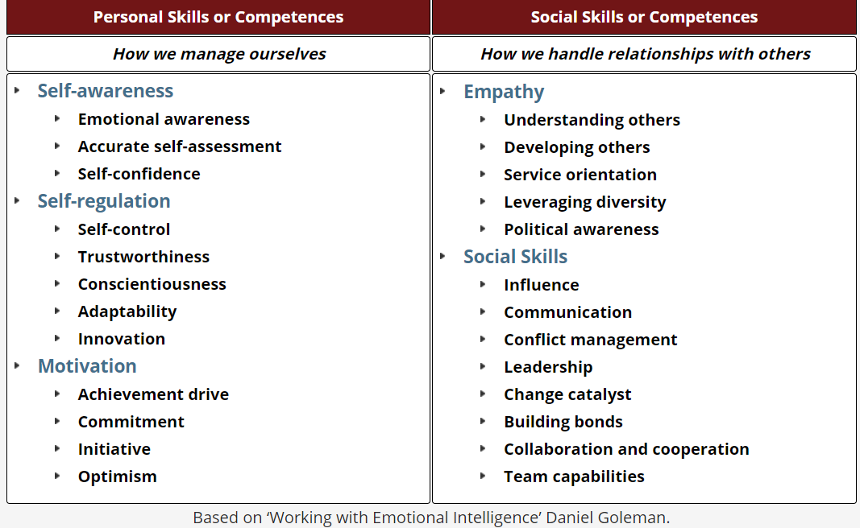

It's possible that improving your emotional intelligence will be the best thing you can do for your own personal development. Several studies show that people with higher levels of emotional intelligence are more successful at work and have more satisfying relationships with other people.
If you give some thought to ways in which you might improve your emotional intelligence, you will not only provide a boost to your own sense of self-worth, but you will also make other people more likely to find you captivating, engaging, and beautiful.

- Digital Competence
In recent years, "digital competence" has emerged as a central concept in several publications relating to policy. It is used particularly in broad conversations on what sorts of abilities and understanding individuals should have in a knowledge society, what to educate young people and how to do so, and what to teach them.
In recent years, the idea of digital competence has emerged as a central topic in the conversation over the kinds of abilities and comprehension that people should have in order to function effectively in a knowledge-based society.
The most up-to-date idea for characterising abilities connected to technology is called "digital competence." In recent years, numerous words have been used to describe the abilities and competency of utilising digital technologies, such as ICT skills, technology skills, information technology skills, 21st century skills, information literacy, digital literacy, and digital skills. These phrases all refer to the same thing: the ability to utilise digital technologies.
There is no escaping the fact that we live in a digital world; this cannot be avoided. It is quite difficult to find a job description in this day and age that does not feature some kind of "computer literacy" as an important talent. This is because computers are at the core of so many of the activities that we engage in, both in our personal lives and at work.

- Team-working Skills
If you wish to work well with your co-workers and teammates, then teamwork is absolutely necessary. Many aspects of your life, ranging from school tasks to the organisation of a friend's birthday party, will likely need you to collaborate with others.
The more effectively you collaborate with other people, the higher the likelihood that your team will be able to realise its objectives. When it comes to completing tasks and projects, employees frequently need to work together or cooperate with others; having abilities and expertise in collaboration will make the process a great deal more enjoyable.
Even if you are good at working independently, employing important life skills like time management, being able to work well as part of a team is a talent that is appreciated for most employment.
The vast majority of occupations that need more than one worker require you to collaborate with other people. Being part of a group of people who are able to get things done is not the same thing as working together effectively as a team. The degree to which members of a team collaborate effectively is what separates a strong group from a weak one.
Your ability to collaborate well with others will also increase the number of opportunities available to you to advance in your profession. People may view you as someone who has a good attitude and who believes it is crucial for the firm to achieve its goals. Having a mentality like this may increase the number of possibilities, responsibilities, and even training and promotion opportunities available to you over time.
- Decision Making
Making decisions is the most valuable talent to have in the business, especially for those in leadership positions. Additionally, it is crucial on a daily basis in your personal life. While some judgments are straightforward and nearly come about on their own, others can be quite challenging. Making poor choices might result in having to deal with the repercussions of those choices for a significant amount of time.
Some individuals are procrastinators and put off making decisions, while others struggle to make even the most basic choices, such as what to eat from the menu at a restaurant, what clothing to wear, or what to buy. When it comes to making judgments, there are some that require prompt action, while others require more time for deliberation, consideration, and assessment.
The ability to make decisions is a key attribute for successful management and leadership. Because of their inability to formulate and implement sound judgments, certain individuals are just not cut out for leadership responsibilities in an organisation.
Challenge your preconceived notions and think creatively beyond the box. If you keep doing things the same way you always have, you will get the same results. You should anticipate receiving the exact same outcomes as you have in the past. Step outside of your comfort zone and utilise your creativity to experiment with new concepts.

2.3 Changes of Employability Skills

According to new study that was published by Careers and Enterprise Company (2020) Britain's business leaders think that the workplace reforms brought on by Covid-19 will now become a permanent aspect of the way that we work and affect the demand for skills.
According to the findings of the research, executives in business feel that the dramatic impact that the epidemic has had on working life would have ramifications that are long-lasting. The trend toward fewer people working in workplaces and more people working from home or virtually will likely continue.
The vast majority of executives in charge of businesses are in agreement that skills such as communication, self-motivation, and the dependability to work remotely are now essential (83 percent), and that the demand for digital and IT skills will increase due to the rise in online and virtual working environments (85 percent).
They bring to light the demand for certain abilities that is being pushed by a changing workplace that is being formed by lockdown. More than three in five people believe that self-motivation, preparation, and the abilities to work remotely will be very essential in the future, while almost three in five people believe that digital and IT skills will be extremely important in the future. You will still require a strong degree of digital literacy even if you do not work in an area that heavily relies on technology such as bitcoin, artificial intelligence, or another tech-heavy business. The analysis of data is going to be required for almost every profession in the future. Data is the most significant topic.

Conclusion

An in-depth examination of what it means to have employability skills is the purpose of this paper, which has been created for that very purpose. It is explored what exactly constitutes employable abilities. It demonstrates what abilities are necessary for employment. Is also covered five different types of employability skills, which the author believes to be the most significant. Several writers agree that being proficient in digital and information technology is going to be an absolute need in the years to come. Everything has been converted to digital format, and this trend will only continue.

Reference:

- Coutu, D., 2002. How Resilience Works. [online] Boyden.com. Available at: <https://www.boyden.com/media/how-resilience-works/img/how-resilience-works.pdf> [Accessed 15 June 2022].
- Crowley, E., 2021. Skills Development in the UK Workplace | Factsheets | CIPD. [online] CIPD. Available at: https://www.cipd.co.uk/knowledge/work/skills/skills-factsheet#gref [Accessed 21 June 2022].
- Doyle, A., 2021. Top Skills and Attributes Employers Look For. The balance careers, [online] Available at: https://www.thebalancecareers.com/top-skills-employers-want-2062481 [Accessed 30 June 2022].
- Fajaryati, Nuryake & Budiyono, B. & Akhyar, Muhammad & Wiranto, (2020). The Employability Skills Needed to Face the Demands of Work in the Future: Systematic Literature Reviews.
- FE News. 2020. Covid will change future of work and skills say business leaders – FE News. [online] Available at: https://www.fenews.co.uk/skills/covid-will-change-future-of-work-and-skills-say-business-leaders/ [Accessed 11 June 2022].
- Goleman, D., 1996. Emotional intelligence. 1st ed. London, UK: Bloomsbury.
- Holmes, K 2017, What Employers Want: The Employability Skills Handbook, Trotman Publishing, Bath.
- Ilomäki, L., Kantosalo, A., & Lakkala, M. (2011). What is digital competence? In Linked portal. Brussels: European Schoolnet. [online] Available at: < https://helda.helsinki.fi/bitstream/handle/10138/154423/Ilom_ki_etal_2011_What_is_digital_competence.pdf>[Accessed 19 June 2022].
- Prince, E., 2013. The advantage. The 7 Soft Skills You Need to Stay One Step Ahead. New York: Pearson Prentice Hall.
- Robinson, J., 2000. What are employability skills? The workplace, [online] Available at: https://www.face.edu/cms/lib/CA01000848/Centricity/Domain/189/employability-skills.pdf [Accessed 25 June 2022].
- Skillsyouneed.com. n.d. Emotional Intelligence. [online] Available at: https://www.skillsyouneed.com/general/emotional-intelligence.html [Accessed 17 June 2022].
- Trought, F 2017, Brilliant Employability Skills PDF E-Book: Brilliant Employability Skills 2e, Pearson Education, Limited, Harlow.

