 | University of Wales  Trinity Saint David
Programme | BA Business management
Module code | LCBB4003
Unit tittle | Introducing the Modern Workplace
Lecturer | Molly Jack

DHL – Managing modern workplace

A group work of Group 3:
Silviya Lazarova 1916917
Teodor Angelov 1917363
Petya Niklenova 1916916
Desislava Zhelyazkova 1917424
Stanimir Iliev 1915932

Part 2:Group Report and PPT Presentation

Date: 05/09/2020

Table of Contents
Introduction 3
1. Teodor Angelov 1917363 3
1.1. Background/outline of your project and related organisation 4
2. Petya Niklenova 1916916 7
2.1. Goals and objectives – importance and establishment 7
2.1.1. Goals and objectives. 7
2.1.2. Organisational structure 8
2.1.3. Organisational culture. 9
3. Silviya Lazarova 1916917 11
3.1. Leadership and management behaviours 11
4. Desislava Zhelyazkova 1917424 15
4.1. Group and team behaviours 15
5. Stanimir Iliev 1915932 18
5.1. Motivation and perception 18
Conclusion 21
References 22
Appendix: PP Presentation (converted) 24

Introduction

This report is a group work of five students each of which has been contributed equally for the completion of the whole group task. This work contains of 5 parts, each of which is presented by different member of the group and is titled under the name of its provider.

The main report aims to create a clear view about the importance of managing a modern workplace. This will be achieved by focusing on certain organisational characteristics, such as organisational structure and culture, management and leadership styles of behaviour, as well the importance of team working, motivation and perception. The presentation share the aims of the report, and it has been a short variant of the whole report. The PPT presentation can be found in the Appendices bellow this report, converted in a word documents as required by the task requirements.

Teodor Angelov 1917363

Background/outline of your project and related organisation

Managing a modern workplace nowadays is a great challenge. This is because the technology is rapidly developing and taking place in each business. Modern workplace management comes with a set of security requirements. New rules and requirements bring great advantages in the contemporary business activities, but they also require a great attention, responsibility and professional management, so that what is in the policy, should be observed. (Davis, 2019).
Modern workplace management is generally considered to be organisations that manage to bring new products, services or software to market. However, this does not mean that once achieved, it remains a guaranteed position, because if over time this business lags behind, ignore employee’s needs and is no longer one of the modern businesses, then its management cannot be called modern workplace management (Booth, 2017).
Nowadays, the organisations in which values ​​soft skills, flexibility of work, application of anti-harassment practices and pay transparency can be considered a modern workplace. This, of course, is only part of the meaning of the term modern workplace management, but these factors have been defined as the four key workplace trends for 2019 (Machacek, 2019).
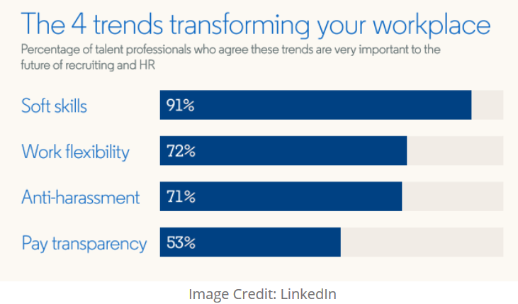
Figure 1. Source: (Machacek, 2019)

In order to gain a better understanding of the situation, which can be defined as modern workplace management, and to have practical clarity on the aspects to be addressed, the working group chose DHL as an example of a modern workplace, whose management can be considered and discussed in this report. This organisation has been chosen because it is a great example of a well-managed modern workplace.
The DHL company was founded on 25 September 1969 performing as a door-to-door express delivery service. Its founders were Adrian Dalsey, Larry Hillblom and Robert Lynn, whose first letters of their surnames formed the name DHL. DHL initially started by transporting customs documents by air. The first flights tended to be between San Francisco and Honolulu but the network was later expanded to all corners of the globe. Since 2013, DHL has been the market-leader with respect to international express deliveries and logistics.
In 1998, Deutsche Post began to acquire shares in DHL this process finished in 2002 when were acquired all outstanding shares. So, founded in the United States, DHL is now a German Logistics company owned by Deutsche Post, which itself is owned by the German government.
The company then absorbed DHL into its Express division, while expanding the use of the DHL brand to other Deutsche Post divisions, business units, and subsidiaries. DHL is currently operating in more than 2020 countries across the world. Its headquarters are in Bonn Germany, and it has over 380,000 employees across the world. Delivering over 1,3 billion parcels per year and operating in over 220 countries and territories.
The four key workplace trends are: Soft Skills, Work Flexibility, Anti- Harassment, and Pay Transparency.
Soft skills include proactiveness, creativity, skills of persuasion, collaboration, adaptability and skills of time management. These soft skills are among the most in demand lately (Machacek, 2019). They are also among these that have been included in the requirements when hiring people in DHL. This is so because they are increasing the success of the company. Also, these soft skills are extremely important for a company dealing with delivery of packages.
Work Flexibility has become is one of the new norms noticed be a trend during the last few years. The flexibility could be both, working from home or working on a flexible hour arrangement. In order to increase the productivity, the employers lately are trying to create a freedom for their employees about where and when to work, within reason. The improvement in the productivity is benefiting both employers and employees, but the element of freedom could bring challenges regarding team bonding and collaborating (Machacek, 2019).
This flexibility has its place in the DHL’s shifts planning in a way that most of the employees are allowed to choose how many days to work, which part of the days, and when to have off days. Based on that, and following the law regarding the limits of working hours and rest time, the management of their teams makes their schedule. Working in their preferred time makes people more motivated, happy, and easy going (DHL Worldwide, 2020).
Anti-Harassment is another very important trend during the last few years. Handling and preventing harassment at work makes each job position in such a company a dreamed job (Machacek, 2019). This is very important for DHL because the international operating company deals with a high diversity of the staff, so harassment should be minimized to zero percentage. To improve the anti-harassment activities and behaviour, DHL has improved their policies and making it possible so that any harassment could be reported safely. Moreover, that all employees of DHL pass through a special training session, so that such issues to be eliminated before arising (DHL , 2020).
Pay Transparency is taking the payments out of confidentiality. This action is quite often a fact lately, because transparency could help ensuring a fairer pay, especially when there are differences by race, gender or any other demographics. Transparency makes the hiring process more efficient, but there are still many employees that still fear salary disputes based on that pay transparency (Machacek, 2019).
In DHL they have implemented the Pay Transparency to an extend of informing the payment per hour, rewarding amounts according to the case and raises of the payment for long time being working with the company. The main individual’s salary though remains confidential.

These are only a few of the factors that define the success of managing a modern workplace. The extent to which managing a modern workplace depends of other factors will take into consideration some important internal factors such as goals and objectives, organisational structure, organisational culture, leadership and management behaviours, group and team’s behaviours, and motivation and perceptions. These internal factors are the constructive elements of a sustainable business, and accessing them will bring clearness and objectivity in understanding the importance of a successful managing of a modern workplace. It is very important to be understood that every of these factors is important in its way, and no one of them is to be ignored, because they work as an operational system which should be in order.

Petya Niklenova 1916916

Goals and objectives – importance and establishment

Goals and objectives.

Goals and objectives are representing the steps one must do to reach the wished destination. Goals show what one wants to achieve. Objectives defines the steps one has to make to achieve the goal (Bateman & Herr, 2011).
Goals define the direction and promote actions, i.e. draw the steps towards the goal-related activities. Goals can be set before a business is set up, with the first goal being to set up a business. Once one goal is achieved, the business must set the next goal, which is actually the principle of continuous development of a business (Slade, 2009).
In her book Barbara Bateman (2011) states that Goals must allow progress assessment and the progress must be assessed (Bateman, 2011). Or said differently, the goals should be progress oriented and the progress should be able to increase the value of the final output. Moreover, that if there is business, there must be at least one goal. Goals are the drivers of the business.
If the goal is the final output to be achievement, then the objectives are the step by step process of achieving of the goals.
Principle of importance: The importance of a goal is proportional to the resources that the agent is willing to expend in pursuit of that goal (Slade, 2009).
Objectives must be clear and serve the achieving the main goal of the business.
For example, the objectives of DHL 2020-2025 are:
1. Achieve world-class employee engagement measured by steady progress in “Great Place to Work” and “Employee Engagement” score of >80% in Employee Opinion Survey (EOS)
2. Achieve best-in-class customer satisfaction measured by dedicated KPIs such as Net Promoter Score.
3. Achieve attractive returns for our shareholders (DHL, 2020).

It is important to realise the level of importance of the steps that will help the business reaching their final goal. Goals and objectives though, are directly and indirectly depending of the organisational structure and organisational culture.

Organisational structure

If the management structure can be defined as a set of components: management bodies with a certain power and interconnected, then the organizational management structures are a set of management bodies and units located at different hierarchical levels and interconnected in such a way that to ensure the implementation of relevant activities from different functional areas (Maguire, 2003).
The organizational structure is a tool that helps the company to define an internal hierarchy that defines roles, responsibilities and the right of supervision. The structure establishes a plan that outlines who can and / or should report to whom, as well as who should be responsible for what. This plan is usually recorded and shared as an internal organization chart that includes both job titles and a reporting structure (Cunliffe & Luhman, 2013).
DHL has divisional organisational structure, where the Group management functions are centralised in the Corporate Center.

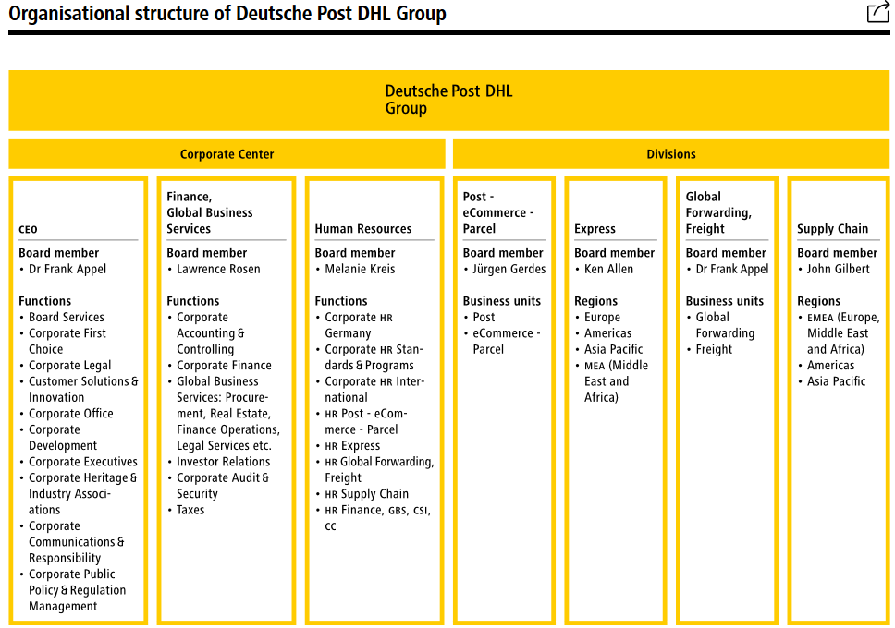
Figure 2. Source: (DHL, 2020)

In a divisional structure, the work is divided into different divisions of an organisation. It is also known as the product or the self-contained-unit structure (Cummings & Worley, 2009).

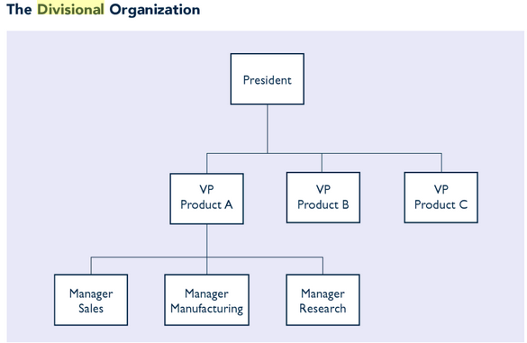

Figure 3. Divisional structure. Source: (Cummings & Worley, 2009)

Even the first divisional structure has been created to serve organisations dealing with the production of different products, this structure became suitable for the organisations operating in different countries. Even if such companies are dealing with the same product or service, the difference comes from the fact that each country they operate in has different law, rules and regulations. This is enough to do separate the branches of the organisation in divisions with their own policies, serving different rules in regulations. Moreover, that even the culture or any other demographical factors could provoke a different internal organisational rules and regulations. One that is important is that these organisations still could establish the same organisational culture, because it is directly influencing the organisational performance, which could impact on the quality of the products or services. That is why the culture in many places is more important than the structure, but they are also interdepended.

Organisational culture.

An organization’s culture consists of the values, beliefs, attitudes, and behaviours that employees share and use on a daily basis in their work (Rogel, 2014).
The culture of an organisation determines how employees understand the business, how they see themselves as part of the organisation, as well as the way they are describing their workplace. The culture is one of the drivers of decisions and actions, which itself impact on the overall organisational performance. So, the culture of an organisation can affect decision making because it is influencing the acceptance or rejection of the decision by its employees (Schein, 2006).

The DHL believes that, the high level of motivation among their employees can be attributed to a corporate culture founded on openness, trust and mutual respect (DHL, 2020). According to the findings of John P. Kotter (2008), the corporate culture is a must for companies aiming long term economic performance, which is actually the case of DHL.

Corporate culture is a culture of guiding the beliefs and behaviours of the employees and management of a company, which of its side determines the way they will interact and handle outside business transactions (Kotter, 2008).
By implementing corporate culture, the company manages to guide how its employees should act, feel, and think. This culture is a result of the social and psychological environment of an organisation. It defines the organisation’s unique personality and expresses its core values, ethics, behaviours, and beliefs (Kotter, 2008).
Such a company culture is most convenient for companies with a huge number of employees located in different parts of the world, which becomes a mechanism for self-selection of employees and candidates on the basis of locality. Its employees are loyal and this contributes to a better performance of the company. Such a culture creates an environment for happy employees, which is a prerequisite for lower turnover and better productivity of the company (Kotter, 2008).
The culture of an organisation is defined by the range of settings that drive the perception and behaviour of the employees in the workplace. The CEO of Deutsche Post DHL Group, Allen Ken states that the company owes its success to the commitment, creativity and expertise of its employees all around the world, which are approximately 380,000. He also states that the high level of motivation among their employees can be attributed to a corporate culture founded on openness, trust and mutual respect (Ken, 2020).
Another very important factor for a modern workplace management is the management and leadership styles.

Silviya Lazarova 1916917

Leadership and management behaviours

Management is the process and planning organising, directing, leading, controlling and problem solving (Armstrong & Stephens, 2005).
“Management is a problem-solving process of effectively organizational objectives through the efficient use of scarce resources in a changing environment.” (Armstrong & Stephens, 2005) To know what to do, how to do and when to do, what it is done in best way and cheap. The contemporary business organisations are increasingly looking for leaders among their managers. Moreover, they are trying to recognise the natural leaders in their organisations, no matter if they are not managers nor supervisors. The most important is that they can motivate and inspire other employees, so that they do great effort to achieve the organisational goals (Prasad, 2019).

“Leadership is developing and communicating a vision for the future, motivating people and gaining their commitment and engagement” (Armstrong & Stephens, 2005). There are some types of leaders that most of the businesses would like to have. A few of them can be listed as:
The Servant Leader – Creative and collaborative, they always create the same work environment where decisions can be taken by the group and there is not hierarchical intentions in their groups. Such a leader guides his people to achieve the organisational goals, but he is also caring about their personal and professional efficiency.
The Mentor Coach – focused on enriching personal and professional growth by sharing important data, experience and knowledge. This style helps employees learn new skills and at the same time empowers them achieving their personal and professional goals.
Transformational Leader – Inspire and motivate his employees, and helping them to enable their creativeness, as well as to learn how to assert independence and ownership. This leaderships help employees to always be able to find another way of doing things or find a new solution for an old problem.
The leader of DHL, Former DHL Express CEO Ken Allen has adopted transformational leadership style. However, DHL is now developing their active leadership style (Maynard Leigh Associates, 2020).
Serving as CEO for 10 years (2008 – 2018), Allen Ken played a crucial role in the company’s turnaround by transforming the company’s staff and strategy. Known as ‘the singing CEO’ for his habit of launching into inspirational songs during management meetings, Allen has an unconventional leadership style. He shares some of the solutions and tactics he employed to make that important turnaround happen (DHL, 2020).
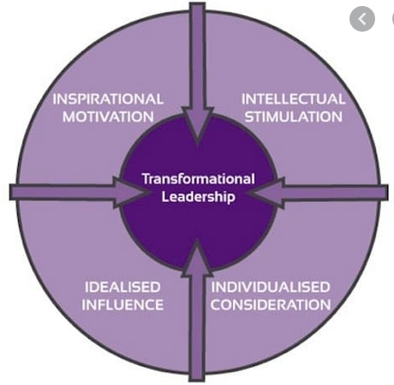
.

Figure 4. Transformational Leadership. Source: (Prasad, 2019)

Leaders and managers must do regular internal analysis, which will allow them see the strengths and weaknesses of their organisation or teams.
For a successful management the managers should know their company very well, with its Strengths and Weaknesses, Opportunities and Threats
With the strength of having a network in more than 220 countries the opportunity for revolution in the e-commerce industry is for sure DHL’s next strength. The threat of Amazon, by entering the logistics should be defeated by using the opportunity of the high growth trajectory in the emerging markets through partnership and acquisitions.

SWOT analysis for DHL
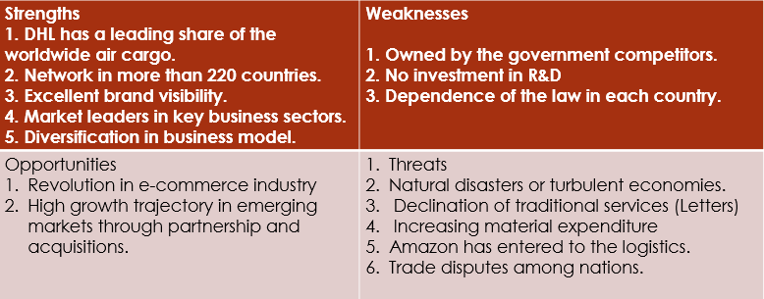

Leaders and managers behaviour impact directly the employee’s performance, so that this is an important factor to be considered when leading and managing modern workplace. The leader’s behaviour means all these things that make from a good individual an effective leader. The behaviour is the set of things a leader does in order to motivate and lead people. Leadership behaviours are effective when the leaders manage to:
- Increase the productivity of a team: A great performance can be achieved by a consistent leadership.
- Retain people: A great leadership and mentorship can increase the retaining staff.
- Nurture future leaders: Leadership behaviours are very important also for integral for developing and nurturing future leaders within their organization (Zgheib, 2014).
Effective leadership behaviour has some specific indicators, so that knowing them, a leader can be effective. Behaving like a leader it is good to to exhibit the following characteristics: Honesty; Confident of own decisioning; Approachable; Objectivity in Providing feedback; Encouraging creativity by giving the communication’ Addressing potential issues before they arise. Paying attention to the individual employees by trying to meet them; etc.
By being honest a leader will help creating a work environment that feels open and fair, which will allow employees trust such a leader. In such an environment the employees will be more likely to trust their leader and share their problems. So, if the leaders are doing what they have said they will do, then that will show the team that they are trustworthy (Morin, 2018).
When a leader is confident in decision making, that means that the employees will believe in him more than usual, because that will make him looks capable of making decisions. When the leader is confident in decision making, then his employees are confident in their leader’ abilities as leader.
Being approachable, a leader will keep line of communication between him and the employees open. That means that they will feel freer to talk to him and share worries and opinions. So, displaying active listening skills is very important, because that encourages the communication, which is so important for the whole circulation of the information needed to be delivered to them.
Being objective when providing feedback is also very important for a leader. That will allow employees know what the leader is expecting from them and can freely work and share information if necessary. From another side, regarding the corrections, it is important to make them individually in a private talk, so that the employees won’t feel embarrassed.
Addressing the potential issues before they really turn into issues and create problems, will help the employees avoid them. For this reason, the leader should closely monitor his employees, so that any area where it is possible to be developed an issue will be noticed and discussed on time.

Many more characteristics can be taken into consideration when managing a modern workplace. Moreover, that transformational and innovative organisational cultures are developing and changing vey fast. Most important for the leader is to manage to control the team and groups behaviours in a positive way that enable a good atmosphere of work and helps for the increasing of the organisational performance (Morin, 2018).

Desislava Zhelyazkova 1917424

Group and team behaviours

A group can be defined as two or more interacting and independent individuals, who come together to achieve particular objectives. A group behaviour can be stated as a course of action, a group can take as a family (Robbins, 2009).
The terms "group" and "team" are not identical concepts..
The group consists of a group of people who share common norms, values ​​and ideals, but in terms of what interests them, they perceive the group as a source of meeting their needs, are cooperative and interdependent, have a sense of solidarity and moral unity, even outside of joint action and develop their own specific group of culture. The group has a number of psychological characteristics (Cameron & Green, 2004).

A team is a small group of people with additional skills who are directly involved in achieving specific common goals, unique results and organizational excellence through an approach for which they are mutually responsible. The team is a group of people with a high degree of interdependence, aimed at achieving a goal or task (Cameron & Green, 2004).

Teams, as per Bruce Tuckman go through 5 stages of development. That are forming, storming, norming, performing and adjourning.

Forming - This is the primary formation of the team. It usually starts with the first day when the team has met ad is trying to orient in the situation or environment. This first period of the development of the team most of the team members are polite and pleasant. They are trying to get to know the other members and feel excited of starting something new. This is the stage when a member of the team could discuss
The skills of the members, their backgrounds an interest. Then one can discuss the project goals, the timeline, some ground rules and possibly the individual roles. Because the group has already started to form, that will provoke the forming of the roles and responsibilities of the team members too. At this first stage the team could not be very productive, because team members are mostly focused on people (Tuckman & Harper, 2012).

Storming – This second stage is where everyone is getting to know the others a bit more detailed. This is the stage where the first impression about someone start change and clear. Team members start discovering some more qualities in each other, as well as they could find some disadvantages in some members’ characters. This is where the team members get to understand about each other’s flaws and this is where a friendship can start or finish forever. That is why this stage has got the name storming. In this stage it is time to start discussing the task and how should it be done.

Here the member could disagree and about something and some could try to get the leadership place. This is where the personalities may clash, which could require calling leaders to establish peace. Most important here is to remember that they are in the team to complete some tasks, so even if the team experience conflict, one should remember that disagreements are normal. Some teams could try to skip the storming stage, but that only makes the problems grow and create problematic situations in the future, when there is no time to do this. That is why members of forming teams should not try to skip the storming stage (Tuckman & Harper, 2012).

Norming – After the storming stage has passed, this is the time when the team members start seeing each other’s strengths. At this point the team starts setting into a groove, i.e. they are getting into the right track. Of course, there is still a chance of coming back to the storming stage, but yet all stages are overlapping a bit the collaborating for the task completing starts bringing more positivism in the team behaviour.

Performing – The fourth stage is the one that can make most of the team members feel that they are more confident in themselves and about each other. This is when the feeling that from here starts the path to the success comes and make the task completing easier. Team members are more positive, so motivation is increasing. They are more familiar with the team members, as well as with the project they have to work on. At this point everyone is at the same page and the teams start working without supervision. This is the stage that each team strive to reach and it contains the real job and times when the team is able to overcome even conflicts. Not always though and not everyone of course, because there are always exceptions (Tuckman & Harper, 2012).

Adjourning – this stage has been added later in 1977, again by Tuckman. This is the time when the project is ready and the team must disband. Sometimes it is sad, but sometimes it is all fine. In some cases the team members are employees in one same organisation or department, so that can be only a reason to celebrate for the successfully completed task. Some member may become friends or part forever, but this is the stage to mark the completed work (Tuckman & Harper, 2012).

Managing a modern workplace require proactive thinking, which means preventing potential problems. Group or team behaviour is a result of the managing style. That is because the management defines the organisational culture, which is the basement of everything that happens in an organisation. If a manager needs to do some changes, the first think to do is to prepare the employees by establishing the right organisational culture. It is the organisational culture that provoke certain behaviour.

So, the employees behaviour depends of the organisational structure, culture, and leadership behaviour. It is obviously that the team’s and group’s behaviour are forming the organisational behaviour, which is a result of the organisational culture and leadership’s behaviour. Still there are many other factors that influence the teams and group behaviours, and that are their personal or group perceptions and the motivation activities, which also change perceptions.

Stanimir Iliev 1915932

Motivation and perception

Employee engagement strategy' means 'increasing the likelihood so that the employees start establishing positive emotional connections with the organisation'. (Price, 2019)

Looking for ideas for a successful employee engagement strategy sometimes leads to some wacky ideas, but this is because before looking for the engagement strategy the organisation should examine and reform the employee’s perception in a way that suits the organisation and its goals. For the employees to be motivated, their situation should be examined. One of the most popular and working theory of motivation is the Adams’ Equity Theory (Miner, 2007).

The Equity theory require taking measures to adjust the level of the workers against each other. Whatever rewards the organisation has given, it must ensure that the employees are being rewarded equally on a fair basis. If there are cases that make some differentiation among the employees, the organisation must act immediately.

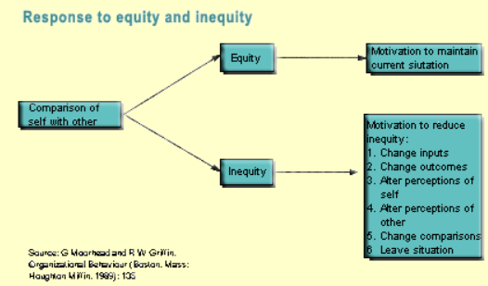
Figure 5. Response to equity and inequity. Source: (Miner, 2007)

The purpose of the Equity theory is to require a fair balance between the employees. According to the theory the finding of the balance will ensure a strong and very productive relationship with the employees. This job motivation theory looks alike with the Maslow’s theory of needs, but the difference is that the equity theory stands at the point where the organisation could find what is missing and providing it, the equity will be balanced. The theory serves the believe that the employees will be demotivated if they have the feeling that they give more than they receive. That is why the organisation have to examine the inputs, such as effort, loyalty, hard work, commitment, skills and abilities, etc. and then to compare them to the outputs, such as recognition, reputation, praise, stimulus, job security, etc. When this is done, the managers should find the balance between the employees’ input and the outputs they receive (Miner, 2007).

In some cases, the Equity theory could show a balanced situation, but something still could be going wrong. For such cases, a Theory of planned behaviour should be seen and if applicable, taken into consideration.

The theory of planned behaviour works in a combination with the establishing of organisational culture. In the beginning this theory has started as the Theory of reasoned action (1980). The main component of this theory is behavioral intentions, what they are influenced by and how they can be changed. Behavioral intentions are influenced by the preconceived notion that the behavior is likely to have some expected outcome, as well as a subjective assessment of certain risks and benefits of the likely outcome.
This theory is usually recommended for predicting and explaining some health behaviors and intentions, such as smoking, drinking, use of health services, and others. However, this theory states that behavioral performance depends on both motivation and the ability to influence behavioral control. This is a seemingly complex theory that distinguishes three types of beliefs - behavioral, normative and control. Planned Behavior Theory consists of six constructions that collectively represent a person's actual control over behavior. See Figure 6
In the last few years, researchers have included and used some TPB constructs. by adding new components of behavioral theory to the basic scheme to make this model a more integrated model. This is in response to some of the limitations of TPB in dealing with public health issues.
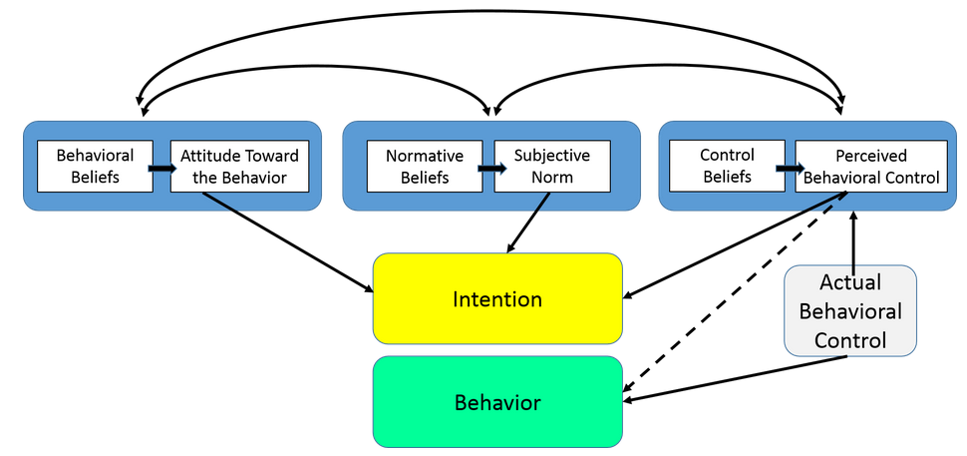
Figure 6. Theory of planned behaviour. Source: (Armitage & Christian, 2004)
This theory was mentioned like one of the most complicated, but in some cases, it is more appropriate than just creating a simple rewarding system. This is because managing a modern workplace is not always so simple, and sometimes the organisations need to find more specific ideas and theories which to apply.
However, the motivation has always been and will be the most powerful tool for increasing the performance of an organisation. To help their employees be motivated an organisation should examine the current situation and then plan what to do, i.e. look for ideas for a successful employee engagement strategy (Cummings & Worley, 2009).
DHL conducts a regular Employee Opinion Survey
DHL value the opinion of their employees. The annual Employee Opinion Survey shows them what the employees think of the current situation within the Group and the leadership behaviour of their superiors. It shows the extent to which they identify with the company's values and strategy, and where the DHL might need to improve. DHL can also use the survey to assess whether their employees deem the information, resources and training the company provide adequate for them to do their jobs (DHL, 2020).
Motivating their employees DHL does by different ways.
- Monetary compensation includes a base salary plus variable remuneration components such as bonus payments that are subject to local and position-specific requirements and regulations.
- Along with monetary compensation, DHL also provides a wide range of non-financial incentives intended to motivate their employees to go the extra mile for the company’s customers and to retain them for the long term.
DHL is the world’s leader in its industry, and at the same time it is managing with the employees’ motivation very successfully. The DHL’s employees are proud and happy to work for their organisation (DHL, 2020).
This situation defines the company as the most well coping with the managing a modern workplace. The modernism in the services is innovated to the newest technologies that can be used in delivering their services. Customers could track their packages at any minute using internet, computer for their online webpage and mobile application that helps those who cannot use a computer at any time of the day.
Managing modern working place is a seemingly complicated process that is not only due to the experience of a particular manager. It is up to the overall organizational system, starting with the organizational structure, which determines the rights and responsibilities of the managers, as well as concerns the issue of organizational culture, which itself is extremely important tool for predisposing workers to a certain way of thinking, i.e. planning employees behaviour. So before managing the modern workplace there is a long process of settings that have to be done in all levels of the organisation.

Conclusion

This report paid a special attention to the culture of the organisation. This was because, the culture in an organisation defines the perception of its employees about the organisational environment. The perception defines the acceptance of the organisational goals by the employees. At this point comes the importance of the motivation, which defines commitment of the employees to achieve the objectives. When the objectives are achieved, the organisational goal has been successfully reached.

References
Armitage, C. J. & Christian, J., 2004. Planned Behavior: The Relationship Between Human Thought and Action. First ed. New Brunswick: Transaction Publishers.
Armstrong, M. & Stephens, T., 2005. A Handbook of Management and Leadership: A Guide to Managing for Results. First ed. London: Kogan Page.
Bateman, B. D., 2011. From Gobbledygook to Clearly Written Annual IEP Goals. First ed. Verona: Attainment Company, Inc..
Bateman, B. D. & Herr, C. M., 2011. Writing Measurable IEP Goals and Objectives. First ed. Verona: Attaiment Company INC.
Booth, A., 2017. Managing the Modern Workplace: Productivity, Politics and Workplace Culture in Postwar Britain. First - reprint ed. London: Routledge.
Cameron, E. & Green, M., 2004. Making Sense of Change Management: A Complete Guide to the Models, Tools & Techniques of Organisational change.. first ed. London: Kogan Page.
Cummings, T. G. & Worley, C. G., 2009. Organization Development and Change. Nineth ed. Mason: CENGAGE Learning.
Cunliffe, A. L. & Luhman, J. T., 2013. Key Concepts in Organization Theory. First ed. London: SAGE.
Davis, D., 2019. Modern workplace management: What is it and how do I get there?. [Online]
Available at: https://blogs.dxc.technology/2019/04/25/modern-workplace-management-what-is-it-and-how-do-i-get-there/
[Accessed 2 September 2020].
DHL , 2020. Excellemce, Simply delivered. [Online]
Available at: https://developer.dhl.com/
[Accessed 30 August 2020].
DHL Worldwide, 2020. CONNECTING PEOPLE. IMPROVING LIVES.. [Online]
Available at: https://www.dhl.com/en/country_profile.html#.X1NwIdTTWpo
[Accessed 28 August 2020].
DHL, 2020. Deutsche Post DHL Group - at a glance. [Online]
Available at: https://www.dpdhl.com/en/about-us/at-a-glance.html
[Accessed 25 August 2020].
Ken, A., 2020. Ken Allen FCCA, CEO of DHL eCommerce Solutions. [Online]
Available at: https://www.accaglobal.com/us/en/member/member/accounting-business/2020/04/interviews/ken-allen.html
[Accessed 15 August 2020].
Kotter, J. P., 2008. Corporate Culture and Performance. Second ed. New York: The Free Press.
Machacek, M., 2019. 4 Key Workplace trends in 2019. [Online]
Available at: https://www.creativepersonnel.co.uk/blog/2019/02/workplace-trends-in-2019
[Accessed 31 August 2020].
Maguire, E. R., 2003. Organizational Structure in American Police Agencies: Context, Complexity. First ed. New York : State University of New York.
Maynard Leigh Associates, 2020. DHL our challenge. [Online]
Available at: https://www.maynardleigh.com/client-stories/dhl
[Accessed 14 August 2020].
Miner, J. B., 2007. Organizational Behavior 4: From Theory to Practice,. Volume 4 ed. London: M. E. Sharpe.
Morin, J., 2018. Leadership and Change Management. First ed. Waltham: ED - Tech Press.
Prasad, A., 2019. Types of Leaders Every Modern Workplace Should Have. [Online]
Available at: https://www.quickfms.com/blog/types-of-leaders-every-modern-workplace-should-have
[Accessed 3 September 2020].
Price, H., 2019. Employee engagement strategy: all you need to know. [Online]
Available at: https://blog.jostle.me/blog/employee-engagement-strategy-inconceivable-2/
[Accessed 15 August 2020].
Robbins, S. P., 2009. organisational behaviour in Southern Africa, 2nd edition. Second ed. South Africa: Pearson Education.
Rogel, C., 2014. The 12 Attributes of a Strong Organizational Culture. [Online]
Available at: https://www.tlnt.com/the-12-attributes-of-a-strong-organizational-culture/
[Accessed 15 August 2020].
Schein, E. H., 2006. Organizational Culture and Leadership. Third ed. San Francisco: Jossey and Bass/Wiley.
Slade, S., 2009. Goal-based Decision Making: An Interpersonal Model. First ed. London: Psychology Press.
Tuckman, B. W. & Harper, B. E., 2012. Conducting Educational Research. Sixth ed. Lanham: Rowman & Littlefield Publishers. Inc..
Zgheib, P. W., 2014. Business Ethics and Diversity in the Modern Workplace. Second ed. Hershey: IGI Global.

Appendix: PP Presentation (converted)

Slide 1

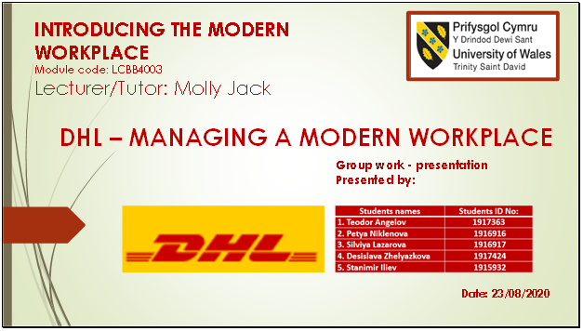
Slide 2

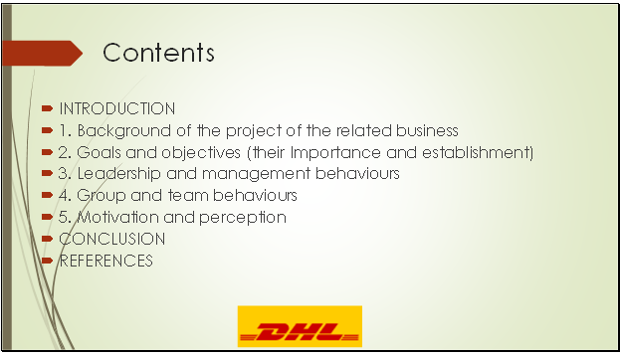

Slide 3

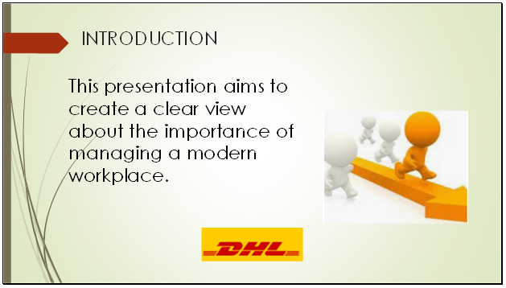

Slide 4

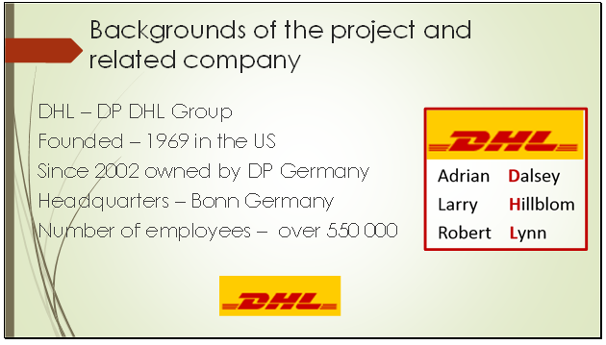

Slide 5

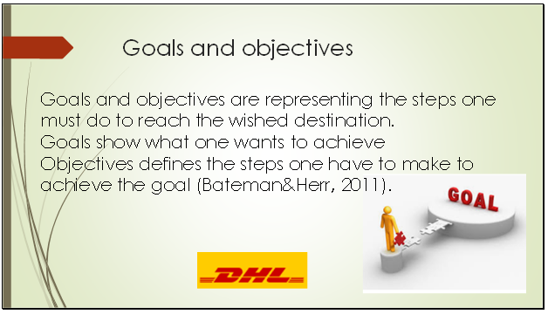

Slide 6

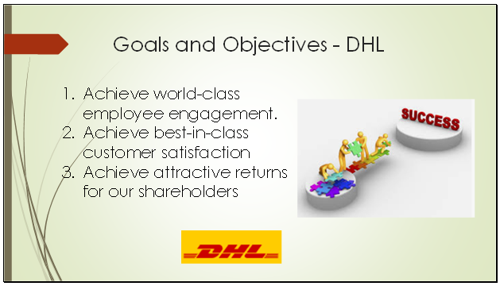

Slide 7

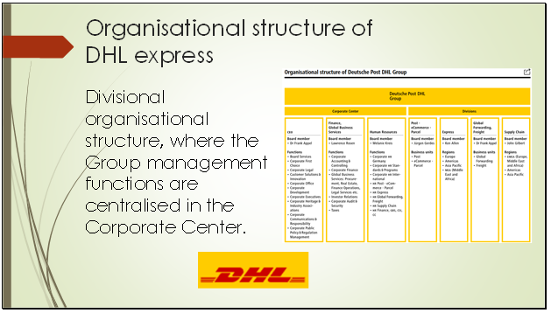
Slide 8

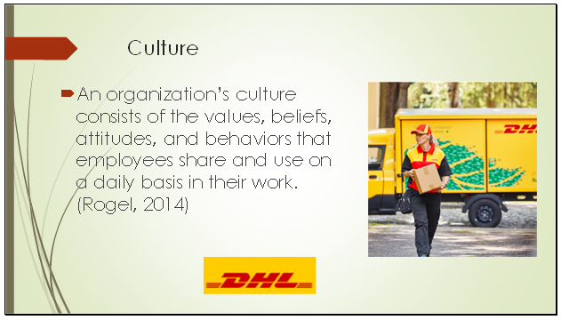

Slide 9

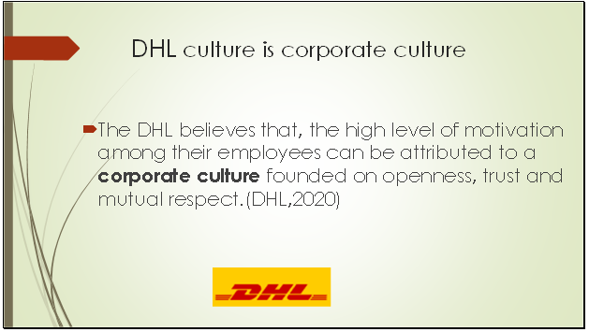

Slide 10

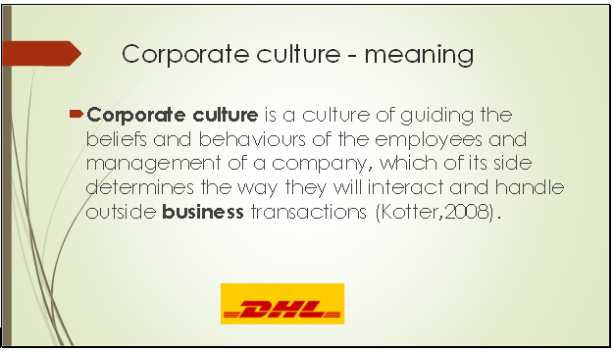

Slide 11

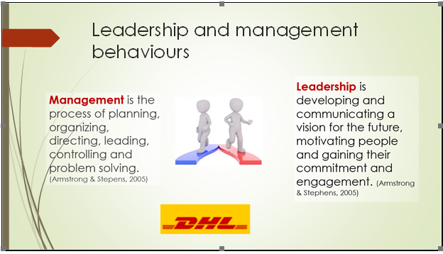

Slide 12
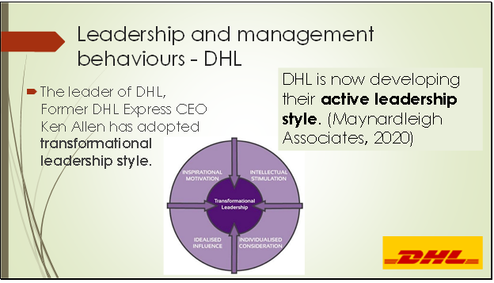

Slide 13

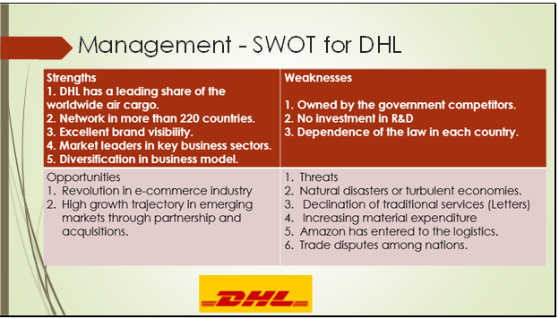

Slide 14

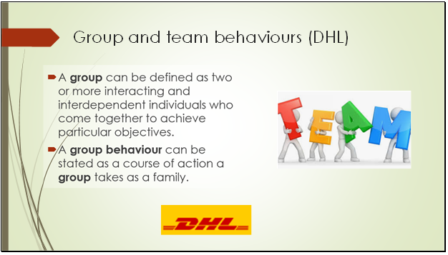

Slide 15

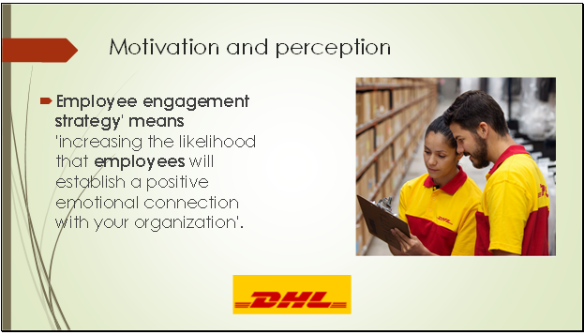

Slide 16

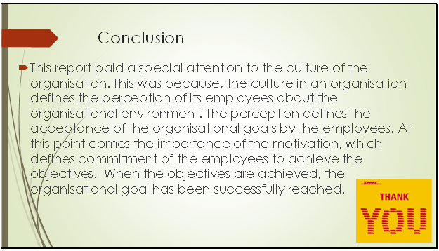
Slide 17



