Samuel Jay Lloyd

2110666
RF Systems
ACDA5002

Contents
Introduction 4
Background research 4
Task 1 4
Task 2 5
Task 3 5
Circuit Diagram 6
Task 1 6
Task 2 6
Task 3 8
Block design 9
Task 1 9
Task 2 10
Task 3 11
Transmitter and Receiver Architectures 11
Task 1 11
Task 2 11
Task 3 11
Simulated Outputs and results 12
Task 1 12
Task 2 14
Task 3 17
Analysing the Results. 20
Task 1 20
Task 2 21
Calculating the theoretical SNR and theoretical Figure of merit. 21
Calculating SNR and figure of merit in DBW with the noise value set to 50dB. 22
Calculating SNR and figure of merit in DBW with the noise value set to 10dB. 22
Task 3 23
Calculating the theoretical SNR and theoretical Figure of merit. 23
Calculating SNR and figure of merit in DBW with the noise value set to 50dB. 24
Calculating SNR and figure of merit in DBW with the noise value set to 10dB. 24
Conclusion 25
Recommendations on future work. 25
References 25

Figure 1: Task 1 6
Figure 2: Task 2.a 6
Figure 3: Task 2.b 7
Figure 4: Task 2.c 7
Figure 5: Task 3.a 8
Figure 6: Task 3.b 8
Figure 7: Task 3.c 9
Figure 8: AM Modulation [6] 9
Figure 9: AM Demodulator [7] 9
Figure 10: DSB-SC modulation [8] 10
Figure 11: DSB-SC demodulation [9] 10
Figure 12: FM Modulation [10] 11
Figure 13: Frequency Discrimination Method [5] 11
Figure 14: Task 1 - 0.6 Modulation Index 12
Figure 15: Task 1 - 1 Modulation Index 12
Figure 16: Task 1 - 1.5 Modulation Index 13
Figure 17: Task 1 - Spectrum output 13
Figure 18: Task 2.a - Scope - 0.5 Modulation Index 14
Figure 19: Task 2.a- Spectrum - 0.5 Modulation index 14
Figure 20: Task 2.a - Filter 15
Figure 21: Task 2.b - Scope output 15
Figure 22: Task 2.b - spectrum analyser output 16
Figure 23: Task 2.b - Filter 16
Figure 24: Task 2.c with -10dB Noise 17
Figure 25: Task 3.a 17
Figure 26: Task 3.b – Scope output 18
Figure 27: Task 3.b – Spectrum output 18
Figure 28: Task 3.c - 20dB noise - Scope output 19
Figure 29: Task 3.c - 100dB noise - Scope output 19
Figure 30: Task 3.c - 100db noise - Spectrum output 20
Figure 31: Under, Critical and Over modulation [12] 20
Figure 32: How to find power values. 22
Figure 33: Finding power values. 24

Equation 1: AM carrier wave [1] 4
Equation 2: AM message wave [1] 4
Equation 3: values for carrier and message frequency 4
Equation 4: Modulation Index [2] 5
Equation 5: DSBSC with a Balanced Modulator [3] 5
Equation 6: FM Modulation [4] 5
Equation 7: Frequency Discrimination Method Formula [5] 5
Equation 8: DSB-SC FOM & SNR [13] 21
Equation 9: FM SNR & FoM [14] 23

Introduction
In this write up there will be a description of 3 tasks that all are to create a form of modulation and demodulation of either a sound wave or a sine wave, then examine the outputs and complete a comparison. For task 1 this required a basic AM Modulation and demodulation using the maths shows in Equation 1. Task 2 is to build a DSB SC modulator using Balanced Modulator and demodulate it to get the original signal both in frequency and time domain. Finally task 3 is to Implement a FM modulator using any FM Modulation technique and demodulate it to get the original signal in frequency and time domain.

Background research

Task 1
For task 1 this required research into Amplitude modulation and how to create the bellow Equation 1 and Equation 2 using the values in Equation 3 as the set values.
$c\left(t\right)= A_{c}sinω_{c}t$;
Equation 1: AM carrier wave [1]
$m\left(t\right)= A_{m}sinω_{m}t$;
Equation 2: AM message wave [1]
$ω_{c}=2π\left(10000\right)$; or $f_{c}=10KHz$
$ω_{m}=2π(1000)$; or $f_{m}=1KHz$
Equation 3: values for carrier and message frequency
A = amplitude
ω_{c}t = frequency in rad/s or f = frequency
It is also important to set the modulation index for the wave, this is done using the Equation 4, so for creating a modulation index = 0.6 you would want A_{m} = 0.6 and A_{c} = 1.
$$m=\frac{A_{m}}{A_{c}}$$
Equation 4: Modulation Index [2]
Once the modulation was completed the next thing to do would be to demodulate the wave and get a wave the same as the starting message, m(t).

Task 2
For this it was important to research how to create a DSB SC modulator using a balance modulator. Once created then transmit a real sound message using the multimedia block and once this is done add noise to the channel recording the sound output for these. The equation for this can be seen in Equation 5.
$$v_{out}=mV_{c}[\cos\left(ω_{c}-ω_{m}\right)t-\cos\left(ω_{c}+ω_{m}\right)]$$
Equation 5: DSBSC with a Balanced Modulator [3]

Task 3
The Final task is to create a FM modulator and demodulator that transmits a sine wave. Once completed then transmit a real sound message using the multimedia block and once this is done add noise to the channel recording the sound output for these.
To start it’s important to understand the formula to create the modulation, this can be seen in Equation 6.
$$x_{FM}\left(t\right)=A_{c}\cos{[2πf_{c}t+2πK_{VCO}\int_{0}^{t}{m(t)dt}]}$$
Equation 6: FM Modulation [4]
From this equation you can draw the logic required to create the modulation for FM. Looking into demodulation techniques there was 2, Frequency Discrimination Method which uses an envelope detector and Phase Discrimination Method which uses a VCO [5]. In this Frequency Discrimination Method will used, this was decided as it was a simpler setup and had all working parts in Simulink, the block diagram can be seen in Figure 13, and formula in Equation 7.
$$\frac{ds(t)}{dt}= A_{c}(2πf_{c})[1+(\frac{k_{f}}{k_{c}})m(t)]sin⁡(2πf_{c}t+2πk_{c}\int{m\left(t\right)dt-{180}^{0}})$$
Equation 7: Frequency Discrimination Method Formula [5]

Circuit Diagram

Task 1
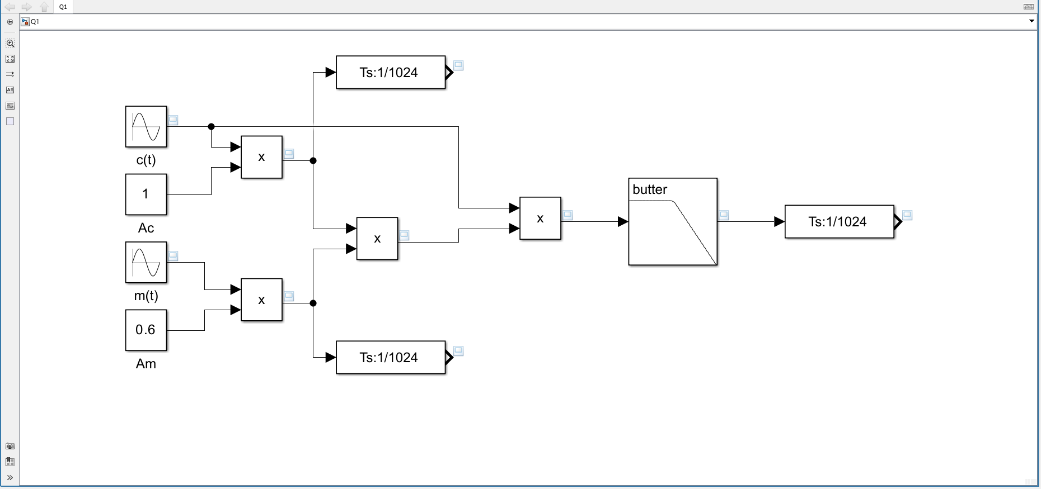
Figure 1: Task 1

Task 2
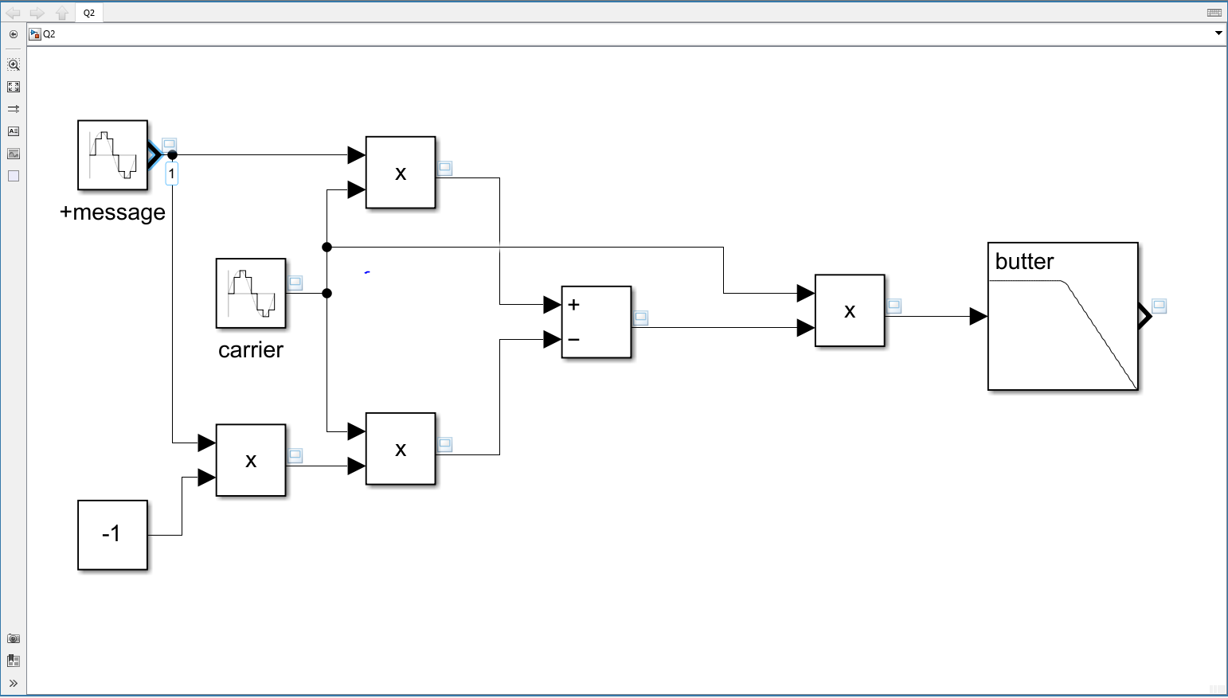
Figure 2: Task 2.a

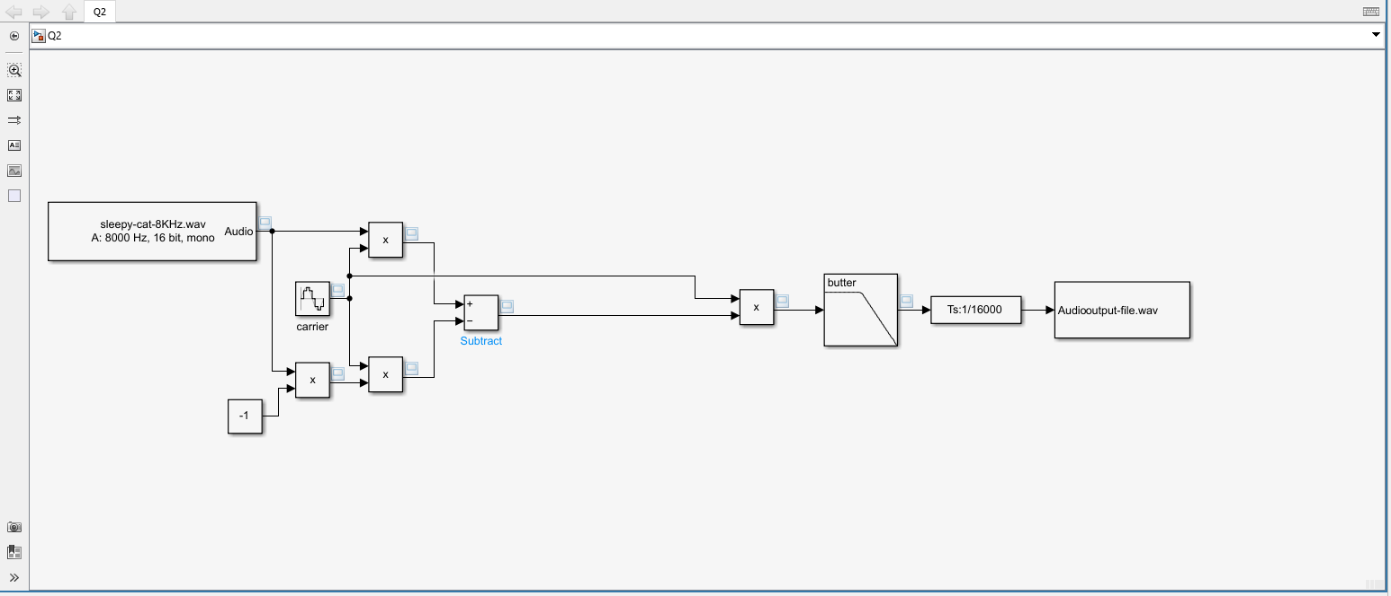
Figure 3: Task 2.b
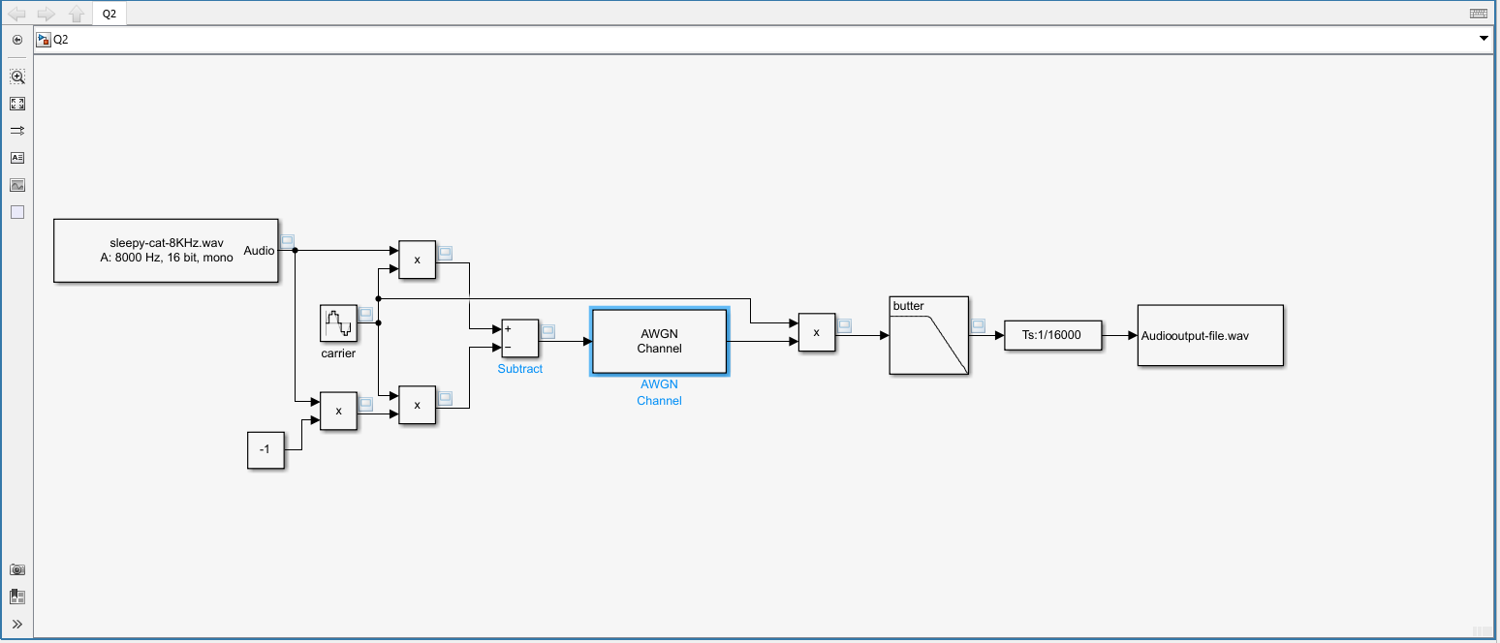
Figure 4: Task 2.c

Task 3
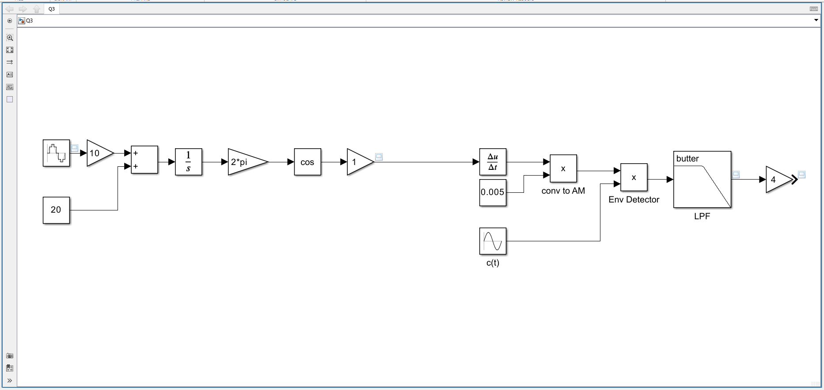
Figure 5: Task 3.a
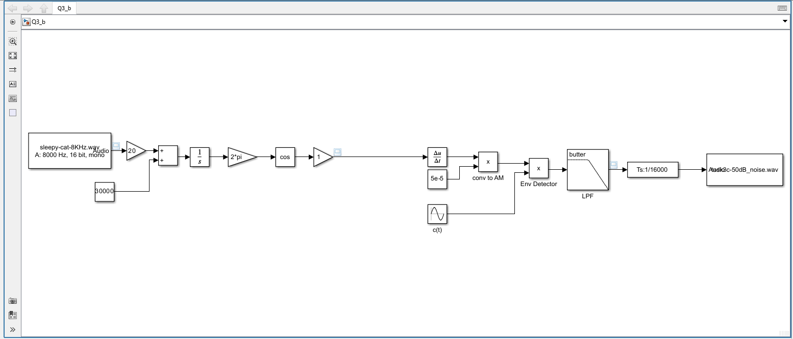
Figure 6: Task 3.b
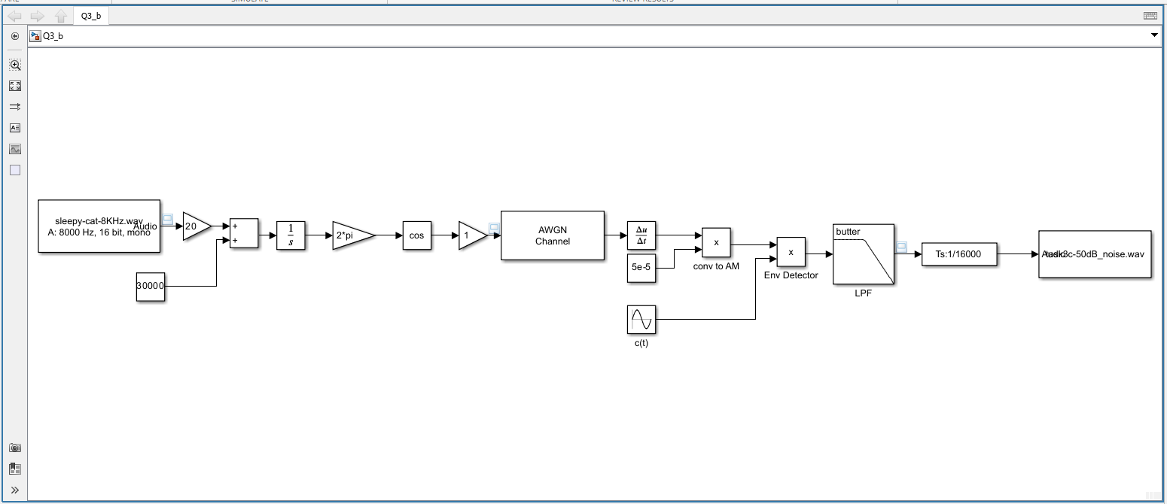
Figure 7: Task 3.c

Block design

Task 1
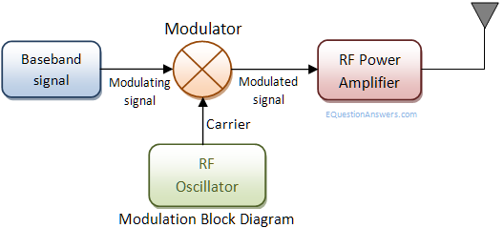
Figure 8: AM Modulation [6]
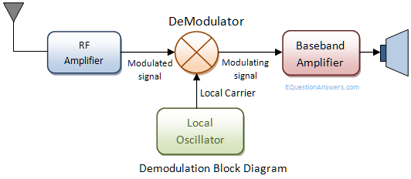
Figure 9: AM Demodulator [7]

Task 2
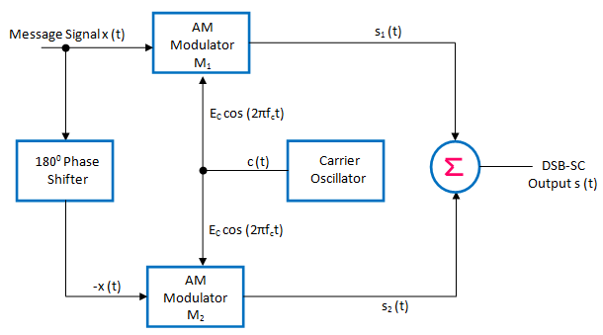
Figure 10: DSB-SC modulation [8]
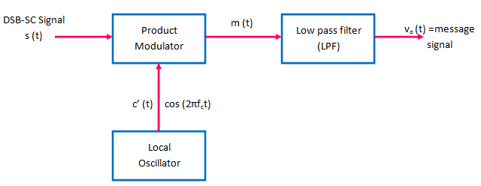
Figure 11: DSB-SC demodulation [9]

Task 3
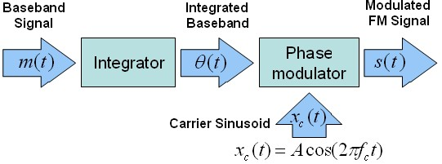
Figure 12: FM Modulation [10]
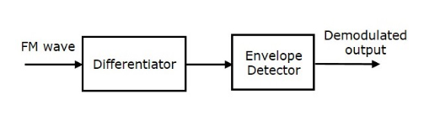
Figure 13: Frequency Discrimination Method [5]

Transmitter and Receiver Architectures

Task 1
The architecture for the AM transmitter can be seen in the block diagram on Figure 8. Inside the modulator the input signal is multiplied with the carrier wave and then output through the antenna, sometimes passing through an amplifier to affect the distance the output can be seen at.
For the AM demodulator shown in the block diagram, Figure 9, this then multiples the wave with the carrier and then outputs the noise. This is sometimes amplified before and after the demodulation, this is to improve the output quality after traveling for long distance and removing.

Task 2
DSB-SC block diagram can be seen in Figure 10, this shows how the circuits takes and input signal, on one side multiples this with the carrier signal. On the other, creates a negative of the input and then multiples this with the carrier and then adds these together and outputs this.
For the demodulation seen in Figure 11 this is the same as for AM modulation in task 1.

Task 3
For Frequency modulation the block diagram can be seen in Figure 12, this is done slightly differently in practice as you need to multiply the input wave and add the desired frequency before then this is integrated, multiplied by 2 and pi, then cos and finally, an amplifier if required, this can all be seen in Figure 5. this is then completed Frequency modulation.
To demodulate Frequency modulation, it is required to make this into an AM wave and then decipher the information, this can be seen in Figure 13. This method is called Frequency Discrimination and is done by differentiating the FM wave, which outputs an AM wave which is then multiplied with a carrier wave which is of the frequency of the FM wave, this is then passed through a filter to get the desired output, this can be seen in Figure 5. The additional step made here is to get the wave in the correct amplitude.

Simulated Outputs and results
For creating simulations MATLAB Simulink was used to create the results [11], this was done by building the block diagrams seen above in Figure 1 to Figure 7 and the simulating these to get the following results and the sound outputs attached in the .zip file attached to this document.

Task 1
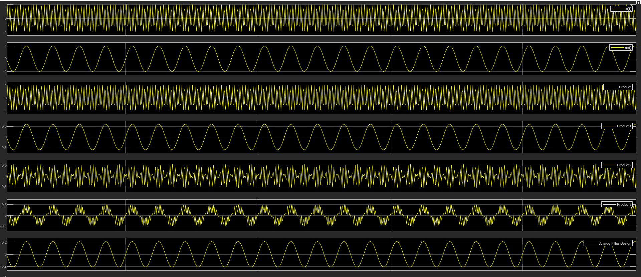
Figure 14: Task 1 - 0.6 Modulation Index
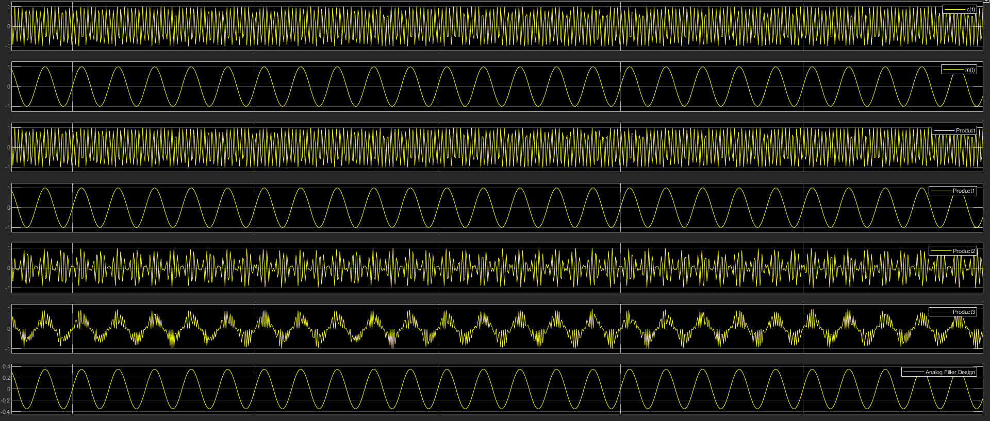
Figure 15: Task 1 - 1 Modulation Index
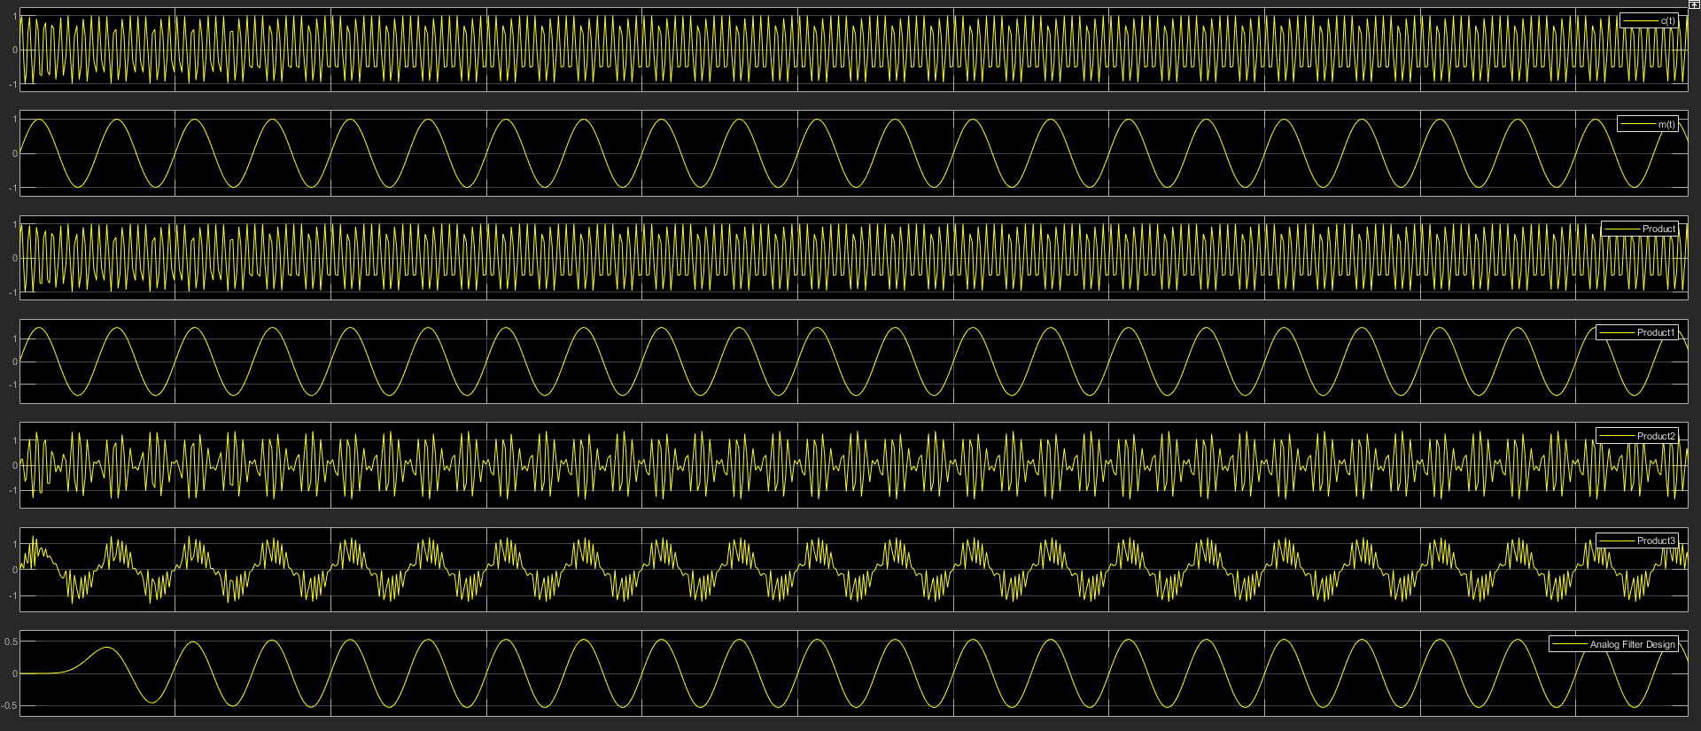
Figure 16: Task 1 - 1.5 Modulation Index
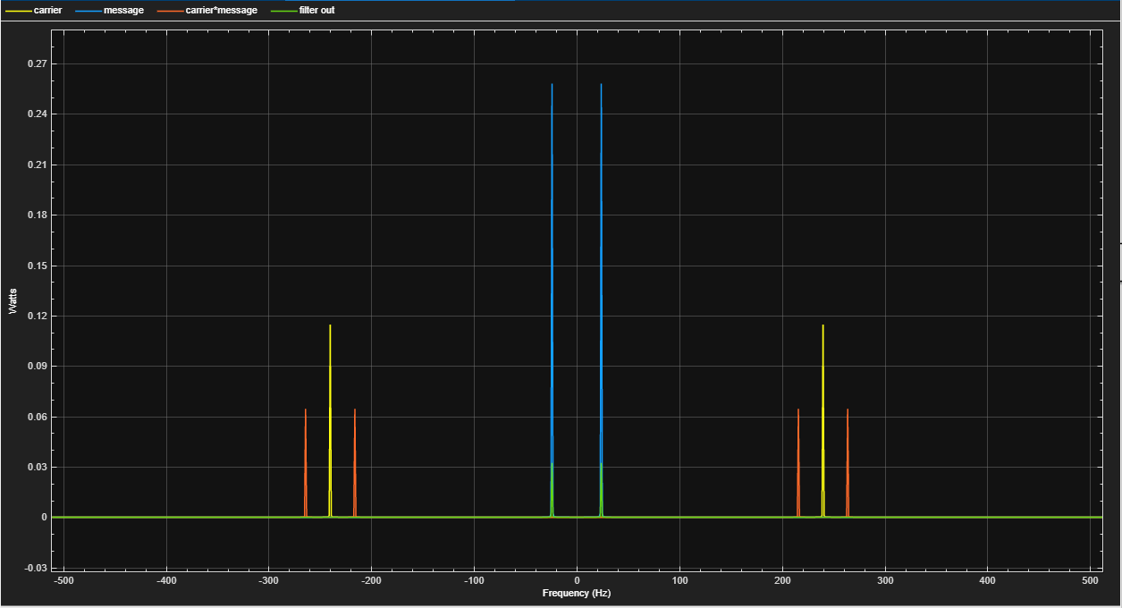
Figure 17: Task 1 - Spectrum output

Task 2
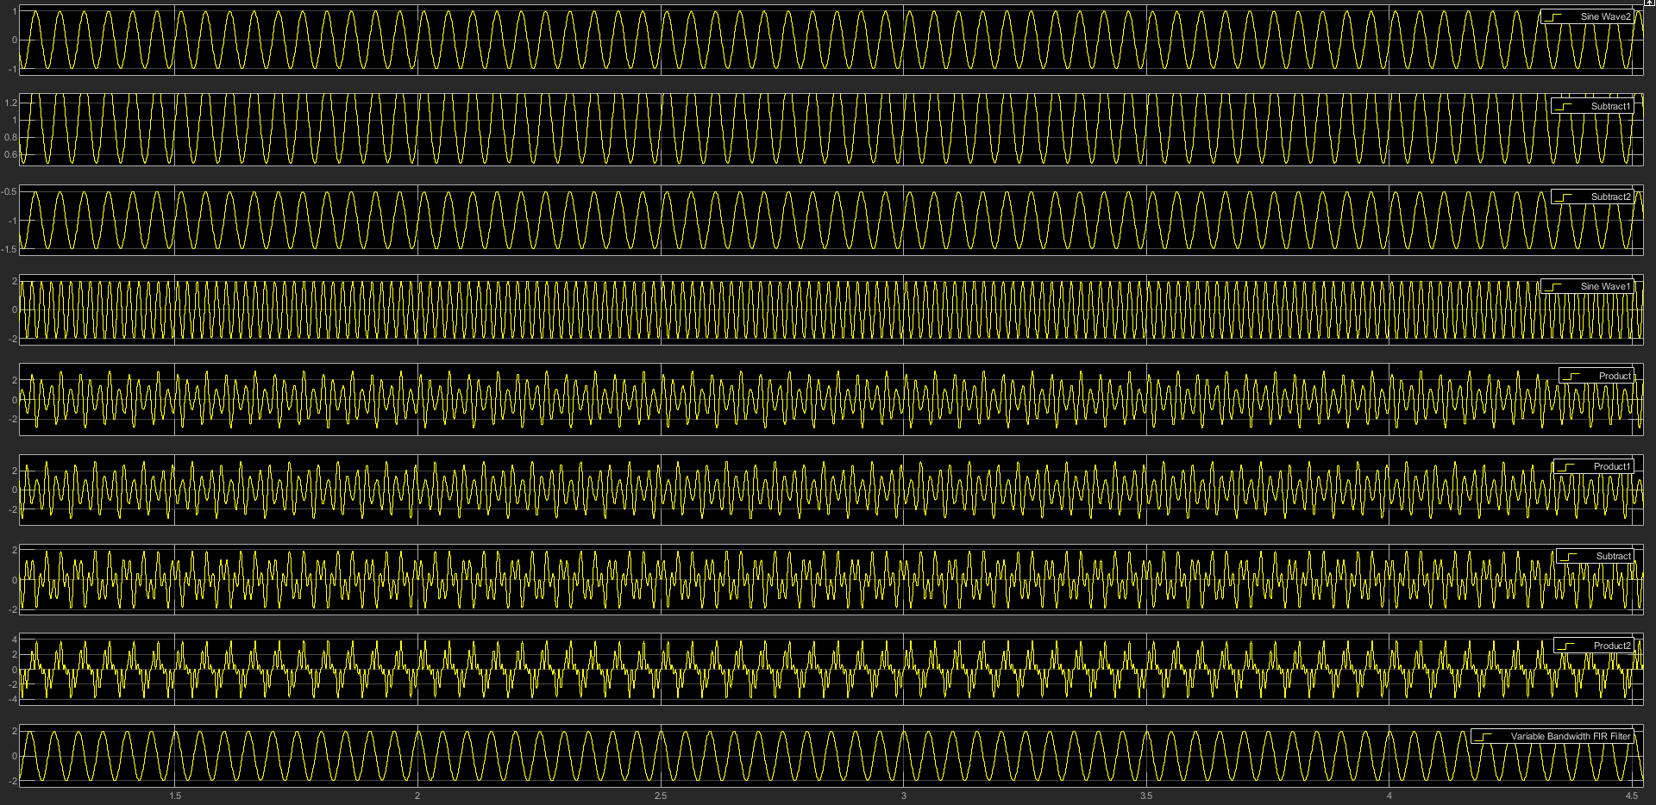
Figure 18: Task 2.a - Scope - 0.5 Modulation Index
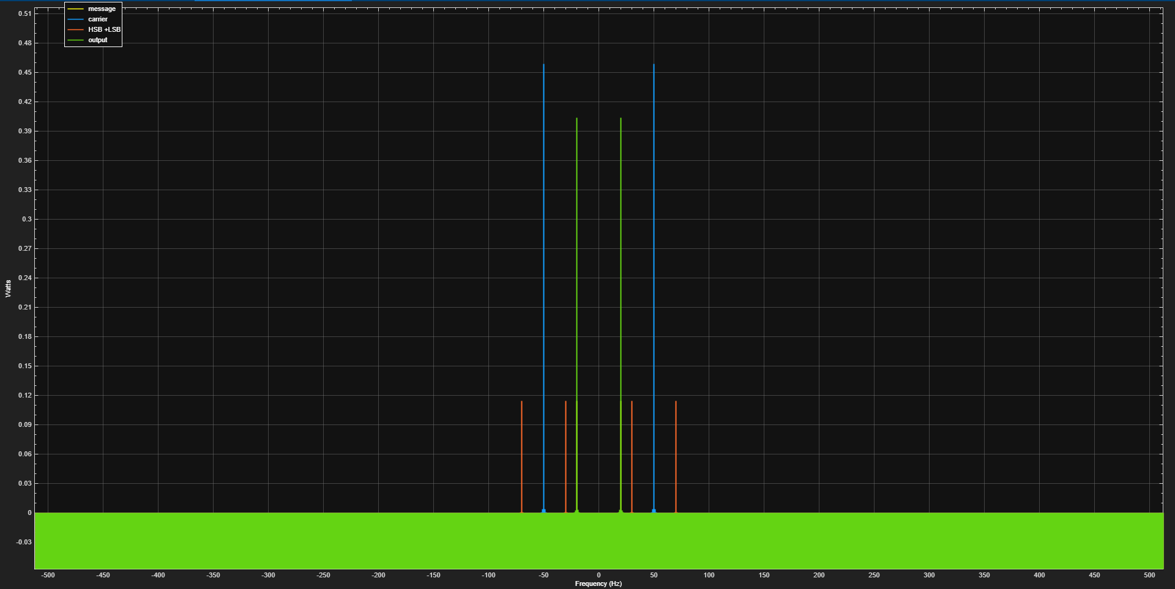
Figure 19: Task 2.a- Spectrum - 0.5 Modulation index
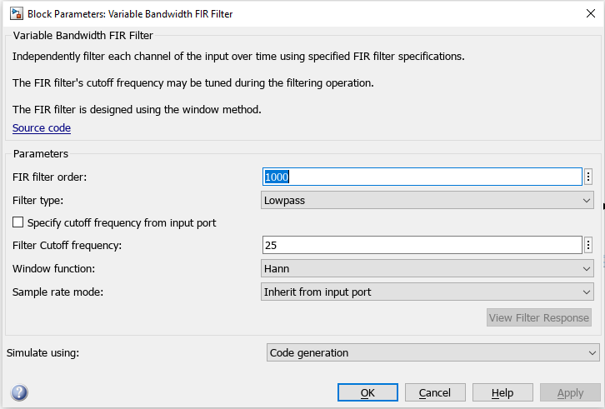
Figure 20: Task 2.a - Filter

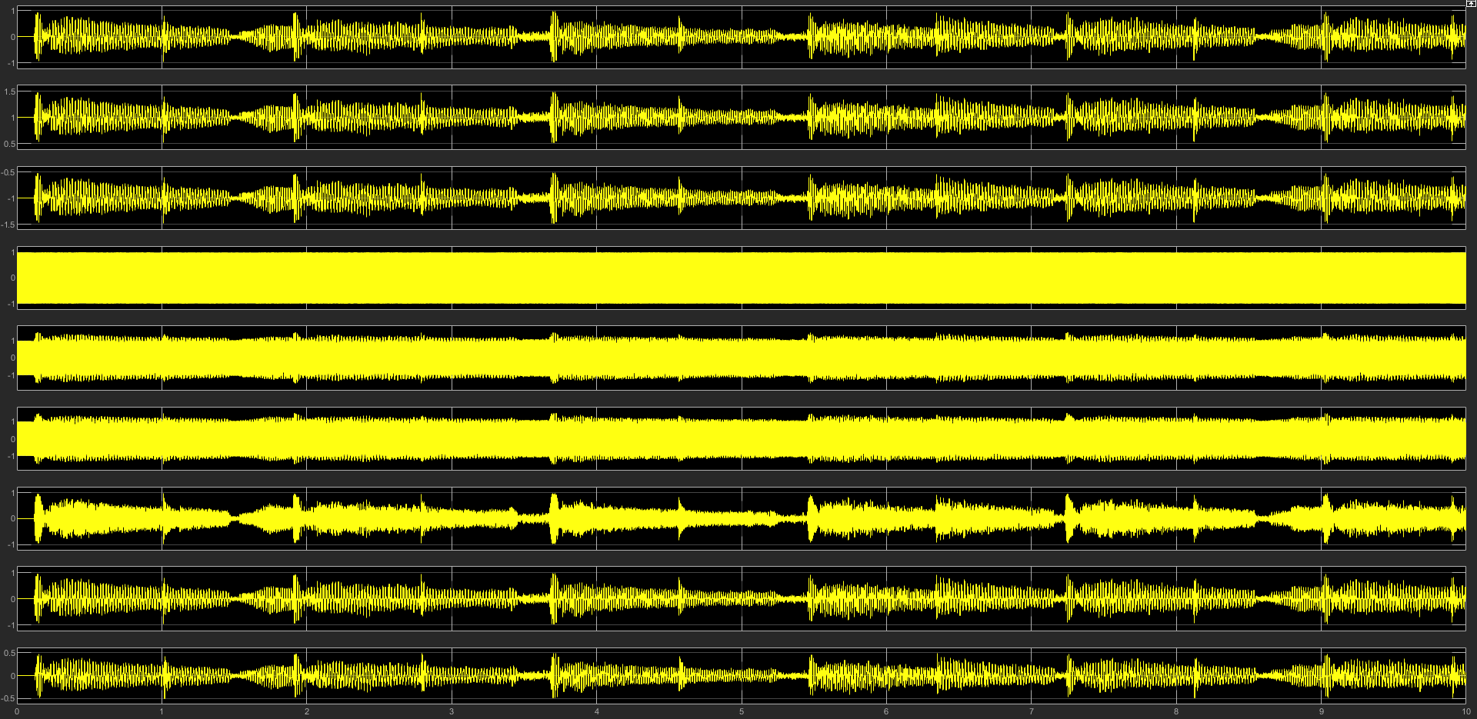
Figure 21: Task 2.b - Scope output
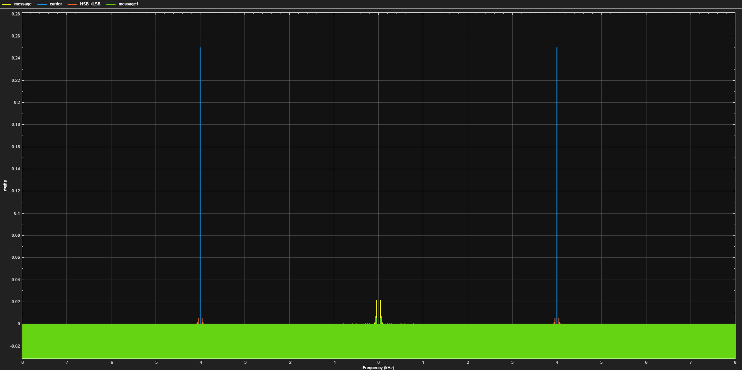
Figure 22: Task 2.b - spectrum analyser output
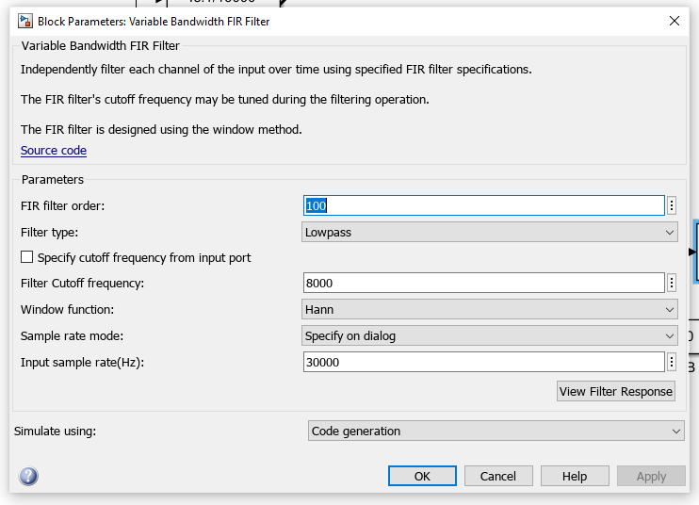
Figure 23: Task 2.b - Filter

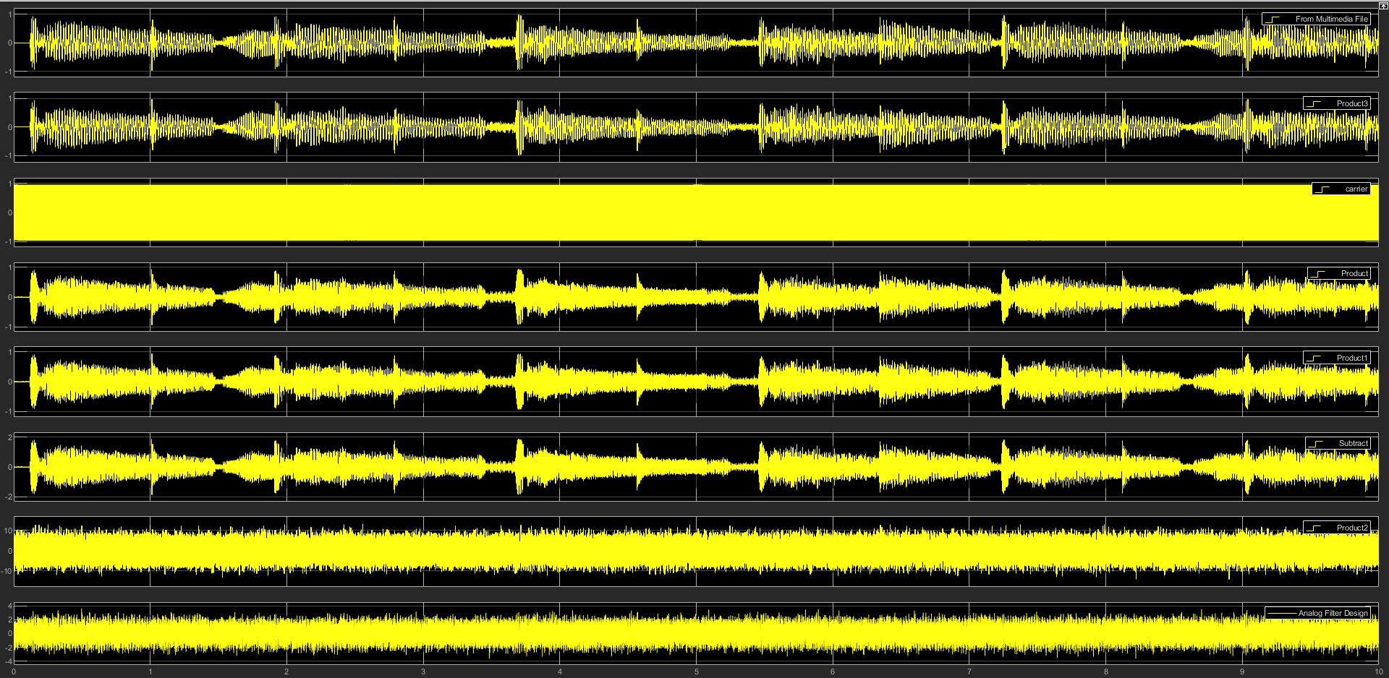
Figure 24: Task 2.c with -10dB Noise

Task 3
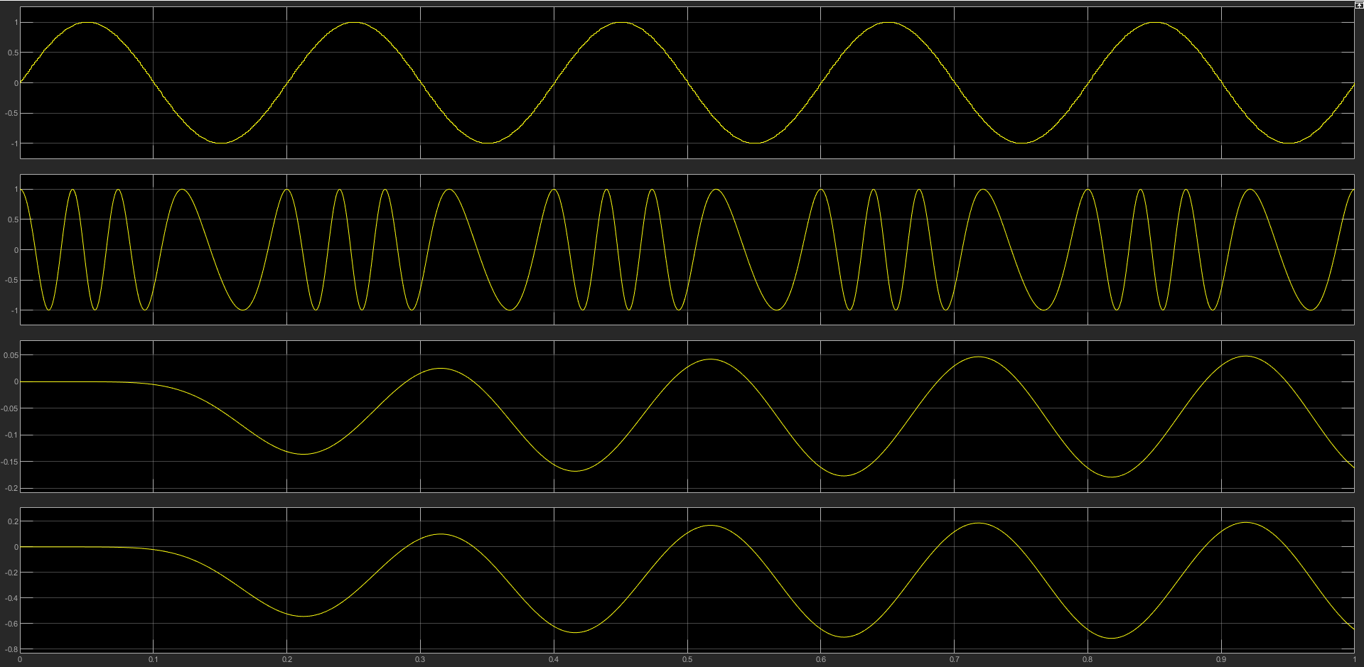
Figure 25: Task 3.a

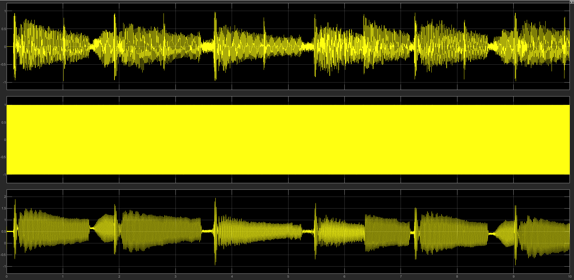
Figure 26: Task 3.b – Scope output
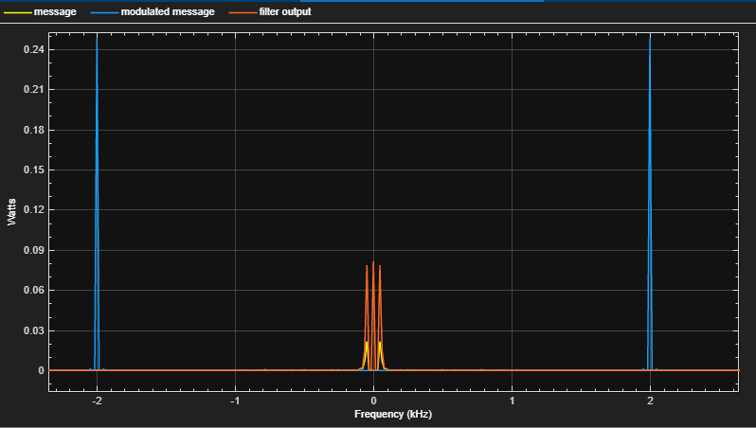
Figure 27: Task 3.b – Spectrum output
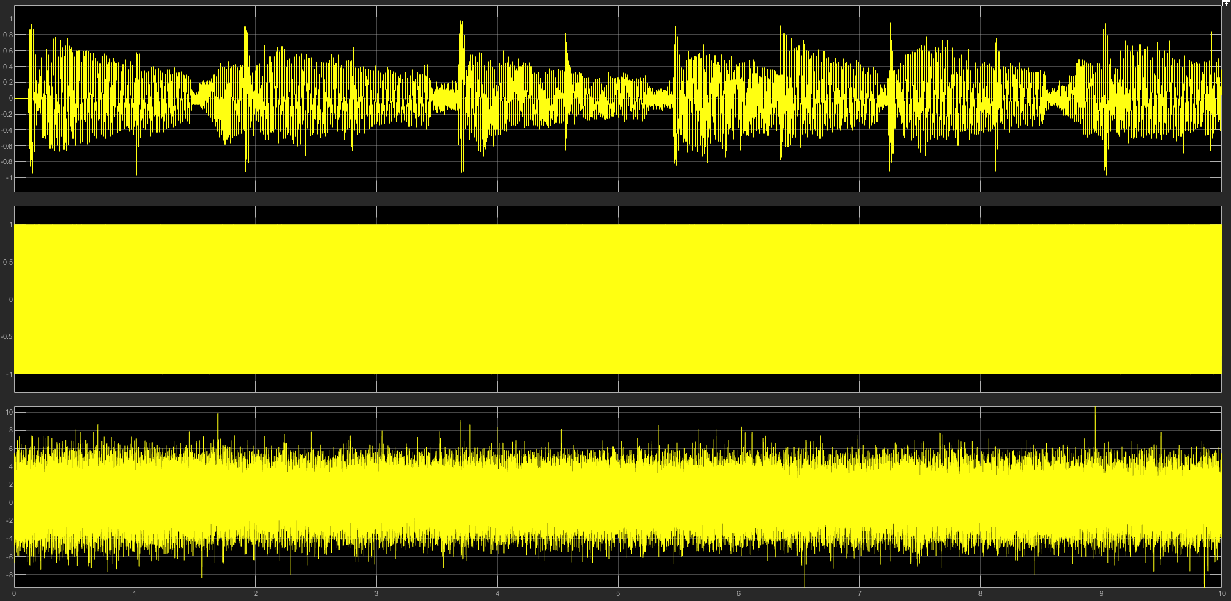
Figure 28: Task 3.c - 20dB noise - Scope output
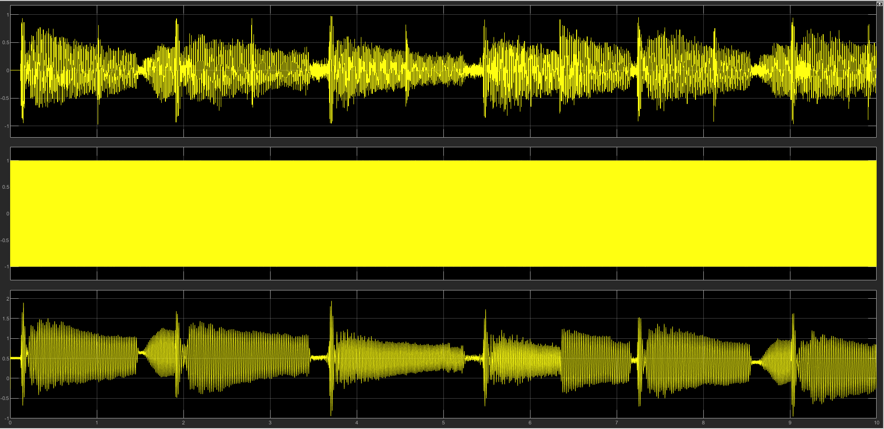
Figure 29: Task 3.c - 100dB noise - Scope output
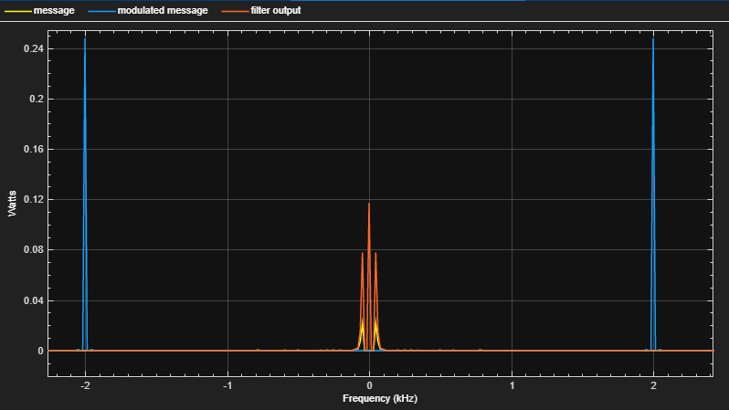
Figure 30: Task 3.c - 100db noise - Spectrum output

Analysing the Results.

Task 1
For this task the aim was to create a working Amplitude modulator and demodulator which was successful in completing, this can be seen in Figure 1 and the results of this in Figure 14. The next step was to show Critical, over and under Modulation and display the effects, an example of this can be seen in Figure 31.
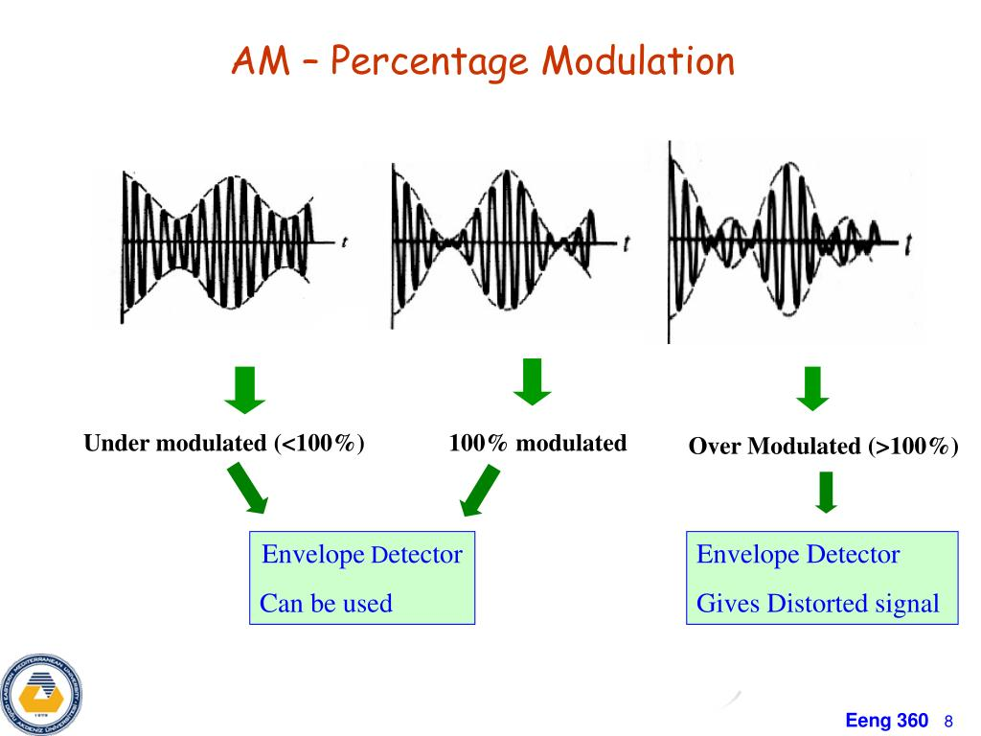
Figure 31: Under, Critical and Over modulation [12]
Testing on Simulink did not show these results as expected. Figure 14 and Figure 15, which show under and critical respectively, showed the results as expected of no data loss occurring. But with an expected data loss in doing Over modulation in Figure 16 this did not occur. It is possible that this is an error in the program that cannot be explained as it was set up appropriately and this can be seen in the figure with the amplitude of the message being higher than that of the carrier. Where data loss should have occurred, it did not in this case. All outputs of all tests can be seen in the relevant figures on the last line.

Task 2
In Figure 2 this shows the working DSB SC modulator built with a 0.5 modulation index, the scope output for the modulation and demodulation of the wave can be seen in Figure 18.
Figure 3 shows how the circuit is built to have a “real message” transmitted. The original message can be seen in the file, this is labelled “sleepy-cat-8KHz”. The outputs of the DSB SC output with no noise is labelled “Task_2b_NoNoise”. This shows a slight distortion to the output compared to the input, but it is clearly still the same message. The output of this can also be seen in Figure 21 which shows the signal at the start and at the end with minimal difference in the wave shape.
For the final part of this task noise was added to the system using the AWGN block in Simulink in the channel, seen in Figure 4. I attempted this with 100dB of noise and 10dB, with 100dB there was very minimal changes, this can be heard in the file titled “Task_2c_100dbNoise”, this is like the no noise as there is a minimal effect but there is some. Whereas with 10 dB noise this was a very distorted noise with little to no resemblance of the original sound, this can be heard in “Task_2c_10dbNoise” and seen on the scope in Figure 24 where this clearly shows the original wave shape cannot be seen at all.

Calculating the theoretical SNR and theoretical Figure of merit.
$$FoM=\frac{SNRc}{SNRo}$$
$$SNRc= \frac{{Ac}^{2}{Ka}^{2}P}{2N_{0}BW}$$
$$SNRo = \frac{{Ac}^{2}(1+{Ka}^{2})P}{2N_{0}BW}$$
Equation 8: DSB-SC FOM & SNR [13]
Using the values
Ac = 2 Ka = 0.5 P = 0.5 N₀ = 1 BW = 16000
This then returns these values.
SNRc = 0.000078125 converted to dB => 1.000018
SNRc = 0.000015625 converted to dB => 1.000004
Theoretical FoM = 1.000014
This value can then be compared to values created using the simulations.

Calculating SNR and figure of merit in DBW with the noise value set to 50dB.
Using the spectrum analyser to gather the data using the channel measurements tab.
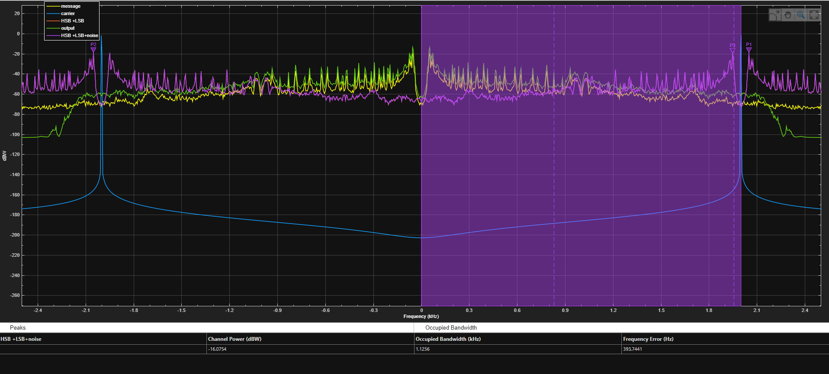
Figure 32: How to find power values.
Using the measurements feature on the spectrum analyser gather results for the channel power for the output, modulated and modulated after noise. The values bellow are rounded to 3dp but were not during the calculations.
Output = -8.2246dBw =>10^{dBW/10} = 0.108…
Modulated =-13.3653dBw =>10^{dBW/10} = 0.024…
Modulated + Noise =-16.0758dBw =>10^{dBW/10} = 0.024…
Noise power = (Modulated + noise) – Modulated
=2.273… x10⁻⁶
SNRo = 10log10(output / Noise power)
= 46.801…dBW
SNRc = 10log10(output / Noise power)
= 40.357…dBW
FOM = 0.8622

Calculating SNR and figure of merit in DBW with the noise value set to 10dB.
Output = -9.6312dBw =>10^{dBW/10} = 0.150…
Modulated =-16.0754dBw =>10^{dBW/10} = 0.046…
Modulated + Noise =-16.0761dBw =>10^{dBW/10} = 0.024…
Noise power = (Modulated + noise) – Modulated
=0.021…
SNRo = 10log10(output / Noise power)
= 8.472…dBW
SNRc = 10log10(output / Noise power)
= 3.331…dBW
FOM = 2.5428

Looking at the values above you can see the theoretical FoM value is very close to that of the 50dB test, this is because the output of this is the best, its very similar to the input. Whereas for the 10dB test the noise has much more of an effect on the output which alters the value away from the theoretical.

Task 3
Figure 5 shows a working FM modulator and demodulator using a Frequency Discrimination Method, the output for this can be seen in Figure 25 when you can see the input then the Frequency modulation and then the demodulated output which is the same as the input showing that the system works.
In Figure 6 you can see the setup for FM using a real message input and then on Figure 26 and Figure 27 you can see the outputs of the scope and spectrum analyser accordingly. You can also hear the sound which is affected by a minimal amount on the file titled “task3b-no_noise”.
Figure 7 shows the FM circuit using a real message including noise. Figure 28 is with 20dB and Figure 29 is with 100dB and Figure 30 is the spectrum of 100dB noise, both the 20db noise and 100db noise also have an audio file attached, “task3c-20dB_noise” and “task3c-100dB_noise”. In these the 100dB message can be clearly heard and seen in the figure, but this clearly losses some of the peaks in places, whereas 20dB is not recognisable on the audio or scope. This is likely because I have not optimised the circuit enough and could be improved but clearly shows the drop of on the circuit.

Calculating the theoretical SNR and theoretical Figure of merit.
$$FoM=\frac{SNRc}{SNRo}$$
$$SNRc= \frac{{Ac}^{2}{Ka}^{2}P}{2N_{0}BW}$$
$$SNRo = \frac{{Ac}^{2}(1+{Ka}^{2})P}{2N_{0}BW}$$
Equation 9: FM SNR & FoM [14]
Using the values:
Ac = 1 Kf = 20 P = 0.5 N₀ = 1 BW = 2*(Kf + Mf) = 16040
these values create the bellow results:
SNRo = 3.117…x10⁻⁵ => 10log₁₀ = -45.062dBW
SNRc = 2.423…x10⁻¹¹ => 10log₁₀ = -106.156dBW
FoM = 0.4344

Calculating SNR and figure of merit in DBW with the noise value set to 50dB.
Using the spectrum analyser to gather the data using the channel measurements tab.
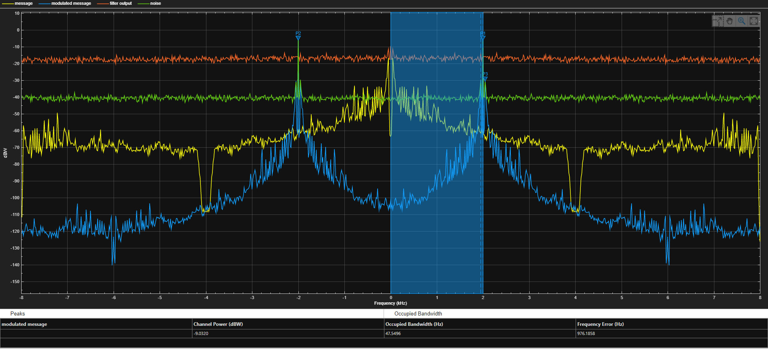
Figure 33: Finding power values.
Using the measurements feature on the spectrum analyser gather results for the channel power for the output, modulated and modulated after noise. The values bellow are rounded to 3dp but were not during the calculations.
Output = -8.7378dBw =>10^{dBW/10} = 0.133…
Modulated = - 9.0317dBw =>10^{dBW/10} = 0.124…
Modulated + Noise = -9.032dBw =>10^{dBW/10} = 0.124…
Noise power = (Modulated + noise) – Modulated
=8.832…x10-6
SNRo = 10log10(output / Noise power)
= 41.900…dBW
SNRc = 10log10(output / Noise power)
= 41.606…dBW
FOM = 1.007

Calculating SNR and figure of merit in DBW with the noise value set to 10dB.
Output = -4.5354dBw =>10^{dBW/10} = 2.841…
Modulated = -8.6456dBw =>10^{dBW/10} = 0.136…
Modulated + Noise = -9.032dBw =>10^{dBW/10} = 0.124…
Noise power = (Modulated + noise) – Modulated
=1.162…x10⁻²
SNRo = 10log10(output / Noise power)
= 23.880…dBW
SNRc = 10log10(output / Noise power)
= 10.699…dBW
FOM = 2.2319 dB
These results show in a similar way to the same calculation on the AM testing that the higher the noise level in the channel the greater the effect on the results here due to a higher level of noise being included on the received signal making the data harder hear if listening or see on a scope/ spectrum analyser.

Conclusion
In this task a Working Amplitude modulator was made and was shown how it works using a scope in different locations and a spectrum analyser. After this it clearly showed under and critical modulations using the scope but failed to demonstrate over modulation as the program didn’t work correctly when doing this even though the inputs was set up correctly. But in general, when looking at the demodulated signal, this is an effective system but is never tested with noise so this cannot be really said.
For task 2 the DSB SC system works well under no and little noise, this can be seen in Figure 18 and Figure 21 but when under higher noise such as in Figure 24 this clearly shows when the errors occur, this can also be heard in the audio files attached. In general, this system performs well with the multimedia file.
Finally for task 3 this demoed how a Frequency modulator worked, how it created and demodulated an FM wave with the input of a sine wave and a multimedia file, this then worked with the added noise and showed the effects this has on the modulated wave.

Recommendations on future work.
In the future it would be beneficial to make these systems more comparable and gather more data on the effect of the noise on the system and create a method of comparing the quality of the outputs if this is a listen in test of something more formal.
Another option for more future work is looking into other techniques of modulations to also compare, for example with FM there are 2 modulation techniques, it is possible to compare these and see if one works better under the effects of noise.

References

[1] | M. J. P. Devaraj, RF_lecture1, UWTSD.
[2] | M. J. P. Devaraj, RF_lecture2, UWTSD.
[3] | EEEGuide, “Generation of DSBSC Signal using Balanced and Ring Modulator,” https://www.eeeguide.com/generation-of-dsbsc-signal-using-balanced-and-ring-modulator/.
[4] | P. Lawrence Der, “Frequency Modulation (FM) Tutorial,” https://wwwqa.silabs.com/documents/public/white-papers/FMTutorial.pdf.
[5] | “Analog Communication - FM Demodulators,” https://www.tutorialspoint.com/analog_communication/analog_communication_fm_demodulators.htm.
[6] | U. PATHRABE, “The Beginners Guide to Communication,” https://analog-modulation.blogspot.com/2020/04/modulation.html, 2020.
[7] | “Analog and Digital Modulation in the field of communications,” https://www.equestionanswers.com/notes/modulation-analog-digital.php.
[8] | Sasmita, “Introduction to Double Sideband Suppressed Carrier (DSB-SC) System . Explain The Generation of DSB-SC Signal,” https://electronicspost.com/introduction-to-double-sideband-suppressed-carrier-dsb-sc-system-explain-the-generation-of-dsb-sc-signal/, 2015.
[9] | Sasmita, “Coherent Detection of DSB-SC Waves,” https://www.bing.com/images/search?view=detailV2&ccid=wD7vRuNH&id=F42EBA47026F6CAF98ECE563AEB9D96F989D9A87&thid=OIP.wD7vRuNHdHqZjv7C901YsgHaC3&mediaurl=https%3a%2f%2felectronicspost.com%2fwp-content%2fuploads%2f2015%2f12%2fcoherent-detection-of-DSB-SC-mod, 2015.
[10] | “Ch 2. Frequency Modulation (FM):,” http://www.rfdh.com/invite/ni/02/02.htm.
[11] | C. Devendra K, Modeling and simulation of systems using matlab and simulink, https://books.google.co.uk/books?hl=en&lr=&id=7WfMBQAAQBAJ&oi=fnd&pg=PP1&dq=using+simulink+matlab&ots=WlIIRIR_Uj&sig=-n085PZlRCOTptVvfYNdNOiUxP0#v=onepage&q&f=false, 2010.
[12] | “Chapter 5 AM, FM, and Digital Modulated Systems Amplitude Modulation (AM),” https://www.slideserve.com/psyche/chapter-5-am-fm-and-digital-modulated-systems-amplitude-modulation-am, 2014.
[13] | “Analog Communication - Introduction,” https://www.tutorialspoint.com/analog_communication/analog_communication_quick_guide.htm.
[14] | M. M. Simon Haykin, “Introduction to Analog and Digital Communications second edition,” 2007.
[15] | M. J. P. Devaraj, “Noise in Analog Communication Systems,” UWTSD.

